***Solution Section* 3.5 – Least Squares Analysis**

***Exercise***

Find the equation of the line that best fits the given points in the least-squares sense and find the error.



***Solution***



Let  be the equation of the line that best fits the given points. Then



where 

The normal equation formula: 















Thus, 

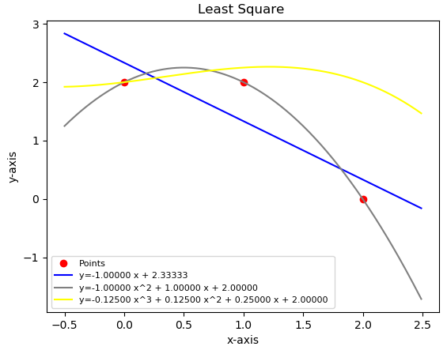







**E*rror***:







*************************************

The ***second*** *order* equation:



***Error*** = 0.00000

*************************************

The ***third order*** equation:



***Error*** = 2.01556

***Exercise***

Find the equation of the line that best fits the given points in the least-squares sense and find the error.



***Solution***



Let  be the equation of the line that best fits the given points. Then

 where 

The normal equation: 



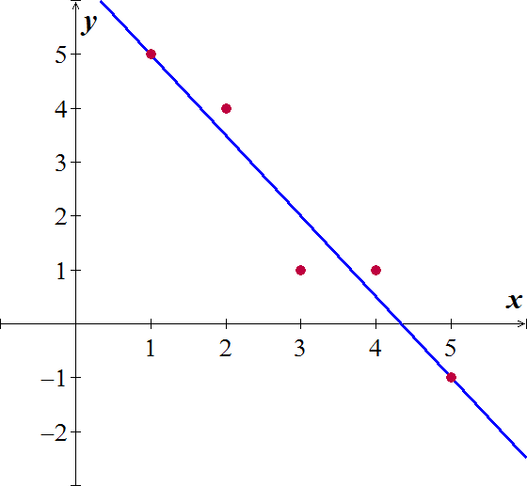













Thus, 



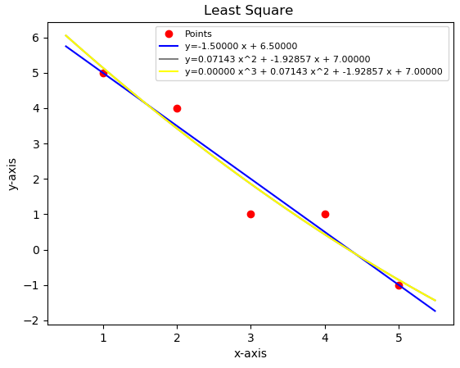 





**E*rror***:







The ***second order*** equation:



***Error*** = 1.19523

*************************************

The ***third order*** equation:



***Error*** = 1.19523

***Exercise***

Find the equation of the line that best fits the given points in the least-squares sense and find the error.



***Solution***

Let  be the equation of the line that best fits the given points. Then



where 

The normal equation: 





 





We have: .

Thus, 



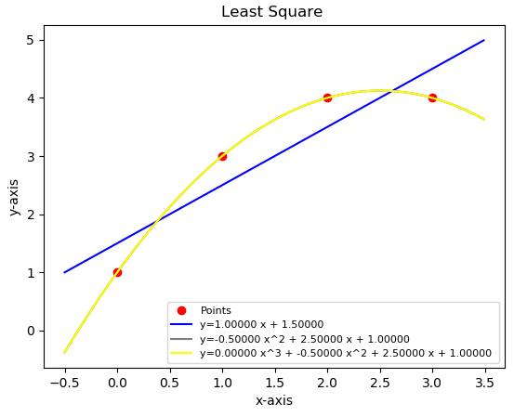 





**E*rror***:





The ***second order*** equation:



***Error*** = 0.0000

*************************************

The ***third order*** equation:



***Error*** = 0.00000

***Exercise***

Find the equation of the line that best fits the given points in the least-squares sense and find the error.



***Solution***

Let  be the equation of the line that best fits the given points. Then



where 

The normal equation: 









We have: 

Thus, 

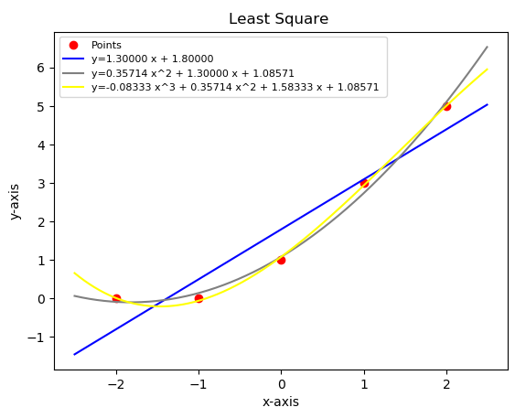

  
 

***Error***: 







The *second order* equation:



***Error*** = 0.33806

*************************************

The *third order* equation:



***Error*** = 0.11952

***Exercise***

Find the equation of the line that best fits the given points in the least-squares sense and find the error.



***Solution***

Let  be the equation of the line that best fits the given points. Then



where 

The normal equation: 











Thus, 



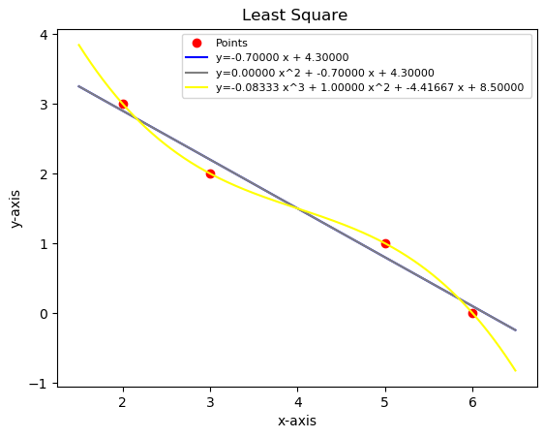 





**E*rror***:







*************************************

The ***second order*** equation:



***Error*** = 0.31623

*************************************

The ***third order*** equation:



***Error*** = 0.00000

***Exercise***

Find the equation of the line that best fits the given points in the least-squares sense and find the error.



***Solution***

Let  be the equation of the line that best fits the given points. Then



where 

The normal equation: 











Thus, 



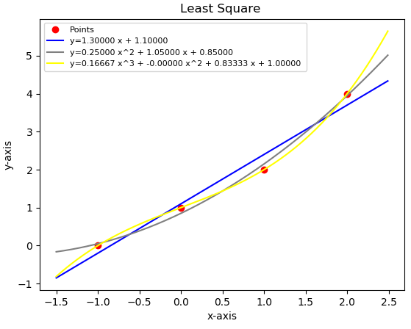 





**E*rror***:









*************************************

The ***second order*** equation:



***Error*** = 0.22361

*************************************

The ***third order*** equation:



***Error*** = 0.00000

***Exercise***

Find the equation of the line that best fits the given points in the least-squares sense and find the error.



***Solution***

Let  be the equation of the line that best fits the given points. Then



where 

The normal equation: 











Thus, 



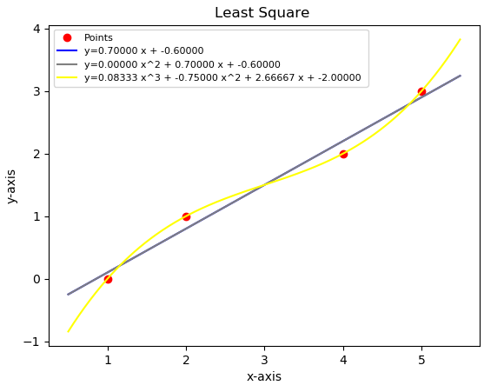 





**E*rror***:







*************************************

The ***second order*** equation:



***Error*** = 0.31623

*************************************

The ***third order*** equation:



***Error*** = 0.00000

***Exercise***

Find the orthogonal projection of the vector  on the subspace of  spanned by the vectors



***Solution***

Let 









The normal solution is 



  





So 







***Exercise***

Find the orthogonal projection of the vector  on the subspace of  spanned by the vectors



***Solution***

Let 









The normal solution is 



  





So 







***Exercise***

Find the orthogonal projection of the vector  on the subspace of  spanned by the vectors



***Solution***

Let 









The normal solution is 



  













***Exercise***

Find the standard matrix for the orthogonal projection *P* of  on the line passes through the origin and makes an angle *θ* with the positive *x-*axis.

***Solution***

Since the line l in 2-dimensional, than we can take  as a basis for this subspace

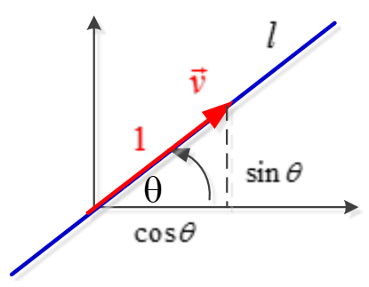







***Exercise***

Hooke’s law in physics states that the length *x* of a uniform spring is a linear function of the force *y* applied to it. If we express the relationship as , then the coefficient *m* is called the spring constant.

Suppose a particular unstretched spring has a measured length of 6.1 *inches*.(i.e., *x* = 6.1 when *y* = 0). Forces of 2 pounds, 4 pounds, and 6 pounds are then applied to the spring, and the corresponding lengths are found to be 7.6 inches, 8.7 inches, and 10.4 inches. Find the spring constant.

***Solution***



The normal equation: 

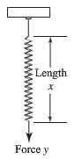









Thus, the estimated value of the spring constant is 

***Exercise***

Prove:

If *A* has a linearly independent column vectors, and if  is orthogonal to the column space of *A*, then the least squares solution of  is.

***Solution***

If *A* has linearly independent column vectors, then  is invertible and the least squares solution of  is the solution of , but since  is orthogonal to the column space of *A*.

, so  is a solution of .

Thus  since  is invertible.

***Exercise***

Let *A* be an  matrix with linearly independent row vectors. Find a standard matrix for the orthogonal projection of  onto the row space of *A*.

***Solution***

 will have linearly independent column vectors, and the column space  is the row space of *A*. Thus, the standard matrix for the orthogonal projection of  onto the row space of *A* is





***Exercise***

Let *W* be the line with parametric equations 

1. Find a basis for *W*.
2. Find the standard matrix for the orthogonal projection on *W*.
3. Use the matrix in part (*b*) to find the orthogonal projection of a point  on *W*.
4. Find the distance between the point  and the line *W*.

***Solution***

1. 

So that the vector  forms a basis for W (linear independence)

1. Let 











1. 
2. 

The distance between  and *W* equals to the distance between  and its projection on W.

The distance between  and  is







***Exercise***

In , consider the line *l* given by the equations 

And the line *m* given by the equations 

Let *P* be the point on *l*, and let *Q* be a point on *m*. Find the values of *t* and *s* that minimize the distance between the lines by minimizing the squared distance 

***Solution***

When  is on line *l*

When  is on line *m*





Thus, these are the values  and  are the values for  that minimize the distance between the lines.

***Exercise***

Determine whether the statement is true or false,

1. If *A* is an  matrix, then  is a square matrix.
2. If  is invertible, then *A* is invertible.
3. If *A* is invertible, then  is invertible.
4. If  is a consistent linear system, then  is also consistent.
5. If  is an inconsistent linear system, then  is also inconsistent.
6. Every linear system has a least squares solution.
7. Every linear system has a unique least squares solution.
8. If *A* is an  matrix with linearly independent columns and is in , then  has a unique least squares solution.

***Solution***

1. ***True***;  is an  matrix
2. ***False***; only square matrix has inverses, but  can be invertible when *A* is not square matrix.
3. ***True***; if *A* is invertible, so is , so the product  is also invertible
4. ***True***
5. ***False***; the system  may be consistent
6. ***True***
7. ***False***; the least squares solution may involve a parameter
8. ***True***; if *A* has linearly independent column vectors; then  is invertible, so  has a unique solution

***Exercise***

A certain experiment produces the data .

Find the function that it will fit these data in the form of 

***Solution***

***Given***: the equation  that best fits the given points. Then



where 

The normal equation formula: 

















***Exercise***

According to Kepler’s first law, a comet should have an ellipse, parabolic, or hyperbolic orbit (with gravitational attractions from the planets ignored). In suitable polar coordinates, the position  of a comet satisfies an equation of the form



Where  is a constant and *e* is the eccentricity of the orbit, with  for an ellipse,  for a parabolic, and  for a hyperbola.

Suppose observations of a newly discovered comet provide the data below.



Determine the type of orbit, and predict where the orbit will be when ?

***Solution***

***Given***: the equation in the form 













where 

The normal equation formula: 

















Therefore, the orbit is an ***ellipse*** type since 

Since 

Then, 

 





***Exercise***

To measure the takeoff performance of an airplane, the horizontal position of the plane was measured every second, from  to 

The position (in *feet*) were:



1. Find the least square cubic curve  for these data.
2. Estimate the velocity of the plane when , using the result from part (*a*).

***Solution***

***Given***: the equation is in form 



The normal equation formula: 











Or I use my program to find the values

rref = (Matrix([

[1, 0, 0, 0, -0.855769230765803],

[0, 1, 0, 0, 4.70248501498163],

[0, 0, 1, 0, 5.55536963037029],

[0, 0, 0, 1, -0.0273601398601744]]))











***Error*** = 3.9734

