***Solution Section* 4.1 – Matrix Transformations from  to** 

***Exercise***

Find the standard matrix for the transformation defined by the equations

1. 
2. 
3. 

***Solution***

1. 

The standard matrix is 

1. 

The standard matrix is 

1. 

The standard matrix is

***Exercise***

Find the standard matrix for the operator *T* defined by the formula



***Solution***





The standard matrix is 

***Exercise***

Find the standard matrix for the operator *T* defined by the formula



***Solution***





The standard matrix is 

***Exercise***

Find the standard matrix for the operator *T* defined by the formula



***Solution***





The standard matrix is 

***Exercise***

Find the standard matrix for the operator *T* defined by the formula



***Solution***





The matrix is 

***Exercise***

Find the standard matrix for the operator *T* defined by the formula



***Solution***



The matrix is 

***Exercise***

Find the standard matrix for the operator *T* defined by the formula



***Solution***







The matrix is 

***Exercise***

Find the standard matrix for the operator *T* defined by the formula



***Solution***





The matrix is 

***Exercise***

Plot  and their images under the given transformation *T*

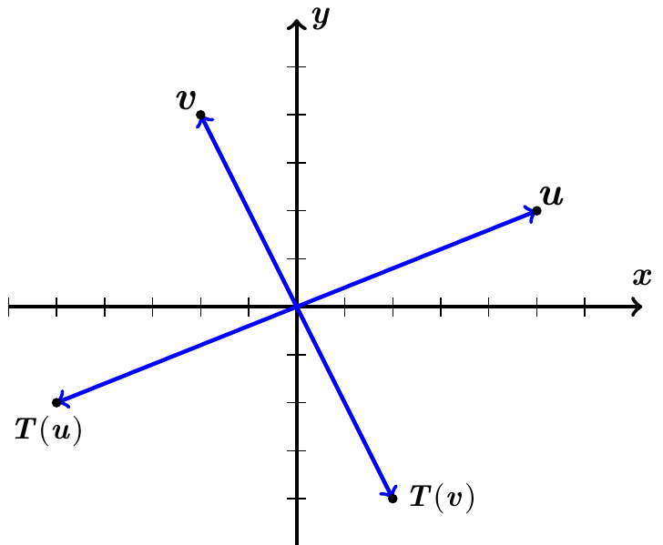

***Solution***









∴ *Reflection* through the origin 

***Exercise***

Plot  and their images under the given transformation *T*



***Solution***

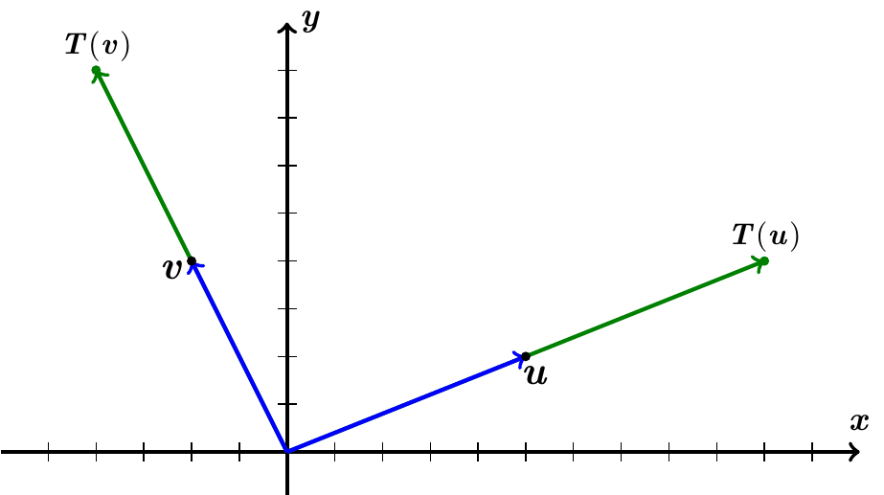











∴ *Dilation* with factor  on 

***Exercise***

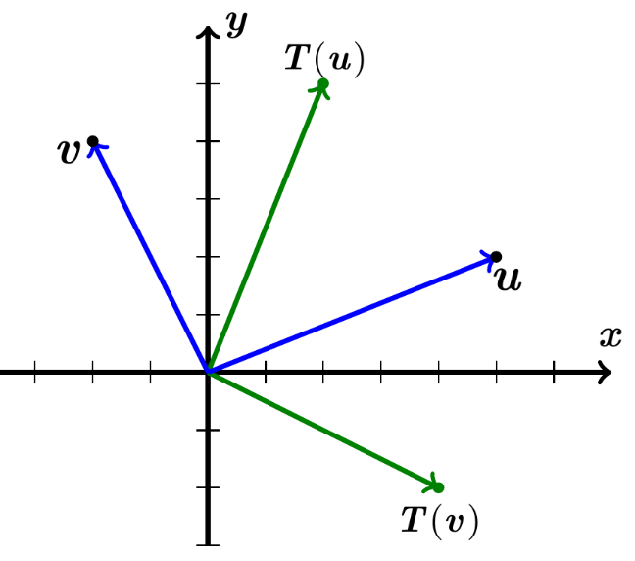Plot  and their images under the given transformation *T*



***Solution***













∴ *reflection* about the line 

***Exercise***

Plot  and their images under the given transformation *T*

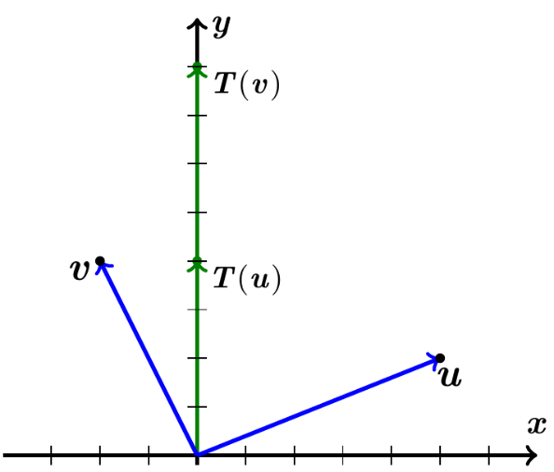

***Solution***













∴ Orthogonal projection on the *y*-axis and with *Dilation* with factor 

***Exercise***

Plot  and their images under the given transformation *T*



***Solution***

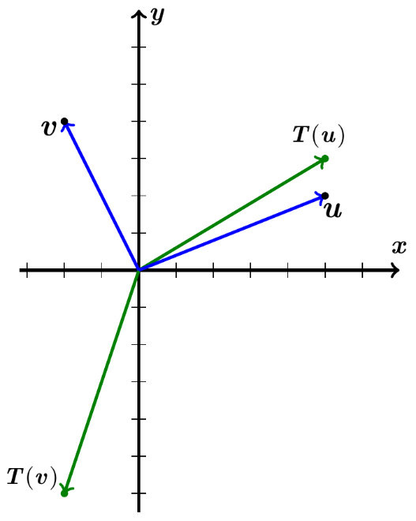











*∴ Expansion* of ** in the *y*−direction with factor 

*∴ Expansion* of ** in the *y*−direction with factor  and reflection about *x*−axis.