***Lecture Four***

***Section* 4.1 – Matrix Transformations from  to **

***Definition***

If *V* and *W* are vector spaces, and if *f* is a function with domain *V* and codomain *W*, then we say that *f* is a transformation from *V* to *W* or that f maps *V* to *W*, which we denote by writing



In the special case where *V* = *W*, the transformation is also called an operator on *V*.

**Matrix Transformation**



Which we can write in matrix formation





Although we could view this as a linear system, we will view it instead as a transformation that maps the column vector  in  into the column vector  in  by multiplying  on the left by *A*. We call this a ***matrix transformation*** or ***function*** or ***mapping T*** from  to  (or ***matrix operator*** if *m = n*) and we denote it by



 is called the domain of *T*

 is called the codomain of *T*

For  in , the vector  in  is called the image of  (under the action of *T*)

The set of all images  is called the range of *T*.

|  |  |
| --- | --- |
|  |  |
| ***T*** *maps vectors to vectors* | ***T*** *maps points to points* |

|  |  |  |  |
| --- | --- | --- | --- |
| *Reflection* about  the *y*-axis |  |  |  |
| *Reflection* about  the *x*-axis |  |  |  |
| *Reflection* about  the line *y* = *x* |  |  |  |
| *Reflection* about  the *xy*-plane |  |  |  |
| *Reflection* about  the *xy*-plane |  |  |  |
| *Reflection* about  the *yz*-plane |  |  |  |
| Orthogonal projection  on the *x*-axis |  |  |  |
| Orthogonal projection  on the *y*-axis |  |  |  |
| Orthogonal projection  on the *xy*-Plane |  |  |  |
| Orthogonal projection  on the *xz*-Plane |  |  |  |
| Orthogonal projection  on the *yz*-Plane |  |  |  |

|  |  |  |  |
| --- | --- | --- | --- |
| ***Rotation Operators*** | | | |
| Rotation through an angle *θ* |  |  |  |
| Counterclockwise rotation about the positive *x*-axis through an angle *θ* |  |  |  |
| Counterclockwise rotation about the positive *y*-axis through an angle *θ* |  |  |  |
| Counterclockwise rotation about the positive *z*-axis through an angle *θ* |  |  |  |

***Contractions and Dilations***

|  |  |  |  |
| --- | --- | --- | --- |
| *Contraction* with factor *k* on |  |  |  |
| *Dilation* with  factor *k* on |  |  |
| *Contraction* with factor *k* on |  | |  |
| *Dilation* with  factor *k* on |  | |

***Expansion or Compression***

|  |  |  |  |
| --- | --- | --- | --- |
| *Compression* of  in the *x*−direction with factor *k* |  |  |  |
| *Expansion* of  in the *x*−direction with factor *k* |  |  |
| *Compression* of  in the *y*−direction with factor *k* |  |  |  |
| *Expansion* of  in the *y*−direction with factor *k* |  |  |

***Shear***

|  |  |  |  |  |
| --- | --- | --- | --- | --- |
| *Shear* of  in the *x*−direction with factor *k* |  |  |  |  |
| *Shear* of  in the *y*−direction with factor *k* |  |  |  |  |

**Orthogonal Projections on Lines through the Origin**





***Example***

Find the orthogonal projection of the vector = (1, 5) on the line through the origin that makes an angle of  with the *x*-axis

***Solution***















***Example***

Define a linear transformation  by





Find the images under *T* of 

***Solution***

















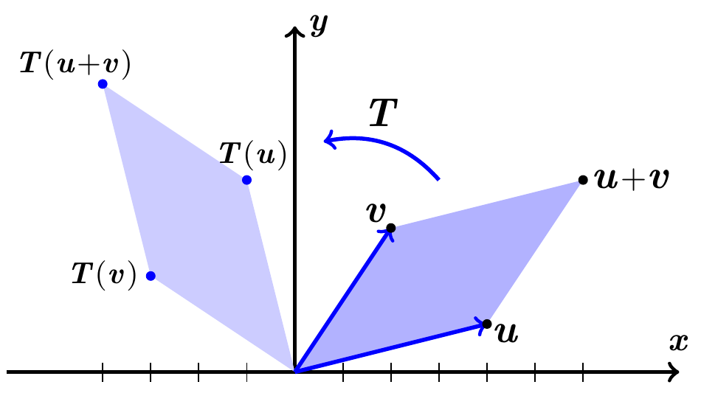

***Four Fundamental Subspaces***

1. The ***row space*** is , a subspace of .
2. The ***column space*** is , a subspace of .
3. The ***nullspace*** is , a subspace of.
4. The ***left nullspace*** is , a subspace of .

***The Four Subspaces for R***

Consider the matrix 3 by 5:



1. Rows 1 and 2 are a basis. The row space contains combination of all 3 rows.

The ***row space*** of has dimension 2 (= ***rank***).

***The dimension of the row space is r***. The nonzero rows of ***R*** form a basis.

1. The ***column space*** of ***R*** has dimension *r* = 2.

The pivot columns 1 and 4 form a basis. They are independent because they start with the *r* by *r* identity matrix.

There are 3 special solutions:



***The dimension of the column space is r***. The pivot columns form a basis.

1. The ***nullspace*** has dimension *n* – *r* = 5 – 2 = 3 (free variables). Here are free (no pivots in those columns). They yield the three special solutions to . Set a free variable to 1, and solve for .



 has the complete solution: 

***The nullspace has dimension*** *n* – *r*. The special solutions form a basis.

1. The ***nullspace*** of  has dimension *m* – *r* = 3 – 2 = 1

The equation : 

The nullspace of  contains all vectors  and it is the line of the basis vector .

***The left nullspace has dimension m – r***. The solutions are 

* In  the row space and nullspace have dimensions *r* and *n* – *r* (adding to *n*)
* In  the column space and left nullspace have dimensions *r* and *m* – *r* (total *m*)

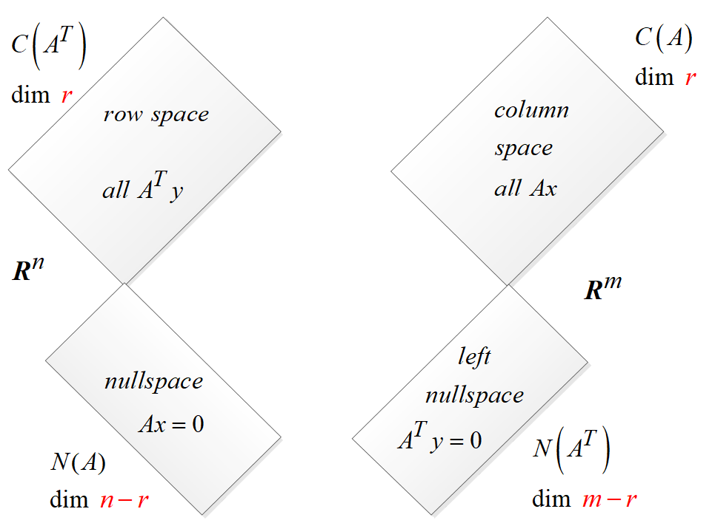

***The Four Subspaces for A***

***The subspace dimensions for A are the same as for R***.

These matrices are connected by an invertible matrix *E*. 

1. ***A*** *has the same row space as* ***R***. Same dimension *r* and same basis

Every row of ***A*** is a combination of the rows of ***R***. Also every row of ***R*** is a combination of the rows of ***A***.

1. *The column space of* ***A*** *has dimension* *r*. The number of independent columns equals the number of independent rows.
2. ***A*** *has the same nullspace as* ***R***. Dimension *n* – *r* and same basis.

**(*dimension of column space*) *+* (*dimension of nullspace*) *= dimension of ***

1. *The left nullspace* ***A*** (the nullspace of) *has dimension m – r*.

**Fundamental Theorem of Linear Algebra**, (Part 1)

The column space and row space both have dimension *r*.

The nullspaces have dimensions *n – r* and *m – r*.

***Example***

Consider 

***A*** has *m* = 1, *n* = 3, and rank: *r* = 1.

The row space is a line in .

The nullspace is the plane . This plane has dimension 2 (which is 3 – 1).

The columns of this is 1 by 3 matrix are in . The column space is all of.

The left nullspace contains only the zero vector.

The only solution to , the only combination of the row that gives the zero row. Thus, , the zero space with dimension 0 (*m – r*). In  the dimensions (1 + 0) = 1.

***Example***

Consider 

***A*** has *m* = 2, *n* = 3, and rank: *r* = 1.

The row space is a line in .

The nullspace is the plane . This plane has dimension 3 (1 + 2).

The columns are multiples of the first column (1, 1).

The left nullspace contains more than one zero vector. The solution to  has the solution .

The column space and nullspace are perpendicular lines in . Their dimensions are 1 and 1 = 2.

Column space = line through 

Left nullspace = line through 

***Exercises***  ***Section* 4.1 – Matrix Transformations from  to **

1. Find the standard matrix for the transformation defined by the equations
2. 
3. 
4. 

(**2 – 8**) Find the standard matrix for the operator *T* defined by the formula

1. 
2. 
3. 
4. 
5. 
6. 
7. 

(**9 – 8**) Plot  and their images under the given transformation *T*

1. 
2. 
3. 
4. 
5. 