***Section* 4.2 – General Linear Transformations**

***Definition***

A transformation *T* assigns an output  to each input vector . The transformation is ***linear*** if it meets these requirements for all  and :



We can combine both into one: 

***Theorem***

If  is a linear transformation, then:

1. 
2.  for all  and  in *V*.

***Example***

If *V* is a vector space and *k* is any scalar, then the mapping  given by  is a linear operator on *V*, for if *c* is any scalar and if  and  are any vectors in *V*, then













If 0 < *k* < 1, then *T* is called ***contraction*** of *V* with factor *k*, and if *k* > 1, then *T* is called ***dilation*** of *V* with factor *k*

|  |  |
| --- | --- |
|  |  |
| ***Dilation of V*** | ***Contraction of V*** |

***Example***

Determine if the given function *T* is a linear transformation. Also give the domain and range of *T*; if *T* is linear, find the *A* such . 

***Solution***

Let 





















Since  and 

Then function *T* is a linear transformation.

***Domain***: 







***Example*** − the Zero Transformations

Let *V* and *W* be any vector spaces. The mapping  such that  for every  in *V* is a linear transformation called the zero transformation. To see that *T* is linear, observe that:



Therefore; 

***Example***

Choose a fixed vector , and let  be the dot product :

***Solution***

Let 







This is linear. The inputs *v* come from three−dimensional space, so . The output just numbers, so the output space is . We are multiplying by the row matrix *A* = [1, 3, 4].

Then 

***Example***

Show that the length  is not linear.

***Solution***



There are not equal because the sides of a triangle satisfy an inequality 



Not - because the length 

***Example***

If  is a fixed nonzero vector in , then the transformation



It has a geometric effect of translating each point  in a direction parallel to  through a distance of .

This cannot be a linear transformation since 

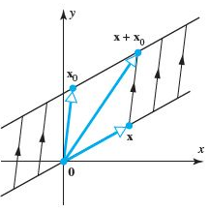

***Theorem***

Let  be the linear transformation, where *V* is finite dimensional. If  is a basis for *V*, then the image of any vector  in *V* can be expressed as



Where  are the coefficients required to express  as a linear combination of the vectors in *S*.

***Example***

Consider the basis  for , where



Let  be the linear transformation for which



Find a formula for , and then use that formula to compute 

***Solution***





















***Example***

*T* is the transformation that rotates every vector by 30°, the domain is the *xy*-plane (where the input vector  is). The range is also the *xy*-plane (where the rotated  is). Is the rotation linear?

***Solution***

Yes it is. We can rotate two vectors and add the results. The sum of rotation  is the same as the rotation  of the sum.

The whole plane is turning together, in this linear transformation.

***Definition***

If  is a linear transformation, then the set of vectors in *V* that *T* maps into   is called ***kernel*** of *T* and is denoted by ***ker***(*T*). The set of all vectors in *W* that are images under *T* of at least one vector in *V* is called the ***range*** of *T* and is denoted by ***R***(*T*).

***Note***:

Transformations have a language of their own. Where there is no matrix, we can’t talk about a column space. But the idea can be rescued and used. The column space consisted of all ouputs .

The nullspace consisted of all inputs for which. Translate those into “range” and “kernel”

**Range** of *T* = set of all outputs : corresponds to column space

**Kernel** of *T* = set of all outputs for which : corresponds to nullspace

***Example***

Project every 3-dimensional vector down onto the *xy* plane.

The range is that plane, which contains every .

The kernel is the ***z*** axis (which projects down to zero). This projection is linear.

***Example*** − ***Kernel and Range of a Rotation***

Let  be the linear operator that rotates each vector in the *xy−*plane through the angle *θ*. Since every vector in the *xy−*plane can be obtained by rotating some vector through the angle *θ*, it follows that .

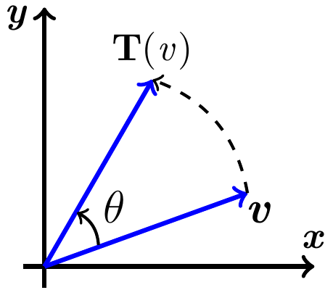

Moreover, the only vector that rotates into  is , so 

***Theorem***

If  is a linear transformation, then:

1. The *kernel* of *T* is a subspace of *V*
2. The *range* of *T* is a subspace of *W*

***Theorem***

If  is a linear transformation from an *n-*dimensional vector space *V* to a vector space *W*, then



***Example***

Project every 3-dimensional vector down onto horizontal plane ***z*** = 1.

The vector  is transformed to . This transformation is not linear, it doesn’t even transform  into .

Multiply every 3-dimensional vector by a 3 by 3 matrix *A*. This is definitely a linear transformation

 which does equal 

***Example***

Suppose *A* is an invertible matrix. The kernel of *T* is the zero vector; the range ***W*** equals the domain ***V***. Another linear transformation is multiplication by .

This is the inverse transformation , which brings every vector  back to :

 matches the matrix multiplication 

***Are all linear transformation produced by matrices?***

Each *m* by *n* matrix does produce a linear transformation from  to . When a linear *T* is described as a “rotation” or “projection” or “...” is there always a matrix hiding behind *T*?

The answer is yes. This is an approach to linear algebra that doesn’t start with matrices. The next section shows that we still end up with matrices.

**Matrices for General Linear Transformations**

Suppose that *V* is an *n*-dimensional vector space, *W* is an *m*-dimensional vector space, and that  is a linear transformation. Suppose further that *B* is a basis for *V*, that  is a basis for *W*, and that for each ***x*** in *V*, the coordinate matrices for ***x*** and  are  and , respectively

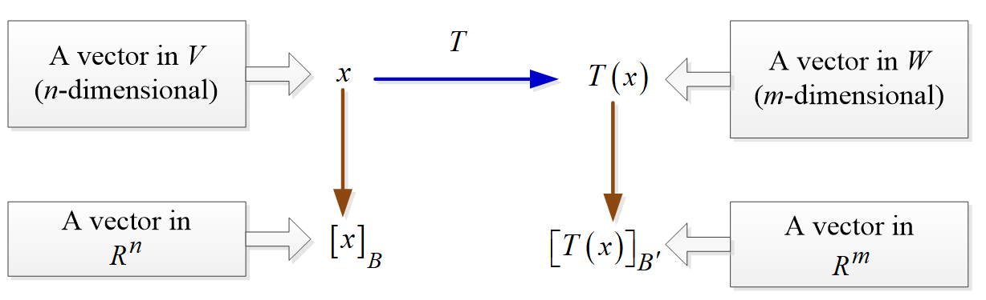

By using matrix multiplication, we can execute the linear transformation and the following indirect procedure:

1. Compute the coordinate vector 
2. Multiply  on the left by *A* to produce 
3. Reconstruct  from its coordinate vector 

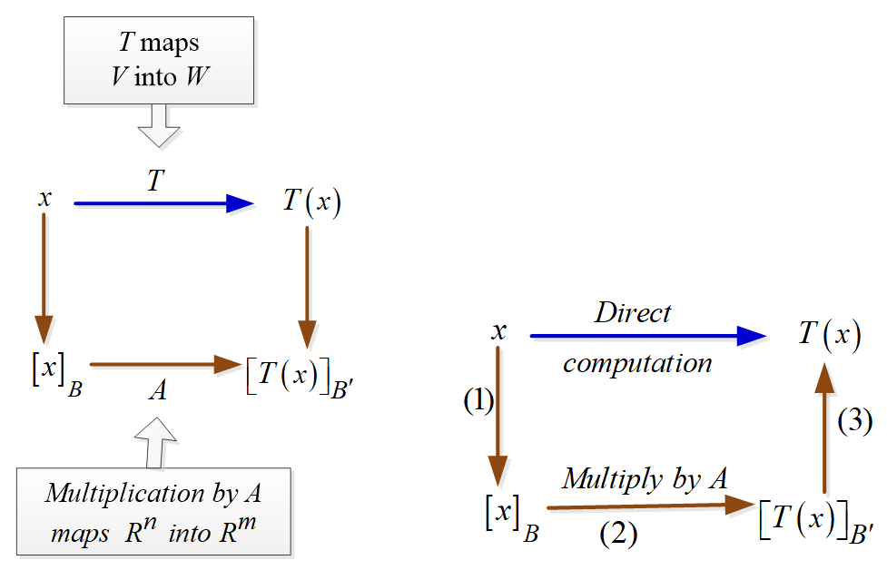



***Example***

Let  be the linear transformation defined by 

Find the matrix for *T* with respect to the standard bases



Where 

***Solution***















The matrix for *T* with respect to *B* and  is





***Example***

Let  be the linear transformation defined by  describe in the following figure to perform the computation



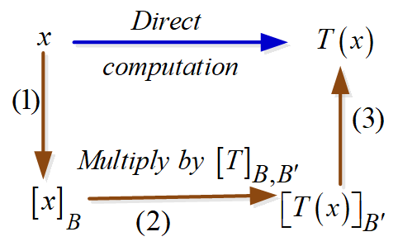



***Solution***

***Step*** 1: The coordinates matrix for  relative to the basis  is



***Step*** 2: Multiply  by the matrix  found in previous example, we obtain







***Step*** 3: Reconstructing  from  we obtain





***Exercises Section* 4.2 – General Linear Transformations**

1. The matrix  gives a shearing transformation .

What happens to (1, 0) and (2, 0) on the *x*-axis.

What happens to the points on the vertical lines *x* = 0 and *x* = *a*?.

1. A nonlinear transformation *T* is invertible if every  in the output space comes from exactly one x in the input space.  always has exactly one solution. Which of these transformation (on real numbers  is invertible and what is ? None are linear, not even . When you solve , you are inverting *T*:



1. If *S* and *T* are linear transformations, is  linear or quadratic?
2. If  and , then  or ?
3.  and  combine into



1. Find the range and kernel (like the column space and nullspace) of *T*:

1. 

1. 

1. 

1. 
2. *M* is any 2 by 2 matrix and . The transformation *T* is defined by . What rules of matrix multiplication show that *T* is linear?
3. Which of these transformations satisfy  and which satisfy ?

1. 

1. 

1. 

1. = largest component of .
2. Consider the basis for , where  and let  be the linear transformation for which



Find a formula for , and then use that formula to compute 

1. Consider the basis for , where  and let  be the linear transformation for which



Find a formula for , and then use that formula to compute 

1. let  be vectors in a vector space *V*, and let  be the linear transformation for which .

Find 

1. Let  be the linear operation given by the formula 

Which of the following vectors are in 



1. Let  be the linear operation given by the formula 

Which of the following vectors are in 



1. Let  be the linear operation given by the formula



Which of the following vectors are in 



1. Let  be the linear operation given by the formula



Which of the following vectors are in 



1. Determine if the given function *T* is a linear transformation



1. Determine if the given function *T* is a linear transformation



1. Determine if the given function *T* is a linear transformation where *A* is fixed  matrix



(**17 – 25**) Determine if the given function *T* is a linear transformation. Also give the domain and range of *T*; if *T* is linear, find the *A* such .

1. 
2. 
3. 

1. 
2. 
3. 
4. 
5. 
6. 
7. A Givens rotation is a linear transformation from  used in computer to create a zero entry in a vector (usually a column of a matrix). The standard matrix of a Givens rotation in  has the form

|  |  |
| --- | --- |
|  | A Givens rotation in |

Find *a* and *b* that  is rotated into .