***Solution Section* 4.3 – LU−Decompositions**

***Exercise***

What matrix *E* puts *A* into triangular form ? Multiply by  to factor A into :



***Solution***



















***Exercise***

Solve  to find **. Then solve  to find . What was *A*?



***Solution***























***Exercise***

Find *L* and *U* for the symmetric matrix



Find four conditions on *a, b, c, d* to get  with four pivots

***Solution***





***Exercise***

For which *c* is  impossible – with three pivots?



***Solution***













*LU* will be impossible for 

***Exercise***

Find an *LU*-decomposition of the coefficient matrix, and then use to solve the system



***Solution***





























The solution: 

***Exercise***

Find an *LU*-decomposition of the coefficient matrix, and then use to solve the system



***Solution***



























The solution: 

***Exercise***

Find an *LU*-decomposition of the coefficient matrix, and then use to solve the system



***Solution***

|  |  |
| --- | --- |
|  |  |
|  |  |
|  |  |
|  |  |
|  |  |
|  |  |





 





Solution: 

***Exercise***

Find an *LU*-decomposition of the coefficient matrix, and then use to solve the system



***Solution***

|  |  |
| --- | --- |
|  |  |
|  |  |
|  |  |
|  |  |
|  |  |











***Solution***: 

***Exercise***

Find an *LU*-decomposition of the coefficient matrix, and then use to solve the system



***Solution***





















***Solution***: 

***Exercise***

Find an *LU*-decomposition of the coefficient matrix, and then use to solve the system



***Solution***





















***Solution***: 

***Exercise***

Find an *LU*-decomposition of the coefficient matrix, and then use to solve the system



***Solution***





















***Solution***: 

***Exercise***

Find an *LU*-decomposition of the coefficient matrix, and then use to solve the system



***Solution***





















***Solution***: 

***Exercise***

Find an *LU*-decomposition of the coefficient matrix, and then use to solve the system



***Solution***

|  |  |
| --- | --- |
|  |  |
|  |  |
|  |  |
|  |  |
|  |  |
|  |  |
|  |  |
|  |  |
|  |  |

***For lower triangular***: 







***Solution***: 

***Exercise***

Find an *LU*-decomposition of the coefficient matrix, and then use to solve the system



***Solution***























***Solution***: 

***Exercise***

Find an *LU f*actorization matrix 

***Solution***









***Exercise***

Find an *LU f*actorization matrix 

***Solution***









***Exercise***

Find an *LU f*actorization matrix 

***Solution***











***Exercise***

Find an *LU f*actorization matrix 

***Solution***











***Exercise***

Find an *LU f*actorization matrix 

***Solution***











***Exercise***

Find an *LU f*actorization matrix 

***Solution***











***Exercise***

Find an *LU f*actorization matrix 

***Solution***











***Exercise***

Find an *LU f*actorization matrix 

***Solution***











***Exercise***

Find an *LU f*actorization matrix 

***Solution***













***Exercise***

Find an *LU f*actorization matrix 

***Solution***













***Exercise***

Let *A* be a lower triangular  matrix with nonzero entries on the diagonal. Show that *A* is invertible and  is lower triangular.

***Solution***

Since *A* is a lower triangular  matrix with nonzero entries on the diagonal, then the determinant is equal to the products of the main diagonal entries.

Therefore,  exists and *A* is invertible.

To find 





To pivot the augmented matrix above and the upper triangular for *A* and *I* are zeros. The results from the pivot will not change the zero values in the upper triangular, since we are trying to get one in the main diagonal and zero elsewhere.



Therefore,  is lower triangular

***Exercise***

Let  be an  factorization. Explain why *A* can be row reduced to *U* using only replacement operations.

***Solution***

Let  be an  factorization for *A*.

Since *L* is unit lower triangular, from previous problem, *A* is invertible. So, the matrix *L* can be row reduced to *I* by using the appropriate pivots to reduced to zero in the lower entries of the main diagonal which maintain one’s.

The row operation done to *L* are row-replacement operations.

If elementary matrices , then







That implies that *A* can be row reduced to *U* using only row-replacement operations.

***Exercise***

Suppose an matrix *A* admits a factorization  where *C* is  and *D* is .

1. Show that *A* is the sum of four outer products.
2. Let . Explain why a computer programmer might prefer to store the data from *A* in the form of two matrices *C* and *D*.

***Solution***

1. *C* is  that implies 

*D* is  that implies 







= Sum of four outer products

1. ***Given***: 

The size of matrix *A* is 

Matrix *C* has: 

Matrix *D* has: 

Both matrices *C* and *D* have:  Only which is lot less than 40,000 entries.

***Exercise***

A ladder network, where two circuits are connected in series, so that the output of one circuit becomes the input of the next circuit.

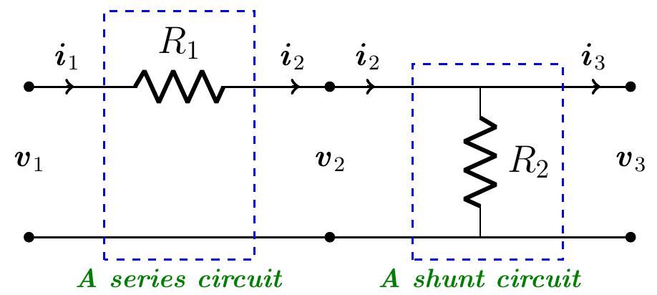

The transformation  is linear with a transfer matrix *A* of the ladder network.

Let the transfer matrix  of the series circuit is given by 

Let the transfer matrix  of the shunt circuit is given by 

1. Compute the transfer matrix of the ladder network.
2. Design a ladder network whose transfer matrix is 

***Solution***

1. For “series circuit”:

The voltage across is: 

The current: 

The drop voltage: 





 *Upper Triangular*

For “shunt circuit”:

The voltage is: 

Voltage : 

The current: 







 *Lower Triangular*

The transfer matrix of the ladder network *A*:







1. 









 ***√***

The given ladder network whose transfer matrix is  has the resistors  and 

***Exercise***

A ladder network, where three circuits are connected in series, so that the output of one circuit becomes the input of the next circuit.

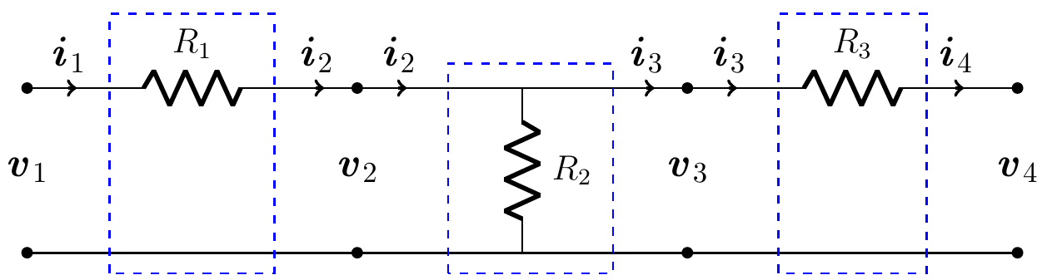

1. Compute the transfer matrix of the ladder network
2. Design a ladder network whose transfer matrix is 

***Solution***

1. Across is:

The current: 

The drop voltage: 





 *Upper Triangular*

For across :

The voltage is: 

Voltage : 

The current: 







 *Lower Triangular*

Across  is:

The current: 

The drop voltage: 





 *Upper Triangular*

The transfer matrix of the ladder network *A*:













1. 











 ***√***

The given ladder network whose transfer matrix is  has the resistors , , and 

***Exercise***

A ladder network, where two circuits are connected in series, so that the output of one circuit becomes the input of the next circuit.

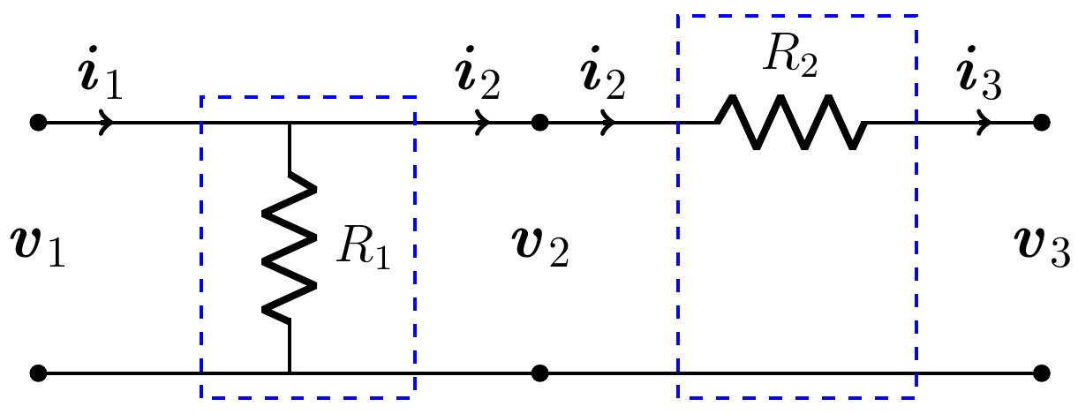

1. Compute the transfer matrix of the ladder network
2. Find the values of the resistors when the input voltage is 12 volts and current is 6 amps if the output voltage is 9 volts and current is 4 amps

***Solution***

1. Across is:

The drop voltage: 

The current: 







 *Lower Triangular*

For across :

The current is: 

The drop voltage: 





 *Upper Triangular*

The transfer matrix of the ladder network *A*:







1. 

















The resistors  and ,