***Section* 4.3 – LU-Decompositions**

The goal is to describe Gaussian elimination in the most useful way by looking at them closely, which are factorizations of a matrix.

***The factors are triangular matrices.***

***The factorization that comes from elimination is .***

**The Method of *LU*−Decomposition**

***Step*** 1: Rewrite the system  as 

***Step*** 2: Define a new  matrix  by 

***Step*** 3: Use  to rewrite  as  and solve this system for .

***Step*** 4: Substitute  in  and solve for .

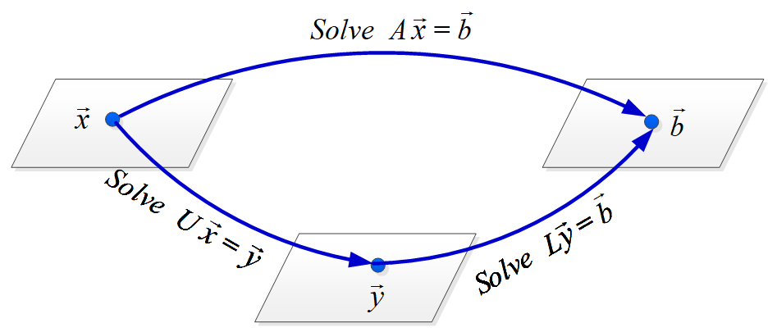

***Example***

Given 2 by 2 matrix 

Find *L* and *U* and verify 

***Solution***

To make ***row*** 2 ***column*** 1 is ***zero*** then we need to subtract 3 times *row* 2 from *row* 2





That step is  in the forward direction such that:





The return step from *U* to *A* is 



Back from *U* to *A*:







Therefore; 

***Example***

What matrix *L* and *U* puts *A* into triangular form  where



***Solution***









***The lower triangular L has all 1’s on its diagonal. The multipliers  are below the diagonal of L with OPPOSITE sign***





* 

*The inverses go in opposite order*.

*  This is ***elimination without row exchanges***. The *upper triangular* ***U*** has the pivots on its diagonal. The *lower triangular* ***L*** has all 1’s on its diagonal.

***The multipliers  are below the diagonal of L***.

***One* Square System = *Two* Triangular Systems**

***Factor:*** into *L* and *U*, by forward elimination on *A*.

***Solve***: forward on  using *L*, then back substitution using *U*.

Solve  and then solve 

***Example***

Forward elimination on  ends at 



***Solution***

The multiplier was 4. 

The lower triangular system: 





The upper triangular system: 





To solve 1000 equations on a PC

* Elimination on *A* requires about  multiplications and  subtractions.
* Each right−side needs  multiplications and  subtractions.

***Exercises Section* 4.3 – LU-Decompositions**

1. What matrix *E* puts *A* into triangular form ? Multiply by  to factor *A* into :



1. Solve  to find **. Then solve  to find . What was *A*?



1. Find *L* and *U* for the symmetric matrix



Find four conditions on *a, b, c, d* to get  with four pivots

1. For which *c* is  impossible – with three pivots?



(**5 – 14**) Find an *LU−*decomposition of the coefficient matrix, and then use to solve the system

|  |  |
| --- | --- |
|  |  |
|  |  |

(**15 – 24**) Find an *LU f*actorization matrix

|  |  |
| --- | --- |
|  |  |

1. Let *A* be a lower triangular  matrix with nonzero entries on the diagonal. Show that *A* is invertible and  is lower triangular.
2. Let  be an  factorization. Explain why *A* can be row reduced to *U* using only replacement operations.
3. Suppose an matrix *A* admits a factorization  where *C* is  and *D* is .
4. Show that *A* is the sum of four outer products.
5. Let . Explain why a computer programmer might prefer to store the data from *A* in the form of two matrices *C* and *D*.
6. A ladder network, where two circuits are connected in series, so that the output of one circuit becomes the input of the next circuit.

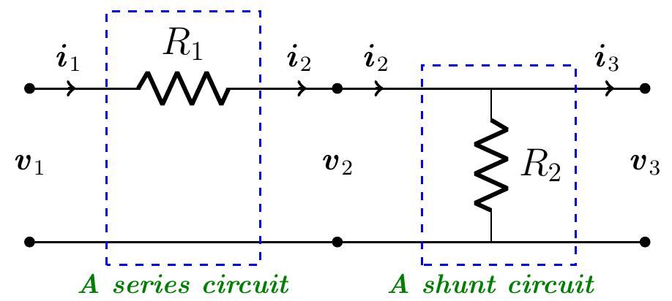

The transformation  is linear with a transfer matrix *A* of the ladder network.

Let the transfer matrix  of the series circuit is given by 

Let the transfer matrix  of the shunt circuit is given by 

1. Compute the transfer matrix of the ladder network
2. Design a ladder network whose transfer matrix is 
3. A ladder network, where three circuits are connected in series, so that the output of one circuit becomes the input of the next circuit.

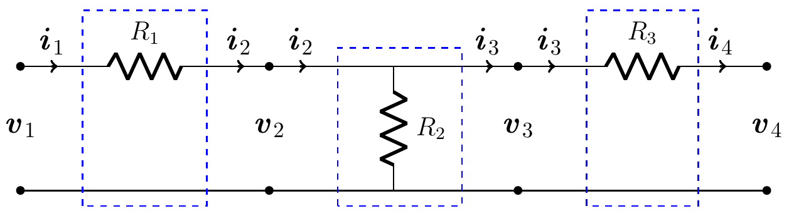

1. Compute the transfer matrix of the ladder network
2. Design a ladder network whose transfer matrix is 
3. A ladder network, where two circuits are connected in series, so that the output of one circuit becomes the input of the next circuit.

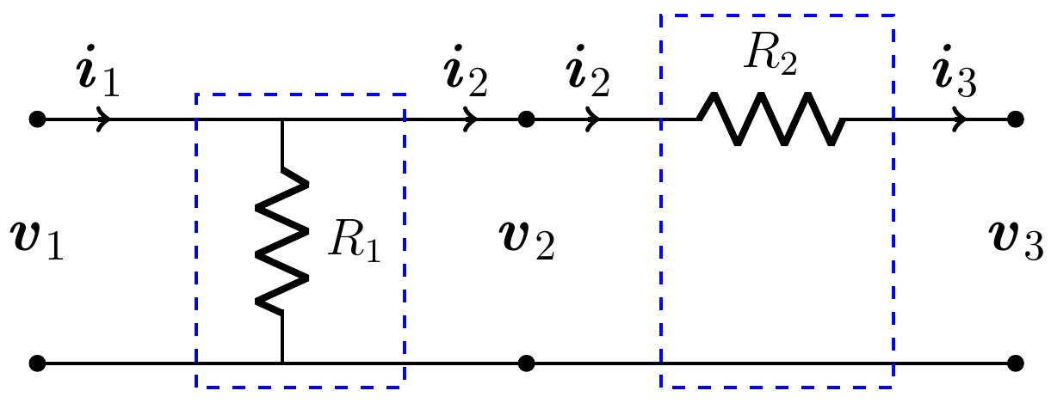

1. Compute the transfer matrix of the ladder network
2. Find the values of the resistors when the input voltage is 12 volts and current is 6 amps if the output voltage is 9 volts and current is 4 amps