***Solution*** ***Section* 4.4 –Eigenvalues & Eigenvectors**

***Exercise***

Find the eigenvalues and eigenvectors of :



Check the trace  and the determinant  for *A* and also .

***Solution***

***For*** ***A***:







The eigenvalues of *A* are .

The trace of a square matrix *A* is the sum of the elements on the main diagonal: 2 + 2 agrees with 1+ 3. The det(*A*) = 3 agrees with the product .

The eigenvectors for *A* are:

: 







Therefore, the eigenvector 

: 





Therefore, the eigenvector 

***For*** :







The eigenvalues of are . ***Or*** 









: 





Therefore; the eigenvector 

: 





Therefore; the eigenvector 

***For*** :











The eigenvalues of are .

: 







Therefore; the eigenvector 

: 







Therefore; the eigenvector 

***For*** :











The eigenvalues of are .

: 







Therefore; the eigenvector 

: 





Therefore; the eigenvector 

The eigenvalues

The eigenvalues 

The eigenvalues 

***Exercise***

Show directly that the given vectors are eigenvectors of the given matrix. What are the corresponding eigenvalues?



***Solution***









 is an eigenvector corresponding to the eigenvalue 7









 is an eigenvector corresponding to the eigenvalue 0









The eigenvalues are: 

***Exercise***

For which real numbers *c* does this matrix *A* have



1. Two real eigenvalues and eigenvectors.
2. A repeated eigenvalue with only one eigenvector
3. Two complex eigenvalues and eigenvectors.

***Solution***











1. Two real eigenvalues and eigenvectors, when







1. A repeated eigenvalue with only one eigenvector, when





1. Two complex eigenvalues and eigenvectors, when





***Exercise***

Find the eigenvalues of ***A***, ***B***, ***AB***, and ***BA***:



1. The eigenvalues of ***AB*** (are equal to) (are not equal to) eigenvalues of ***A*** times eigenvalues of ***B***.
2. The eigenvalues of ***AB*** (are equal to) (are not equal to) eigenvalues of ***BA***.

***Solution***

Since ***A*** is a lower triangular, then 

Since ***B*** is an upper triangular, then 

















1. The eigenvalues of ***AB*** are ***not*** equal to eigenvalues of ***A*** times eigenvalues of ***B***.
2. The eigenvalues of ***AB*** are equal to the eigenvalues of ***BA***.

***Exercise***

When  show that (1, 1) is an eigenvector and find both eigenvalues of



***Solution***







If 









 

The eigenvalues for :









The eigenvector: 

***Exercise***

The eigenvalues of *A* equal to the eigenvalues of . This is because  equals . That is true because _____. Show by an example that the eigenvectors of *A* and  are not the same.

***Solution***







Therefore, *A* and have the same eigenvalues.

Let consider the matrix:







The eigenvalues of *A* are: 

For : 







For : 







For the transpose matrix 





The eigenvalues of  are: 

For : 



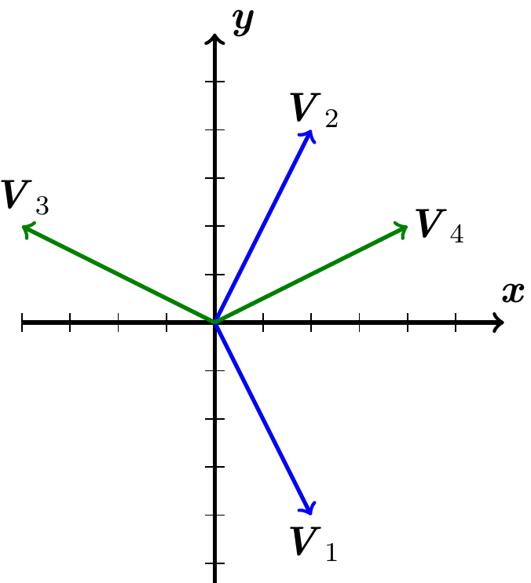



For : 









The eigenvectors of *A* and  are not the same and from the graph they are not on same line.

***Exercise***

Let . Compute the eigenvalues and eigenvectors of *A*.

***Solution***











The eigenvalues of *A* are:

For 







The eigenvector is: 

For 





The eigenvector is: 

***Exercise***

Let 

1. What is the characteristic polynomial for *A* (i.e. compute ?
2. Verify that 1 is an eigenvalue of *A*. What is a corresponding eigenvector?
3. What are the other eigenvalues of *A*?

***Solution***

1. 









1. 







1 is an eigenvalue of *A*.







The eigenvector for  is 

1. 



***Exercise***

For the matrix: 

1. Find the characteristic equation
2. Find the eigenvalues
3. Find the eigenvectors

***Solution***



1. 





The characteristic equation: 

1. 

The eigenvalues are 

1. 





Therefore, the eigenvector 







Therefore; the eigenvector 

The eigenvectors are given by: 

***Exercise***

For the matrix: 

1. Find the characteristic equation
2. Find the eigenvalues
3. Find the eigenvectors

***Solution***



1. 





The characteristic equation: 

1. 

The eigenvalues are 

1. 





Therefore; the eigenvector 

For the second eigenvector 





If 



***Exercise***

For the matrix: 

1. Find the characteristic equation
2. Find the eigenvalues
3. Find the eigenvectors

***Solution***



1. 



The characteristic equation: 

1. 

The eigenvalues are 

1. For 





Therefore; the eigenvector 

For 





Therefore; the eigenvector 

The vectors are given by: 

***Exercise***

For the matrix: 

1. Find the characteristic equation
2. Find the eigenvalues
3. Find the eigenvectors

***Solution***



1. 





The characteristic equation: 

1. 

The eigenvalues are: 

1. For 





Therefore; the eigenvector 

For 





Therefore; the eigenvector 

The vectors are given by: 

***Exercise***

For the matrix: 

1. Find the characteristic equation
2. Find the eigenvalues
3. Find the eigenvectors

***Solution***



1. 







The characteristic equation: 

1. The eigenvalues are: 
2. For , we have: 









For , we have 







The vectors are given by: 

***Exercise***

For the matrix: 

1. Find the characteristic equation
2. Find the eigenvalues
3. Find the eigenvectors

***Solution***



1. 





The characteristic equation: 

1. Thus, the eigenvalues are: 
2. For 











For 











The eigenvectors can be written: 

***Exercise***

For the matrix: 

1. Find the characteristic equation
2. Find the eigenvalues
3. Find the eigenvectors

***Solution***



1. 





The characteristic equation: 

1. Thus, the eigenvalues are: 
2. For : 







For  







***Exercise***

For the matrix: 

1. Find the characteristic equation
2. Find the eigenvalues
3. Find the eigenvectors

***Solution***



1. 





The characteristic equation: 

1. Thus, the eigenvalues are: 
2. For : 







For : 







***Exercise***

For the matrix: 

1. Find the characteristic equation
2. Find the eigenvalues
3. Find the eigenvectors

***Solution***



1. 





The characteristic equation: 

1. Thus, the eigenvalues are: 
2. For 







For 







***Exercise***

For the matrix: 

1. Find the characteristic equation
2. Find the eigenvalues
3. Find the eigenvectors

***Solution***



1. 



The characteristic equation: 

1. The eigenvalues are: 
2. For 







For 







***Exercise***

For the matrix: 

1. Find the characteristic equation
2. Find the eigenvalues
3. Find the eigenvectors

***Solution***



1. 



The characteristic equation: 

1. The eigenvalues are: 
2. For 







For 







***Exercise***

For the matrix: 

1. Find the characteristic equation
2. Find the eigenvalues
3. Find the eigenvectors

***Solution***



1. 



The characteristic equation: 

1. The eigenvalues are: 
2. For 







For 







***Exercise***

For the matrix: 

1. Find the characteristic equation
2. Find the eigenvalues
3. Find the eigenvectors

***Solution***



1. 



The characteristic equation: 

1. The eigenvalues are: 
2. For 







For 







***Exercise***

For the matrix: 

1. Find the characteristic equation
2. Find the eigenvalues
3. Find the eigenvectors

***Solution***



1. 





The characteristic equation: 

1. The eigenvalues are: 
2. For 







For the second eigenvector 







***Exercise***

For the matrix: 

1. Find the characteristic equation
2. Find the eigenvalues
3. Find the eigenvectors

***Solution***



1. 





The characteristic equation: 

1. The eigenvalues are: 
2. For 







For the second eigenvector 







***Exercise***

For the matrix: 

1. Find the characteristic equation
2. Find the eigenvalues
3. Find the eigenvectors

***Solution***



1. 



The characteristic equation: 

1. 

The eigenvalues are: 

1. For 









***Exercise***

For the matrix: 

1. Find the characteristic equation
2. Find the eigenvalues
3. Find the eigenvectors

***Solution***



1. 



The characteristic equation: 

1. 

The eigenvalues are: 

1. For 









***Exercise***

For the matrix: 

1. Find the characteristic equation
2. Find the eigenvalues
3. Find the eigenvectors

***Solution***



1. 





The characteristic equation: 

1. 

The eigenvalues are: 

1. For 









***Exercise***

For the matrix: 

1. Find the characteristic equation
2. Find the eigenvalues
3. Find the eigenvectors

***Solution***



1. 





The characteristic equation: 

1. 

The eigenvalues are: 

1. For 









***Exercise***

For the matrix: 

1. Find the characteristic equation
2. Find the eigenvalues
3. Find the eigenvectors

***Solution***



1. 





The characteristic equation: 

1. The eigenvalues are: 
2. For 







For 







***Exercise***

For the matrix: 

1. Find the characteristic equation
2. Find the eigenvalues
3. Find the eigenvectors

***Solution***



1. 





The characteristic equation: 

1. The eigenvalues are: 
2. For 







For 







***Exercise***

For the matrix: 

1. Find the characteristic equation
2. Find the eigenvalues
3. Find the eigenvectors

***Solution***



1. 



The characteristic equation: 

1. The eigenvalues are: 
2. For 







For 







***Exercise***

For the matrix: 

1. Find the characteristic equation
2. Find the eigenvalues
3. Find the eigenvectors

***Solution***



1. 





The characteristic equation: 

1. The eigenvalues are: 
2. For 







For 







***Exercise***

For the matrix: 

1. Find the characteristic equation
2. Find the eigenvalues
3. Find the eigenvectors

***Solution***



1. 





The characteristic equation: 

1. The eigenvalues are: 
2. For 







For 







***Exercise***

For the matrix: 

1. Find the characteristic equation
2. Find the eigenvalues
3. Find the eigenvectors

***Solution***



1. 





The characteristic equation: 

1. The eigenvalues are: 
2. For 







For 







***Exercise***

For the matrix: 

1. Find the characteristic equation
2. Find the eigenvalues
3. Find the eigenvectors

***Solution***



1. 





The characteristic equation: 

1. 



The eigenvalues are: 

1. For 







For 







***Exercise***

For the matrix: 

1. Find the characteristic equation
2. Find the eigenvalues
3. Find the eigenvectors

***Solution***



1. 





The characteristic equation: 

1. 



The eigenvalues are: 

1. For 







For 







***Exercise***

For the matrix: 

1. Find the characteristic equation
2. Find the eigenvalues
3. Find the eigenvectors

***Solution***



1. 





The characteristic equation: 

1. 



The eigenvalues are: 

1. For 







For 







***Exercise***

For the matrix: 

1. Find the characteristic equation
2. Find the eigenvalues
3. Find the eigenvectors

***Solution***



1. 





The characteristic equation: 

1. 



The eigenvalues are: 

1. For 







For 







***Exercise***

For the matrix: 

1. Find the characteristic equation
2. Find the eigenvalues
3. Find the eigenvectors

***Solution***



1. 





The characteristic equation: 

1. 

The eigenvalues are: 

1. For 







For 







***Exercise***

For the matrix: 

1. Find the characteristic equation
2. Find the eigenvalues
3. Find the eigenvectors

***Solution***



1. 





The characteristic equation: 

1. 

The eigenvalues are: 

1. For 









***Exercise***

For the matrix: 

1. Find the characteristic equation
2. Find the eigenvalues
3. Find the eigenvectors

***Solution***



1. 









The characteristic equation: 

1. 



The eigenvalues are: 

1. For 

 





For 









For 







The vectors are given by: 

***Exercise***

For the matrix: 

1. Find the characteristic equation
2. Find the eigenvalues
3. Find the eigenvectors

***Solution***



1. 



The characteristic equation: 

1. The eigenvalues are: 
2. For 







r 





For 







***Exercise***

For the matrix: 

1. Find the characteristic equation
2. Find the eigenvalues
3. Find the eigenvectors

***Solution***



1. 







The characteristic equation: 

1. 



The eigenvalues are: 

1. For 





For 





For 





***Exercise***

For the matrix: 

1. Find the characteristic equation
2. Find the eigenvalues
3. Find the eigenvectors

***Solution***



1. 







The characteristic equation: 

1. 



The eigenvalues are: 

1. For 





For 











***Exercise***

For the matrix: 

1. Find the characteristic equation
2. Find the eigenvalues
3. Find the eigenvectors

***Solution***



1. 







The characteristic equation: 

1. 



The eigenvalues are: 

1. For 



Assume 



Assume 



For 









Assume 



***Exercise***

For the matrix: 

1. Find the characteristic equation
2. Find the eigenvalues
3. Find the eigenvectors

***Solution***



1. 





The characteristic equation: 

1. 



The eigenvalues are: 

1. For 



Assume 







For 











For 









***Exercise***

For the matrix: 

1. Find the characteristic equation
2. Find the eigenvalues
3. Find the eigenvectors

***Solution***



1. 





The characteristic equation: 

1. 



The eigenvalues are: 

1. For 



Assume 







For 



Assume 



For 



Assume 







***Exercise***

For the matrix: 

1. Find the characteristic equation
2. Find the eigenvalues
3. Find the eigenvectors

***Solution***



1. 





The characteristic equation: 

1. The eigenvalues are: 
2. For 







For 





For 







***Exercise***

For the matrix: 

1. Find the characteristic equation
2. Find the eigenvalues
3. Find the eigenvectors

***Solution***



1. 







The characteristic equation: 

1. 







The eigenvalues are: 

1. For 



Assume 





Assume 





For 



Assume 







***Exercise***

For the matrix: 

1. Find the characteristic equation
2. Find the eigenvalues
3. Find the eigenvectors

***Solution***



1. 







The characteristic equation: 

1. 



Therefore; the eigenvalues are: 

1. For 







Therefore; the eigenvector 

For 





Therefore; the eigenvector 

For 





Therefore; the eigenvector 

***Exercise***

For the matrix: 

1. Find the characteristic equation
2. Find the eigenvalues
3. Find the eigenvectors

***Solution***



1. 









The characteristic equation: 

1. 

Therefore; the eigenvalues are: 

1. For 





Therefore; the eigenvector 

For 





Therefore; the eigenvector 

For 





Therefore; the eigenvector 

***Exercise***

For the matrix: 

1. Find the characteristic equation
2. Find the eigenvalues
3. Find the eigenvectors

***Solution***



1. 









The characteristic equation: 

1. 

Therefore; the eigenvalues are: 

1. For 





Therefore; the eigenvector 

For 





Therefore; the eigenvector 

For 





Therefore; the eigenvector 

***Exercise***

For the matrix: 

1. Find the characteristic equation
2. Find the eigenvalues
3. Find the eigenvectors

***Solution***



1. 









The characteristic equation: 

1. 



Therefore; the eigenvalues are: 

1. For  , we have: 





Therefore, the eigenvector 

For  , we have: 





Therefore; the eigenvector 



***Exercise***

For the matrix: 

1. Find the characteristic equation
2. Find the eigenvalues
3. Find the eigenvectors

***Solution***



1. 







The characteristic equation: 

1. 



Thus, the eigenvalues are: 

1. For 





If 



For 







For 









***Exercise***

For the matrix: 

1. Find the characteristic equation
2. Find the eigenvalues
3. Find the eigenvectors

***Solution***



1. 







The characteristic equation: 

1. 



Thus, the eigenvalues are: 

1. For 







For 









For 









***Exercise***

For the matrix: 

1. Find the characteristic equation
2. Find the eigenvalues
3. Find the eigenvectors

***Solution***



1. 







The characteristic equation: 

1. 



Thus, the eigenvalues are: 

1. For 











For 











For 







***Exercise***

For the matrix: 

1. Find the characteristic equation
2. Find the eigenvalues
3. Find the eigenvectors

***Solution***



1. 





The characteristic equation: 

1. 

Thus, the eigenvalues are: 

1. For 













For 

















For 









***Exercise***

For the matrix: 

1. Find the characteristic equation
2. Find the eigenvalues
3. Find the eigenvectors

***Solution***



1. 









The characteristic equation: 

1. 



Thus, the eigenvalues are: 

1. For 







Therefore; the eigenvector 

For 







Therefore; the eigenvector 

For 







Therefore; the eigenvector 







Therefore; the eigenvector  

***Exercise***

For the matrix: 

1. Find the characteristic equation
2. Find the eigenvalues
3. Find the eigenvectors

***Solution***



1. 











⇒ The characteristic equation: 

1. 
2. For 







Therefore; the eigenvector 





 



Therefore; the eigenvector 

For 













Therefore; the eigenvector 

Therefore; the eigenvector 

***Exercise***

Find the eigenvalues of  for 

***Solution***

Since the matrix is an upper triangular, then the eigenvalues are: 

The eigenvalues of  are: 



***Exercise***

Given: . Compute 

***Solution***





The eigenvalues are: 

For  , we have: 





The eigenvector 

For  , we have: 









The eigenvector 

For  , we have: 





The eigenvector 























***Exercise***

Find the eigenvalues of the matrices



***Solution***

The eigenvalues for:











The eigenvalues are: 

The eigenvalues for:





The eigenvalues for:







The eigenvalues for:





The eigenvalues are: 

***Exercise***

Given the matrix 

1. Find the characteristic polynomial.
2. Find the eigenvalues
3. Find the bases for its eigenspaces
4. Graph the eigenspaces
5. Verify directly that , for all associated eigenvectors and eigenvalues.

***Solution***

1. 





The characteristic polynomial is 

1. 
2. For  , we have: 





Therefore, the eigenvector 

For  , we have: 





Therefore, the eigenvector 

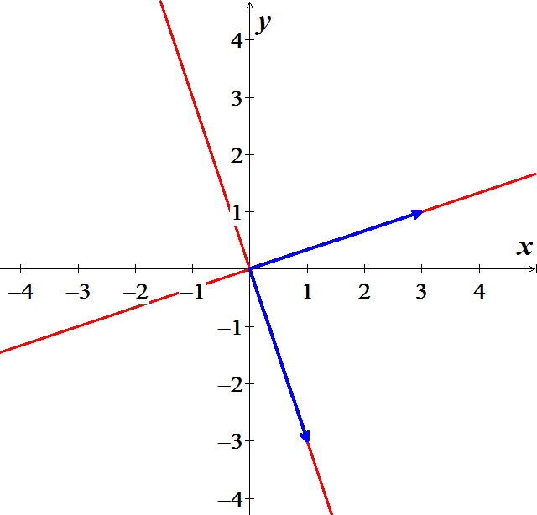

1. 



***√***





***√***

***Exercise***

Given the matrix 

1. Find the characteristic polynomial.
2. Find the eigenvalues
3. Find the bases for its eigenspaces
4. Graph the eigenspaces
5. Verify directly that , for all associated eigenvectors and eigenvalues.

***Solution***

1. 







The characteristic polynomial is 

1. 





The eigenvalues are: 

1. For  , we have: 





Therefore, the eigenvector 

For  , we have: 





Therefore, the eigenvector 

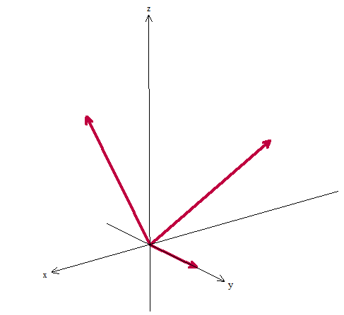

1. 



***√***





***√***





***√***

***Exercise***

Explain why a  matrix can have at most two distinct eigenvalues. Explain why an  matrix can have at most *n* distinct eigenvalues

***Solution***

A  matrix has only 2 entries in the main diagonal. Then, Lambda exists only twice in those entries. By using the determinant, the product will produce a power two characteristics equation. A second−degree equation will produce 2 real distinct eigenvalues, or 2 repeated eigenvalues, or 2 complex eigenvalues. Therefore, a  matrix can have at most two distinct eigenvalues.

The same for an  matrix, the matrix has *n* entries in the main diagonal with lambda. Then the product of *nth* lambda will produce a characteristic equation with *n* power. That means that will have *n* real distinct eigenvalues, or *n* repeated eigenvalues, or *n* complex eigenvalues.

Therefore, a  matrix can have at most *n* distinct eigenvalues.

***Exercise***

Construct an example of a  matrix with only one distinct eigenvalue.

***Solution***

A  matrix with only one distinct eigenvalue, which means that we have repeated lambda.

To do so, the other diagonal has a zero and the main diagonal has the same value.

Example for one zero in the diagonal.







Example: 

***Exercise***

Let  be an eigenvalue of an invertible matrix *A*. Show that  is an eigenvalue of .

***Solution***

Since matrix *A* in invertible, then 

Let  be an eigenvalue of an invertible matrix *A*, then there is a nonzero eigenvector  such that 







Since  and cannot be zero. Then





That will prove that  is an eigenvalue of 

***Exercise***

Show that if  is the zero matrix, then the only eigenvalue of *A* is 0

***Solution***

Assume that  is the zero matrix.

If 









Since  and  is the zero matrix. Then  must be zero.

Therefore, each eigenvalue of *A* is zero.

***Exercise***

Show that  is an eigenvalue of *A* if and only if  is an eigenvalue of .

***Solution***

Suppose that  is an eigenvalue of *A*, then 





This will result that matrix and its transpose have the same characteristic equation.

Thus,  is an eigenvalue of *A* if and only if  is an eigenvalue of 

***Exercise***

For , find one eigenvalue, without calculation. Justify your answer.

***Solution***

Since the matrix *A* has the row then matrix *A* in not invertible (Columns are linearly dependent).

Therefore, the eigenvalue is zero of the matrix.

***Exercise***

For , find one eigenvalue, and two linearly independent eigenvectors, without calculation. Justify your answer.

***Solution***

Since the matrix *A* has the row then matrix *A* in not invertible (Columns are linearly dependent).

Therefore, the eigenvalue is zero of the matrix.

For , then the eigenvector is given by 

Since , that implies to 

Since matrix *A* is nonzero matrix that it will imply to  all rows are the same.

Which it will result to: 

The two linearly independent eigenvectors:



***Exercise***

Consider an matrix *A* with the property that the row sums all equal the same number ***s***. Show that ***s*** is an eigenvalue of *A.*

***Solution***

Let consider a  matrix with all ones as entries









One of the eigenvalues is: 

Let 

With 







 ***√***

For matrix *A*:



Where 







 ***√***

That prove that ***s*** is an eigenvalue of *A.*

***Exercise***

Consider an matrix *A* with the property that the column sums all equal the same number ***s***. Show that ***s*** is an eigenvalue of *A.*

***Solution***

Given that the column sums of an matrix *A* all equal the same number ***s***.

Then the transpose of the matrix *A* will imply that  has the row sums all equal the same number ***s***. In addition, the matrix *A* and  have the same eigenvalues.

 Where 

 Where 







 ***√***

That show that ***s*** is an eigenvalue of and since *A* and  have the same eigenvalues.

The prove is completed that ***s*** is an eigenvalue of *A.*

***Exercise***

Let *A* be the matrix of the linear transformation *T* on 

*T*: reflects points across some line through the origin.

Without writing *A*, find an eigenvalue of *A* and describe the eigenspace.

***Solution***

Given *T* reflects points across some line through the origin in , which implies that the coordinates are equal .

The linear transformation can be written in the form: 

This line more likely is the scalar nonzero product of the eigenvectors .



Since *A* be the matrix of the linear transformation *T* on , then .

Thus, the eigenvalue  of the matrix *A* which will result to the corresponding eigenvector .

The other eigenvector  can be generated by applying the orthogonal to the line and which leads to the eigenvalue . The result form that each vector on the line through  can be transformed into the opposite sign of that vector.

***Exercise***

Let *A* be the matrix of the linear transformation *T* on 

*T*: reflects points about some line through the origin.

Without writing *A*, find an eigenvalue of *A* and describe the eigenspace.

***Solution***

Given *T* reflects points *about* some line through the origin.

If  lines on the line, then the linear transformation can be written in the form:



That implies to *T* rotates points around a given line, the points on the line are not moved at all.

Thus, the eigenvalue  of the matrix *A* which will result to the corresponding eigenvector .

The corresponding eigenspace is either just the line if *T* doesn’t rotate full rotation .

Therefore, the corresponding eigenspace is the line the points are being rotated around.

***Exercise***

Show that if  is an eigenvector of the matrix product  and , then  is an eigenvector of 

***Solution***

Since  is an eigenvector of the matrix product , that must be some eigenvalue  to satisfy.

Such that  and .

Since , then we can rewrite



 Multiply both sides by matrix *B*.





Therefore, since , that is clearly that  is an eigenvector of .

***Exercise***

Explain and demonstrate that the eigenspace of a matrix *A* corresponding to some eigenvalue  is a subspace.

***Solution***

 is an eigenvalue of a square matrix , then  and  is a non-zero vector.

That implies to: .

The eigenspace consists of the zero vector and all the eigenvectors  corresponding to the eigenvalue .

This is equivalent to the null space of  which includes the trivial (zero vector) solution of  as well as the non-trivial (non-zero) solutions. As the null space is definitely a subspace, and the eigenspace is essentially the same, then the eigenspace is a sunspace too.

Is the eigenspace is closed under addition?

Suppose that  and are eigenvectors corresponding to .

Let assume that  and 







Therefore,  is in the eigenspace of  under addition.

Is the eigenspace is closed under scalar multiplication?

Let  be an eigenvector corresponding to  and *c* be any real scalar.







Therefore,  is in the eigenspace of  under scalar multiplication.

Therefore, the eigenspace of a matrix *A* corresponding to some eigenvalue  is a subspace.

***Exercise***

If  is an eigenvalue of the matrix *A*, prove that  is an eigenvalue of .

***Solution***

Since  is an eigenvalue of the matrix *A*, then  where .





 





Therefore,  is an eigenvalue of 