***Solution Section* 4.6 – Orthogonal Diagonalization**

***Exercise***

Determine whether the matrix is orthogonal 

***Solution***

Let 





 ***√***

Therefore, the given matrix is orthogonal.

***Exercise***

Determine whether the matrix is orthogonal 

***Solution***

Let 





 ***√***

Therefore, the given matrix is orthogonal.

***Exercise***

Determine whether the matrix is orthogonal 

***Solution***

Let 







Therefore, the given matrix is ***not*** orthogonal.

***Exercise***

Determine whether the matrix is orthogonal



***Solution***

Let 





 ***√***

Therefore, the given matrix is orthogonal.

***Exercise***

Determine whether the matrix is orthogonal



***Solution***

Let 





 ***√***

Therefore, the given matrix is orthogonal.

***Exercise***

Determine whether the matrix is orthogonal



***Solution***

Let 







Therefore, the given matrix is ***not*** orthogonal.

***Exercise***

Determine whether the matrix is orthogonal



***Solution***

Let 







Therefore, the given matrix is ***not*** orthogonal.

***Exercise***

Determine whether the matrix is orthogonal



***Solution***

Let 





 ***√***

Therefore, the given matrix is orthogonal.

***Exercise***

Determine whether the matrix is orthogonal



***Solution***

Let 







Therefore, the given matrix is ***not*** orthogonal.

***Exercise***

Determine whether the matrix is orthogonal



***Solution***

Let 





 ***√***

Therefore, the given matrix is orthogonal.

***Exercise***

Find a matrix *P* that orthogonally diagonalizes *A*, and determine  

***Solution***







The eigenvalues are: 

For , we have: 





Therefore, the eigenvector 

For , we have: 





Therefore, the eigenvector 























***Exercise***

Find a matrix *P* that orthogonally diagonalizes *A*, and determine  

***Solution***







The eigenvalues are: 

For , we have: 





Therefore, the eigenvector 

For , we have: 





Therefore, the eigenvector 

























 ***√***

***Exercise***

Find a matrix *P* that orthogonally diagonalizes *A*, and determine  

***Solution***







The eigenvalues are: 

For , we have: 





Therefore, the eigenvector 

For , we have: 





Therefore, the eigenvector 





















 ***√***

***Exercise***

Find a matrix *P* that orthogonally diagonalizes *A*, and determine  

***Solution***







The eigenvalues are: 

For , we have: 





Therefore, the eigenvector 

For , we have: 





Therefore, the eigenvector 



















 ***√***

***Exercise***

Find a matrix *P* that orthogonally diagonalizes *A*, and determine  

***Solution***







The eigenvalues are: 

For , we have: 





Therefore, the eigenvector 

For , we have: 





Therefore, the eigenvector 



















 ***√***

***Exercise***

Find a matrix *P* that orthogonally diagonalizes *A*, and determine 



***Solution***











The eigenvalues are: 

For , we have: 



If 

Therefore, the eigenvector 

If 

Therefore, the eigenvector 

For , we have: 













Therefore, the eigenvector 





































 ***√***

***Exercise***

Find a matrix *P* that orthogonally diagonalizes *A*, and determine 



***Solution***











The eigenvalues are: 

For , we have: 















Therefore, the eigenvector 

For , we have: 













Therefore, the eigenvector 

For , we have: 















Therefore, the eigenvector 

























 ***√***

***Exercise***

Find a matrix *P* that orthogonally diagonalizes *A*, and determine 



***Solution***







The eigenvalues are: 

For , we have: 















Therefore, the eigenvector 

For , we have: 











Therefore, the eigenvector 

For , we have: 















Therefore, the eigenvector 



























 ***√***

***Exercise***

Find a matrix *P* that orthogonally diagonalizes *A*, and determine 



***Solution***













The eigenvalues are: 

For , we have: 



If 

Therefore, the eigenvector 

If 

Therefore, the eigenvector 

For , we have: 















Therefore, the eigenvector 







































 ***√***

***Exercise***

Find a matrix *P* that orthogonally diagonalizes *A*, and determine 



***Solution***



















The eigenvalues are: 

For , we have: 







Therefore, the eigenvector 

For , we have: 









Therefore, the eigenvector 

For , we have: 







Therefore, the eigenvector 































***Exercise***

Find a matrix *P* that orthogonally diagonalizes *A*, and determine 



***Solution***







The eigenvalues are: 

For , we have: 





Therefore, the eigenvector 

For , we have: 





Therefore; the eigenvector 



























 ***√***

***Exercise***

Find a matrix *P* that orthogonally diagonalizes *A*, and determine 



***Solution***









The eigenvalues are: 

For , we have: 















Therefore; the eigenvector 

For , we have: 





Therefore; the eigenvector 













































 ***√***

***Exercise***

Find a matrix *P* that orthogonally diagonalizes *A*, and determine 



***Solution***











The eigenvalues are: 

For , we have:











Therefore; the eigenvector 

For , we have:











Therefore; the eigenvector 

































 ***√***

***Exercise***

Find a matrix *P* that orthogonally diagonalizes *A*, and determine 



***Solution***











Therefore, the matrix has eigenvalues



For  , then 





The eigenvectors are: 

For  , then 





The eigenvectors are:  or 

For  , then 





The eigenvectors are: 









 ***√***

***Exercise***

Find the eigenvalues of *A* and *B* and check the Orthogonality of their first two eigenvectors. Graph these eigenvectors to see the discrete sines and cosines:



The −1, 2, −1 pattern in both matrices is a “second derivative. Then  and  are like . This has eigenvectors  and  that are the bases for Fourier series. The matrices lead to “discrete sines” and “discrete cosines” that are the bases for the discrete Fourier Transform. This DFT is absolutely central to all areas of digital signal processing.

***Solution***

The eigenvalues of *A* are .

Their sum is 6 (the trace of *A*) and their product is 4 (the determinant).

The eigenvector matrix *S* gives the “Discrete Sine Transform”.

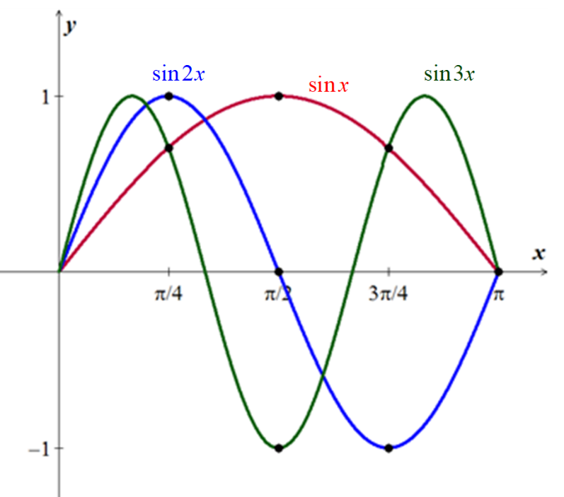

 

 

 

The eigenvalues of *B* are .



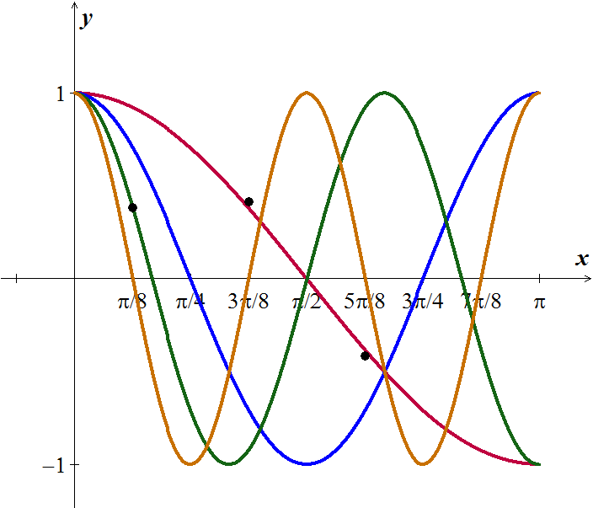

***Exercise***

Suppose  and  and λ ≠ 0. Then y is in the nullspace and  is in the column space. They are perpendicular because _______. (why are these subspaces orthogonal?) If the second eigenvalue is a nonzero number β, apply this argument to . The eigenvalue moves to zero and the eigenvectors stay the same – so they are perpendicular.

***Solution***

Suppose that  and , , and λ ≠ 0. Then *x* is in the column space of *A*, and *y* is in the left nullspace of *A* since . But *C*(*A*) and  are orthogonal complements, so *x* and *y* are perpendicular.

If with  then  and . Since  it follows that *x* is in the column space *A- βI*  and *y* is in the nullspace of *A- βI*, and , Therefore we can replace A with  in the argument of previous paragraph and it follows that *x* and *y* are perpendicular.

***Exercise***

Which of these classes of matrices do *A* and *B* belong to: Invertible, orthogonal, projection, permutation, diagonalizable, Markov?



Which of these factorizations are possible for *A* and *B*: *LU*, *QR*, , ?

***Solution***

Matrix *A* is invertible, orthogonal, a permutation matrix, diagonalizable, and Markov! (Everything but a projection).

Matrix *A* satisfies  , , and also , This means it is invertible, symmetric, and orthogonal. Since it is symmetric, it is diagonalizable (with real eigenvalues!). It is a permutation matrix by just looking at it. It is Markov since the columns add to 1. It is not a projection since .

All of the factorization are possible for it: *LU* and *QR* are always possible.  is possible since it is diagonalizable, and  is possible since it is symmetric.

Matrix *B* is a projection, diagonalizable, and Markov. It is not invertible, not orthogonal, and not a permutation.

*B* is a projection since , it is symmetric and thus diagonalizable, and it is Markov since the columns add to 1. It is not invertible since the columns are visibly linearly dependent, it is not orthogonal since the columns are far from orthonormal, and it’s clearly not a permutation.

All the factorizations are possible for it: *LU* and *QR* are always possible.  is possible since it is diagonalizable, and  is possible since it is symmetric.

***Exercise***

True or false. Give a reason or a counterexample.

1. A matrix with real eigenvalues and eigenvectors is symmetric.
2. A matrix with real eigenvalues and orthogonal eigenvectors is symmetric.
3. The inverse of a symmetric matrix is symmetric
4. The eigenvector matrix *S* of a symmetric matrix is symmetric.
5. A complex symmetric matrix has real eigenvalues.
6. If *A* is symmetric, then  is symmetric.
7. If *A* is Hermitian, then  is Hermitian.
8. An  matrix that is orthogonally diagonalizable must be symmetric.
9. If  and if vectors  and  satisfy  and , then 
10. An  symmetric matrix has *n* distinct real eigenvalues.
11. For nonzero  in , the matrix  is called a projection matrix.
12. Every symmetric matrix is orthogonally diagonalizable
13. If , where  and *D* is a diagonal matrix, then *B* is a symmetric matrix.
14. An orthogonal matrix is orthogonally diagonalizable.
15. The dimension of an eigenspace of a symmetric matrix equals the multiplicity of the corresponding eigenvalue.

***Solution***

1. ***False***. Let 

Then 

So, *A* has eigenvalues 

The eigenvectors are:  so both the eigenvalues and eigenvectors are real but *A* is not symmetric.

1. ***True***. If the matrix *A* has orthogonal eigenvectors  with eigenvalues , we can define  for all *i*; then  for all *i* and the  are orthonormal. Then we can diagonalize *A* as:  where the *ith* column of *S* is , and Λ is the diagonal matrix, so  and .







So, *A* is symmetric.

1. ***True***. If *A* is symmetric then it can be diagonalized by an orthogonal matrix Q, , and then . Since is still a diagonal matrix, it follows:





1. ***False***. The eigenvalues of  are:  and the eigenvectors are: .

We can diagonalize *A* with eigenvector matrix  which is not symmetric.

1. ***False***. For example, *A* = (*i*), the 1 by 1 matrix. The eigenvalue is ***i***, it is not a real number.
2. ***True***. 
3. ***False***. . It is typically not the same as .

Taking *A* = (1), the 1 by 1 matrix, would be an enough example because  which is not a real number.

1. An  matrix that is orthogonally diagonalizable must be symmetric.
2. If  and if vectors  and  satisfy  and , then 
3. An  symmetric matrix has *n* distinct real eigenvalues.
4. For nonzero  in , the matrix  is called a projection matrix.
5. Every symmetric matrix is orthogonally diagonalizable
6. If , where  and *D* is a diagonal matrix, then *B* is a symmetric matrix.
7. An orthogonal matrix is orthogonally diagonalizable.
8. The dimension of an eigenspace of a symmetric matrix equals the multiplicity of the corresponding eigenvalue.

***Exercise***

Find a symmetric matrix  that has a negative eigenvalue.

1. How do you know it must have a negative pivot?
2. How do you know it can’t have two negative eigenvalues?

***Solution***

1. The eigenvalues of that matrix are / so take any . In this case, the determinant is .
2. The signs of the pivots coincide with the signs of the eigenvalues. Alternatively, the product of the pivots is the determinant, which is negative in this case. So, one of the two pivots must be negative.
3. The product of the eigenvalues equals the determinant, which is negative in this case. So, precisely one numbers cannot have a negative product.

***Exercise***

Prove that *A* is any  matrix, then  has an orthonormal set of *n* eigenvectors

***Solution***

, then  is symmetric, therefore there is an eigenvector  for .

Let 

 

 





 Since 

Therefore; 

Then the vectors  are orthogonal











***Example***

Construct a 3 by 3 matrix *A* with no zero entries whose columns are mutually perpendicular. Compute . Why is it a diagonal matrix?

***Solution***

Consider the matrix  to be columns mutual perpendicular

Let assume  







***Exercise***

Assuming that , find a matrix that orthogonally diagonalizes 

***Solution***









Therefore; the eigenvalues are: 

Assume that .

For  , then 



The eigenvectors are: 

For  , then 



The eigenvectors are: 

Applying the Gram Schmidt process.





















***Exercise***

Suppose *A* is a symmetric  matrix and *B* is any  matrix. Show that , , and  are symmetric matrices.

***Solution***

*A* is a symmetric, that implies to 



 ***√***

Since, , then  is symmetric.



 ***√***

Therefore,  is symmetric.



 ***√***

Therefore, is symmetric.

***Exercise***

Show that if *A* is an  symmetric matrix, then  for all 

***Solution***

*A* is a symmetric, that implies to 







 ***√***

***Exercise***

Suppose *A* is invertible and orthogonally diagonalizable. Explain why  is also orthogonally diagonalizable.

***Solution***

Since *A* is invertible, then 

And *A* is orthogonally diagonalizable, then 



  (is a diagonal matrix)

 ***√***

Therefore,  is also orthogonally diagonalizable.

***Exercise***

Suppose *A* and *B* are both orthogonally diagonalizable and . Explain why *AB* is also orthogonally diagonalizable

***Solution***

Since *A* and *B* are both orthogonally diagonalizable, and *A* and *B* are symmetric, then



If , then



 *A* and *B* are symmetric

 ***√***

Therefore, *AB* is also orthogonally diagonalizable

***Exercise***

Let , where *P* is orthogonal and *D* is diagonal, let  be an eigenvalue of *A* of multiplicity *k*. Then  appears *k* times on the diagonal of *D*. Explain why the dimension of the eigenspace for  is *k*.

***Solution***

The columns of *P* are linearly independent eigenvectors by the ***diagonalization*** theorem corresponding to the eigenvalues  of *A*.

Since *D* is a diagonal with the eigenvalues . when the eigenvalues  is of multiplicity *k*, then  appears *k* times on the diagonal of *D.*

So, *P* has exactly *k* columns of eigenvectors corresponding to the eigenvalues .

Therefore, the *k* columns form a basis for the eigenspace.

***Exercise***

Suppose , where *P* is orthogonal and *U* is an upper triangular. Show that if *A* is symmetric, then *U* is symmetric and hence is actually a diagonal matrix.

***Solution***

Given: 

If *A* is symmetric, then 







Since *P* is orthogonal, then





 *A is symmetric*



That implies that *U* is symmetric

Since *U* is an upper triangular and symmetric, then the entries above and below the main diagonal must be equal to zeros.

Therefore, *U* is a diagonal matrix.

***Exercise***

Let  be a unit vector in , and let.

1. Given , compute  and show that  is the orthogonal projection of  onto .
2. Show that *B* is a symmetric matrix and .
3. Show that  is an eigenvector of *B*. What is the corresponding eigenvalue?

***Solution***

1. Given 





 : *scalar*



Given that  is a unit vector in , then  is the orthogonal projection of  onto .

1. 





 ***√***

Therefore, *B* is symmetric.





 



 ***√***

Therefore,  is symmetric.

1. Since , then









Therefore,  is an eigenvector of *B* with the corresponding eigenvalue 1.

***Exercise***

Let *B* be an  symmetric matrix such that . Any such matrix is called a ***projection matrix*** (or an *orthogonal projection matrix*). Given any , let  and .

1. Show that  is orthogonal to .
2. Let *W* be the column space of *B*. Show that  is the sum of a vector in *W* and a vector in . Why does this prove that  is the orthogonal projection of  onto the column space of *B*?

***Solution***

Since *B* is symmetric, then 

Given too, that  which is symmetric.



1. 







 





Therefore,  is orthogonal to 

1. Since *W* be the column space of *B*, then  has the form  (for some )





 





Therefore,  is in , and the decomposition  expresses  as the sum of a vector in *W* and a vector in .

By the orthogonal Decomposition, this decomposition is unique, and so  must be orthogonal projection of  onto the column space of *B* (*W*)