***Section* 4.6 – Orthogonal Diagonalization**

***Definition***

A square matrix ***A*** is called orthogonally diagonalizable if there is an orthogonal matrix *P* such that  is diagonal; the matrix *P* is said to orthogonally diagonalize *A*.



We say that *A* is orthogonally diagonalizable and that *P* orthogonally diagonalizes *A*.

***Theorem***

If ***A*** is an *n* x *n* matrix, then the following are equivalent.

1. ***A*** is orthogonally diagonalizable
2. ***A*** has an orthonormal set of *n* eigenvectors.
3. ***A*** is symmetric.

***Theorem***

If ***A*** is symmetric matrix, then:

1. The eigenvalues of ***A*** are all real numbers.
2. Eigenvectors from different eigenspaces are orthogonal.

***Example***

Find an orthogonal matrix *P* that diagonalizes



***Solution***











The eigenvalues are: 

For , we have: 





If 

Therefore, the eigenvector 

If 

Therefore, the eigenvector 

For , we have: 















Therefore the eigenvector 







































 (*Orthogonal*)







**Spectral Decomposition**

The spectral decomposition of *A* is:



***Example***

The matrix 

***Solution***







The eigenvalues are: 

For : 



Therefore, the eigenvector 

For : 



Therefore, the eigenvector 

The corresponding eigenvectors are: 



























The spectral decomposition about the image of the vector 

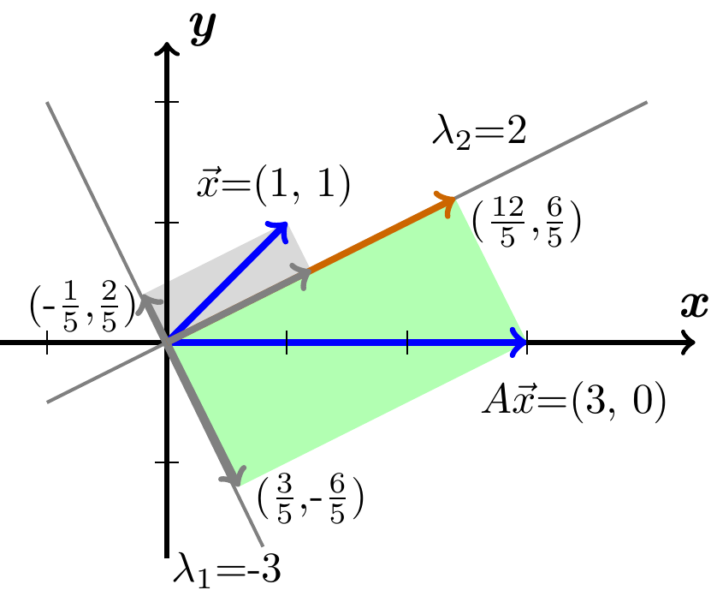









***Example***

Consider a 2 by 2 symmetric matrix 

***Solution***

The eigenvalues are:







 

The eigenvectors are:

For 









For 























Therefore, these eigenvectors are perpendicular.

***Theorem***

***Orthogonal Eigenvectors:*** Eigenvectors of a real symmetric matrix (when they correspond to different λ′s) are always perpendicular.

***Proof***

Suppose  ,  and .

The dot products of the first equation with *y* and the second with *x*:











Since , this proves that .

The eigenvector   is perpendicular to the eigenvector  

***Example***

Find the λ′s and *v*′s for this symmetric matrix with trace zero:

***Solution***









The eigenvalues are: 

The eigenvectors are:

For 







For 













Thus, the eigenvectors are perpendicular.

The unit vector of the eigenvectors by dividing by their length 

The eigenvectors are the columns of *Q*.













 ***√***

* Every symmetric matrix *A* has a complete set of orthogonal eigenvectors:



**Complex Eigenvalues of Real Matrices**

For real matrices, complex λ′s and *x*′s come in “conjugate pairs”



***Example***

Given 

***Solution***

The eigenvalues of *A*:











 





The *eigenvalues* are conjugate to each other.

For : 







The eigenvectors:

















This fact holds for the eigenvalues of every orthogonal matrix.

***Theorem*** − ***Equivalent Statements***

If *A* is an  matrix, then the following statements are equivalent.

1. *A* is invertible
2.  has only the trivial solution
3. The reduced row echelon form of *A* is 
4. *A* is expressible as a product of elementary matrices
5.  is consistent for every  matrix 
6.  has exactly one solution for every  matrix 
7. 
8. The column vectors of *A* are linearly independent
9. The row vectors of *A* are linearly independent
10. The column vectors of *A* span 
11. The row vectors of *A* span 
12. The column vectors of *A* form a basis for 
13. The row vectors of *A* form a basis for 
14. *A* has a rank *n*.
15. *A* has nullity 0.
16. The orthogonal complement of the null space of *A* is 
17. The orthogonal complement of the row space of *A* is 
18. The range of  is 
19.  is one-to-one.
20.  is not an eigenvalue of A.
21.  is invertible,

***Exercises Section* 4.6 – Orthogonal Diagonalization**

(**1 − 10**) Determine whether the matrix *is* orthogonal

|  |  |
| --- | --- |
|  |  |

(**11 − 24**) Find a matrix *P* that orthogonally diagonalizes *A*, and determine 

|  |  |
| --- | --- |
|  |  |

|  |  |
| --- | --- |
|  |  |

1. Find the eigenvalues of *A* and *B* and check the Orthogonality of their first two eigenvectors. Graph these eigenvectors to see the discrete sines and cosines:



The −1, 2, −1 pattern in both matrices is a “second derivative. Then  and  are like . This has eigenvectors  and  that are the bases for Fourier series. The matrices lead to “discrete sines” and “discrete cosines” that are the bases for the discrete Fourier Transform. This DFT is absolutely central to all areas of digital signal processing.

1. Suppose  and  and λ ≠ 0. Then y is in the nullspace and  is in the column space. They are perpendicular because _______. (why are these subspaces orthogonal?) If the second eigenvalue is a nonzero number β, apply this argument to . The eigenvalue moves to zero and the eigenvectors stay the same – so they are perpendicular.
2. Which of these classes of matrices do *A* and *B* belong to: Invertible, orthogonal, projection, permutation, diagonalizable, Markov?



Which of these factorizations are possible for *A* and *B*: *LU*, *QR*, , ?

1. *True* or *false*. Give a reason or a counterexample.
2. A matrix with real eigenvalues and eigenvectors is symmetric.
3. A matrix with real eigenvalues and orthogonal eigenvectors is symmetric.
4. The inverse of a symmetric matrix is symmetric
5. The eigenvector matrix *S* of a symmetric matrix is symmetric.
6. A complex symmetric matrix has real eigenvalues.
7. If *A* is symmetric, then  is symmetric.
8. If *A* is Hermitian, then  is Hermitian.
9. An  matrix that is orthogonally diagonalizable must be symmetric.
10. If  and if vectors  and  satisfy  and , then 
11. An  symmetric matrix has *n* distinct real eigenvalues.
12. For nonzero  in , the matrix  is called a projection matrix.
13. Every symmetric matrix is orthogonally diagonalizable
14. If , where  and *D* is a diagonal matrix, then *B* is a symmetric matrix.
15. An orthogonal matrix is orthogonally diagonalizable.
16. The dimension of an eigenspace of a symmetric matrix equals the multiplicity of the corresponding eigenvalue.
17. Find a symmetric matrix  that has a negative eigenvalue.
18. How do you know it must have a negative pivot?
19. How do you know it can’t have two negative eigenvalues?
20. Prove that *A* is any  matrix, then  has an orthonormal set of *n* eigenvectors
21. Construct a 3 by 3 matrix *A* with no zero entries whose columns are mutually perpendicular. Compute . Why is it a diagonal matrix?
22. Assuming that , find a matrix that orthogonally diagonalizes 
23. Suppose *A* is a symmetric  matrix and *B* is any  matrix. Show that , , and  are symmetric matrices.
24. Show that if *A* is an  symmetric matrix, then  for all .
25. Suppose *A* is invertible and orthogonally diagonalizable. Explain why  is also orthogonally diagonalizable.
26. Suppose *A* and *B* are both orthogonally diagonalizable and . Explain why *AB* is also orthogonally diagonalizable.
27. Let , where *P* is orthogonal and *D* is diagonal, let  be an eigenvalue of *A* of multiplicity *k*. Then  appears *k* times on the diagonal of *D*. Explain why the dimension of the eigenspace for  is *k*.
28. Suppose , where *P* is orthogonal and *U* is an upper triangular. Show that if *A* is symmetric, then *U* is symmetric and hence is actually a diagonal matrix.
29. Let  be a unit vector in , and let .
30. Given , compute  and show that  is the orthogonal projection of  onto .
31. Show that *B* is a symmetric matrix and .
32. Show that  is an eigenvector of *B*. What is the corresponding eigenvalue?
33. Let *B* be an  symmetric matrix such that . Any such matrix is called a ***projection matrix*** (or an *orthogonal projection matrix*). Given any , let  and .
34. Show that  is orthogonal to .
35. Let *W* be the column space of *B*. Show that  is the sum of a vector in *W* and a vector in . Why does this prove that  is the orthogonal projection of  onto the column space of *B*?