***Lecture One***

***Section* 1.1 – Introduction to System of Linear Equations**

Given the linear equations



The solution to this system is , which means that 2 lines meeting at a single point.

We can rewrite the system equation as linear combination:









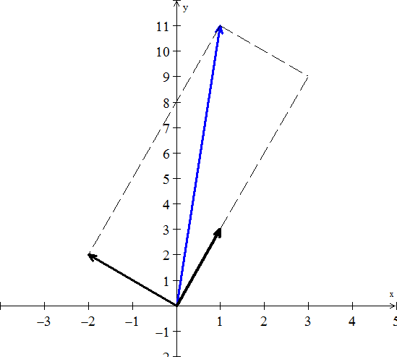 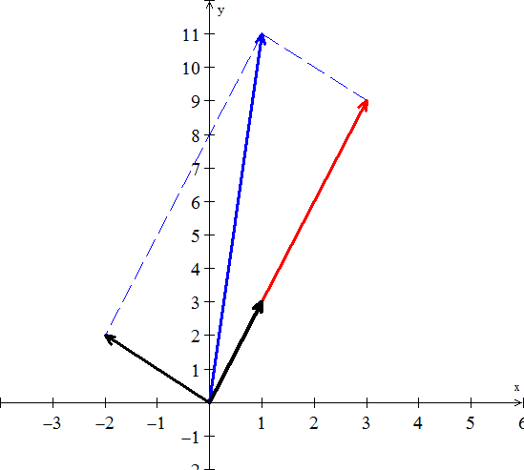

Therefore, the side vectors are

The diagonal sum is 

The linear combination is given by:



Thus, the solution is 

***Note***

is called the coefficient matrix

The matrix form of the system is written as 



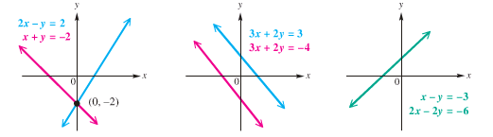

***One solution (lines intersect) No Solution (lines // ) Infinite solution***

***Consistent Inconsistent Consistent***

***Independent Independent Dependent***

***Three* Equations in 3 Unknowns**

Given the system equations



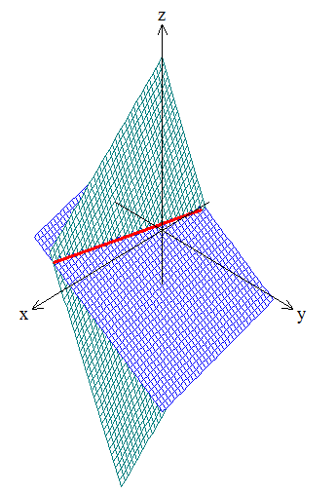 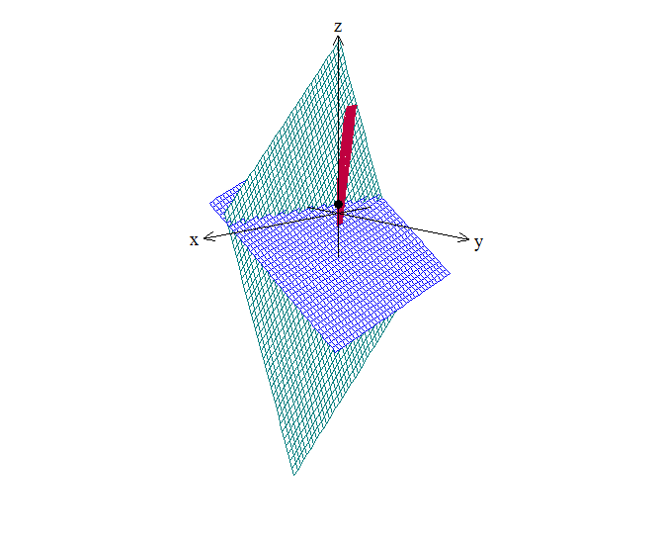

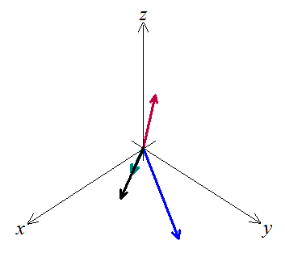

This system can be written as linear combination:



Let 

We want to multiply the three column vectors by  to produce ***b***.

The combination of the three vectors that produces vector *b* is 2 times the third vector.



Therefore the coefficients that we need are .



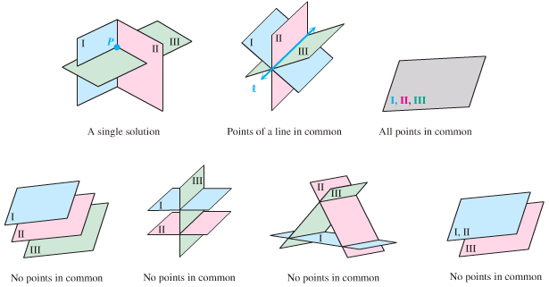

***Exercises Section* 1.1 – Introduction to System of Linear Equations**

1. Find a solution for *x, y, z* to the system of equations



1. Draw the two pictures in two planes for the equations: 
2. Normally 4 planes in 4-dimensional space meet at a ________. Normally 4 column vectors in 4-deimensional space can combine to produce *b*. what combinations of  produces ?

What 4 equations for  are you solving?

1. What 2 by 2 matrix *A* rotates every vector through 45° ?

The vector (1, 0) goes to . The vector (0, 1) goes to .

Those determine the matrix. Draw these particular vectors is the *xy*-plane and find *A*.

1. What two vectors are obtained by rotating the plane vectors  and  by 30° (*cw*) ?

Write a matrix *A* such that for every vector *v* in the plane, *Av* is the vector obtained by rotating *v* clockwise by 30°.

Find a matrix *B* such that for every 3-dimensional vector *v*, the vector *Bv* is the reflection of *v* through the plane . 

1. In each part, find a system of linear equation corresponding to the given augmented matrix
2. 
3. 
4. Find the augmented matrix for the given system of linear equations.

|  |  |
| --- | --- |
|  |  |

***Section* 1.2 – Gaussian Elimination**

Elimination produces an ***upper triangular system***.



The equation 

This process is called ***back substitution***.

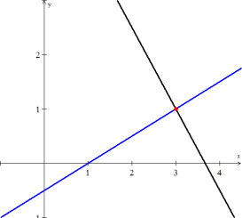 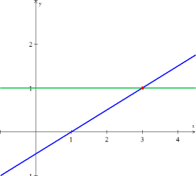

***Before elimination After elimination***

***Definitions***

***Pivot***: first nonzero in the row that does the elimination

***Multiplier***: (entry to eliminate) divide by pivot



The first pivot is 4 (the coefficient of *x*) and the multiplier is 

The pivots are on the diagonal of the triangle after elimination.

***Reduced Row Echelon Form***

  

***Example***

Use the Gaussian elimination method to solve the system



***Solution***

 

 0 1 2 13

 

 0 0 1 5

 ⇒ 

(2) ⇒ *y* = 13 − 2*z* = 13 − 2(5) = 3

(3) ⇒ *x* = 19 − *y* − 2*z* = 19 − 3 − 10 = 6

**⇒ (6, 3, 5)**

***Example***

Use Gauss-Jordan elimination to solve the homogeneous linear system



***Solution***











 

The general solution of the system: 

***Example***

Use Gauss-Jordan elimination to solve the homogeneous linear system

 

***Solution***

 *Interchange* 





Solution: 

***Theorem*: Free Variable Theorem for Homogeneous Systems**

If a *homogeneous linear* system has ***n*** unknowns, and if the reduced row echelon form of its augmented matrix has ***r*** nonzero rows, then the system has *n* − *r* free variables.

***Theorem***

A *homogeneous linear* system with more unknowns than equations has ***infinitely******many*** *unknowns*.

***Breakdown Elimination***

***Permanent failure with no solution***



The last equation ; therefore there is *no* solution. This system has no second pivot, since no zero allowed as a pivot.

***Permanent failure with infinitely many solutions***



Every *y* satisfies . There is only one equation .

There are ***unique infinitely*** many solutions.

**Three Equations in Three Unknowns**

To understand Gaussian elimination, you have to go beyond 2 by 2 systems.

Consider the system equations: 







The solution is 

***Exercises Section* 1.2 – Gaussian Elimination**

1. When elimination is applied to the matrix 
2. What are the first and second pivots?
3. What is the multiplier in the first step ( times row 1 is subtracted from row 2)?
4. What entry in the 2, 2 position (instead of 9) would force an exchange of rows 2 and 3?
5. What is the multiplier , subtracting 0 times row 1 from row 3?
6. Use elimination to reach upper triangular matrices U. Solve by back substitution or explain why this impossible. What are the pivots (never zero)? Exchange equations when necessary. The only difference is the  in equation (3).

 

1. For which numbers *a* does the elimination break down (1) permanently (2) temporarily



Solve for *x* and *y* after fixing the second breakdown by a row change.

1. Find the pivots and the solution for these four equations:



1. Look for a matrix that has row sums 4 and 8, and column sums 2 and *s*.



The four equations are solvable only if *s* = ____. Then find two different matrices that have the correct row and column sums.

1. Three planes can fail to have an intersection point, even if no planes are parallel. The system is singular if row 3 of *A* is a _______ of the first two rows. Find a third equation that can’t be solved together with  and 
2. Solve the linear system by Gauss-Jordan elimination.

 

 

1. Solve the given linear system by any method

 

1. Add 3 times the second row to the first of



1. Solve the system using Gaussian elimination 

***Section* 1.3 – The Algebra of Matrices**

***Matrices***



This is called Matrix (*Matrices*)

Each number in the array is an ***element*** or ***entry***

The matrix is said to be of order *m x n*

*m*: numbers of rows,

*n*: number of columns

When *m = n*, then matrix is said to be ***square***.

*Given the system equations*



Write into an ***augmented matrix*** form



The Matrix:  is called the ***coefficient matrix*** of the system.

The matrix *A* above has 3 rows and 3 columns, therefore the order of the matrix *A* is (3 *x* 3)



***Equality of Matrices***

**Definition of Equality of Matrices**

Two matrices ***A*** and ***B*** are equal if and only if they have the same order (size) *m* *x* *n* and if each pair corresponding elements is equal

 for *i* = 1, 2, …, *m* ***and*** *j* = 1, 2, …, *n*

***Example***

Find the values of the variables for which each statement is true, if possible.

1. 



1. 

*can’t be true*

1. 



***Addition* and *Subtraction* of Matrices**

***Definition***

If  and  are  matrices, their sum, is the  matrix obtained by adding the corresponding entries; that is



Matrices can be added if their shapes are the same, meaning have the same ***order***.





***Scalar* Multiplication Matrices**

***Definition***

If *k* is a scalar and  is an  matrices, then scalar product ***kA*** is the  matrix obtained by multiplying each entry of *A* by *k*; that is







***Example***





***Definition***

If  are matrices of the same size, and if  are scalars, then expression of the form



Is called a ***linear combination*** of  with *coefficients* .

***Matrix Multiplication***

**Product of Two Matrices**

Let ***A*** be an *m x n* matrix and let ***B*** be an *n x k* matrix. To find the element in the *ith* row and *jth* column of the product matrix ***AB***, multiply each element in the *ith* row of ***A*** by the corresponding element in the *jth* column of ***B***, and then add these products. The product matrix ***AB*** is an *m x k* matrix.

*Matrix* ***A*** *Matrix B*

*m x n n x k*

***Outer***: Order of *AB* is *m x k*

***Inner*** *must be equal*

* To multiply ***AB*** or dot product, if ***A*** has ***n*** columns, ***B*** must have ***n*** rows.
* Squares matrices can be multiplied if and only if (***iff***) they have the same size.
* The entry in row *i* and column *j* of AB is 

The result: 







 

 

 

 



***Example***

Find: 

***Solution***





***Special Case***

When *A* is a square matrix, then









***Block Multiplication***

If the cuts between columns of ***A***match the cuts between rows of ***B***, then the block multiplication of ***AB*** allowed.



***Important special case***





**Matrix Form of the Equations**

The coefficient matrix is 

The equivalent matrix equation is in the form :



Multiplication by ***rows*** 

Multiplication by ***columns*** 



***Identity Matrix***

The identity matrix is given by the form:  

***Properties of Matrix***

**Addition and Scalar Multiplication**

 *Commutative Property of Addition*

 *Associative Property of Addition*

 *Associative Property of Scalar Multiplication*

 *Distributive Property*

 *Distributive Property*

 *Distributive Property*

 *Distributive Property*

 *Additive Identity Property*

 *Additive Inverse Property*



***Multiplication***

 *Commutative “****law****” is usually broken*

 *Associative Property of Multiplication* (***Parentheses not needed***)

 *Distributive Property*

 *Distributive Property*

 *Distributive Property*

 *Distributive Property*

**\*\*\*\*\*\*\*\*\*\*\*\*\*\*\*\*\*\*\*\*\*\*\***

Consider the three vectors:

  

The linear combinations in three-dimensional space are 

***Combination*** 

Combine the three vectors  into on matrix *A*.



Multiplies the matrix *A* by a vector *x*, where  are the component of a vector *x*.



We can rewrite the form, matrix *A* times the vector *x*, as the combination 



Write the matrix in the form 



Where the *x* is the input and *b* is the output.

**Cyclic Difference**

The linear combinations of three vectors  lead to a cyclic difference matrix *C* and is given by:

  



The matrix *C* is not triangular. It is not easy to find the solution to , because either we are going to have ***infinitely many solution*** or ***no solution***..

Let looks at these problems geometrically.



***Exercises Section* 1.3 – The Algebra of Matrices**

1. For the matrices:  and , when does 
2. Find a combination  that gives the zero vector:



Those vectors are independent or dependent?

The vectors lie in a ______.

The matrix W with those columns is not invertible.

1. The very last words say that the 5 by 5 centered difference matrix is not invertible, Write down the 5 equations . Find a combination of left sides that gives zero. What combination of must be zero?
2. A direct graph starts with *n* nodes. There are possible edges, each edge leaves one of the *n* nodes and enters one of the *n* nodes (possibly itself). The *n* by *n* adjacency matrix has  when edge leaves node *i* and enter node *j*; if no edge then . Here are directed graphs and their adjacency matrices:

 

 

The *i*, *j* entry of is .

Why does that sum count the two-step paths from *i* to any node to *j*?

The *i*, *j* entry of  counts *k*-steps paths:



List all 3-step paths between each pair of nodes and compare with . When  has ***no zeros***, that number *k* is the diameter of the graph – the number of edges needed to connect the most pair of nodes. What is the diameter of the second graph?

1. *A* is 3 by 5, B is 5 by 3, *C* is 5 by 1, and *D* is 3 by 1. All entries are 1. Which of these matrix operations are allowed, and what are the results?

*a*) AB *b*) BA *c*) ABD *d*) DBA

*e*) ABC *f*) ABCD *g*) A(B + C)

1. What rows or columns or matrices do you multiply to find.
2. The third column of *AB*?
3. The second column of *AB*?
4. The first row of *AB*?
5. The second row of *AB*?
6. The entry in row 3, column 4 of *AB*?
7. The entry in row 2, column 3 of *AB*?
8. Add *AB* to *AC* and compare with :



1. True or False
2. If  is defined then A is necessarily square.
3. If  and  are defined then A and B are square.
4. If  and  are defined then and  are square.
5. If , then 
6. *a*) Find a nonzero matrix *A* such that 

*b*) Find a matrix that has  but 

1. Suppose you solve  for three special right sides *b*:



If the three solutions  are the columns of a matrix *X*, what is *A* times *X*?

1. Show that  is different from , when



Write down the correct rule for 

1. Find the product of the 2 matrices by rows or by columns:

|  |  |
| --- | --- |
|  |  |
|  |  |

1. Given   Find 
2. Given   Find 
3. Given   Find 
4. Given   Find 
5. Consider the matrices

    

Compute the following (where possible):

***a***)  ***b***)  ***c***)  ***d***)  ***e***)  ***g***) 

***Section* 1.4 – Inverse Matrices - Finding **

***Definition***

The matrix *A* is invertible if there exists a matrix  such that:



 and *A* has to be a ***square matrix***.

***Not all matrices have inverses***.

1. The inverse exists *iff* elimination produces *n* pivots (row exchanges allow).
2. The matrix *A* cannot have two different inverses.
3. If *A* is invertible, the one and only one solution to  is 



 ***Multiply both side by A-1***

 ***Associate property***

 ***Multiplicative inverse property***

 ***Identity property***

1. Suppose there is a ***nonzero*** vector *x* such that . Then *A* cannot have an inverse
2. A 2 by 2 matrix is invertible iff  is not zero.

 ⇒  ***Only for 2 by 2 matrices***

If is the determinant, then doesn’t exist

**The Inverse of a Product **

***Theorem***

If an  matrix has an inverse, that inverse is unique.

***Proof***

Suppose that *A* has an inverse  and *B* is a matrix such that 



***Theorem***

If *A* and *B* are invertible then so is  Theinverse of a product is 

***Proof***









***Reverse Order***



***Theorem***

If *A* is invertible and *n* is a nonnegative integer, then:

1.  is *invertible* and 
2.  is *invertible* and 
3.  is *invertible* for any nonzero scalar *k*, and 

***Proof***





**Finding  using Gauss-Jordan Elimination**



Find 

  





  

 

* Matrix ***A*** is ***symmetric*** across its main diagonal. So is 
* Matrix ***A*** is ***tridiagonal*** (only three nonzero diagonals). But  is a full matrix with no zeros. (another reason we don’t compute )

**Singular *versus* Invertible**

 exists when *A* has a full set of *n* pivots. (Row exchanges allowed)

* With *n* pivots, elimination solves all the equations . The columns  go into . Then  is at least a ***right-inverse***.
* Elimination is really a sequence of multiplications.

***Conclusion***

* If *A* doesn’t have *n* pivots, elimination will lead to a ***zero row***.
* Elimination steps are taken by an invertible *M*. So a row of *MA* is zero.
* If  then . The zero row of *MA*, times *B*, gives a zero row of *M*.
* The invertible matrix *M* can’t have a zero row! A must have *n* pivots if .

***Elementary Matrices***

***Definition***

Let ***e*** be an elementary row operation. Then the  ***elementary matrix*** *E* associated with ***e*** is the matrix obtained by applying ***e*** to the identity matrix. Thus



***Example***

1. 
2. 
3. 
4. 

***Theorem***

Let *e* be an elementary operation and let *E* be the corresponding elementary matrix . Then for every  matrix *A*



That is, an elementary row operation can be performed on *A* by multiplying *A* on the left by the corresponding elementary matrix.

***Example***

Let    



This result can be obtained from *A* by multiplying the first row by 2.



This result can be obtained from *A* by interchanging rows 2 and 3.



This result can be obtained from *A* by adding 3 times row 1 to row 3.

**Uniqueness of Echelon Form**

Two matrices *A* and *B* are row-equivalent if and only if they have the same reduced echelon form.

***Proof***

If *A* and *B* have the same reduced echelon form *E*, then *A* is row-equivalent to *E* and *E* is row-equivalent to *B*. It follows that *A* is row-equivalent to *B*.

Now Suppose *A* and *B* are row-equivalent. Let  be a reduced echelon form of *A* and  be a reduced echelon form of *B*. Then  and  are row equivalent.

Suppose . Since  and  are row equivalent, for some matrix C. This means  and . But then .

***Example***

Show that the two matrices are row equivalent



***Solution***







***Definition***

A relationship ~ (equivalent) between elements of a set is called an equivalence relation if

* A ~ A is always true,
* A ~ B always implies B ~ A,
* A ~ B and B ~ C always implies A ~ C.

***Exercises Section* 1.4 – Inverse Matrices - Finding **

1. Apply Gauss-Jordan method to find the inverse of this triangular “Pascal matrix”

***Triangular Pascal matrix*** 

1. If *A* is invertible and , prove that 
2. If , find two matrices  such that 
3. If *A* has ***row*** 1 + ***row*** 2 = ***row*** 3, show that *A* is not invertible
4. Explain why  can’t have a solution.
5. Which right sides  might allow a solution to
6. What happens to ***row*** 3 in elimination?
7. True or false (with a counterexample if false and a reason if true):
8. A 4 by 4 matrix with a row of zeros is not invertible.
9. A matrix with 1’s down the main diagonal is invertible.
10. If *A* is invertible then  is invertible.
11. If *A* is invertible then  is invertible.
12. Do there exist 2 by 2 matrices *A* and *B* with real entries such that , where *I* is the identity matrix?
13. If *B* is the inverse of , show that  is the inverse of *A*.
14. Find and check the inverses (assuming they exist) of these block matrices.



1. For which three numbers *c* is this matrix not invertible, and why not?



1. Find  and  (if they exist) by elimination.



1. Find  using the Gauss-Jordan method, which has a remarkable inverse.



1. Find the inverse.

|  |  |  |
| --- | --- | --- |
|  |  |  |

1. Show that *A* is not invertible for any values of the entries



1. Prove that if *A* is an invertible matrix and *B* is row equivalent to *A*, then *B* is also invertible.
2. Determine if the given matrix has an inverse, and find the inverse if it exists. Check your answer by multiplying 

|  |  |
| --- | --- |
|  |  |

1. Show that the inverse of  is 

***Section* 1.5 – Transpose, Diagonal, Triangular, and Symmetric Matrices**

***Transpose***

***Definition***

The transpose of a matrix *A* is defined as the matrix that is obtained by interchanging the corresponding rows and columns in *A*. Then the transpose of **A**, denoted by  or .

*The columns of are the rows of A*.

When *A* is an *m* by *n* matrix, the transpose is *n* by *m*:



The matrix ***flips over*** the main diagonal. The entry in row *i*, column *j* of  comes from row *j*, column *i* of the original *A*.



**Properties of Transpose**

1. 
2. 
3. 
4. 
5. 

*The transpose of a product of any number of matrices is the product of the transposes in the reverse order.*

***Theorem***

If *A* is an invertible matrix, then  is also invertible and



***Proof***







⇒ 

***Trace***

***Definition***

If *A* is a square matrix, then the trace of *A*, denoted by **tr(*A*)**, is defined to the sum of the entries on the main diagonal of *A*. The trace of *A* is undefined if *A* is not a square matrix.

***Example***



***Diagonal***

A square matrix in which all the entries off the main diagonal are zero is called a ***diagonal matrix***. A general  diagonal matrix can be written as



A diagonal matrix is invertible iff all of its diagonal entries are nonzero; the



Powers of diagonal matrices are:



***Triangular Matrices***

A square matrix in which all the entries above the main diagonal are zero is called ***lower diagonal triangular***.

A square matrix in which all the entries below the main diagonal are zero is called ***upper diagonal triangular***.

A matrix that is either upper triangular or lower triangular is called ***triangular***.

 

***lower diagonal triangular upper diagonal triangular***

***Theorem***

* The transpose of a lower triangular matrix is upper triangular, and the transpose of a upper triangular matrix is lower triangular.
* The product of lower triangular matrices is lower triangular, and the product of upper triangular matrices is upper triangular.
* A triangular matrix is invertible iff its diagonal entries are all nonzero.
* The inverse of an invertible lower triangular matrix is lower triangular, and the inverse of an invertible upper triangular matrix is upper triangular.

***Example***

, 

***Solution***

  

The goal is to describe Gaussian elimination in the most useful way by looking at them closely, which are factorizations of a matrix.

***The factors are triangular matrices.***

***The factorization that comes from elimination is .***

***Symmetric Matrices***

***Definition***

A square matrix *A* is said to be ***symmetric*** if . That means a square matrix must satisfies 

***Example***





* The ***inverse*** of a symmetric matrix is also ***symmetric***.

***Example***

Given , show that the inverse is symmetric too?

***Solution***



***Theorem***

If *A* and *B* are symmetric matrices with the same size, and if *k* is any scalar, then:

1.  is symmetric
2. *A* + *B* and *A* – *B* are symmetric.
3. *kA* is symmetric

* If *A* is an invertible symmetric matrix, then  is *symmetric*.

***Proof***

Assume that *A* is symmetric and invertible then 



Which proves that  is *symmetric*

* Multiplying *M* by  gives a symmetric matrix.

***Proof***

The entry  of , it is the dot product of ***row*** *i* of  (column *i* of *M*) with column *j* of *M*. The  entry is the same dot product, column *j* with column *i*. so  is symmetric.

The matrix  is also symmetric and  is a different matrix from .

* If *A* is an invertible symmetric matrix, then and  are also invertible.
* Matrix ***A*** is symmetric across its main diagonal. So is 
* Matrix ***A*** is tridiagonal (only three nonzero diagonals). But  is a full matrix with no zeros. (another reason we don’t compute )

***Example***

Given  and . Find  and 

***Solution***





***Symmetric in* LDU**

When elimination is applied to a symmetric matrix,  is an advantage.





* If  can be factored into *LDU* with no row exchanges, then . The ***symmetric*** ***factorization*** ***of a symmetric matrix is*** 

***Exercises Section* 1.5 – Transpose, Diagonal, Triangular, and Symmetric Matrices**

1. Solve  to find***c***. Then solve  to find ***x***. What was *A*?



1. Find *L* and *U* for the symmetric matrix



Find four conditions on *a, b, c, d* to get  with four pivots

1. Determine whether the given matrix is invertible



1. Find  by inspection

  

1. Decide whether the given matrix is symmetric

  

1. Find all values of the unknown constant(s) in order for *A* to be symmetric



1. Find a diagonal matrix *A* that satisfies the given condition 
2. Let *A* be an  symmetric matrix
3. Show that  is symmetric
4. Show that  is symmetric
5. Prove if , then *A* is symmetric and 
6. A square matrix *A* is called ***skew-symmetric*** if . Prove
7. If *A* is an invertible skew-symmetric matrix, then  is skew-symmetric.
8. If *A* and *B* are skew-symmetric matrices, then so are  for any scalar *k*.
9. Every square matrix *A* can be expressed as the sum of a symmetric matrix and a skew-symmetric matrix.



1. Suppose *R* is rectangular (*m* by *n*) and *A* is symmetric (*m* by *m*)
2. Transpose  to show its symmetric
3. Show why  has no negative numbers on its diagonal.
4. If *L* is a lower-triangular matrix, then  is _______Triangular
5. True or False
6. The block matrix  is automatically symmetric
7. If *A* and *B* are symmetric then their product is symmetric
8. If *A* is not symmetric then  is not symmetric
9. When *A, B, C* are symmetric, the transpose of *ABC* is *CBA*.
10. The transpose of a diagonal matrix is a diagonal.
11. The transpose of an upper triangular matrix is an upper triangular matrix.
12. The sum of an upper triangular matrix and a lower triangular matrix is a diagonal matrix.
13. All entries of a symmetric matrix are determined by the entries occurring on and above the main diagonal.
14. All entries of an upper triangular matrix are determined by the entries occurring on and above the main diagonal.
15. The inverse of an invertible lower triangular matrix is an upper triangular matrix.
16. A diagonal matrix is invertible if and only if all of its diagonal entries are positive.
17. The sum of a diagonal matrix and a lower triangular matrix is a lower triangular matrix.
18. A matrix that is both symmetric and upper triangular must be a diagonal matrix.
19. If *A* and *B* are  matrices such that  is symmetric, then *A* and *B* are symmetric.
20. If *A* and *B* are  matrices such that  is upper triangular, then *A* and *B* are upper triangular.
21. If  is a symmetric matrix, then *A* is a symmetric matrix.
22. If  is a symmetric matrix for some , then *A* is a symmetric matrix.
23. Find 2 by 2 symmetric matrices  with these properties
24.  is not invertible
25. *A* is invertible but cannot be factored into *LU* (row exchanges needed)
26. *A* can be factored into  but not into  (because of negative *D*)
27. A group of matrices includes *AB* and  if it includes *A* and *B* . “Products and inverses stay in the group.” Which of these sets are groups?

Lower triangular matrices *L* with 1’s on the diagonal, symmetric matrices *S*, positive matrices *M*, diagonal invertible matrices *D*, permutation matrices *P*, matrices with . ***Invent two more matrix groups***.

1. Write  as the product *EH* of an elementary row operation matrix *E* and a symmetric matrix *H*.
2. When is the product of two symmetric matrices symmetric? Explain your answer.
3. Express  in terms of  and 
4. Find the transpose of the given matrix: 
5. For the given matrix, compute , , , and , then compare and 



***Section* 1.6 – Determinants and Properties**

The determinant is a number that contains information about matrix. It is used to find formulas for inverse matrices, pivots, and solutions.

 has inverse 

Determinant of the matrix  is written  and is define as



The determinant is zero when the matrix has no inverse.

**Properties of the Determinants**

There are 3 basic properties (rules 1, 2, 3), by using those rules we can compute the determinant of any square matrix.

1. ***Determinant of the n by n identity matrix is* 1.**



1. ***Determinant changes sign when 2 rows are exchanged.***



1. ***Determinant is a linear function of each row separately***.

Multiply row 1 by any number *t*: 

Add row 1 of A to row 1 of A ′: 

* ***For 2 by 2 determinants, if you expand to a rectangle, the determinants equal areas.***
* ***For n-dimensional, the determinants equal volumes.***

1. ***If 2 rows of A are equal, then***.



1. ***Subtracting a multiple of one row from another row leaves *** ***unchanged.***



1. ***A matrix with a row of zeros has ***.



1. ***If A is triangular then  = product of diagonal entries.***



1. ***If A is singular then *. *If A is invertible then*.**
2. ***The determinant of AB *** ***is times : ***
3. ***The transpose has the same determinant as A:***  

* 

***Big Formula* for Determinants (Diagonal)**

***Determinant Using Diagonal Method***



 

 

*Determinant***: *D* = (1) + (2)**



***Example***

Evaluate: 

***Solution***







**Determinant by *Cofactors***



***Minor***

For a square matrix **, the minor . Of an element  is the ***determinant*** of the matrix formed by deleting the *ith* row and the *j*th column of *A*.

***Example***

Let  Find 

***Solution***







***Theorem***

The determinant is the dot product of any row ***i*** of ***A*** with its cofactors:

Cofactor Formula: 





***Example***

Find the determinant of the matrix:



***Solution***





= −8(−30 – (−21)) – 0 + 6(−12 − 6)

= −8(−9) + 6(−18)

= −36

* By the property of determinants, If ***A*** is triangular then  = product of diagonal entries.

***Example***



***Theorem***

Let ***A*** be any *n* by *n* matrix.

1. If ***A*′** is the matrix that results when a single row of ***A*** is multiplied by a constant ***k***, then .
2. If ***A*′** is the matrix that results when two rows of ***A*** are interchanged, then 
3. If ***A*′** is the matrix that results when a multiple of one row of ***A*** is added to another row then 

***Example***

Evaluate 

***Solution***

 ***Interchanged* 1s*t and* 2*nd row***

 ***A common factor of* 3 *from the first row* (*no need*)**











***Exercises Section* 1.6 – Determinants and Properties**

1. Verify that  when: 
2. For which value(s) of ***k*** does *A* fail to be invertible? 
3. Without directly evaluating, show that 
4. If the entries in every row of *A* add to zero, solve ***Ax*** = 0 to prove det *A* = 0. If those entries add to one, show that det (*A – I*) = 0. Does this mean det *A = I*?
5. Does  in general?
6. True or false if ***A*** and ***B*** are square *n* x *n* matrices?
7. True or false if ***A*** is *m* x *n* and B is *n* x *m* with ?
8. True or false, with a reason if true or a counterexample if false:
9. The determinant of  is 1 + det ***A***.
10. The determinant of ABC is .
11. The determinant of 4*A* is 
12. The determinant of *AB – BA* is zero. (try an example)
13. If *A* is not invertible then *AB* is not invertible.
14. The determinant of *A – B* equals to det *A* – det *B*.
15. Use row operations to show the 3 by 3 “Vandermonde determinant” is



1. The inverse of a 2 by 2 matrix seems to have determinant = 1:



What is wrong with this calculation? What is the correct 

1. A *Hessenberg* matrix is a triangular matrix with one extra diagonal. Use cofactors of row 1 to show that the 4 by 4 determinant satisfies Fibonacci’s rule . The same rule will continue for all sizes . Which Fibonacci number is ?



1. Evaluate the determinant:

|  |  |
| --- | --- |
|  |  |

1. Find all the values of λ for which det(***A***) = 0



1. Prove that if a square matrix ***A*** has a column of zeros, then det(***A***) = 0
2. With 2 by 2 blocks in 4 by 4 matrices, you cannot always use block determinants:



1. Why is the first statement true? Somehow *B* doesn’t enter.
2. Show by example that equality fails (as shown) when *C* enters.
3. Show by example that the answer  is also wrong.
4. Show that the value of the following determinant is independent of *θ*.



1. Show that the matrices 

commute if and only if 

1. Show that  for every  matrix A.
2. What is the maximum number of zeros that a  matrix can have without a zero determinant? Explain your reasoning.
3. Evaluate *det* ***A***, *det* ***E***, and *det* (***AE***). Then verify that (*det* ***A***)( *det* ***E***) = *det*(***AE***)



1. Show that  is not invertible for any values of *α, β, γ*

***Section* 1.7 – Cramer’s Rule**

**Cramer’s Rule**

***Theorem***

If  is a system of a linear equations in n unknowns such that , then the system has a unique solution. This solution is



Where 



***Example***

Use Cramer’s rule to solve



***Solution***



  

   ***Solution***: 

***Example***

Use Cramer’s Rule to solve.



***Solution***











**A Formula for** 

***Theorem***: ***Inverse of a matrix using its Adjoint***

The  entry of  is the cofactor  divided by det(***A***):

***Formula for ***: 



***Example***

Find the inverse matrix of using its adjoint.

***Solution***







 and  

***Theorem***

If *A* is an  matrix, then the following statements are equivalent

1. *A* is invertible
2. *A****x*** = 0 has only the trivial solution
3. The reduced row echelon form of *A* is 
4. *A* can be expressed as a product of elementary matrices
5. *A****x*** = ***b*** is consistent for every  matrix ***b***
6. 

***Exercises Section* 1.7 – Cramer’s Rule**

1. Use Cramer’s Rule with ratios  to solve *A****x*** *= b*. Also find the inverse matrix . Why is the solution ***x*** is the first part the same as column 3 of ? Which cofactors are involved in computing that column ***x***?



1. Verify that  and determine whether the equality  holds



1. Verify that 

|  |  |
| --- | --- |
|  |  |

1. Solve by using Cramer’s rule

|  |  |
| --- | --- |
|  |  |

1. Show that the matrix *A* is invertible for all values of *θ*, then find  using 

