***Solution Section* 3.1 – Inner Products**

***Exercise***

Let  be the Euclidean inner product on , and let , , , and . Compute the following.

1. 
2. 
3. 
4. 
5. 
6. 

***Solution***

1. 
2. 





1. 





1. 
2. 







1. 







***Exercise***

Let  be the Euclidean inner product on , and let , , , and . Compute the following for the weighted Euclidean inner product  .

1. 
2. 
3. 
4. 
5. 
6. 

***Solution***

1. 
2. 
3. 





1. 
2. 







1. 







***Exercise***

Let  be the Euclidean inner product on , and let , , , and . Verify the following.

1. 
2. 
3. 
4. 
5. 

***Solution***

1. 



1. 



1. 



1. 



1. 



***Exercise***

Let  be the Euclidean inner product on , and let , , , and . Verify the following for the weighted Euclidean inner product  .

1. 
2. 
3. 
4. 
5. 

***Solution***

1. 



1. 



1. 



1. 



1. 



***Exercise***

Let  and . Show that the following are inner product on  by verifying that the inner product axioms hold. 

***Solution***

*Axiom* 1: 

*Axiom* 2: 









*Axiom* 3: 

**



*Axiom* 4: 

**



***Exercise***

Show that the following identity holds for the vectors in any inner product space



***Solution***









  ***√***

***Solution Section* 3.2 – Angle and Orthogonality in Inner Product Spaces**

***Exercise***

Which of the following form orthonormal sets?

1. (1, 0), (0, 2) in 
2.  in 
3.  in 
4.  in 
5.  in 
6.  in 

***Solution***

1. , they are ***orthonormal*** sets
2. , they are orthonormal sets
3. 

They are ***not orthonormal***

1. 







They are ***not orthonormal*** sets

1. 







They are ***not orthonormal*** sets

1. 

They are ***orthonormal*** sets

***Exercise***

Find the cosine of the angle between ***u*** and ***v***.

1. 
2. 
3. 
4. 
5. 
6. 

***Solution***

1. 















1. 









1. 









1. 









1. 
2. 









***Exercise***

Find the cosine of the angle between ***A*** and ***B***.

|  |  |
| --- | --- |
|  |  |

***Solution***

1. 

















1. 















***Exercise***

Determine whether the given vectors are orthogonal with respect to the Euclidean inner product.

|  |  |
| --- | --- |
|  |  |

***Solution***

1.  Therefore the given vectors are orthogonal.
2.  Therefore the given vectors are orthogonal.
3.  Therefore the given vectors are ***not*** orthogonal.
4.  Therefore the given vectors are ***not*** orthogonal.
5. 











The vectors ***u*** and ***v*** are NOT orthogonal with respect to the Euclidean

***Exercise***

Do there exist scalars *k* and *l* such that the vectors are mutually orthogonal with respect to the Euclidean inner product?

***Solution***









Thus, there are no scalars such that the vectors are mutually orthogonal

***Exercise***

Let  have the Euclidean inner product. For which values of *k* are ***u*** and ***v*** orthogonal?

1. 
2. 

***Solution***

1. 



***u*** and ***v*** are orthogonal for 

1. 



***u*** and ***v*** are orthogonal for 

***Exercise***

Let *V* be an inner product space. Show that if ***u*** and ***v*** are orthogonal unit vectors in *V*, then 

***Solution***











Thus 

***Exercise***

Let **S** be a subspace of . Explain what  means and why it is true.

***Solution***

 is the orthogonal complement of , , which is itself the orthogonal complement of **S**, so  means that **S** is the orthogonal of its orthogonal complement.

We need to show that **S** is contained in  and, conversely, that  is contained in **S** to be true.

1. Suppose  and . Then  by definition of . Thus **S** is certainly contained is  (which consists of all vectors in which are orthogonal to ).
2. Suppose  (means is orthogonal to all vectors in ); then we need to show that .

Let assume  be a basis for **S** and let  be a basis for . If , then  is linearly independent set. Since each vector ifs that set is orthogonal to all of , the set  is linearly independent. Since there are  vectors in this set, this means that . On the other hand, If *A* is the matrix whose *ith* row is , then the row space of *A* is **S** and the nullspace of *A* is . Since **S** is *p*-dimensional, the rank of *A* is *p*, meaning that the dimension of  is . Therefore,



Which contradict the fact that . From this, we see that, if , it must be the case that .

***Exercise***

The methane molecule  is arranged as if the carbon atom were at the center of a regular tetrahedron with four hydrogen atoms at the vertices. If vertices are placed at , ,  and  − (***note*** that all six edges have length , so the tetrahedron is regular). What is the cosine of the angle between the rays going from the center  to the vertices?

***Solution***

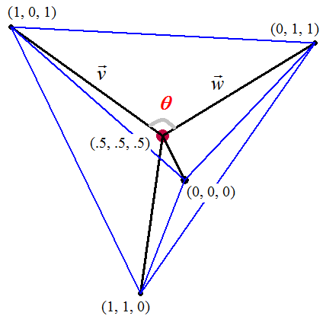

Let  be the vector of the segment (1, 0, 1) and 



# Let GB-BXi5-4570R

be the vector of the segment (0, 1, 1) and 



We have:











***Exercise***

Determine if the given vectors are orthogonal.



***Solution***













The given vectors are orthogonal

***Exercise***

Which of the following sets of vectors are orthogonal with respect to the Euclidean inner

1. 
2. 

***Solution***

1. 





Therefore the given vectors are ***not*** orthogonal.

1. 





Therefore the given vectors are orthogonal.

***Solution Section* 3.3 – Gram-Schmidt Process**

***Exercise***

Use the Gram-Schmidt process to find an orthonormal basis for the subspaces of .

1. 
2. 
3. 
4. 
5. 
6. 
7. 
8. 

***Solution***

1. 



















1. 















1. 































1. 









































1. 



































1. 





























1. 

































1. 







.

















































***Exercise***

Find the *QR*−decomposition of

|  |  |  |
| --- | --- | --- |
|  |  |  |

***Solution***

1. Since , The matrix is invertible





























The *QR*-decomposition of the matrix is



1. The column vectors of are: 



























1. Since the column vectors  are linearly independent, so has a *QR*−decomposition.



























The *QR−*decomposition of the matrix is

1. Since , The matrix is invertible, so it has a *QR*-decomposition.























 

































The *QR*−decomposition of the matrix is 

1. 

The matrix is linearly dependent, so doesn’t have a *QR*−decomposition.

***Exercise***

Verify that the Cauchy-Schwarz inequality holds for the given vectors using the Euclidean inner product



***Solution***













***Solution Section* 3.4 – Orthogonal Matrices**

***Exercise***

Show that the matrix is orthogonal

|  |  |
| --- | --- |
|  |  |

***Solution***

1. 



∴ ***A*** is an orthogonal

1. 



∴ ***A*** is an orthogonal

***Exercise***

Determine if the matrix is orthogonal. For those that is orthogonal find the inverse

|  |  |  |
| --- | --- | --- |
|  |  |  |

***Solution***

1. 

***A*** is orthogonal with inverse 

1. 

***∴ A*** is orthogonal with inverse  (It is a standard matrix for a rotation of 45°)

1. 

Or  ∴***A*** is ***not*** orthogonal

1. 

***∴ A*** is orthogonal with inverse 

1. 

***∴ A*** is orthogonal with inverse 

1. 

***Or***



∴ The matrix is ***not*** an orthogonal

***Exercise***

Prove that if *A* is orthogonal, then  is orthogonal.

***Solution***

If *A* is orthogonal then  and 

Then   is orthogonal

Another word, since *A* is orthogonal, then both column and row vectors of *A* form an orthonormal set.

 is just *A* with its row and column vectors are swapped. The column vectors of  (which are the row vectors of *A*) and row vectors of  (which are the column vectors of *A*) form orthonormal sets, therefore  is orthogonal

***Exercise***

Find a last column so that the resulting matrix is orthogonal



***Solution***





Let 









***Exercise***

Determine if the given matrix is orthogonal. If it is, find its inverse



***Solution***









The given matrix is ***not*** orthogonal

***Solution Section* 3.5 – Least Squares Analysis**

***Exercise***

Find the equation of the line that best fits the given points in the least-squares sense.

1. 
2. 
3. 
4. 

***Solution***

1. 

Let  be the equation of the line that best fits the given points. Then

 where 

The normal equation formula: 





We have: .

Thus, 

1. 

Let  be the equation of the line that best fits the given points. Then

 where 

The normal equation: 

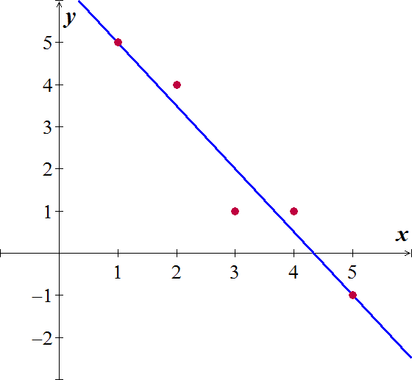



We have: .

Thus, 

1. 

Let  be the equation of the line that best fits the given points. Then

 where 

The normal equation: 







We have: .

Thus, 

1. 

Let  be the equation of the line that best fits the given points. Then

 where 

The normal equation: 







We have: .

Thus, 

***Exercise***

Find the orthogonal projection of the vector  on the subspace of  spanned by the vectors

1. 
2. 
3. 

***Solution***

1. Let 



The normal solution is 



So 



1. 

Let 



The normal solution is 



So 



1. 

Let 



The normal solution is 



So 



***Exercise***

Find the standard matrix for the orthogonal projection *P* of  on the line passes through the origin and makes an angle *θ* with the positive *x-*axis.

***Solution***

Since the line l in 2-dimensional, than we can take  as a basis for this subspace







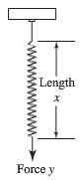***Exercise***

Hooke’s law in physics states that the length *x* of a uniform spring is a linear function of the force *y* applied to it. If we express the relationship as , then the coefficient *m* is called the spring constant. Suppose a particular unstretched spring has a measured length of 6.1 *inches*.(i.e., *x* = 6.1 when *y* = 0). Forces of 2 pounds, 4 pounds, and 6 pounds are then applied to the spring, and the corresponding lengths are found to be 7.6 inches, 8.7 inches, and 10.4 inches. Find the spring constant.

***Solution***



The normal equation: 







Thus, the estimated value of the spring constant is .

***Exercise***

Prove: If *A* has a linearly independent column vectors, and if  is orthogonal to the column space of *A*, then the least squares solution of  is.

***Solution***

If *A* has linearly independent column vectors, then  is invertible and the least squares solution of  is the solution of , but since ***b*** is orthogonal to the column space of A. , so ***x*** is a solution of . Thus  since  is invertible.

***Exercise***

Let *A* be an  matrix with linearly independent row vectors. Find a standard matrix for the orthogonal projection of  onto the row space of *A*.

***Solution***

 will have linearly independent column vectors, and the column space  is the row space of *A*. Thus, the standard matrix for the orthogonal projection of  onto the row space of A is



***Exercise***

Let *W* be the line with parametric equations 

1. Find a basis for *W*.
2. Find the standard matrix for the orthogonal projection on *W*.
3. Use the matrix in part (*b*) to find the orthogonal projection of a point  on *W*.
4. Find the distance between the point  and the line *W*.

***Solution***

1.  so that the vector  forms a basis for W (linear independence)
2. Let 











1. 
2. 

The distance between  and *W* equals to the distance between  and its projection on W.

The distance between  and  is







***Exercise***

In , consider the line *l* given by the equations 

And the line *m* given by the equations 

Let *P* be the point on *l*, and let *Q* be a point on *m*. Find the values of *t* and *s* that minimize the distance between the lines by minimizing the squared distance 

***Solution***

When  is on line *l*

When  is on line *m*





Thus these are the values  and  are the values for  that minimize the distance between the lines.

***Exercise***

Determine whether the statement is true or false,

1. If *A* is an  matrix, then  is a square matrix.
2. If  is invertible, then *A* is invertible.
3. If *A* is invertible, then  is invertible.
4. If  is a consistent linear system, then  is also consistent.
5. If  is an inconsistent linear system, then  is also inconsistent.
6. Every linear system has a least squares solution.
7. Every linear system has a unique least squares solution.
8. If *A* is an  matrix with linearly independent columns and ***b*** is in , then  has a unique least squares solution.

***Solution***

1. ***True***;  is an  matrix
2. ***False***; only square matrix has inverses, but  can be invertible when *A* is not square matrix.
3. ***True***; if *A* is invertible, so is , so the product  is also invertible
4. ***True***
5. ***False***; the system  may be consistent
6. ***True***
7. ***False***; the least squares solution may involve a parameter
8. ***True***; if *A* has linearly independent column vectors; then  is invertible, so  has a unique solution