Math 2312 – Pre-Calculus ***Exam* 1** ***Review***

*Professor*: Fred Khoury

1. Use the binomial theorem to expand and simplify

   

1. Find the domain of:
2. 
3. 
4. For the function *f* given by , find the difference quotient 
5. Sketch the graph 
6. Let 
7. Find  and the domain of 
8. Find  and the domain of 
9. Let 
10. Find  and the domain of 
11. Find  and the domain of 
12. Let 
13. Find  and the domain of 
14. Find  and the domain of 
15. Let . Find all values of *x* such that and all *x* such that , and then sketch the graph of .
16. Find the quotient and remainder if  is divided by 
17. Find the zeros of , and state the multiplicity of each zero.
18. Find all solutions of the equation: 
19. Find the vertical asymptotes, horizontal asymptotes, oblique asymptotes, intercepts, and holes (if any) of:
20. 
21. 
22. 
23. Find an equation of a rational function  that satisfies the given conditions



1. Let 
2. Is one-to-one function
3. Find , if it exists.
4. Find the domain and range of  and 
5. Sketch  and 
6. Let 
7. Is  one-to-one function
8. Find , if it exists.
9. Find the domain and range of  and 
10. Sketch  and 
11. Let , determine the asymptote, domain, range, increasing and decreasing, and sketch 
12. Let , determine the asymptote, domain, range, increasing and decreasing, and sketch 
13. Solve the equations:
14. 
15. 
16. 
17. 
18. 
19. 
20. 
21. 
22. 
23. 
24. Solve the equation for ***x*** in terms of ***y***.
25. 
26. 
27. Express the following in terms of sums and differences of logarithms 

***Solution***

1. *a*) 

*b*) 

*c*) 

*d*) 

1. 

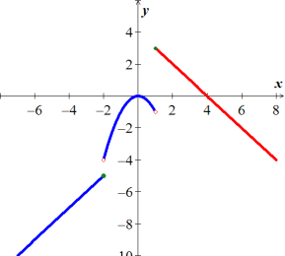

1. 



1. 



1. 



1. 

|  |  |  |  |  |  |
| --- | --- | --- | --- | --- | --- |
| −4 −2 0 2 4 | | | | | |
| − | + | − | + | − | + |





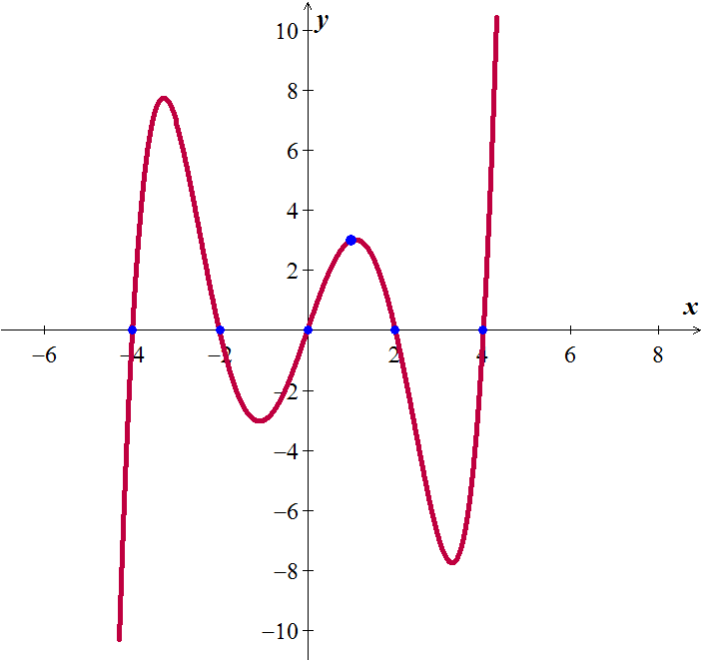

1. 
2. ; 
3. 
4. *a*) 

*b*) 

*c*) 

1. 
2. *a*) Yes *b*)  *c*) Domain & Range of  and : 

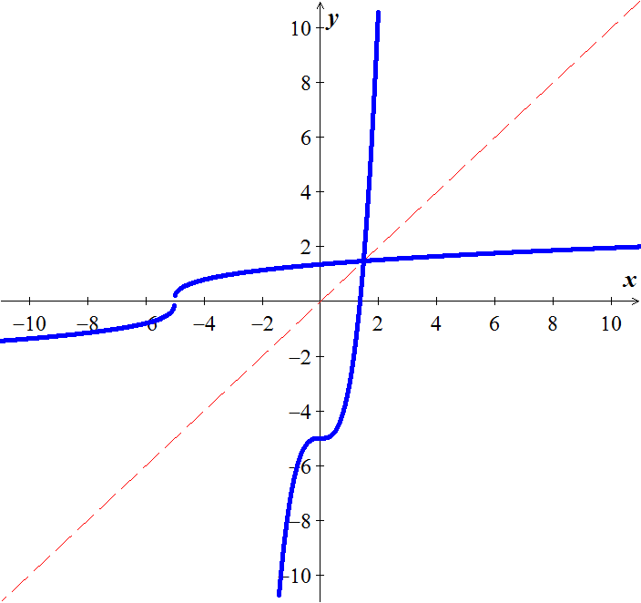

1. *a*) Yes *b*)  *c*) Domain of  = Range of : R −

Range of  = Domain of : R −

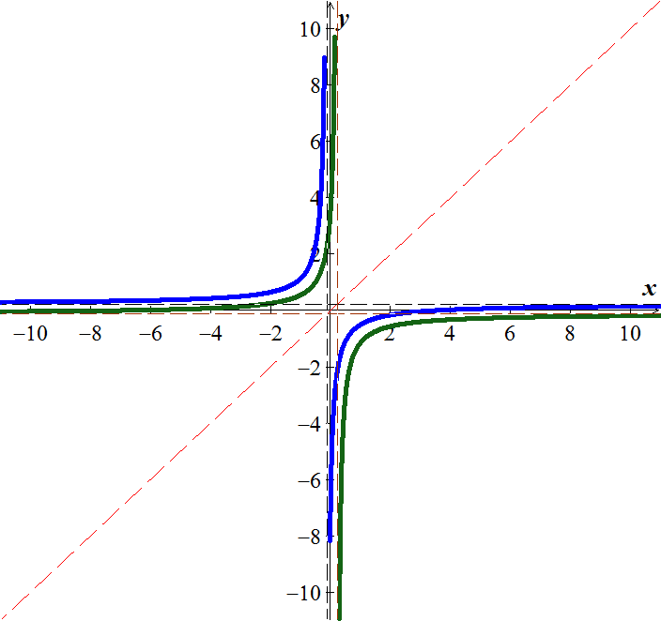

|  |  |
| --- | --- |
| ***Asymptote***: *y* = 0  ***Domain***:  ***Range***:  ***Incr***.:  ***Decr***.: |  |

|  |  |
| --- | --- |
| ***Asymptote***: *x* = −3  ***Domain***:  ***Range***:  ***Incr***.:  ***Decr***.: None. |  |

1. 



















1.  
2. 