Math 2312 – Pre-Calculus ***Exam* 4** ***Review***

*Professor*: Fred Khoury

1. Find the first four terms and the seventh term of the sequence:
2.  *b*) 
3. Find the specified term of the arithmetic sequence that has two given terms:
4.  *b*) 
5. Express the sum in terms of summation notation:
6. 
7. 
8. 
9. 
10. 
11. Find the *n*th term, and the tenth term of the sequence:
12. 
13. 
14. 
15. 
16. Evaluate:

  

1. Find the sum of the infinite geometric series if it exists:
2.  *b*)  *c*) 
3. Use the binomial theorem to expand and simplify

   

1. Find the center and the radius of
2. 
3. 
4. 
5. 
6. Find the vertex, focus, and directrix of the parabola.
7. 
8. 
9. 
10. 
11. Find an equation of a parabola that satisfies the given conditions
12. 
13. 
14. 
15. Find the vertices, minors and foci of the ellipse, and then sketch the graph of

  

 

1. Find the vertices, the endpoints, the foci, and the equations of the asymptotes of the hyperbola. Sketch its graph, showing the asymptotes.
2. 
3. 
4. 
5. 
6. 
7. Find the partial fraction decomposition

|  |  |  |
| --- | --- | --- |
|  |  |  |
|  |  |  |
|  |  |  |
|  |  |  |

***Solution***

1. ***a***)  ***b***) 
2. ***a***)  ***b***) 
3. ***a***)  ***b***)  ***c***)  ***d***) 

***e***) 

1. *a*) 

*b*) 

*c*) 

*d*) 

1. *a*)  *b*)  *c*) 
2. *a*)  *b*)  *c*) 
3. *a*) 

*b*) 

*b*) 

*b*) 

1. ***a***) Center ; radius: 4 ***b***) Center ; radius: 3

***c***) Center ; radius: 6 ***d***) Center ; radius: 3

1. ***a***) 

***b***) 

***c***) 

***d***) 

1. ***a***) 

***b***) 

***c***) 

1. *a*) 

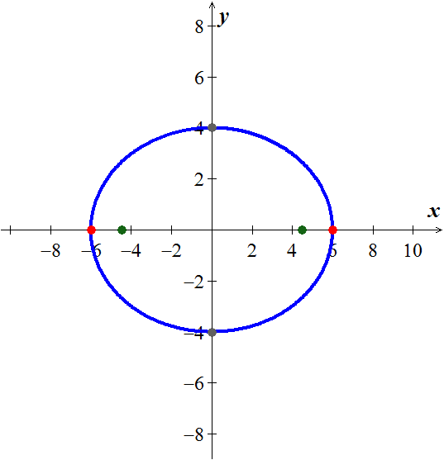

*b*) 

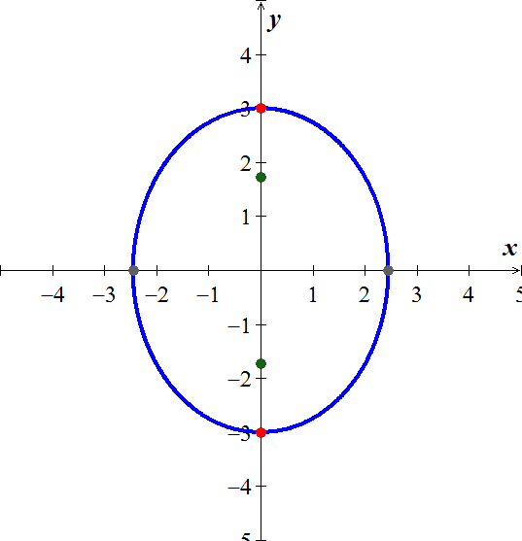

*c*) 

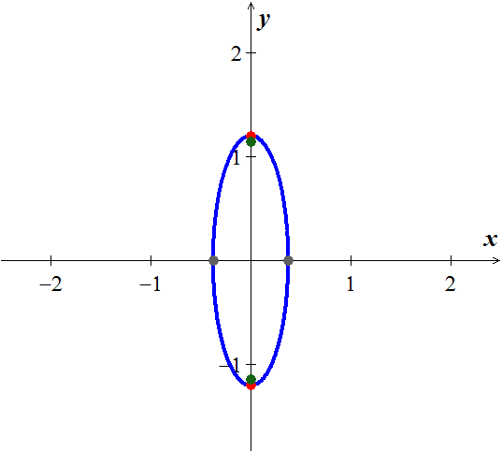

*d*) 

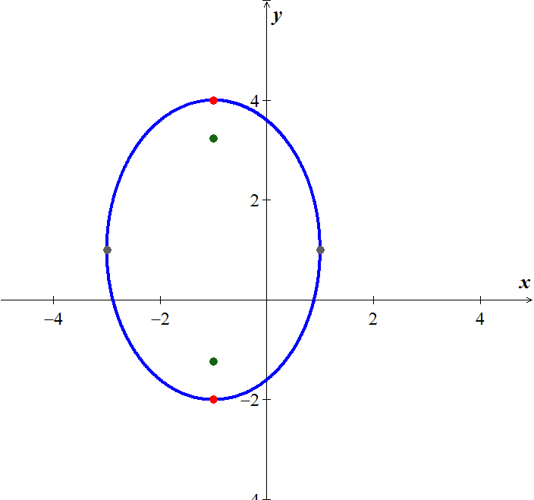

*e*) 

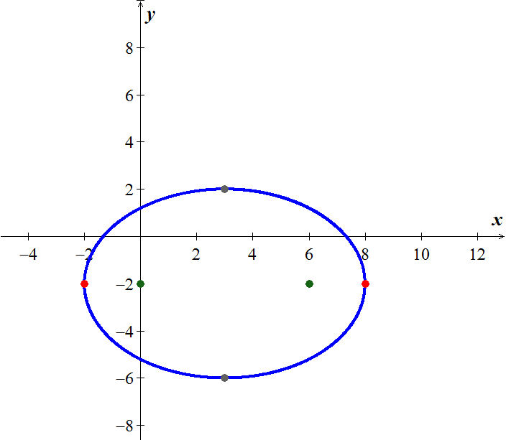

1. *a*) 

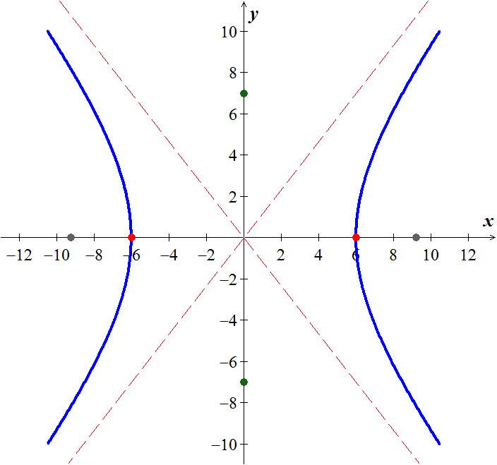

*b*) 

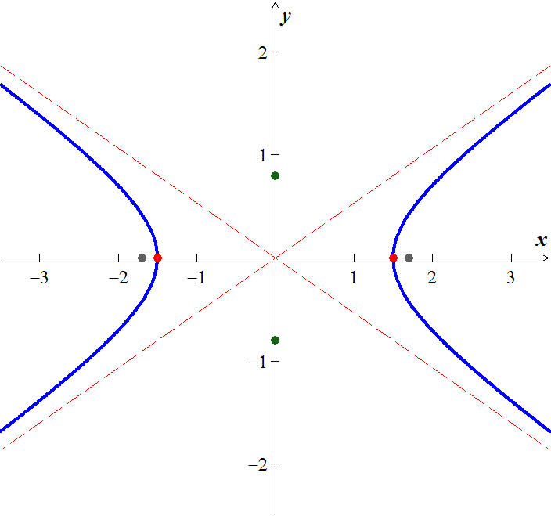

*c*) 

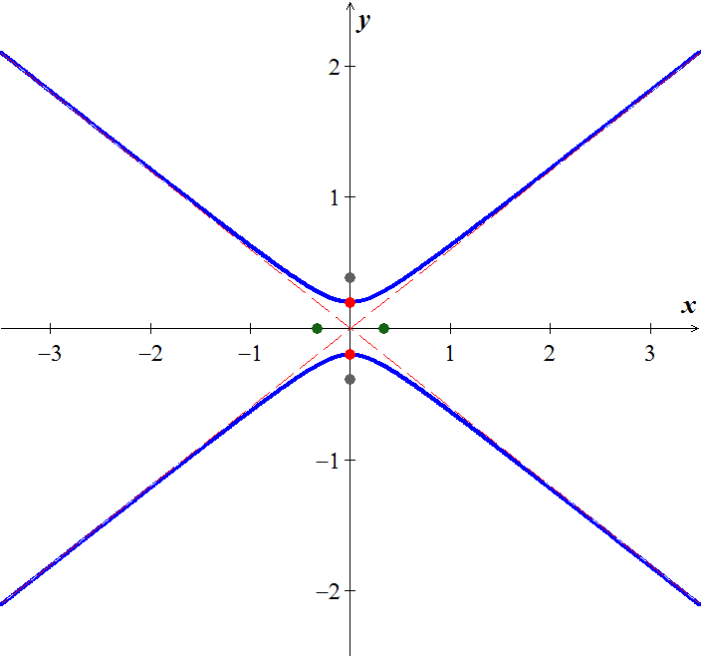

*d*) 

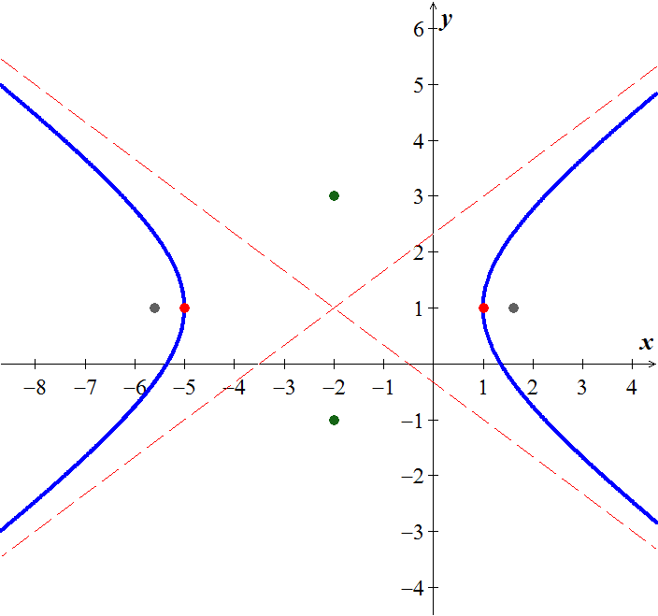

*e*) 

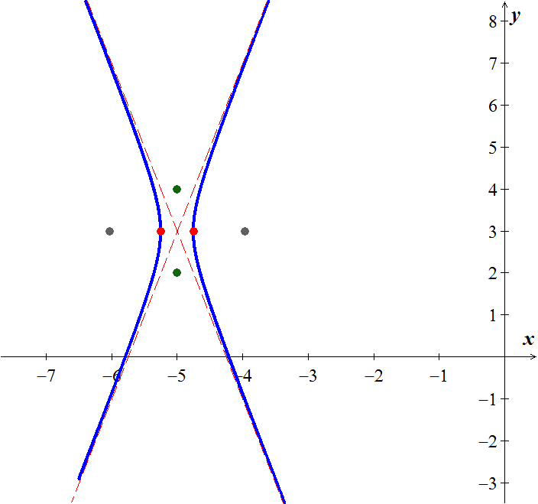

1.   

  

  



 