***Lecture* 1 *−* Functions, Exponential & Logarithms**

***Section* 1.1 – Functions**

A ***set*** is a collection of objects of some type, and the objects are called ***elements*** of the set.

|  |  |  |
| --- | --- | --- |
| ***Notation or Terminology*** | ***Meaning*** | ***Example*** |
|  | ***a*** is an element of ***S*** |  |
|  | ***a*** is not an element of ***S*** |  |
|  | S is a ***subset*** of T  Every element of S is an element of T |  |
| ***Constant*** | A letter or symbol that represents a specific element of a set. |  |
| ***Variable*** | A letter or symbol that represents any element of a set. | Let ***x*** denote any real number |

**Definition of a *Function***

A ***function*** is a relation between two variables such that to matches each element of a first set (called ***domain***) to an element of a second set (called ***range***) in such way that no element in the first set is assigned to two different elements in the second set.

The ***domain*** of the function is the set of all values of the independent variable for which the function is defined.

The ***range*** of the function is the set of all values taken on by the dependent variable.

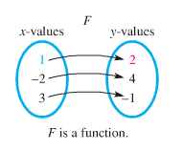 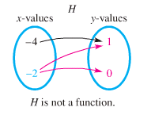

**The *Domain* of a Function**

1. *Rational* function:  ⇒***Domain***: 

***Example***:  ***Domain****: x* ≠ 3

1. *Irrational* function:  ⇒ ***Domain***: 

***Example***:  ⇒ 3 – *x* ≥ 0 ⇒ – *x* ≥ -3

***Domain***: *x* ≤ 3

1. Otherwise: *Domain* all real numbers

***Example***:  ***Domain***: All real numbers 

**(1) *&* (2)→** Find the domain:  ⇒ ***Domain:*** *x* > 3



***Example***

Let . Find the domain of *g*.

***Solution***

 

**Difference Quotients**



The difference quotient is given by: 

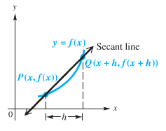

***Example***

For the function *f* given by , find the difference quotient 

***Solution***



 















***Sum*** 

***Difference*** 

***Product*** 

***Quotient*** 

***Example***

Let and. Find and give the domain

***Solution***

***Domain*** of *f*: 

***Domain*** of *g*: 

1. 



***Domain***:  or 

1. 



***Domain***: 

1. 



***Domain***: 

1. 

 

***Domain***: 

***Even and Odd Functions***

Given the function then find and simplify:

* If ⇒ *f* is ***even***, or
* If ⇒ *f* is ***odd***
* ***Neither***

***Example***

Decide whether each function is even, odd, or neither

1. 







Function is *Even*

1. 









Function is *Odd*

1. 





Function is *Neither*

**Piecewise-Defined Functions**

Function are sometimes described by more than one expression, we call such functions ***piecewise-defined functions***.

***Example***

Graph each function



***Solution***

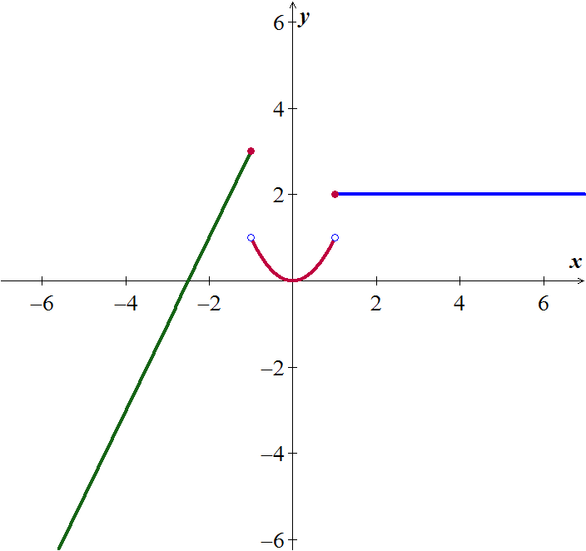

***Composition of Functions***

**The composite function, the composite of *f* and *g*, is defined as



Where *x* is in the domain of *g*

andis in the domain of *f*

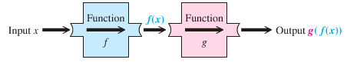

***Example***

Let 

1. Find  and the domain of 
2. Find  and the domain of 
3. Find  in two different ways: first using the functions *f* and *g* separately and second using the composite function .

***Solution***

1. 

 







 

***Domain*** of : 

1. 

 





 

***Domain*** of : 

1. 













***Example***

Let 

1. Find  and the domain of 
2. Find  and the domain of 

***Solution***

1. 

 



 

***Domain*** of : 

1. 

 

 

***Domain*** of : 

***Exercises*** ***Section* 1.1 –Functions**

Find the Domain

|  |  |  |
| --- | --- | --- |
|  |  |  |

Find the difference quotient , for the given function

|  |  |  |
| --- | --- | --- |
| 1. , |  |  |

1. Find  and the domain of 
2. Find  and the domain of 
3. Let  and . Find each of the following and give the domain

|  |  |  |  |
| --- | --- | --- | --- |
|  |  |  |  |

1. Given that  and 
2. Find 
3. Find the domain of 
4. Find: 
5. Given that  and 
6. Find  and its domain
7. Find  and its domain
8. Find : 
9. Find : 
10. Find : 
11. Let 
12. Find  and the domain of 
13. Find  and the domain of 
14. Let 
15. Find  and the domain of 
16. Find  and the domain of 
17. Let 
18. Find  and the domain of 
19. Find  and the domain of 
20. Let 
21. Find  and the domain of 
22. Find  and the domain of 
23. Given and , find , and their domain.
24. Given that  and, find , and their domain.
25. Given that  and, find , and their domain.
26. Given that  and, find ,  and their domain then find 
27. Given that  and, find
28. 
29. 
30. 
31. Given that  and, find
32. 
33. 
34. 

Determine whether *f* is even, odd, or neither

|  |  |
| --- | --- |
|  |  |

1.  Find: 
2.  Find: 
3. 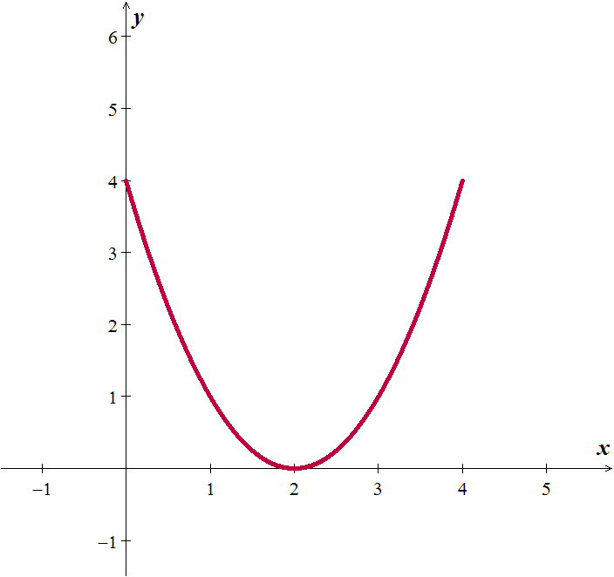The graph of a function *f* with domain [0, 4] is shown:
4. 
5. 
6. 
7. 
8.  Find: 
9.  Find: 
10. Graph the piecewise function defined by 
11. Sketch the graph 
12. Sketch the graph 

***Section* 1.2 – Polynomial Functions & Graphs**

**Polynomial Function**

A *Polynomial function* *P*(*x*) in *x* is a sum of the form is given by:



Where the coefficients are real numbers and the exponents are whole numbers.

***Degree***



***Leading Term***

***Leading Coefficient***

Non-polynomial Functions: 

|  |  |  |
| --- | --- | --- |
| ***Degree of f*** | ***Form of f(x)*** | ***Graph of f(x)*** |
| 0 |  | A horizontal line |
| 1 |  | A line with slope |
| 2 |  | A parabola with a vertical axis |

All polynomial functions are ***continuous functions***.

*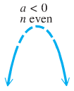****End Behavior* **

If *n* (degree) is even:

If  (in front  is negative), then the function falls from the left and right side

***Falls left***



***Falls right***

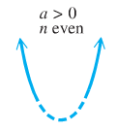 

***Rises right***

If  (in front  is positive), then the function rises from the left and right side

***Rises left***





***Rises left***

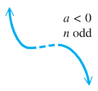If *n* (degree) is odd:

If  (negative), then the function rises from the left side and falls from the right side



***Falls right***



***Rises right***

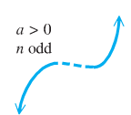If  (positive), then the function falls from the left side and rises from the right side





***Falls left***

***Example***

Determine the end behavior of the graph of the polynomial function 

***Solution***

Leading term:  with 5th degree (*n* is odd)

  rises left

  falls right

**The intermediate value *Theorem***

For any polynomial function  with real coefficients and  for , then  takes on every value between  and  in the interval .

∴  and are the opposite signs. Then the function has a real zero between *a* and *b*.

***Example***

Using the intermediate value theorem, determine, if possible, whether the function has a real zero between *a* and *b*.

1. 
2. 

***Solution***

1. 



 *f(x)* has a zero between −4 and −2.

1. 



 *Can’t be determined*.

***Example***

Show that  has a zero between 1 and 2.

***Solution***





Since  have opposite signs; therefore,  for at least one real number *c* between 1 and 2.

**Properties of Division**

***Long Division***

Divide 

*Quotient*

 *Dividend*

*Remainder*

*Divisor*





**Remainder *Theorem***

If a number *c* is substituted for *x* in the polynomial *,* then the result  is the remainder that would be obtained by dividing by *x* – *c*.

That is, if 

**Factor *Theorem***

A polynomial  has a factor  if and only if 

***Synthetic Division***

Use synthetic division to find the quotient and the remainder of

 

**The Rational Zeros *Theorem***

If the polynomial  coefficients and if  is a rational zero of  such that ***c*** and ***d*** have no common prime factor, then

1. The numerator *c* of the zero is a factor of the constant term 
2. The denominator *d* of the zero is a factor of the leading coefficient 



***Example***

Find all rational solutions of the equation: 

***Solution***

|  |  |
| --- | --- |
|  |  |
|  |  |
|  |  |

Using the calculator, the result will show that −2 is a zero.



Hence, the polynomial has roots 

***Sketching***

***Example***

Let . Find all values of *x* such that and all *x* such that , and then sketch the graph of .

***Solution***









The zeros of ( *x*-intercepts) are: 

|  |  |  |  |  |
| --- | --- | --- | --- | --- |
| ***Interval*** | **0** 2 | | | |
| Sign of | **−** | **+** | **−** | **+** |
| Position | **Below *x*-axis** | **Above *x*-axis** | **Below *x*-axis** | **Above *x*-axis** |

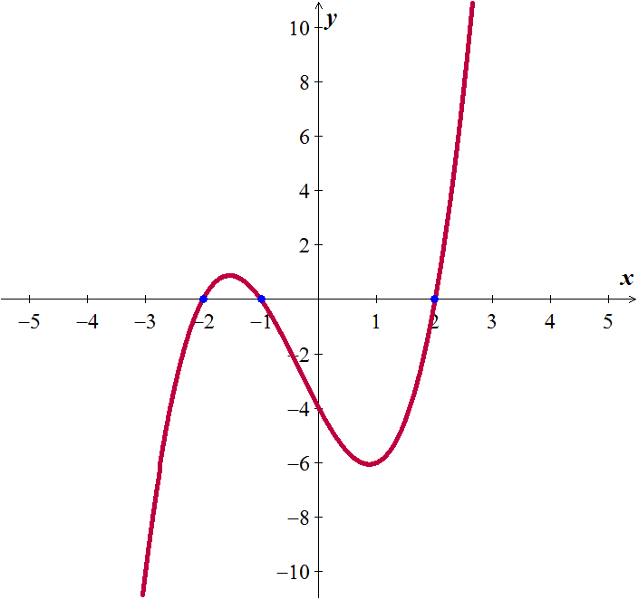

We can conclude from the chart and the graph that:





***Example***

Let . Find all values of *x* such that and all *x* such that , and then sketch the graph of .

***Solution***





The zeros are: 0, 1, 3. Since the factor is always positive, it has no factor

|  |  |  |
| --- | --- | --- |
| 1 **2** 3 | | |
| **+** | **−** | **+** |

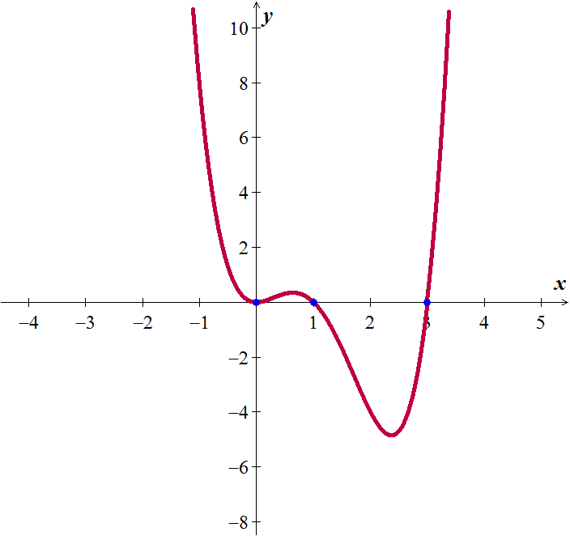





***Fundamental Theorem* of Algebra**

If a polynomial  has positive degree and complex coefficients, then  has at least one complex zero.

**Complete Factorization Theorem for Polynomials**

If  is a polynomial of degree , then there exist *n* complex numbers  such that:



Where *a* is the leading coefficient of . Each number  is a zero of .

***Example***

|  |  |  |
| --- | --- | --- |
|  | ***Factored From*** | ***Zeros of*** |
|  |  | 4, 2*i* |
|  |  |  |

***Example***

Express  as a product of linear factors, and find the five zeros of 

***Solution***

 











The number 0 is a zero of multiplicity of 3. ∴ 

***Exercises*** ***Section* 1.2 – Polynomial Functions & Graphs**

Find the quotient and remainder if  is divided by 

|  |  |
| --- | --- |
|  |  |

Use the remainder theorem to find 

|  |  |
| --- | --- |
|  |  |

1. Use the factor theorem to show that  is a factor of  

Use the synthetic division to find the quotient and remainder if the first polynomial is divided by the second

|  |  |
| --- | --- |
|  |  |

Use the synthetic division to find 

|  |  |
| --- | --- |
|  |  |

1. Use the synthetic division to show that *c* is a zero of  
2. Use the synthetic division to show that *c* is a zero of  

Find all values of *k* such that  is divisible by the given linear polynomial:

1. 
2. 
3. 

Find all solutions of the equation

|  |  |
| --- | --- |
|  |  |

|  |  |
| --- | --- |
|  |  |

1. If , find a number *k* such that the graph of contains the point (−1, 4).
2. If , find a number *k* such that the graph of contains the point (2, 12).
3. If one zero of  is 2, find two other zeros.
4. If one zero of  is −2, find two other zeros.
5. Find a polynomial  of degree 3 that has the zeros −1, 2, 3; and satisfies the given condition: 
6. Find a polynomial  of degree 3 that has the zeros −2*i*, 2*i*, 3; and satisfies the given condition: 
7. Find a polynomial  of degree 4 with leading coefficient 1 such that both −4 and 3 are zeros of multiplicity 2, and sketch the graph of .

Find the zeros of the following functions and state the multiplicity of each zero

|  |  |
| --- | --- |
|  |  |

Find all values of *x* such that and all *x* such that , and then sketch the graph of 

|  |  |
| --- | --- |
|  |  |

1. A storage shelter is to be constructed in the shape of a cube with a triangular prism forming the roof. The length *x* of a side of the cube is yet to be determined.

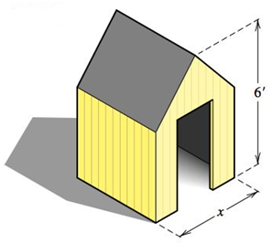

1. If the total height of the structure is 6 *feet*, show that its volume *V* is given by 
2. Determine *x* so that the volume is 
3. A canvas camping tent is to be constructed in the shape of a pyramid with a square base. An 8−foot pole will form the center support. Find the length *x* of a side of the base so that the total amount of canvas needed for the sides and bottom is 

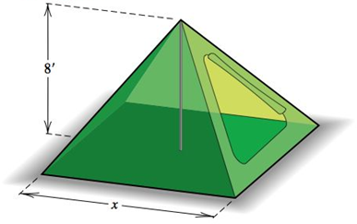

***Section* 1.3 – Rational Functions**

A function  is a ***rational function*** if ,

Where  and  are polynomials. The domain of  consists of all real numbers ***except*** the zeros of the denominator .

|  |  |
| --- | --- |
| ***Notation*** | ***Terminology*** |
|  | *x* approaches *a* from the left (through values ***less*** than *a*) |
|  | *x* approaches *a* from the right (through values ***greater*** than *a*) |
|  | increases without bound (can be made as large positive as desired) |
|  | decreases without bound (can be made as large negative as desired) |

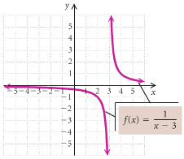**The Domain of a Rational Function**

***Example***

Consider: 

Find the domain and graph *f*.

***Solution***



Thus the domain is: 

|  |  |  |
| --- | --- | --- |
| ***Function*** | ***Domain*** | |
|  |  |  |
|  |  |  |
|  |  |  |
|  |  |  |

***Asymptotes***

**Vertical Asymptote (*VA*) - *Think Domain***

The line  is a ***vertical asymptote*** for the graph of a function  if



As ***x*** approaches ***a*** from either the left or the right

***Example***

Find the vertical asymptote of , and sketch the graph.

***Solution***

VA: 





***Hole***

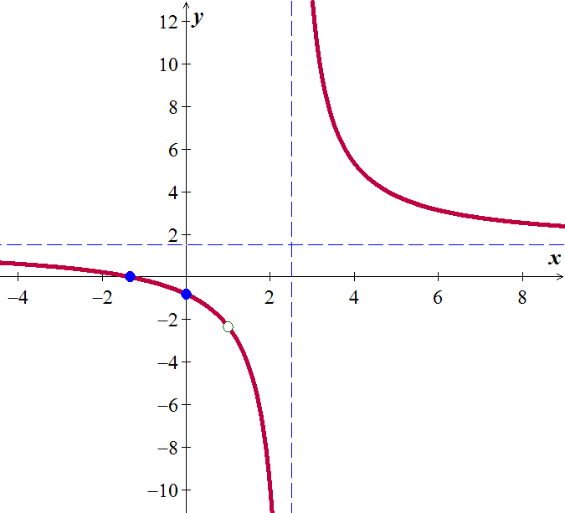***Example***

Sketch the graph of if 

***Solution***



 has a hole at 

**Horizontal Asymptote (*HA*)**

The line  is a ***horizontal asymptote*** for the graph of a function  if



Let  be a rational function.

1. If the degree of numerator is less than of denominator (*n* < *m*) ⇒ y = 0



1. If the degree of numerator is equal of denominator (*n* = *m*) ⇒



1. If the degree of numerator is greater than of denominator (*n* > *m*)⇒ No horizontal asymptote



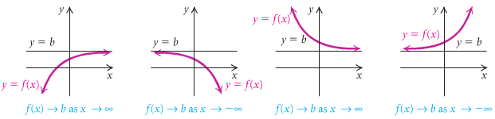

***Slant* or *Oblique* Asymptotes**

When the degree of the numerator is one greater than the degree of the numerator, the graph has a slant or oblique asymptote and it is a line . To find the slant asymptote, divide the fraction using long division. The quotient (not remainder) is the slant asymptote.



** **

The ***oblique*** ***asymptote*** is the line ***y* = 3*x* - 6**

***Example***

Find all the asymptotes and sketch the graph of  if 

***Solution***

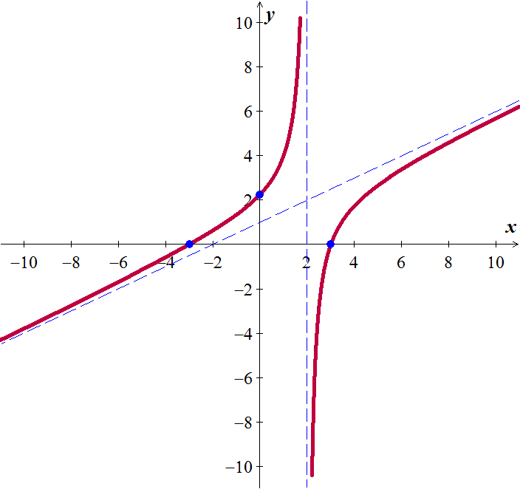



|  |  |
| --- | --- |
| ***VA*** | *x* = 2 |
| ***HA*** | *n/a* |
| ***OA*** |  |

|  |  |
| --- | --- |
| ***x*** | ***y*** |
| 0 | 2.25 |
| ±3 | 0 |

***Example***

Find all asymptotes for the graph of , if it exists

|  |  |  |
| --- | --- | --- |
|  |  |  |

***Solution***

1. 

***VA***:  ***HA***: 

***Hole***:  ***Oblique asymptote***: 

1. 



***VA***:  ***HA***: 

***Hole***:  ***Oblique asymptote***: 

1. 

***VA***:  ***HA***: 

***Hole***:  ***Oblique asymptote***: 



***Example***

Sketch the graph of if 

***Solution***

|  |  |  |  |  |  |  |  |  |  |
| --- | --- | --- | --- | --- | --- | --- | --- | --- | --- |
| ***VA***:  ***HA***:  ***Hole***:  ***Oblique asymptote***: | |  |  | | --- | --- | | ***x*** | ***y*** | | 0 |  | |  | 0 | | 4 | 5.3 | |



***Example***

Sketch the graph of if 

***Solution***

|  |  |  |  |  |  |  |  |  |  |  |  |
| --- | --- | --- | --- | --- | --- | --- | --- | --- | --- | --- | --- |
| ***VA***:  ***HA***:  ***Hole***:  ***Oblique asymptote***: | |  |  | | --- | --- | | ***x*** | ***y*** | | 0 | 0 | | −4 |  | | −2 | 1 | | 3 |  | |

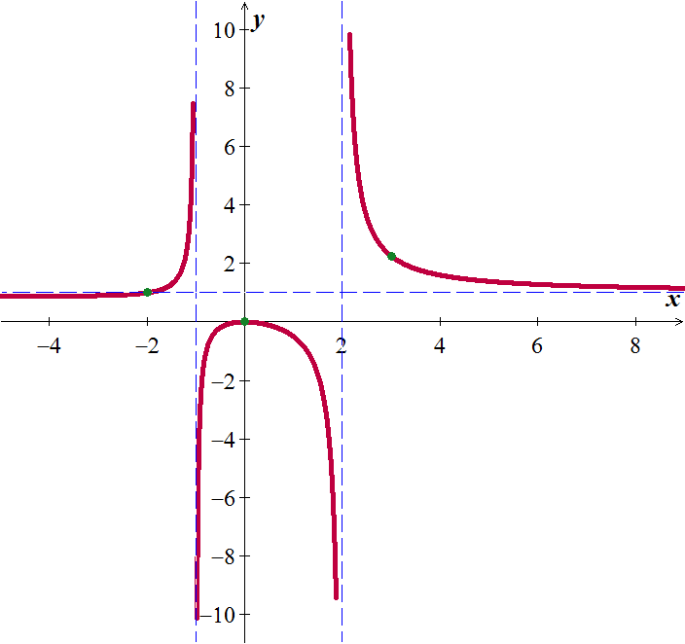

***Example***

Sketch the graph of if 

***Solution***

|  |  |  |  |  |  |  |  |  |  |  |  |  |  |  |  |
| --- | --- | --- | --- | --- | --- | --- | --- | --- | --- | --- | --- | --- | --- | --- | --- |
| ***VA***:  ***HA***:  ***Hole***:  ***Oblique asymptote***: | |  |  | | --- | --- | | ***x*** | ***y*** | | −4 | −.36 | | −3 | −.67 | | 0 |  | | 1 | 0 | | 4 | .5 | | 5 |  | |

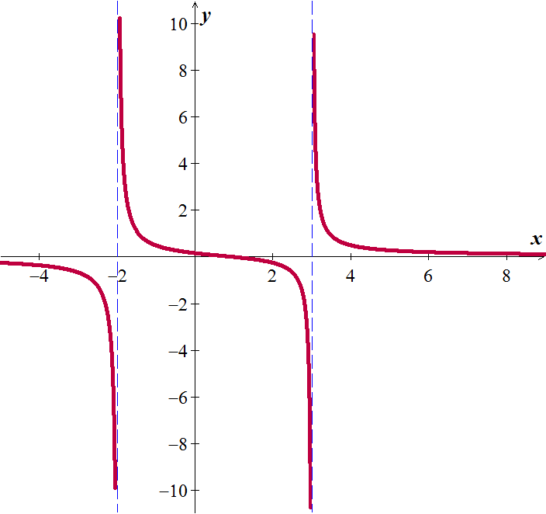

***Exercises Section* 1.3 – Rational Functions**

Determine all asymptotes of the function

|  |  |  |
| --- | --- | --- |
|  |  |  |

Determine all asymptotes and sketch the graph of

|  |  |  |
| --- | --- | --- |
|  |  |  |

Find an equation of a rational function  that satisfies the given conditions

|  |  |
| --- | --- |
|  |  |

|  |  |
| --- | --- |
|  |  |

***Section* 1.4 – Inverse Functions**

***Inverse* Relations**

Interchanging the first and second coordinates of each ordered pair in a relation produces the inverse relation.

If a relation is defined by an equation, interchanging the variables produces an equation of the inverse relation

***One-to-One* Function**

A function  is one-to-one (1 – 1) if different inputs have different outputs that is,



A function  is one-to-one (1 – 1) if different outputs the same, the inputs are the same – that is,



***Example***

Given the function described by, prove that  is one-to-one.

***Solution***



 ***Add* 3 *on both sides***

 ***Divide by* 2**



 is one-to-one

***Example***

If, prove that  is not one-to-one.

***Solution***







 is not one-to-one. In fact, since  is an even function that implies to .

***Theorem***

A function that is increasing throughout its domain is one-to-one.

A function that is decreasing throughout its domain is one-to-one.

***Definition of Inverse Function***

Let  be one-to-one function with domain *D* and range *R*. A function with domain *R* and range *D* is the ***inverse function*** of , provided the following condition is true for every *x* in *D* and every *y* in *R*:



Let and be two functions such that: 

 

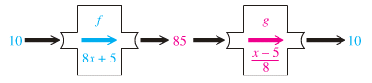

If the inverse of a function  is also a function, it is named  read “− inverse”

**The -1 in  is not an exponent! And is not equal to **

***Definition***

If a functionis one-to-one, then  is the unique function such that each of the following holds.

 for each *x* in the domain of , and

 for each *x* in the domain of 

*The condition that f is one-to-one in the definition of inverse function is important; otherwise, g will not define a function*

***Domain* and *Range* of **





 

***Example***

Show that each function is the inverse of the other: 

***Solution***

|  |  |
| --- | --- |
|  |  |

**Finding the *Inverse Function***

***Example***

Finding an Inverse Function 

1. Replace  with *y* 
2. Interchange *x* and *y* 
3. Solve for *y* 



1. Replace *y* with  

**Guidelines for Finding  in Simple Cases**

1. Verify that  is a one-to-one function throughout its domain.
2. Solve the equation  for *x* in terms of *y*, obtaining an equation of the form .
3. Verify the following two conditions:

 for every *x* in the domain of , and

 for every *x* in the domain of 

***Example***

Let  for . Find the inverse function of .

***Solution***







 ***Since*** 





***Exercises*** ***Section* 1.4 – Inverse Functions**

Determine whether the function is one-to-one

|  |  |  |
| --- | --- | --- |
|  |  |  |

Prove the  are inverse functions of each other, and sketch the graphs of 

|  |  |
| --- | --- |
|  |  |

Determine the domain and range of  (Hint: first find the domain and range of *f*)

|  |  |  |
| --- | --- | --- |
|  |  |  |

For the given functions

1. Is  one-to-one function
2. Find , if it exists
3. Find the domain and range of  and 

|  |  |  |
| --- | --- | --- |
|  |  |  |

1. Let  and , is *g* the inverse function of *f*?
2. Given that, use composition of functions to show that 
3. Given the function 
4. Find 
5. Graph  and  in the same rectangular coordinate system
6. Find the domain and the range of  and 

***Section* 1.5 – Exponential Functions**

**Definition**

The exponential function *f* with base ***b*** is defined by



Base

where *b* > 0, *b* ≠ 1 and ***x*** is any real number.



***Example***

If , find each of the following. 

***Solution***

1. 
2. 
3. 

***Theorem***

**Exponential Functions are One-to-One**

The exponential function  given by:

 for 

is one to one. Thus the following equivalent conditions are satisfied for ream numbers 





**Graphing Exponential**

***Example***

1. Define the Horizontal Asymptote  

*y* = 0 ± d Asymptote: *y* = 0

|  |  |
| --- | --- |
| *x* | *f(x)* |
| −2 | 1/9 |
| −1 | 1/3 |
| 0 | 1 |
| 1 | 3 |
| 2 | 9 |

*The exponential function always equals to 0*



2. Define/Make a table

(Force your exponential to = 0, then solve for *x*)

|  |  |
| --- | --- |
| ***x*** | ***f(x)*** |
| *x* − 2 |  |
| *x* − 1 |  |
| ***x*** |  |
| *x* + 1 |  |
| *x* + 2 |  |

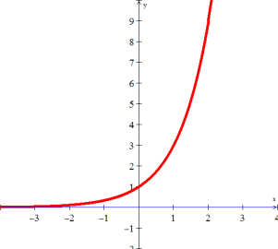

*Domain*: 

*Range*: 

** ***Example***

Sketch 

***Solution***





*Reflected across y-axis*

Asymptote: *y* = 0

*Domain*: 

*Range*: 

***Example***

Sketch 

***Solution***

*Shift right 2 unit*

Asymptote: *y* = 0

|  |  |
| --- | --- |
| *x* | *f(x)* |
| 1 | 1/3 |
| 2 | 1 |
| 3 | 3 |
| 4 | 9 |

*Domain*: 

*Range*: 

***Example***

Sketch the graph of 

**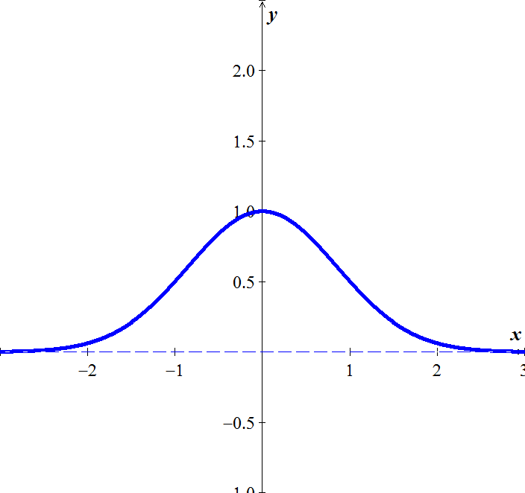*Solution***



Asymptote: *y* = 0

|  |  |
| --- | --- |
| *x* |  |
| ±0 | 1 |
| ±1 |  |
| ±2 |  |

Function is increasing 

Function is decreasing 

**The Number *e***

If *n* is a positive integer, then



**Natural Base *e***

The irrational number *e* is called natural base

 is called natural exponential function

***Example***

Sketch 

***Solution***

Asymptote: *y* = 0

|  |  |
| --- | --- |
| ***x*** | ***f(x)*** |
| −2 | .14 |
| −1 | .4 |
| 0 | 1 |
| 1 | 2.7 |
| 2 | 7.4 |



***Example***

Sketch 

***Solution***

*Shifted left 3 units*

Asymptote: *y* = 0

***Exercises*** ***Section* 1.5 – Exponential Functions**

Sketch the graph

|  |  |  |
| --- | --- | --- |
|  |  |  |

1. Simplify the expression 
2. Simplify the expression 
3. The exponential function  models the gray wolf population of the Western Great Lakes,, in billions, *x* years after 1978. Project the gray population in the recovery area in 2012.
4. The function  describes world population, , in billions, *x* years after 2004 subject to a growth rate of 1.23% annually. Use the function to predict world population in 2050.

***Section* 1.6 – Logarithmic Functions and Properties**

**Logarithmic Function (*Definition)***

For ***x* > 0** and *b* > 0, *b* ≠ 1

 is equivalent to 



**Base**

The function  is the logarithmic function with base *b*.

: *read* log base *b* of *x * 

***Example***

Write each equation in its equivalent exponential form:

1.  
2.  

Write each equation in its equivalent logarithmic form:

1.  
2.  

***Example***

The number *N* of bacteria in a certain culture after ***t*** hours is given by . Express ***t*** as logarithmic function of *N* with base 2.

***Solution***



***Basic* Logarithmic Properties**

 



***Inverse* Properties**

 

 

***Example***

Find the number, if possible



 

 

***Natural* Logarithms**

***Definition***



The logarithmic function with base ***e*** is called natural logarithmic function.

 *read* "**el en of *x***"

log(-1) = *doesn’t exist* ln(-1) = *doesn’t exist*

log0 = *doesn’t exist* ln0 = *doesn’t exist*

 

log1 = 0 ln1 = 0

 

log10 = 1 ln*e* = 1

**Change-of-Base Logarithmic**

 

Evaluate

 

***Or***

 

***Domain***

The domain of a logarithmic function of the form  is the set of all positive real numbers.

(*Inside* the log has to be > 0)

***Range***: 

*Example*

Find the domain of

1. 

 ***Domain****:* 

1. 

4 − *x* > 0

⇒ *x* < 4 ***Domain***: 

1. 

*x*2 > 0 ⇒ all real numbers except 0.

***Domain***: {*x*| *x* ≠ 0} or 

**Graphs of *Logarithmic* Functions**

***Example***

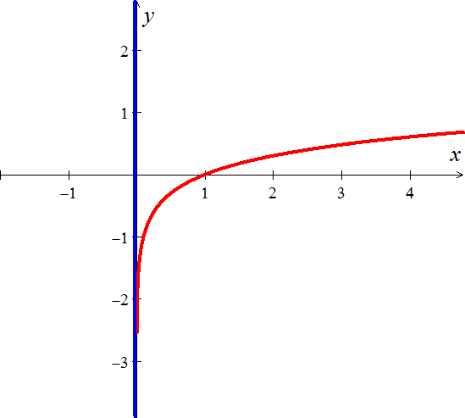Graph 

***Solution***

Asymptote: *x* = 0

(*Force inside log to be equal to zero, then solve for x*)

|  |  |
| --- | --- |
| ***x*** | ***g*(*x*)** |
| 0 |  |
| 0.5 | −.3 |
| 1 | 0 |
| 2 | .3 |
| 3 | .5 |

***Example***

Graph 

***Solution***



Therefore; the graph is symmetric with respect to the *y*-axis.

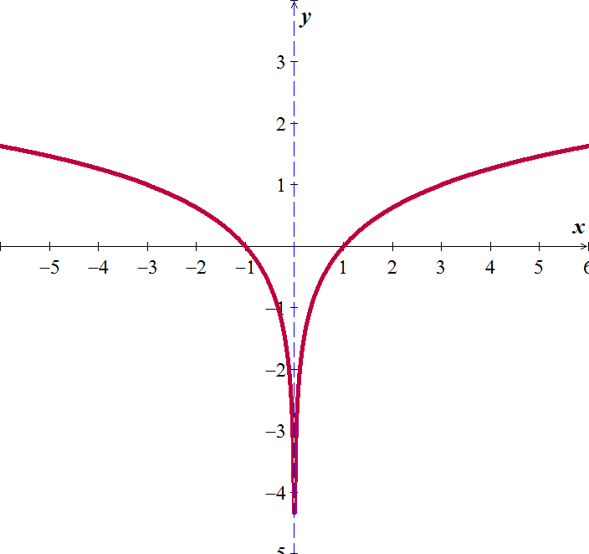

**Properties of Logarithms**

***Product* Rule**

 ***For M > 0 and N > 0***

***Proof***

 ⇒ MN = *bx by* = *bx+y*

Convert back to logarithmic form: 



***Power* Rule**



***Quotient* Rule**



***Example***

Express  in terms of logarithms of *x, y*, and *z*.

***Solution***

 ***Quotient Rule***

 ***Product Rule***

 ***Power Rule***

***Example***

Express as one logarithm: 

***Solution***

 ***Power Rule***

 ***Factor* (−)**

 ***Product Rule***

 ***Quotient Rule***

***Exercises*** ***Section* 1.6 – Logarithmic Functions and Properties**

Change to logarithm form

|  |  |  |  |
| --- | --- | --- | --- |
|  |  |  |  |

Change to exponential form

|  |  |  |
| --- | --- | --- |
|  |  |  |

Find the number

|  |  |  |  |
| --- | --- | --- | --- |
|  |  |  |  |

1. Find  using common logarithms

Evaluate using the change of base formula (without a calculator)

|  |  |
| --- | --- |
|  |  |

Sketch the graph of

|  |  |  |
| --- | --- | --- |
|  |  |  |

Find the domain of

|  |  |  |
| --- | --- | --- |
|  |  |  |

1. Express  in terms of logarithms of *x, y*, *z*, and *w*.
2. Express  in terms of logarithms of *x, y*, and *z*.
3. Express  in terms of logarithms of *x, y*, and *z*.
4. Express  in terms of logarithms of *x, y*, and *z*.

Express the following in terms of sums and differences of logarithms

|  |  |  |
| --- | --- | --- |
|  |  |  |

Write the expression as a single logarithm

|  |  |
| --- | --- |
|  |  |

1. On a study by psychologists Bornstein and Bornstein, it was found that the average walking speed *w*, in feet per second, of a person living in a city of population *P*, in ***thousands***, is given by the function:

*w*(*P*) = 0.37 ln *P*  + 0.05

1. The population is 124,848. Find the average walking speed of people living in Hartford.
2. The population is 1,236,249. Find the average walking speed of people living in San Antonio.
3. The loudness of sounds is measured in a unit called a decibel. To measure with this unit, we first assign an intensity of to a very faint sound, called the threshold sound. If a particular sound has intensity *I*, then the decibel rating of this louder sound is



Find the exact decibel rating of a sound with intensity 

1. Students in an accounting class took a final exam and then took equivalent forms of the exam at monthly intervals thereafter. The average score *S*(*t*), as a percent, after *t* months was found to be given by the function

*S*(*t*) = 78 – 15 log(*t* + 1), t ≥ 0

1. What was the average score when the students initially took the test, *t* = 0?
2. What was the average score after 4 months? 24 months?

***Section* 1.7 – Exponential and Logarithmic Equations**

**Exponential Functions are One-to-One**

 for any b > 0, ≠ 1

***Example***

Solve 

***Solution***













**Using *Natural Logarithms***

1. Isolate the exponential expression
2. Take the natural logarithm on both sides of the equation
3. Simplify using one of the following properties: 
4. Solve for the variable

***Example***

Solve the equation 

***Solution***

|  |  |
| --- | --- |
| **1st *method*** | **2nd *method*** |
| ***ln both sides*** | ***Convert to log form***  ***Change of base*** |

***Example***

Solve the equation 

***Solution***

















***Example***

Solve the equation 

***Solution***

 ***Multiply by 2 both sides***

 ***Multiply by  both sides***















**Logarithmic Equations**

1. Express the equation in the form 
2. Use the definition of a logarithm to rewrite the equation in exponential form:



1. Solve for the variable
2. Check proposed solution in the original equation. Include only the set for *M* > 0

***Example***

Solve: 

***Solution***

 ***Product Rule***

***Convert to exponential form***

*x*2 − 3*x* = 10

*x*2 − 3*x* – 10 = 0 ***Solve for x***

⇒ *x* = −2, 5

***Check***: *x* = −2 ⇒ 

*x* = 5 ⇒ 

***Example***

Solve the equation 

***Solution***

 ***Product Rule***

 ***Change to exponential form***

 ***Solve for x***



***Check***:  Not a solution (negative inside the log)

 Only solution

**Property of Logarithmic Equality**

The logarithmic function with base ***b*** is 1-1. Thus the following equivalent conditions are satisfied for positive real numbers *M* and *N*.

For any *M* > 0, *N* > 0, *b* > 0, ≠ 1

If  **⇒** 

If  **⇒ **

***Example***

Solve the equation 

***Solution***











***Check***: 

 ***True statement***

 is a solution

***Example***

Solve the equation 

***Solution***



















***Check***: 



 is the solution

***Example***

Solve the equation  for *x*.

***Solution***













 

 



***Check***: 



The equation has two solutions: 

***Example*** (*hyperbolic secant function*)

Solve the equation  for *x* in terms of *y*.

***Solution***























***Exercises*** ***Section* 1.7 – Exponential and Logarithmic Equations**

Solve

|  |  |
| --- | --- |
|  |  |

|  |  |
| --- | --- |
|  |  |

Use common logarithms to solve for ***x*** in terms of ***y***

|  |  |
| --- | --- |
|  |  |

1. Solve for *t* using logarithms with base *a*: 
2. Solve for *t* using logarithms with base *a*: 