***Lecture* *Three* – Identities and Solving Trigonometric**

***Section* 3.1 - Proving Identities**

***Reciprocal Identities***

|  |  |  |
| --- | --- | --- |
|  |  |  |
|  |  |  |

***Ratio Identities***

|  |  |
| --- | --- |
|  |  |

***Pythagorean Identities***











***Example***

Write  in terms of sin*θ* and cos*θ*, and then simplify.

***Solution***



***Example***

Add 

***Solution***

 

***Example***

Write:  in terms of 

***Solution***









***Example***

Prove: 

***Solution***

















***Example***

Prove: 

***Solution***







**Guidelines for Proving Identities**

1. Work on the complicated side first (more trigonometry functions)
2. Look for trigonometry substitutions.
3. Look for algebraic operations
4. If not always change everything to sines and cosines
5. Keep an eye on the side you are not working.

***Example***

Prove 

***Solution***

 

 







***Example***

Prove: 

***Solution***

 

 



***Example***

Prove: 

***Solution***





 



 



***Example***

Prove : 

***Solution***















***Example***

Prove 

***Solution***









***Example***

Show that  is not an identity by finding a counterexample

***Solution***









***Exercises Section* 3.1 – Proving Identities**

Prove the identity

|  |  |  |
| --- | --- | --- |
|  |  | |
|  | |  |

***Section* 3.2 – Sum and Difference Formulas**

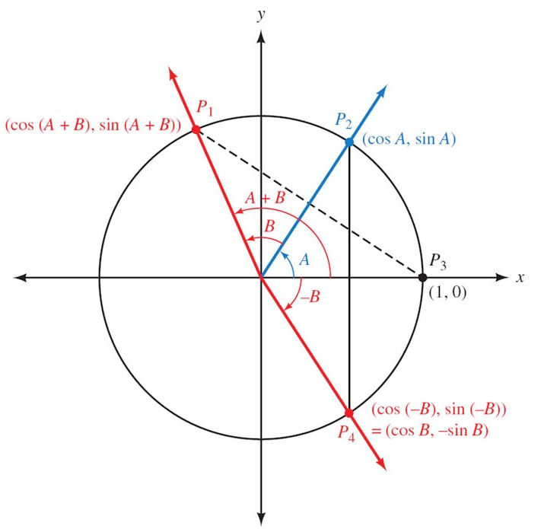



 ***Distance between points***

















|  |  |
| --- | --- |
| ***Example***  Find the exact value for  ***Solution*** | ***Example***  Show that  ***Solution*** |
| ***Example***  Simplify:  ***Solution*** | ***Example***  Show that  ***Solution*** |



|  |  |
| --- | --- |
| ***Example***  Find the exact value of  ***Solution*** | ***Example***  Find the exact value of  ***Solution*** |

***Example***

If  with *A* in QI, and  with *B* in QIII, find , , and 

***Solution***

 

 

|  |  |
| --- | --- |
|  |  |
|  |  |











 



***Example***

If with *A* in Q*I*, and  with *B* in Q*III*, find 

***Solution***















***Example***

Establish the identity: 

***Solution***





 ***√***

***Example***

Establish the identity: 

***Solution***







 ***√***

***Example***

Establish the identity: 

***Solution***













 ***√***

***Exercises Section* 3.2 – Sum and Difference Formulas**

1. Write the expression as a single trigonometric function 
2. Show that 
3. If , and  , find

|  |  |  |
| --- | --- | --- |
|  |  |  |
|  |  |  |

1. If , and  , find

|  |  |  |
| --- | --- | --- |
|  |  |  |
|  |  |  |

1. If  , and  , find

|  |  |  |
| --- | --- | --- |
|  |  |  |
|  |  |  |

1. If , and  , find

|  |  |  |
| --- | --- | --- |
|  |  |  |
|  |  |  |

1. If , and  , find

|  |  |  |
| --- | --- | --- |
|  |  |  |
|  |  |  |

1. If , and  , find

|  |  |  |
| --- | --- | --- |
|  |  |  |
|  |  |  |

1. If , and  , find

|  |  |  |
| --- | --- | --- |
|  |  |  |
|  |  |  |

1. If , and  , find

|  |  |  |
| --- | --- | --- |
|  |  |  |
|  |  |  |

1. If with *A* in Q*I*, and  with *B* in Q*I*, find 

Prove the identity

|  |  |
| --- | --- |
|  |  |

1. Common household current is called ***alternating current*** because the current alternates direction within the wires. The voltage *V* in a typical 115-*volt* outlet can be expressed by the function  where *ω* is the angular speed (in *radians* per *second*) of the rotating generator at the electrical plant, and *t* is time measured in seconds.
2. It is essential for electric generators to rotate at precisely 60 cycles per second so household appliances and computers will function properly. Determine *ω* for these electric generators.
3. Determine a value of *φ* so that the graph of  is the same as the graph of 

***Section* 3.3 – Double-angle and Half-Angle Formulas**





 

|  |  |  |
| --- | --- | --- |
|  |  |  |

***Example***

If  with *A* in QII, find 

***Solution***









***Example***

Prove 

***Solution***









***Example***

Prove 

***Solution***













***Example***

Prove 

***Solution***





















***Example***

Simplify 

***Solution***







***Example***

Prove 

***Solution***











***Example***

Given  and , find 

***Solution***

|  |  |
| --- | --- |
|  |  |
|  |

***Half-Angle Formulas***

|  |  |
| --- | --- |
| *Divide both sides by 2*  *Replace x with* | *Divide both sides by 2*  *Replace x with* |

***Example***

If  with  find the six trigonometric function of *A*/2

***Solution***

Since 



 

|  |  |  |
| --- | --- | --- |
|  |  |  |
|  |  |  |

 

***Example***

Find the exact of 

***Solution***











***Example***

Prove 

***Solution***











***Exercises Section* 3.3 – Double-angle Half-Angle Formulas**

1. Let  with *A* in Q*III* and find

|  |  |  |  |  |  |
| --- | --- | --- | --- | --- | --- |
|  |  |  |  |  |  |

1. Let  with *A* in Q*II* and find

|  |  |  |  |  |  |
| --- | --- | --- | --- | --- | --- |
|  |  |  |  |  |  |

1. Let  with *A* in Q*IV* and find

|  |  |  |  |  |  |
| --- | --- | --- | --- | --- | --- |
|  |  |  |  |  |  |

1. Let  with *A* in Q*I* and find

|  |  |  |  |  |  |
| --- | --- | --- | --- | --- | --- |
|  |  |  |  |  |  |

1. Let  with *A* in Q*II* and find

|  |  |  |  |  |  |
| --- | --- | --- | --- | --- | --- |
|  |  |  |  |  |  |

1. Let  with *A* in Q*III* and find

|  |  |  |  |  |  |
| --- | --- | --- | --- | --- | --- |
|  |  |  |  |  |  |

1. Let  with *A* in Q*IV* and find

|  |  |  |  |  |  |
| --- | --- | --- | --- | --- | --- |
|  |  |  |  |  |  |

1. Let  with *A* in Q*I* and find

|  |  |  |  |  |  |
| --- | --- | --- | --- | --- | --- |
|  |  |  |  |  |  |

1. Let  with *x* in Q*IV* and find 
2. Verify: 
3. Verify: 
4. Simplify 
5. Write  in terms of 
6. Find the values of the six trigonometric functions of *θ* if 
7. Use half-angle formulas to find the exact value of 
8. Find the exact of 
9. Given: , find 
10. Use a right triangle in Q*II* to find the value of 

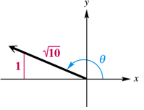

Prove the following equation is an identity

|  |  |
| --- | --- |
|  |  |

1. A common form of cardiovascular branching is bifurcation, in which an artery splits into two smaller blood vessels. The bifurcation angle *θ* is the angle formed by the two smaller arteries. The line through *A* and *D* bisects *θ* and is perpendicular to the line through *B* and *C*.

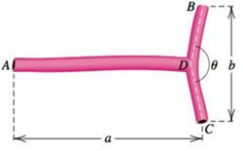

1. Show that the length  of the artery from *A* to *B* is given by .
2. Estimate the length  from the three measurements  and .
3. A proposed rail road route through three towns located at points *A, B*, and *C*. At *B*, the track will turn toward *C* at an angle .

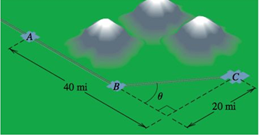

1. Show that the total distance *d* from *A* to *C* is given by 
2. Because of mountains between *A* and *C*, the turning point *B* must be at least 20 *miles* from *A*.Is there a route that avoids the mountains and measures exactly 50 *miles*?
3. Throwing events in track and field include the shot put, the discus throw, the hammer throw, and the javelin throw. The distance that the athlete can achieve depends on the initial speed of the object thrown and the angle above the horizontal at which the object leaves the hand. This angle is represented by *θ*. The distance, *d*, in *feet*, that the athlete throws is modeled by the formula



In which  is the initial speed of the object thrown, in *feet* per *second*, and *θ* is the angle, in *degrees*, at which the object leaves the hand.

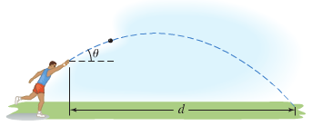

1. Use the identity to express the formula so that it contains the since function only.
2. Use the formula from part (*a*) to find the angle, *θ*, that produces the maximum distance, *d*, for a given initial speed, .
3. The speed of a supersonic aircraft is usually represented by a Mach number. A Mach number is the speed of the aircraft, in *miles* per *hour*, divided by the speed of sound, approximately 740 *mph*. Thus, a plane flying at twice the speed of sound has a speed, *M*, of Mach 2.

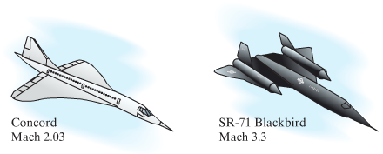

If an aircraft has a speed greater than Mach 1, a sonic boom is heard, created by sound waves that form a cone with a vertex angle *θ*.

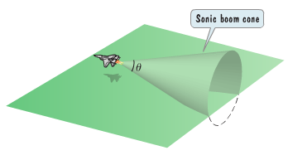

The relationship between the cone’s vertex angle *θ*, and the Mach speed, *M*, of an aircraft that is flying faster than the speed of sound is given by



1. If , determine the Mach speed, *M*, of the aircraft. Express the speed as an exact value and as decimal to the nearest tenth.
2. If , determine the Mach speed, *M*, of the aircraft. Express the speed as an exact value and as decimal to the nearest tenth.

***Section* 3.4 – Solving Trigonometry Equations**

***Example***

Find the solutions of the equation  if

1. *θ* is in the interval 
2. *θ*  is any real number

***Solution***

1. 
2. Since the sine function has period 2π.



***Example***

Solve the equation 

***Solution***





 



 

 

 

The solutions are:  for every integer *n*.

***Example***

Solve the equation , and express the solutions both in radians and degrees.

***Solution***



 



 ***Multiply by* −1**

 ***Factor or use quadratic formula***



 

 



** **

** **



***Example***

Solve the equation  in the interval .

***Solution***



 ***Factor out* tan*x***

 



  

  

***Example***

Find the solutions of 

***Solution***



 

 







***Example***

Approximate to the nearest degree, the solutions of the following equation in the interval :



***Solution***







 

  **θ ∈ QII, QIV**





***Exercises*** ***Section* 3.4 – Trigonometric Equations**

Find all solutions of the equation

|  |  |
| --- | --- |
|  |  |

Find the solutions of the equation that are in the interval 

|  |  |
| --- | --- |
|  |  |

Find the solutions of the equation that are in the interval 

|  |  |
| --- | --- |
|  |  |

1. Solve 
2. Solve 
3. If a projectile (such as a bullet) is fired into the air with an initial velocity ***v*** at an angle of elevation *θ*, then the height *h* of the projectile at time *t* is given by: 

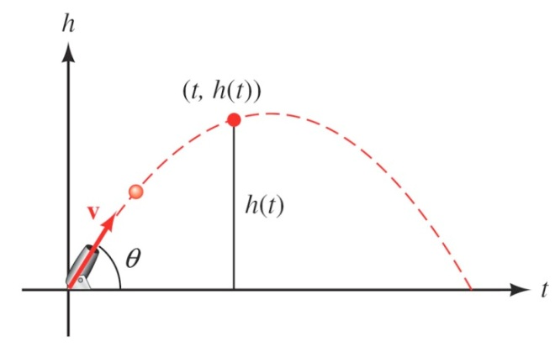

1. Give the equation for the height, if ***v*** is 600 *ft./sec* and *θ* = 45°.
2. Use the equation in part (*a*) to find the height of the object after  seconds.
3. Find the angle of elevation of *θ* of a rifle barrel, if a bullet fired at 1,500 *ft./sec* takes 3 seconds to reach a height of 750 feet. Give your answer in the nearest of a degree.

***Section* 3.5 – Inverse Trigonometry Functions**

**Relationships Between  *and* **

*  if and only if , where ***x*** is in the domain of and ***y*** is in the domain of 
* Domain of  = Range of 
* Range of  = Domain of 
*  for every *x* in the domain of 
*  for every *y* in the domain of 
* The point (*a*, *b*) is on the graph of  ***iff*** the point (*b*, *a*) is on the graph of .
* The graphs of  and  are reflections of each other through the line *y* = *x*.

**The Inverse *Sine* Function**

 ***iff*** 

**Properties of **





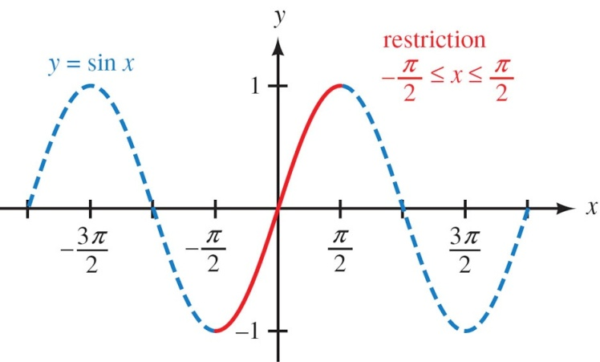 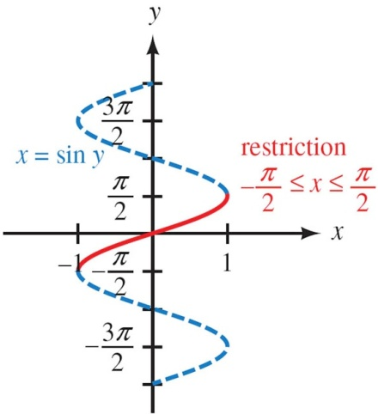

***Example***

Find the exact value: , 

***Solution***

 Since 

 Since 

**The Inverse *Cosine* Function**

***Definition***

The inverse cosine function, denoted by , is defined by

 *for *

|  |  |
| --- | --- |
| ***Notation*** | ***Meaning*** |
|  |  |

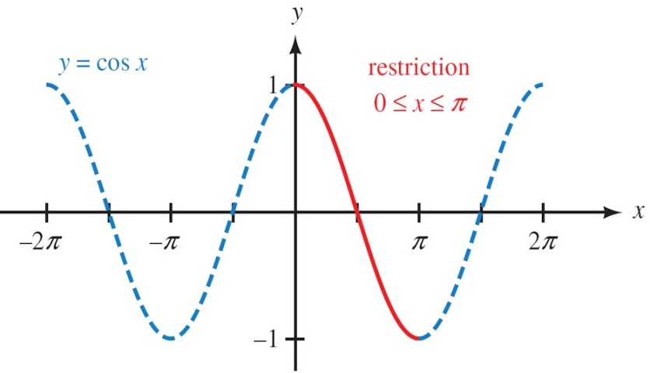 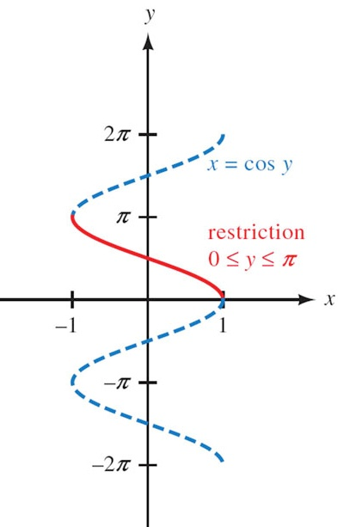

**Properties of **





***Example***

Find the exact value: 

***Solution***

 Since 

 Since 



***Example***

Find the exact value of 

***Solution***

 





**The Inverse *Tangent*  Function**

***Definition***

The inverse cosine function, denoted by , is defined by

 for any real number *x* and for  **



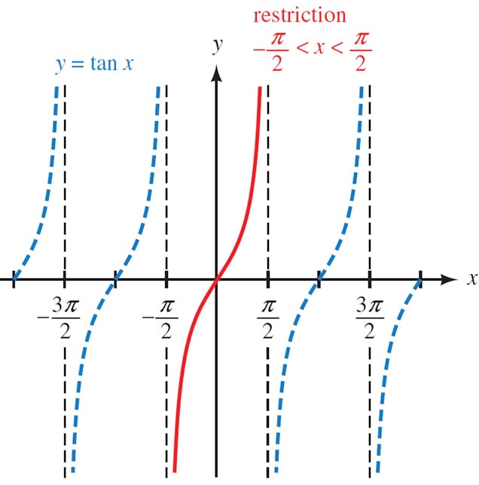 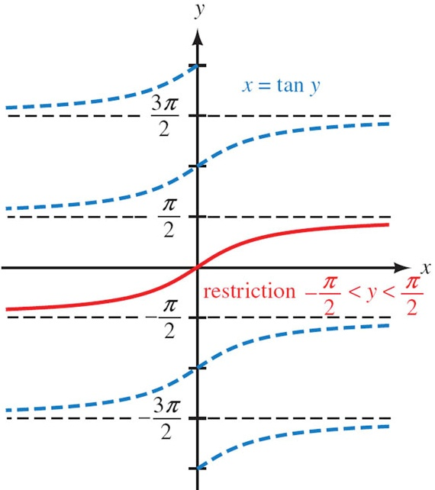

**Properties of **





***Example***

Find the exact value: 

***Solution***



 Since 

 

***Example***

Evaluate in radians without using a calculator or tables.

1. 





1. 





1. 





***Example***

Use a calculator to evaluate each expression to the nearest tenth of a degree

1. 



1. 



1. 



1. 



1. 



1. 



***Example***

Find the exact value: 

***Solution***







***Example***

Find the exact value: 

***Solution***















***Example***

If , rewrite  as an algebraic expression in *x*.

***Solution***





***Exercises Section* 3.5 – Inverse Trigonometric Functions**

Find the exact value of the expression whenever it is defined

|  |  |  |
| --- | --- | --- |
|  |  |  |

Evaluate without using a calculator

|  |  |  |
| --- | --- | --- |
|  |  |  |

Write an equivalent expression that involves *x* only for

|  |  |
| --- | --- |
|  |  |

Sketch the graph of the equation:

|  |  |  |
| --- | --- | --- |
|  |  |  |

1. Evaluate without using a calculator
2. Evaluate  as an equivalent expression in *x* only

**Section 3.6 − Polar Coordinates**

To reach the point whose address is (2, 1), we start from origin and travel 2 units right and then 1 unit up. Another way to get to that point, we can travel  units on the terminal side of an angle in standard position and this type is called *Polar Coordinates*.

***Definition* of Polar Coordinates**

To define polar coordinates, let an ***origin*** *O* (called the ***pole***) and an ***initial ray*** from *O*. Then each point *P* can be located by assigning to it a ***polar coordinate pair***  in which r gives the directed from *O* to *P* and *θ* gives the directed angle from the initial ray to yay *OP*.

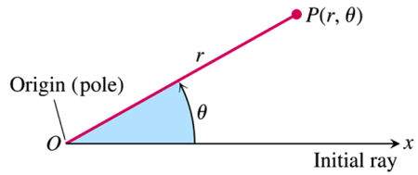

***Polar Coordinates***

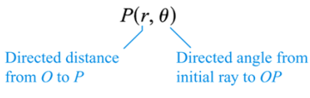

***Definition* – Relationships between Rectangular and Polar Coordinates**

The rectangular coordinates (*x*, *y*) and polar coordinates  of a point P are related as follows:

1. 
2. 

***Example***

If  are polar coordinates of a point *P*, find the rectangular coordinates of *P*.

***Solution***





The rectangular coordinates of *P* are 

***Example***

Graph the points , , , and  on a polar coordinate system

***Solution***

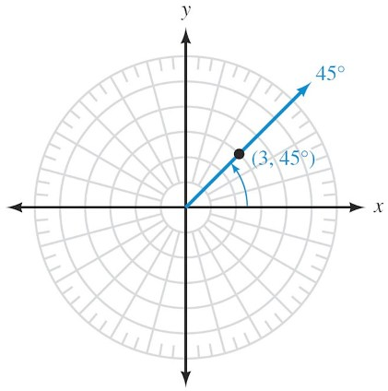 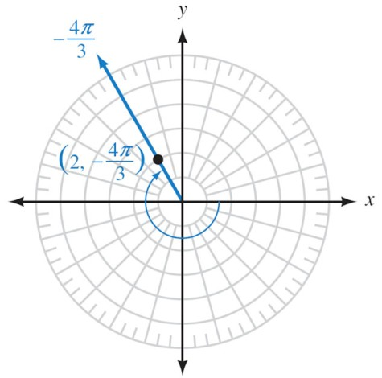

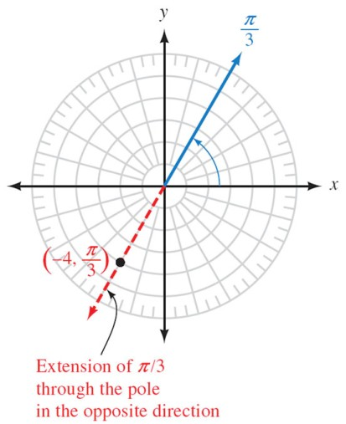 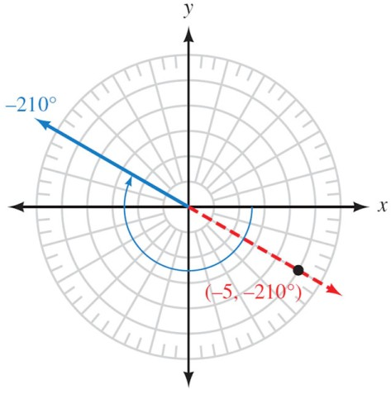

***Example***

If  are rectangular coordinates of a point *P*, find three different pairs the polar coordinates of *P*.

***Solution***





















The polar coordinates of *P* are: , , and 

***Example***

Find a polar equation of an arbitrary line.

***Solution***

An equation of a line can be written in the form: .









***Example***

Find a polar equation of the hyperbola .

***Solution***













***Example***

Find an equation in *x* and *y* that has the same graph as the polar equation . Sketch the graph.

***Solution***





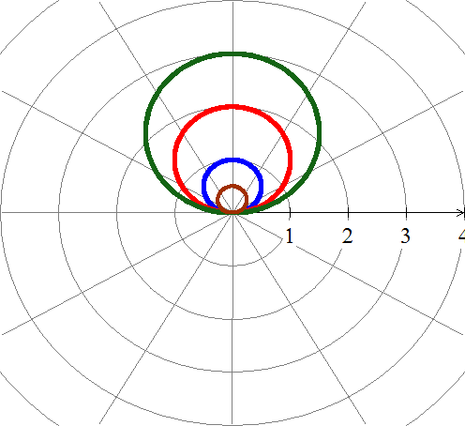

***Example***

Sketch the graph of the polar equation .

***Solution***

|  |  |  |  |  |  |  |  |
| --- | --- | --- | --- | --- | --- | --- | --- |
| ***θ*** | 0 |  |  |  |  |  |  |
| ***r*** | 4 |  | 2 |  | 0 | 2 | 4 |

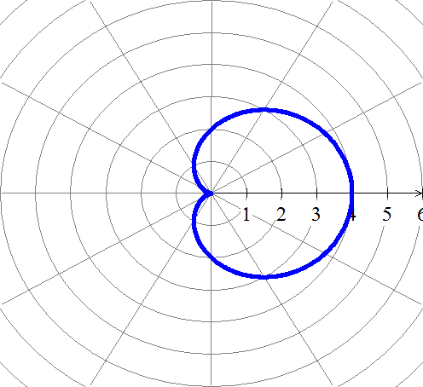

***Exercises Section* 3.6 – Polar Coordinates**

Convert to rectangular coordinates

|  |  |  |
| --- | --- | --- |
|  |  |  |

1. Change the polar coordinates to rectangular coordinates 
2. Change the polar coordinates to rectangular coordinates 
3. Change the polar coordinates to rectangular coordinates 

Convert to polar coordinates

|  |  |  |
| --- | --- | --- |
|  |  |  |

1. Change the rectangular coordinates to polar coordinates 
2. Change the rectangular coordinates to polar coordinates 
3. The point in rectangular coordinates is equivalent to  in polar coordinates.
4. The point in rectangular coordinates is equivalent to  in polar coordinates.
5. A point lies at (4, 4) on a rectangular coordinate system. Give its address in polar coordinates 

Write the equation in rectangular coordinates

|  |  |  |
| --- | --- | --- |
|  |  |  |

Find a polar equation that has the same graph as the equation in *x* and *y*

|  |  |
| --- | --- |
|  |  |

Write the equation in polar coordinates

|  |  |  |
| --- | --- | --- |
|  |  |  |

Sketch the graph of the polar equation

|  |  |  |
| --- | --- | --- |
|  |  |  |

***Section* 3.7 – Trigonometric Form**



The graph of the complex number *x* = *yi* is a vector (arrow) that extends from the origin out to the point (*x, y*)

* Horizontal axis: ***real******axis***
* Vertical axis: ***imaginary******axis***

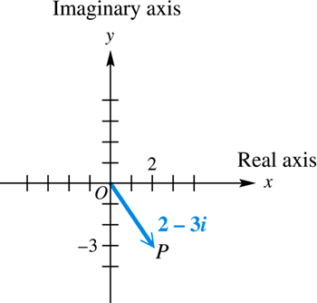

***Example***

Graph each complex number: , , and 

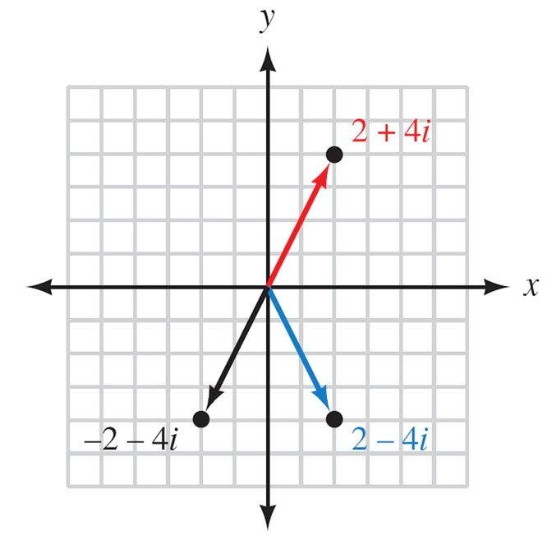

***Example***

Graph each complex number: 

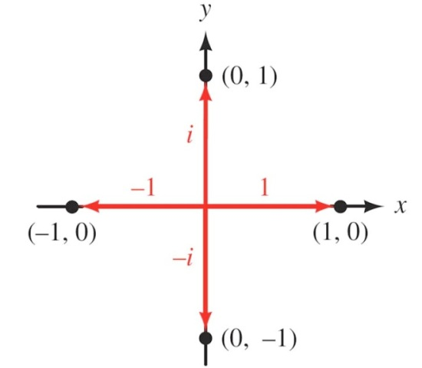

***Example***

Find the sum of 6 – 2*i* and –4 – 3*i*. Graph both complex numbers and their resultant.

***Solution***

(6 – 2*i*) + (–4 – 3*i*) = 6 – 4 – 2i – 3i = 2 – 5*i*

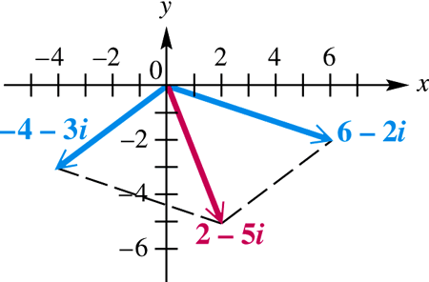

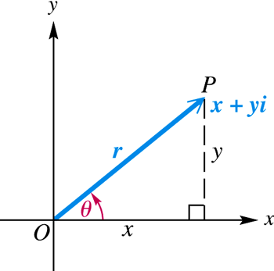***Definition***

The *absolute value* or ***modulus*** of the complex number  is the distance from the origin to the point (*x, y*). If this distance is denoted by *r*, then



The ***argument***of the complex number  denoted is the smallest possible angle *θ* from the positive real axis to the graph of *z*.

 

 





 → is called the *trigonometric* from of *z*.

***Definition***

If  is a complex number in standard form then the ***trigonometric form*** for *z* is given by



Where ***r*** is the modulus or absolute value of *z* and

***θ***  is the argument of *z*.

We can convert back and forth between standard form and trigonometric form by using the relationships that follow

For 





***Example***

Write  in trigonometric form

***Solution***

The modulus *r*:















In radians: 

***Example***

Write  in rectangular form.

***Solution***









***Example***

Express  in rectangular form.

***Solution***





***Example***

Find the modulus of each of the complex numbers *5i*, 7, and 3 + 4*i*

***Solution***

For z = *5i* = 0 + 5*i* 

For *z* = *7* = 7 + 0*i* 

For 3 + 4*i* 

***Product Theorem***

If  and  are any two complex numbers, then









***Example***

Find the product of and . Write the result in rectangular form.

***Solution***











***Quotient Theorem***

If  and  are any two complex numbers, then





***Example***

Find the quotient . Write the result in rectangular form.

***Solution***











**De Moivre’s *Theorem***

If  is a complex number, then





***Example***

Find  and express the result in rectangular form.

***Solution***







θ is in QI, that implies: 



Apply De Moivre’s theorem:





 







***n*th Root Theorem**

For a positive integer *n*, the complex number *a* + *bi* is an ***nth* root** of the complex number *x* + *iy* if



If *n* is any positive integer, *r* is a positive real number, and *θ* is in degrees, then the nonzero complex number has exactly *n* distinct *n*th roots, given by

 or 

Where  

 

***Example***

Find the two square root of **4*i***. Write the roots in rectangular form.

***Solution***

 





The absolute value: 

Argument: 

Since there are ***two*** square root, then *k* = 0 and 1.





The square roots are: 

 

 

***Example***

Find all fourth roots of . Write the roots in rectangular form.

***Solution***









The fourth roots have absolute value: 



Since there are ***four*** roots, then *k* = 0, 1, 2, and 3.









The fourth roots are: 









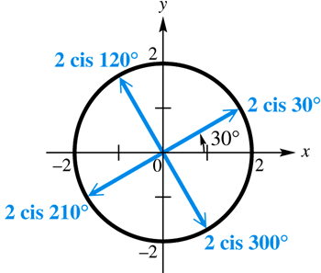

***Example***

Find all complex number solutions of . Graph them as vectors in the complex plane.

***Solution***



There is one real solution, 1, while there are five complex solutions.









The fifth roots have absolute value: 



Since there are ***fifth*** roots, then *k* = 0, 1, 2, 3, and 4.











Solution: 

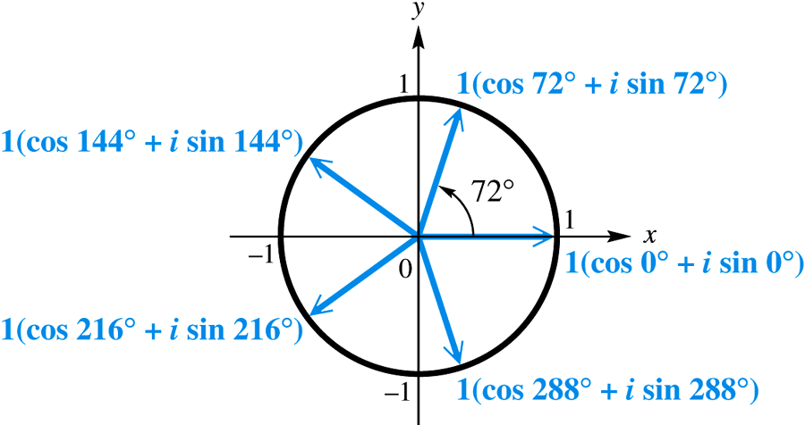

The graphs of the roots lie on a unit circle. The roots are equally spaced about the circle, 72° apart.

***Exercises Section* 3.7 – Trigonometric Form**

Write complex form in trigonometric form

|  |  |  |  |
| --- | --- | --- | --- |
|  |  |  |  |

Write in standard form

|  |  |  |  |  |  |
| --- | --- | --- | --- | --- | --- |
|  |  |  |  |  |  |

1. Find the quotient . Write the result in rectangular form.
2. Divide . Write the result in rectangular form.

Find and express the result in rectangular form

|  |  |  |  |
| --- | --- | --- | --- |
|  |  |  |  |

1. Find fifth complex roots of  and express the result in rectangular form.

Find the fourth roots of

|  |  |  |  |
| --- | --- | --- | --- |
|  |  |  |  |

Find the cube roots of

|  |  |  |  |
| --- | --- | --- | --- |
| 1. 27 |  |  |  |

1. Find all complex number solutions of .