   

   

|  |  |
| --- | --- |
|  |  |

|  |  |
| --- | --- |
|  |  |



* 
* 

**|*X*| < *c*** are the numbers that satisfy **– *c* < *X* < *c***.

**|*X*| > *c*** are the numbers that satisfy ***X* < – *c*** or ***X* > *c***.

***The Binomial Theorem***





Equation of a line:  (***b****:* *y* - intercept)

 (*Given:* **slope and one point**)

Two slopes  are: ***Parallel*** (**//**) if 

***Perpendicular*** (**⊥**) 

Two points  and 

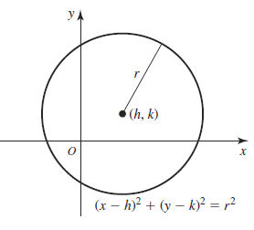***Distance*** between 2 points: 

***Midpoint*** = 

***Equation of a circle*** with a center (*h*, *k*) and radius *r*:



(*Diameter* = 2.*r*)



|  |  |  |
| --- | --- | --- |
| e0 = 1 | e1 = 2.7183 |  |
|  |  |  |
|  |  |  |
|  |  |  |





|  |  |  |
| --- | --- | --- |
|  |  |  |

Exponential Growth / Decay:

Growth Rate and Doubling Time: 

***Geometry***

|  |  |  |
| --- | --- | --- |
| ***Parallelogram*** | ***Triangle*** | ***Trapezoid*** |
| ***Circle*** | ***Sector*** | ***Ellipse*** |
| ***Cone*** | ***Cylinder*** | ***Sphere*** |

|  |  |  |
| --- | --- | --- |
| ***Rectangular Prism*** | ***Square Based Pyramid*** | ***Triangular Prism*** |
| ***Cube*** |  | ***Ellipsoid*** |

 

 

    

  

*y* = *x*3  *y* = |*x*|