***Series***



***Arithmetic***

 

***Geometric***







 

























































































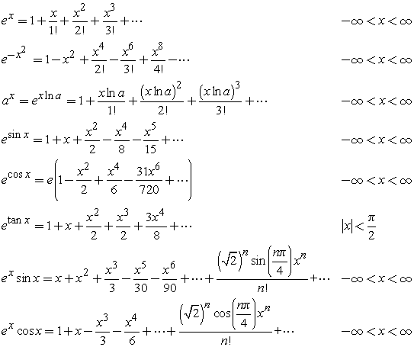

***Legendre Polynomial***

 

***The nth term of an arithmetic sequence***: 



***Sum of a certain number of terms*** ***of an arithmetic sequence*** 

The ***arithmetic mean*** of two numbers *a* and *b* is defined as 

***The nth term of a geometric sequence***: 

***Sum of nth term of a geometric sequence***: 

***Sum of infinite term of a geometric sequence***: 