2π (radians) ≡ 360° ≡ 1 revolution  (radians)  



 

|  |  |  |
| --- | --- | --- |
|  |  |  |
|  |  |  |

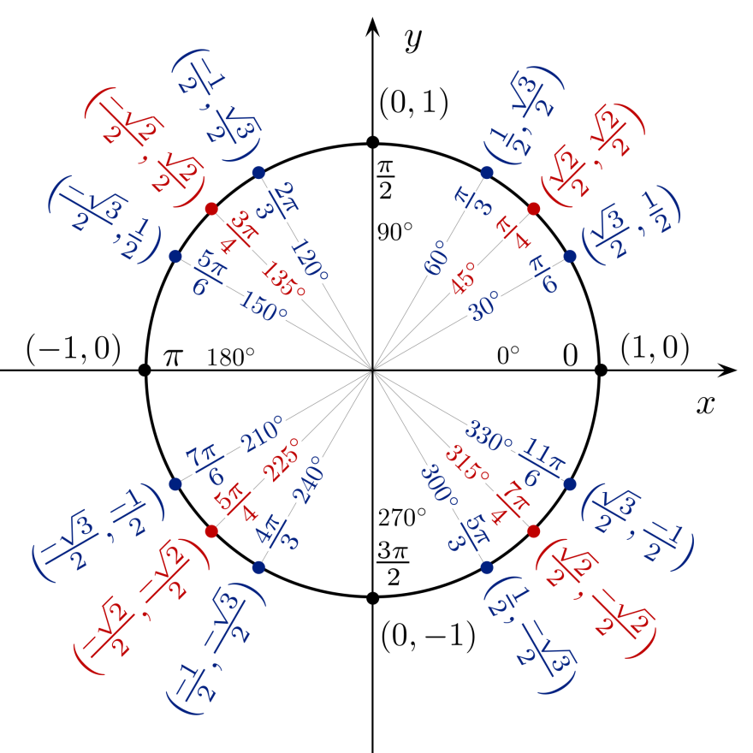

  

cos(-α) = cosα sin(-α) = - sinα tan(-α) = - tanα

cos(90° - α) = sinα sin(90° - α) = cosα tan(90° - α) = cotα

|  |  |  |
| --- | --- | --- |
| cos(α - β) = cosα cosβ + sinα sinβ  cos(α + β) = cosα cosβ - sinα sinβ | sin(α - β) = sinα cosβ - cosα sinβ  sin(α + β) = sinα cosβ + cosα sinβ |  |

***Half-Angle:***   

 where , , and 

***Double-Angle***

|  |  |  |
| --- | --- | --- |
|  |  |  |
|  |  |  |

***Product-to-Sum:***

|  |  |
| --- | --- |
|  |  |
|  |  |

***Sum-to-Product:***

|  |  |
| --- | --- |
|  |  |
|  |  |

***Law of Sines***:  

***Law of Cosines***:

|  |  |
| --- | --- |
|  |  |
|  |  |
|  |  |

***Vectors***:

|  |  |
| --- | --- |
| *Magnitude*: | *Angle:* |
| *Dot Product:* | |

  

 

**De Moivre’s *Theorem*:**  

The graphs of  and, where *B* > 0, will have the following characteristics:

Amplitude =  Period =  Phase Shift  One cycle:

Vertical Shift: 

***To graph*** *“****Sine* or *Cosine”***

1. Find the Amplitude
2. Find the Period
3. Construct a table

|  |  |  |
| --- | --- | --- |
| *x* |  |  |
|  |  |  |
|  |  |  |
|  |  |  |
|  |  |  |
|  |  |  |

1. Graph *One Cycle*
2. Extend the graph, if necessary

The graphs of  and, where *B* > 0, will have the following characteristics:

*No Amplitude* Period  Phase Shift = One cycle:

Vertical Shift: 

|  |  |  |
| --- | --- | --- |
| *x* |  |  |
|  |  |  |
|  |  |  |
|  |  |  |
|  |  |  |
|  |  |  |