**SOHCAHTOA**

A way of remembering how to compute the [**sine**](http://www.mathwords.com/s/sine.htm), [**cosine**](http://www.mathwords.com/c/cosine.htm), and [**tangent**](http://www.mathwords.com/t/tangent.htm) of an [angle](http://www.mathwords.com/a/angle.htm).

**SOH** stands for **S**ine equals **O**pposite over [**H**ypotenuse](http://www.mathwords.com/h/hypotenuse.htm).

**CAH** stands for **C**osine equals [**A**djacent](http://www.mathwords.com/a/adjacent.htm) over [**H**ypotenuse](http://www.mathwords.com/h/hypotenuse.htm).

**TOA** stands for **T**angent equals **O**ppositeover [**A**djacent](http://www.mathwords.com/a/adjacent.htm).

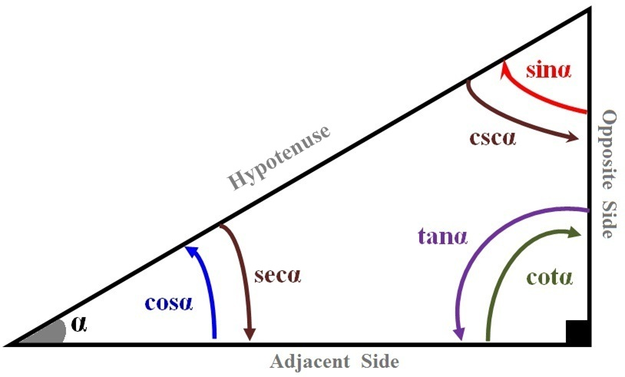 ***SOH*** 

***CAH*** 

***TOA*** 







|  |  |  |  |  |  |  |  |
| --- | --- | --- | --- | --- | --- | --- | --- |
| Angle θ  in *degree* | Angle θ  in *radian* | *sin θ* | *cos θ* | *tan θ* | *cot θ* | *sec θ* | *csc θ* |
| 0° | 0 | 0 | 1 | 0 | ∞ (*undefined*) | 1 | ∞ (*undefined*) |
| 30° | π/6 |  |  |  |  |  | 2 |
| 45° | π/4 |  |  | 1 | 1 |  |  |
| 60° | π/3 |  |  |  |  | 2 |  |
| 90° | π/2 | 1 | 0 | ± ∞ | 0 | ± ∞ | 1 |
| 120° | 2π/3 |  | − | − | − | −2 |  |
| 135° | 3π/4 |  | − | −1 | −1 | − |  |
| 150° | 5π/6 |  | − | − | − | − | 2 |
| 180° | π | 0 | −1 | 0 | ± ∞ | −1 | ± ∞ |

|  |  |  |  |  |  |  |
| --- | --- | --- | --- | --- | --- | --- |
| **Function** | **Domain (*n* ∈ Ζ)** | **Range** | **I** | **II** | **III** | **IV** |
| *y = sin t* | {*t* | - ∞ < *t* < ∞} | −1 ≤ *y* ≤ 1 | **+** | **+** | − | − |
| *y = cos t* | {*t* | - ∞ < *t* < ∞} | −1 ≤ *y* ≤ 1 | **+** | − | **v** | **+** |
| *y = tan t* | {*t* | - ∞ < *t* < ∞, *t* ≠ (2n+1) π/2} | −∞ < *y* < ∞ | **+** | − | **+** | − |
| *y = cot t* | {*t* | - ∞ < *t* < ∞, *t* ≠ nπ} | −∞ < *y* < ∞ | **+** | − | **+** | − |
| *y = csc t* | {*t* | - ∞ < *t* < ∞, *t* ≠ nπ} | *y* ≤ −1, *y* ≥ 1 | **+** | **+** | − | − |
| *y = sec t* | {*t* | - ∞ < *t* < ∞, *t* ≠ (2n+1) π/2} | *y* ≤ −1, *y* ≥ 1 | **+** | − | − | **+** |

|  |  |  |
| --- | --- | --- |
|  | ***sin*** | ***cos*** |
| 0° | 0 | 4 |
| 30° | 1 | 3 |
| 45° | 2 | 2 |
| 60° | 3 | 1 |
| 90° | 4 | 0 |

|  |  |  |
| --- | --- | --- |
| 0° |  |  |
| 30° |  |  |
| 45° |  |  |
| 60° |  |  |
| 90° |  |  |

|  |  |  |
| --- | --- | --- |
| 0° |  |  |
| 30° |  |  |
| 45° |  |  |
| 60° |  |  |
| 90° |  |  |

|  |  |  |
| --- | --- | --- |
|  | ***sin*** | ***cos*** |
| 0° | 0 | 1 |
| 30° |  |  |
| 45° |  |  |
| 60° |  |  |
| 90° | 1 | 0 |

 



 

 







