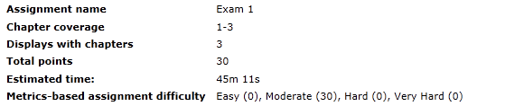

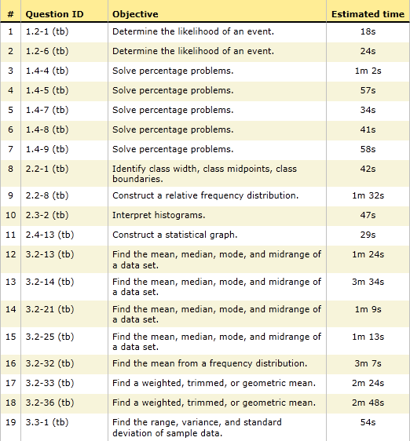

Sec 1.6 - Statistical Graphics

Sec 1.5 - Frequency Dist.

Sec 1.3 - Critical Thinking

Sec 1.7 - Measures of Center

Sec 1.3 - Critical Thinking

Sec 1.1 - Statistical Thinking

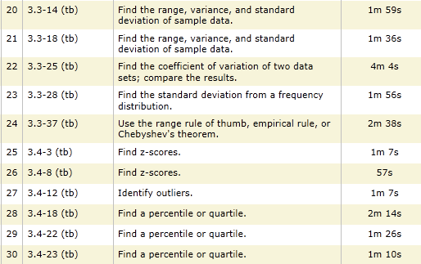

Sec 1.8 - Measures of Variation

Sec 1.9 - Measures of Rel.