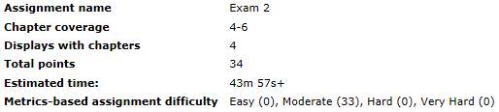

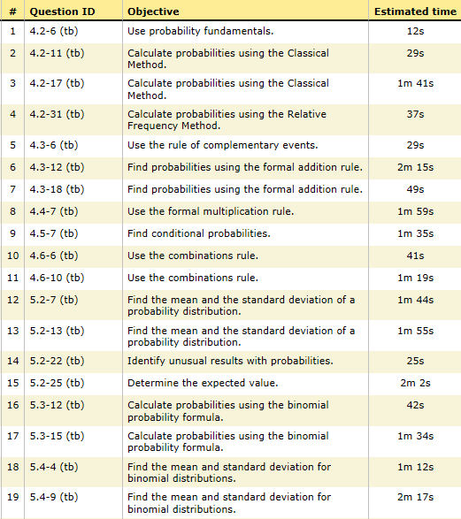

Sec 2.2

Sec 2.1

Sec 2.6

Sec 2.5

Sec 2.4

Sec 2.3

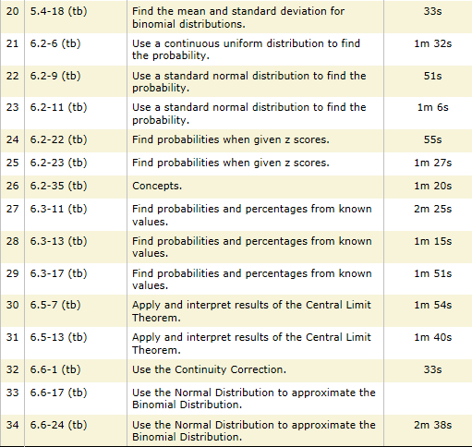

Sec 2.11

Sec 2.10

sec 2.8

Sec 2.7

Sec 2.6