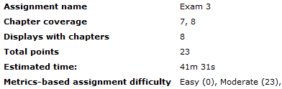

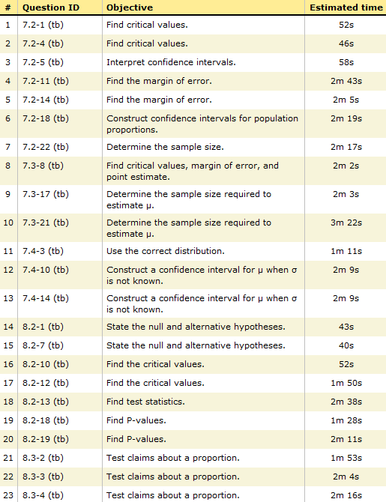

Sec 3.1

Sec 3.6

Sec 3.5

Sec 3.3

Sec 3.2