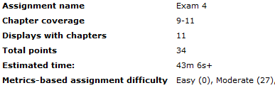

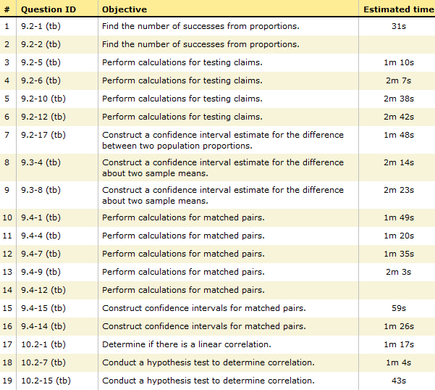

Sec 4.3

Sec 4.4

Sec 4.2

Sec 4.1

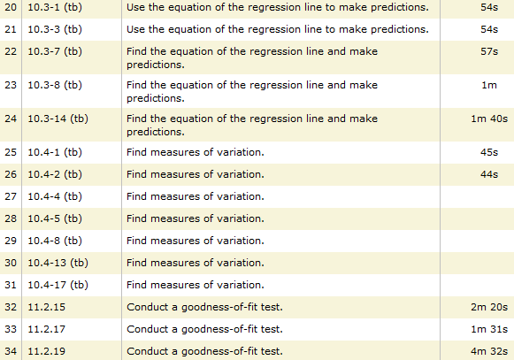

Sec 4.7

Sec 4.6

Sec 4.5