***Solution*** ***Section* 2.1 − Basic Concepts of Probability − Addition Rule**

***Exercise***

Based on recent results, the probability of someone in the U.S. being injured while using sports or recreation equipment is  (based on data from Statistical Abstract of the U.S.). What does it mean when we say that the probability is ? Is such an injury unusual?

***Solution***

The probability of being injured while using recreation equipment in  means that approximately one injury occurs for every 500 times that recreation equipment is used. The probability is  is small; such an injury is considered unusual.

***Exercise***

When a baby is born, there is approximately a 50−50 chance that the baby is a girl. Indicate the degree of likelihood as a probability value between 0 and 1.

***Solution***



***Exercise***

When a rolling a single die, there are 6 chances in 36 that the outcome is a 7. Indicate the degree of likelihood as a probability value between 0 and 1.

***Solution***



***Exercise***

Identify probability values

1. What is the probability of an event that is certain to occur?
2. What is the probability of an impossible event?
3. A sample space consists of 10 separate events that are equally likely. What is the probability of each?
4. On a true/false test, what is the probability of answering a question correctly if you make a random guess?
5. On a multiple-choice test with five possible answers for each question, what is the probability of answering a question correctly if you make a random guess?

***Solution***

1. If event E is certain to occur, then 
2. If it is not possible for event E to occur, then 
3. A sample space consists of 10 separate events that are equally likely, then 
4. 
5. 

***Exercise***

When a couple has 3 children, find the probability of each event.

1. There is exactly one girl.
2. There are exactly 2 girls.
3. All are girls

***Solution***



1. 



1. 



1.  

***Exercise***

The 110th Congress of the U.S. included 84 male Senators and 16 female Senators. If one of these Senators is randomly selected, what is the probability that a woman is selected? Does this probability agree with a claim that men and women have the same chance of being elected as Senators?

***Solution***

Total senators: 84 + 16 = 100 senators.



No; this probability is too far below 0.50 to agree with the claim that men and women have equal opportunities to become a senator.

***Exercise***

When Mendel conducted his famous genetics experiments with peas, one sample of offspring consisted of 428 green peas and 152 yellow peas. Based on those results, estimate the probability of getting an offspring pea that is green, Is the result reasonably close to the expected value of , as claimed by Mendel?

***Solution***

Total plants: 428 + 152 = 580 plants.

Let *G* = getting an offspring pea that is green.



The result is very close to the  expected by Mendel

***Exercise***

A single fair die is rolled. Find the probability of each event

1. Getting a 2
2. Getting an odd number
3. Getting a number less than 5
4. Getting a number greater than 2
5. Getting any number except 3

***Solution***

1. 
2. 
3. 
4. 
5. 

***Exercise***

A jar contains 3 white, 4 orange, 5 yellow, and 8 black marbles. If a marble is drawn at random, find the probability that it is the following.

1. White
2. Orange
3. Yellow
4. Black
5. Not black

***Solution***

1. 
2. 
3. 
4. 
5.  

***Exercise***

The student sitting next to you in class concludes that the probability of the ceiling falling down on both of you before class ends is 1/2, because there are two possible outcomes - the ceiling will fall or not fall. What is wrong with this reasoning?

***Solution***

The outcomes are not equally likely.

***Exercise***

Let consider rolling 2 dice. Find the probabilities of the following events

1. *E* = Sum of 5 turns up
2. *F* = a sum that is a prime number greater than 7 turns up

***Solution***

1. 
2. 

***Exercise***

A poll was conducted preceding an election to determine the relationship between voter persuasion concerning a controversial issue and the area of the city in which the voter lives. Five hundred registered voters were interviewed from three areas of the city. The data are shown below. Compute the probability of having no opinion on the issue or living in the inner city.

***Area of city Favor Oppose No Opinion***

East 30 40 55

North 25 45 50

Inner 95 65 85

***Solution***









***Exercise***

Suppose a single fair die is rolled. Use the sample space  and give the probability of each event.

1. E: the die shows an even number
2. F: the die show a number less than 10
3. G: the die shows an 8

***Solution***

1. Even number: 







1. Number less than 10





1. Die shows an 8

 ***Impossible***

***Exercise***

A solitaire game was played 500 times. Among the 500 trials, the game was won 77 times. (The results are from the solitaire game, and the Vegas rules of “draw 3” with $52 bet and a return of $5 per card are used). Based on these results, find the odds against winning.

***Solution***

Odd against winning are: 

Which is approximately 5.5:1 ***or*** 11:2

***Exercise***

A roulette wheel has 38 slots. One slot is 0, another is 00, and the others are numbered 1 through 36, respectively. You place a bet that the outcome is an odd number.

1. What is your probability of winning?
2. What are the actual odds against winning?
3. When you bet that the outcome is an odd number, the payoff odds are 1:1. How much profit do you make if you bet $18 and win?
4. How much profit would you make on the $18 bet if you could somehow convince the casino to change its payoff odds so that they are the same as the actual odds against winning?

***Solution***

Out of 38 slots, 18 numbers are odd.

Let *W* = outcome is an odd number occurs

1. 
2. Odds against: 
3. If you payoff odds are 1:1, if you bet $18 and win, you get back 18 + 18 = $36 and your profit is $18.
4. If you payoff odds are 10:9 (odds against), a win get back your bet $10 for every $9 bet. If you bet $18 and win, you get back 18 + 2(10) = $38 and your profit is $20.

***Exercise***

Women have a 0.25% rate of red/green color blindness. If a woman is randomly selected, what is the probability that she does not have red/green color blindness?

***Solution***

Let *W* = a selected woman has red/green color blindness.









***Exercise***

A pew Research center poll showed that 79% of Americans believe that it is morally wrong to not report all income on tax returns. What is the probability that an American does not have that belief?

***Solution***

Let *A* = a American believes is morally wrong to not report all income.









***Exercise***

When the author observed a sobriety checkpoint conducted by the Dutchess County Sheriff Department, he saw that 676 drivers were screened and 6 were arrested for driving while intoxicated. Based on those results, we can estimate that , where *I* denotes the event of screening a driver and getting someone who is intoxicated. What does  denote and what is its value?

***Solution***

 is the probability that a screened driver is not intoxicated







***Exercise***

Use the polygraph test data

|  |  |  |
| --- | --- | --- |
|  | ***No*** (Did Not Lie) | ***Yes*** (Lied) |
| Positive test result | 15  (*false positive*) | 42  (*true positive*) |
| Negative test result | 32  (*true negative*) | 9  (*false negative*) |

1. If one of the test subjects is randomly selected, find the probability that the subject had a positive test result or did not lie
2. If one of the test subjects is randomly selected, find the probability that the subject did not lie
3. If one of the test subjects is randomly selected, find the probability that the subject had a true negative test result
4. If one of the test subjects is randomly selected, find the probability that the subject had a negative test result or lied.

***Solution***

***From*** the table:



1. 







1. 
2. 
3. 







***Exercise***

Use the data

|  |  |  |
| --- | --- | --- |
| ***Was the challenge to the call successful?*** | | |
|  | ***Yes*** | ***No*** |
| Men | 201 | 288 |
| Women | 126 | 224 |

1. If *S* denotes the event of selecting a successful challenge, find 
2. If *M* denotes the event of selecting a challenge made by a man, find 
3. Find the probability that the selected challenge was made by a man or was successful.
4. Find the probability that the selected challenge was made by a woman or was successful.
5. Find 
6. Find 

***Solution***

*Total people* = 201 + 126 + 288 + 224 = 839

1. 
2. 
3. 





1. 





1. 





1. 





***Exercise***

Refer to the table below

|  |  |  |  |  |  |  |
| --- | --- | --- | --- | --- | --- | --- |
|  | ***Age*** | | | | | |
|  | 18 – 21 | 22 – 29 | 30 – 39 | 40 – 49 | 50 – 59 | 60 and over |
| ***Responded*** | 73 | 255 | 245 | 136 | 138 | 202 |
| ***Refused*** | 11 | 20 | 33 | 16 | 27 | 49 |

1. What is the probability that the selected person refused to answer? Does that probability value suggest that refusals are a problem for pollsters? Why or why not?
2. A pharmaceutical company is interested in opinions of the elderly, because they are either receiving Medicare or will receive it soon. What is the probability that the selected subject is someone 60 and over who responded?
3. What is the probability that the selected person responded or is in the 18–21 age bracket?
4. What is the probability that the selected person refused or is over 59 years of age?
5. A market researcher is interested in responses, especially from those between the ages of 22 and 39, because they are the people more likely to make purchases. Find the probability that a selected responds or is aged between the ages of 22 and 39.
6. A market researcher is not interested in refusals or subjects below 22 years of age or over 59. Find the probability that the selected person refused to answer or is below 22 or is older than 59.

***Solution***

***Let***: *Y* = there is a response *N* = there is a refusal

=73+255+245+136+138+202=1049 =11+20+33+16+27+49=156

*A* = age is 18 – 21 *B* = age is 22 – 29 *C* = age is 30 – 39

*D* = age is 40 – 49 *E* = age is 50 – 59 *F* = age is 60+

1. 
2. 
3. 







1. 







1. 

Use the intuitive approach rather than the formal addition rule









1. Use the intuitive approach rather than the formal addition rule









***Exercise***

Two dice are rolled. Find the probabilities of the following events.

1. The first die is 3 or the sum is 8
2. The second die is 5 or the sum is 10.

***Solution***

1. 







1. 







***Exercise***

One card is drawn from an ordinary of 52 cards. Find the probabilities of drawing the following cards

1. A 9 or 10
2. A red card or a 3
3. A 9 or a black 10
4. A heart or a black card
5. A face card or a diamond

***Solution***

1. 
2. 
3. 
4. 
5. 

***Exercise***

One card is drawn from an ordinary of 52 cards. Find the probabilities of drawing the following cards

1. Less than a 4 (count aces as ones)
2. A diamond or a 7
3. A black card or an ace
4. A heart or a jack
5. A red card or a face card

***Solution***

1. 
2. 
3. 
4. 
5. 

***Exercise***

Pam invites relatives to a party: her mother, 2 aunts, 3 uncles, 2 brothers, 1 male cousin, and 4 female cousins. If the chances of any one guest first equally likely, find the probabilities that the first guest to arrive is as follows.

1. A brother or an uncle
2. A brother or a cousin
3. A brother or her mother
4. An uncle or a cousin
5. A male or a cousin
6. A female or a cousin

***Solution***

1. 
2. 
3. 
4. 
5. 
6. 

***Exercise***

Suppose , , and . Find the following

1. 
2. 
3. 
4. 

***Solution***

1. 
2. 
3. 
4. 

***Exercise***

Suppose , , and . Find the following

1. 
2. 
3. 
4. 

***Solution***







1. 
2. 
3. 
4. 

***Exercise***

From survey involving 1,000 people in the certain city, it was found that 500 people had tried a certain brand of diet cola, 600 had tried a certain brand of regular cola, and 200 had tried both types of cola. If a resident of the city is selected at random, what is the empirical probability that

1. The resident has not tried either cola? What are the empirical odds for this event?
2. The resident has tried the diet or has not tried the regular cola? What are the empirical odds against this event?

***Solution***

1. *n*(S) = 1000 



300











100

***D***

***R***

 









Odds for ***E***: 

1. 









Against Odds for P(*E*): 

***Exercise***

In a poll, respondents were asked whether they had ever been in a car accident. 329 respondents indicated that they had been in a car accident and 322 respondents said that they had not been in a car accident. If one of these respondents is randomly selected, what is the probability of getting someone who has been in a car accident?

***Solution***



***Exercise***

Refer to the table which summarizes the results of testing for a certain disease

|  |  |  |
| --- | --- | --- |
|  | ***Positive Test***  ***Result*** | ***Negative Test***  ***Result*** |
| Subject has the disease | 114 | 5 |
| Subject does not have the disease | 12 | 177 |

If one of the results is randomly selected, what is the probability that it is a false negative (test indicates the person does not have the disease when in fact they do)?. What is the probability suggest about the accuracy of the test?

***Solution***

Person does not have the disease when in fact they do ⇒ Person has the disease & Negative



The probability of this error is low so the test is fairly accurate.

***Exercise***

In a certain town, 2% of people commute to work by bicycle. If a person is selected randomly from the town, what are the odds against selecting someone who commutes by bicycle?

***Solution***







***Exercise***

Suppose you are playing a game of chance, if you bet $4 on a certain event, you will collect $176 (including your $4 bet) if you win. Find the odds used for determining the payoff.

***Solution***

The amount that you win: 

You loose: 





***Solution*** ***Section* 2.2 − Multiplication Rule: Basics, Complements and Conditional**

***Exercise***

Use the data below:

|  |  |  |
| --- | --- | --- |
|  | ***No*** (Did Not Lie) | ***Yes*** (Lied) |
| Positive test result | 15  (*false positive*) | 42  (*true positive*) |
| Negative test result | 32  (*true negative*) | 9  (*false negative*) |

1. If 2 of the 98 test subjects are randomly selected without replacement find the probability that they both had false positive results. Is it unusual to randomly select 2 subjects without replacement and get 2 results that are both false positive results? Explain.
2. If 3 of the 98 test subjects are randomly selected without replacement, find the probability that all had false positive results. Is it unusual to randomly select 3 subjects without replacement and get 3 results that are all false positive results? Explain.
3. If 4 of the test subjects are randomly selected without replacement find the probability that, in each case, the polygraph indicated that the subject lied. Is such an event unusual?
4. If 4 of the test subjects are randomly selected without replacement find the probability that they all had incorrect test result (either false positive or false negative). Is such an event Likely?
5. Assume that 1 of the 98 test subjects is randomly selected. Find the probability of selecting a subject with a negative test result, given that the subject lied. What does this result suggest about the polygraph test?
6. Find 

|  |  |  |  |
| --- | --- | --- | --- |
|  |  | ***L*** |  |
| ***P*** | 15 | 42 | 57 |
| ***N*** | 32 | 9 | 41 |
|  | 47 | 51 | **98** |

1. Find 

***Solution***

Let *F* = selected person had false positive results

Let *P* = selected person tested positive

1. 





Yes; since 0.0221 ≤ 0.05, getting 2 subjects who had false positives would be unusual.

1. 





Yes; since 0.00229 ≤ 0.05, getting 3 subjects who had false positives would be unusual.

1. 





No; since 0.109 > 0.05, getting 4 subjects who had false positives would not be unusual.

1. Let *I* = selected person had incorrect results.









Yes; since 0.00294 ≤ 0.05, getting 4 subjects who had incorrect results would be unusual.

1. 

This result suggests that the polygraph is not very reliable because 17.6% of the time it fails to catch a person who really is lying.

1. 
2. 

***Exercise***

Use the data in the table below

|  |  |  |  |  |
| --- | --- | --- | --- | --- |
|  | ***Group*** | | | |
| ***Type*** | ***O*** | ***A*** | ***B*** | ***AB*** |
|  | 39 | 35 | 8 | 4 |
|  | 6 | 5 | 2 | 1 |

1. If 2 of the 100 subjects are randomly selected, find the probability that they are both group O and type 
2. Assume that the selections are made with replacement.
3. Assume that the selections are made without replacement.
4. If 3 of the 100 subjects are randomly selected, find the probability that they are both group B and type 
5. Assume that the selections are made with replacement.
6. Assume that the selections are made without replacement.
7. People with blood that is group O and type  are considered to be universal donors, because they can give blood to anyone. If 4 of the 100 subjects are randomly selected, find the probability that they are all universal donors.
8. Assume that the selections are made with replacement.
9. Assume that the selections are made without replacement.
10. People with blood that is group AB and type  are considered to be universal donors, because they can give blood to anyone. If 3 of the 100 subjects are randomly selected, find the probability that they are all universal recipients.
11. Assume that the selections are made with replacement.
12. Assume that the selections are made without replacement.

***Solution***

1. 
2. 
3. 
4. 
5. 
6. 
7. 
8. 
9. 
10. 
11. 
12. 

***Exercise***

With one method of a procedure called *acceptance sampling*, a sample of items is randomly selected without replacement and the entire batch is accepted if every item in the sample is okay. The Telektronics Company manufactured a batch of 400 backup power supply units for computers, and 8 of them are defective. If 3 of the units are randomly selected for testing, what is the probability that the entire batch will be accepted?

***Solution***

Let *P* = power supply unit is OK.









***Exercise***

It is common for public opinion polls to have a “confidence level” of 95% meaning that there is a 095 probability that the poll results are accurate within the claimed margins of error. If each of the following organizations conducts an independent poll, find the probability that all of them are accurate within the claim margins of error: Gallup, Roper, Yankelovich, Harris, CNN, ABC, CBS, and NBC, New York Times. Does the result suggest that with a confidence level of 95%, we can expect that almost all polls will be within the claimed margin of error?

***Solution***

Let *A* = public opinion poll is accurate within its margin of error.

Each polling organization: 









No, with 9 independent polls the probability that at least one of them is not accurate within its margin of error is





***Exercise***

The principle of redundancy is used when system reliability is improved through redundant or back up components. Assume that your alarm clock has a 0.9 probability of working on any given morning.

1. What is the probability that your alarm clock will not work on the morning of an important final exam?
2. If you have 2 such alarm clocks, what is the probability that they both fail on the morning of an important final exam?
3. With one alarm clock, you have a 0.9 probability of being awakened. What is the probability of being awakened if you use two alarm clocks?
4. Does a second alarm clock result in greatly improved reliability?

***Solution***

Let *A* = alarm works.

For each alarm: 

1. 
2. 





1. 







1. From parts (*b*) and (*c*) assume that the alarm clocks work independently of each other. This would not be true if they are both electric alarm clocks.

***Exercise***

The wheeling Tire Company produced a batch of 5,000 tires that includes exactly 200 that are defective.

1. If 4 tires are randomly selected for installation on a car, what is the probability that they are all good?
2. If 100 tires are randomly selected for shipment to an outlet, what is the probability that they are all good? Should this outlet plan to deal with defective tires returned by consumers?

***Solution***

Let *G* = getting a good tire.



1. 





1. Since *n* = 100 represents  of the population, use the 5% guideline and treat the repeated selections as being independent.









Yes; since 0.0169 ≤ 0.05, getting 100 good tires would be unusual event and the outlet should plan on dealing with returns of defective tires.

***Exercise***

When the 15 players on the LA Lakers basketball team are tested for steroids, at least one of them tests positive. Provide a written description of the complement of this event.

***Solution***

If it is not true that at least one of the 15 tests positive, then all 15 of them test negative.

***Exercise***

If a couple plans to have 6 children, what is the probability that they will have at least one girl? Is that probability high enough for the couple to be very confident that they will get at least one girl in six children?

***Solution***











Yes, the probability is high enough for the couple to be very confident that they will get at least one girl in 6 children.

***Exercise***

If a couple plans to have 8 children (it could happen), what is the probability that they will have at least one girl? Is the couple eventually has 8 children and they are all boys, what can the couple conclude?

***Solution***







 



If the couple has 8 boys, either a very rare event has occurred or there is some environmental or genetic factor that makes boys more likely for this couple.

***Exercise***

If you make guesses for 4 multiple-choice test questions (each with 5 possible answers), what is the probability of getting at least one correct? If a very lenient instructor says that passing test occurs if there is at least one correct answer, can you reasonably expect to pass by guessing?

***Solution***











Since there is a greater chance of passing than of failing, the expectation is that such a strategy would lead to passing. In that sense, one can reasonably expect to pass by guess. Nut while the expectation for a single test may be pass, such a strategy can be expected to lead to failing about 4 times every 10 times it is applied.

***Exercise***

Find the probability of a couple having a baby girl when their fourth child is born, given that the first 3 children were all girls. Is the result the same as the probability of getting 4 girls among 4 children?

***Solution***

Sample Space:



Let *F* = first 3 children are girls.

Let = fourth child is a girl.

 









 independent (occurred during the first 3 births)

This probability is not true the same as 

***Exercise***

In China, the probability of a baby being a boy is 0.5845. Couples are allowed to have only one child. If relatives give birth to 5 babies, what is the probability that there is at least one girl? Can that system continue to work indefinitely?

***Solution***







 



Probably not; the system will produce such a shortage of females that baby girls will become a valuable asset and parents will take appropriate measures to change the probabilities.

***Exercise***

An experiment with fruit flies involves one parent with normal wings and one parent with vestigial wings. When these parents have an offspring, there is a  probability that the offspring has normal wings and a  probability of vestigial wings. If the parents give birth to 10 offspring, what is the probability that at least 1 of the offspring has vestigial wings? If researchers need at least one offspring with vestigial wings, can they be reasonably confident of getting one?

***Solution***









 



Yes, the researchers can be 94.4% certain of getting at least one such offspring.

***Exercise***

According to FBI data, 24.9% of robberies are cleared with arrests. A new detective is assigned to 10 different robberies.

1. What is the probability that at least 1 of them is cleared with an arrest?
2. What is the probability that the detective clears all 10 robberies with arrests?
3. What should we conclude if the detective clears all 10 robberies with arrests?

***Solution***

Let 



1. 







 



1. 









1. If the detective clears all 10 cases with arrests, we should conclude that the  rate does not apply to this detective − The probability he clears a case with an arrest is much higher than 0.249.

***Exercise***

A statistics student wants to ensure that she is not late for an early statistics class because of a malfunctioning alarm clock. Instead of using one alarm clock, she decides to use three. What is the probability that at least one of her alarm clocks works correctly if each individual alarm clock has a 90% chance of working correctly? Does the student really gain much by using three alarm clocks instead on only one? How are the results affected if all of the alarm clocks run on electricity instead of batteries?

***Solution***

Let 











Yes, the probability of a working clock rises from 90% with just one clock to 99.9% with 3 clocks? If the alarm clocks run on electricity instead of batteries, then the clocks do not operate independently and the failure of one could be the result of a power failure or interruption and may be related to the failure of another  no longer 

***Exercise***

In a batch of 8,000 clock radios 8% are defective. A sample of 5 clock radios is randomly selected without replacement from the 8,000 and tested. The entire batch will be rejected if at least one of those tested is defective. Find the probability that the entire batch will be rejected.

***Solution***

Number of defective radios: 









***Exercise***

In a blood testing procedure, blood samples from 3 people are combined into one mixture. The mixture will only test negative if all the individual samples are negative. If the probability that an individual sample tests positive is 0.1, find the probability that the mixture will test positive.

***Solution***

Probability that the mixture will test positive = 1 − (probability all negative)





***Exercise***

A sample of 4 different calculators is randomly selected from a group containing 16 that are defective and 36 that have no effects. Find the probability that at least one of the calculator is defective.

***Solution***









***Exercise***

Among the contestants in a competition are 46 women and 29 men. If 5 winners are randomly selected, find the probability that they are all men?

***Solution***



***Exercise***

A bin contains 60 lights bubs of which 7 are defective. If 4 light bulbs are randomly selected from the bin with replacement, find the probability that all the bulbs selected are good ones.

***Solution***



***Exercise***

You are dealt two cards successively (without replacement) from a shuffled deck of 52 playing cards. Find the probability that both cards are black. Express your answer as a simplified fraction.

***Solution***



***Solution*** ***Section* 2.3 − Counting**

***Exercise***

Find the number of different ways that five test questions can be arranged in order by evaluating 5!

***Solution***



***Exercise***

In the game of blackjack played with one deck, a player is initially dealt 2 cards. Find the number of different two-card initial hands by evaluating 

***Solution***

  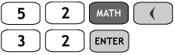

***Exercise***

A political strategist must visit state capitols, but she has time to visit only 3 of them. Find the number of different possible routes by evaluating 

***Solution***

  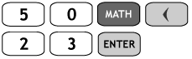

***Exercise***

Select the six winning numbers from 1, 2, …, 54. Find the probability of winning lottery by buying one ticket. 

***Solution***



Since only one combination wins



***Exercise***

Select the five winning numbers from 1, 2, …, 36. Find the probability of winning lottery by buying one ticket. 

***Solution***



Since only one combination wins



***Exercise***

In a club with 9 male and 11 female members, how many 5-member committees can be chosen that have

1. All men?
2. All women?
3. 3 men and 2 women?

***Solution***

1. 
2. 
3. 

***Exercise***

In a club with 9 male and 11 female members, how many 5-member committees can be selected that have

1. At least 4 women?
2. No more than 2 men?

***Solution***

1. 
2. 

***Exercise***

In how many ways can 5 out of 9 plants be arranged in a row on a windowsill?

***Solution***



***Exercise***

From a pool of 8 secretaries, 3 are selected to be assigned to 3 managers, one per manager. In how many ways can they be selected and assigned?

***Solution***



***Exercise***

A group of 9 workers decides to send a delegation of 3 to their supervisor to discuss their grievances.

1. How many delegations are possible?
2. If it is decided that a particular worker must be in the delegation, how many different delegations are possible?
3. If there are 4 women and 5 men in the group, how many delegations would include at least 1 woman?

***Solution***

1. 
2. 
3. 

***Exercise***

Hamburger Hut sells regular hamburgers as well as a larger burger. Either type can include cheese, relish, lettuce, tomato, mustard, or catsup.

1. How many different hamburgers can be ordered with exactly three extras?
2. How many different regular hamburgers can be ordered with exactly three extras?
3. How many different regular hamburgers can be ordered with at least five extras?

***Solution***

1. 
2. 
3. 

***Exercise***

In an experiment on plant hardiness, a researcher gathers 6 wheat plants, 3 barley plants, and 2 rye plants. She wishes to select 4 plants at random.

1. In how many ways can this be done?
2. In how many ways can this be done if exactly 2 wheat plants must be included?

***Solution***

1. 
2. 

***Exercise***

A legislative committee consists of 5 Democrats and 4 Republicans. A delegation of 3 is to be selected to visit a small Pacific island republic.

1. How many different delegations are possible?
2. How many delegations would have all Democrats?
3. How many delegations would have 2 Democrats and 1 Republican?
4. How many delegations would have at least 1 Republican?

***Solution***

1. 
2. 
3. 
4. 

***Exercise***

Five cards are chosen from an ordinary deck to form a hand in poker. In how many ways is it possible to get the following results?

1. 4 queens
2. No face card
3. Exactly 2 face cards
4. At least 2 face cards
5. 1 heart, 2 diamonds, and 2 clubs

***Solution***

1. 
2. 
3. 
4. 
5. 

***Exercise***

The student sitting next to you in class concludes that the probability of the ceiling falling down on both of you before class ends is 1/2, because there are two possible outcomes - the ceiling will fall or not fall. What is wrong with this reasoning?

***Solution***

The outcomes are not equally likely.

***Exercise***

Identity theft often begins by someone discovering your 9-digit social security number. Answer each of the following. Express probabilities as fractions.

1. What is the probability of randomly generating 9 digits and getting your social security number?
2. In the past, many teachers posted grades along with the last 4 digits of your social security number, what is the probability that if they randomly generated the order digits, they would match yours? Is that something to worry about?

***Solution***

1. Let *G* = generating a given social security number in a single trial.

Total number of possible sequences 



Since only one sequence is correct: 

1. Let *F* = generating first 5 digits of a given social security number in a single trial.

Total number of possible sequences 



Since only one sequence is correct: 

Since this probability is so small, need not worry about the given scenario

***Exercise***

Credit card numbers typically have 16 digits, but not all of them are random. Answer the following and express probabilities as fractions.

1. What is the probability of randomly generating 16 digits and getting your MasterCard number?
2. Receipts often show the last 4 digits of a credit card number. If those last 4 digits are known, what is the probability of randomly generating the order digits of your MasterCard number?
3. Discover cards begin with the digits 6011. If you also know the last 4 digits, what is the probability of randomly generating the other digits and getting all of them correct? Is this something to worry about?

***Solution***

1. Let *G* = generating a given credit card number in a single trial.

Total number of possible sequences 



Since only one sequence is correct: 

1. Let *F* = generating first 12 digits of a given credit card number in a single trial.

Total number of possible sequences 



Since only one sequence is correct: 

1. Let *M* = generating the middle digits of a given credit card number in a single trial.

Total number of possible sequences 



Since only one sequence is correct: 

This is not something to worry about.

***Exercise***

When testing for current in a cable with five color-coded wires, the author used a meter to test two wires at a time. How many different tests are required for every possible pairing of two wires?

***Solution***

Since the order of the 2 wires being tested is irrelevant:



***Exercise***

The starting 4 players for the Boston Celtics basketball team have agreed to make charity appearances tomorrow night. If you must send three players to the United Way event and the other 2 to a Heart Fund event, how many different ways can you make the assignments?

***Solution***

Since the order in which the 3 are picked makes no difference.



***Exercise***

In phase I of a clinical trial with gene therapy used for treating HIV, 5 subjects were treated (based on data from Medical News Today). If 20 people were eligible for the Phase I treatment and a simple random of 5 is selected, how many different simple random samples are possible? What is the probability of each simple random sample?

***Solution***

Since the order in which the subjects are placed in the groups is not relevant.





***Exercise***

Many newspapers carry “Jumble” a puzzle in which the reader must unscramble letters to form words. The letters BUJOM were included in newspapers. How many ways can the letters if BUJOM be arranged? Identify the correct unscrambling and then determine the probability of getting that result by randomly selecting one arrangement of the given letters.

***Solution***

The number of possible sequences: 

The unscrambled sequence word is JUMBO.

Since there is only 1 correct sequence; the probability of finding it with one random arrangement is

***Exercise***

There are 11 members on the board of directors for the Coca Cola Company.

1. If they must select a chairperson, first vice chairperson, second vice chairperson, and secretary, how many different slates of candidates are possible?
2. If they must form an ethics subcommittee of 4 members, how many different subcommittees are possible?

***Solution***

1. Since order makes a difference, there are 4 different offices 
2. Since the order in which the 4 are picked makes no differences 

***Exercise***

The author owns a safe in which he stores his book. The safe combination consists of 4 numbers between 0 and 99. If another author breaks in and tries to steal this book, what is the probability that he or she will get the correct combination on the first attempt? Assume that the numbers are randomly selected. Given the number of possibilities, does it seem feasible to try opening the safe by making random guesses for the combination?

***Solution***

There are 4 tasks to perform, and each task can be performed in any of 100 ways.

Total number of possible sequence is 

Since there is only one correct sequence, the probability of finding is 

Since there are so many possibilities, it would not be feasible to try opening the safe by making random guesses.

***Exercise***

In a preliminary test of the MicroSort gender selection method, 14 babies were born and 13 of them were girls

1. Find the number of different possible sequences of genders that are possible when 14 babies are born.
2. How many ways can 13 girls and 1 boy be arranged in a sequence?
3. If 14 babies are randomly selected, what is the probability that they consist of 13 girls and 1 boy?
4. Does the gender-selection method appear to yield a result that is significantly different from a result that might be expected by random chance?

***Solution***

1. There are 14 tasks to perform, and each task can be performed in either of 2 ways

Total number of possible sequences is 



1. The number of possible sequences of *n* objects is when some are alike is



1. 
2. Yes, since  is so small, and since 13G, 1B so far (only the 14G, 0B result is more extreme) from the expected 7G, 7B result, the gender-selection method appears to yield results significantly different from those of chance alone.

***Exercise***

You become suspicious when a genetics researcher randomly selects groups of 20 newborn babies and seems to consistently get 10 girls and 10 boys. The researchers claims that it is common to get 10 girls and 10 boys in such cases,

1. If 20 newborn babies are randomly selected, how many different gender sequences are possible?
2. How many different ways can 10 girls and 10 boys be arranged in sequence?
3. What is the probability of getting 10 girls and 10 boys when 10 babies are born?
4. Based on the preceding results, do you agree with the researcher’s explanation that ir is common to get 10 girls and 10 boys when 20 babies are randomly selected?

***Solution***

1. There are 20 tasks to perform, and each task can be performed in either of 2 ways

Total number of possible sequences is 



1. The number of possible sequences of *n* objects is when some are alike is



1. 
2. It is not unusual for an event with probability 0.176 to occur once, but repeated occurrences should be considered unusual – as the probability of the event occurring twice in a row, for example, is .

***Exercise***

The Powerball lottery is run in 29 states. Winning the jackpot requires that you select the correct five numbers between 1 and 55 and, in a separate drawing, you must also select the correct single number between 1 and 42. Find the probability of winning the jackpot.

***Solution***

Let *A* = selecting the correct 5 numbers from 1 to 55

Let B = selecting the correct winning number from 1 to 42

The number of possible selection: 

Since there is only one winning number: 

There are 42 possible selections.

Since there is only one winning number: 











***Exercise***

The Mega Millions lottery is run in 12 states. Winning the jackpot requires that you select the correct 5 numbers between 1 and 56 and, in a separate drawing, you must also select the correct single number between 1 and 46. Find the probability of winning the jackpot.

***Solution***

Let *A* = selecting the correct 5 numbers from 1 to 56

Let B = selecting the correct winning number from 1 to 46

The number of possible selection: 

Since there is only one winning number: 

There are 46 possible selections.

Since there is only one winning number: 











***Exercise***

A state lottery involves the random selection of six different numbers between 1 and 31. If you select one six number combination, what is the probability that it will be the winning combination?

***Solution***



***Exercise***

How many ways can 6 people be chosen and arranged in a straight line if there are 8 people to choose from?

***Solution***



***Exercise***

12 wrestlers compete in a competition. If each wrestler wrestles one match with each other wrestler, what are the total numbers of matches?

***Solution***



***Solution Section* 2.4 − Random Variables**

***Exercise***

Determine whether or not a probability distribution is given. If a probability is given, find its mean and standard deviation. If the probability is not given, identify the requirements that are not satisfied.

|  |  |  |  |  |  |  |  |  |  |  |  |  |  |  |  |  |  |  |  |  |  |
| --- | --- | --- | --- | --- | --- | --- | --- | --- | --- | --- | --- | --- | --- | --- | --- | --- | --- | --- | --- | --- | --- |
| *a*)   |  |  | | --- | --- | | ***x*** |  | | 0 | 0.125 | | 1 | 0.375 | | 2 | 0.375 | | 3 | 0.125 | | *b*)   |  |  | | --- | --- | | ***x*** |  | | 0 | 0.22 | | 1 | 0.16 | | 2 | 0.21 | | 3 | 0.16 | |
| *c*)   |  |  | | --- | --- | | ***x*** |  | | 0 | 0.528 | | 1 | 0.360 | | 2 | 0.098 | | 3 | 0.013 | | 4 | 0.001 | | 5 | 0+ |   0+ denotes a positive probability value that is very small. | *d*)   |  |  | | --- | --- | | ***x*** |  | | 0 | 0.02 | | 1 | 0.15 | | 2 | 0.29 | | 3 | 0.26 | | 4 | 0.16 | | 5 | 0.12 | |

***Solution***

1. Since 

|  |  |  |  |  |
| --- | --- | --- | --- | --- |
| ***x*** |  |  |  |  |
| 0 | 0.125 | 0 | 0 | 0 |
| 1 | 0.375 | 0.375 | 1 | 0.375 |
| 2 | 0.375 | 0.750 | 4 | 1.500 |
| 3 | 0.125 | 0.375 | 9 | 1.125 |
|  | 1.000 | 1.500 |  | 3.000 |

***Mean***: 

*Variance*: 

***Standard deviation***: 

1. Since 



This given table is not a probability distribution.

1. Since 

|  |  |  |  |  |
| --- | --- | --- | --- | --- |
| ***x*** |  |  |  |  |
| 0 | 0.528 | 0 | 0 | 0 |
| 1 | 0.360 | 0.360 | 1 | 0.360 |
| 2 | 0.098 | 0.196 | 4 | 0.392 |
| 3 | 0.013 | 0.039 | 9 | 0.117 |
| 4 | 0.001 | .004 | 16 | 0.016 |
| 5 | 0+ | 0 | 25 | 0 |
|  | 1.000 | 0.599 |  | 0.885 |

***Mean***: 

*Variance*: 

***Standard deviation***: 

1. Since 

|  |  |  |  |  |
| --- | --- | --- | --- | --- |
| ***x*** |  |  |  |  |
| 0 | 0.02 | 0 | 0 | 0 |
| 1 | 0.15 | 0.15 | 1 | 0.15 |
| 2 | 0.29 | 0.58 | 4 | 1.16 |
| 3 | 0.26 | 0.78 | 9 | 2.34 |
| 4 | 0.16 | 0.64 | 16 | 2.56 |
| 5 | 0.12 | 0.60 | 25 | 3.00 |
|  | 1.000 | 2.75 |  | 9.21 |

***Mean***: 

*Variance*: 

***Standard deviation***: 

***Exercise***

Based on past results found in the *Information Please Almanac*, there is a 0.1919 probability that a baseball World Series context will last 4 games, is a 0.2121 probability that it will last 5 games, a 0.2222 probability that it will last 6 games, a 0.3737 probability that us will last 7 games.

1. Does the given information describe a probability distribution?
2. Assuming that the given information describes a probability distribution, find the mean and standard deviation for the numbers of games in World Series contests.
3. Is it unusual for a team to “sweep” by winning in four games? Why or why not?

***Solution***

1. Since 

|  |  |  |  |  |
| --- | --- | --- | --- | --- |
| ***x*** |  |  |  |  |
| 4 | 0.1919 | 0.7676 | 16 | 3.0704 |
| 5 | 0.2121 | 1.0605 | 25 | 5.3025 |
| 6 | 0.2222 | 1.3332 | 36 | 7.9992 |
| 7 | 0.3737 | 2.6159 | 49 | 18.3113 |
|  | 0.9999 | 5.7772 |  | 34.6834 |

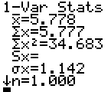***Mean***: 

*Variance*: 

***Standard deviation***: 

1. 
2. No, since  , winning in 4 games is not an unusual event.

***Exercise***

Based on information from MRI Network, some job applicants are required to have several interviews before a decision is made. The number of required interviews and the corresponding probabilities are: 1 (0.09); 2 (0.31); 3 (0.37); 4 (0.12); 5 (0.05); 6 (0.05).

1. Does the given information describe a probability distribution?
2. Assuming that a probability distribution is described, find its mean and standard deviation.
3. Use the range rule of thumb to identify the range of values for usual numbers of interviews.
4. Is it unusual to have a decision after just one interview? Explain?

***Solution***

1. Since 

|  |  |  |  |  |
| --- | --- | --- | --- | --- |
| ***x*** |  |  |  |  |
| 1 | 0.09 | 0.09 | 1 | 0.09 |
| 2 | 0.31 | 0.62 | 4 | 1.24 |
| 3 | 0.37 | 1.11 | 9 | 3.33 |
| 4 | 0.12 | 0.48 | 16 | 1.92 |
| 5 | 0.05 | 0.25 | 25 | 1.25 |
| 6 | 0.05 | 0.30 | 36 | 1.80 |
|  | 0.99 | 2.85 |  | 9.63 |

***Mean***: 

*Variance*: 

***Standard deviation***: 

1. 
2. The range rule of thumb suggests that “usual” values are those within two standard deviations of the mean.

*Minimum usual value* 

*Maximum usual value* 

The range of values for usual numbers of interviews is from 0.5 to 5.3.

1. No, since  , it is not unusual to have a decision after just one interview.

***Exercise***

Based on information from Car dealer, when a car is randomly selected the number of bumper stickers and the corresponding probabilities are: 0 (0.824); 1 (0.083); 2 (0.039); 3 (0.014); 4 (0.012); 5 (0.008); 6 (0.008); 7 (0.004); 8 (0.004); 9 (0.004).

1. Does the given information describe a probability distribution?
2. Assuming that a probability distribution is described, find its mean and standard deviation.
3. Use the range rule of thumb to identify the range of values for usual numbers of bumper stickers.
4. Is it unusual for a car to have more than one bumper sticker? Explain?

***Solution***

1. Since 

|  |  |  |  |  |
| --- | --- | --- | --- | --- |
| ***x*** |  |  |  |  |
| 0 | 0.824 | 0 | 0 | 0 |
| 1 | 0.083 | 0.083 | 1 | 0.83 |
| 2 | 0.039 | 0.078 | 4 | 0.156 |
| 3 | 0.014 | 0.042 | 9 | 0.126 |
| 4 | 0.012 | 0.048 | 16 | 0.192 |
| 5 | 0.008 | 0.040 | 25 | 0.288 |
| 6 | 0.008 | 0.048 | 36 | 0.288 |
| 7 | 0.004 | 0.028 | 49 | 0.196 |
| 8 | 0.004 | 0.032 | 64 | 0.256 |
| 9 | 0.004 | 0.036 | 81 | 0.324 |
|  | 1.000 | 0.435 |  | 1.821 |

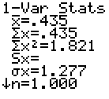***Mean***: 

*Variance*: 

***Standard deviation***: 

1. 
2. The range rule of thumb suggests that “*usual*” values are those within two standard deviations of the mean.

*Minimum usual value* 

*Maximum usual value* 

The range of values for usual numbers of interviews is from 0 to 3.0.

1. No, since  , it is not unusual to have more than 1 bumper sticker.

***Exercise***

A Company hired 8 employees from a large pool of applicants with an equal numbers of males and females. If the hiring is done without regard to sex, the numbers of females hired and the corresponding probabilities are: 0 (0.004); 1 (0.0313); 2 (0.109); 3 (0.219); 4 (0.273); 5 (0.219); 6 (0.109); 7 (0.031); 8 (0.004).

1. Does the given information describe a probability distribution?
2. Assuming that a probability distribution is described, find its mean and standard deviation.
3. Use the range rule of thumb to identify the range of values for usual numbers of females hired in such groups of 8.
4. If the most recent group of 8 newly hired employees does not include any females, does there appear to be discrimination based on sex? Explain?

***Solution***

1. Since 

|  |  |  |  |  |
| --- | --- | --- | --- | --- |
| ***x*** |  |  |  |  |
| 0 | 0.004 | 0 | 0 | 0 |
| 1 | 0.031 | 0.031 | 1 | 0.031 |
| 2 | 0.109 | 0.218 | 4 | 0.436 |
| 3 | 0.219 | 0.657 | 9 | 1.971 |
| 4 | 0.273 | 1.092 | 16 | 4.368 |
| 5 | 0.219 | 1.095 | 25 | 5.475 |
| 6 | 0.109 | 0.654 | 36 | 3.924 |
| 7 | 0.031 | 0.217 | 49 | 1.519 |
| 8 | 0.004 | 0.032 | 64 | 0.256 |
|  | 0.999 | 3.996 |  | 17.980 |

***Mean***: 

*Variance*: 

***Standard deviation***: 

1. 
2. The range rule of thumb suggests that “*usual*” values are those within two standard deviations of the mean.

*Minimum usual value* 

*Maximum usual value* 

The range of values for usual numbers of interviews is from 1.2 to 6.8.

1. Yes, since  , it would be unusual to hire no females if only factors were in operation.

***Exercise***

Let the random variable *x* represent the number of girls in a family of 4 children. Construct a table describing the probability distribution; then find the mean and the standard deviation. (Hint: List the different possible outcomes.) Is it unusual for a family of 3 children to consist of 3 girls?

***Solution***

The sample space is: 

Therefore, there are 8 equally likely possible outcomes.

|  |  |  |  |  |
| --- | --- | --- | --- | --- |
| ***x*** |  |  |  |  |
| 0 | 0.125 | 0 | 0 | 0 |
| 1 | 0.375 | 0.375 | 1 | 0.375 |
| 2 | 0.375 | 0.750 | 4 | 1.500 |
| 3 | 0.125 | 0.375 | 9 | 1.125 |
|  | 1.000 | 1.500 |  | 3.000 |

***Mean***: 

*Variance*: 

***Standard deviation***: 



No, since  , it is not unusual for a family to have all girls.

***Exercise***

In 4 lottery game, you pay 50¢ to select a sequence of 4 digits, such 1332. If you select the same sequence of 4 digits that are drawn, you win and collect $2788.

1. How many different selections are possible?
2. What is the probability of winning?
3. If you win, what is your net profit?
4. Find the expected value.

***Solution***

1. Since each of the 4 positions could be filled with replacement by any of the 10 digits



1. Since only one possible selection: 
2. The net profit is the payoff minus the original bet. $2,788.00 − $0.50 = $2,787.50

|  |  |  |  |
| --- | --- | --- | --- |
| ***Event*** |  |  |  |
| Lose | −$0.50 | 0.9999 | −$.49995 |
| Gain | $2787.50 | 0.0001 | $0.27875 |
| Total |  |  | −$0.2212 |

1. The expected value is −22.1¢

***Exercise***

When playing roulette at casino, a gambler is trying to decide whether to bet $5 on the number 13 or bet $5 that the outcomes any one of these 5 possibilities: 0 or 00 or 1 or 2 or 3.the expected value of the $5 bet for a single number is −26¢. For the $5 bet that the outcome 0 or 00 or 1 or 2 or 3, there is a probability of  of making a net profit of $30 and a  probability of losing $5.

1. Find the expected value for the $5 bet that the outcome is 0 or 00 or 1 or 2 or 3.
2. Which bet is better: A $5 bet on the number 13 or a $5 bet the outcome is 0 or 00 or 1 or 2 or 3? Why?

***Solution***

|  |  |  |  |
| --- | --- | --- | --- |
| ***Event*** |  |  |  |
| Lose | −5 |  | − |
| Gain | 30 |  |  |
| Total |  | 1 | −0.3947 |

The expected value is −39.5¢

1. Since −26 > −39.5, wagering $5 on the number 13 is the better bet.

***Exercise***

There is a 0.9986 probability that a randomly selected 30-year-old male lives through the year. As insurance company charges $161 for insuring that the male will live through the year. If the male does not survive the year, the policy pays out $100,000 as a death benefit.

1. From the perspective of the 30-year-old male, what are the values corresponding to the 2 events of surviving the year and not surviving?
2. If a 30-year-old male purchases the policy, what is his expected value?
3. Can the insurance company expect to make a profit from many such policies? Why?

***Solution***

1. From the 30-year-old male’s perspective, the 2 possible outcome values are −$161, if he lives  is he dies.

|  |  |  |  |
| --- | --- | --- | --- |
| ***Event*** |  |  |  |
| Lose | −161 | 0.9986 | −160.7446 |
| Gain | 99,839 | 0.0014 | 139.7746 |
| Total |  | 1.0000 | −21 |

The expected value is −$21.0

1. Yes; the insurance company can expect to make an average of $21.00 per policy.

***Solution Section* 2.5 − Binomial Distributions**

***Exercise***

20 different Senators are randomly selected from the 100 Senators in the current Congress, and each was asked whether he or she is in favor of abolishing estate taxes. Does this procedure result in a binomial distribution, if it is not binomial, identify at least one requirement that is not satisfied?

***Solution***

NO; requirements (2) and (4) are not met.

Since  and the selections are done without replacement, the trials cannot be considered independent. The value of *p* of obtaining a success changes from trial to trial as each selection without replacement changes the population from which the next selection is made.

***Exercise***

15 different Governors are randomly selected from the 50 Governors in the currently office and the sex of each Governor is recorded. Does this procedure result in a binomial distribution, if it is not binomial, identify at least one requirement that is not satisfied?

***Solution***

NO; requirements (2) and (4) are not met.

Since  and the selections are done without replacement, the trials cannot be considered independent. The value of *p* of obtaining a success changes from trial to trial as each selection without replacement changes the population from which the next selection is made.

***Exercise***

200 statistics students are randomly selected and each asked if he or she owns a TI-84 Plus calculator. Does this procedure result in a binomial distribution, if it is not binomial, identify at least one requirement that is not satisfied?

***Solution***

Yes; all requirements are met. Since 200 statistics students are assumed to be less than 5% of the population of all statistics students, the selections can considered to be independent – even though ther are made without replacement.

***Exercise***

Multiple choice questions on the SAT test have 5 possible answers (*a, b, c, d, e*), 1 of which is correct. Assume that you guess the answers to 3 such questions.

1. Use the multiplication rule to find the probability that the first 2 guesses are wrong and the third is correct. That is, find *P*(*WWC*), where *C* denotes a correct answer and *W* denotes a wrong answer.
2. Beginning with *WWC*, make a complete list of the different possible arrangements of 2 wrong answers and 1 correct answer, then find the probability for each entry in the list.
3. Based on the proceeding results, what is the probability of getting exactly 1 correct answer when 3 guesses are made?

***Solution***



1. 





1. There are: *WWC, WCW, CWW* – 3 possible arrangements







1. 









***Exercise***

A psychology test consists of multiple choice questions, each having 4 possible answers (*a, b, c, d*), 1 of which is correct. Assume that you guess the answers to 6 such questions.

1. Use the multiplication rule to find the probability that the first 2 guesses are wrong and the last 4 guesses are correct. That is, find *P*(*WWCCCC*), where *C* denotes a correct answer and *W* denotes a wrong answer.
2. Beginning with *WWCCCC*, make a complete list of the different possible arrangements of 2 wrong answers and 4 correct answers, then find the probability for each entry in the list.
3. Based on the proceeding results, what is the probability of getting exactly 4 correct answers when 6 guesses are made?

***Solution***



1. 







1. There are  possible arrangements.

*WWCCCC WCWCCC WCCWCC WCCCWC WCCCCW CWCCCW CCWCCW*

*CCCWCW CCCCWW CWWCCC CCWWCC CCCWWC CCCWWC CWCWCC CCWCWC*

 (part *a*)

1. 









***Exercise***

Use the Binomial Probability Table to find the probability of *x* success given the probability *p* of success on a single trial

|  |  |
| --- | --- |
|  |  |
|  |  |
|  |  |

***Solution***











From the Table: 





From the Table: 



From the Table: 



From the Table: 



From the Table: 

***Exercise***

Use the Binomial Probability Formula to find the probability of *x* success given the probability *p* of success on a single trial

|  |  |
| --- | --- |
|  |  |
|  |  |

***Solution***







 









 







 







 



***Exercise***

In the US, 40% of the population have brown eyes. If 14 people are randomly selected, find the probability that at least 12 of them have brown eyes. Is it unusual to randomly select 14 people and find that at least 12 of them have brown eyes? Why or why not?

***Solution***

Let *x* = number of people with brown eyes.

Binomial: 

From the Binomial Probability Table:







Yes, since , getting at least 12 persons with brown eyes would be unusual.

***Exercise***

When blood donors were randomly selected, 45% of them had blood that is Group *O*. The display shows that the probabilities obtained by entering the values of *n* = 5 and *p* = 0.45.

1. Find the probability that at least 1 of the 5 donors has Group *O* blood. If at least 1 Group *O* donor is needed, is it reasonable to expect that at least 1 will be obtained?
2. Find the probability that at least 3 of the 5 donors have Group *O* blood. If at least 3 Group *O* donors are needed, is it very likely to expect that at least 3 will be obtained?
3. Find the probability that all donors have Group *O* blood. Is it unusual to get 5 Group *O* donors from 5 randomly selected donors? Why or Why not?
4. Find the probability that at most 2 of the 5 donors have Group *O* blood.

|  |  |
| --- | --- |
| ***x*** | ***P*(*x*)** |
| 0 | 0.050328 |
| 1 | 0.205889 |
| 2 | 0.336909 |
| 3 | 0.275653 |
| 4 | 0.112767 |
| 5 | 0.018453 |

***Solution***

1. 





Yes, it is reasonable to expect that at least one group O donor will be obtained.

1. 







No; it is not *very likely* that at least 3 group of O donors will be obtained.

Since  getting at least 3 such donors would not be an unusual event – but it would not be considered *very likely*.

1. 

Yes, since  getting all 5 donors from group O would be considered unusual event.

1. 







***Exercise***

There is 1% delinquency rate for consumers with FICO credit rating scores above 800. If a bank provides large loans 12 people with FICL scores above 800, what is the probability that at least one of them becomes delinquent? Based on that probability, should the bank plan on dealing with a delinquency?

***Solution***

Let *x* = number of delinquencies

Binomial: ; from the Binomial Probability Table:







Yes, since , it would be unusual for at least one of the people to become delinquent. The bank should make plans for dealing with a delinquency.

***Exercise***

Ten peas are generated from parents having the green/yellow pair of genes, so there is a 0.75 probability that an individual pea will have a green pod. Find the probability that among the 10 offspring peas, at least 9 have green pods. Is it unusual to get at least 9 peas with green pods when 10 offspring peas are generated? Why or why not?

***Solution***

Let *x* = number of delinquencies

Binomial: ; using the binomial formula:









The usual rounded rule (to 3 significant digits) is not satisfactory in this case since applying that rule would suggest , which is a certainly.

In this case, 6 significant digits are necessary to differentiate the probability of this very likely event from the probability of an event that is a certainly.

***Exercise***

You purchased a slot machine configured so that there is a  probability of winning the jackpot on any individual trial. Although no one would seriously consider tricking the author, suppose that a guest claims that she played the slot machine 5 times and hit the jackpot twice

1. Find the probability of exactly 2 jackpots in 5 trials.
2. Find the probability of at least 2 jackpots in 5 trials.
3. Does the guest’s claim of hitting 2 jackpots in 5 trials seem valid? Explain.

***Solution***

Let *x* = number of jackpots hit.

Binomial: ; using the binomial formula: 

1. 



1. 









1. No; since , it would be unusual to hit 2 jackpots. If the machine is functioning as it is supposed to, either the guest is not telling the truth or an extremely rare event has occurred.

***Exercise***

In a survey of 320 college graduates, 36% reported that they stayed on their first full-time job less than one year.

1. If 15 of those survey subjects are randomly selected without replacement for a follow-up survey, find the probability that 5 of them stayed on their first full-time job less than one year.
2. If part (a) is changed so that 20 different survey subjects are selected, explain why the binomial probability formula *cannot* be used.

***Solution***

Let *x* = number who stayed less than one year.

Binomial: ; using the binomial formula: 

1. 
2. The binomial distribution requires that the repeated selections be independent. Since these persons are selected from the original group of 320 without replacement, the repeated selections are not independent and the binomial distribution should not be used.

The sample size is  of the population and the repeated samples may be treated as though they are independent.

If the sample size is increased to 20, the sample is  of the population and the criteria for using independence to get an approximate probability is no longer met.

***Exercise***

In a survey of 150 senior executives, 47% said that the most common job interview mistake is to have little or no knowledge of the company.

1. If 6 of those surveyed executives are randomly selected without replacement for a follow-up survey, find the probability that 3 of them said that the most common job interview mistake is to have little or no knowledge of the company.
2. If part (a) is changed so that 9 different surveyed executives are selected, explain why the binomial probability formula *cannot* be used.

***Solution***

Let *x* = number who said the most common mistake is not to know the company

Binomial: ; using the binomial formula: 

1. 
2. The binomial distribution requires that the repeated selections be independent. Since these persons are selected from the original group of 150 without replacement, the repeated selections are not independent and the binomial distribution should not be used. In part (*a*), however, the sample size is  of the population and the repeated samples may be treated as though they are independent. If the sample size is increased to 9, the sample is  of the population and the criteria for using independence to get an approximate probability is no longer met.

***Solution Section* 2.6 − Mean, Variance, and Standard Deviation for the Binomial Distributions**

***Exercise***

In a Gallup poll of 1236 adults, it was found that 5% of those polled said that bad luck occurs after breaking a mirror. Based on these results, such randomly selected groups of 1236 adults will have a mean of 61.8 people with that belief, and a standard deviation of 7.7 people. What is the variance?

***Solution***

Exact formula: 

Using the rounded value: 

***Exercise***

Random guesses are made for 50 SAT multiple choice questions, so  and .

1. Find the mean μ and standard deviation σ.
2. Use the range rule of thumb to find the minimum usual number and the maximum usual number.

***Solution***

1. *Mean*: 

*Standard deviation*: 

1. *Minimum usual value* 

*Maximum usual value* 

***Exercise***

In an analysis of test result from the YSORT gender selection method, 152 babies are born and it is assumed that boys and girls are equally likely, so  and .

1. Find the mean μ and standard deviation σ.
2. Use the range rule of thumb to find the minimum usual number and the maximum usual number.

***Solution***

1. *Mean*: 

*Standard deviation*: 

1. *Minimum usual value* 

*Maximum usual value* 

***Exercise***

In a Gallup poll of 1236 adults, it showed that 145% believe that bad luck follows if your path is crossed by a black car, so  and .

1. Find the mean μ and standard deviation σ.
2. Use the range rule of thumb to find the minimum usual number and the maximum usual number.

***Solution***

1. *Mean*: 

*Standard deviation*: 

1. *Minimum usual value* 

*Maximum usual value* 

***Exercise***

The midterm exam in a nursing course consists of 75 true/false questions. Assume that an unprepared student makes random guesses for each of the answers.

1. Find the mean and standard deviation for the number of correct answers for such students.
2. Would it be unusual for a student to pass this exam by guessing and getting at least 45 correct answers? Why or why not?

***Solution***

Since the questions are T/F, then  and *n* = 75

1. *Mean*: 

*Standard deviation*: 

1. *Minimum usual value* 

*Maximum usual value* 

No, Since 45 is within the above limits, it would not be unusual for a student to pass by getting at least 45 correct answers.

***Exercise***

The final exam in a nursing course consists of 100 multiple-choice questions. Each question has 5 possible answers, and only 1 of them is correct. An unprepared student makes random guesses for all of the answers.

1. Find the mean and standard deviation for the number of correct answers for such students.
2. Would it be unusual for a student to pass this exam by guessing and getting at least 60 correct answers? Why or why not?

***Solution***

Since there are 5 questions, and only 1 of them is correct  and *n* = 100

1. *Mean*: 

*Standard deviation*: 

1. *Minimum usual value* 

*Maximum usual value* 

Yes, Since 60 is not within the above limits, it would be unusual for a student to pass by getting at least 60 correct answers.

***Exercise***

In a test of the XSORT method of gender selection, 574 babies are born to couples trying to have baby girls, and 525 of those babies are girls.

1. If the gender-selection method has no effect and boys and girls are equally likely, find the mean and standard deviation for the numbers of girls born in groups of 574.
2. Is the result of 525 girls unusual? Does it suggest that the gender-selection method appears to be effective?

***Solution***

Binomial problem: since 2 genders,  and *n* = 574

1. *Mean*: 

*Standard deviation*: 

1. *Minimum usual value* 

*Maximum usual value* 

Yes, Since 525 is not within the above limits, it would be unusual for 574 births to include 525 girls. The results suggest that the gender selection method is effective.

***Exercise***

In a test of the YSORT method of gender selection, 152 babies are born to couples trying to have baby boys, and 127 of those babies are boys.

1. If the gender-selection method has no effect and boys and girls are equally likely, find the mean and standard deviation for the numbers of boys born in groups of 152.
2. Is the result of 127 boys unusual? Does it suggest that the gender-selection method appears to be effective?

***Solution***

Binomial problem; and since 2 genders,  and *n* = 152

1. *Mean*: 

*Standard deviation*: 

1. *Minimum usual value* 

*Maximum usual value* 

Yes, Since 127 is not within the above limits, it would be unusual for 152 births to include 127 boys. The results suggest that the gender selection method is effective.

***Exercise***

A headline in USA Today states that “most stay at first job less than 2 years.” That headline is based on a poll of 320 college graduates. Among those polled, 78% stayed at their full-time job less than 2 years.

1. Assuming that 50% is the true percentage of graduates who stay at their first job less than 2 years, find the mean and the standard deviation of the numbers of such graduates in randomly selected groups of 320 graduates.
2. Assuming that the 50% rate in part (*a*) is correct; find the range of usual values for the numbers of graduates among 320 who stay at their first job less than 2 years.
3. Find the actual number of surveyed who stayed at their first job less 2 years. Use the range of values from part (*b*) to determine whether that number is unusual. Does the result suggest that the headline is not justified?
4. This statement was given as part of the description of the survey methods used: “Alumni who opted-in to receive communications from Experience were invited to participate in the online poll, and 320 of them completed the survey.” What does that statement suggest about the result?

***Solution***

Let *x* = the number who stay at their job less than 2 years.

Binomial problem,  and *n* = 320

1. *Mean*: 

*Standard deviation*: 

1. *Minimum unusual value* 

*Maximum unusual value* 

1. 

Since 250 is not within the above limits, it would be unusual for 320 graduates to include 250 persons who stayed at their job less than 2 years if the true proportion were 50%.

Since 250 is greater than above limits, the true proportion is most likely greater than 50%. The result suggests that the headline is justified.

1. The statement suggests that the 320 participants were a voluntary response sample, and so the results might not be representative of the target population.

***Exercise***

In a study of 420,095 cell phone users in Denmark, it was found that 135 developed cancer of the brain or nervous system. If we assume that the use of cell phones has no effect on developing such cancer, then the probability of a person having such cancer is 0.000340.

1. Assuming that the cell phones have no effect on developing cancer, find the mean and the standard deviation of the numbers of people in groups of 420,095 that can be expected to have cancer of the brain or nervous system.
2. Based on the result from part (*a*), is it unusual to find that among 420,095 people, there are 135 cases of cancer of the brain or nervous system? Why or why not?
3. What do these results suggest about the publicized concern that cell phones are a health danger because they increase the risk of cancer of the brain or nervous system?

***Solution***

Binomial problem,  and *n* = 420,095

1. *Mean*: 

*Standard deviation*: 

1. *Minimum unusual value* 

*Maximum unusual value* 

No, since 135 is within the above limits, it is not an unusual result.

1. These results do not provide evidence that cell phone use increases the risk of such cancers.

***Exercise***

Mario’s Pizza Parlor has just opened. Due to a lack of employee training, there is only a 0.8 probability that a pizza will be edible. An order for 5 pizzas has just been placed. What is the minimum number of pizzas that must be made in order to be at least 99% sure that there will be 5 that are edible?

***Solution***

Let *x* = the number of edible pizzas.

Binomial problem,  and *n* = *unknown*

Find: 

Using *Binomial Probability Table*:

For 



For 





For 





For 





For 





For 





The minimum number of pizza necessary to be at least 99% sure that there will be 5 edible pizzas available is *n* = 10.

*This procedure may not be the most efficient, but it is easy to follow and promotes better understanding of the concepts involved.*

***Solution Section* 2.7 − Standard Normal Distributions**

***Exercise***

Find the area shaded region. The graph depicts the standard distribution with mean 0 and standard deviation 1.

|  |  |
| --- | --- |
| *a*) | *b*) |
| *c*) | *d*) |

***Solution***





1. 





1. 











1. 





1. 





***Exercise***

Find the indicated *z*-score. The graph depicts the standard distribution with mean 0 and standard deviation 1.0.

|  |  |
| --- | --- |
| *a*) | *b*) |
| *c*) | *d*) |

***Solution***

*Using Normal Distribution Table*





1. For 
2. For 
3. Area to the right of z, then: 

For 

1. Area to the right of *z*, then: 

For 

***Exercise***

Assume that thermometer readings are normally distributed with a mean of 0ºC and the standard deviation of the readings is 1.00ºC. A thermometer is randomly selected and tested. In each case, draw a sketch, and find the probability of each reading.

1. Less than −1.50
2. Less than −2.75
3. Less than 1.23
4. Greater than 2.22
5. Greater than 2.33
6. Greater than −1.75
7. Between 0.50 and 1.00
8. Between −3.00 and −1.00
9. Between −1.20 and 1.95
10. Between −2.50 and 5.00
11. Greater than 0
12. Less than 0

***Solution***

|  |  |
| --- | --- |
|  |  |
|  |  |
|  |  |
|  |  |
|  |  |
|  |  |

***Exercise***

Assume that thermometer readings are normally distributed with a mean of 0ºC and the standard deviation of the readings is 1.00º*C*. A thermometer is randomly selected and tested. In each case, draw a sketch, and find the temperature reading corresponding to the given information.

1. Find , the 95th percentile. This is the temperature separating the bottom 95% from the top 5%.
2. Find , the 1st percentile. This is the temperature separating the bottom 1% from the top 99%.
3. If 2.5% of the thermometers are rejected because they have readings that are too high and another 2.5% are rejected because they have readings that are too low, find the 2 readings that are cutoff values separating the rejected thermometers from the others.
4. If 0.5% of the thermometers are rejected because they have readings that are too high and another 0.5% are rejected because they have readings that are too low, find the 2 readings that are cutoff values separating the rejected thermometers from the others.

***Solution***

1. For , the cumulative area is 0.95000.







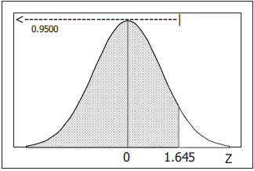

1. For , the cumulative area is 0.0100.







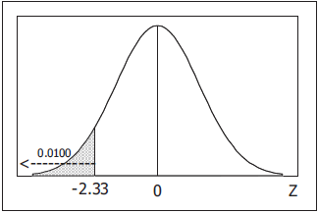

1. For the lowest 2.5%, the cumulative area is 0.0250.



For the highest 2.5%, the cumulative area is 1 − 0.0250 = 0.9750



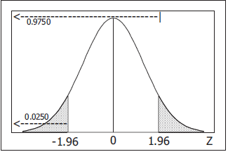

1. For the lowest 0.5%, the cumulative area is 0.0050.



For the highest 0.5%, the cumulative area is 1 − 0.0050 = 0.9950



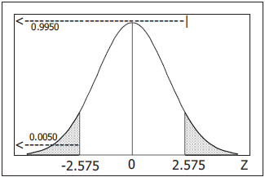

***Exercise***

For a standard normal distribution, find the percentage of data that are

1. Within 2 standard deviations of the mean.
2. More than 1 standard deviation away from the mean.
3. More than 1.96 standard deviations away from the mean.
4. Between μ − 3σ and μ + 3σ.
5. More than 3 standard deviations away from the mean.

***Solution***

1. 





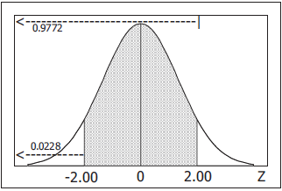

1. 





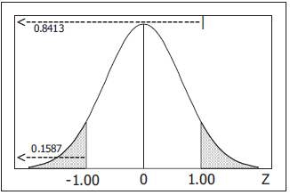

1. 





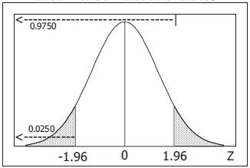

1. 





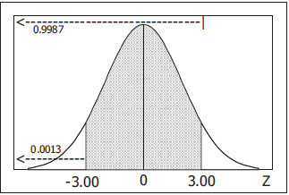

***Solution Section* 2.8 − Applications Normal Distributions**

***Exercise***

The distribution of IQ scores is a nonstandard normal distribution with mean of 100 and standard deviation of 15. What are the values of the mean and standard deviation after all IQ scores have been standardized by converting them to *z-*scores using ?

***Solution***

For any distribution, converting to *z* scores using the formula  produces a same-shaped distribution with mean 0 and standard deviation 1.

***Exercise***

Find the area of the shaded region. The graphs depict IQ scores adults, and those scores are normally distributed with mean of 100 and standard deviation of 15.

|  |  |
| --- | --- |
| *a*) | *b*) |
| *c*) | *d*) |

***Solution***

1. 



1. 









1. 











1. 











***Exercise***

Find the Indicated IQ scores. The graphs depict IQ scores adults, and those scores are normally distributed with mean of 100 and standard deviation of 15.

|  |  |
| --- | --- |
| *a*) | *b*) |
| *c*) | *d*) |

***Solution***

1. The *z* score with *A* = 0.6 below it is: *z* = 0.25 (~0.5987)









1. The *z* score with *A* = 0.8 above is the *z* score with *A* = 0.2 below; it is: *z* = −0.84







1. The *z* score with *A* = 0.95 above is the *z* score with *A* = 0.05 below; it is: *z* = −1.645







1. The *z* score with *A* = 0.99 below; it is: *z* = 2.33







***Exercise***

Assume that adults have IQ scores that are normally distributed with mean of 100 and standard deviation of 15

1. Find the probability that a randomly selected adult has an IQ that is less than 115.
2. Find the probability that a randomly selected adult has an IQ that is greater than 131.5.
3. Find the probability that a randomly selected adult has an IQ that is between 90 and 110.
4. Find the probability that a randomly selected adult has an IQ that is between 110 and 120.
5. Find  which is the IQ score separating the bottom 30% from the top 70%.
6. 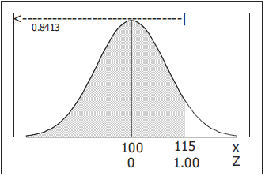Find the first quartile which is the IQ score separating the bottom 25% from the top 75%.

***Solution***

1. 



1. 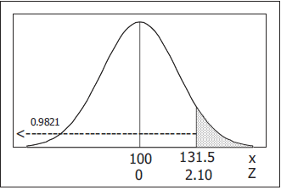









1. 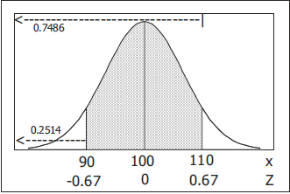











1. 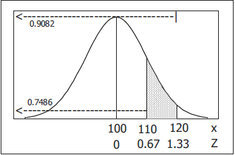









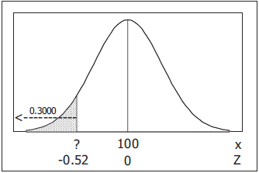 

1. For  , 







1. 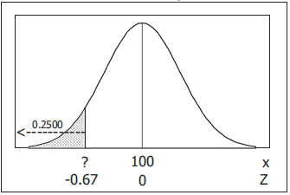For  , 







***Exercise***

The Gulfstream 100 is an executive jet that seats six, and it has a doorway height of 51.6

* ***Men’s*** heights are normally distributed with mean 69.0 in. and standard deviation 2.8 in.
* ***Women’s*** heights are normally distributed with mean 63.6 in. and standard deviation 2.5 in.

1. What percentage of adult men can fit through the door without bending?
2. What percentage of adult women can fit through the door without bending?
3. Does the door design with a height of 51.6 in. appear to be adequate? Why didn’t the engineers design larder door?
4. What doorway height would allow 60% of men to fit without bending?

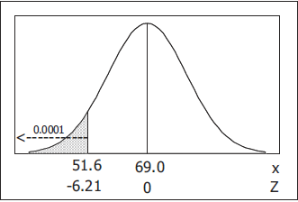***Solution***

1. Normal distribution with: 







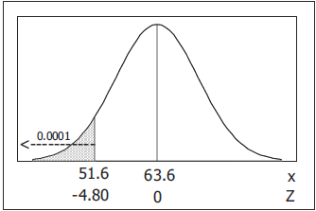

1. Normal distribution with: 







1. 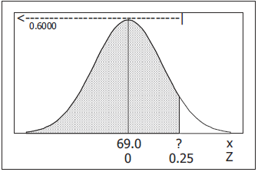Maybe. While it may not be convenient, it presents no danger of injury because of the obvious need for everyone to bend. Considering the small size of the plane, the door is probably as large as possible.
2. For 







***Exercise***

Assume that human body temperatures are normally distributed with a mean of 98.20°F and a standard deviation of 0.62°F.

1. A Hospital uses 100.6°F as the lowest temperature considered to be a fever. What percentage of normal and healthy persons would be considered to have fever? Does this percentage suggest that a cutoff of 100.6°F is appropriate?
2. Physicians want to select a minimum temperature for requiring further medical tests. What should that temperature be, if we want only 5.0% of healthy people to exceed it? (Such a result is a false positive, meaning that the test result is positive, but the subject is not really sick.)

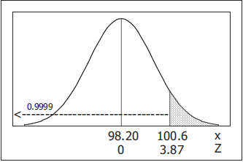***Solution***

1. Normal distribution with: 











Yes. The cut-off is appropriate in that there is a small probability of saying that a healthy person has a fever, but many with low grade fevers may erroneously be labeled healthy.

1. 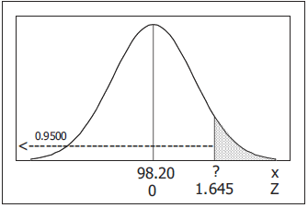For the highest 5%: 







***Exercise***

The lengths of pregnancies are normally distributed with a mean of 268 days and a standard deviation of 15 days.

1. One classical use of the normal distribution is inspired by a letter to “Dear Abby” in which a wife claimed to have given birth 308 days after a brief visit from her husband. Given this information, find the probability of a pregnancy lasting 308 days or longer. What does the result suggest?
2. If we stipulate that a baby is premature if the length of pregnancy is the lowest 4%, find the length that separates premature babies from those who are not premature. Premature babies often require special care, and this result could be helpful to hospital administrators in planning for that care.

***Solution***

Normal distribution with: 

1. 

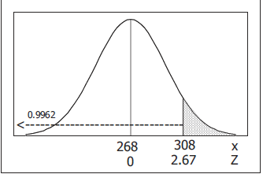 





The result suggests that an unusual event has occurred – but certainly not an impossible one, as about 38 of every 10,000 pregnancies can be expected to last as long.

1. 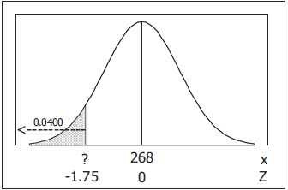For the lowest 4%: 







***Exercise***

A statistics professor gives a test and finds that the scores are normally distributed with a mean of 25 and a standard deviation of 5. She plans to curve the scores.

1. If the curves by adding 50 to each grade, what is the new mean? What is the new standard deviation?
2. Is it fair to curve by adding 50 to each grade? Why or why not?
3. If the grades are curved according to the following scheme (instead of adding 50), find the numerical limits for each letter grade.

A: Top 10%

B: Scores above the bottom 70% and below the top 10%.

C: Scores above the bottom 30% and below the top 30%.

D: Scores above the bottom 10% and below the top 70%.

F: Bottom 10%.

1. Which method of curving the grades is fairer: Adding 50 to each grade or using the scheme given in part (*c*)? Explain.

***Solution***

Normal distribution with: 

1. For a population of size N, 

Adding a constant to each score increases the mean by that amount but does not affect the standard deviation.

In non-statistical terms, shifting everything by *k* units does not affect the spread of the scores. This is true for any set of scores – regardless of the shape of the original distribution.

Let 



















If the teacher adds 50 to each grade,

New mean = 25 + 50 = 75

New standard deviation = 5

1. No; curving should consider the variation. Had the test been more appropriately constructed, it is not likely that every student would score exactly 50 points higher, If the typical student score increased by 50, we would expect the better students to increase by more than 50 and the poorer students to increase by less than 50. This would make the scores spread out and would increase the standard deviation.
2. For the top 10%: 







For the bottom 70%: 







For the bottom 30%: 







For the bottom 10%: 







|  |  |
| --- | --- |
| ***A*** | Higher than 31.4 |
| ***B*** | 27.6 to 31.4 |
| ***C*** | 22.4 to 27.6 |
| ***D*** | 18.6 to 22.4 |
| ***E*** | Less than 18.6 |

1. The curving scheme in part (*c*) is fairer because it takes into account the variation as discussed in part (*b*). Assuming the usual 90-80-7060 letter grade cut-offs, for example, the percentage of *A*’s under the scheme in part (a) with  is









This is considerably less than the 10% *A* under the scheme in part (*c*) and reflects the fact that the variation in part (a) in unrealistically small.

***Solution Section* 2.9 − Sampling Distributions and Estimators**

***Exercise***

You want to estimate the proportion of all U.S. college students who have the profound wisdom to take a statistics course. You obtain a simple random sample of students. Is the resulting sample proportion a good estimator of the population proportion? Why or why not?

***Solution***

No; the students at University are not necessarily representative (by major, race, etc.) of the population of all U.S. college students.

***Exercise***

Samples of size  are randomly selected from the population of the last digits of telephone numbers. If the sample mean is found for each sample, what is the distribution of the sample means?

***Solution***

The sample means will have a distribution that is approximately normal. They will tend to form a symmetric, unimodal and bell-shaped distribution around the value of the population mean.

***Exercise***

The ages (years) of the four U.S. presidents when they were assassinated in office are 56 (Lincoln), 49 (Garfield), 58 (McKinley), and 46 (Kennedy).

1. Assuming that 2 of the ages are randomly selected with replacement, list the 16 different possible samples.
2. Find the mean of each of the 16 samples; then summarize the sapling distribution of the means in the format of a table representing the probability distribution.
3. Compare the population mean to the mean of the sample means.

|  |  |  |
| --- | --- | --- |
|  |  |  |
| 46.0 | 1/16 | 46/16 |
| 47.5 | 2/16 | 95/16 |
| 49.0 | 1/16 | 49/16 |
| 51.0 | 2/16 | 102/16 |
| 52.0 | 2/16 | 104/16 |
| 52.5 | 2/16 | 105/16 |
| 53.5 | 2/16 | 107/16 |
| 56.0 | 1/16 | 56/16 |
| 57.0 | 2/16 | 114/16 |
| 58.0 | 1/16 | 58/16 |
|  | 16/16 | 836/16 |

1. Do the sample means target the value of the population mean? In general, do sample means make good estimators of population means? Why or why not?

***Solution***

1. The 16 possible samples are given:
2. The 16 possible means are given in column 2. The sampling distribution of the mean is given in the first 2 columns.
3. The population mean is 52.25. The mean of the sample means is . They are the same.
4. Yes. The sample mean always targets the value of the population mean. For this reason, the sample mean is a good estimator of the population mean.

***Exercise***

The ages (years) of the four U.S. presidents when they were assassinated in office are 56 (Lincoln), 49 (Garfield), 58 (McKinley), and 46 (Kennedy).

1. Assuming that 2 of the ages are randomly selected with replacement, list the 16 different possible samples.
2. Find the median of each of the 16 samples; then summarize the sapling distribution of the medians in the format of a table representing the probability distribution.
3. Compare the population median to the median of the sample means.
4. Do the sample medians target the value of the population mean? In general, do sample medians make good estimators of population medians? Why or why not?

***Solution***

|  |  |  |  |  |  |  |  |  |  |  |  |  |  |  |  |  |  |  |  |  |  |  |  |  |  |  |  |  |  |  |  |  |  |  |  |  |  |
| --- | --- | --- | --- | --- | --- | --- | --- | --- | --- | --- | --- | --- | --- | --- | --- | --- | --- | --- | --- | --- | --- | --- | --- | --- | --- | --- | --- | --- | --- | --- | --- | --- | --- | --- | --- | --- | --- |
| 1. The 16 possible samples are given: 2. The 16 possible medians are given in column 23. The sampling distribution of the median is given in the first 2 columns. 3. The population median is 52.25. The mean of the sample means is . They are not the same. 4. No. The sample medians do not always target the value of the population median. For this reason, the sample median is not a good estimator of the population median. | |  |  |  | | --- | --- | --- | |  |  |  | | 46.0 | 1/16 | 46/16 | | 47.5 | 2/16 | 95/16 | | 49.0 | 1/16 | 49/16 | | 51.0 | 2/16 | 102/16 | | 52.0 | 2/16 | 104/16 | | 52.5 | 2/16 | 105/16 | | 53.5 | 2/16 | 107/16 | | 56.0 | 1/16 | 56/16 | | 57.0 | 2/16 | 114/16 | | 58.0 | 1/16 | 58/16 | |  | 16/16 | 836/16 | |

***Exercise***

After constructing a new manufacturing machine, 5 prototype integrated circuit chips are produced and it is found that 2 are defective (*D*) and 3 are acceptable (*A*). Assume that 2 of the chips are randomly selected *with replacement* from his population.

1. After identify the 25 different possible samples, find the proportion of defects in each of them, then use a table to describe the sampling distribution of the proportions of defects.
2. Find the mean of the sampling distribution.
3. Is the mean of the sampling distribution (b) equal to the population proportion of defects? Does the mean of the sampling distribution of proportions always equal the population proportion?

***Solution***

Identify the 2 defective chips as *x* and *y*, and identify the 3 acceptable chips as *a, b*, and *c*.

1. The sampling distribution of the proportion is given in columns 5 and 6 of the table.
2. The mean of the sampling distribution is 
3. The population proportion of defectives is . Yes, the 2 values are the same. The sample proportion always targets the value of the population proportion. For this reason, the sample proportion is a good estimator of the population proportion.

|  |  |  |  |  |  |  |
| --- | --- | --- | --- | --- | --- | --- |
| *Pair* |  | *Pair* |  |  |  |  |
| *xx* | 1.0 | *ax* | 0.5 | 0.0 | 9/25 | 0.0/25 |
| *xy* | 1.0 | *ay* | 0.5 | 0.5 | 12/25 | 6.0/25 |
| *xa* | 0.5 | *aa* | 0.0 | 1.0 | 4/25 | 4.0/16 |
| *xb* | 0.5 | *ac* | 0.0 |  | 25/25 | 10.0/25 |
| *xc* | 0.5 | *bx* | 0.5 |  |  |  |
| *yx* | 1.0 | *by* | 0.5 |  |  |  |
| *yy* | 1.0 | *ba* | 0.0 |  |  |  |
| *ya* | 0.5 | *bb* | 0.0 |  |  |  |
| *yb* | 0.5 | *bc* | 0.0 |  |  |  |
| *yc* | 0.5 | *cx* | 0.5 |  |  |  |
|  |  | *cy* | 0.5 |  |  |  |
|  |  | *ca* | 0.0 |  |  |  |
|  |  | *cb* | 0.0 |  |  |  |
|  |  | *cc* | 0.0 |  |  |  |

***Exercise***

Tell whether the following statistic is a biased or unbiased estimator of a population parameter

1. Sample variance used to estimate a population variance.
2. Sample mean used to estimate a population mean.
3. Sample proportion used to estimate a population proportion.

***Solution***

1. Unbiased
2. Unbiased
3. Unbiased

***Solution Section* 2.10 − Central Limit Theorem**

***Exercise***

Assume that SAT scores are normally distributed with mean  and standard deviation  , use the Central Limit Theorem

1. If 1 SAT score is randomly selected, find the probability that it is less than 1500.
2. If 100 SAT scores are randomly selected; find the probability that they have a mean less than 1500.
3. If 1 SAT score is randomly selected, find the probability that it is greater than 1600.
4. If 64 SAT scores are randomly selected, find the probability that they have a mean greater than 1600.
5. If 1 SAT score is randomly selected; find the probability that it is between 1550 and 1575.
6. If 25 SAT scores are randomly selected; find the probability that they have a mean between 1550 and 1575.

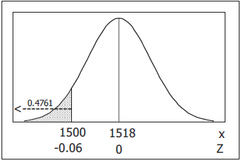***Solution***

1. Normal distribution with: 







1. 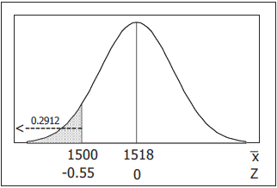Normal distribution, since the original distribution is so











1. 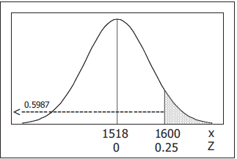Normal distribution with: 











1. Normal distribution, since the original distribution is so

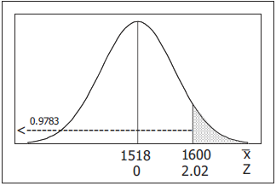













1. Normal distribution with: 

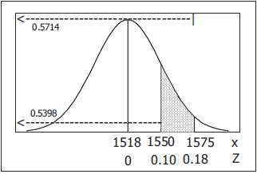











1. Normal distribution, since the original distribution is so

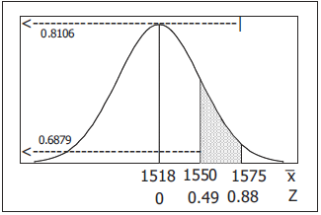















***Exercise***

Assume that weights of mean are normally distributed with a mean of 172 lb. and a standard deviation of 29 lb.

1. Find the probability that if an individual man is randomly selected, his weight will be greater than 180 lb.
2. Find the probability that 20 randomly selected men will have a mean weight that is greater than 180 lb.
3. If 20 mean have a mean weight greater than 180 lb., the total weight exceeds the 3500 lb. safe capacity of a particular water taxi. Based on the proceeding results, is this safety concern? Why or why not?

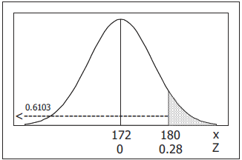***Solution***

1. Normal distribution with: 











1. Normal distribution, since the original distribution is so

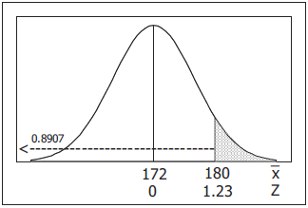













1. Yes. A capacity of 20 is not appropriate when the passengers are all adult men, since a 10.93% probability of overloading is too much of a risk.

***Exercise***

Membership requires an IQ score above 131.5. Nine candidates take IQ tests, and their summary results indicated that their mean IQ score is 133, (IQ scores are normally distributed with mean of 100 and a standard deviation of 15.)

1. If 1 person is randomly selected from the general population, find the probability of getting someone with an IQ score of at least 133.
2. If 9 people are randomly selected, find the probability that their mean IQ score is at least 133.
3. Although the summary results are available, the individual IQ test scores have been lost. Can it be concluded that all 9 candidates have IQ scores above 131.5 so that they are all eligible for membership?

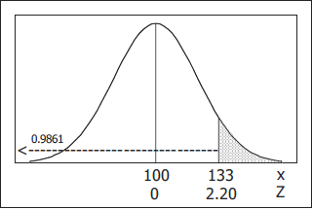***Solution***

1. Normal distribution with: 











1. Normal distribution, since the original distribution is so

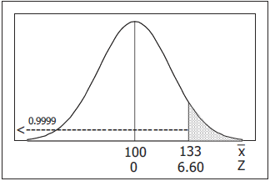













1. No. Even though the mean score is 133, some of the individual scores may be below 131.5.

***Exercise***

For women aged 18-24, systolic blood pressures (in mm Hg) are normally distributed with a mean of 114.8 and a standard deviation of 13.1. Hypertension is commonly defined as a systolic blood pressure above 140.

1. If a woman between the ages of 18 and 24 is randomly selected, find the probability that her systolic blood pressure is greater than 140.
2. If 4 women in that age bracket are randomly selected, find the probability that their mean systolic blood pressure is greater than 140.
3. Given that part (*b*) involves a sample size that is not larger than 30, why can the central limit theorem be used?
4. If a physician is given a report stating that 4 women have a mean systolic, blood pressure below 140, can she conclude that none of the women have hypertension (with a blood pressure greater than 140)?

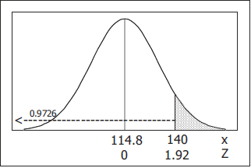***Solution***

1. Normal distribution with: 











1. Normal distribution, since the original distribution is so

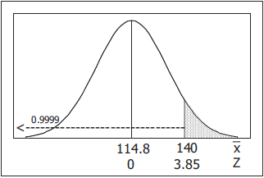













1. Since the original distribution is normal, the Central Limit Theorem can be used in part (b) even though the sample size does not exceed 30.
2. The mean can be less than 140 when one or more of the values is greater than 140.

***Exercise***

Engineers must consider the breadths of male heads when designing motorcycle helmets. Men have head breaths that are normally distributed with a mean of 6.0 in. and a standard deviation of 1.0 in.

1. If one male is randomly selected, find the probability that his head breadth is less than 6.2 in.
2. The Safeguard Helmet Company plans an initial production run of 100 helmets. Find the probability that 100 randomly selected men have a mean head breadth less than 6.2 in.
3. The production manager sees the result from part (b) and reasons that all helmets should be made for men with head breadths less than 6.2 in., because they would fit all but a few men. What is wrong with that reasoning?

***Solution***

1. Normal distribution with: 







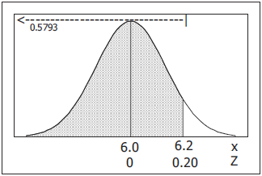

1. 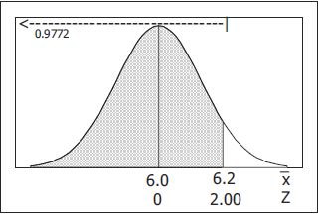Normal distribution, since the original distribution is so











1. Probabilities concerning means do not apply to individuals, It is the information from part (a) that is relevant, since the helmets will be worn by one man at a time – and that indicates that the proportion of men with head breadth greater than 6.2 inches is 1 – 0.5793 = 0.4207 = 42.07%.

***Exercise***

Currently, quarters have weighs that are normally distributed with a mean 5,670 g and a standard deviation of 0.062 g. A vending machine is configured to accept only those quarters with weights between 5.550 g and 5.790 g.

1. If 280 different quarters are inserted into the vending machine, what is the expected number of rejected quarter?
2. If 280 different quarters are inserted into the vending machine, what is the probability that the mean falls between the limits of 5.550 g and 5.790 g?
3. If you own the vending machine, which result would concern you more? The result from part (*a*) or the result from part (*b*)? Why?

***Solution***

1. 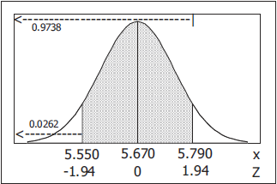Normal distribution with: 













If 0.9476 of the quarters are accepted, then 1 – 0.9476 = 0.0524 of the quarters are rejected.

For 280 quarters, we expect  of them rejected.

1. Normal distribution, since the original distribution is so

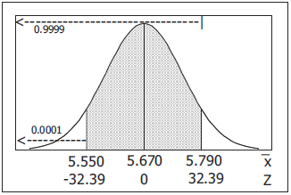















1. Probabilities concerning means do not apply to individuals, It is the information from part (a) that is relevant, since the vending machine deals with quarters one at a time.

***Exercise***

The annual precipitation amounts in a certain mountain range are normally distributed with a mean of 101 inches, and a standard deviation of 12 inches. What is the probability that the mean annual precipitation during 36 randomly picked years will be less than 103.8 inches?

***Solution***

***Given***: 









***Exercise***

The annual precipitation amounts in a certain mountain range are normally distributed with a mean of 72 inches, and a standard deviation of 14 inches. What is the probability that the mean annual precipitation during 49 randomly picked years will be less than 74.8 inches?

***Solution***

***Given***: 









***Exercise***

The weights of the fish in a certain lake are normally distributed with a mean of 13 lb. and a standard deviation of 6. If 4 fish are randomly selected, what is the probability that the mean weight will be between 10.6 and 16.6 lb.?

***Solution***

***Given***: 



 









***Exercise***

For women aged 18-24, systolic blood pressures (in mm Hg) are normally distributed with a mean of 114.8 and a standard deviation of 13.1. If 23 women aged 18-24 are randomly selected, find the probability that their mean systolic blood pressure is between 119 and 122.

***Solution***

***Given***: 



 









***Exercise***

A study of the amount of time it takes a mechanic to rebuild the transmission for 2005 Chevy shows that the mean is 8.4 hours and the standard deviation is 1.8 hours. If 40 mechanics are randomly selected, find the probability that their mean rebuild time

1. Exceeds 8.7 hours.
2. Exceeds 8.1 hours.

***Solution***

1. ***Given***: 













1. ***Given***: 













***Exercise***

A final exam in Math 160 has a mean of 73 with standard deviation 7.8. If 24 students are randomly selected, find the probability that the mean of their test scores is greater than 71.

***Solution***











***Solution Section* 2.11 − Normal Approximations to Binomial**

***Exercise***

The Wechsler test is used to measure IQ scores. It is designed so that the mean IQ score 1—and the standard deviation is 15. It is known that IQ scores have a normal distribution. Assume that we want to find the probability that a randomly selected person has an IQ equal to 107. What is the continuity correction, and how would it be applied in finding that probability?

***Solution***

IQ’s are measured in whole numbers, but the normal distribution is continuous. In a continuous representation, an IQ of *x* = 107 corresponds to 106.5 < *x* < 107.5.

***Exercise***

The Genetics & IVF Institute has developed methods for helping coupes determine the gender of their children. For comparison, a large sample of randomly selected families with four children is obtained, and the proportion of girls in each family is recorded. If the normal distribution a good approximation of the distribution of those proportions? Why or why not?

***Solution***

No. With *n* = 4 and *p* = 0.5. 

The requirements that  and  are not met.

***Exercise***

The given values are discrete. Use the continuity correction and describe the region of the normal distribution that corresponds to the indicated probability.

The probability of “more than 30 defective items” corresponds to the area of the normal curve − The area to the right of 20.5.

1. Probability of more than 8 Senators who are women.
2. Probability of at least 2 traffic tickets this year.
3. Probability of fewer than 5 passengers who do not show up for a flight.
4. Probability that the number of students who are absent is exactly 4
5. Probability that the number of defective computer power supplies is between 12 and 16 inclusive.
6. Probability that exactly 24 felony indictments result in convictions.

***Solution***

1. The area to the right of 8.5 Symbols: 
2. The area to the right of 1.5 Symbols: 
3. The area to the left of 4.5 Symbols: 
4. The area between 3.5 and 4.5 Symbols: 
5. The area between 12.5 and 15.5 Symbols: 

The area between 11.5 and 16.5 Symbols: 

1. The area between 23.5 and 24.5 Symbols: 

***Exercise***

Using Normal Approximation. Do the following

1. Find the indicated *binomial probability* using the Table.
2. If  and  , also estimate the indicated probability by using the normal distribution as an approximation to the binomial distribution; if  , then state that the normal approximation is not suitable.
3. 
4. 
5. 

***Solution***

1. Binomial: 
2. From the Probability Distribution Table:



1. 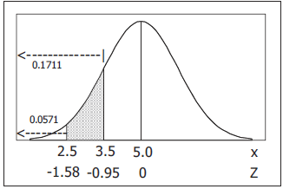Normal approximation appropriate since























1. Binomial: 
2. From the Probability Distribution Table:



1. 

 ⇒ Normal approximation not appropriate

1. Binomial: 
2. From the Probability Distribution Table:







1. 

 ⇒ Normal approximation not appropriate

***Exercise***

In a test of the XSORT method to increase the probability of conceiving a girl. Among 574 women using that method, 525 had baby girls. Assuming that the method has no effect so that boys and girls are equally likely, find the probability of getting at least 525 girls among 574 babies. Does the result suggest that the XSORT method is effective? Why or why not?

***Solution***

Binomial: 

Normal approximation appropriate since





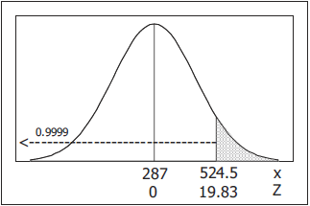













Yes. Since the probability of getting at least 525 girls by chance alone is so small, it appears that the method is effective and that the genders were not being determined by chance alone.

***Exercise***

In a test of the YSORT method to increase the probability of conceiving a boy. Among 152 women using that method, 127 had baby boys. Assuming that the method has no effect so that boys and girls are equally likely, find the probability of getting at least 127 boys among 152 babies. Does the result suggest that the YSORT method is effective? Why or why not?

***Solution***

Binomial: 

Normal approximation appropriate since



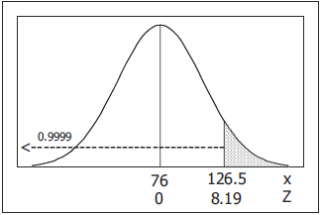

















Yes. Since the probability of getting at least 127 boys by chance alone is so small, it appears that the method is effective and that the genders were not being determined by chance alone.

***Exercise***

When Mendel conducted his famous hybridization experiments, he used peas with green pods and yellow pods/ One experiment involved crossing peas in such a way that 25% (or 145) of the 580 offspring peas were expected to have yellow pods. Instead of getting 145 peas with yellow pods, he obtained 152. Assume that Mendel’s 25% rate is correct

1. Find the probability that among the 580 offspring peas, exactly 152 have yellow pods.
2. Find the probability that among the 580 offspring peas, at least 152 have yellow pods.
3. Which result is useful for determining whether Mendel’s claimed rate of 25% is incorrect? ((*a*) or (*b*))
4. Is there strong evidence to suggest that Mendel’s rate of 25% is incorrect?

***Solution***

Binomial: 

Normal approximation appropriate since







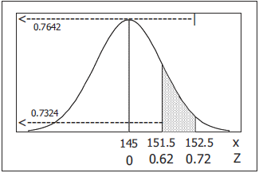

1. 











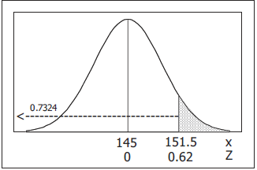 

1. 











1. The part (*b*) answer is the useful probability. In situations involving multiple ordered outcomes, the unusuakness of a particular outcome is generally determined by the probability of getting that outcome or a more extreme outcome.
2. No. Since 0.2676 > 0.05, Mendel’s result could easily occur by chance alone if the true rate were really 0.25.

***Exercise***

In a study of 420,095 cell phone users in Denmark, it was found that 135 developed cancer of the brain or nervous system. If we assume that the use of cell phones has no effect on developing such cancer, then the probability of a person having such cancer is 0.000340. We therefore expect about 143 cases of such cancer in a group of 420,095 randomly selected people. Estimate the probabitlity of 135 or fewer cases of such cancer in a group of 420,095 people. What do these results suggest about media reports that cell phones cause cancer of the brain or nervous system?

***Solution***

Binomial: 

Normal approximation appropriate since





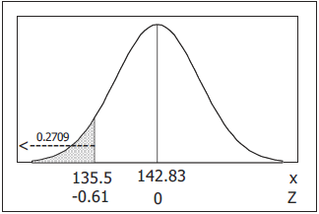











To conclude that cell phones increase the likelihood of experiencing such cancers requires *x* > 142.83. Since 135 < 142.83, these results definitely do not support the media reports.

***Exercise***

There is an 80% chance that a prospective employer will check the educational background of a job applicants, find the probability that exactly 85 have their educational backgrounds checked.

***Solution***

Binomial: 

Normal approximation appropriate since



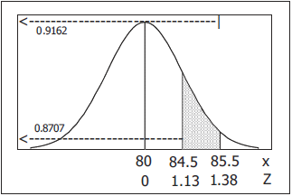



















***Exercise***

When working as investigator, you analyzed the leading digits of amounts on checks from companies that were suspected of fraud. Among 784 checks, 479 had amounts with leading digits of 5, but checks issued in the normal course of honest transactions were expected to have 7.9% of the checks with amounts having leading digits of 5. Is there strong evidence to indicate that the check amounts are significantly different from amounts that are normally expected? Explain?

***Solution***

Binomial: 

Normal approximation appropriate since







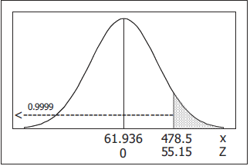













Yes. Since the probability of obtaining 479 or more such checks from normal honest transactions by chance alone is so very strong, there is strong evidence to indicate that the checks from the suspected companies do not follow the normal pattern and are likely fraudulent.

***Exercise***

The probability of flu symptoms for a person not receiving any treatment is 0.019. In a clinical trial of Lipitor, a drug commonly used to lower cholesterol, 863 patients were given a treatment of 10-mg atorvastatin tablets, and 19 of those patients experienced flu symptoms. Assuming that these tablets have no effect on flu symptoms, estimate the probability that at least 19 of 863 people experience flu symptoms. What do these results suggest about the flu symptoms as an adverse to the drug?

***Solution***

Binomial: 

Normal approximation appropriate since







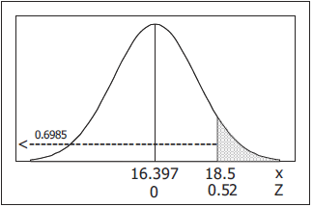













Since the 0.3015 > 0.05, 19 or more persons experiencing flu symptoms is not an unusual occurrence for a normal population. There is no evidence to suggest that flu symptoms are an adverse reaction to the drug.

***Exercise***

Assume that a baseball player hits .350, so his probability of a hit is 0.350. Also assume that his hitting attempts are independent of each other.

1. Find the probability of at least 1 hit in 4 tries in a single game.
2. Assuming that this batter gets up to bat 4 times each game, find the probability of getting a total of at least 56 hits in 56 games.
3. Assuming that this batter gets up to bat 4 times each game, find the probability of getting a total of at least 1 hit in 56 consecutive games (Joe DiMaggio’s 1941 record).

***Solution***

1. Binomial: 



 





1. Binomial: 

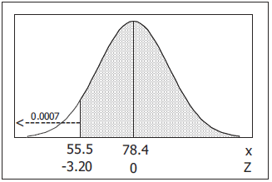Normal approximation appropriate since





















1. Let *H* = getting at least one hit in 4 at bats.

 (from part (*a*))

For 56 consecutive games:



1. The solution employs the techniques and notation of part (*a*) and (*c*)

For 





For 

















***Exercise***

The given values are discrete. Use the continuity correction and describe the region of the normal distribution that corresponds to the indicated probability.

1. The probability of at least 44 boys.
2. The probability of fewer than 33 democrats.
3. The probability of exactly 51 green marbles.
4. The probability that the number of correct answers is between 15 and 43 inclusive

***Solution***

1. The area to the right of 
2. The area to the left of 
3. The area between 50.5 and 51.5.
4. The area between 14.5 and 43.5.

***Exercise***

*E*stimate the probability of getting exactly 43 boys in 90 births.

***Solution***

Binomial: 



















***Exercise***

For the binomial distribution with the given values for *n* and *p*, state whether or not it is suitable to use the normal distribution as an approximation: 

***Solution***

 ⇒ Normal approximation is suitable

***Exercise***

A multiple choice test consists of 60 questions. Each question has 4 possible answers of which one is correct If all answers are random guesses, estimate the probability of getting at least 20% correct.

***Solution***

Binomial: 

















