***Solution*** ***Section* 3.1 − Estimating a Population Proportion**

***Exercise***

Find the critical value  that corresponds to a 99% confidence level.

***Solution***

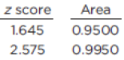For 99% confidence, 

For the upper 0.005: 



***Exercise***

Find the critical value  that corresponds to a 99.5% confidence level.

***Solution***

For 95% confidence, 

|  |  |
| --- | --- |
| For the upper 0.0025: |  |

***Exercise***

Find the critical value  that corresponds to a 98% confidence level.

***Solution***

For 95% confidence, 

For the upper 0.01: 



***Exercise***

Find for .

***Solution***

For 

For the upper 0.05: 



***Exercise***

Find for .

***Solution***

For 

For the upper 0.01: 







***Exercise***

Express the confidence interval  in the form 

***Solution***

Let *L* = the lower confidence limit *U* = the upper confidence limit





∴ The interval can be expressed as 

***Exercise***

Express the confidence interval  in the form 

***Solution***





∴ The interval can be expressed as 

***Exercise***

Express the confidence interval  in the form 

***Solution***

***Given***: 

 

∴ The interval can be expressed as 

***Exercise***

Find the point estimate  and the margin of error *E* of 

***Solution***





***Exercise***

Find the margin of error *E* of 

***Solution***



***Exercise***

Find the point estimate  of 

***Solution***



***Exercise***

Find the point estimate  and the margin of error *E* of 

***Solution***





***Exercise***

Find the point estimate  and the margin of error *E* of 

***Solution***





***Exercise***

Assume that a sample is used to estimate a population proportion *p*. Find the margin of error *E* that corresponds to the given 

***Solution***









 



***Exercise***

Assume that a sample is used to estimate a population proportion *p*. Find the margin of error *E* that corresponds to the given 

***Solution***





 



***Exercise***

Assume that a sample is used to estimate a population proportion *p*. Find the margin of error *E* that corresponds to the given 

***Solution***









***Exercise***

Assume that a sample is used to estimate a population proportion *p*. Find the margin of error *E* that corresponds to the given 98% confidence; the sample size is 1230, of which 40% are successes.

***Solution***















***Exercise***

Construct the confidence interval estimate of the population proportion *p* that corresponds to the given 

***Solution***





















***Exercise***

Construct the confidence interval estimate of the population proportion *p* that corresponds to the given 

***Solution***

















***Exercise***

Construct the confidence interval estimate of the population proportion *p* that corresponds to the given 

***Solution***

















***Exercise***

Find the minimum sample size requires to estimate a population proportion or percentage:

Margin of error: 0.045; confidence level: 95%: 

***Solution***















***Exercise***

Find the minimum sample size requires to estimate a population proportion or percentage:

Margin of error: 2% points; confidence level: 99%: from prior study,  is estimate by the decimal equivalent of 14%

***Solution***











***Exercise***

The Genetics and IVF Institute conducted a clinical trial of the XSORT method designed to increase the probability of conceiving a girl. As of this writing, 574 babies were born to parents using the XSORT method, and 525 of them were girls.

1. What is the best point estimate of the population proportion of girls born to parents using the XSORT method?
2. Use the sample data to construct a 95% confidence interval estimate of the percentage of girls born to parents using the XSORT method.
3. Based on the results, does the XSORT method appear to be effective? Why or why not?

***Solution***

Let *x* = the number of girls born using the method

1. 
2. 











1. Yes. Since 0.5 is not within the confidence interval, and below the interval, we can be 95% certain that the method is effective.

***Exercise***

An important issue facing Americans is the large number of medical malpractice lawsuits and the expenses that they generate. In a study of 1228 randomly selected medical malpractice lawsuits, it is found that 856 of them were later dropped or dismissed.

1. What is the best point estimate of the proportion of medical malpractice lawsuits that are dropped or dismissed?
2. Construct a 99% confidence interval estimate of the proportion of medical malpractice lawsuits that are dropped or dismissed.
3. Does it appear that the majority of such suits are dropped or dismissed?

***Solution***

Let *x* = the number of suits dropped or dismissed

1. 
2. 











1. Yes. Since 0.5 is not within the confidence interval, and below the interval, we can be 99% certain that more than half the suits are dropped or dismissed.

***Exercise***

A study of 420,095 Danish cell phone users found that 135 of them developed cancer was found to be 0.0340% for those not using cell phones.

1. Use the sample data to construct a 95% confidence interval estimate of the percentage of cell phone users who develop cancer of the brain or nervous system.
2. Do cell phone users appear to have a rate of cancer of the brain or nervous system that is different from the rate of such cancer among those not using cells phones? Why or why not?

***Solution***

Let *x* = the number that develop those types of cancer.

1. 
2. 











1. No. Since 0.034% is within the confidence interval, it is a reasonable possibility for the true population value. The results do not provide evidence that cell phone users have a different cancer rate than the general population.

***Exercise***

In an Account survey of 150 senior executives, 47% said that the most common job interview mistake is to have little or no knowledge of the company. Construct a 99% confidence interval estimate of the proportion of all senior executives who have that same opinion. Is it possible that exactly half of all senior executives believe that the most common job interview mistake is to have little or no knowledge of the company? Why or why not?

***Solution***

Let *x* = the number who display little or no knowledge of the company.



 











Yes. Since 0.50 is within the confidence interval, it is a likely value for the true population proportion.

***Solution*** ***Section* 3.2 − Estimating a Population Mean: Sigma Known**

***Exercise***

A design engineer of the Ford Motor Company must estimate the mean leg length of all adults. She obtains a list of the 1275 employees at her facility; then obtains a simple random sample of 50 employees. If she uses this sample to construct a 95% confidence interval to estimate the mean leg length for the population of all adults, will her estimate be good? Why or why not?

***Solution***

No. The list of the employees at her facility from which she obtained her simple random sample is itself a convenience sample. Those employees are likely not representative of the population age, gender, ethnicity, or other factors that may affect leg length.

***Exercise***

Find the critical value  that corresponds to a 90% confidence level.

***Solution***

For 90% confidence, 



***Exercise***

Find the critical value  that corresponds to a 98% confidence level.

***Solution***

For 98% confidence, 







***Exercise***

Find  for 

***Solution***

For 

For upper 0.10, 







***Exercise***

Find  for 

***Solution***

For 

For upper 0.035, 







***Exercise***

How many adults must be randomly selected to estimate the mean FICO (credit rating) score of working adults in U.S.? We want 95% confidence that the sample mean is within 3 points of the population mean, and the population standard deviation is 68.

***Solution***















***Exercise***

A simple random sample of 40 salaries of NCAA football coaches has a mean of $415,953. Assume that σ = $463,364.

1. Find the best estimate of the mean salary of all NCAA football coaches.
2. Construct a 95% confidence interval estimate of the mean salary of an NCAA football coach.
3. Does the confidence interval contain the actual population mean of $474,477?

***Solution***

1. 
2. 











1. Yes. In this case the confidence interval includes the true population mean.

***Exercise***

A simple random sample of 50 adults (including males and females) is obtained, and each person’s red blood cell count (in cells per microliter) is measured. The sample mean is 4.63. The population standard deviation for red blood cell counts is 0.54.

1. Find the best point estimate of the mean red blood cell count of adults.
2. Construct a 99% confidence interval estimate of the mean red blood cell count of adults.
3. The normal range of red blood cell counts for adults is 4.7 to 6.1 for males and 4.3 to 5.4 for females. What does the confidence interval suggest about these normal ranges?

***Solution***

1. 
2. 











1. The intervals are not comparable, since the 2 given in part (*c*) are normal ranges for individual counts and the one calculated in part (*b*) is a confidence interval for mean counts. One would expect the confidence interval for mean counts to be well within the normal ranges for individual counts. The fact that the point estimate and the lower confidence interval limit for the mean are so close to the lower limit of the normal ranges for individuals suggests that the sample may consist of persons with lower red blood cell counts.

***Exercise***

A simple random sample of 125 SAT scores has a mean of 1522. Assume that SAT scores have a standard deviation of 333.

1. Construct a 95% confidence interval estimate of the mean SAT score.
2. Construct a 99% confidence interval estimate of the mean SAT score.
3. Which of the preceding confidence intervals is wider? Why?

***Solution***

1. 











1. 











1. The 99% confidence interval in part (b) is wider than the 95% confidence interval in part (a). For an interval to have more confidence associated with it, it must be wider to allow for more possibilities.

***Exercise***

When 14 different second-year medical students measured the blood pressure of the same person, they obtained the results listed below. Assuming that the population standard deviation is known to be 10 mmHg, construct a 95% confidence interval estimate of the population mean. Ideally, what should the confidence interval be in this situation?

138 130 135 140 120 125 120 130 130 144 143 140 130 150

***Solution***





















There is sense in which all the measurements should be the same – and in that case there would be no need for a confidence interval. It is unclear what the given *σ* = 10 represents in this situation. Is it the true standard deviation in the values of all people in the population (in which case it would not be appropriate in this context where only a single person is involved)?

Is it the true standard deviation in readings from evaluator to evaluator (when they are supposedly evaluating the same thing)? Using the methods of this section and assuming *σ* = 10, the confidence interval would be  as given above even if all the readings were the same.

***Exercise***

Do the given conditions justify using the margin of error  when finding a confidence interval estimate of the population mean μ?

1. The sample size is , and the original population is normally distributed
2. The sample size is  and σ is not known

***Solution***

1. Yes
2. No, σ is not given

***Exercise***

Use the confidence level and sample data to find the margin of error E.

1. Replacement times for washing machines: 90% confidence; 
2. College students’ annual earnings: 99% confidence; 

***Solution***

1. 









1. 









***Exercise***

Use the confidence level and sample data to find a confidence interval for estimating the population μ.

A laboratory tested 89 chicken eggs and found that the mean amount of cholesterol was 203 milligrams with . Construct a 95% confidence interval for the true mean cholesterol content μ, of all such eggs.

***Solution***



 ⇒ 







***Exercise***

Use the confidence level and sample data to find a confidence interval for estimating the population μ.

A group of 66 randomly selected students have a mean score of 34.3 on a placement test. The population standard deviation . What is the 90% confidence interval for the mean score, μ, of all students taking the test?

***Solution***



 ⇒ 







***Exercise***

Use the given information to find the minimum sample size required to estimate an unknown population mean µ. Margin error: $139, confidence level: 99%, σ = $522

***Solution***

 ⇒ 



***Solution*** ***Section* 3.3 − Estimating a Population Mean: σ Not Known**

***Exercise***

What does it mean when we say that the methods for constructing confidence intervals in this section are robust against departures from normality? Are the methods for constructing confidence intervals in this section robust against poor sampling methods?

***Solution***

Robust against departure from normality mans that the requirement that the original population be approximately normal is not a strong requirement, and that the methods of this section still give good results if the departure from normality is not too extreme. The methods of this section are not robust against poor sampling methods, as poor sampling methods can yield data that are entirely useless.

***Exercise***

Assume that we want tic instruct a confidence interval using the given confidence level

95%;  *σ* is unknown; population appears to be normally distributed. Do one of the following

1. Find the critical value 
2. Find the critical value 
3. State that neither the normal nor the *t*-distribution applies.

***Solution***

σ unknown, normal population, *n* = 23; It is *t*-distribution with 



|  |
| --- |
|  |
|  |

***Exercise***

Assume that we want tic instruct a confidence interval using the given confidence level

99%;  *σ* is known; population appears to be normally distributed. Do one of the following

1. Find the critical value 
2. Find the critical value 
3. State that neither the normal nor the *t*-distribution applies.

***Solution***

σ unknown, normal population, *Use* ***z***



***Exercise***

Assume that we want tic instruct a confidence interval using the given confidence level

99%;  *σ* is unknown; population appears to be very skewed. Do one of the following

1. Find the critical value 
2. Find the critical value 
3. State that neither the normal nor the *t*-distribution applies.

***Solution***

σ unknown, population not normal, *n* = 6: Neither normal nor *t* applies.

***Exercise***

Assume that we want tic instruct a confidence interval using the given confidence level

90%;  *σ* = 15.0; population appears to be skewed. Do one of the following

1. Find the critical value 
2. Find the critical value 
3. State that neither the normal nor the *t*-distribution applies.

***Solution***

σ known, population not normal, *n* = 200, *Use* ***z***



***Exercise***

Assume that we want tic instruct a confidence interval using the given confidence level

95%;  *σ* is unknown; population appears to be very skewed. Do one of the following

1. Find the critical value 
2. Find the critical value 
3. State that neither the normal nor the *t*-distribution applies.

***Solution***

σ unknown, population not normal, *n* = 9: Neither normal nor *t* applies.

***Exercise***

Given . Assume that the sample is a simple random and the population has a normal distribution.

1. Find the margin error
2. Find the confidence interval for the population mean μ.

***Solution***

σ unknown, normal population, *n* = 20; It is *t*-distribution with 



|  |
| --- |
|  |
|  |

1. 





1. 







***Exercise***

Given . Assume that the sample is a simple random and the population has a normal distribution.

1. Find the margin error
2. Find the confidence interval for the population mean μ.

***Solution***

σ unknown, normal population, *n* = 7; It is *t*-distribution with 



|  |
| --- |
|  |
|  |

1. 





1. 







***Exercise***

In a test of the effectiveness of garlic for lowering cholesterol, 47 subjects were treated with Garlicin, which is garlic in a processed tablet form. Cholesterol levels were measured before and after the treatment. The changes in their levels of LDL cholesterol (in mg/dL) have a mean of 3.2 and standard deviation of 18.6.

1. What is the best point estimate of the population mean net change LDL cholesterol after Garlicin treatment?
2. Construct a 95% confidence interval estimate of the mean net change in LDL cholesterol after the Garlicin treatment. What does the confidence interval suggest about the effectiveness of Garlicin in reducing LDL cholesterol?

***Solution***

1. 
2. σ unknown, *n* > 30; use *t*-distribution with 



|  |
| --- |
|  |
|  |











Since the confidence interval includes 0, there is a reasonable possibility that the true value is zero – i.e., that the Garlicin treatment has no effect on LDL cholesterol levels.

***Exercise***

A random sample of the birth weights of 186 babies has a mean of 3103 g and a standard deviation of 696 g. These babies were born to mothers who did not use cocaine during their pregnancies.

1. What is the best point estimate of the mean weight of babies born to mothers who did not use cocaine during their pregnancies?
2. Construct a 95% confidence interval estimate of the mean birth for all such babies.
3. Compare the confidence interval from part (*b*) to this confidence interval obtained from birth weights of babies born to mothers who used cocaine during pregnancy: . Does cocaine use appear to affect the birth weight of a baby?

***Solution***

1. 
2. σ unknown, *n* > 30; use *t*-distribution with 



|  |
| --- |
|  |
|  |











1. Yes. Since the confidence interval for the mean birth weight for mothers who used cocaine is entirely below the confidence interval in part (b), it appears that cocaine use is associated with lower birth rates.

***Exercise***

In a study designed to test the effectiveness of acupuncture for treating migraine, 142 subjects were treated with acupuncture and 80 subjects were given a sham treatment. The numbers of migraine attacks for the acupuncture treatment group had a mean of 1.8 and a standard deviation of 1.4. The numbers of migraine attacks for the sham treatment group had a mean of 1.6 and standard deviation of 1.2

1. Construct a 95% confidence interval estimate of the mean number of migraine attacks for those treated with acupuncture.
2. Construct a 95% confidence interval estimate of the mean number of migraine attacks for those given a sham treatment.
3. Compare the two confidence intervals. What do the results about the effectiveness of acupuncture?

***Solution***

1. σ unknown, *n* > 30; use *t*-distribution with 



|  |
| --- |
|  |
|  |











1. σ unknown, *n* > 30; use *t*-distribution with 



|  |
| --- |
|  |
|  |











1. The 2 confidence intervals are very similar and overlap considerably. There is no evidence that the acupuncture treatment is effective.

***Exercise***

30 randomly selected students took the statistics final. If the sample mean was 79 and the standard deviation was 14.5, construct a 99% confidence interval for the mean score of all students.

Use the given degree of confidence and sample data to construct a confidence level interval for the population mean μ. Assume that the population has a normal distribution.

***Solution***

*s* = 14.5, , *n* = 30





|  |
| --- |
|  |
|  |







***Solution Section* 3.4 − Estimating a Population Variance**

***Exercise***

Using the weights of the M&M candies. We use the standard deviation of the sample  to obtain the following 95% confidence interval estimate of the standard deviation of the weights of all M&Ms: . Write a statement that correctly interprets that confidence interval.

***Solution***

We can be 95% confident that the interval from 0.0455 grams to 0.0602 grams includes the true value of the standard deviation in the weights for the population of all M&M’s

***Exercise***

Find and that corresponds to: 

***Solution***



|  |
| --- |
|  |
|  |

 

***Exercise***

Find and that corresponds to: 

***Solution***



|  |
| --- |
|  |
|  |

 

***Exercise***

Find and that corresponds to: 

***Solution***



|  |
| --- |
|  |
|  |

 



***Exercise***

Find a confidence interval for the population standard deviation *σ*

 (*Assume has a normal distribution*)

***Solution***



|  |
| --- |
|  |
|  |

 







***Exercise***

Find a confidence interval for the population standard deviation *σ*

 (*Assume has a normal distribution*)

***Solution***



|  |
| --- |
|  |
|  |

 







***Exercise***

Find a confidence interval for the population standard deviation *σ*

 (*Assume has a normal distribution*)

***Solution***



|  |
| --- |
|  |
|  |

 







***Exercise***

In a study of the effects of prenatal cocaine use on infants, the following sample data were obtained for weights at birth: . Use the sample data to construct a 95% confidence interval estimate of the standard deviation of all birth weights of infants born to mothers who used cocaine during pregnancy. Because from the Table, a maximum of 100 degrees of freedom while we require 189 degrees of freedom, use these critical values to obtained  and . Based on the result, does the standard deviation appear to be different from the standard deviation of 696g for birth weights of babies born to mothers who did not use cocaine during pregnancy?

***Solution***

***Given***:  









No. Since the confidence interval includes 696, it is a reasonable possibility for *σ*.

***Exercise***

In the course of designing theather seats, the sitting heights (in *mm*) of a simple random sample of adults women is obtained, and the results are

849 807 821 856 864 877 772 848 802 807 887 815

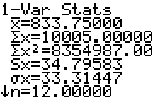Use the sample data to construct a 95% confidence interval estimate of *σ*, the standard deviation of sitting heights of all women. Does the confidence contain the value of 35 *mm*, which is believed to be the standard deviation of sitting heights of women?

***Solution***

Using the calculator: 



|  |
| --- |
|  |
|  |

 







Yes. The interval contains the traditionally believed value of 35 *mm*.

***Solution Section* 3.5 − Basic of Hypothesis Testing**

***Exercise***

Bottles of Bayer aspirin are labeled with a statement that the tablets each contain 325 mg of aspirin. A quality control manager claims that a large sample of data can be used to support the claim that the mean amount of aspirin in the tablets is equal to 325 mg, as the label indicates. Can a hypothesis test be used to support that claim? Why or Why not?

***Solution***

No. Since the claim that the mean is equal to a specific value must be the null hypothesis, the only possible conclusions are to reject that claim or to fail to reject that claim, Hypothesis testing cannot be used to support a claim that a parameter is equal to a particular value.

***Exercise***

In the preliminary results from couples using the Gender Choice method of gender selection to increase the likelihood of having a baby girl, 20 couples used the Gender Choice method with the result that 8 of them had baby girls and 12 had baby boys. Given that the sample proportion of girls is , can the sample data support the claim that the proportion of girls is greater than 0.5? Can any sample proportion less than 0.5 be used to support a claim that the population proportion is greater than 0.5?

***Solution***

No. Sample data that is not consistent with a claim can’t be used to support that claim. In particular, no sample proportion less than 0.5 can ever be used to support a claim that the population proportion is greater than 0.5.

***Exercise***

Express the null hypothesis  and alternative hypothesis  in symbolic form. Be sure to use the correct symbol  for indicated parameter

1. The mean annual income of employees who took a statistics course is greater than $60,000.
2. The proportion of people aged 18 to 25 who currently use illicit drugs is equal to 0.20 (or 20%).
3. The standard deviation of human body temperatures is equal to 0.62°F.
4. The majority of college students have credit cards.
5. The proportion of homes with fire extinguishers is 0.80.
6. The mean weight of plastic discarded by households in one week is less than 1 kg.

***Solution***

1. Original claim: 



1. Original claim: 



1. Original claim: 



1. Original claim: 



1. Original claim: 



1. Original claim: 



***Exercise***

Assume that the normal distribution applies and find the critical *z* values.

|  |  |
| --- | --- |
| 1. Two-tailed test: *α* = 0.01. 2. Right-tailed test: *α* = 0.02. 3. Left-tailed test: *α* = 0.10. | 2. *α* = 0.05 for two-tailed test 3. *α* = 0.05 for left-tailed test |

***Solution***

1. Two-tailed test; place  in each tail.



*Critical value*: 

1. Right-tailed test; place  in the upper tail. 





*Critical value*: 

1. Left-tailed test; place  in the lower tail. 





*Critical value*: 

1. Two-tailed test; place  in each tail. 





*Critical value*: 

1. Right-tailed test; place  in the upper tail. 





*Critical value*: 

1. Left-tailed test; place  in the lower tail. 

*Critical value*: 

1. Two-tailed test; place  in each tail.



*Critical value*: 

1. Left-tailed test;  

*Critical value*: 

1. Two-tailed test; place  in each tail. 

*Critical value*: 

***Exercise***

The claim is that the proportion of peas with yellow pods is equal to 0.25 (or 25%). The sample statistics from one of Mendel’s experiments include 580 peas with 152 of them having yellow pods. Find the value of the test statistic *z* using 

***Solution***



  

***Exercise***

The claim is that less than  of adults in U.S. have carbon monoxide detectors. A KRC Research survey of 1005 adults resulted in 462 who have carbon monoxide detectors. Find the value of the test statistic *z* using 

***Solution***



  

***Exercise***

The claim is that more than 25% of adults prefer Italian food as their favorite ethnic food. A Harris Interactive survey of 1122 adults resulted in 314 who say that Italian food is their favorite ethnic food. Find the value of the test statistic *z* using 

***Solution***



  

***Exercise***

Find *P-*value by using a 0.05 significance level and state the conclusion about the null hypothesis. (Reject the null hypothesis or fail to reject the null hypothesis)

1. The test statistic in a left-tailed test is *z* = −1.25
2. The test statistic in a right-tailed test is *z* = 2.50
3. The test statistic in a two-tailed test is *z* = 1.75
4. With , the test statistic is *z* = −2.75
5. With , the test statistic is *z* = 2.30
6. With , the test statistic is *z* = −2.95

***Solution***

|  |  |
| --- | --- |
| 1. *P-*value       Since 0.1056 > 0.05, fail to reject |  |
| 1. *P-*value           Since 0.0062 < 0.05, reject |  |
| 1. *P-*value       Since 0.0802 > 0.05, fail to reject |  |
| 1. *P-*value       Since 0.006 > 0.05, reject |  |
| 1. *P-*value       Since 0.0107 < 0.05, reject |  |
| 1. *P-*value     Since 0.0016 < 0.05, reject |  |

***Exercise***

The percentage of nonsmokers exposed to secondhand smoke is equal to 41%. Identify the type I error and type II error.

***Solution***

Original claim: 



Type I error: rejecting  when  is actually true rejecting the claim that the percentage of non-smokers exposed to secondhand smoke is 41% when that percentage actually is 41%

Type II error: failing to reject  when  is actually true failing to reject the claim that the percentage is actually different from 41%

***Exercise***

The percentage of Americans who believe that life exists only on earth is equal to 20%. Identify the type I error and type II error.

***Solution***

Original claim: 



Type I error: rejecting  when  is actually true rejecting the claim that the percentage of Americans who believe that life exists only on earth is 20% when that percentage actually is 20%

Type II error: failing to reject  when  is actually true failing to reject the claim that the percentage of Americans who believe that life exists only on earth is 20% when that percentage is actually different from 20%

***Exercise***

The percentage of college students who consume alcohol is greater than 70%. Identify the type I error and type II error.

***Solution***

Original claim: 



Type I error: rejecting  when  is actually true rejecting the claim that the percentage of college students who use alcohol is 70% when that percentage actually is 70%.

Type II error: failing to reject  when  is actually true failing to reject the claim that the percentage of college students who use alcohol is 70% when that percentage actually is actually greater than 70%

***Exercise***

An entomologist writes an article in a scientific journal which claims that fewer than 13 in 10,000 male fireflies are unable to produce light due to a genetic mutation. Use the parameter p, the true proportion of fireflies unable to produce light. Express the null hypothesis and the alternative hypothesis in symbolic form. 

***Solution***



Since the claims are fewer than it will be “<”



***Solution Section* 3.6 − Testing a Claim about a Proportion**

***Exercise***

In a Harris poll, adults were asked if they are in favor of abolishing the penny. Among the responses, 1261 answered “no”, and 491 answered “yes”, and 384 had no opinion. What is the sample proportion of *yes* responses, and what notation is used to represent it?

***Solution***

Total Responses: 

The sample proportion of yes responses is 

 is used to represent a sample proportion.

***Exercise***

A recent study showed that 53% of college applications were submitted online. Assume that this result is based on a simple random sample of 1000 college applications, with 530 submitted online. Use a 0.01 significance level to test the claim that among all college applications the percentage submitted online is equal to 50%

1. What is the test statistic?
2. What are the critical values?
3. What is the *P-*Value?
4. What is the conclusion?
5. Can a hypothesis test be used to “prove” that the percentage of college applications submitted online is equal to 50% as claimed?

***Solution***

1. 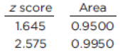







1. 



1. 

 

 

1. Do not reject ; there is not sufficient evidence to reject the claim that the percentage of all college applications that are submitted online is 50%.
2. No. A hypothesis test will either “reject” or “fail to reject” a claim that a population parameter is equal to a specified value.

***Exercise***

In a survey, 1864 out of 2246 randomly selected adults in the U.S. said that texting while driving should be illegal. Consider a hypothesis test that uses a 0.05 significance level to test the claim that more than 80% of adults believe that testing while driving should be illegal

1. What is the test statistic?
2. What are the critical values?
3. What is the *P-*Value?
4. What is the conclusion?

***Solution***

1. 





 

1. 



1. 





1. Reject ; there is sufficient evidence to conclude that the proportion of adults who believe that texting while driving should be illegal is greater than 80%.

***Exercise***

In a Pew Research Center poll of 745 randomly selected adults, 589 said that it is morally wrong to not report all income on tax returns. Use a 0.01 significance level to test the claim that 75% of adults say that it is morally wrong to not report all income on tax returns.

Identify the null hypothesis, alternative hypothesis, test statistic, *P-*value or critical value(s), conclusion about the null hypothesis, and final conclusion that address the original claim.

***Solution***

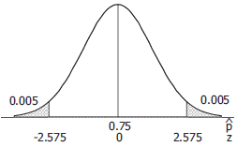Original claim: 







Assume: 



Critical value: 







|  |  |
| --- | --- |
|  |  |

***Conclusion***

Reject ; there is sufficient evidence to conclude that the proportion of adults who believe that texting while driving should be illegal is greater than 80%.

***Exercise***

308 out of 611 voters surveyed said that they voted for the candidate who won. Use a 0.01 significance level to test the claim that among all voters, the percentage who believe that they voted for the winning candidate is equal to 43%, which is the actual percentage of votes for the winning candidate. What does the result suggest about voter perceptions?

Identify the null hypothesis, alternative hypothesis, test statistic, *P-*value or critical value(s), conclusion about the null hypothesis, and final conclusion that address the original claim.

***Solution***

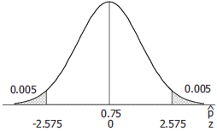Original claim: 







Assume: 



Critical value: 







|  |  |
| --- | --- |
|  |  |

***Conclusion***

Reject ; there is sufficient evidence to reject the claim that and conclude that (in fact, that ). There is sufficient evidence to reject the claim that the proportion of adults who believe they voted for the winning candidate is 43%. Either the voters are deliberately not telling the truth, or they have faulty memories about how they actually voted.

***Exercise***

The company Drug Test Success provides a “1-Panel-THC” test for marijuana usage. Among 300 tested subjects, results from 27 subjects were wrong (either a false positive or a false negative). Use a 0.05 significance level to test the claim that less than 10% of the test results are wrong. Does the test appear to be good for most purposes?

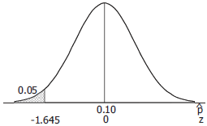***Solution***

Original claim: 









*Critical Value*: 







|  |  |
| --- | --- |
|  |  |

***Conclusion***

Do not reject ; there is not sufficient evidence to conclude that . There is not sufficient evidence to support the claim that the proportion of test results that are incorrect is less than 10%.

No; the test appears to have too high of an error rate to be considered reliable for most purposes.

***Exercise***

When testing gas pumps in Michigan for accuracy, fuel-quality enforcement specialists tested pumps and found that 1299 of them were not pumping accurately (within 3.3 oz. when 5 gal. is pumped), and 5686 pumps were accurate. Use a 0.01 significance level to test the claim of an industry representative that less than 20% of Michigan gas pumps are inaccurate. From the perspective of the consumer, does that rate appear to be low enough?

***Solution***

Original claim: 

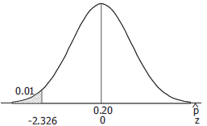







*Critical Value*:

|  |  |
| --- | --- |
|  |  |







|  |  |
| --- | --- |
|  |  |

***Conclusion***

Reject ; there is sufficient evidence to conclude that . There is sufficient evidence to support the claim that less than 20% of Michigan gas pumps are inaccurate.

No; from the perspective of the consumer, the rate does not appear to be low enough. While the point estimate of 0.186 indicates the rate is lower than 20%. It should probably be about  of that.

***Exercise***

Trials in an experiment with a polygraph include 98 results that include 24 cases of wrong results and 74 cases of correct results. Use a 0.05 significance level to test the claim that such polygraph results are correct less than 80% of the time. Based on the results, should polygraph test results be prohibited as evidence in trials?

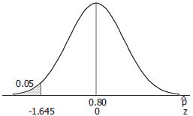***Solution***

Original claim: 









*Critical Value*: 







|  |  |
| --- | --- |
|  |  |

***Conclusion***

Do not reject ; there is not sufficient evidence to conclude that . There is not sufficient evidence to support the claim polygraph tests are correct less than 80% of the time.

Yes; based on these results, polygraph test results should probably be prohibited as evidence in trials. Even though the point estimate of 75.5% accuracy does not support the less than 80% claim, the accuracy rate is still far too small to make conclusions beyond a reasonable doubt.

***Exercise***

In recent years, the Town of Newport experienced an arrest rate of 25% for robberies. The new sheriff compiles records showing that among 30 recent robberies, the arrest rate is 30%, so she claims that her arrest rate is greater than the 25% rate in the past. Is there sufficient evidence to support her claim that the arrest rate is greater than 25%?

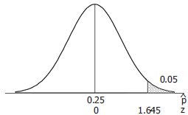***Solution***

Original claim: 







Assumed: 

*Critical Value*: 







|  |  |
| --- | --- |
|  |  |

***Conclusion***

Do not reject ; there is not sufficient evidence to conclude that . There is not sufficient evidence to support the new sheriff’s claim that the new arrest rate is greater than 25%.

***Exercise***

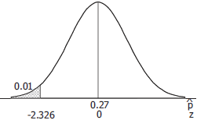A survey showed that among 785 randomly selected subjects who completed 4 years of college, 18.3 % smoke and 81.7% do not smoke. Use a 0.01 significance level to test the claim that the rate of smoking among those with 4 years of college is less than the 27% rate for the general population. Why would college graduates smoke at a lower rate than others?

***Solution***

Original claim: 









*Critical Value*:

|  |  |
| --- | --- |
|  |  |



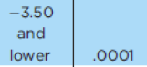 





***Conclusion***

Reject ; there is sufficient evidence to conclude that . There is sufficient evidence to support the claim that the proportion of smokers among those with four years of college is less than the general rate of 27%. College graduates would smoke at a lower rate others because those with better education tend to make wiser decisions and are more likely to recognize the various disadvantages of smoking.

***Exercise***

When 3011 adults were surveyed, 73% said that they use the Internet. Is it okay for a newspaper reporter to write that “3/4 of all adults use the internet”? Why or Why not?

***Solution***

The value for *x* is not given,





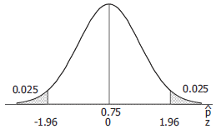Original claim: 







Assumed: 

*Critical Value*:

|  |  |
| --- | --- |
|  |  |







|  |  |
| --- | --- |
|  |  |

***Conclusion***

Reject ; there is sufficient evidence to conclude that  and conclude that (in fact, that ). There is sufficient evidence to reject the claim that the proportion of adults who use the internet is . While the difference between 0.73 and 0.75 may be of little practical significance, in the interest of accuracy the reporter should not write that  of all adults use the internet.

***Exercise***

A hypothesis test is performed to test the claim that a population proportion is greater than 0.7. Find the probability of a type II error, *β*, given that the true value of the population proportion is 0.72. The sample size is 50 and the significance level is 0.05.

***Solution***



The rejection region for the test is any sample proportion greater than:









The probability for the true value of 0.72



*Because for a type II error, failure to reject the null when it is false, requires that the true value be in alternative space. Since the in the first set up, the value of 0.72 is in the null space, the null hypothesis is true and β does not exists, because a Type II error is impossible.*

***Exercise***

In a sample of 88 children selected randomly from one town, it is found that 8 of them suffer asthma. Find the *P*-value for a test of the claim that the proportion of all children in the town who suffer from asthma is equal to 11%.

***Solution***

Original claim:  & 









***Exercise***

An airline claims that the no-show rate for passengers booked on its flights is less than 6%. Of 380 randomly selected reservation, 18 were no-shows. Find the P-value for a test of the airline’s claim.

***Solution***

Original claim: 







***Solution Section* 3.7 − Testing a Claim about a Mean: Sigma Known**

***Exercise***

Because the amounts of nicotine in king size cigarettes listed below

|  |  |  |  |  |  |  |  |  |  |  |  |  |
| --- | --- | --- | --- | --- | --- | --- | --- | --- | --- | --- | --- | --- |
| 1.1 | 1.7 | 1.7 | 1.1 | 1.1 | 1.4 | 1.1 | 1.4 | 1 | 1.2 | 1.1 | 1.1 | 1.1 |
| 1.1 | 1.1 | 1.8 | 1.6 | 1.1 | 1.2 | 1.5 | 1.3 | 1.1 | 1.3 | 1.1 | 1.1 |  |

We must satisfy the requirement that the population is normally distributed. How do we verify that a population is normally distributed?

***Solution***

We consider the normality requirement to be satisfied if there are no outliers and the histogram of the sample data is approximately bell-shaped. More formally, a normal quantile plot could be used to determine whether the sample data are approximately normally distributed.

***Exercise***

If you want to construct a confidence interval to be used for testing the claim that college students have a mean IQ score that is greater than 100, and you want the test conducted with a 0.01 significance level, what confidence level should be used for the confidence interval?

***Solution***

A one-tailed test at the 0.01 level of significance rejects the null hypothesis if the sample statistic falls into the extreme 1% of the sampling distribution in the appropriate tail. The corresponding (two-sided) confidence interval test that places 1% each tail would be a 98% confidence interval.

***Exercise***

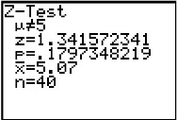A jewelry designer claims that women have wrist breadths with a mean equal to 5 cm. A simple random sample of the wrist breadths of 40 women has a mean of 5.07 cm. Assume that the population standard deviation is 0.33 cm. Use the accompanying TI display to test the designer’s claim.

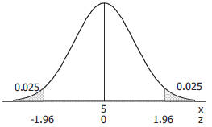Identify the null hypothesis, alternative hypothesis, test statistic, *P-*value or critical value(s), conclusion about the null hypothesis, and final conclusion that address the original claim.

***Solution***

Original claim: *μ* = 5 cm





Assume: 

Critical value: 

*P-*value = 0.1797 [***TI***]

 [***TI***]

***Conclusion***

Do not reject ; there is not sufficient evidence to reject the claim that *μ* = 5. There is not sufficient evidence the claim that women have a mean wrist breadth equal to 5 cm.

***Exercise***

The U.S. Mint has a specification that pennies have a mean weight of 2.5 g. Assume that weights of pennies have a standard deviation of 0.0165 g and use the accompanying Minitab display to test the claim that the sample is from a population with a mean that is less than 2.5 g. These Minitab results were obtained using the 37 weights of post 1983 pennies.

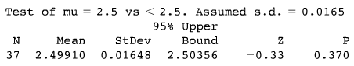

***Solution***

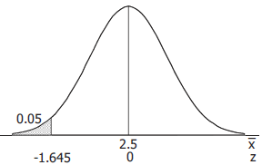Original claim: *μ* < 2.5 g.





Assume: 

Critical value: 

 [***Minitab***]

*P-*value = 0.370 [***Minitab***]

***Conclusion***

Do not reject ; there is not sufficient evidence to reject the claim that *μ* < 2.5. There is not sufficient evidence to support the claim the sample is from a population with a mean less than 2.5 g.

***Exercise***

In the manual “How long to have a Number One the Easy Way,” by KLF Publications, it is stated that a song “must be no longer than 3 minutes and 30 seconds” (or 210 seconds). A simple random sample of 40 current hit songs results in a mean length of 252.5 sec. Assume that the standard deviation of song lengths is 54.5 sec. Use a 0.05 significance level to test the claim that the sample is from a population of songs with a mean greater than 210 sec. What do these results suggest about the advice given in the manual?

***Solution***

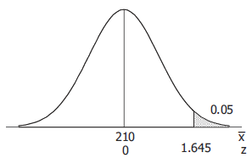Original claim: *μ*  > 210 sec.





Given: 

Critical value: 





**

***Conclusion***

Reject ; there is sufficient evidence to conclude that *μ* > 210. There is sufficient evidence to support the claim the sample is from a population of songs with a mean greater than 210 sec. These results suggest that the advice given in the manual is not good advice.

***Exercise***

A simple random sample of 50 adults is obtained, and each person’s red blood cell count (in cells per microliter) is measured. The sample mean is 5.23. The population standard deviation for red blood cell counts is 0.54. Use a 0.01 significance level to test the claim that the sample is from population with a mean less than 5.4, which is value often used for the upper limit of the range of normal values. What do the results suggest about the sample group?

***Solution***

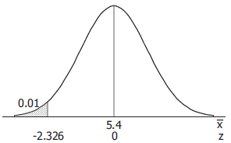Original claim: *μ*  < 5.4 cells/microliter.





*Given*: 





Critical value: 

 

**

***Conclusion***

Do not reject ; there is not sufficient evidence to reject the claim that *μ* < 5.4. There is not sufficient evidence to support the claim the sample is from a population with a mean red blood cell count less than 504 cells/microliter. If 5.4 is the upper limit for the range of normal individuals, and if the mean of the sample group is not significantly below the upper limit for an individual and the mean of the sample group may have manually high red cell counts. The  guideline for normal values suggests that the population mean is approximately , and the sample mean of 5.23 is considerably higher than that.

***Exercise***

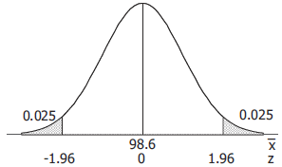A simple random sample of 106 body temperature with a mean of 98.20 °F. Assume that σ is known to be 0.62 °F. Use a 0.05 significance level to test the claim that the mean body temperature of the population is equal to 98.6 °F, as is commonly believed. Is there sufficient evidence to conclude that the common belief is wrong?

***Solution***

Original claim: *μ*  = 98.6 °F.





*Given*: 





Critical value:





 



**

**

**

***Conclusion***

Reject ; there is sufficient evidence to reject the claim that *μ* = 98.6 and conclude that  (in fact, that ). There is sufficient evidence to reject the claim that the mean body temperature of the population is 98.6°F. Yes; it appears there is sufficient evidence to conclude that the common belief is wrong.

***Exercise***

When 40 people used the Weight Watchers diet for one year, their mean weight loss was 3.0 lb. Assume that the standard deviation of all such weight changes is ***σ*** = 4.9 lb. and use a 0.01 significance level to test the claim that the mean weight loss is greater than 0. Based on these results, does the diet appear to be effective? Does the diet appear to have a practical significance?

***Solution***

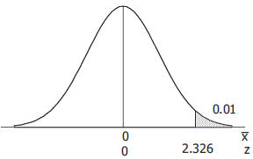Original claim: *μ*  > 0 lb.





*Given*: 

Critical value:



 

**

***Conclusion***

Reject ; there is sufficient evidence to reject the claim that *μ* > 0. There is sufficient evidence to support the claim that the mean weight lost is greater than 0. The diet is effective in that the weight loss is statistically significant – but a mere 3.0 lbs. weight loss after following the regimen for an entire year suggests the diet may have no practical significance.

***Exercise***

The health of the bear population in Yellowstone National Park is monitored by periodic measurements taken from anesthetized bears. A sample of 54 bears has a mean weight of 182.9 lb. Assuming that ***σ*** is known to be 121.8 lb. use a 0.05 significance level to test the claim that the population mean of all such bear weights is greater than 150 lb.

***Solution***

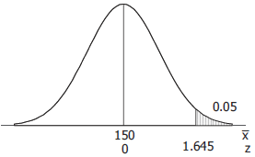Original claim: *μ*  > 150 lbs.





*Given*: 

Critical value:



 

**

***Conclusion***

Reject ; there is sufficient evidence to conclude that *μ* > 150. There is sufficient evidence to support the claim that the mean weight of all such bears is greater than 150 lbs.

***Exercise***

A simple random sample of 401 salaries of NCAA football coaches in the NCAA has a mean of $415,953. The standard deviation of all salaries of NCAA football coaches is $463,364. Use a 0.05 significance level to test the claim that the mean salary of a football coach in the NCAA is less than $500,000.

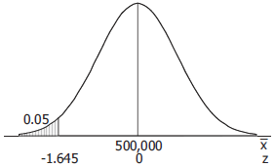***Solution***

Original claim: *μ*  < $500,000.





*Given*: 

Critical value: 

 

**

***Conclusion***

Do not reject ; there is not sufficient evidence to conclude that *μ* < 500,000. There is not sufficient evidence to support the claim that the mean salary of an NCAA football coach is less than $500,000.

***Exercise***

A simple random sample of 36 cans of regular Coke has a mean volume of 12.19 oz. Assume that the standard deviation of all cans of regular Coke is 0.11 oz. Use a 0.01 significance level to test the claim that cans if regular Coke have volumes with a mean of 12 oz., as stated on the label. If there is a difference, is it substantial?

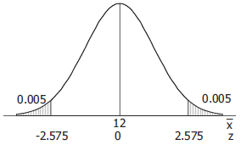***Solution***

Original claim: *μ*  < 12 oz.





*Given*: 

Critical value: 

 

**

***Conclusion***

Reject ; there is sufficient evidence to reject the claim that *μ* = 12 and conclude that  (in fact, that ). There is sufficient evidence to reject the claim that cans of regular Coke have a mean volume of 12 oz. The difference is statistically significant, but the difference is of practical significance only in that it guarantees that virtually 100% of the product meets the volume stated on the label.

***Exercise***

A simple random sample of FICO credit rating scores is obtained, and the scores are listed below.

|  |  |  |  |  |  |  |  |  |  |  |  |
| --- | --- | --- | --- | --- | --- | --- | --- | --- | --- | --- | --- |
| 714 | 751 | 664 | 789 | 818 | 779 | 698 | 836 | 753 | 834 | 693 | 802 |

As the writing, the mean FICO score was reported to be 678. Assuming the standard deviation of all FICO scores is known to be 58.3, use a 0.05 significance level to test the claim that these sample FICO scores come from a population with a mean equal to 678.

Identify the null hypothesis, alternative hypothesis, test statistic, *P-*value or critical value(s), conclusion about the null hypothesis, and final conclusion that address the original claim.

***Solution***



Original claim: *μ*  < 678 FICO units.





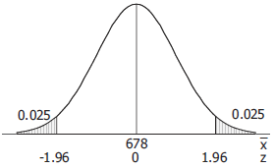*Given*: 

Critical value: 



**

***Conclusion***

Reject ; there is sufficient evidence to reject the claim that *μ* = 678 and conclude that  (in fact, that ). There is sufficient evidence to reject the claim that these FICO scores come from a population with a mean equal to 678.

***Exercise***

Listed below are recorded speeds (in mi/h) of randomly selected cars traveling on a section of Highway 405 in Los Angeles.

|  |  |  |  |  |  |  |  |  |  |  |  |  |  |  |  |  |  |  |  |
| --- | --- | --- | --- | --- | --- | --- | --- | --- | --- | --- | --- | --- | --- | --- | --- | --- | --- | --- | --- |
| 68 | 68 | 72 | 73 | 65 | 74 | 73 | 72 | 68 | 65 | 65 | 73 | 66 | 71 | 68 | 74 | 66 | 71 | 65 | 73 |
| 59 | 75 | 70 | 56 | 66 | 75 | 68 | 75 | 62 | 72 | 60 | 73 | 61 | 75 | 58 | 74 | 60 | 73 | 58 | 75 |

That part of the highway has posted speed limit of 65 mi/h. Assume that the standard deviation od speeds is 5.7 mi/h and use a 0.01 significance level to test the claim that the sample is from a population with a mean that is greater than 65 mi/h.

Identify the null hypothesis, alternative hypothesis, test statistic, *P-*value or critical value(s), conclusion about the null hypothesis, and final conclusion that address the original claim.

***Solution***



Original claim: *μ*  > 65 mph..

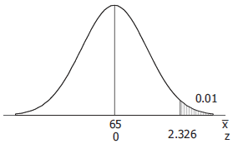



*Given*: 

Critical value: 



**

***Conclusion***

Reject ; there is sufficient evidence to conclude that *μ* > 65. There is sufficient evidence to support the claim that the sample is from a population with a mean greater than 65 mph.

***Solution Section* 3.8 − Testing a Claim about a Mean: Sigma Not Known**

***Exercise***

Given a simple random sample of speeds of cars on Highway in CA, you want to test the claim that the sample that the sample values are from a population with a mean greater than the posted speed limit of 65 mi/hr. Is it necessary to determine whether the sample is from a normally distributed population? If so, what methods can be used to make that determination?

***Solution***

Yes, since , the sample should be from a population that is approximately normally distributed. We consider the normality requirement to be satisfied for such data if there are no outliers and the histogram of the sample data is approximately bell-shaped. More formally, a normal quantile plot could be used to determine whether the sample data are approximately normally distributed.

***Exercise***

In statistics, what does ***df*** denote. If a simple random sample of 20 speeds of cars is to be used to test the claim that the sample values are from a population with a mean greater than the posted speed limit of 65 mi/h, what is the specific value of ***df***?

***Solution***

In statistics, ***df*** denotes the degrees of freedom. In general, the degrees of freedom give the number of pieces of information that are free to vary without changing the mathematical constraint of the problem. When using a *t* test with  sample values to test a claim about the mean of a population, 

***Exercise***

Claim about IQ scores of statistics instructors: , sample data: . The sample data appear to come from a normally distributed population with unknown *μ* and *σ*. Determine whether the hypotheses test involves a sampling distribution of means that is a normal distribution, student *t* distribution, or neither.

***Solution***

Use *t*. When *σ* is unknown and the *x*’s approximately normally distributed, use *t*.

***Exercise***

Claim about FICO credit scores of adults: , sample data: . The sample data appear to come from a population with a distribution that is not normal, and *σ* Is unknown Determine whether the hypotheses test involves a sampling distribution of means that is a normal distribution, student *t* distribution, or neither.

***Solution***

Neither the *z* nor the *t* applies. When *σ* is unknown and the *x*’s are not normally distributed sample sizes  cannot be used with these techniques.

***Exercise***

Claim about daily rainfall amounts in Boston: , sample data:

The sample data appear to come from a population with a distribution that is very far from normal, and *σ* is unknown Determine whether the hypotheses test involves a sampling distribution of means that is a normal distribution, student *t* distribution, or neither.

***Solution***

Neither the *z* nor the *t* applies. When *σ* is unknown and the *x*’s are not normally distributed sample sizes  cannot be used with these techniques.

***Exercise***

Testing a claim about the mean weight of M&M’s: Right-tailed test with *n* = 25 and test statistic *t* = 0.430. Find the *P-*value and find a range of values for the *P-*value.

***Solution***



Table for area in one tail: [0.430 < 1.318] 

TI: ***tcdf***(0.430, 99, 24) = 0.3355

 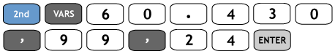

***Exercise***

Test a claim about the mean body temperature of healthy adults: left-tailed test with *n* = 11 and test statistic *t* = −3.158. Find the *P-*value and find a range of values for the *P-*value.

***Solution***



Table for area in one tail: [−3.518 < −3.169]



TI: ***tcdf***(−99, −3.518, 10) = 0.00278

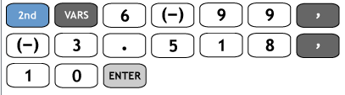 

***Exercise***

Two-tailed test with *n* = 15 and test statistic *t* = 1.495. Find the *P-*value and find a range of values for the *P-*value.

***Solution***



Table for area in two tails: [1.345 < 1.495 < 1.761]



TI: 2·***tcdf***(1.495, 99, 14) = 0.1571

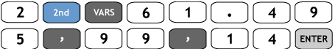 

***Exercise***

In an analysis investigating the usefulness of pennies, the cents portions of 100 randomly selected checks are recorded. The sample has mean of 23.8 cents and a standard deviation of 32.0 cents. If the amounts from 0 cents to 99 cents are all equally likely, the mean is expected to be 49.5 cents. Use a 0.01 significance level to test the claim that the sample is from a population with a mean less than 49.5 cents. What does the result suggest about the cents portions of the checks?

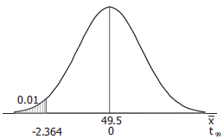***Solution***

Original claim: *μ*  = 49.5 cents.





*Given*: 

Critical value: 

 

**

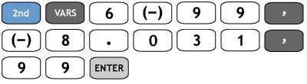 

***Conclusion***

Reject ; there is sufficient evidence to conclude that *μ* < 49.5. There is sufficient evidence to that the cents portion of all checks has a mean that is less than 49.5 cents. The results suggest that the cents portions of checks are not uniformly distributed from 0 to 99 cents.

***Exercise***

A simple random sample of 40 recorded speeds (in mi/h) is obtained from cars traveling on a section of Highway 405 in Los Angeles. The sample has a mean of 68.4 mi/h and a standard deviation of 5.7 mi/h.

Use a 0.05 significance level to test the claim that the mean speed of all cars is greater than the posted speed limit of 65 mi/h.

***Solution***



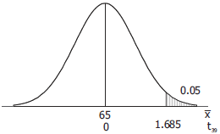Original claim: *μ*  > 65 mph.





*Given*: 

Critical value: 

|  |
| --- |
|  |
|  |



**

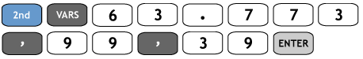 

***Conclusion***

Reject ; there is sufficient evidence to conclude that *μ* > 65. There is sufficient evidence to support the claim that the mean speed of all such cars is greater than the posted speed of 65 mph.

***Exercise***

The heights are measured for the simple random sample of supermodels. They have mean height of 70.0 in. and a standard deviation of 1.5 in. Use a 0.01 significance level to test the claim that supermodels have heights with a mean that is greater than the mean heights of 63.6 in. for women in general population. Given that there are only nine heights represented, can we really conclude that supermodels are taller than the typical woman?

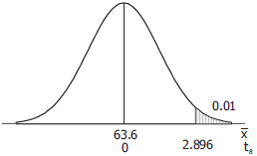***Solution***

Original claim: *μ*  > 63.6 in.





*Given*: 

Critical value: 

|  |
| --- |
|  |
|  |



**

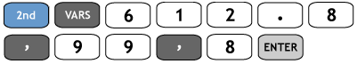 

***Conclusion***

Reject ; there is sufficient evidence to conclude that *μ* > 63.6. There is sufficient evidence to support the claim that supermodels have a mean height that is greater than the 63.6 in. of the general population of women. Yes; assuming that the heights of supermodels are approximately normally distributed around their mean, the test and the conclusion are valid.

***Exercise***

The National Highway Traffic Safety Administration conducted crash tests of child booster seats for cars. Listed below are results from those tests, with measurement given in hic (standard *head injury condition* units). The safety requirement is that the hic measurement should be less than 1000 hic. Use a 0.01 significance level to test the claim that the sample is from a population with a mean less than 1000 hic.

|  |  |  |  |  |  |
| --- | --- | --- | --- | --- | --- |
| 774 | 649 | 1210 | 546 | 431 | 612 |

Do the results suggest that all of the child booster seats meet the specified requirement?

***Solution***

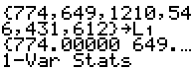 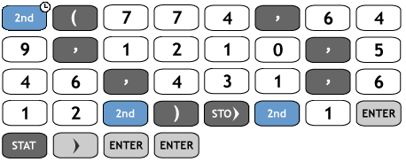 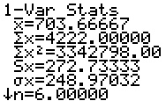



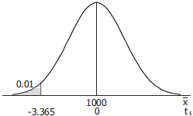Original claim: *μ*  < 1000 hic.





*Given*: 

Critical value: 

|  |
| --- |
|  |
|  |



**

***Conclusion***

Do not reject ; there is not sufficient evidence to conclude that *μ* < 1000. There is not sufficient evidence to support the claim that the population mean is less than 1000 hic. No; since one of the sample values is 1210, there is proof that not all of the child booster seats meet the specified requirement.

***Exercise***

The trend of thinner Miss America winners has generated charges that the contest encourages unhealthy diet habits among young women. Listed below are body mass indexes (BMI) for recent Miss America winners. Use a 0.01 significance level to test the claim that recent Miss America winners are from a population with a mean BMI less than 20.16, which was the BMI for winners from the 1920s and 1930s.

|  |  |  |  |  |  |  |  |  |  |
| --- | --- | --- | --- | --- | --- | --- | --- | --- | --- |
| 19.5 | 20.3 | 19.6 | 20.2 | 17.8 | 17.9 | 19.1 | 18.8 | 17.6 | 16.8 |

Do recent winners appear to be significantly different from those in the 1920s and 1930s?

***Solution***

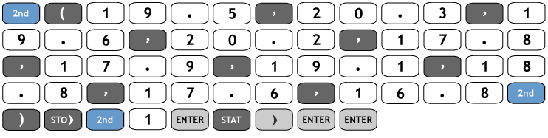 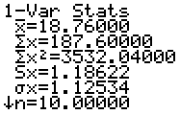



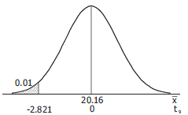Original claim: *μ*  < 20.16.





*Given*: 

Critical value: 

|  |
| --- |
|  |
|  |



**

***Conclusion***

Reject ; there is sufficient evidence to conclude that *μ* < 20.16. There is sufficient evidence to support the claim that the recent winners are from a population with BMI less than 20.16, which was the BMI for winners in the 1920’s and 1930’s.

Yes; recent winners appear to be significantly different from those in the earlier years.

***Exercise***

The list measured voltage amounts supplied directly to the author’s home

|  |  |  |  |  |  |  |  |  |  |  |  |
| --- | --- | --- | --- | --- | --- | --- | --- | --- | --- | --- | --- |
| 123.8 | 123.9 | 123.9 | 123.3 | 123.4 | 123.3 | 123.3 | 123.6 | 123.5 | 123.5 | 123.5 | 123.7 |
| 123.6 | 123.7 | 123.9 | 124.0 | 124.2 | 123.9 | 123.8 | 123.8 | 124.0 | 123.9 | 123.6 | 123.5 |
| 123.4 | 123.4 | 123.4 | 123.4 | 123.3 | 123.3 | 123.5 | 123.6 | 123.8 | 123.9 | 123.9 | 123.8 |
| 123.9 | 123.7 | 123.8 | 123.8 |  |  |  |  |  |  |  |  |

The Central Hudson power supply company states that it has a target power supply of 120 volts. Using those home voltage amounts, test the claim that the mean is 120 volts. Use a 0.01 significance level.

***Solution***

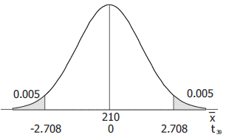

Original claim: *μ*  = 120 volts.





*Given*: 

Critical value: 

|  |
| --- |
|  |
|  |



**

***Conclusion***

Reject ; there is sufficient evidence to conclude that *μ* = 120 and conclude that  (in fact the ). There is sufficient evidence to reject the claim that the mean home voltage amount is 120 volts.

***Exercise***

The list measured human body temperature.

|  |  |  |  |  |  |  |  |  |  |  |  |  |  |  |
| --- | --- | --- | --- | --- | --- | --- | --- | --- | --- | --- | --- | --- | --- | --- |
| 98.6 | 98.6 | 98.0 | 98.0 | 99.0 | 98.4 | 98.4 | 98.4 | 98.4 | 98.6 | 98.6 | 98.8 | 98.6 | 97.0 | 97.0 |
| 98.8 | 97.6 | 97.7 | 98.8 | 98.0 | 98.0 | 98.3 | 98.5 | 97.3 | 98.7 | 97.4 | 98.9 | 98.6 | 99.5 | 97.5 |
| 97.3 | 97.6 | 98.2 | 99.6 | 98.7 | 99.4 | 98.2 | 98.0 | 98.6 | 98.6 | 97.2 | 98.4 | 98.6 | 98.2 | 98.0 |
| 97.8 | 98.0 | 98.4 | 98.6 | 98.6 | 97.8 | 99.0 | 96.5 | 97.6 | 98.0 | 96.9 | 97.6 | 97.1 | 97.9 | 98.4 |
| 97.3 | 98.0 | 97.5 | 97.6 | 98.2 | 98.5 | 98.8 | 98.7 | 97.8 | 98.0 | 97.1 | 97.4 | 99.4 | 98.4 | 98.6 |
| 98.4 | 98.5 | 98.6 | 98.3 | 98.7 | 98.8 | 99.1 | 98.6 | 97.9 | 98.8 | 98.0 | 98.7 | 98.5 | 98.9 | 98.4 |
| 98.6 | 97.1 | 97.9 | 98.8 | 98.7 | 97.6 | 98.2 | 99.2 | 97.8 | 98.0 | 98.4 | 97.8 | 98.4 | 97.4 | 98.0 |
| 97.0 |  |  |  |  |  |  |  |  |  |  |  |  |  |  |

Use the temperatures listed for 12 AM on day 2 to test the common belief that the mean body temperature is 98.6 °F. Does that common belief appear to be wrong?

***Solution***

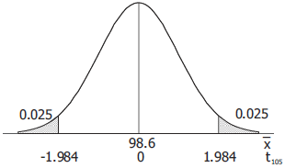

Original claim: *μ*  = 98.6 °F.





*Given*: 

Critical value: 

|  |
| --- |
|  |
|  |



**

***Conclusion***

Reject ; there is sufficient evidence to conclude that *μ* = 98.6 and conclude that  (in fact the ). There is sufficient evidence to reject the claim that the mean body temperature of the population is 98.6 °F. Yes; it appears there is sufficient evidence to conclude that the common belief is wrong.

***Exercise***

When testing a claim about a population mean with a simple random sample selected from a normally distributed population with unknown σ, the student t distribution should be used for finding critical values and/or a P−value. If the standard normal distribution is incorrectly used instead, does that mistake make you more or less likely to reject the null hypothesis, or does it not make a difference? Explain.

***Solution***

Because the *z* distribution has less spread than a *t* distribution,  is less than for any *α*. This makes the critical *z* value smaller (closer to 0) than the corresponding critical *t* value, which means that rejection is more likely with *z* than with *t*.

***Exercise***

Determine whether the hypothesis test involves a sampling distribution of means that is a normal distribution, student *t* distribution, or neither

1. Claim . Sample data: . The sample data appear to come from a normally distributed population with .
2. Claim . Sample data: . The sample data appear to come from a normally distributed population with unknown .

***Solution***

1. Normal
2. Student *t*. (*σ* in unknown and the *x*’s approximately normally distributed, use *t*.

***Solution Section* 3.9 − Testing a Claim about Variation**

***Exercise***

There is a claim that the lengths of men’s hands have a standard deviation less than 200 mm. You plan to test that claim with a 0.01 significance level by constructing a confidence interval. What level of confidence should be used for the confidence interval? Will the conclusion based on the confidence interval be the same as the conclusion based on a hypothesis test that uses the traditional method or the *P-*value method?

***Solution***

A one-tailed test at the 0.01 level of significance rejects the null hypothesis if the sample statistic falls into the extreme 1% of the sampling distribution in the appropriate tail. The corresponding (two-sided) confidence interval test that places 1% each tail would be a 98% confidence interval. When testing claims about a standard deviation, the confidence interval method gives the same results as test using the traditional method or the *P-*value method.

***Exercise***

There is a claim that daily rainfall amounts in Boston have a standard deviation equal to 0.25 in. Sample data show that daily rainfall amounts are from a population with a distribution that is very far from normal. Can the use of a very large sample compensate for the lack of normality, so that the methods of this section can be used for the hypothesis test?

***Solution***

No. Unlike tests and confidence intervals involving the mean, which do not require normality when , test and confidence intervals involving standard deviations require approximate normality for all sample sizes.

***Exercise***

There is a claim that men have foot breaths with a variance equal to 36 . Is a hypothesis test of the claim that the variance is equal to 36  equivalent to a test of the claim that the standard deviation is equal to 6 *mm*.

***Solution***

Yes. The claim that the variance is equal to 36  and the claim that the standard deviation is equal to 6 *mm* are equivalent claims, and their corresponding tests are equivalent.

***Exercise***

Given: , Find

1. Find the test statistic
2. Find critical value(s)
3. Find *P-*value limits
4. Determine whether there is sufficient evidence to support the given alternative hypothesis.

***Solution***

1. Test statistic: 
2. Critical values for 

|  |
| --- |
|  |
|  |





1. *P-*value limits: 15.659 < 20.612 (part *a*)

*P-*value > 0.20

*P-*value exact: 

1. Conclusion: Do not reject ; there is not sufficient to conclude that 

***Exercise***

Given: , Find

1. Find the test statistic
2. Find critical value(s)
3. Find *P-*value limits
4. Determine whether there is sufficient evidence to support the given alternative hypothesis.

***Solution***

1. Test statistic: 
2. Critical values for 

|  |
| --- |
|  |
|  |



1. *P-*value limits: (part *a*) 0.468 < 0.989

*P-*value < 0.005

*P-*value exact: 

1. Conclusion: Reject ; there is sufficient to conclude that 

***Exercise***

Given: , Find

1. Find the test statistic
2. Find critical value(s)
3. Find *P-*value limits
4. Determine whether there is sufficient evidence to support the given alternative hypothesis.

***Solution***

1. Test statistic: 
2. Critical values for 

|  |
| --- |
|  |
|  |



1. *P-*value limits: 26.119 < 26.331 < 29.141

0.01 < *P-*value < 0.025

*P-*value exact: 

1. Conclusion: Do not reject ; there is not sufficient evidence to conclude that 

***Exercise***

Given: , Find

1. Find the test statistic
2. Find critical value(s)
3. Find *P-*value limits
4. Determine whether there is sufficient evidence to support the given alternative hypothesis.

***Solution***

1. Test statistic: 
2. Critical values for 

|  |
| --- |
|  |
|  |





1. *P-*value limits: 12.198 < 12.960 < 13.844

0.02 < *P-*value < 0.05

*P-*value exact: 

1. Conclusion: Do not reject ; there is not sufficient to conclude that 

***Exercise***

A simple random sample of 40 men results in a standard deviation of 11.3 beats per minute. The normal range of pulse rates of adults is typically given as 60 to 100 beats per minute. If the range rule of thumb is applied to that normal range, the result is a standard deviation of 10 beats per minute. Use the sample results with a 0.05 significance level to test the claim that rates of men have a standard deviation greater than 10 beats per minute.

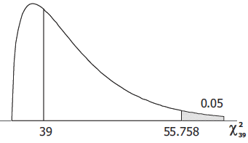***Solution***

Original claim: 





*Given*: 

Critical value: 

|  |
| --- |
|  |
|  |



*P-*value exact: 

***Conclusion***

Do not reject ; there is not sufficient evidence to conclude that . There is not sufficient evidence to support the claim that the pulse rate of men have a standard deviation greater than 10 *beats/min*.

***Exercise***

A simple random sample of 25 filtered 100 mm cigarettes is obtained, and the tar content of each cigarette is measured. The sample has a standard deviation of 3.7 mg. Use a 0.05 significance level to test the claim that the tar content of filtered 100 mm cigarettes has a standard deviation different from 3.2 mg, which is the standard deviation for unfiltered king size cigarettes.

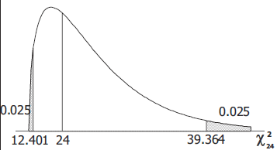***Solution***

Original claim: 





*Given*: 

Critical value:

|  |
| --- |
|  |
|  |







*P-*value exact: 

***Conclusion***

Do not reject ; there is not sufficient evidence to conclude that . There is not sufficient evidence to support the claim that the tar content of such cigarettes has a standard deviation different from 3.2 *mg*.

***Exercise***

When 40 people used the Weight Watchers diet for one year, their weight losses had a standard deviation of 4.9 lb. Use 0.01 significance level to test the claim that the amounts of weight loss have a standard deviation equal to 6.0 lb., which appears to be the standard deviation for the amounts of weight loss with the Zone diet.

***Solution***

Original claim: 





*Given*: 

Critical value:

|  |
| --- |
|  |
|  |

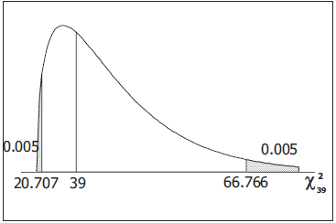





*P-*value exact:



***Conclusion***

Do not reject ; there is not sufficient evidence to conclude that . There is not sufficient evidence to support the claim that the weight losses from this diet have a standard deviation different of 6.0 *lbs*.

***Exercise***

Tests in the statistic classes have scores with a standard deviation equal to 14.1. One of the last classes has 27 test scores with a standard deviation of 9.3. Use a 0.01 significance level to test the claim that this class has less variation than other past classes. Does a lower standard deviation suggest that this last class is doing better?

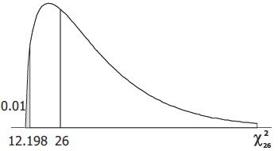***Solution***

Original claim: 





*Given*: 

Critical value:

|  |
| --- |
|  |
|  |





*P-*value exact:

***Conclusion***

Reject ; there is sufficient evidence to conclude that . There is sufficient evidence to support the claim that this class has less variation than other past classes.

No; a lower standard deviation means that the scores are closer together, but it says nothing about whether they are higher or lower.

***Exercise***

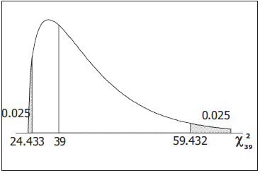A simple random sample of pulse rates of 40 women results in a standard deviation of 12.5 *beats/min*. The normal range of pulse rates of adults is typically given as 60 to 100 *beats/min*. If the range rule of thumb is applied to that normal range, the result is a standard deviation of 10 *beats/min*. Use the sample results with a 0.05 significance level to test the claim that pulse rates of women have a standard deviation equal to 10 *beats/min*.

***Solution***

Original claim: 





*Given*: 

Critical value:

|  |
| --- |
|  |
|  |







*P-*value exact: 

***Conclusion***

Reject ; there is sufficient evidence to reject the claim that  conclude that . There is sufficient evidence to reject the claim that the pulse rates of women have a standard deviation equal to 10 *beats/min*.

***Exercise***

Listed below are the playing times (in seconds) of songs that were popular at the time of this writing. Use a 0.05 significance level to test the claim that the songs are from a population with a standard deviation less than on minute.

|  |  |  |  |  |  |  |  |  |  |  |  |  |  |  |  |
| --- | --- | --- | --- | --- | --- | --- | --- | --- | --- | --- | --- | --- | --- | --- | --- |
| 448 | 242 | 231 | 246 | 246 | 293 | 280 | 227 | 244 | 213 | 262 | 239 | 213 | 258 | 255 | 257 |

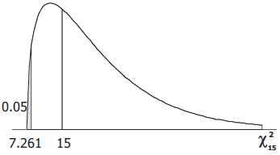***Solution***



Original claim: 





*Given*: 

Critical value

|  |
| --- |
|  |
|  |





*P-*value exact: 

***Conclusion***

Do not reject ; there is not sufficient evidence to conclude that . There is not sufficient evidence to support the claim that the songs are from a population with a standard deviation less than one minute.

***Exercise***

Find the critical value or values of  based on the given information

1. 
2. 
3. 
4. 

***Solution***

Using Chi-Square  Distribution Table

1. 

|  |
| --- |
|  |
|  |

Critical value: 



1. 

|  |
| --- |
|  |
|  |

Since , then 

1. 

|  |
| --- |
|  |
|  |

Since , then 

1. 

|  |
| --- |
|  |
|  |

Critical value: 

