***Lecture Three***

***Section* 3.1** − **Estimating a Population Proportion**

In this section we present methods for using a sample proportion to estimate the value of a population proportion.

* The sample proportion is the best point estimate of the population proportion.
* We can use a sample proportion to construct a confidence interval to estimate the true value of a population proportion, and we should know how to interpret such confidence intervals.
* We should know how to find the sample size necessary to estimate a population proportion.

***Definition***

A ***point estimate*** is a single value (or point) used to approximate a population parameter.

The ***sample proportion***  is the best point estimate of the population proportion *p*.

***Example***

In the Chapter Problem we noted that in a Pew Research Center poll, 70% of 1501 randomly selected adults in the United States believe in global warming, so the sample proportion is = 0.70. Find the best point estimate of the proportion of all adults in the United States who believe in global warming.

***Solution***

Because the sample proportion is the best point estimate of the population proportion, we conclude that the best point estimate of *p* is 0.70. When using the sample results to estimate the percentage of all adults in the United States who believe in global warming, the best estimate is 70%.

***Definition***

A ***confidence interval*** (or ***interval estimate***) is a range (or an interval) of values used to estimate the true value of a population parameter. A confidence interval is sometimes abbreviated as CI.

***Definition***

A ***confidence level*** is the probability 1 – *α* (often expressed as the equivalent percentage value) that the confidence interval actually does contain the population parameter, assuming that the estimation process is repeated a large number of times. (The confidence level is also called ***degree of confidence***, or the ***confidence coefficient***.)

*Most common choices* are 90%, 95%, or 99%. (*a* = 10%), (*a* = 5%), (*a* = 1%)

**Interpreting a Confidence Interval**

We must be careful to interpret confidence intervals correctly. There is a correct interpretation and many different and creative incorrect interpretations of the confidence interval 0.677 < *p* < 0.723.

***Correct***: “We are 95% confident that the interval from 0.677 to 0.723 actually does contain the true value of the population proportion *p*.”

This means that if we were to select many different samples of size 1501 and construct the corresponding confidence intervals, 95% of them would actually contain the value of the population proportion *p*.

(Note that in this correct interpretation, the level of 95% refers to the success rate of the process being used to estimate the proportion.)

***Incorrect***: “There is a 95% chance that the true value of p will fall between 0.677 and 0.723.” It would also be incorrect to say that 95% of sample proportions fall between 0.677 and 0.723.

***Caution***:

* Know the correct interpretation of a confidence interval.
* Confidence intervals can be used informally to compare different data sets, but the overlapping of confidence intervals should not be used for making formal and final conclusions about equality of proportions.

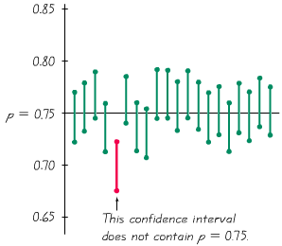

**Critical Values**

A standard *z* score can be used to distinguish between sample statistics that are likely to occur and those that are unlikely to occur. Such a *z* score is called a critical value. Critical values are based on the following observations:

1. Under certain conditions, the sampling distribution of sample proportions can be approximated by a normal distribution.

**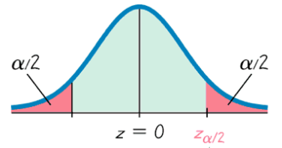**

1. A *z* score associated with a sample proportion has a probability of *α*/2 of falling in the right tail.

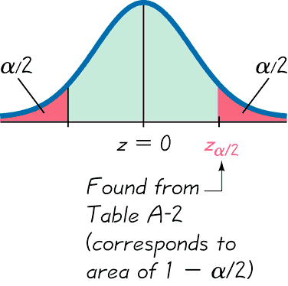

1. The *z* score separating the right-tail region is commonly denoted by  and is referred to as a ***critical value*** because it is on the borderline separating *z* scores from sample proportions that are likely to occur from those that are unlikely to occur.

***Definition***

A ***critical value*** is the number on the borderline separating sample statistics that are likely to occur from those that are unlikely to occur. The number is a critical value that is a *z* score with the property that it separates an area of in the right tail of the standard normal distribution.

**Notation for Critical Value**

The critical value is the positive *z* value that is at the vertical boundary separating an area of in the right tail of the standard normal distribution. (The value of –is at the vertical boundary for the area of in the left tail.) The subscript is simply a reminder that the *z* score separates an area of in the right tail of the standard normal distribution.

***Definition***

When data from a simple random sample are used to estimate a population proportion *p*, the ***margin of error***, denoted by ***E***, is the maximum likely difference (with probability 1 – *α*, such as 0.95) between the observed proportion  and the true value of the population proportion *p*. The margin of error *E* is also called the maximum error of the estimate and can be found by multiplying the critical value and the standard deviation of the sample proportions:



***Example***

Find the critical value  corresponding to a 95% confidence level.

***Solution***

A 95% confidence level corresponds to 

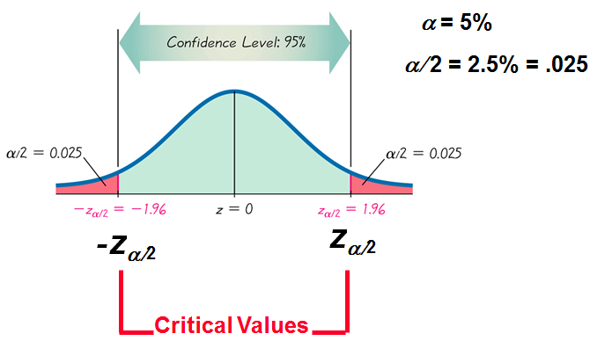

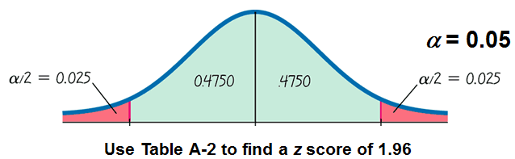

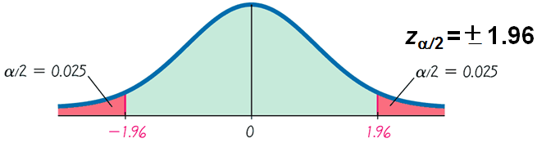

The area in each of the red-shaded tails is . The cumulative area to its left must be . From the Normal Distribution Table, the area of 0.975 corresponds to . For a 95% confidence level, the critical value is therefore 

**Confidence Interval for Estimating a Population Proportion *p***

***Notation***

*p* = population proportion

= sample proportion

*n* = number of sample values

*E* = margin of error

= *z* score separating an area of *α*/2 in the right tail of the standard normal distribution

***Requirements***

1. The sample is a simple random sample.
2. The conditions for the binomial distribution are satisfied: there is a fixed number of trials, the trials are independent, there are two categories of outcomes, and the probabilities remain constant for each trial.
3. There are at least 5 successes and 5 failures.

**Procedure for Constructing a Confidence Interval for *p***

1. Verify that the required assumptions are satisfied. (The sample is a simple random sample, the conditions for the binomial distribution are satisfied, and the normal distribution can be used to approximate the distribution of sample proportions because *np* ≥ 5, and *nq* ≥ 5 are both satisfied.)
2. Refer to Standard Normal Distribution Table and find the critical value  that corresponds to the desired confidence level.
3. Evaluate the margin of error 
4. Using the value of the calculated margin of error, *E* and the value of the sample proportion, , find the values of ** and **. Substitute those values in the general format for the confidence interval:



1. Round the resulting confidence interval limits to three significant digits.

***Example***

In the Chapter Problem we noted that a Pew Research Center poll of 1501 randomly selected U.S. adults showed that 70% of the respondents believe in global warming. The sample results are *n* = 1501, and **

1. Find the margin of error E that corresponds to a 95% confidence level.
2. Find the 95% confidence interval estimate of the population proportion *p*.
3. Based on the results, can we safely conclude that the majority of adults believe in global warming?
4. Assuming that you are a newspaper reporter, write a brief statement that accurately describes the results and includes all of the relevant information.

***Solution***

Requirement check: simple random sample; fixed number of trials, 1501; trials are independent; two categories of outcomes (believes or does not); probability remains constant. Note: number of successes and failures are both at least 5.

***a****)* Use the formula to find the margin of error.







***b***) The 95% confidence interval:

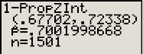





***TI*-84:** Go STATS → TESTS → select A: 1-PropZInt

For *x* values mulptiply .7 (70%) by 1501 (*n*), however go back and round the number (.7\*1501 = 1050.7) therefore the *x*-value is 1051

***c)*** Based on the confidence interval obtained in part (*b*), it does appear that the proportion of adults who believe in global warming is greater than 0.5 (or 50%), so we can safely conclude that the majority of adults believe in global warming. Because the limits of 0.677 and 0.723 are likely to contain the true population proportion, it appears that the population proportion is a value greater than 0.5.

1. Here is one statement that summarizes the results: 70% of United States adults believe that the earth is getting warmer. That percentage is based on a Pew Research Center poll of 1501 randomly selected adults in the United States. In theory, in 95% of such polls, the percentage should differ by no more than 2.3 percentage points in either direction from the percentage that would be found by interviewing all adults in the United States.

**Analyzing Polls**

When analyzing polls consider:

1. The sample should be a simple random sample, not an inappropriate sample (such as a voluntary response sample).
2. The confidence level should be provided. (It is often 95%, but media reports often neglect to identify it.)
3. The sample size should be provided. (It is usually provided by the media, but not always.)
4. Except for relatively rare cases, the quality of the poll results depends on the sampling method and the size of the sample, but the size of the population is usually not a factor.

***Caution***

Never follow the common misconception that poll results are unreliable if the sample size is a small percentage of the population size. The population size is usually not a factor in determining the reliability of a poll.

**Sample Size**

Suppose we want to collect sample data in order to estimate some population proportion. The question is how many sample items must be obtained?

**Round-Off Rule for Determining Sample Size**

If the computed sample size *n* is not a whole number, round the value of *n* up to the next larger whole number.

***Example***

The Internet is affecting us all in many different ways, so there are many reasons for estimating the proportion of adults who use it. Assume that a manager for E-Bay wants to determine the current percentage of U.S. adults who now use the Internet. How many adults must be surveyed in order to be 95% confident that the sample percentage is in error by no more than three percentage points?

1. In 2006, 73% of adults used the Internet.
2. No known possible value of the proportion.

***Solution***

1. ***Given***: 

With a 95% confidence level, we have , so . Also the margin of error is  (the decimal equivalent of “3 percentage points”)









We must obtain a simple random sample that includes at least 842 adults.

1. ***Given***:  and 

But with no prior knowledge of 





To be 95% confident that our sample percentage is within three percentage points of the true percentage for all adults, we should obtain a simple random sample of 1068 adults.

**Finding the Point Estimate and *E* from a Confidence Interval**

*Point estimate of p:*  

*Margin Error:*  

***Example***

The article “High-Dose Nicotine Patch Therapy,” by Dale Hurt, includes this statement: “off the 71 subjects, 70% were abstinent from smoking at 8 weeks (95% confidence interval, 58% to 81%),” Use that statement to find the point estimate  and the margin error E.

***Solution***













***Exercises*** ***Section* 3.1 − Estimating a Population Proportion**

1. Find the critical value  that corresponds to a 99% confidence level.
2. Find the critical value  that corresponds to a 99.5% confidence level.
3. Find the critical value  that corresponds to a 98% confidence level.
4. Find for .
5. Find for .
6. Express the confidence interval  in the form 
7. Express the confidence interval  in the form 
8. Express the confidence interval  in the form 
9. Find the point estimate  and the margin of error *E* of 
10. Find the margin of error *E* of 
11. Find the point estimate  of 
12. Find the point estimate  and the margin of error *E* of 
13. Find the point estimate  and the margin of error *E* of 
14. Assume that a sample is used to estimate a population proportion *p*. Find the margin of error *E* that corresponds to the given 
15. Assume that a sample is used to estimate a population proportion *p*. Find the margin of error *E* that corresponds to the given 
16. Assume that a sample is used to estimate a population proportion *p*. Find the margin of error *E* that corresponds to the given 
17. Assume that a sample is used to estimate a population proportion *p*. Find the margin of error *E* that corresponds to the given 98% confidence; the sample size is 1230, of which 40% are successes.
18. Construct the confidence interval estimate of the population proportion *p* that corresponds to the given 
19. Construct the confidence interval estimate of the population proportion *p* that corresponds to the given 
20. Construct the confidence interval estimate of the population proportion *p* that corresponds to the given 
21. Find the minimum sample size requires to estimate a population proportion or percentage:

Margin of error: 0.045; confidence level: 95%: 

1. Find the minimum sample size requires to estimate a population proportion or percentage:

Margin of error: 2% points; confidence level: 99%: from prior study,  is estimate by the decimal equivalent of 14%

1. The Genetics and IVF Institute conducted a clinical trial of the XSORT method designed to increase the probability of conceiving a girl. As of this writing, 574 babies were born to parents using the XSORT method, and 525 of them were girls.
2. What is the best point estimate of the population proportion of girls born to parents using the XSORT method?
3. Use the sample data to construct a 95% confidence interval estimate of the percentage of girls born to parents using the XSORT method.
4. Based on the results, does the XSORT method appear to be effective? Why or why not?
5. An important issue facing Americans is the large number of medical malpractice lawsuits and the expenses that they generate. In a study of 1228 randomly selected medical malpractice lawsuits, it is found that 856 of them were later dropped or dismissed.
6. What is the best point estimate of the proportion of medical malpractice lawsuits that are dropped or dismissed?
7. Construct a 99% confidence interval estimate of the proportion of medical malpractice lawsuits that are dropped or dismissed.
8. Does it appear that the majority of such suits are dropped or dismissed?
9. A study of 420,095 Danish cell phone users found that 135 of them developed cancer was found to be 0.0340% for those not using cell phones.
10. Use the sample data to construct a 95% confidence interval estimate of the percentage of cell phone users who develop cancer of the brain or nervous system.
11. Do cell phone users appear to have a rate of cancer of the brain or nervous system that is different from the rate of such cancer among those not using cells phones? Why or why not?
12. In an Account survey of 150 senior executives, 47% said that the most common job interview mistake is to have little or no knowledge of the company. Construct a 99% confidence interval estimate of the proportion of all senior executives who have that same opinion. Is it possible that exactly half of all senior executives believe that the most common job interview mistake is to have little or no knowledge of the company? Why or why not?

***Section* 3.2 − Estimating a Population Mean: Sigma Known**

**Point Estimate of the Population Mean**

The sample mean  is the best point estimate of the population mean *µ*.

**Confidence Interval for Estimating a Population Mean (with *σ* Known)**

***Objective***

Construct a confidence interval used to estimate a population mean.

***Notation***

*μ* = population mean

*σ* = population standard deviation

= sample mean

*n* = number of sample values

*E* = margin of error

= *z* score separating an area of *α*/2 in the right tail of the standard normal distribution

***Requirements***

1. The sample is a simple random sample. (All samples of the same size have an equal chance of being selected.)
2. The value of the population standard deviation *σ* is known.
3. Either or both of these conditions is/are satisfied: The population is normally distributed or *n* > 30.

***Confidence Interval***



Or 

Or 

***Definition***

The two values and  are called ***confidence interval limits***.

**Sample Mean**

1. For all populations, the sample mean *x* is an unbiased estimator of the population mean *μ*, meaning that the distribution of sample means tends to center about the value of the population mean *μ*.
2. For many populations, the distribution of sample means *x* tends to be more consistent (with less variation) than the distributions of other sample statistics.

**Procedure for Constructing a Confidence Interval for *µ* (with Known *σ*)**

1. Verify that the requirements are satisfied.
2. Refer to Standard Normal Distribution Table or use technology to find the critical value  that corresponds to the desired confidence level.
3. Evaluate the margin of error 
4. Find the values of and . Substitute those values in the general format of the confidence interval: 
5. Round using the confidence intervals round-off rules.

**Round-Off Rule for Confidence Intervals Used to Estimate *µ***

1. When using the *original set of data*, round the confidence interval limits to one more decimal place than used in original set of data.
2. When the original set of data is unknown and only the **summary statistics**(*n,* *, s*) are used, round the confidence interval limits to the same number of decimal places used for the sample mean.

***Example***

People have died in boat and aircraft accidents because an obsolete estimate of the mean weight of men was used. In recent decades, the mean weight of men has increased considerably, so we need to update our estimate of that mean so that boats, aircraft, elevators, and other such devices do not become dangerously overloaded. Using the weights of men from Data Set 1 in Appendix B, we obtain these sample statistics for the simple random sample: *n* = 40 and = 172.55 lb. Research from several other sources suggests that the population of weights of men has a standard deviation given by *σ* = 26 lb.

1. Find the best point estimate of the mean weight of the population of all men.
2. Construct a 95% confidence interval estimate of the mean weight of all men.
3. What do the results suggest about the mean weight of 166.3 lb that was used to determine the safe passenger capacity of water vessels in 1960 (as given in the National Transportation and Safety Board safety recommendation M-04-04)?

***Solution***

1. The sample mean of 172.55 lb. is the best point estimate of the mean weight of the population of all men
2. A 95% confidence interval or 0.95 implies *σ* = 0.05, so .  
   Calculate the margin of error.







The confidence interval: 





1. Based on the confidence interval, it is possible that the mean weight of 166.3 lb. used in 1960 could be the mean weight of men today. However, the best point estimate of 172.55 lb. suggests that the mean weight of men is now considerably greater than 166.3 lb. considering that an underestimate of the mean weight of men could result in lives lost through overloaded boats and aircraft, these results strongly suggest that additional data should be collected. (Additional data have been collected, and the assumed mean weight of men has been increased.)

**Finding a Sample Size for Estimating a Population Mean**

*μ* = population mean

*σ* = population standard deviation

 = population standard deviation

*E* = desired margin of error

= *z* score separating an area of *α*/2 in the right tail of the standard normal distribution



**Round-Off Rule for Sample Size *n***

If the computed sample size *n* is not a whole number, round the value of *n* up to the next larger whole number.

**Finding the Sample Size *n* when *σ* is Unknown**

1. Use the range rule of thumb to estimate the standard deviation as follows: *σ* ≈ range/4.
2. Start the sample collection process without knowing *σ* and, using the first several values, calculate the sample standard deviation s and use it in place of *σ .* The estimated value of *σ* can then be improved as more sample data are obtained, and the sample size can be refined accordingly.
3. Estimate the value of *σ* by using the results of some other study that was done earlier.

***Example***

Assume that we want to estimate the mean IQ score for the population of statistics students. How many statistics students must be randomly selected for IQ tests if we want 95% confidence that the sample mean is within 3 IQ points of the population mean?

***Solution***

For 95% confidence interval, we have 

Since we need the sample mean to be within 3 IQ points of μ, the margin of error is *E* = 3. Also, 







With a simple random sample of only 97 statistics students, we will be 95% confident that the sample mean is within 3 IQ points of the true population mean *μ*.

***Exercises*** ***Section* 3.2 − Estimating a Population Mean: Sigma Known**

1. A design engineer of the Ford Motor Company must estimate the mean leg length of all adults. She obtains a list of the 1275 employees at her facility; then obtains a simple random sample of 50 employees. If she uses this sample to construct a 95% confidence interval to estimate the mean leg length for the population of all adults, will her estimate be good? Why or why not?
2. Find the critical value  that corresponds to a 90% confidence level.
3. Find the critical value  that corresponds to a 98% confidence level.
4. Find  for 
5. Find  for 
6. How many adults must be randomly selected to estimate the mean FICO (credit rating) score of working adults in U.S.? We want 95% confidence that the sample mean is within 3 points of the population mean, and the population standard deviation is 68.
7. A simple random sample of 40 salaries of NCAA football coaches has a mean of $415,953. Assume that σ = $463,364.
8. Find the best estimate of the mean salary of all NCAA football coaches.
9. Construct a 95% confidence interval estimate of the mean salary of an NCAA football coach.
10. Does the confidence interval contain the actual population mean of $474,477?
11. A simple random sample of 50 adults (including males and females) is obtained, and each person’s red blood cell count (in cells per microliter) is measured. The sample mean is 4.63. The population standard deviation for red blood cell counts is 0.54.
12. Find the best point estimate of the mean red blood cell count of adults.
13. Construct a 99% confidence interval estimate of the mean red blood cell count of adults.
14. The normal range of red blood cell counts for adults is 4.7 to 6.1 for males and 4.3 to 5.4 for females. What does the confidence interval suggest about these normal ranges?
15. A simple random sample of 125 SAT scores has a mean of 1522. Assume that SAT scores have a standard deviation of 333.
16. Construct a 95% confidence interval estimate of the mean SAT score.
17. Construct a 99% confidence interval estimate of the mean SAT score.
18. Which of the preceding confidence intervals is wider? Why?
19. When 14 different second-year medical students measured the blood pressure of the same person, they obtained the results listed below. Assuming that the population standard deviation is known to be 10 mmHg, construct a 95% confidence interval estimate of the population mean. Ideally, what should the confidence interval be in this situation?

138 130 135 140 120 125 120 130 130 144 143 140 130 150

1. Do the given conditions justify using the margin of error  when finding a confidence interval estimate of the population mean μ?
2. The sample size is , and the original population is normally distributed
3. The sample size is  and σ is not known
4. Use the confidence level and sample data to find the margin of error E.
5. Replacement times for washing machines: 90% confidence; 
6. College students’ annual earnings: 99% confidence; 
7. Use the confidence level and sample data to find a confidence interval for estimating the population μ. A laboratory tested 89 chicken eggs and found that the mean amount of cholesterol was 203 milligrams with . Construct a 95% confidence interval for the true mean cholesterol content μ, of all such eggs.
8. Use the confidence level and sample data to find a confidence interval for estimating the population μ. A group of 66 randomly selected students have a mean score of 34.3 on a placement test. The population standard deviation . What is the 90% confidence interval for the mean score, μ, of all students taking the test?
9. Use the given information to find the minimum sample size required to estimate an unknown population mean µ. Margin error: $139, confidence level: 99%, σ = $522

***Section* 3.3 − Estimating a Population Mean: Sigma Not Known**

**Sample Mean**

The sample mean  is the best point estimate of the population mean μ.

**Student *t* Distribution**

If the distribution of a population is essentially normal, then the distribution of  is a Student *t* Distribution for all samples of size *n*. It is often referred to as a *t* distribution and is used to find critical values denoted by .

***Definition***

The number of ***degrees of freedom*** for a collection of sample data is the number of sample values that can vary after certain restrictions have been imposed on all data values. The degree of freedom is often abbreviated df.

**Degrees of freedom *= n* – 1**

***Example***

A sample of size  is a simple random sample selected from a normally distributed population. Find the critical value corresponding to a 95% confidence level.

***Solution***

Because , the number of degrees of freedom is: .

Using *t*−Distribution Table:





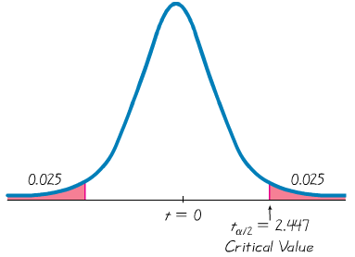The value is 2.447.



Such critical values  are used for the margin of error *E* and confidence interval.

**Margin of Error *E* for Estimate of *m* (With *σ* Not Known)**



where has *n* – 1 degrees of freedom.

***Notation***

*μ* = population mean

= sample mean

*s* = sample standard deviation

*n* = number of sample values

*E* = margin of error

= critical *t* value separating an area of *α*/2 in the right tail of the *t* distribution

**Confidence Interval for the Estimate of *μ* (With *σ* Not Known)**



Where 

**Procedure for Constructing a Confidence Interval for *µ* (**With *σ* Unknown**)**

1. Verify that the requirements are satisfied.
2. Using *n* – 1 degrees of freedom, refer to Table A-3 or use technology to find the critical value *ta*/2 that corresponds to the desired confidence level.
3. Evaluate the margin of error 
4. Find the values of . Substitute those values in the general format for the confidence interval:
5. Round the resulting confidence interval limits.

***Example***

A common claim is that garlic lowers cholesterol levels. In a test of the effectiveness of garlic, 49 subjects were treated with doses of raw garlic, and their cholesterol levels were measured before and after the treatment. The changes in their levels of LDL cholesterol (in mg/dL) have a mean of 0.4 and a standard deviation of 21.0. Use the sample statistics of *n* = 49,  = 0.4 and *s* = 21.0 to construct a 95% confidence interval estimate of the mean net change in LDL cholesterol after the garlic treatment. What does the confidence interval suggest about the effectiveness of garlic in reducing LDL cholesterol?

***Solution***

Requirements are satisfied: simple random sample and *n* = 49 (i.e., *n* > 30).

95% implies *a* = 0.05.  
With *n* = 49, the df = 49 – 1 = 48

Closest df is 50, two tails, so 

Using , *s* = 21.0 and *n* = 49 the margin of error is:







**Construct the confidence interval: **







We are 95% confident that the limits of –5.6 and 6.4 actually do contain the value of *μ*, the mean of the changes in LDL cholesterol for the population. Because the confidence interval limits contain the value of 0, it is very possible that the mean of the changes in LDL cholesterol is equal to 0, suggesting that the garlic treatment did not affect the LDL cholesterol levels. It does not appear that the garlic treatment is effective in lowering LDL cholesterol.

**Important Properties of the Student *t* Distribution**

1. The Student *t* distribution is different for different sample sizes (see the following slide, for the cases *n* = 3 and *n* = 12).

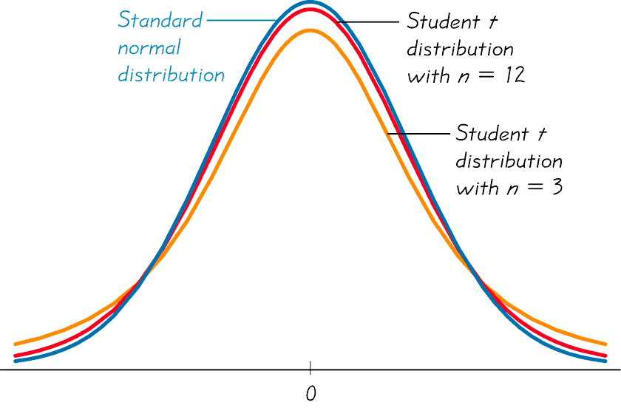

1. The Student *t* distribution has the same general symmetric bell shape as the standard normal distribution but it reflects the greater variability (with wider distributions) that is expected with small samples.
2. The Student *t* distribution has a mean of *t* = 0 (just as the standard normal distribution has a mean of *z* = 0).
3. The standard deviation of the Student *t* distribution varies with the sample size and is greater than 1 (unlike the standard normal distribution, which has a *s* = 1).
4. As the sample size *n* gets larger, the Student *t* distribution gets closer to the normal distribution.

**Finding the Point Estimate and *E* from a Confidence Interval**

Point estimate of *µ*: 

Margin of Error: 

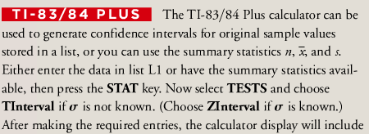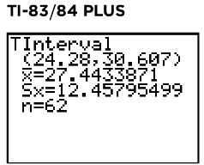



**Confidence Intervals for Comparing Data**

Confidence intervals can be used informally to compare different data sets, but the overlapping of confidence intervals should not be used for making formal and final conclusions about equality of means.

***Exercises*** ***Section* 3.3 − Estimating a Population Mean: σ Not Known**

1. What does it mean when we say that the methods for constructing confidence intervals in this section are robust against departures from normality? Are the methods for constructing confidence intervals in this section robust against poor sampling methods?
2. Assume that we want tic instruct a confidence interval using the given confidence level

95%;  ***σ*** is unknown; population appears to be normally distributed. Do one of the following

1. Find the critical value 
2. Find the critical value 
3. State that neither the normal nor the *t*-distribution applies.
4. Assume that we want tic instruct a confidence interval using the given confidence level

99%;  ***σ*** is known; population appears to be normally distributed. Do one of the following

1. Find the critical value 
2. Find the critical value 
3. State that neither the normal nor the *t*-distribution applies.
4. Assume that we want tic instruct a confidence interval using the given confidence level

99%;  ***σ*** is unknown; population appears to be very skewed. Do one of the following

1. Find the critical value 
2. Find the critical value 
3. State that neither the normal nor the *t*-distribution applies.
4. Assume that we want tic instruct a confidence interval using the given confidence level

90%;  ***σ*** = 15.0; population appears to be skewed. Do one of the following

1. Find the critical value 
2. Find the critical value 
3. State that neither the normal nor the *t*-distribution applies.
4. Assume that we want tic instruct a confidence interval using the given confidence level

95%;  ***σ*** is unknown; population appears to be very skewed. Do one of the following

1. Find the critical value 
2. Find the critical value 
3. State that neither the normal nor the *t*-distribution applies.
4. Given . Assume that the sample is a simple random and the population has a normal distribution.
5. Find the margin error
6. Find the confidence interval for the population mean μ.
7. Given . Assume that the sample is a simple random and the population has a normal distribution.
8. Find the margin error
9. Find the confidence interval for the population mean μ.
10. In a test of the effectiveness of garlic for lowering cholesterol, 47 subjects were treated with Garlicin, which is garlic in a processed tablet form. Cholesterol levels were measured before and after the treatment. The changes in their levels of LDL cholesterol (in mg/dL) have a mean of 3.2 and standard deviation of 18.6.
11. What is the best point estimate of the population mean net change LDL cholesterol after Garlicin treatment?
12. Construct a 95% confidence interval estimate of the mean net change in LDL cholesterol after the Garlicin treatment. What does the confidence interval suggest about the effectiveness of Garlicin in reducing LDL cholesterol?
13. A random sample of the birth weights of 186 babies has a mean of 3103 g and a standard deviation of 696 g. These babies were born to mothers who did not use cocaine during their pregnancies.
14. What is the best point estimate of the mean weight of babies born to mothers who did not use cocaine during their pregnancies?
15. Construct a 95% confidence interval estimate of the mean birth for all such babies.
16. Compare the confidence interval from part (*b*) to this confidence interval obtained from birth weights of babies born to mothers who used cocaine during pregnancy: . Does cocaine use appear to affect the birth weight of a baby?
17. In a study designed to test the effectiveness of acupuncture for treating migraine, 142 subjects were treated with acupuncture and 80 subjects were given a sham treatment. The numbers of migraine attacks for the acupuncture treatment group had a mean of 1.8 and a standard deviation of 1.4. The numbers of migraine attacks for the sham treatment group had a mean of 1.6 and standard deviation of 1.2
18. Construct a 95% confidence interval estimate of the mean number of migraine attacks for those treated with acupuncture.
19. Construct a 95% confidence interval estimate of the mean number of migraine attacks for those given a sham treatment.
20. Compare the two confidence intervals. What do the results about the effectiveness of acupuncture?
21. 30 randomly selected students took the statistics final. If the sample mean was 79 and the standard deviation was 14.5, construct a 99% confidence interval for the mean score of all students.

Use the given degree of confidence and sample data to construct a confidence level interval for the population mean μ. Assume that the population has a normal distribution.

***Section* 3.4 − Estimating a Population Variance**

***Chi-Square* Distribution**

In a normally distributed population with variance  assume that we randomly select independent samples of size *n* and, for each sample, compute the sample variance (which is the square of the sample standard deviations). The sample statistic  (pronounced chi-square) has a sampling distribution called the ***chi-square distribution***.



Where

*n* = sample size

= sample variance

= population variance

degrees of freedom = *n* – 1

**Properties of the Distribution of the Chi-Square Statistic**

1. The chi-square distribution is not symmetric, unlike the normal and Student *t* distributions.

As the number of degrees of freedom increases, the distribution becomes more symmetric.

|  |
| --- |
| 6_08 |
| Chi-Square Distribution |

1. The values of chi-square can be zero or positive, but they cannot be negative.
2. The chi-square distribution is different for each number of degrees of freedom, which is df = *n* – 1. As the number of degrees of freedom increases, the chi-square distribution approaches a normal distribution.

In ***Table Chi-Square*** ***Distribution***, each critical value of  corresponds to an area given in the top row of the table, and that area represents the cumulative area located to the right of the critical value.

|  |
| --- |
| 6_09 |
| Chi-Square Distribution for df = 10 and df = 20 |

***Example***

A simple random sample of ten voltage levels is obtained. Construction of a confidence interval for the population standard deviation *σ* requires the left and right critical values of  corresponding to a confidence level of 95% and a sample size of *n* = 10. Find the critical value of  separating an area of 0.025 in the left tail, and find the critical value of  separating an area of 0.025 in the right tail.

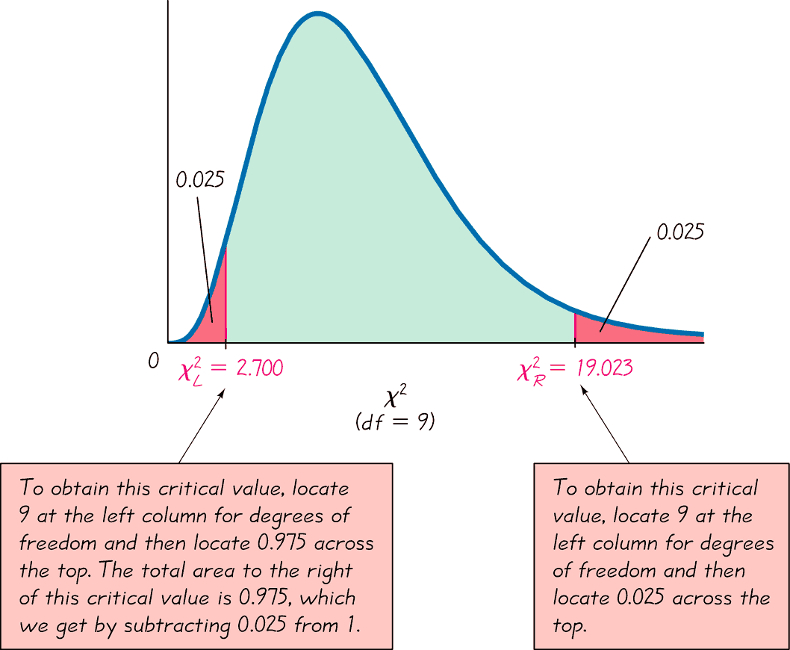

***Example***

For a sample of 10 values taken from a normally distributed population, the chi-square statistic  has a 0.95 probability of falling between the chi-square critical values of 2.700 and 19.023.

Instead of using ***Table Chi-Square*** ***Distribution***, technology (such as STATDISK, Excel, and Minitab) can be used to find critical values of . A major advantage of technology is that it can be used for any number of degrees of freedom and any confidence level, not just the limited choices included in ***Table Chi-Square*** ***Distribution***.

**Estimators of ****

The sample variance ****** is the best point estimate of the population variance ******.

**Estimators of *σ***

The sample standard deviation *s* is a commonly used point estimate of*σ*  (even though it is a biased estimate).

**Confidence Interval for Estimating a Population Standard Deviation or Variance**

*σ* = population standard deviation

*s* = sample standard deviation

*n* = number of sample values

= left-tailed critical value of 

****** = population variance

******= sample variance

*E* = margin of error

= right-tailed critical value of 

***Requirements:***

1. The sample is a simple random sample.
2. The population must have normally distributed values (even if the sample is large).

Confidence Interval for the Population Variance ******



Confidence Interval for the Population Standard Deviation *σ*



**Procedure for Constructing a Confidence Interval for *σ* or ****

1. Verify that the required assumptions are satisfied.
2. Using *n –* 1 degrees of freedom, refer to ***Table Chi-Square*** ***Distribution*** or use technology to find the critical values and  that correspond to the desired confidence level.
3. Evaluate the upper and lower confidence interval limits using this format of the confidence interval:



1. If a confidence interval estimate of *σ* is desired, take the square root of the upper and lower confidence interval limits and change ****** to *σ*.
2. Round the resulting confidence level limits. If using the original set of data to construct a confidence interval, round the confidence interval limits to one more decimal place than is used for the original set of data. If using the sample standard deviation or variance, round the confidence interval limits to the same number of decimals places.

**Confidence Intervals for Comparing Data *Caution***

Confidence intervals can be used ***informally*** to compare the variation in different data sets, but *the overlapping of confidence intervals should not be used for making formal and final conclusions about equality of variances or standard deviations*.

***Example***

The proper operation of typical home appliances requires voltage levels that do not vary much. Listed below are ten voltage levels (in volts) recorded in the author’s home on ten different days. These ten values have a standard deviation of *s* = 0.15 volt. Use the sample data to construct a 95% confidence interval estimate of the standard deviation of all voltage levels.

123.3 123.5 123.7 123.4 123.6 123.5 123.5 123.4 123.6 123.8

***Solution***

Requirements are satisfied: simple random sample and normality

*n* = 10 so df = 10 – 1 = 9 Use Chi-Square Distribution table to find:

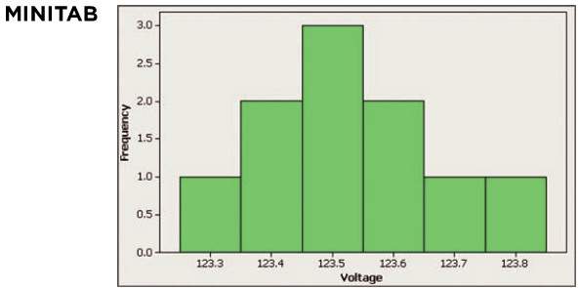

Construct the confidence interval: *n* = 10, *s* = 0.15









Finding the square root of each part (before rounding), then rounding to two decimal places, yields this 95% confidence interval estimate of the population standard deviation:



* Based on this result, we have 95% confidence that the limits of 0.10 volt and 0.27 volt contain the true value of *σ*.

***Determining Sample Sizes***

The procedures for finding the sample size necessary to estimate *σ*2 are much more complex than the procedures given earlier for means and proportions. Instead of using very complicated procedures, we will use Table.

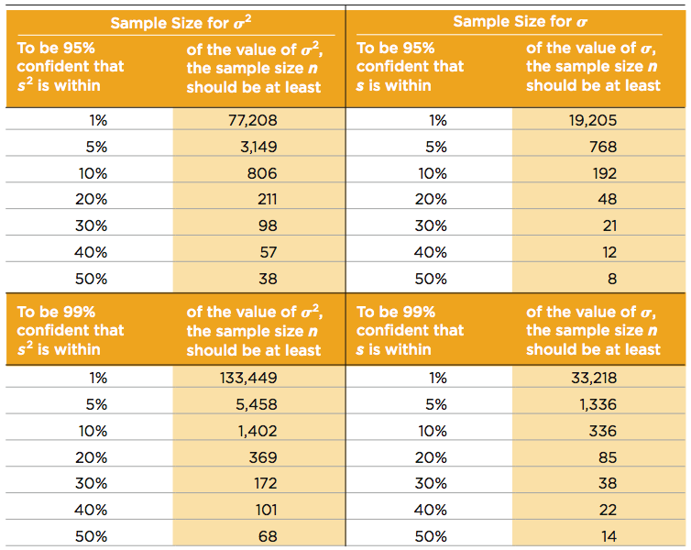

*STATDISK also provides sample sizes. With STATDISK, select Analysis, Sample Size Determination, and then Estimate St Dev. Minitab, Excel, and the TI-83/84 Plus calculator do not provide such sample sizes.*

***Example***

We want to estimate the standard deviation *σ* of all voltage levels in a home. We want to be 95% confident that our estimate is within 20% of the true value of *σ*. How large should the sample be? Assume that the population is normally distributed.

***Solution***

From thr Table, we can see that 95% confidence and an error of 20% for *σ* correspond to a sample of size 48. We should obtain a simple random sample of 48 voltage levels form the population of voltage levels.

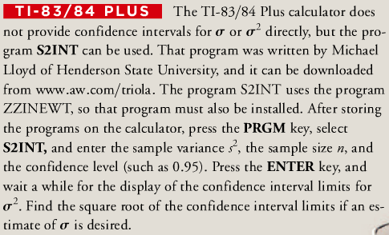

***Exercises Section* 3.4 − Estimating a Population Variance**

1. Using the weights of the M&M candies. We use the standard deviation of the sample  to obtain the following 95% confidence interval estimate of the standard deviation of the weights of all M&Ms: . Write a statement that correctly interprets that confidence interval.
2. Find and that corresponds to: 
3. Find and that corresponds to: 
4. Find and that corresponds to: 
5. Find a confidence interval for the population standard deviation *σ* .  (*Assume has a normal distribution*)
6. Find a confidence interval for the population standard deviation *σ*  (*Assume has a normal distribution*)
7. Find a confidence interval for the population standard deviation *σ*  (*Assume has a normal distribution*)
8. In a study of the effects of prenatal cocaine use on infants, the following sample data were obtained for weights at birth: . Use the sample data to construct a 95% confidence interval estimate of the standard deviation of all birth weights of infants born to mothers who used cocaine during pregnancy. Because from the Table, a maximum of 100 degrees of freedom while we require 189 degrees of freedom, use these critical values to obtained  and . Based on the result, does the standard deviation appear to be different from the standard deviation of 696g for birth weights of babies born to mothers who did not use cocaine during pregnancy?
9. In the course of designing theather seats, the sitting heights (in *mm*) of a simple random sample of adults women is obtained, and the results are

849 807 821 856 864 877 772 848 802 807 887 815

Use the sample data to construct a 95% confidence interval estimate of ***σ***, the standard deviation of sitting heights of all women. Does the confidence contain the value of 35 *mm*, which is believed to be the standard deviation of sitting heights of women?

***Section* 3.5 − Basic of Hypothesis Testing**

**Rare Event Rule for Inferential Statistics**

If, under a given assumption, the probability of a particular observed event is exceptionally small, we conclude that the assumption is probably not correct.

***Example***

ProCare Industries, Ltd provided a product called “Gender Choice”, which, according to advertising claims, allowed couples to “increase your chances of having a girl up to 80%.” Suppose we conduct an experiment with 100 couples who want to have baby girls, and they all follow the Gender Choice “easy-to-use in-home system” described in the pink package designed for girls. Assuming that Gender Choice has no effect and using only common sense and no formal statistical methods, what should we conclude about the assumption of “no effect” from Gender Choice if 100 couples using Gender Choice have 100 babies consisting of the following

1. 52 girls
2. 97 girls

***Solution***

1. We normally expect around 50 girls in 100 births. The result of 52 girls is close to 50, so the Gender Choice product is effective. The result of 52 girls could easily occur by chance, so there isn’t sufficient evidence to say that Gender Choice is effective, even though the sample proportion of girls is greater than 50%.
2. The result of 97 girls in 100 births is extremely unlikely to occur by chance.

Either an extremely rare event has occurred by chance, or Gender Choice is effective. The extremely low probability of getting 97 girls suggests that Gender Choice is effective.

***Using Statistics***

* A hypothesis is a statement or assertion about the state of nature (about the true value of an unknown population parameter):
* The accused is innocent
* 
* Every hypothesis implies its contradiction or alternative
* The accused is guilty
* 
* A hypothesis is either true or false, and you may fail to reject it or you may reject it on the basis of information
* Trial testimony and evidence
* Sample data

***Making Decision***

One hypothesis is maintained to be true until a decision is made to reject it as false:

* Guilt is proven “beyond a reasonable doubt”
* The alternative is highly improbable

A decision to fail to reject or reject a hypothesis may be:

* Correct

A true hypothesis may not be rejected

» An innocent defendant may be acquitted

A false hypothesis may be rejected

» A guilty defendant may be convicted

* Incorrect

A true hypothesis may be rejected

» An innocent defendant may be convicted

A false hypothesis may not be rejected

» A guilty defendant may be acquitted

***Components of a Formal Hypothesis Test***

**Null Hypothesis: **

* The null hypothesis (denoted by ****) is a statement that the value of a population parameter (such as proportion, mean, or standard deviation) is equal to some claimed value.
* We test the null hypothesis directly.
* Either reject **** or fail to reject ****.
* 

**Alternative Hypothesis: **

* The alternative hypothesis (denoted by **** or ****or ****) is the statement that the parameter has a value that somehow differs from the null hypothesis.
* The symbolic form of the alternative hypothesis must use one of these symbols: ≠, <, >.
* 

**Note about Forming Your Own Claims (*Hypotheses*)**

If you are conducting a study and want to use a hypothesis test to ***support*** your claim, the claim must be worded so that it becomes the alternative hypothesis.

**Note about Identifying**  **and** 

***Example***

Consider the claim that the mean weight of airline passengers (including carry-on baggage) is at most 195 lb. (the current value used by the Federal Aviation Administration). Follow the three-step procedure outlined in Figure to identify the null hypothesis and the alternative hypothesis.

***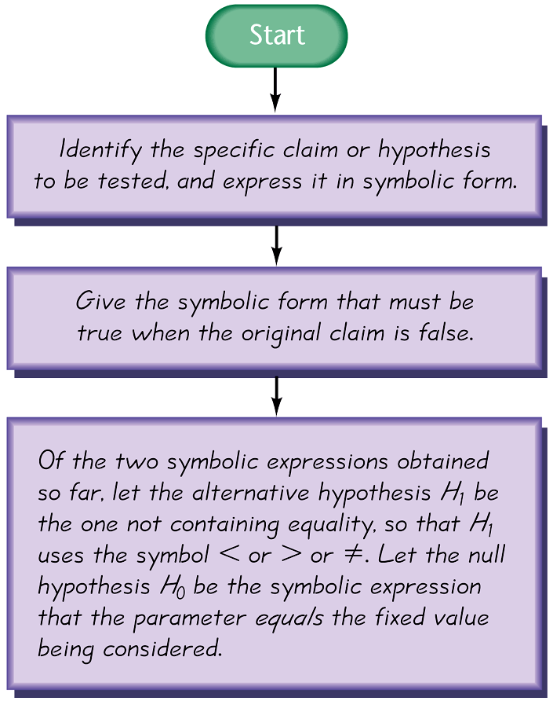Solution***

***Step*** 1: Express the given claim in symbolic form. The claim that the mean is at most 195 lb. is expressed in symbolic form as *μ* ≤ 195 lb.

***Step*** 2: If *μ* ≤ 195 lb. is false, then *μ* > 195 lb. must be true.

***Step*** 3: Of the two symbolic expressions *μ* ≤ 195 lb. and *μ* > 195 lb., we see that *μ* > 195 lb. does not contain equality, so we let the alternative hypothesis  be *μ* > 195 lb. Also, the null hypothesis must be a statement that the mean equals 195 lb., so we let  be *μ* = 195 lb.

* ***Note*** that the original claim that the mean is at most 195 lb is neither the alternative hypothesis nor the null hypothesis. (However, we would be able to address the original claim upon completion of a hypothesis test.)

**Test Statistic**

***Definition***

The test statistic is a value used in making a decision about the null hypothesis, and is found by converting the sample statistic to a score with the assumption that the null hypothesis is true.

**Test Statistic - Formulas**

Test statistic for ***proportion*** 

Test statistic for ***mean*** 

Test statistic for ***standard deviation*** 

***Example***

Let’s again consider the claim that the XSORT method of gender selection increases the likelihood of having a baby girl. Preliminary results from a test of the XSORT method of gender selection involved 14 couples who gave birth to 13 girls and 1 boy. Use the given claim and the preliminary results to calculate the value of the test statistic. Use the format of the test statistic given above, so that a normal distribution is used to approximate a binomial distribution. (There are other exact methods that do not use the normal approximation.)

***Solution***

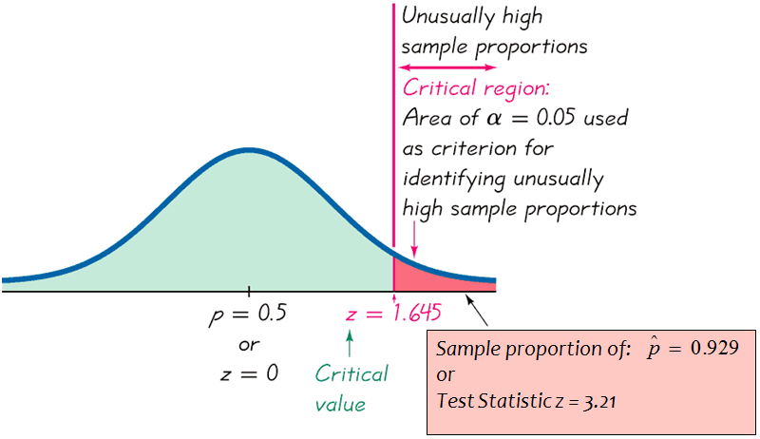The claim that the XSORT method of gender selection increases the likelihood of having a baby girl results in the following null and alternative hypothesis : *p* = 0.5 and : *p* > 0.5. We work under the assumption that the null hypothesis is true with *p = 0.5.* The sample proportion of 13 girls in 14 births results in  . Using *p* = 0.5,  and *n* = 14, we find the value of the test statistic as follows:







*We know that a z score of* 3.21 *is “unusual” (because it is greater than* 2). *It appears that in addition to being greater than* 0.5*, the sample proportion of* 13/14 *or* 0.929 *is significantly greater than* 0.5*. The figure on the next slide shows that the sample proportion of* 0.929 *does fall within the range of values considered to be significant because they are so far above* 0.5 *that they are not likely to occur by chance (assuming that the population proportion is p* = 0.5).

***Critical Region***

The ***critical region*** (or ***rejection region***) is the set of all values of the test statistic that cause us to reject the null hypothesis. For example, see the red-shaded region in the previous figure.

***Significance Level***

The significance level (denoted by *α*) is the probability that the test statistic will fall in the critical region when the null hypothesis is actually true. Common choices for *α* are 0.05, 0.01, and 0.10.

***Critical Value***

A critical value is any value that separates the critical region (where we reject the null hypothesis) from the values of the test statistic that do not lead to rejection of the null hypothesis. The critical values depend on the nature of the null hypothesis, the sampling distribution that applies, and the significance level *α*. The critical value of *z* = 1.645 corresponds to a significance level of *α* = 0.05.

***Example***

Using a significant level of , find the critical *z* value for the alternative hypothesis : *p* > 0.5 (assuming that the normal distribution can be used to approximate the binomial distribution). This alternative hypothesis is used to test the claim that the XSORT method of gender selection is effective, so that baby girls are more likely, with a proportion greater than 0.5

**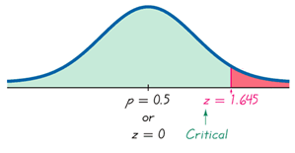*Solution***

With : *p* > 0.5, the critical region is in the right tail.

With the right tail area of 0.05, the critical value is found to be . If the right-tailed critical region is 0.05, the cumulative area to the left of the critical value is 0.95 is .

***Example***

Using a significant level of , find the critical *z* value for the alternative hypothesis  (assuming that the normal distribution can be used to approximate the binomial distribution).

***Solution***

With , the significant level is 0.05, each of the two tails has an area of 0.025.

From the Normal Distribution Table,  and  (right side)





|  |  |  |
| --- | --- | --- |
|  |  |  |

***P*-Value**

The ***P*-value** (or ***p*-value** or ***probability value***) is the probability of getting a value of the test statistic that is ***at least as extreme*** as the one representing the sample data, assuming that the null hypothesis is true.

|  |  |
| --- | --- |
| Critical region in the ***left*** tail: | *P*-value = area to the ***left*** of the test statistic |
| Critical region in the ***right*** tail: | *P*-value = area to the ***right*** of the test statistic |
| Critical region in ***two*** tails: | *P*-value = ***twice*** the area in the tail beyond the test statistic |

The null hypothesis is rejected if the *P*-value is very small, such as 0.05 or less.

Here is a memory tool useful for interpreting the *P*-value:

* If the *P* is low, the null must go.
* If the *P* is high, the null will fly.

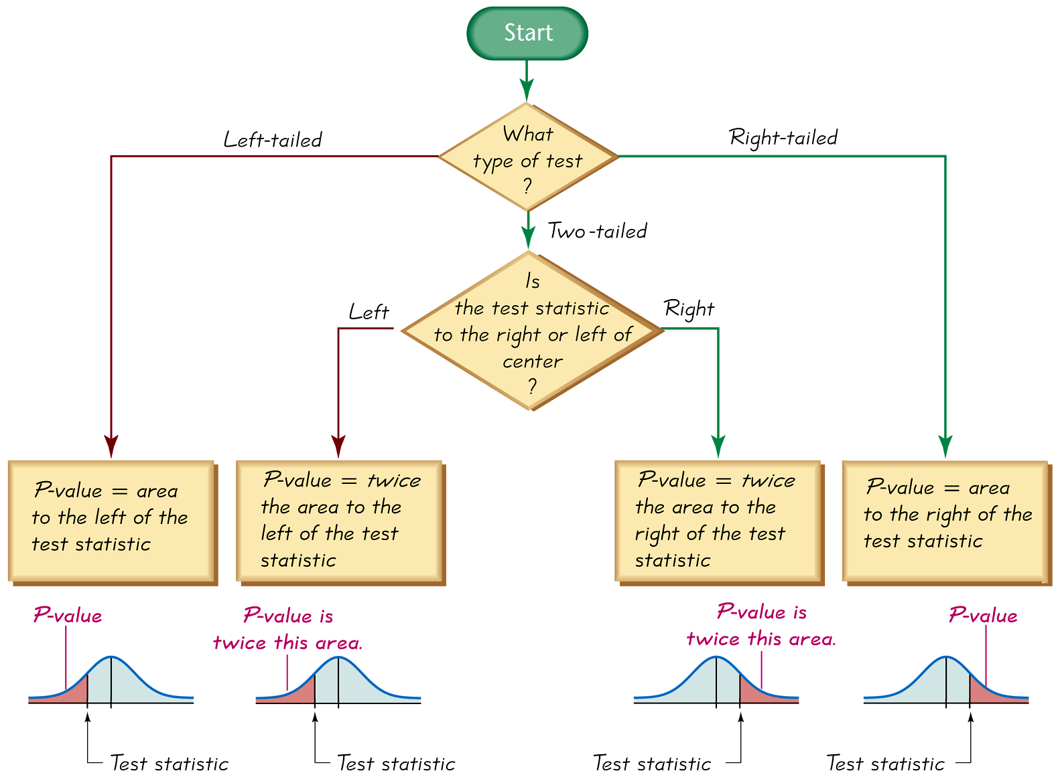

***Caution***

Don’t confuse a *P*-value with a proportion *p*. Know this distinction:

***P*-value** = probability of getting a test statistic at least as extreme as the one representing sample data

***p*** = population proportion

***Example***

Consider the claim that with the XSORT method of gender selection, the likelihood of having a baby girl is different from *p* = 0.5, and use the test statistic *z* = 3.21 found from 13 girls in 14 births. First determine whether the given conditions result in a critical region in the right tail, left tail, or two tails, then use Figure 8-5 to find the *P*-value. Interpret the *P*-value.

***Solution***

The claim that the likelihood of having a baby girl is different from *p* = 0.5 can be expressed as  so the critical region is in two tails. Using Figure 8-5 to find the *P*-value for a two-tailed test, we see that the *P*-value is *twice* the area to the right of the test statistic *z* = 3.21. From Normal Distribution Table, the area to the right of *z* = 3.21 is 0.0007.

In this case, the *P*-value is twice the area to the right of the test statistic, so we have:

*P*−value = 2 × 0.0007 = 0.0014

* The *P*-value is 0.0014 (or 0.0013 if greater precision is used for the calculations). The small *P*-value of 0.0014 shows that there is a very small chance of getting the sample results that led to a test statistic of *z* = 3.21. This suggests that with the XSORT method of gender selection, the likelihood of having a baby girl is different from 0.5.

**Types of Hypothesis Tests: Two-tailed, Left-tailed, Right-tailed**

The ***tails*** in a distribution are the extreme regions bounded by critical values.

Determinations of *P*-values and critical values are affected by whether a critical region is in two tails, the left tail, or the right tail. It therefore becomes important to correctly characterize a hypothesis test as two-tailed, left-tailed, or right-tailed.



***α*** is divided equally between the two tails of the critical region

***Two−tailed test***: The critical region is the two extreme regions (tails) under the curve

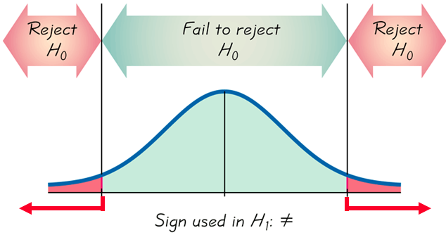

***Left−tailed test***: The critical region is in the extreme region (tail) under the curve

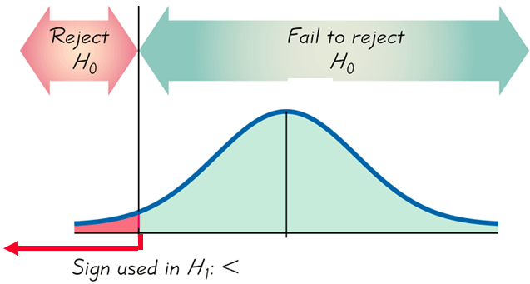

***Right−tailed test***: The critical region is in the extreme right region (tail) under the curve

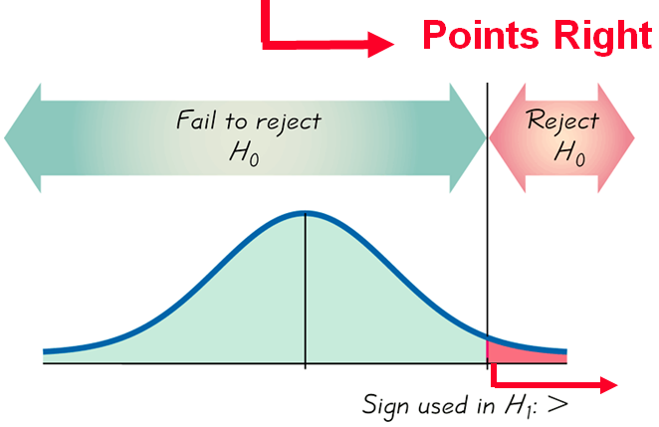

**Conclusions in Hypothesis Testing**

We always test the null hypothesis. The initial conclusion will always be one of the following:

1. Reject the null hypothesis.

2. Fail to reject the null hypothesis.

**Decision Criterion**

***P-value method:***

Using the significance level *α*:

If *P*-value ≤ *α* ,***reject***.

If *P*-value > *α* , ***fail to reject*** .

***Traditional method****:*

If the test statistic falls within the critical region, ***reject***.

If the test statistic does not fall within the critical region, ***fail to reject*** .

***Another option:***

Instead of using a significance level such as 0.05, simply identify the P-value and leave the decision to the reader.

***Confidence Intervals:***

A confidence interval estimate of a population parameter contains the likely values of that parameter.

If a confidence interval does not include a claimed value of a population parameter, reject that claim.

**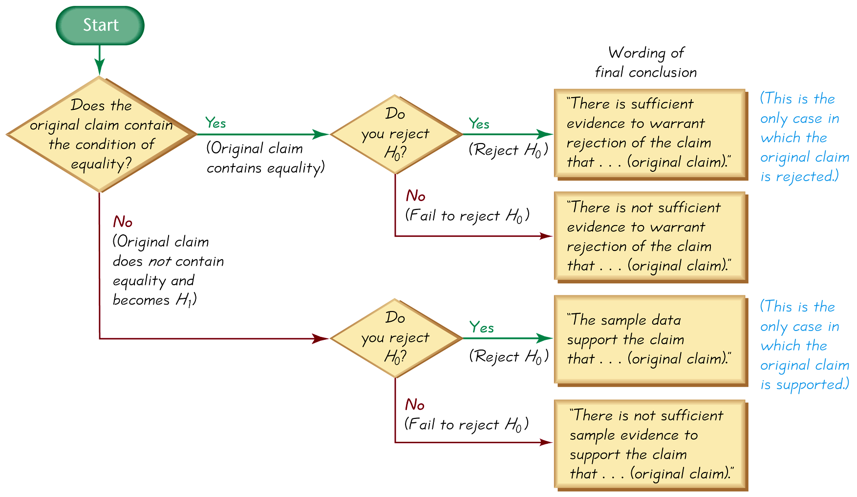**

***Example***

Suppose a geneticist claims that the XSORT method of gender selection increases the likelihood of a baby girl. This claim of  becomes the alternative hypothesis, while the null hypothesis becomes . Further suppose that the sample evidence causes us to reject the null hypothesis of . State the conclusion in simple, nontechnical terms.

***Solution***

Because the original claim does not contain equality, it becomes the alternative hypothesis. Because we reject the null hypothesis, we conclude “There is sufficient evidence to support the claim that the XSORT method of gender selection increases the likelihood of a baby girl.

***Type I and Type II Errors***

**Type I error**: The mistake of rejecting the null hypothesis when it is actually true. The symbol *α* (alpha) is used to represent the probability of a type I error.

**Type II error**: The mistake of failing to reject the null hypothesis when it is actually false. The symbol *β* (beta) is used to represent the probability of a type II error.

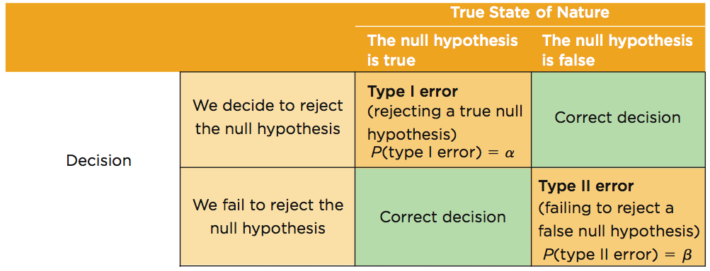

***Example***

Assume that we are conducting a hypothesis test of the claim that a method of gender selection increases the likelihood of a baby girl, so that the probability of a baby girls is *p* > 0.5. Here are the null and alternative hypotheses: : *p* = 0.5, and : *p* > 0.5.

1. Identify a type I error.
2. Identify a type II error.

***Solution***

1. A type I error is the mistake of rejecting a true null hypothesis, so this is a type I error: Conclude that there is sufficient evidence to support *p* > 0.5, when in reality *p* = 0.5.
2. A type II error is the mistake of failing to reject the null hypothesis when it is false, so this is a type II error: Fail to reject *p* = 0.5 (and therefore fail to support *p* > 0.5) when in reality *p* > 0.5.

**Controlling Type I and Type II Errors**

* For any fixed *a*, an increase in the sample size *n* will cause a decrease in *b.*
* For any fixed sample size *n*, a decrease in *a* will cause an increase in *b*. Conversely, an increase in *a* will cause a decrease in *b*.
* To decrease both *a* and *b*, increase the sample size.

**Comprehensive Hypothesis Test**

A confidence interval estimate of a population parameter contains the likely values of that parameter. We should therefore reject a claim that the population parameter has a value that is not included in the confidence interval.

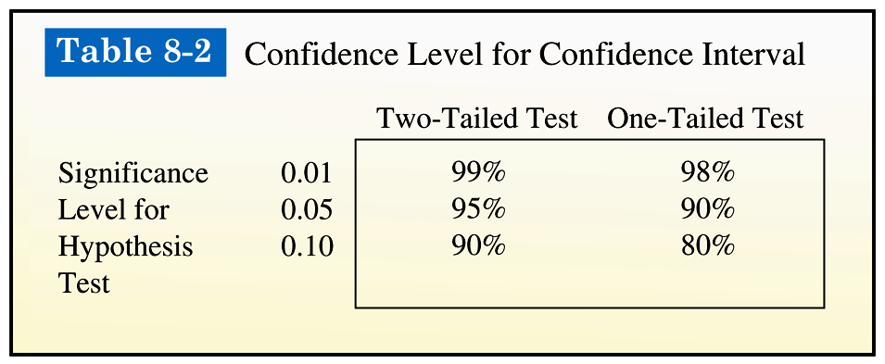

***Caution***

In some cases, a conclusion based on a confidence interval may be different from a conclusion based on a hypothesis test. See the comments in the individual sections.

|  |  |
| --- | --- |
| ***Comprehensive Hypothesis Test – P-Value Method*** | ***Comprehensive Hypothesis Test – Traditional Method*** |
| 08_08 | 08_09 |

***Definition***

The ***power of a hypothesis test*** is the probability (1 –  *β* ) of rejecting a false null hypothesis. The value of the power is computed by using a particular significance level αand a particular value of the population parameter that is an alternative to the value assumed true in the null hypothesis.

That is, the power of the hypothesis test is the probability of supporting an alternative hypothesis that is true.

**Power and the Design of Experiments**

Just as 0.05 is a common choice for a significance level, a power of at least 0.80 is a common requirement for determining that a hypothesis test is effective. (Some statisticians argue that the power should be higher, such as 0.85 or 0.90.) When designing an experiment, we might consider how much of a difference between the claimed value of a parameter and its true value is an important amount of difference. When designing an experiment, a goal of having a power value of at least 0.80 can often be used to determine the minimum required sample size.

***Exercises Section* 3.5 − Basic of Hypothesis Testing**

1. Bottles of Bayer aspirin are labeled with a statement that the tablets each contain 325 mg of aspirin. A quality control manager claims that a large sample of data can be used to support the claim that the mean amount of aspirin in the tablets is equal to 325 mg, as the label indicates. Can a hypothesis test be used to support that claim? Why or Why not?
2. In the preliminary results from couples using the Gender Choice method of gender selection to increase the likelihood of having a baby girl, 20 couples used the Gender Choice method with the result that 8 of them had baby girls and 12 had baby boys. Given that the sample proportion of girls is , can the sample data support the claim that the proportion of girls is greater than 0.5? Can any sample proportion less than 0.5 be used to support a claim that the population proportion is greater than 0.5?
3. Express the null hypothesis  and alternative hypothesis  in symbolic form. Be sure to use the correct symbol  for indicated parameter
4. The mean annual income of employees who took a statistics course is greater than $60,000.
5. The proportion of people aged 18 to 25 who currently use illicit drugs is equal to 0.20 (or 20%).
6. The standard deviation of human body temperatures is equal to 0.62°F.
7. The majority of college students have credit cards.
8. The proportion of homes with fire extinguishers is 0.80.
9. The mean weight of plastic discarded by households in one week is less than 1 kg.
10. Assume that the normal distribution applies and find the critical *z* values.
11. Two-tailed test: *α* = 0.01.
12. Right-tailed test: *α* = 0.02.
13. Left-tailed test: *α* = 0.10.
14. 
15. 
16. 
17. *α* = 0.05 for two-tailed test
18. *α* = 0.05 for left-tailed test
19. 
20. The claim is that the proportion of peas with yellow pods is equal to 0.25 (or 25%). The sample statistics from one of Mendel’s experiments include 580 peas with 152 of them having yellow pods. Find the value of the test statistic *z* using 
21. The claim is that less than  of adults in U.S. have carbon monoxide detectors. A KRC Research survey of 1005 adults resulted in 462 who have carbon monoxide detectors. Find the value of the test statistic *z* using 
22. The claim is that more than 25% of adults prefer Italian food as their favorite ethnic food. A Harris Interactive survey of 1122 adults resulted in 314 who say that Italian food is their favorite ethnic food. Find the value of the test statistic *z* using 
23. Find *P-*value by using a 0.05 significance level and state the conclusion about the null hypothesis. (reject the null hypothesis or fail to reject the null hypothesis)
24. The test statistic in a left-tailed test is *z* = −1.25
25. The test statistic in a right-tailed test is *z* = 2.50
26. The test statistic in a two-tailed test is *z* = 1.75
27. With , the test statistic is *z* = −2.75
28. With , the test statistic is *z* = 2.30
29. With , the test statistic is *z* = −2.95
30. The percentage of nonsmokers exposed to secondhand smoke is equal to 41%. Identify the type I error and type II error.
31. The percentage of Americans who believe that life exists only on earth is equal to 20%. Identify the type I error and type II error.
32. The percentage of college students who consume alcohol is greater than 70%. Identify the type I error and type II error.
33. An entomologist writes an article in a scientific journal which claims that fewer than 13 in 10,000 male fireflies are unable to produce light due to a genetic mutation. Use the parameter p, the true proportion of fireflies unable to produce light. Express the null hypothesis and the alternative hypothesis in symbolic form. 

***Section* 3.6 − Testing a Claim about a Proportion**

**Basic Methods of Testing Claims about a Population Proportion *p***

***Notation***

*n* = number of trials

 (***sample*** proportion)

*p* = population proportion (used in the null hypothesis)

*q* = 1 – *p*

**Requirements for Testing Claims about a Population Proportion *p***

1. The sample observations are a simple random sample.
2. The conditions for a ***binomial distribution*** are satisfied.
3. The conditions *np* ≥ 5 and *nq* ≥ 5 are both satisfied, so the binomial distribution of sample proportions can be approximated by a normal distribution with *µ* = *np* and  . Note: *p* is the assumed proportion not the sample proportion.

**Test Statistic for Testing a Claim about a Proportion**



***P*-values:** Use the standard Normal Distribution Table and refer to Figure

**Critical Values:** Use the standard Normal Distribution Table

***Caution*:** Don’t confuse a *P*-value with a proportion *p*.

*P*-value = probability of getting a test statistic at least as extreme as the one representing sample data

*p* = population proportion

* When testing claims about a population proportion, the traditional method and the *P*-value method are equivalent and will yield the same result since they use the same standard deviation based on the ***claimed proportion*** *p*. However, the confidence interval uses an estimated standard deviation based upon the ***sample proportion***  . Consequently, it is possible that the traditional and *P*-value methods may yield a different conclusion than the confidence interval method.

A good strategy is to use a confidence interval to estimate a population proportion, but use the *P*-value or traditional method for testing a claim about the proportion.

***Example***

The text refers to a study in which 57 out of 104 pregnant women correctly guessed the sex of their babies. Use these sample data to test the claim that the success rate of such guesses is no different from the 50% success rate expected with random chance guesses. Use a 0.05 significance level.

***Solution***

Requirements are satisfied: simple random sample; fixed number of trials (104) with two categories (guess correctly or do not)

*np* = (104)(0.5) = 52 ≥ 5

*nq* = (104)(0.5) = 52 ≥ 5

*Step* 1: Original claim is that the success rate is no different from 50%: *p* = 0.50

*Step* 2: Opposite of original claim is *p* ≠ 0.50

*Step* 3: *p* ≠ 0.50 does not contain equality so it is *H*1.

 : *p* = 0.50 null hypothesis and original claim

: *p* ≠ 0.50 alternative hypothesis

*Step* 4: significance level is *α* = 0.50

*Step* 5: sample involves proportion so the relevant statistic is the sample proportion, 

*Step* 6: calculate *z*:







Two-tailed test, *P*-value is twice the area to the right of test statistic

From the Normal Distribution Table; *z* = 0.98 has an area of 0.8365 to its left, so area to the right is , doubles yields 0.3270 (technology provides a more accurate *P*−value of 0.3268

***P*−Value Method**

***Example***

Suppose a geneticist claims that the XSORT method of gender selection. Among 726 babies born to couples using the XSORT method in an attempt to have a baby girl, 668 of the babies were girls and the others were boys. Use these results with a 0.05 significant level to test the claim that among babies born to couples using the XSORT method, the proportion of girls is greater than the value of 0.5 that is expected with no treatment. Here is a summary of the claim and the sample data:

***Solution***

Claim: With the XSORT method, the proportion of girls 

Sample data: 

***Step* 1:** The original claim is symbolic is 

***Step* 2:** The opposite of the original claim is 

***Step* 3:**  does not contain equality, so it becomes the alternative hypothesis. The null hypothesis is the statement that *p* equals the fixed value of 0.5.





***Step* 4:** The significant level of , which is a very common choice.

***Step* 5:** Because we are testing a claim about a population proportion *p*, the sample statistic  is relevant to this test. The sampling distribution of sample proportion can be approximated by a normal distribution.

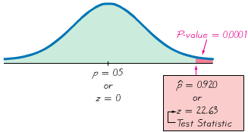

***Step* 6:** The test statistic:



*P*−values are:

Left−tailed test: *P*−value = area to left of test statistic *z*

Right−tailed test: *P*−value = area to right of test statistic *z*

Two−tailed test: *P*−value = twice the area of the extreme region bounded by test statistic *z*

Because the hypothesis test we are considering is right-tailed with a test statistic of , the *P-*value is the area to the right of . Referring to Normal Distribution Table, for values of  and higher, we use 0.0001 for the cumulative area to the *right* of the test statistic. The *P-*value is therefore 0.0001.

***Step* 7:** Because the *P-*value is 0.0001 is less than or equal to the significance level of , we reject the null hypothesis

***Step* 8: W**e conclude that there is sufficient sample evidence to support the claim that among babies born to couples using the XSORT method, the proportion of girls is greater than 0.5.

***Traditional Method***

Steps 1 – 5 are the same as *P-*value method.

***Step* 6:** The test statistic: is computed to be . With the traditional method, we find the critical region is an area of  in the right tail. From the Normal Distribution Table, we find the critical value of  is at the boundary of the critical region.

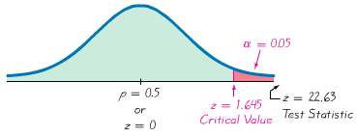

***Step* 7:** Because the test statistic falls within the critical region, we reject null hypothesis.

***Step* 8: W**e conclude that there is sufficient sample evidence to support the claim that among babies born to couples using the XSORT method, the proportion of girls is greater than 0.5. It does appear that the XSORT method is effective

**Obtaining** 

sometimes is given directly “10% of the observed sports cars are red” is expressed as 

 sometimes must be calculated “96 surveyed households have cable TV and 54 do not” is calculated using



**Testing Claims**

We can get exact results by using the binomial probability distribution. Binomial probabilities are a nuisance to calculate manually, but technology makes this approach quite simple. Also, this exact approach does not require that *np* ≥ 5 and *nq* ≥ 5 so we have a method that applies when that requirement is not satisfied. To test hypotheses using the exact binomial distribution, use the binomial probability distribution with the *P*-value method, use the value of p assumed in the null hypothesis, and find *P*-values as follows:

***Left-tailed test***: The *P*-value is the probability of getting *x* or fewer successes among *n* trials.

***Right-tailed test***: The *P*-value is the probability of getting *x* or more successes among *n* trials.

***Two-tailed test*:**

If  the *P*-value is twice the probability of getting *x* or more successes

If  the *P*-value is twice the probability of getting *x* or fewer successes

***Exercises Section* 3.6 − Testing a Claim about a Proportion**

1. In a Harris poll, adults were asked if they are in favor of abolishing the penny. Among the responses, 1261 answered “no”, and 491 answered “yes”, and 384 had no opinion. What is the sample proportion of ***yes*** responses, and what notation is used to represent it?
2. A recent study showed that 53% of college applications were submitted online. Assume that this result is based on a simple random sample of 1000 college applications, with 530 submitted online. Use a 0.01 significance level to test the claim that among all college applications the percentage submitted online is equal to 50%
3. What is the test statistic?
4. What are the critical values?
5. What is the *P-*Value?
6. What is the conclusion?
7. Can a hypothesis test be used to “prove” that the percentage of college applications submitted online is equal to 50% as claimed?
8. In a survey, 1864 out of 2246 randomly selected adults in the U.S. said that texting while driving should be illegal. Consider a hypothesis test that uses a 0.05 significance level to test the claim that more than 80% of adults believe that testing while driving should be illegal
9. What is the test statistic?
10. What are the critical values?
11. What is the *P-*Value?
12. What is the conclusion?
13. In a Pew Research Center poll of 745 randomly selected adults, 589 said that it is morally wrong to not report all income on tax returns. Use a 0.01 significance level to test the claim that 75% of adults say that it is morally wrong to not report all income on tax returns.

Identify the null hypothesis, alternative hypothesis, test statistic, *P-*value or critical value(s), conclusion about the null hypothesis, and final conclusion that address the original claim.

1. 308 out of 611 voters surveyed said that they voted for the candidate who won. Use a 0.01 significance level to test the claim that among all voters, the percentage who believe that they voted for the winning candidate is equal to 43%, which is the actual percentage of votes for the winning candidate. What does the result suggest about voter perceptions?

Identify the null hypothesis, alternative hypothesis, test statistic, *P-*value or critical value(s), conclusion about the null hypothesis, and final conclusion that address the original claim.

1. The company Drug Test Success provides a “1-Panel-THC” test for marijuana usage. Among 300 tested subjects, results from 27 subjects were wrong (either a false positive or a false negative). Use a 0.05 significance level to test the claim that less than 10% of the test results are wrong. Does the test appear to be good for most purposes?
2. When testing gas pumps in Michigan for accuracy, fuel-quality enforcement specialists tested pumps and found that 1299 of them were not pumping accurately (within 3.3 oz. when 5 gal. is pumped), and 5686 pumps were accurate. Use a 0.01 significance level to test the claim of an industry representative that less than 20% of Michigan gas pumps are inaccurate. From the perspective of the consumer, does that rate appear to be low enough?
3. Trials in an experiment with a polygraph include 98 results that include 24 cases of wrong results and 74 cases of correct results. Use a 0.05 significance level to test the claim that such polygraph results are correct less than 80% of the time. Based on the results, should polygraph test results be prohibited as evidence in trials?
4. In recent years, the Town of Newport experienced an arrest rate of 25% for robberies. The new sheriff compiles records showing that among 30 recent robberies, the arrest rate is 30%, so she claims that her arrest rate is greater than the 25% rate in the past. Is there sufficient evidence to support her claim that the arrest rate is greater than 25%?
5. A survey showed that among 785 randomly selected subjects who completed 4 years of college, 18.3 % smoke and 81.7% do not smoke. Use a 0.01 significance level to test the claim that the rate of smoking among those with 4 years of college is less than the 27% rate for the general population. Why would college graduates smoke at a lower rate than others?
6. When 3011 adults were surveyed, 73% said that they use the Internet. Is it okay for a newspaper reporter to write that “3/4 of all adults use the internet”? Why or Why not?
7. A hypothesis test is performed to test the claim that a population proportion is greater than 0.7. Find the probability of a type II error, *β*, given that the true value of the population proportion is 0.72. The sample size is 50 and the significance level is 0.05.
8. In a sample of 88 children selected randomly from one town, it is found that 8 of them suffer asthma. Find the *P*-value for a test of the claim that the proportion of all children in the town who suffer from asthma is equal to 11%.
9. An airline claims that the no-show rate for passengers booked on its flights is less than 6%. Of 380 randomly selected reservation, 18 were no-shows. Find the P-value for a test of the airline’s claim.

***Section* 3.7 − Testing a Claim about a Mean: Sigma (σ) Known**

***Objective***

Test a claim about a population mean (with ***σ*** known) by using a formal method of hypothesis testing.

***Notation***

*n* = Sample size

 = sample mean

 = population mean of all sample means from samples of size *n*

*σ* = known value of the population standard deviation

|  |  |
| --- | --- |
|  |  |

**Requirements for Testing Claims about a Population Mean (with *σ* Known)**

1. The sample is a simple random sample.
2. The value of the population standard deviation *σ* is known.
3. Either or both of these conditions is satisfied: The population is normally distributed or *n* > 30.

**Test Statistic for Testing a Claim About a Mean (with *σ* Known)**



***Example***

People have died in boat accidents because an obsolete estimate of the mean weight of men was used. Using the weights of the simple random sample of men from Data Set 1 in Appendix B, we obtain these sample statistics: *n* = 40 and  = 172.55 lb. Research from several other sources suggests that the population of weights of men has a standard deviation given by *σ* = 26 lb. Use these results to test the claim that men have a mean weight greater than 166.3 lb, which was the weight in the National Transportation and Safety Board’s recommendation M-04-04. Use a 0.05 significance level, and use the *P*-value method outlined in Figure 8-8.

***Solution***

Requirements are satisfied: simple random sample, *σ* is known (26 lb), sample size is 40 (*n* > 30)

*Step* 1: Express claim as *μ* > 166.3 lb

*Step* 2: alternative to claim is *μ* ≤ 166.3 lb

*Step* 3: *μ* > 166.3 lb does not contain equality, it is the alternative hypothesis:

 : *μ* = 166.3 lb. null hypothesis

: *μ >* 166.3 lb. alternative hypothesisand original claim

*Step* 4: significance level is *α* = 0.50

*Step* 5: claim is about the population mean, so the relevant statistic is the sample mean (172.55 lb), *σ* is known (26 lb), sample size greater than 30

*Step* 6: calculate *z*:



Right-tailed test, so *P*-value is thearea is to the right of *z* = 1.52;

From the Normal Distribution Table; area to the left of *z* = 1.52 is 0.9357, so the area to the right is 1 – 0.9357 = 0.0643. The *P-*value is 0.0643

*Step* **7:** The *P*-value of 0.0643 is greater than the significance level of *α* = 0.05, we fail to reject the null hypothesis.

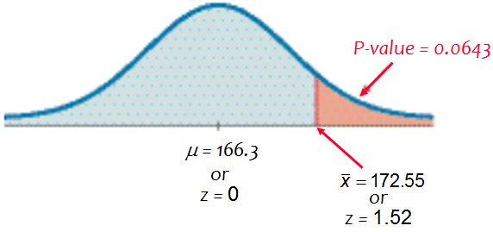

* The *P*-value of 0.0643 tells us that if men have a mean weight given by *μ* = 166.3 lb, there is a good chance (0.0643) of getting a sample mean of 172.55 lb. A sample mean such as 172.55 lb could easily occur by chance. There is not sufficient evidence to support a conclusion that the population mean is greater than 166.3 lb, as in the National Transportation and Safety Board’s recommendation.

The ***traditional method***: Use *z* = 1.645 instead of finding the *P*-value. Since *z* = 1.52 does not fall in the critical region, again fail to reject the null hypothesis.

***Confidence Interval method***: Use a one-tailed test with a = 0.05, so construct a 90% confidence interval: 165.8 < *μ* < 179.3

The confidence interval contains 166.3 lb, we cannot support a claim that *μ* is greater than 166.3. Again, fail to reject the null hypothesis.

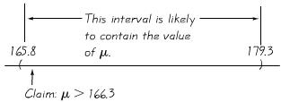

**Underlying Rationale of Hypothesis Testing**

If, under a given assumption, there is an extremely small probability of getting sample results at least as extreme as the results that were obtained, we conclude that the assumption is probably not correct.

When testing a claim, we make an assumption (null hypothesis) of equality. We then compare the assumption and the sample results and we form one of the following conclusions:

* If the sample results (or more extreme results) can easily occur when the assumption (null hypothesis) is true, we attribute the relatively small discrepancy between the assumption and the sample results to chance.
* If the sample results cannot easily occur when that assumption (null hypothesis) is true, we explain the relatively large discrepancy between the assumption and the sample results by concluding that the assumption is not true, so we reject the assumption.

***Exercises Section* 3.7 − Testing a Claim about a Mean: Sigma Known**

1. Because the amounts of nicotine in king size cigarettes listed below

|  |  |  |  |  |  |  |  |  |  |  |  |  |
| --- | --- | --- | --- | --- | --- | --- | --- | --- | --- | --- | --- | --- |
| 1.1 | 1.7 | 1.7 | 1.1 | 1.1 | 1.4 | 1.1 | 1.4 | 1 | 1.2 | 1.1 | 1.1 | 1.1 |
| 1.1 | 1.1 | 1.8 | 1.6 | 1.1 | 1.2 | 1.5 | 1.3 | 1.1 | 1.3 | 1.1 | 1.1 |  |

We must satisfy the requirement that the population is normally distributed. How do we verify that a population is normally distributed?

1. If you want to construct a confidence interval to be used for testing the claim that college students have a mean IQ score that is greater than 100, and you want the test conducted with a 0.01 significance level, what confidence level should be used for the confidence interval?
2. 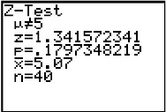A jewelry designer claims that women have wrist breadths with a mean equal to 5 cm. A simple random sample of the wrist breadths of 40 women has a mean of 5.07 cm. Assume that the population standard deviation is 0.33 cm. Use the accompanying TI display to test the designer’s claim.

Identify the null hypothesis, alternative hypothesis, test statistic, *P-*value or critical value(s), conclusion about the null hypothesis, and final conclusion that address the original claim.

1. The U.S. Mint has a specification that pennies have a mean weight of 2.5 g. Assume that weights of pennies have a standard deviation of 0.0165 g and use the accompanying Minitab display to test the claim that the sample is from a population with a mean that is less than 2.5 g. These Minitab results were obtained using the 37 weights of post 1983 pennies.

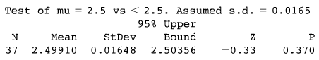

1. In the manual “How long to have a Number One the Easy Way,” by KLF Publications, it is stated that a song “must be no longer than 3 minutes and 30 seconds” (or 210 seconds). A simple random sample of 40 current hit songs results in a mean length of 252.5 sec. Assume that the standard deviation of song lengths is 54.5 sec. Use a 0.05 significance level to test the claim that the sample is from a population of songs with a mean greater than 210 sec. What do these results suggest about the advice given in the manual?
2. A simple random sample of 50 adults is obtained, and each person’s red blood cell count (in cells per microliter) is measured. The sample mean is 5.23. The population standard deviation for red blood cell counts is 0.54. Use a 0.01 significance level to test the claim that the sample is from population with a mean less than 5.4, which is value often used for the upper limit of the range of normal values. What do the results suggest about the sample group?
3. A simple random sample of 106 body temperature with a mean of 98.20 °F. Assume that σ is known to be 0.62 °F. Use a 0.05 significance level to test the claim that the mean body temperature of the population is equal to 98.6 °F, as is commonly believed. Is there sufficient evidence to conclude that the common belief is wrong?
4. When 40 people used the Weight Watchers diet for one year, their mean weight loss was 3.0 lb. Assume that the standard deviation of all such weight changes is *σ* = 4.9 lb. and use a 0.01 significance level to test the claim that the mean weight loss is greater than 0. Based on these results, does the diet appear to be effective? Does the diet appear to have a practical significance?
5. The health of the bear population in Yellowstone National Park is monitored by periodic measurements taken from anesthetized bears. A sample of 54 bears has a mean weight of 182.9 lb. Assuming that *σ* is known to be 121.8 lb. use a 0.05 significance level to test the claim that the population mean of all such bear weights is greater than 150 lb.
6. A simple random sample of 401 salaries of NCAA football coaches in the NCAA has a mean of $415,953. The standard deviation of all salaries of NCAA football coaches is $463,364. Use a 0.05 significance level to test the claim that the mean salary of a football coach in the NCAA is less than $500,000.
7. A simple random sample of 36 cans of regular Coke has a mean volume of 12.19 oz. Assume that the standard deviation of all cans of regular Coke is 0.11 oz. Use a 0.01 significance level to test the claim that cans if regular Coke have volumes with a mean of 12 oz., as stated on the label. If there is a difference, is it substantial?
8. A simple random sample of FICO credit rating scores is obtained, and the scores are listed below.

|  |  |  |  |  |  |  |  |  |  |  |  |
| --- | --- | --- | --- | --- | --- | --- | --- | --- | --- | --- | --- |
| 714 | 751 | 664 | 789 | 818 | 779 | 698 | 836 | 753 | 834 | 693 | 802 |

As the writing, the mean FICO score was reported to be 678. Assuming the standard deviation of all FICO scores is known to be 58.3, use a 0.05 significance level to test the claim that these sample FICO scores come from a population with a mean equal to 678.

Identify the null hypothesis, alternative hypothesis, test statistic, *P-*value or critical value(s), conclusion about the null hypothesis, and final conclusion that address the original claim.

1. Listed below are recorded speeds (in mi/h) of randomly selected cars traveling on a section of Highway 405 in Los Angeles.

|  |  |  |  |  |  |  |  |  |  |  |  |  |  |  |  |  |  |  |  |
| --- | --- | --- | --- | --- | --- | --- | --- | --- | --- | --- | --- | --- | --- | --- | --- | --- | --- | --- | --- |
| 68 | 68 | 72 | 73 | 65 | 74 | 73 | 72 | 68 | 65 | 65 | 73 | 66 | 71 | 68 | 74 | 66 | 71 | 65 | 73 |
| 59 | 75 | 70 | 56 | 66 | 75 | 68 | 75 | 62 | 72 | 60 | 73 | 61 | 75 | 58 | 74 | 60 | 73 | 58 | 75 |

That part of the highway has posted speed limit of 65 mi/h. Assume that the standard deviation od speeds is 5.7 mi/h and use a 0.01 significance level to test the claim that the sample is from a population with a mean that is greater than 65 mi/h.

Identify the null hypothesis, alternative hypothesis, test statistic, *P-*value or critical value(s), conclusion about the null hypothesis, and final conclusion that address the original claim.

***Section* 3.8 − Testing a Claim about a Mean: Sigma (σ) Not Known**

***Objective***

Test a claim about a population mean (with ***σ*** not known) by using a formal method of hypothesis testing.

***Notation***

*n* = Sample size

 = sample mean

 = population mean of all sample means from samples of size *n*

**Requirements for Testing Claims About a Population Mean (with *σ* Not Known)**

1. The sample is a simple random sample.
2. The value of the population standard deviation *σ* is not known.
3. Either or both of these conditions is satisfied: The population is normally distributed or *n* > 30.

**Test Statistic for Testing a Claim about a Mean (with *σ* Not Known)**



***P*-values and Critical Values**

* Found in Table *A*-3
* Degrees of freedom (df) = *n* – 1

**Important Properties of the Student *t* Distribution**

1. The Student *t* distribution is different for different sample sizes.



1. The Student *t* distribution has the same general bell shape as the normal distribution; its wider shape reflects the greater variability that is expected when *s* is used to estimate *σ* .
2. The Student *t* distribution has a mean of *t* = 0 (just as the standard normal distribution has a mean of *z* = 0).
3. The standard deviation of the Student *t* distribution varies with the sample size and is greater than 1 (unlike the standard normal distribution, which has *σ*  = 1).
4. As the sample size *n* gets larger, the Student *t* distribution gets closer to the standard normal distribution.

**Choosing between the Normal and Student *t* Distributions when Testing a Claim about a Population Mean *µ***

Use the Student *t* distribution when *σ* is not known and either or both of these conditions is satisfied:  
The population is normally distributed or *n* > 30.

***Example***

People have died in boat accidents because an obsolete estimate of the mean weight of men was used. Using the weights of the simple random sample of men from Data Set 1 in Appendix B, we obtain these sample statistics: *n* = 40 and , and *σ* = 26.33 *lb*. Do not assume that the value of *σ* is known. Use these results to test the claim that men have a mean weight greater than 166.3 *lb*., which was the weight in the National Transportation and Safety Board’s recommendation M-04-04. Use a 0.05 significance level, and the traditional method.

***Solution***

Requirements are satisfied: simple random sample, population standard deviation is not known, sample size is 40 (*n* > 30)

*Step* 1: Express claim as *μ* > 166.3 *lb.*

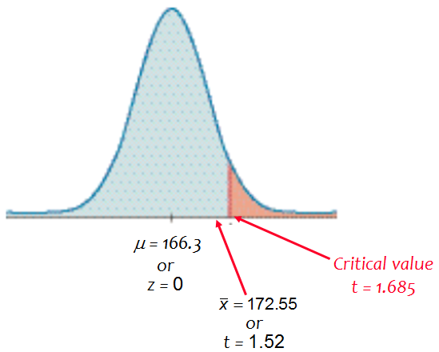*Step* 2: Alternative to claim is *μ* ≤ 166.3 *lb.*

*Step* 3: *μ*  > 166.3  *lb.* does not contain equality, it is the alternative hypothesis:

: *μ* = 166.3 *lb.* null hypothesis

: *μ* > 166.3 *lb.* alternative hypothesis and original claim

*Step* 4: Significance level is *α* = 0.05

*Step* 5: Claim is about the population mean, so the relevant statistic is the sample mean, 172.55 lb.

*Step* 6: Calculate *t*



df = *n* – 1 = 39, area of 0.05, one-tail yields *t* = 1.685;

*Step* 7: *t* = 1.501 does not fall in the critical region bounded by *t* = 1.685, we fail to reject the null hypothesis.+

* Because we fail to reject the null hypothesis, we conclude that there is not sufficient evidence to support a conclusion that the population mean is greater than 166.3 lb, as in the National Transportation and Safety Board’s recommendation.

**Normal Distribution versus Student *t* Distribution**

The critical value in the preceding example was *t* = 1.782, but if the normal distribution were being used, the critical value would have been *z* = 1.645.  
The Student *t* critical value is larger (farther to the right), showing that with the Student *t* distribution, the sample evidence must be more extreme before we can consider it to be significant.

***Example***

Assuming that neither software nor a TI calculator is available, use Table A-3 to find a range of values for the *P*-value corresponding to the given results.

1. In a left-tailed hypothesis test, the sample size is *n* = 12, and the test statistic is *t* = –2.007.
2. In a right-tailed hypothesis test, the sample size is *n* = 12, and the test statistic is *t* = 1.222.
3. In a two-tailed hypothesis test, the sample size is *n* = 12, and the test statistic is *t* = –3.456.

***Solution***

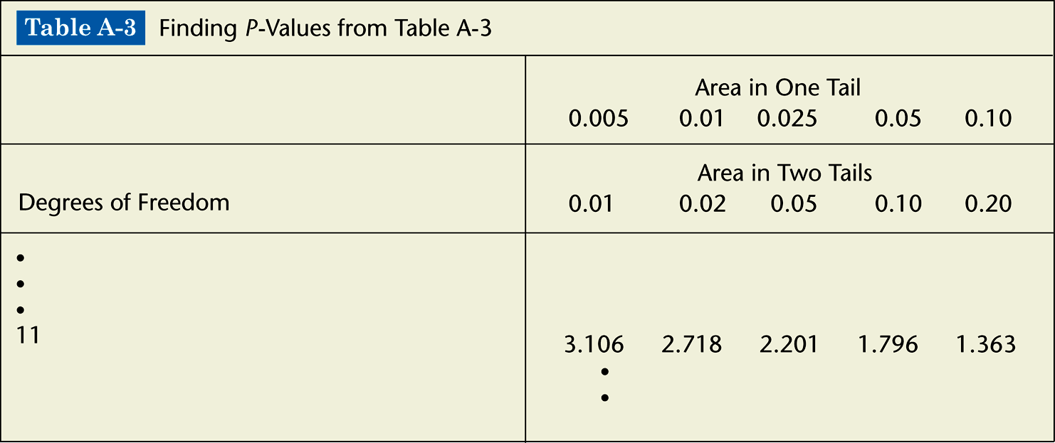

1. The test is a left-tailed test with test statistic *t* = –2.007, so the *P*-value is the area to the left of –2.007. Because of the symmetry of the *t* distribution, that is the same as the area to the right of +2.007. Any test statistic between 2.201 and 1.796 has a right-tailed *P*-value that is between 0.025 and 0.05. We conclude that 0.025 < *P*-value < 0.05.
2. The test is a right-tailed test with test statistic *t* = 1.222, so the *P*-value is the area to the right of 1.222. Any test statistic less than 1.363 has a right-tailed *P*-value that is greater than 0.10. We conclude that *P*-value > 0.10.
3. The test is a two-tailed test with test statistic *t* = –3.456. The *P*-value is twice the area to the right of –3.456. Any test statistic greater than 3.106 has a two-tailed *P*-value that is less than 0.01. We conclude that *P*-value < 0.01.

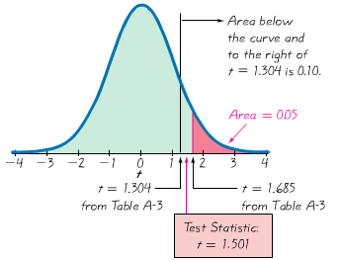

***Using TI – to calculate tcdf***

2 · ***tcdf***(1.495, 99, 14) = 0.1571

 

***Exercises Section* 3.8 − Testing a Claim about a Mean: Sigma Not Known**

1. Given a simple random sample of speeds of cars on Highway in CA, you want to test the claim that the sample that the sample values are from a population with a mean greater than the posted speed limit of 65 mi/hr. Is it necessary to determine whether the sample is from a normally distributed population? If so, what methods can be used to make that determination?
2. In statistics, what does ***df*** denote. If a simple random sample of 20 speeds of cars is to be used to test the claim that the sample values are from a population with a mean greater than the posted speed limit of 65 mi/h, what is the specific value of df?
3. Claim about IQ scores of statistics instructors: , sample data: . The sample data appear to come from a normally distributed population with unknown *μ* and *σ*. Determine whether the hypotheses test involves a sampling distribution of means that is a normal distribution, student *t* distribution, or neither.
4. Claim about FICO credit scores of adults: , sample data: . The sample data appear to come from a population with a distribution that is not normal, and *σ* Is unknown Determine whether the hypotheses test involves a sampling distribution of means that is a normal distribution, student *t* distribution, or neither.
5. Claim about daily rainfall amounts in Boston: , sample data:
6. The sample data appear to come from a population with a distribution that is very far from normal, and *σ* is unknown Determine whether the hypotheses test involves a sampling distribution of means that is a normal distribution, student *t* distribution, or neither.
7. Testing a claim about the mean weight of M&M’s: Right-tailed test with *n* = 25 and test statistic *t* = 0.430. Find the *P-*value and find a range of values for the *P-*value.
8. Test a claim about the mean body temperature of healthy adults: left-tailed test with *n* = 11 and test statistic *t* = −3.158. Find the *P-*value and find a range of values for the *P-*value.
9. Two-tailed test with *n* = 15 and test statistic *t* = 1.495. Find the *P-*value and find a range of values for the *P-*value.
10. In an analysis investigating the usefulness of pennies, the cents portions of 100 randomly selected checks are recorded. The sample has mean of 23.8 cents and a standard deviation of 32.0 cents. If the amounts from 0 cents to 99 cents are all equally likely, the mean is expected to be 49.5 cents. Use a 0.01 significance level to test the claim that the sample is from a population with a mean less than 49.5 cents. What does the result suggest about the cents portions of the checks?
11. A simple random sample of 40 recorded speeds (in mi/h) is obtained from cars traveling on a section of Highway 405 in Los Angeles. The sample has a mean of 68.4 mi/h and a standard deviation of 5.7 mi/h. Use a 0.05 significance level to test the claim that the mean speed of all cars is greater than the posted speed limit of 65 mi/h.
12. The heights are measured for the simple random sample of supermodels. They have mean height of 70.0 in. and a standard deviation of 1.5 in. Use a 0.01 significance level to test the claim that supermodels have heights with a mean that is greater than the mean heights of 63.6 in. for women in general population. Given that there are only nine heights represented, can we really conclude that supermodels are taller than the typical woman?
13. The National Highway Traffic Safety Administration conducted crash tests of child booster seats for cars. Listed below are results from those tests, with measurement given in hic (standard *head injury condition* units). The safety requirement is that the hic measurement should be less than 1000 hic. Use a 0.01 significance level to test the claim that the sample is from a population with a mean less than 1000 hic.

|  |  |  |  |  |  |
| --- | --- | --- | --- | --- | --- |
| 774 | 649 | 1210 | 546 | 431 | 612 |

Do the results suggest that all of the child booster seats meet the specified requirement?

1. The trend of thinner Miss America winners has generated charges that the contest encourages unhealthy diet habits among young women. Listed below are body mass indexes (BMI) for recent Miss America winners. Use a 0.01 significance level to test the claim that recent Miss America winners are from a population with a mean BMI less than 20.16, which was the BMI for winners from the 1920s and 1930s.

|  |  |  |  |  |  |  |  |  |  |
| --- | --- | --- | --- | --- | --- | --- | --- | --- | --- |
| 19.5 | 20.3 | 19.6 | 20.2 | 17.8 | 17.9 | 19.1 | 18.8 | 17.6 | 16.8 |

Do recent winners appear to be significantly different from those in the 1920s and 1930s?

1. The list measured voltage amounts supplied directly to the author’s home

|  |  |  |  |  |  |  |  |  |  |  |  |
| --- | --- | --- | --- | --- | --- | --- | --- | --- | --- | --- | --- |
| 123.8 | 123.9 | 123.9 | 123.3 | 123.4 | 123.3 | 123.3 | 123.6 | 123.5 | 123.5 | 123.5 | 123.7 |
| 123.6 | 123.7 | 123.9 | 124.0 | 124.2 | 123.9 | 123.8 | 123.8 | 124.0 | 123.9 | 123.6 | 123.5 |
| 123.4 | 123.4 | 123.4 | 123.4 | 123.3 | 123.3 | 123.5 | 123.6 | 123.8 | 123.9 | 123.9 | 123.8 |
| 123.9 | 123.7 | 123.8 | 123.8 |  |  |  |  |  |  |  |  |

The Central Hudson power supply company states that it has a target power supply of 120 volts. Using those home voltage amounts, test the claim that the mean is 120 volts. Use a 0.01 significance level.

1. When testing a claim about a population mean with a simple random sample selected from a normally distributed population with unknown σ, the student t distribution should be used for finding critical values and/or a P−value. If the standard normal distribution is incorrectly used instead, does that mistake make you more or less likely to reject the null hypothesis, or does it not make a difference? Explain.
2. The list measured human body temperature.

|  |  |  |  |  |  |  |  |  |  |  |  |  |  |  |
| --- | --- | --- | --- | --- | --- | --- | --- | --- | --- | --- | --- | --- | --- | --- |
| 98.6 | 98.6 | 98.0 | 98.0 | 99.0 | 98.4 | 98.4 | 98.4 | 98.4 | 98.6 | 98.6 | 98.8 | 98.6 | 97.0 | 97.0 |
| 98.8 | 97.6 | 97.7 | 98.8 | 98.0 | 98.0 | 98.3 | 98.5 | 97.3 | 98.7 | 97.4 | 98.9 | 98.6 | 99.5 | 97.5 |
| 97.3 | 97.6 | 98.2 | 99.6 | 98.7 | 99.4 | 98.2 | 98.0 | 98.6 | 98.6 | 97.2 | 98.4 | 98.6 | 98.2 | 98.0 |
| 97.8 | 98.0 | 98.4 | 98.6 | 98.6 | 97.8 | 99.0 | 96.5 | 97.6 | 98.0 | 96.9 | 97.6 | 97.1 | 97.9 | 98.4 |
| 97.3 | 98.0 | 97.5 | 97.6 | 98.2 | 98.5 | 98.8 | 98.7 | 97.8 | 98.0 | 97.1 | 97.4 | 99.4 | 98.4 | 98.6 |
| 98.4 | 98.5 | 98.6 | 98.3 | 98.7 | 98.8 | 99.1 | 98.6 | 97.9 | 98.8 | 98.0 | 98.7 | 98.5 | 98.9 | 98.4 |
| 98.6 | 97.1 | 97.9 | 98.8 | 98.7 | 97.6 | 98.2 | 99.2 | 97.8 | 98.0 | 98.4 | 97.8 | 98.4 | 97.4 | 98.0 |
| 97.0 |  |  |  |  |  |  |  |  |  |  |  |  |  |  |

Use the temperatures listed for 12 AM on day 2 to test the common belief that the mean body temperature is 98.6 °F. Does that common belief appear to be wrong?

1. Determine whether the hypothesis test involves a sampling distribution of means that is a normal distribution, student *t* distribution, or neither
2. Claim . Sample data: . The sample data appear to come from a normally distributed population with .
3. Claim . Sample data: . The sample data appear to come from a normally distributed population with unknown .

***Section* 3.9 − Testing a Claim about Variation**

***Objective***

Test a claim about a population standard deviation ***σ*** (or population variance  ) by using a formal method of hypothesis testing.

***Notation***

*n* = Sample size

 = sample standard deviation

 = sample variance

 = claimed value of the population standard deviation

 = claimed value of the population variance

**Requirements for Testing Claims About a Population Mean (with *σ* Not Known)**

1. The sample is a simple random sample.
2. The population has a normal distribution. (This is a much stricter requirement than the requirement of a normal distribution when testing claims about means.)

**Chi-Square Distribution**

* ***Test Statistic*** 
* Use Chi-Square Distribution Table.
* The degrees of freedom = *n* – 1.

**Properties of Chi-Square Distribution**

* All values of *χ* 2 are nonnegative, and the distribution is not symmetric.

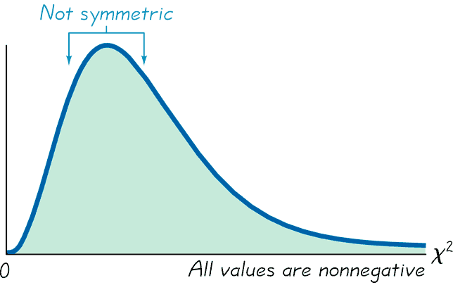

* There is a different distribution for each number of degrees of freedom.

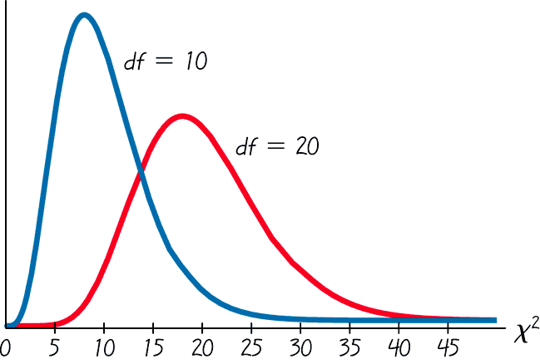

* The critical values are found in Chi-Square Distribution Table using *n –* 1 degrees of freedom.

***Caution***

The *χ* 2 test of this section is not *robust* against a departure from normality, meaning that the test does not work well if the population has a distribution that is far from normal. The condition of a normally distributed population is therefore a much stricter requirement in this section

***Chi-Square Distribution Table***

Chi-Square Distribution Table is based on cumulative areas from the right (unlike the entries in Standard Normal Distribution Table, which are cumulative areas from the left). Critical values are found in Chi-Square  Distribution Table by first locating the row corresponding to the appropriate number of degrees of freedom (where df = *n* –1). Next, the significance level *α* is used to determine the correct column. The following examples are based on a significance level of *α* = 0.05, but any other significance level can be used in a similar manner.

***Right-tailed test:*** Because the area to the right of the critical value is 0.05, locate 0.05 at the top of Chi-Square Distribution Table.

***Left-tailed test***: With a left-tailed area of 0.05, the area to the right of the critical value is 0.95, so locate 0.95 at the top of Chi-Square Distribution Table.

***Two-tailed test***: Unlike the normal and Student *t* distributions, the critical values in this *χ*2 test will be two different positive values (instead of something like ±1.96 ). Divide a significance level of 0.05 between the left and right tails, so the areas to the right of the two critical values are 0.975 and 0.025, respectively. Locate 0.975 and 0.025 at the top of Chi-Square Distribution Table

***Example***

A common goal in business and industry is to improve the quality of goods or services by reducing variation. Quality control engineers want to ensure that a product has an acceptable mean, but they also want to produce items of consistent quality so that there will be few defects. If weights of coins have a specified mean but too much variation, some will have weights that are too low or too high, so that vending machines will not work correctly (unlike the stellar performance that they now provide).

Consider the simple random sample of the 37 weights of post-1983 pennies listed in Data Set 20 in Appendix B. Those 37 weights have a mean of 2.49910 g and a standard deviation of 0.01648 g. U.S. Mint specifications require that pennies be manufactured so that the mean weight is 2.500 g. A hypothesis test will verify that the sample appears to come from a population with a mean of 2.500 g as required, but use a 0.05 significance level to test the claim that the population of weights has a standard deviation less than the specification of 0.0230 g.

***Solution***

Requirements are satisfied: simple random sample; and STATDISK generated the histogram and quantile plot - sample appears to come from a population having a normal distribution.

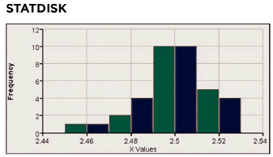 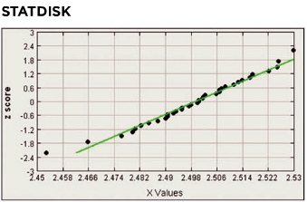

*Step* 1: Express claim as *σ* < 0.0230 g

*Step* 2: If *σ* < 0.0230 g is false, then *σ* ≥ 0.0230 g

*Step* 3: *σ* < 0.0230 g does not contain equality so it is the alternative hypothesis; null hypothesis is *σ* = 0.0230 g

*H*0: *σ* = 0.0230 g

*H*1: *σ* < 0.0230 g

*Step* 4: significance level is *α* = 0.05

*Step* 5: Claim is about *σ* so use chi-square

*Step* 6: The test statistic is

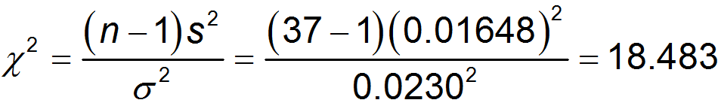

The critical value from Chi-Square  Distribution Table corresponds to 36 degrees of freedom and an “area to the right” of 0.95 (based on the significance level of 0.05 for a left-tailed test). Chi-Square  Distribution Table does not include 36 degrees of freedom, but Chi-Square  Distribution Table shows that the critical value is between 18.493 and 26.509. (Using technology, the critical value is 23.269.)

*Step* 7: Because the test statistic is in the critical region, reject the null hypothesis.

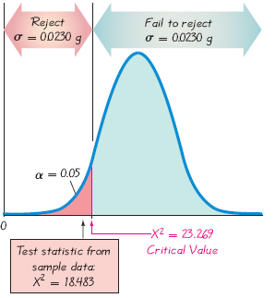

* There is sufficient evidence to support the claim that the standard deviation of weights is less than 0.0230 g. It appears that the variation is less than 0.0230 g as specified, so the manufacturing process is acceptable.

***Exercises Section* 3.9 − Testing a Claim about Variation**

1. There is a claim that the lengths of men’s hands have a standard deviation less than 200 mm. You plan to test that claim with a 0.01 significance level by constructing a confidence interval. What level of confidence should be used for the confidence interval? Will the conclusion based on the confidence interval be the same as the conclusion based on a hypothesis test that uses the traditional method or the *P-*value method?
2. There is a claim that daily rainfall amounts in Boston have a standard deviation equal to 0.25 in. Sample data show that daily rainfall amounts are from a population with a distribution that is very far from normal. Can the use of a very large sample compensate for the lack of normality, so that the methods of this section can be used for the hypothesis test?
3. There is a claim that men have foot breaths with a variance equal to 36 . Is a hypothesis test of the claim that the variance is equal to 36  equivalent to a test of the claim that the standard deviation is equal to 6 *mm*.
4. Given: , Find
5. Find the test statistic
6. Find critical value(s)
7. Find *P-*value limits
8. Determine whether there is sufficient evidence to support the given alternative hypothesis.
9. Given: , Find
10. Find the test statistic
11. Find critical value(s)
12. Find *P-*value limits
13. Determine whether there is sufficient evidence to support the given alternative hypothesis.
14. Given: , Find
15. Find the test statistic
16. Find critical value(s)
17. Find *P-*value limits
18. Determine whether there is sufficient evidence to support the given alternative hypothesis.
19. Given: , Find
20. Find the test statistic
21. Find critical value(s)
22. Find *P-*value limits
23. Determine whether there is sufficient evidence to support the given alternative hypothesis.
24. A simple random sample of 40 men results in a standard deviation of 11.3 beats per minute. The normal range of pulse rates of adults is typically given as 60 to 100 beats per minute. If the range rule of thumb is applied to that normal range, the result is a standard deviation of 10 beats per minute. Use the sample results with a 0.05 significance level to test the claim that rates of men have a standard deviation greater than 10 beats per minute.
25. A simple random sample of 25 filtered 100 mm cigarettes is obtained, and the tar content of each cigarette is measured. The sample has a standard deviation of 3.7 mg. Use a 0.05 significance level to test the claim that the tar content of filtered 100 mm cigarettes has a standard deviation different from 3.2 mg, which is the standard deviation for unfiltered king size cigarettes.
26. When 40 people used the Weight Watchers diet for one year, their weight losses had a standard deviation of 4.9 lb. Use 0.01 significance level to test the claim that the amounts of weight loss have a standard deviation equal to 6.0 lb., which appears to be the standard deviation for the amounts of weight loss with the Zone diet.
27. Tests in the statistic classes have scores with a standard deviation equal to 14.1. One of the last classes has 27 test scores with a standard deviation of 9.3. Use a 0.01 significance level to test the claim that this class has less variation than other past classes. Does a lower standard deviation suggest that this last class is doing better?
28. A simple random sample of pulse rates of 40 women results in a standard deviation of 12.5 *beats/min*. The normal range of pulse rates of adults is typically given as 60 to 100 *beats/min*. If the range rule of thumb is applied to that normal range, the result is a standard deviation of 10 *beats/min*. Use the sample results with a 0.05 significance level to test the claim that pulse rates of women have a standard deviation equal to 10 *beats/min*.
29. Listed below are the playing times (in seconds) of songs that were popular at the time of this writing. Use a 0.05 significance level to test the claim that the songs are from a population with a standard deviation less than on minute.

|  |  |  |  |  |  |  |  |  |  |  |  |  |  |  |  |
| --- | --- | --- | --- | --- | --- | --- | --- | --- | --- | --- | --- | --- | --- | --- | --- |
| 448 | 242 | 231 | 246 | 246 | 293 | 280 | 227 | 244 | 213 | 262 | 239 | 213 | 258 | 255 | 257 |

1. Find the critical value or values of  based on the given information
2. 
3. 
4. 
5. 