***Hypothesis testing*** is a procedure, based on sample evidence and probability, used to test statements regarding a characteristic of one or more populations.

**Null Hypothesis:** The ***null hypothesis***, denoted , is a statement to be tested. The null hypothesis is a statement of no change, no effect or no difference and is assumed true until evidence indicates otherwise.

**Alternative Hypothesis:** The ***alternative hypothesis***, denoted , is a statement that we are trying to find evidence to support.

**Three ways to set up the null and alternative hypotheses**

1. Equal versus not equal hypothesis (two-tailed test)

*H*0: parameter = some value

*H*1: parameter ≠ some value

1. Equal versus less than (left-tailed test)

*H*0: parameter = some value

*H*1: parameter < some value

1. Equal versus greater than (right-tailed test)

*H*0: parameter = some value

*H*1: parameter > some value

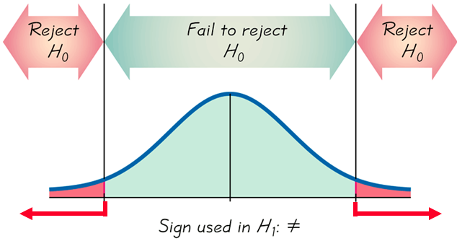

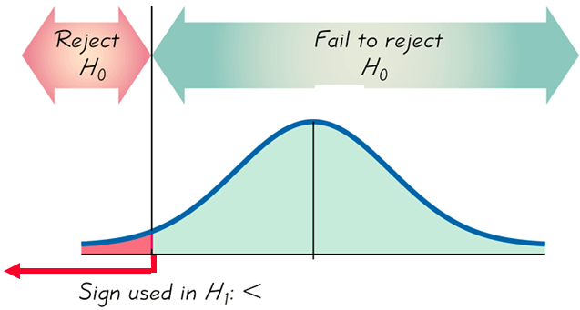 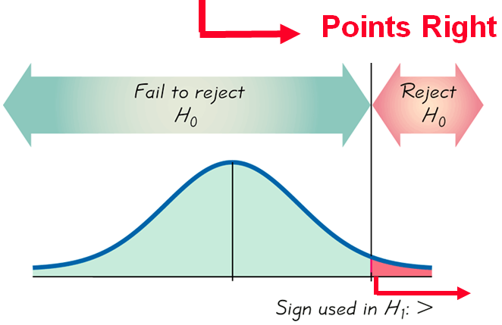

*If* ***P-value < α****, reject the null hypothesis*

If *P*-value > *α* , ***fail to reject*** .

|  |  |  |
| --- | --- | --- |
| *Two−Tailed* | *Left−Tailed* | *Right−Tailed* |
|  |  |  |
|  |  |  |
| *Reject the null hypothesis* | *Reject the null hypothesis* | *Reject the null hypothesis* |
| T10_553ae | T10_553af | T10_553ag |
|  |  |  |
|  |  |  |
| *Reject the null hypothesis* | *Reject the null hypothesis* | *Reject the null hypothesis* |
| 11_585_aa | 11_585_ab | 11_585_ac |
|  |  |  |
|  |  |  |
| *Reject the null hypothesis* | *Reject the null hypothesis* | *Reject the null hypothesis* |
| T10_562aa | T10_562ab  T10_562ae | T10_562ac  T10_562af |