***Lecture One -* Trigonometric Functions**

***Section* 1.1– Angles, Degrees, and Special Triangles**

**Basic Terminology**

Two distinct points determine line *AB*.

***Line segment AB:*** portion of the line between *A* and *B*. 

***Ray AB***: portion of the line *AB* starts at *A* and continues through *B*, and past *B*.

*A B*

***Angles* in General**

Terminal side

Initial side

**θ**

**O**

*B*

*A*

An angle is formed by 2 rays with the same end point.

The two rays are the sides of the angle.

Angle *θ* = *AOB*

**O** is the common endpoint and it is called ***vertex*** of the angle

An angle is in a Counterclockwise (*CCW*) direction: positive angle

An angle is in a Clockwise (*CW*) direction: negative angle

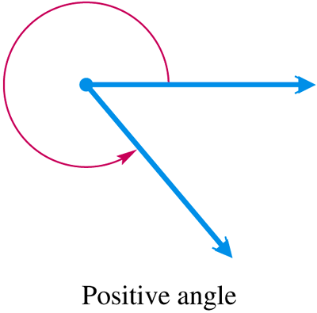 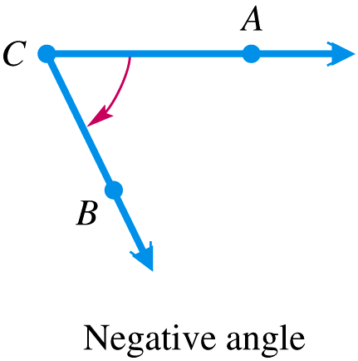

**Type of Angles: *Degree***

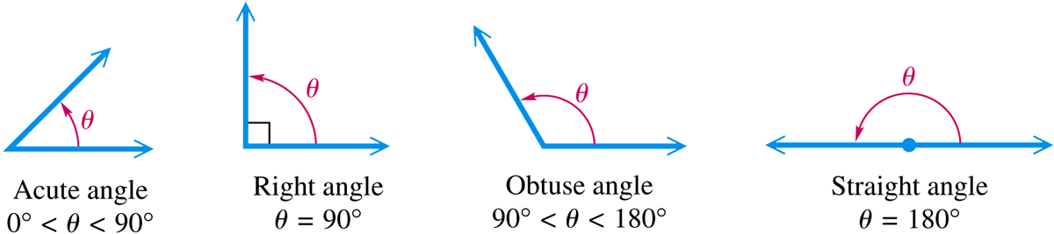

Complementary angles: α + β = 90°

Supplementary angles: α + β = 180°

***Example***

Give the complement and the supplement of each angle: 

*Solution*

1. 40° Complement: 90° - 40° = 50° Supplement:180° - 40° = 140°
2. 110° Complement: 90° - 110° = -20° Supplement:180° - 110° = 70°
3. θ Complement: 90° - *θ* Supplement:180° - *θ*

**Degrees, Minutes, Seconds**

1°: 1 *degree* 

: 1 *minute* 

: 1 *second* 

**1*full Rotation*** or ***Revolution*= 360°**

 

***Example***

Add  and 

*Solution*







***Example***

Subtract  and 

*Solution*



***Example***

Change 27.25° to degrees and minutes

*Solution*

27.25° = 27° + .25°

= 27° + .25(**60′**)

= 27° + 15′

= 27° 15′

**Angles in Standard Position**

An angle is said to be in standard position if its initial side is along the positive *x*-axis and its vertex is at the origin.

If angle *θ* is in standard position and the terminal side of *θ* lies in quadrant I, then we say *θ* lies in QI



If the terminal side of an angle in standard position lies along one of the axes (*x*-axis or *y*-axis), such as angles with measures 90°, 180°, 270°, then that called a ***quadrantal*** *angle*.

Two angles in standard position with the same terminal side are called ***coterminal*** *angles*.

**90°**

Q II

(- , +)

Q I

(+ , +)

**180°**

**0°**

**360°**

**-90°**

Q IV

(+ , -)

Q III

(- , -)

**270°**

***Example***

Find all angles that are coterminal with 120°.

*Solution*:

120° + 360°k

***Example***

Find the angle of least possible positive measure coterminal with an angle of 908°.

*Solution*



An angle of 908° is coterminal with an angle of 188°

***Example***

CD players always spin at the same speed. Suppose a Constant Angular Velocity player makes 480 revolutions per minute. What degrees will a point on the edge of a CD spins for 2 seconds?

*Solution*

The player revolves 480 times in one minute

In 2 sec, the CD will spin: 2.8 = 16 times

Therefore; CD will revolve 

***Triangles***

|  |  |
| --- | --- |
| ***Equilateral*** – All angles always equal to 60°& all sides are equals  Equilateral Triangle | ***Isosceles***: 2 sides and angles are equals  Isosceles Triangle |
| ***Scalene***: No equal sides or angles  Scalene Triangle | ***Right***: Has a right angle 90°.  Right Triangle |
| ***Obtuse***: Has an angle more than 90°.  Obtuse Triangle | ***Acute***: All angles are less than 90°.  Acute Triangle |

***Pythagorean Theorem***



***Example***

*A*

*B*

*C*

*x*

*13*

*x+7*

Solve for *x* in the right triangle













Only since we can’t have -12 for a length

***Exercises*** ***Section* 1.1– Angles, Degrees, and Special Triangles**

1. Indicate the angle if it is an acute or obtuse. Then give the complement and the supplement of each angle.

*a*) 10° *b*) 52° *c*) 90° *d*) 120° *e*) 150°

1. Change 10° 45′ to decimal degrees.
2. Convert to decimal degrees.
3. Convert to decimal degrees.
4. Change to decimal degrees to the nearest thousandth.
5. Convertto degrees, minutes, and seconds.
6. Convert to degrees, minutes, and seconds.
7. Convert to degrees, minutes, and seconds.
8. Convert to degrees, minutes, and seconds.
9. Perform each calculation
10. 
11. 
12. 
13. 
14. Find the angle of least possible positive measure coterminal with an angle of -75°.
15. Find the angle of least possible positive measure coterminal with an angle of -800°.
16. Find the angle of least possible positive measure coterminal with an angle of 270°.
17. A vertical rise of the Forest Double chair lift 1,170 feet and the length of the chair lift as 5,570 feet. To the nearest foot, find the horizontal distance covered by a person riding this lift.
18. A tire is rotating 600 times per minute. Through how many degrees does a point of the edge of the tire move in  second?
19. A windmill makes 90 revolutions per minute. How many revolutions does it make per second?

***Section* 1.2 – Trigonometric Functions**

Let (*x, y*) be a point on the terminal side of an angle *θ* in standard position

The distance from the point to the origin is given by: 

(*x, y*)

***y***

***x***

***θ***

***r***

**Six Trigonometry Functions**





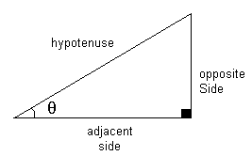







***Undefined* Function Values**

If the terminal side of a quadrantal angle lies along the ***y*-axis**, then the ***tangent***and ***secant*** functions are undefined.

If the terminal side of a quadrantal angle lies along the ***x*-axis**, then the ***cotangent*** and ***cosecant*** functions are undefined.

***Example***

Find the six trigonometry functions of *θ* if *θ* is in the standard position and the point (8, 15)is on the terminal side of *θ*.

*Solution*



|  |  |  |  |
| --- | --- | --- | --- |
|  |  |  |  |
|  |  |  |  |

***Example***

Find the sine and cosine of 45° at the convenient point (1, 1)

*Solution*



 

***Example***

Find the six trigonometry functions of 270°

**270°**

*Solution*

The convenient point (0, -1)







|  |  |  |
| --- | --- | --- |
|  |  |  |
|  |  |  |
|  |  |  |

***Example***

Which will be greater, tan 30° or tan 40°?

(*x, y*2)

***40°***

***30°***

(*x, y*1)

How large could tan*θ* be?

*Solution*







→tan 40°> tan 30°

No limit as to how large tan*θ* can be

|  |  |  |  |  |
| --- | --- | --- | --- | --- |
| **Function** | **I** | **II** | **III** | **IV** |
| *y = sin x* | **+** | **+** | **-** | **-** |
| *y = cosx* | **+** | **-** | **-** | **+** |
| *y = tan x* | **+** | **-** | **+** | **-** |
| *y = cot x* | **+** | **-** | **+** | **-** |
| *y = cscx* | **+** | **+** | **-** | **-** |
| *y = sec x* | **+** | **-** | **-** | **+** |

***Example***

If , and *θ* is QIV, find sin*θ* and tan*θ* .

*Solution*













 Since *θ* is Q IV





***Reciprocal Identities***

|  |  |  |
| --- | --- | --- |
|  |  |  |
|  |  |  |

***Ratio Identities***

|  |  |
| --- | --- |
|  |  |

***Pythagorean Identities***









Solving for 







Solving for *sinθ*

|  |
| --- |
|  |
|  |
|  |
|  |
|  |













***Example***

Prove 

*Solution*





***Example***

Write  in terms of sin*θ*.

*Solution*







***Example***

If  and *θ* terminated in QIV, find the remaining trigonometric ratios for *θ*.

*Solution*



















***Example***

Find sin*θ* and cos*θ*, given that and *θ* is in QIII.

*Solution*

Using the identity 







 













***Example***

Show that the following statement is true by transforming the left side into the right side.



*Solution*





***Example***

Simplify the expression  as much as possible after substituting  for *x*

*Solution*













***Exercise Section* 1.2 – Trigonometric Functions**

1. Find the six trigonometry functions of *θ* if *θ* is in the standard position and the point (−2, 3) is on the terminal side of *θ*.
2. Find the six trigonometry functions of *θ* if *θ* is in the standard position and the point (−3, −4) is on the terminal side of *θ*.
3. Find the six trigonometry functions of *θ* in standard position with terminal side through the point.
4. Find the six trigonometry functions of *θ* if*θ* is in the standard position and the point (12, −5) is on the terminal side of *θ*.
5. Find the values of the six trigonometric functions for an angle of 90°.
6. Indicate the two quadrants *θ* could terminate in if 
7. Indicate the two quadrants *θ* could terminate in if 
8. Find the remaining trigonometric function of *θ* if and *θ* terminates in QI.
9. Find the remaining trigonometric function of *θ* if and *θ* terminates in QII.
10. Find the remaining trigonometric function of *θ* if and *θ* terminates in QIII.
11. Find the remaining trigonometric function of *θ* if and *θ* terminates in QIV.
12. Find the remaining trigonometric functions of *θ* if  and *θ* is terminates in QIV.
13. Find the remaining trigonometric functions of *θ* if  and .
14. If , and *θ* is QIII, find cos*θ* and tan*θ* .
15. If , and *θ* is QIV, find sin*θ* and tan*θ* .
16. Use the reciprocal identities if  find 
17. Find , given that 
18. Find , given that 
19. Use a ratio identity to find  if  and 
20. If  and *θ* terminates in QII, find 
21. If  and *θ* terminated in QII, find  and tan*θ*.
22. Find  if  and *θ* terminates in QI
23. Find the remaining trigonometric ratios of *θ*, if  and 
24. Using the calculator and rounding your answer to the nearest hundredth, find the remaining trigonometric ratios of *θ* ifand 
25. Write  in terms of sin*θ* and cos*θ*, and then simplify if possible.
26. Write  in terms of sin*θ* and cos*θ*, and then simplify if possible.
27. Write  in terms of sin*θ* and/or cos*θ*, and then simplify if possible.
28. Write  in terms of sin*θ* and cos*θ*, and then simplify if possible.
29. Multiply 
30. Multiply 
31. Simplify the expression  as much as possible after substituting  for *x*.
32. Simplify the expression  as much as possible after substituting  for *x*

***Section* 1.3 – Evaluating Trigonometry Functions**



*A*

*B*

*C*

***b***

***a***

***c***

Hypotenuse

Side opposite B

and Adjacent to A

Side opposite A

and Adjacent to B











***Example***

Triangle ABC is a right triangle with C = 90°. If *a* = 6 and *c* = 10, find the six trigonometric functions of A.





















***Cofunction Theorem***

A trigonometric function of an angle is always equal to the cofunction of the complement of the angle.

***Example***

Fill in the blanks

*a*. 

*Solution*



*b*. 

*Solution*



***Example***

Write each function in terms of its cofunction

1. 

*Solution*



1. 

*Solution*



1. 

*Solution*



***The* 30° - 60° - 90° *Triangle***

*30°*

*60°*

*t*

*h*

*30°*

*60°*

*t*

*t*

*30°*

*60°*

*2t*

*2t*

*h*











*30°*

*60°*

*1*

*2*

*1*

*30°*

*60°*

*t*

*2t*

*1*



***The* 45° - 45° - 90°*Triangle***

*t*

*45°*

*45°*

*t*







*t*

*45°*

*45°*

*t*

*1*

*45°*

*45°*

*1*

*t*

**



|  |  |  |  |
| --- | --- | --- | --- |
| ***θ*** | **sin*θ*** | **cos*θ*** | **tan*θ*** |
| 30° |  |  |  |
| 45° |  |  | 1 |
| 60° |  |  |  |

***Example***

Show that the following are true

*a*. 



*b*. 



***Example***

Let *x* = 30° and *y* = 45° in each of the expressions that follow, and then simplify each expression as much as possible

*a*. 



*b*. 



*c*. 



**Reference Angle**

***Definition***

The reference angle or related angle for any angle *θ* in standard position ifs the positive acute angle between the terminal side of *θ* and the *x*-axis, and it is denoted 

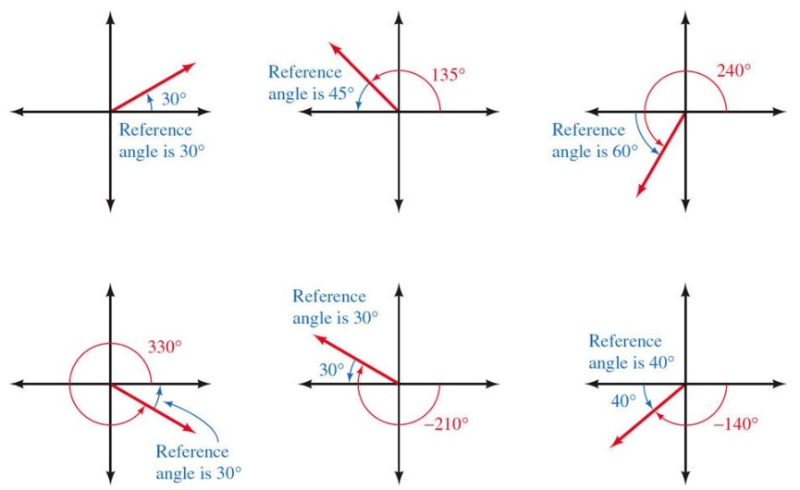









**Reference Angle Theorem**

A trigonometric function of an angle and its reference angle are the same, except difference in sign.

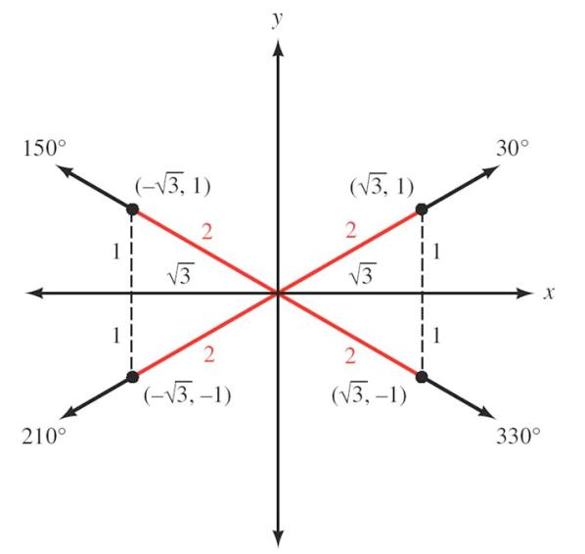





***Example***

Find the exact value of 

*Solution*

 





***Example***

Find the exact value of 

*Solution*

 





The trigonometry function of an angle and any coterminal to it are always equals.





***Example***

Find the exact value of 

*Solution*









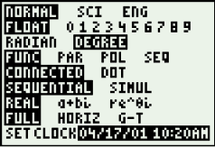

***Approximation***- Simply using calculator









*To find the angle by using the inverse trigonometry functions, always enter a* ***positive*** *value.*

***Example***

Find *θ* if  and *θ* terminates in QIII with.

*Solution*



*θ*∈ QIII



***Example***

Find *θ* to the nearest degree if  and *θ* terminates in QII with.

*Solution*









*θ*∈ QII



|  |  |  |  |  |  |  |
| --- | --- | --- | --- | --- | --- | --- |
| Angle θ  in *degree* | *sin θ* | *cosθ* | *tan θ* | *cot θ* | *sec θ* | *cscθ* |
| 0° | 0 | 1 | 0 | **∞** (*undefined*) | 1 | ∞ |
| 30° |  |  |  |  |  | 2 |
| 45° |  |  | 1 | 1 |  |  |
| 60° |  |  |  |  | 2 |  |
| 90° | 1 | 0 | ±∞ | 0 | ±∞ | 1 |
| 120° |  | − | − | − | −2 |  |
| 135° |  | − | −1 | −1 | − |  |
| 150° |  | − | − | − | − | 2 |
| 180° | 0 | −1 | 0 | ±∞ | −1 | ±∞ |

***Exercise Section* 1.3 – Evaluating Trigonometry Functions**

1. Simplify by using the table.
2. Simplify by using the table
3. Simplify by using the table
4. Find the exact value of 
5. Find *θ* if  and *θ* terminates in QIII with.
6. Find *θ* to the nearest degree if  and *θ* terminates in QIV with.
7. Find the exact value of 
8. Find the exact value of 
9. Find the exact value of 
10. Find the exact value of 
11. Use the calculator to find the value of 
12. Use the calculator to find the value of 
13. Use the calculator to find the value of 
14. Use the calculator to find *θ* to the nearest degree if  with *θ* ∈ QIV with 
15. Use the calculator to find *θ* to the nearest degree if  with *θ* ∈ QIII with 
16. Use the calculator to find *θ* to the nearest degree if  with *θ* ∈ QII with 
17. Find *θ* to the nearest tenth of a degree if  and *θ* terminates in QIV with
18. Use the calculator to find *θ* to the nearest degree if  with *θ* ∈ QII with 

***Section* 1.4 – Solving Right Triangle Trigonometry**

***Example***

In the right triangle *ABC*, *A* = 40° and c = 12 cm. Find *a*, *b*, and *B*.

*A*

*B*

*C*

***b***

***a***

**12**

**40°**

*Solution*















*B* = 90° - *A*

= 90° - 40°



***Example***

In the right triangle *ABC*, *a* = 29.43 and *c* = 53.58. Find the remaining side and angles.

*Solution*

*A*

*B*

*C*

***b***

**29.43**

**53.58**



















***Example***

A circle has its center at *C* and a radius of 18 inches. If triangle *ADC* is a right triangle and *A* = 35°.

Find *x*, the distance from *A* to *B*.

*Solution*

*C*

*A*

*D*

18

***x***

35°

*B*











***Example***

392 *ft*

***h***

29.5°

49.2°

Find *h* as indicated in the figure.

*Solution*

Triangle *DCB*

*A*

*B*

*C*

392 *ft*

***h***

***x***

*D*

29.5°

49.2°





Triangle *ACB*

















**Definitions**

*angle of elevation*

*horizontal*

An angle measured from the horizontal up is called an ***angle of elevation***.

*angle of depression*

*horizontal*

An angle measured from the horizontal down is called an ***angle of depression***.

***Example***

The two equal sides of an isosceles triangle are each 24 cm. If each of the two equal angles measures 52°, find the length of the base and the altitude.

*Solution*



*x*

*24*

*24*

*A*

*B*

*C*

*y*

*52°*













***Example***

A man climbs 213 meters up the side of a pyramid. Find that the angle of depression to his starting point is 52.6°. How high off of the ground is he?

*213*

*A*

*B*

*C*

*52.6°*

*Solution*







***Example***

From a given point on the ground, the angle of elevation to the top of a tree is 36.7°. From a second point, 50 feet back, the angle of elevation to the top of the tree is 22.2°. Find the height of the tree to the nearest foot.

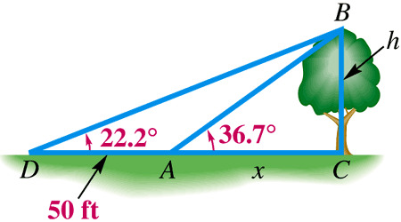

*Solution*

Triangle *DCB*





Triangle *ACB*





















The tree is about 45 feet tall.

***Bearing***

***Definition***

The *bearing of a line l* is the acute angle formed by the *north*-*south* line and the line *l*.

The notation used to designate the bearing of a line begins with N (for north) or S (for south), followed by the number of degrees in the angle, and ends with E (for east) or W (for west).

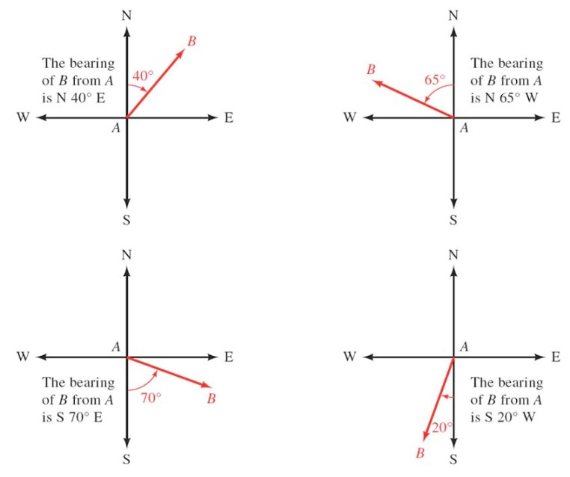

***Example***

A boat travels on a course of bearing N 52° 40′ E for distance of 238 miles. How many miles north and how many miles east have the boat traveled?

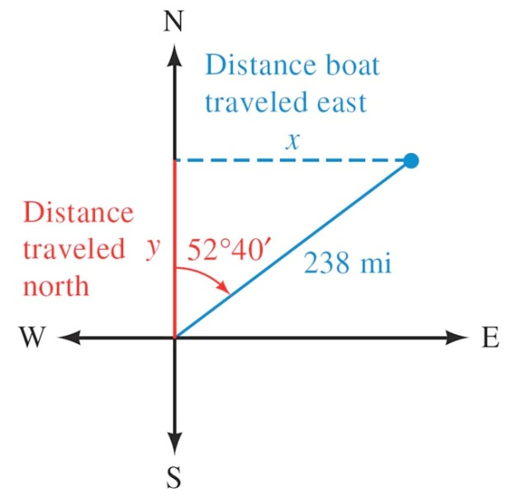*Solution*















***Example***

Radar stations *A* and *B* are on the east-west line, 3.7 km apart. Station *A* detects a place at *C*, on a bearing of 61°. Station *B* simultaneously detects the same plane, on a bearing of 331°. Find the distance from *A* to *C*.

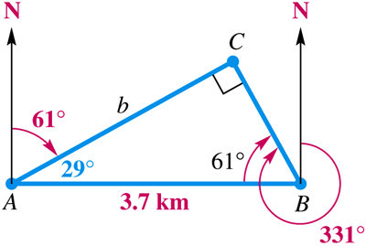*Solution*







***Example***

A diagram that shows how Diane estimates the height of a flagpole. She can't measure the distance between herself and the flagpole directly because there is a fence in the way. So she stands at point *A* facing the pole and finds the angle of elevation from point *A* to the top of the pole to be 61.7°. Then she turns 90° and walks 25.0 ft to point *B*, where she measures the angle between her path and a line from *B* to the base of the pole. She finds that angle is 54.5°. Use this information to find the height of the pole.

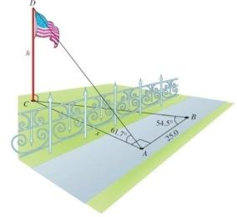*Solution*













***Example***

A helicopter is hovering over the desert when it develops mechanical problems and is forced to land. After landing, the pilot radios his position to a pair of radar station located 25 miles apart along a straight road running north and south. The bearing of the helicopter from one station is N 13° E, and from the other it is S 19° E. After doing a few trigonometric calculations, one of the stations instructs the pilot to walk due west for 3.5 miles to reach the road. Is this information correct?

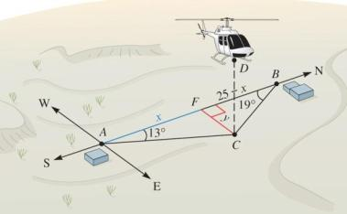*Solution*

In triangle AFC





In triangle BFC

























***Example***

A method that surveyors use to determine a small distance *d* between two points *P* and *Q* is called the ***subtense bar method***. The subtense bar with length *b* is centered at *Q* and situated perpendicular to the line of sight between *P* and *Q*. Angle *θ* is measured, then the distance d can be determined.

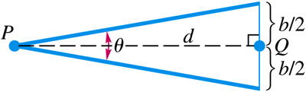

1. Find *d* with  and 
2. Angle *θ* usually cannot be measured more accurately than to the nearest 1″. How much change would there be in the value of *d* if *θ* were measured 1″ larger?

*Solution*

1. 













1. 







The change is: 

***Exercises*** ***Section* 1.4 – Solving Right Triangle Trigonometry**

1. In the right triangle *ABC*, *a* = 2.73 and *b* = 3.41. Find the remaining side and angles.
2. The distance from *A* to *D* is 32 feet. Use the information in figure to solve *x*, the distance between *D* and *C*.

*A*

*B*

*C*

32

h

*x*

*D*

*38°*

*54°*

1. If C = 26° and *r* = 19, find *x*.

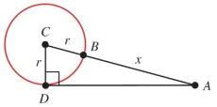

1. If ∠ABD = 53°, C = 48°, and BC = 42, find ***x***and then find ***h***.

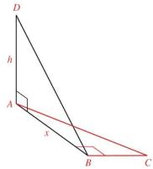

1. If A = 41°, ∠BDC = 58°, and AB = 28, find ***h***, then ***x*.**

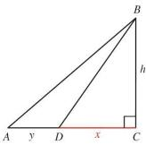

1. A plane flies 1.7 hours at 120 mph on a bearing of 10°. It then turns and flies 9.6 hours at the same speed on a bearing of 100°. How far is the plane from its starting point?

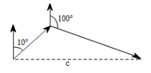

1. The shadow of a vertical tower is 67.0 *ft* long when the angle of elevation of the sun is 36.0°. Find the height of the tower.

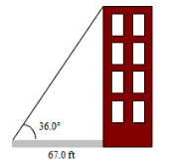

1. The base of a pyramid is square with sides 700 ft long, and the height of the pyramid is 600 ft. Find the angle of elevation of the edge indicated in the figure to two significant digits. (Hint: The base of the triangle in the figure is half the diagonal of the square base of the pyramid.)

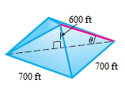

1. Suppose each edge of the cube is 3.00 inches long. Find the measure of the angle formed by diagonals DE and DG. *Round your answer to the nearest tenth of a degree*.

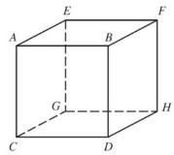

1. If a 73-foot flagpole casts a shadow 51 feet long, what is the angle of elevation of the sun (to the nearest tenth of a degree)?
2. A person standing at point A notices that the angle of elevation to the top of the antenna is 47° 30′. A second person standing 33.0 feet farther from the antenna than the person at A finds the angle of elevation to the top of the antenna to be 42° 10′. How far is the person at A from the base of the antenna?

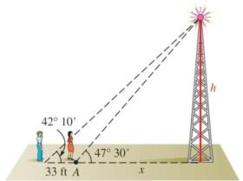

1. Find ***h*** as indicated in the figure.

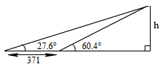

1. Find ***h*** as indicated in the figure.

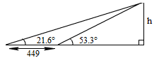

1. The angle of elevation from a point on the ground to the top of a pyramid is 31° 40′. The angle of elevation from a point 143 *ft* farther back to the top of the pyramid is 14° 50′. Find the height of the pyramid.

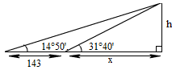

1. 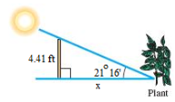In one area, the lowest angle of elevation of the sun in winter is 21° 16′. Find the minimum distance, ***x***, that a plant needing full sun can be placed from a fence 4.41 *ft* high.
2. 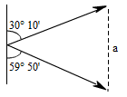A ship leaves its port and sails on a bearing of N 30° 10′ E, at speed 29.4 mph. Another ship leaves the same port at the same time and sails on a bearing of S 59° 50′ E, at speed 17.1 mph. Find the distance between the two ships after 2 hrs.
3. Suppose the figure below is exaggerated diagram of a plane flying above the earth. If the plane is 4.55 miles above the earth and the radius of the earth is 3,960 miles, how far is it from the plane to the horizon? What is the measure of angle A?

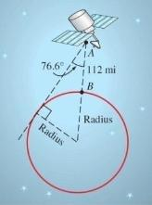

1. The Ferry wheel has a 250 feet diameter and 14 feet above the ground. If *θ* is the central angle formed as a rider moves from position P0 to position P1, find the rider’s height above the ground h when *θ* is 45°.

**h**

*θ*

P0

P1

14 *ft*

*O*

*P*

1. The length of the shadow of a building 34.09 *m* tall is 37.62 *m*. Find the angle of the elevation of the sun.

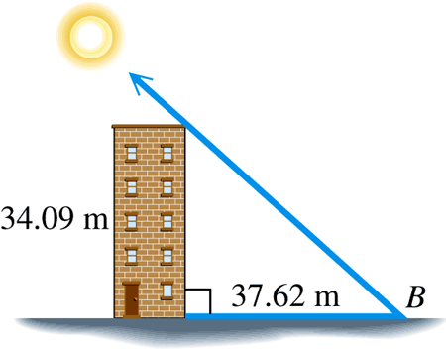

1. San Luis Obispo, California is 12 miles due north of Grover Beach. If Arroyo Grande is 4.6 miles due east of Grover Beach, what is the bearing of San Luis Obispo from Arroyo Grande?
2. The bearing from *A* to *C* is S 52° E. The bearing from *A* to *B* is N 84° E. The bearing from *B* to *C* is S 38° W. A plane flying at 250 mph takes 2.4 hours to go from *A* to *B*. Find the distance from *A* to *C*.
3. A man wondering in the desert walks 2.3 miles in the direction S 31° W. He then turns 90° and walks 3.5 miles in the direction N 59° W. At that time, how far is he from his starting point, and what is his bearing from his starting point?
4. From a window 31.0 *ft.* above the street, the angle of elevation to the top of the building across the street is 49.0° and the angle of depression to the base of this building is 15.0°. Find the height of the building across the street.

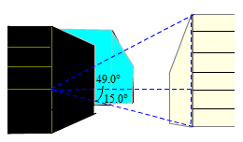

1. A 10.5-*m* fire truck ladder is leaning against a wall. Find the distance ***d*** the ladder goes up the wall (above the fire truck) if the ladder makes an angle of 35° 29′ with the horizontal.

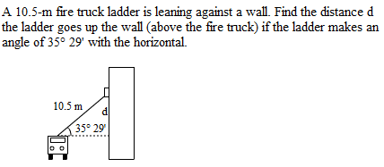

1. The angle of elevation from a point 93.2 ft from the base of a tower to the top of the tower is 38° 20′. Find the height of the tower.

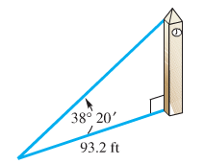

1. 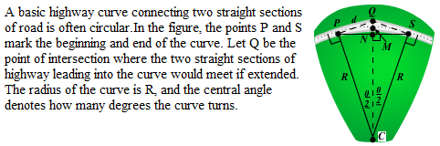A basic curve connecting two straight sections of road is often circular. In the figure, the points ***P*** and ***S*** mark the beginning and end of the curve. Let ***Q*** be the point of intersection where the two straight sections of highway leading into the curve would meet if extended. The radius of the curve is ***R***, and the central angle denotes how many degrees the curve turns.
2. If ***R*** = 965 ft. and **θ** = 37°, find the distance d between P and ***Q***.
3. Find an expression in terms of ***R*** and **θ** for the distance between points ***M*** and ***N***.
4. Jane was hiking directly toward a long straight road when she encountered a swamp. She turned 65° to the right and hiked 4 mi in that direction to reach the road. How far was she form the road when she encountered the swamp?

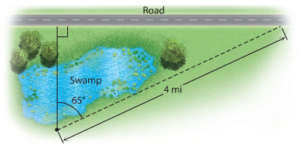

1. From a highway overpass, 14.3 m above the road, the angle of depression of an oncoming car is measured at 18.3°. How far is the car from a point on the highway directly below the observer?
2. A tunnel under a river is 196.8 ft. below the surface at its lowest point. If the angle of depression of the tunnel is 4.962° , then how far apart on the surface are the entrances to the tunnel? How long is the tunnel?

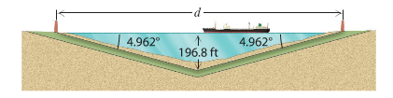

1. A boat sailing north sights a lighthouse to the east at an angle of 32° from the north. After the boat travels one more kilometer, the angle of the lighthouse from the north is 36°. If the boat continues to sail north, then how close will the boat come to the lighthouse?

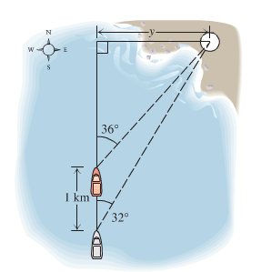

1. The angle of elevation of a pedestrian crosswalk over a busy highway is 8.34°, as shown in the drawing. If the distance between the ends of the crosswalk measured on the ground is 342 ft., then what is the height h of the crosswalk at the center?

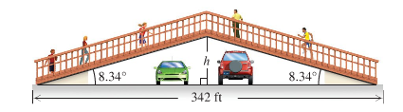

1. A policewoman has positioned herself 500 ft. from the intersection of two roads. She has carefully measured the angles of the lines of sight to points A and B. If a car passes from A to B is 1.75 sec and the speed limit is 55 mph, is the car speeding? (Hint: Find the distance from B to A and use R = D/T)

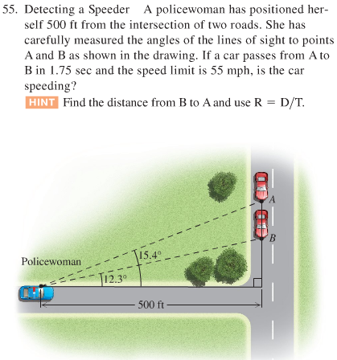

1. From point A the angle of elevation to the top of the building is 30°. From point B, 20 meters closer to the building, the angle of elevation is 45°. Find the angle of elevation of the building from point C, which is another 20 meters closer to the building.

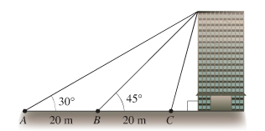

1. A hot air balloon is rising upward from the earth at a constant rate. An observer 250 m away spots the balloon at an angle of elevation of 24°. Two minutes later the angle of elevation of the balloon is 58°. At what rate is the balloon ascending?

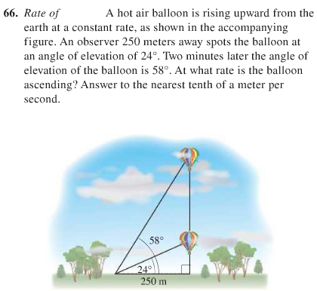

1. A skateboarder wishes to build a jump ramp that is inclined at a 19° angle and that has a maximum height of 32.0 inches. Find the horizontal width *x* of the ramp.

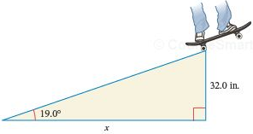

1. For best illumination of a piece of art, a lighting specialist for an art gallery recommends that a ceiling-mounted light be 6 ft from the piece of art and that the angle of depression of the light be 38°. How far from a wall should the light be placed so that the recommendations of the specialist are met? Notice that the art extends outward 4 inches from the wall.

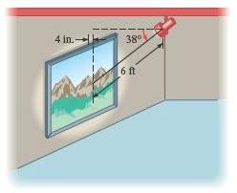

1. A surveyor determines that the angle of elevation from a transit to the top of a building is 27.8°. The transit is positioned 5.5 feet above ground level and 131 feet from the building. Find the height of the building to the nearest tenth of a foot.

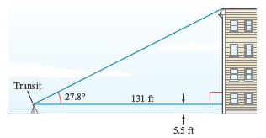

1. From a point A on a line from the base of the Washington Monument, the angle of elevation to the top of the monument is 42.0°. From a point 100 ft away from A and on the same line, the angle to the top is 37.8°. Find the height, to the nearest foot, of the Monument.

