***Lecture Three* - Identities**

***Section* 3.1 – Proving Identities**

**Reciprocal Identities**

|  |  |  |
| --- | --- | --- |
|  |  |  |
|  |  |  |

***Ratio Identities***

|  |  |
| --- | --- |
|  |  |

***Pythagorean Identities***











***Example***

Write  in terms of sin*θ* and cos*θ*, and then simplify.

*Solution*





***Example***

Add 

*Solution*

 

***Example***

Write:  in terms of 

*Solution*









***Example***

Prove: 

*Solution*

















***Example***

Prove: 

*Solution*







**Guidelines for Proving Identities**

1. Work on the complicated side first (more trigonometry functions)
2. Look for trigonometry substitutions.
3. Look for algebraic operations
4. If not always change everything to sines and cosines
5. Keep an eye on the side you are not working.

***Example***

Prove 

*Solution*

 

 







***Example***

Prove: 

*Solution*

 

 



***Example***

Prove: 

*Solution*





 



 



***Example***

Prove : 

*Solution*















***Example***

Prove 

*Solution*









***Example***

Show that  is not an identity by finding a counterexample

*Solution*









***Exercises Section* 3.1 – Proving Identities**

1. Prove the identity: 
2. Prove the identity: 
3. Prove the identity: 
4. Prove the identity: 
5. Prove the identity: 
6. Prove the identity: 
7. Prove the identity: 
8. Prove the identity: 
9. Prove the identity: 
10. Prove the identity: 
11. Prove the identity: 
12. Prove the identity: 
13. Prove the identity: 
14. Prove the identity: 
15. Prove the identity: 
16. Prove the identity: 
17. Prove the identity: 
18. Prove the identity: 
19. Prove the identity: 
20. Prove the identity: 
21. Prove the following equation is an identity: 
22. Prove the following equation is an identity: 
23. Prove the following equation is an identity: 
24. Prove the following equation is an identity: 
25. Prove the following equation is an identity: 
26. Prove the following equation is an identity: 
27. Prove the following equation is an identity: 
28. Prove the following equation is an identity: 
29. Prove the following equation is an identity: 
30. Prove the following equation is an identity: 
31. Prove the following equation is an identity: 
32. Prove the following equation is an identity: 
33. Prove the following equation is an identity: 
34. Prove the following equation is an identity: 
35. Prove the following equation is an identity: 
36. Prove the following equation is an identity: 
37. Prove the following equation is an identity: 
38. Prove the following equation is an identity: 
39. Prove the following equation is an identity: 
40. Prove the following equation is an identity: 
41. Prove the following equation is an identity: 
42. Prove the following equation is an identity: 
43. Prove the following equation is an identity: 
44. Prove the following equation is an identity: 
45. Prove the following equation is an identity: 
46. Prove the following equation is an identity: 
47. Prove the following equation is an identity: 
48. Prove the following equation is an identity: 
49. Prove the following equation is an identity: 
50. Prove the following equation is an identity: 
51. Prove the following equation is an identity: 
52. Prove the following equation is an identity: 
53. Prove the following equation is an identity: 
54. Prove the following equation is an identity: 
55. Prove the following equation is an identity: 
56. Prove the following equation is an identity: 
57. Prove the following equation is an identity: 
58. Prove the following equation is an identity: 
59. Prove the following equation is an identity: 
60. Prove the following equation is an identity: 
61. Prove the following equation is an identity: 
62. Prove the following equation is an identity: 
63. Prove the following equation is an identity: 
64. Prove the following equation is an identity: 
65. Prove the following equation is an identity: 
66. Prove the following equation is an identity: 
67. Prove the following equation is an identity: 
68. Prove the following equation is an identity: 
69. Prove the following equation is an identity: 
70. Prove the following equation is an identity: 
71. Prove the following equation is an identity: 
72. Prove the following equation is an identity: 
73. Prove the following equation is an identity: 
74. Prove the following equation is an identity: 
75. Prove the following equation is an identity: 
76. Prove the identity: 
77. Prove the identity: 
78. Prove the identity: 
79. Prove the identity: 
80. Prove the identity: 
81. Prove the identity: 

***Section* 3.2 – Sum and Difference Formulas**

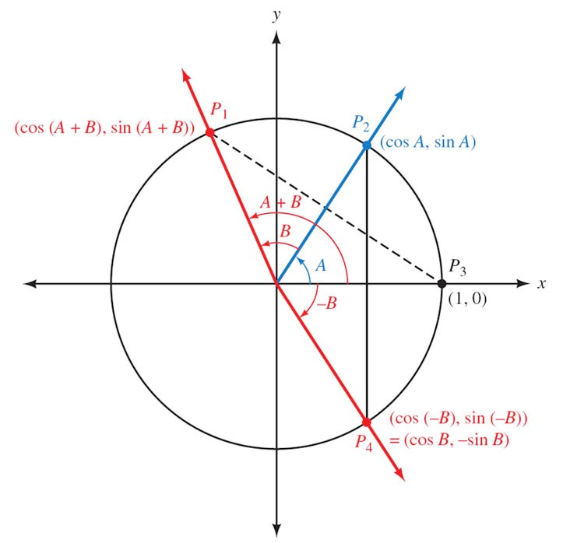



 *Distance between points*

















***Example***

Find the exact value for 

*Solution*









***Example***

Show that 

*Solution*







***Example***

Simplify: 

*Solution*





***Example***

Show that 

*Solution*









***Example***

Find the exact value of 

*Solution*









***Example***

Find the exact value of 

*Solution*











***Example***

If  with *A* in QI, and  with *B* in QIII, find , , and 

*Solution*

 

 

 

 







|  |  |
| --- | --- |
|  |  |
|  |  |











 



***Example***

If with *A* in QI, and  with *B* in QIII, find 

*Solution*

 

 

 











***Example***

Common household current is called ***alternating current*** because the current alternates direction within the wires. The voltage *V* in a typical 115-volt outlet can be expressed by the function 

where *ω* is the angular speed (in radians per second) of the rotating generator at the electrical plant, and *t* is time measured in seconds.

1. It is essential for electric generators to rotate at precisely 60 cycles per second so household appliances and computers will function properly. Determine *ω* for these electric generators.
2. Determine a value of *φ* so that the graph of  is the same as the graph of 

*Solution*

1. Each cycle is 2π radians at 60 cycles per second, so the angular speed is *ω* = 60(2*π*) = 120*π* radians per second.
2. 





If 

***Exercises Section* 3.2 – Sum and Difference Formulas**

1. Prove the identity 
2. Prove the identity 
3. Prove the identity 
4. Prove the identity 
5. Prove the identity 
6. Write the expression as a single trigonometric function 
7. Show that 
8. If with *A* in QII, and  with *B* in QIII, find , , and 
9. If with *A* in QI, and  with *B* in QI, find , , and 
10. If with *A* in QI, and  with *B* in QI, find 
11. Prove the following equation is an identity: 
12. Prove the following equation is an identity: 
13. Prove the following equation is an identity: 
14. Prove the following equation is an identity: 
15. Prove the following equation is an identity: 
16. Prove the following equation is an identity: 
17. Prove the following equation is an identity: 
18. Prove the following equation is an identity: 
19. Prove the following equation is an identity: 
20. Prove the following equation is an identity: 
21. Prove the following equation is an identity: 
22. Prove the following equation is an identity: 
23. Prove the following equation is an identity: 
24. Prove the following equation is an identity: 

***Section* 3.3 – Double-angle Formulas**





 

***Example***

If  with *A* in QII, find 

*Solution*



















***Example***

Prove 

*Solution*





































***Example***

If , find 

*Solution*











***Example***

Prove 

*Solution*













***Example***

Prove 

*Solution*





















***Example***

Simplify 

*Solution*







***Example***

Prove 

*Solution*









***Example***

Given  and , find 

*Solution*

|  |  |
| --- | --- |
|  |  |
|  |

***Example***

If , write the expression  in terms of just *x*.

*Solution*

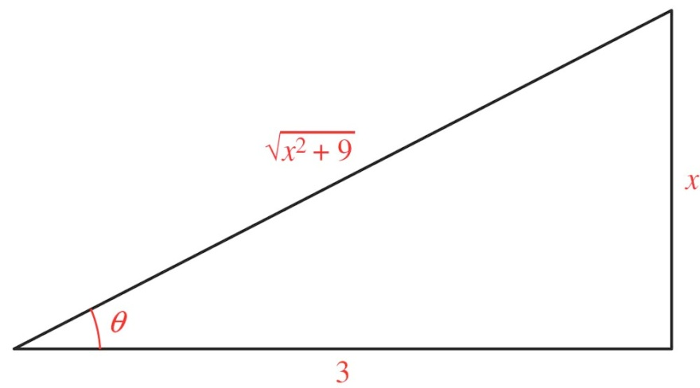















***Exercises Section* 3.3 – Double-angle Formulas**

1. Let  with A in QIII and find 
2. Let  with *x* in QIV and find 
3. Verify: 
4. Verify: 
5. Prove: 
6. Simplify 
7. Write  in terms of 
8. Find the values of the six trigonometric functions of *θ* if 
9. Use a right triangle in QII to find the value of 

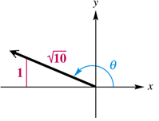

1. Prove the following equation is an identity: 
2. Prove the following equation is an identity: 
3. Prove the following equation is an identity: 
4. Prove the following equation is an identity: 
5. Prove the following equation is an identity: 
6. Prove the following equation is an identity: 
7. Prove the following equation is an identity: 
8. Prove the following equation is an identity: 
9. Prove the following equation is an identity: 
10. Prove the following equation is an identity: 
11. Prove the following equation is an identity: 
12. Prove the following equation is an identity: 
13. Prove the following equation is an identity: 
14. Prove the following equation is an identity: 
15. Prove the following equation is an identity: 
16. Prove the following equation is an identity: 
17. Prove the following equation is an identity: 
18. Prove the following equation is an identity: 

***Section* 3.4 – Half-Angle Formulas**









 *Divide both sides by 2*

 *Replace x with *









 *Divide both sides by 2*

 *Replace x with *



***Example***

Find the exact value of 

*Solution*









***Example***

If  with  find 

*Solution*

Since 



 

|  |  |
| --- | --- |
|  |  |







***Example***

If  with  find the six trigonometric function of *A*/2

*Solution*

Since 



 







































 

***Example***

Find the exact of 

*Solution*











***Example***

Prove 

*Solution*











***Exercises Section* 3.4 – Half-Angle Formulas**

1. Use half-angle formulas to find the exact value of 
2. Find the exact of 
3. Given: , find 
4. Prove the identity 
5. Prove the identity 
6. Prove the following equation is an identity: 
7. Prove the following equation is an identity: 
8. Prove the following equation is an identity: 
9. Prove the following equation is an identity: 
10. Prove the following equation is an identity: 
11. Prove the following equation is an identity: 
12. Prove the following equation is an identity: 

***Section* 3.5 – Additional Identities**

**Identities and Formulas Involving Inverse Functions**

***Example***

Evaluate  without using a calculator.

*Solution*





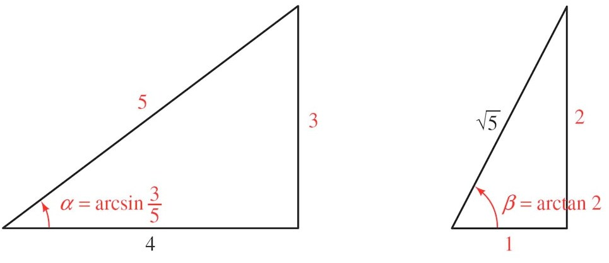

   

 







***Example***

Write as an equivalent expression involving only *x*. (Assume *x* is positive)

*Solution*

Let 



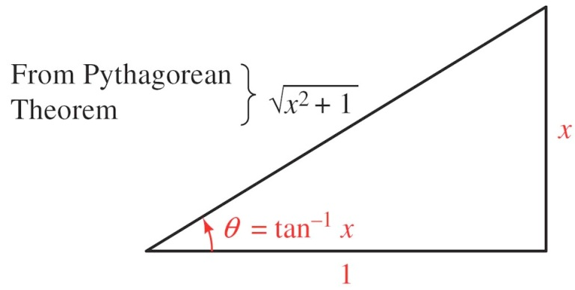

 









***Product to Sum Formulas***





***Example***

Verify product formula  for and 

*Solution*









***Example***

Write  as a sum or difference

*Solution*





***Sum to Product Formulas***

 



 

Let 



 

 



***Example***

Verify sum formula  for and 

*Solution*











***Example***

Verify the identity 

*Solution*









***Example***

Write  as product of two functions.

*Solution*









***Exercises Section* 3.5 – Additional Identities**

1. Evaluate without using the calculator 
2. Evaluate without using the calculator 
3. Evaluate without using the calculator 
4. Evaluate without using the calculator 
5. Evaluate without using the calculator 
6. Write as an equivalent expression involving only *x*.
7. Write as an equivalent expression involving only *x*.
8. Write as an equivalent expression involving only *x*.
9. Write  as a sum or difference
10. Prove the identity: 
11. Prove the following equation is an identity: 
12. Prove the following equation is an identity: 
13. Prove the following equation is an identity: 
14. Prove the following equation is an identity: 
15. Prove the following equation is an identity: 
16. Prove the following equation is an identity: 
17. Prove the following equation is an identity: 
18. Prove the following equation is an identity: 
19. Prove the following equation is an identity: 
20. Prove the following equation is an identity: 
21. Prove the following equation is an identity: 
22. Prove the following equation is an identity: 
23. Prove the following equation is an identity: 
24. Prove the following equation is an identity: 
25. Prove the following equation is an identity: 
26. Prove the following equation is an identity: 
27. Prove the following equation is an identity: 
28. Prove the following equation is an identity: 
29. Prove the following equation is an identity: 

***Section* 3.6 – Solving Trigonometry Equations**

**Addition Property of Equality**

For any three algebraic expressions *A*, *B*, and *C*

If 

Then 

**Multiplication Property of Equality**

For any three algebraic expressions *A*, *B*, and *C,* with *C* ≠ 0

If 

Then 

***Example***

Solve 

*Solution*





Solutions between (0° and 360°) 

Solutions between (0 and 2π) 

All solutions: 



***Example***

Solve , 

*Solution*





* can’t be greater than 1*

*No solution*

***Example***

Solve 

*Solution*



*is negative → cosine is in QII or QIII*.



 

 

 

 

***Example***

Solve  

*Solution*









*Negative sign → sine is in QIII or QIV*

 

 

***Example***

Solve  

*Solution*











 



 *(QI or QII)*

 

***Example***

Solve: , 

*Solution*









 

 

 

***The solutions are:*** 

***Example***

Solve: , 

*Solution*









 

 

 

***The solutions are:*** 

***Example***

Solve: , 

*Solution*















***The solutions are:*** 

***Example***

Solve: , 

*Solution*





 

 



 

***Example***

Solve: , 

*Solution*















 

 

 

*Check*

|  |  |  |
| --- | --- | --- |
|  | **(*False statement*)** |  |

***The solutions are:*** 

***Exercises Section* 3.6 – Solving Trigonometry Equations**

1. Solve  
2. Solve  
3. Solve  
4. Solve  
5. Solve: 
6. Solve: 
7. Solve:  
8. Solve:  
9. Solve  
10. Solve  
11. Solve  
12. Solve  
13. Solve 
14. If a projectile (such as a bullet) is fired into the air with an initial velocity ***v*** at an angle of elevation θ, then the height *h* of the projectile at time *t* is given by:



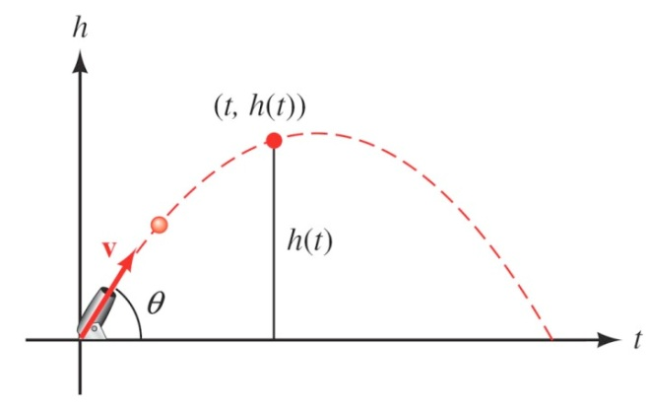

1. Give the equation for the height, if ***v*** is 600 *ft./sec* and θ = 45°.
2. Use the equation in part (*a*) to find the height of the object after  seconds.
3. Find the angle of elevation of θ of a rifle barrel, if a bullet fired at 1,500 ft./sec takes 3 seconds to reach a height of 750 feet. Give your answer in the nearest of a degree.