***Lecture Four* – Applications of Trigonometry**

***Section* 4.1 – Law of Sines**

**Oblique Triangle**

A triangle that is not a right triangle, either acute or obtuse.

The measures of the three sides and the three angles of a triangle can be found if at least one side and any other two measures are known.

**The Law of Sines**

There are many relationships that exist between the sides and angles in a triangle.

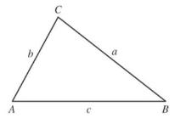One such relation is called the law of sines.

Given triangle ABC



*or, equivalently*



***Proof***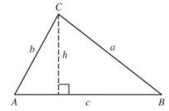

 

 

From (1) & (2)









**Angle – Side - Angle (*ASA* or *AAS*)**

If two angles and the included side of one triangle are equal, respectively, to two angles and the included side of a second triangle, then the triangles are congruent.

***Example***

In triangle *ABC*,,, and . Find the length of side c.

*Solution*

















***Example***

Find the missing parts of triangle *ABC* if ,, , and .

*Solution*







|  |  |
| --- | --- |
|  |  |

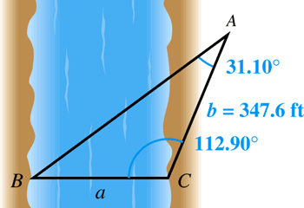***Example***

You wish to measure the distance across a River. You determine that *C* = 112.90°, *A* = 31.10°, and . Find the distance *a* across the river.

*Solution*















***Example***

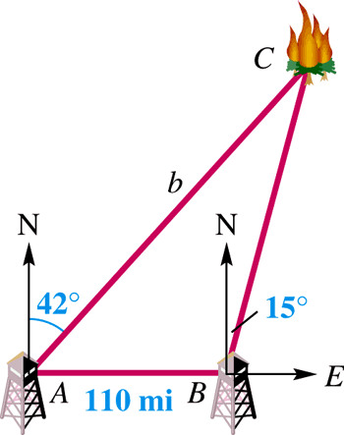Two ranger stations are on an east-west line 110 mi apart. A forest fire is located on a bearing N 42° E from the western station at *A* and a bearing of N 15° E from the eastern station at *B*. How far is the fire from the western station?

*Solution*















The fire is about 234 miles from the western station.

***Example***

Find distance *x* if *a* = 562 *ft.*, and 

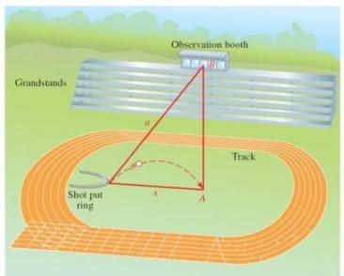

***a***

***B***

***A***

***x***

*Solution*









***Ambiguous Case***

**Side – Angle – Side (*SAS*)**

If two sides and the included angle of one triangle are equal, respectively, to two sides and the included angle of a second triangle, then the triangles are congruent.

***Example***

Find angle *B* in triangle ABC if *a* = 2, *b* = 6, and 

*Solution*







 

Since  is impossible, no such triangle exists.

***Example***

Find the missing parts in triangle ABC if *C* = 35.4°, *a* = 205 ft., and *c* = 314 ft.

*Solution*









 













***Example***

Find the missing parts in triangle ABC if *a* = 54 cm, *b* = 62 cm, and *A* = 40°.

*Solution*









 

 

 

 

 

 

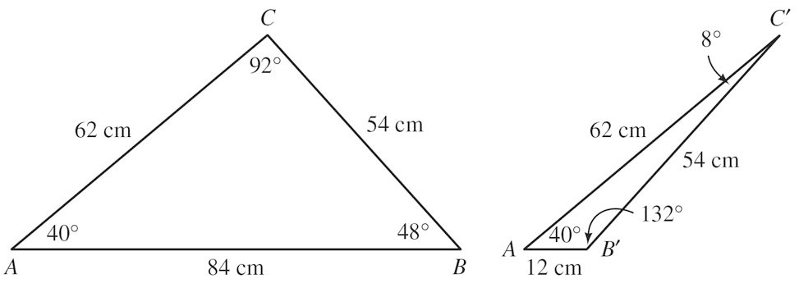

***Area of a Triangle* (*SAS*)**

In any triangle *ABC*, the area *A* is given by the following formulas:

  

***Example***

Find the area of triangle *ABC* if 

*Solution*



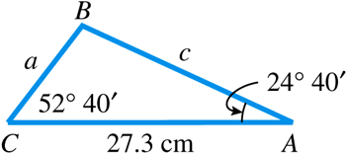 

















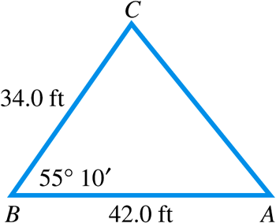***Example***

Find the area of triangle *ABC*.

*Solution*







***Number of Triangles Satisfying the Ambiguous Case* (SSA)**

Let sides *a* and *b* and angle *A* be given in triangle *ABC*. (The law of sines can be used to calculate the value of sin *B*.)

1. If applying the law of sines results in an equation having sin *B* > 1, then *no triangle* satisfies the given conditions.
2. If sin *B* = 1, then *one triangle* satisfies the given conditions and *B* = 90°.
3. If 0 < sin *B* < 1, then either *one or two triangles* satisfy the given conditions.
4. If sin *B* = *k*, then let and use for *B* in the first triangle.
5. Let . If , then a second triangle exists. In this case, use for *B* in the second triangle.

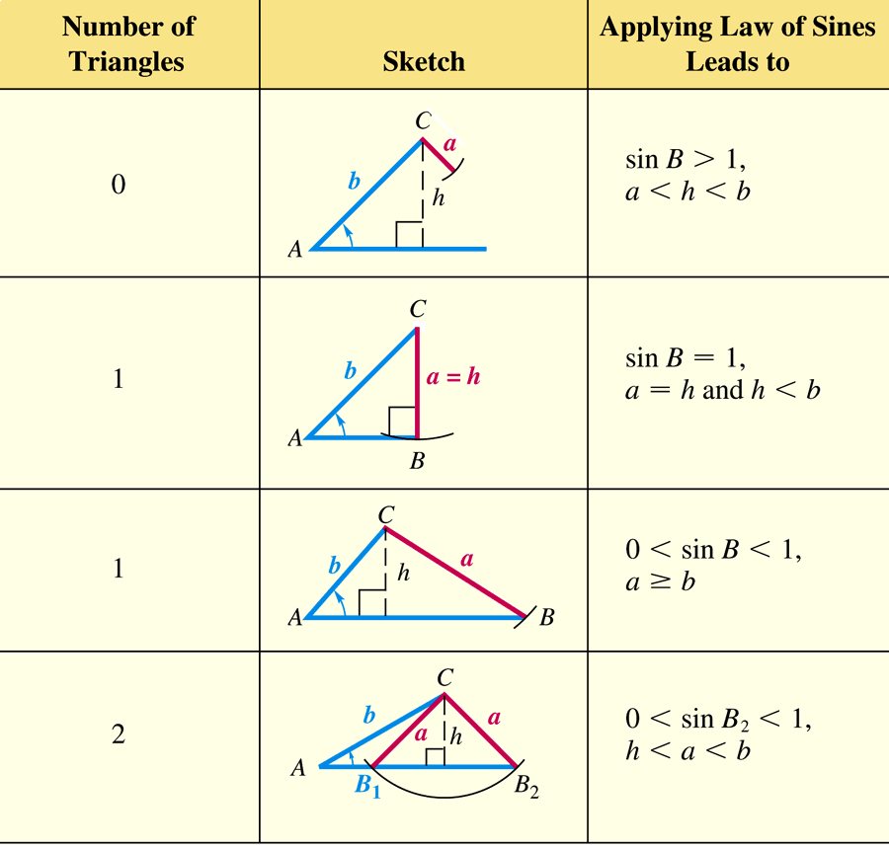

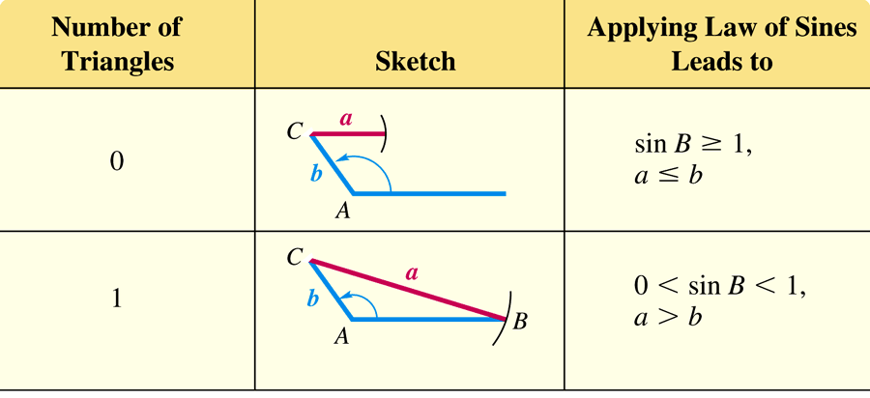

***Exercises*** ***Section* 4.1 – Law of Sines**

1. In triangle *ABC*,, and . Find the length of side *c*.
2. In triangle *ABC*,,  and . Find all the missing parts.
3. Find the missing parts of triangle *ABC,* if , , and .
4. Solve triangle *ABC* if *B* = 55°40′, *b* = 8.94 m, and *a* = 25.1 m.
5. Solve triangle *ABC* if *A* = 55.3°, *a* = 22.8 *ft.*, and *b* = 24.9 ft.
6. Solve triangle *ABC* given *A* = 43.5°, *a* = 10.7 in., and *c* = 7.2 in.

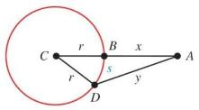

1. If  find *x*
2. A man flying in a hot-air balloon in a straight line at a constant rate of 5 feet per second, while keeping it at a constant altitude. As he approaches the parking lot of a market, he notices that the angle of depression from his balloon to a friend’s car in the parking lot is 35°. A minute and a half later, after flying directly over this friend’s car, he looks back to see his friend getting into the car and observes the angle of depression to be 36°. At that time, what is the distance between him and his friend?
3. A satellite is circling above the earth. When the satellite is directly above point *B*, angle *A* is 75.4°. If the distance between points *B* and *D* on the circumference of the earth is 910 miles and the radius of the earth is 3,960 miles, how far above the earth is the satellite?

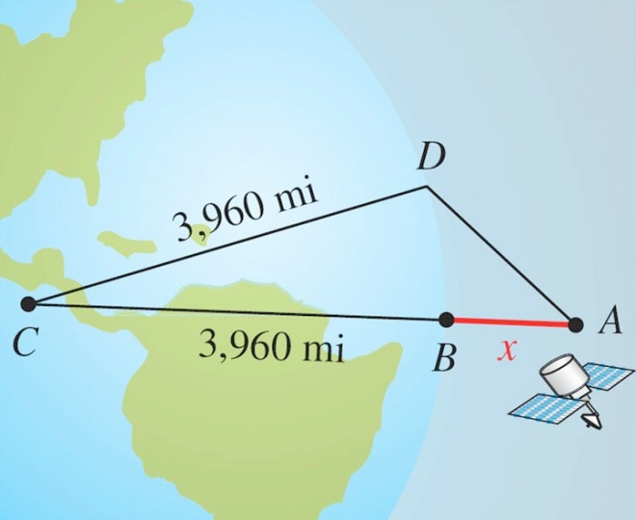

1. A pilot left Fairbanks in a light plane and flew 100 miles toward Fort in still air on a course with bearing of 18°. She then flew due east (bearing 90°) for some time drop supplies to a snowbound family. After the drop, her course to return to Fairbanks had bearing of 225°. What was her maximum distance from Fairbanks?
2. The dimensions of a land are given in the figure. Find the area of the property in square feet.

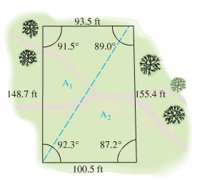

1. The angle of elevation of the top of a water tower from point A on the ground is 19.9°. From point B, 50.0 feet closer to the tower, the angle of elevation is 21.8°. What is the height of the tower?

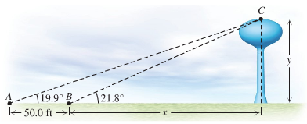

1. A 40-ft wide house has a roof with a 6-12 pitch (the roof rises 6 ft for a run of 12 ft). The owner plans a 14-ft wide addition that will have a 3-12 pitch to its roof. Find the lengths of  and 

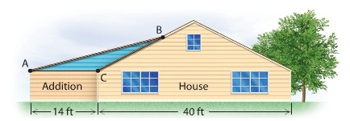

1. A hill has an angle of inclination of 36°. A study completed by a state’s highway commission showed that the placement of a highway requires that 400 ft of the hill, measured horizontally, be removed. The engineers plan to leave a slope alongside the highway with an angle of inclination of 62°. Located 750 ft up the hill measured from the base is a tree containing the nest of an endangered hawk. Will this tree be removed in the excavation?

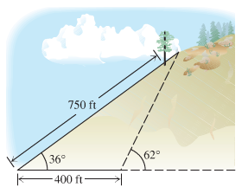

1. A cruise missile is traveling straight across the desert at 548 mph at an altitude of 1 mile. A gunner spots the missile coming in his direction and fires a projectile at the missile when the angle of elevation of the missile is 35°. If the speed of the projectile is 688 mph, then for what angle of elevation of the gun will the projectile hit the missile?

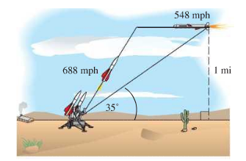

1. When the ball is snapped, Smith starts running at a 50° angle to the line of scrimmage. At the moment when Smith is at a 60° angle from Jones, Smith is running at 17 ft/sec and Jones passes the ball at 60 ft/sec to Smith. However, to complete the pass, Jones must lead Smith by the angle *θ*. Find *θ* (find *θ*  in his head. Note that *θ* can be found without knowing any distances.)

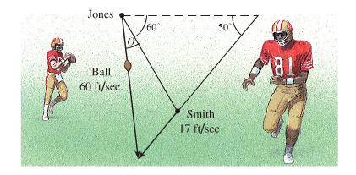

1. A rabbit starts running from point *A* in a straight line in the direction 30° from the north at 3.5 *ft/sec*. At the same time a fox starts running in a straight line from a position 30 *ft* to the west of the rabbit 6.5 *ft/sec*. The fox chooses his path so that he will catch the rabbit at point C. In how many seconds will the fox catch the rabbit?

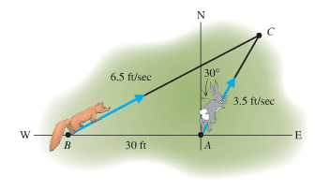

1. A hot-air balloon is flying over a dry lake when the wind stops blowing. The balloon comes to a stop 450 feet above the ground at point *D*. A jeep following the balloon runs out of gas at point *A*. The nearest service station is due north of the jeep at point *B*. The bearing of the balloon from the jeep at *A* is N 13° E, while the bearing of the balloon from the service station at *B* is S 19° E. If the angle of elevation of the balloon from *A* is 12°, how far will the people in the jeep have to walk to reach the service station at point *B*?

***Section* 4.2 - Law of Cosines**

**Law of Cosines** (*SAS*)







***Derivation***

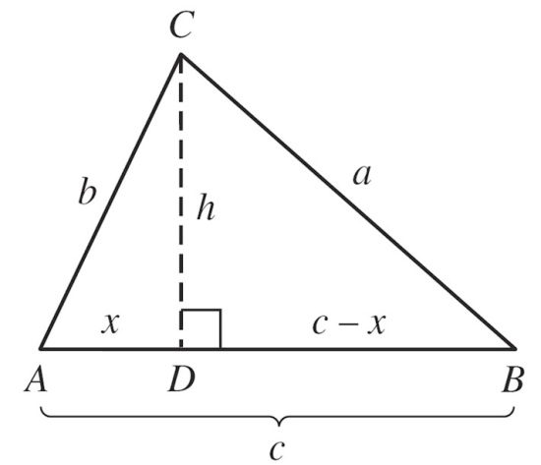



 **(1)**

 **(2)**

From **(2):**

**(1)** 

 **(3)**





**(3)** ⇒ 

***Example***

Find the missing parts in triangle *ABC* if *A* = 60°, *b* = 20 in, and *c* = 30 in.

*Solution*

























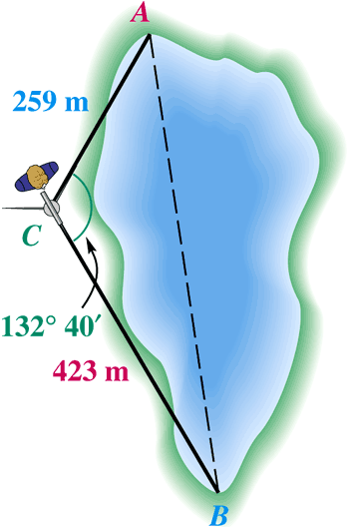***Example***

A surveyor wishes to find the distance between two inaccessible points *A* and *B* on opposite sides of a lake. While standing at point *C*, she finds that *AC* = 259 m, *BC* = 423 m, and angle *ACB* = 132°40′. Find the distance *AB*.

*Solution*









**Law of Cosines** (***SSS***) - Three Sides







***Example***

Solve triangle *ABC* if *a* = 34 km, *b* = 20 km, and c = 18 km

*Solution*





































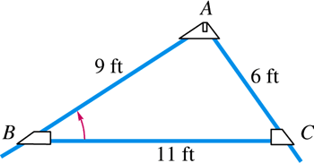***Example***

Find the measure of angle *B* in the figure of a roof truss.

*Solution*



 

***Heron’s Area Formula* (*SSS*)**

If a triangle has sides of lengths *a, b*, and *c*, with semi-perimeter



Then the area of the triangle is:



***Example***

The distance “as the crow flies” from Los Angeles to New York is 2451 miles, from New York to Montreal is 331 miles, and from Montreal to Los Angeles is 2427 miles. What is the area of the triangular region having these three cities as vertices? (Ignore the curvature of Earth.)

*Solution*

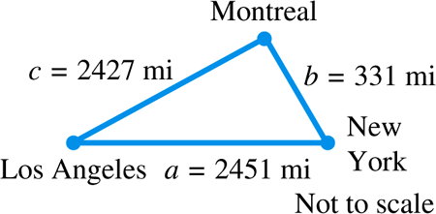The semi-perimeter *s* is:













***Exercises Section* 4.2 - Law of Cosines**

1. If *a* = 13 yd., *b* = 14 yd., and *c* = 15 yd., find the largest angle.
2. Solve triangle *ABC* if *b* = 63.4 km, and *c* = 75.2 km, *A* = 124° 40′
3. Solve triangle *ABC* if 
4. Solve triangle *ABC* if *a* = 832 ft., *b* = 623 ft., and c = 345 ft.
5. Solve triangle *ABC* if 
6. The diagonals of a parallelogram are 24.2 cm and 35.4 cm and intersect at an angle of 65.5°. Find the length of the shorter side of the parallelogram
7. An engineer wants to position three pipes at the vertices of a triangle. If the pipes *A, B*, and *C* have radii 2 in, 3 in, and 4 in, respectively, then what are the measures of the angles of the triangle *ABC*?

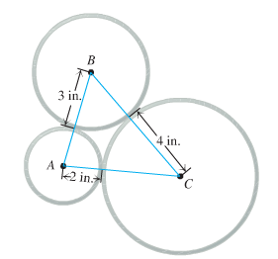

1. A solar panel with a width of 1.2 m is positioned on a flat roof. What is the angle of elevation α of the solar panel?

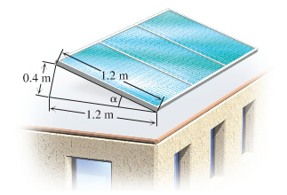

1. Andrea and Steve left the airport at the same time. Andrea flew at 180 mph on a course with bearing 80°, and Steve flew at 240 mph on a course with bearing 210°. How far apart were they after 3 hr.?
2. A submarine sights a moving target at a distance of 820 m. A torpedo is fired 9° ahead of the target, and travels 924 m in a straight line to hit the target. How far has the target moved from the time the torpedo is fired to the time of the hit?

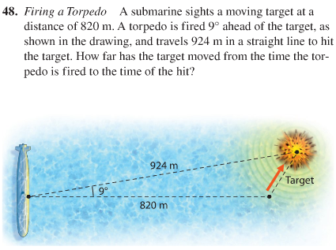

1. A tunnel is planned through a mountain to connect points *A* and *B* on two existing roads. If the angle between the roads at point *C* is 28°, what is the distance from point *A* to *B*? Find ∠*CBA* and ∠*CAB* to the nearest tenth of a degree.

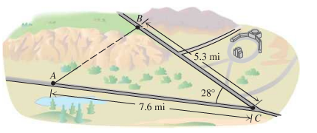

1. A 6-ft antenna is installed at the top of a roof. A guy wire is to be attached to the top of the antenna and to a point 10 ft down the roof. If the angle of elevation of the roof is 28°, then what length guy wire is needed?

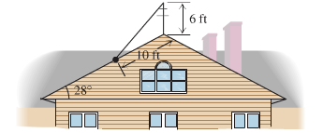

1. On June 30, 1861, Comet Tebutt, one of the greatest comets, was visible even before sunset. One of the factors that causes a comet to be extra bright is a small scattering angle θ. When Comet Tebutt was at its brightest, it was 0.133 a.u. from the earth, 0.894 a.u. from the sun, and the earth was 1.017 a.u. from the sun. Find the phase angle α and the scattering angle θ for Comet Tebutt on June 30, 1861. (One astronomical unit (a.u) is the average distance between the earth and the sub.)

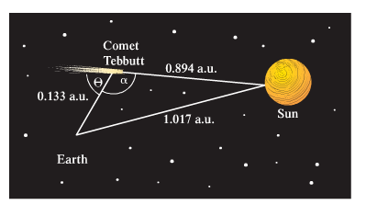

1. A human arm consists of an upper arm of 30 cm and a lower arm of 30 cm. To move the hand to the point (36, 8), the human brain chooses angle  to the nearest tenth of a degree.

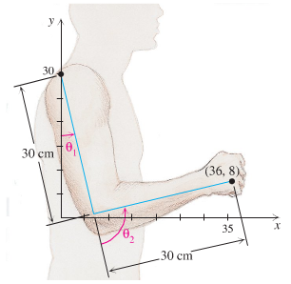

1. A forest ranger is 150 ft above the ground in a fire tower when she spots an angry grizzly bear east of the tower with an angle of depression of 10°. Southeast of the tower she spots a hiker with an angle of depression of 15°. Find the distance between the hiker and the angry bear.

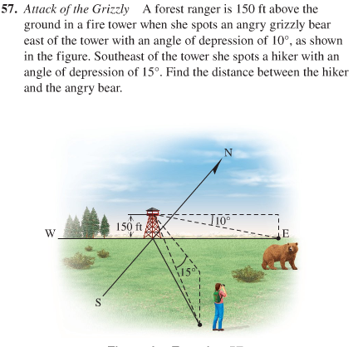

***Section* 4.3 – Vectors and Dot Product**

|  |  |
| --- | --- |
| ***Notation*** | ***The quantity is*** |
| **V** | *a vector* |
|  | *a vector* |
|  | *a vector* |
|  | *a vector* |
| *x* | *Scalar* |
| |V| | *Magnitude of vector V, a scalar* |

***Equality* for Vectors**

The vectors are equivalent if they have the same magnitude and the same direction. 

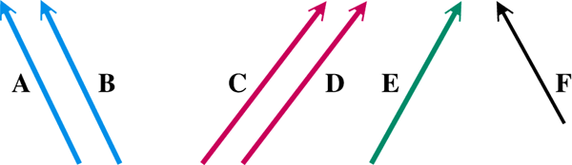

***A = B C = D A ≠ E A ≠ E***

**Standard Position**

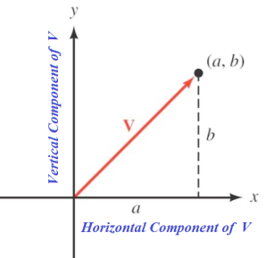

A vector with its initial point at the origin is called a ***position vector***.

***Magnitude* of a Vector**

The length or ***magnitude of a vector*** can be written:

 

**Direction *Angle* of a Vector**

The direction angle *θ* satisfies , where *a* ≠ 0.

***Zero* Vector**

A vector has a magnitude of zero  and has no defined direction.

***Example***

Draw the vector *V* = (3, -4) in standard position and find its magnitude.

*Solution*

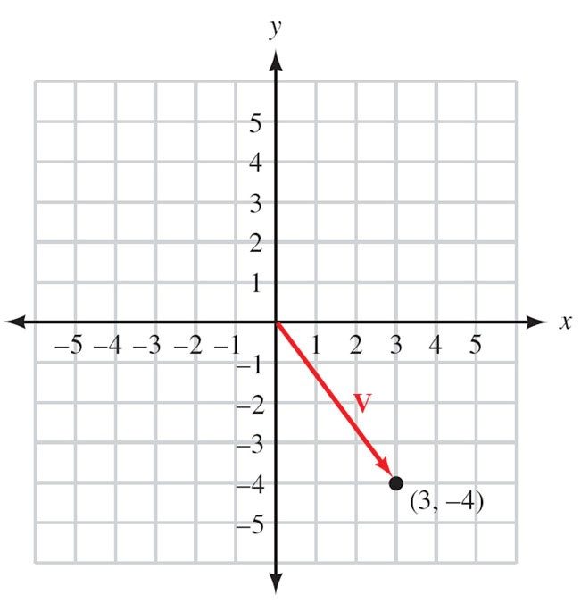







***Example***

Find the magnitude and direction angle for **u** = 〈3, –2〉.

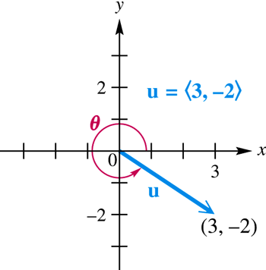*Solution*















**Horizontal & Vertical Vector Components**

The horizontal and vertical components, respectively, of a vector **V** having magnitude |**V**| and direction angle *θ* are given by:



** is the ***horizontal vector component*** of *V*

52°

*y*

*x*

V*x*

***V =* 15**

V*y*







** is the ***vertical vector component*** of *V*







***Example***

The human cannonball is shot from cannon with an initial velocity of 53 miles per hour at an angle of 60° from the horizontal. Find the magnitude of the horizontal and vertical vector components of the velocity vector.

60°

*y*

*x*

V*x*

**53**

V*y*

*Solution*









**Addition and Subtraction of Vectors**

The sum of the vectors ***U*** and ***V*** (**U + V**) is called the ***resultant vector***.

***U***

***V***

***U + V***

***U***

***V***

***U + V***

**U – V = U + (-V)**

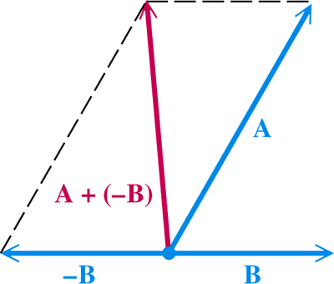

***U***

***V***

***U - V***

The sum of a vector ***V*** and its opposite –***V*** has magnitude 0 and is called the ***zero vector***.

**Addition and subtraction with *Algebraic* Vectors**

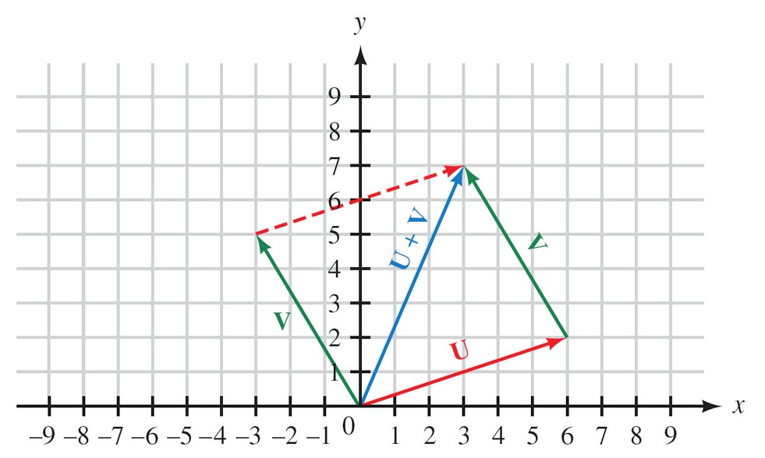













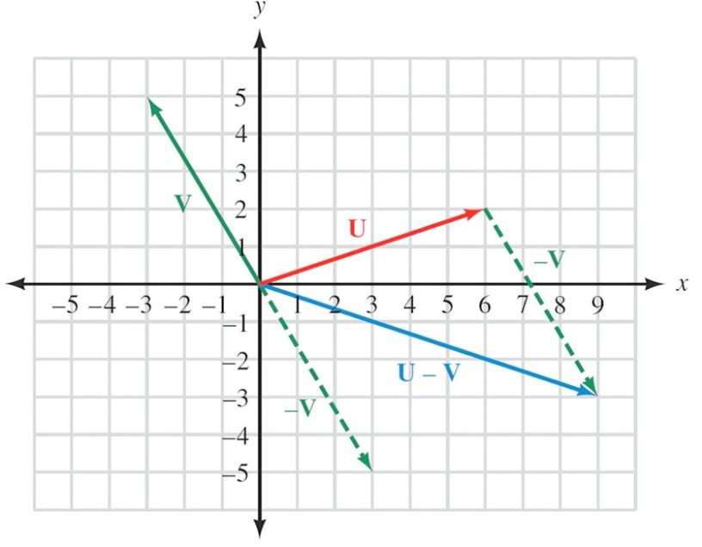

***Scalar* Multiplication**

***Example***

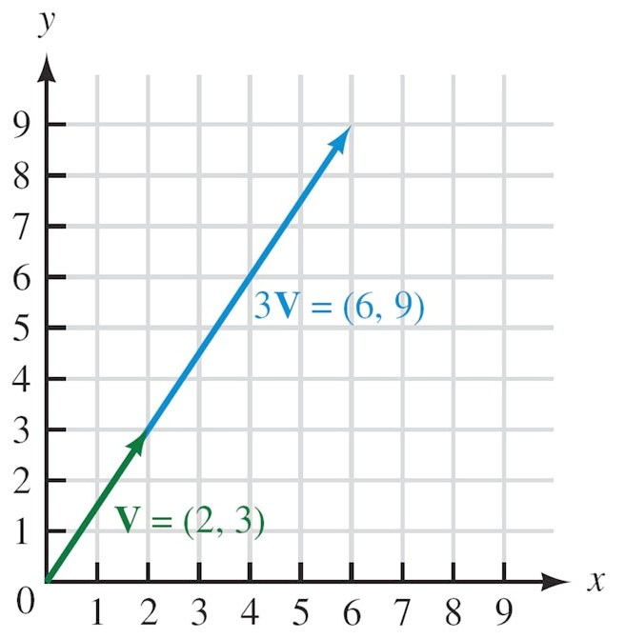





***Example***

If  and , find:

1. 
2. 

*Solution*

1. 





1. 









**Component Vector Form**

The vector that extends from the origin to the point (1, 0) is called the unit horizontal vector and is denoted by ***i***.

The vector that extends from the origin to the point (0, 1) is called the unit vertical vector and is denoted by ***j***.

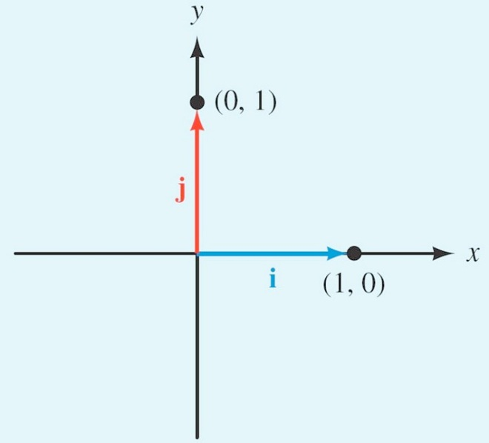

***Example***

Write the vector  in terms of the unit vectors ***i*** and ***j***.

*Solution*



**Algebraic Vectors**

If ***i*** is the unit vector from (0, 0) to (1, 0), and ***j*** is the unit vector from (0, 0) to (0, 1), then any vector *V* can be written as



Where *a* and *b* are real numbers. The magnitude of *V* is







***Example***

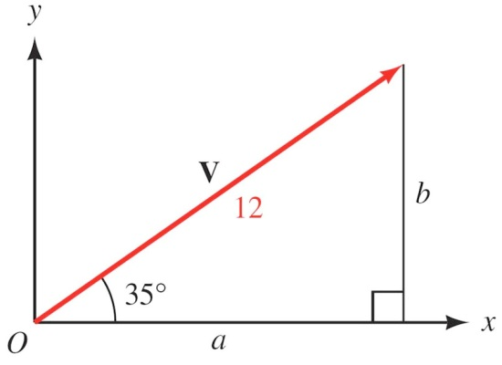Vector *V* has its tail at the origin, and makes an angle of 35° with the positive *x*-axis. Its magnitude is 12. Write *V* in terms of the unit vectors *i* and *j*.

*Solution*







***Example***

If  and 

1. 





1. 







***Example***

Vector **w** has magnitude 25.0 and direction angle 41.7°. Find the horizontal and vertical components.

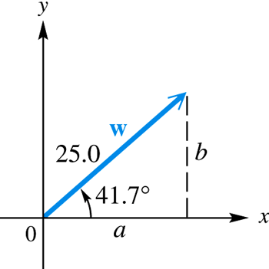*Solution*















Horizontal component: 18.7

Vertical component: 16.6

***Example***

A traffic light weighing 22 pounds is suspended by two wires. Find the magnitude of the tension in wire *AB*, and the magnitude of the tension in wire *AC*.

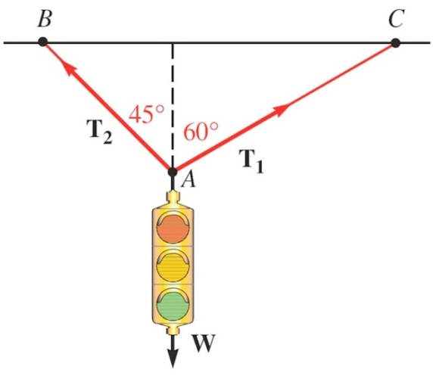 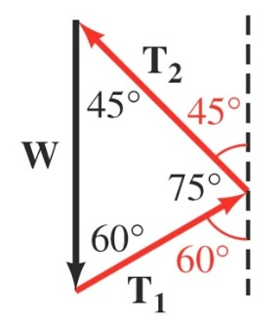

*Solution*













***Force***

When an object is stationary (at rest) we say it is in a state of static equilibrium.

When an object is in this state, the sum of the forces acting on the object must be equal to the zero vector **0**.

***Example***

Danny is 5 years old and weighs 42 pounds. He is sitting on a swing when his sister Stacey pulls him and the swing back horizontally through an angle of 30° and then stops. Find the tension in the ropes of the swing and the magnitude of the force exerted by Stacey.

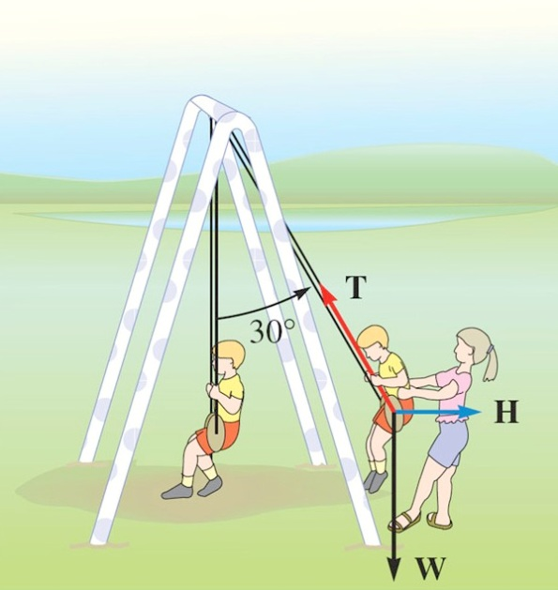 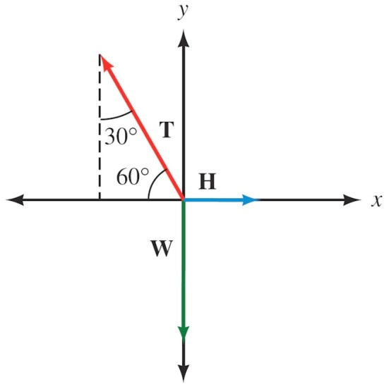

*Solution*







 Static equilibrium ⇒ 







 













**The DOT *Product***

The *dot product* (or scalar product) of two vectors  and  is written  and is defined as follows:





The dot product is a real number (scalar), not a vector.

* *It is helpful to find the angle between two vectors.*
* *Finding the work done by a force*

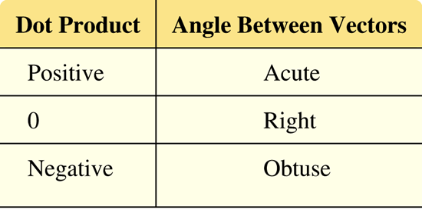

***Example***

Find each of the following dot products

* 1. 







* 1. 





* 1. 





**Finding the Angle Between Two Vectors**

The dot product of two vectors is equal to the product of their magnitudes multiplies by the cosine of the angle between them. That is, when *θ* is the angle between two nonzero vectors *U* and *V*, then





***Example***

Find the angle between the vectors *U* and *V*.

1. 
2. 

*Solution*

1. 













1. 













**Perpendicular Vectors**

If *U* and *V* are two nonzero vectors, then



Two vectors are perpendicular if and only if (*iff*) their dot product is 0.

***Example***

Which of the following vectors are perpendicular to each other?

  

*Solution*





 ∴ *U* and *V* are perpendicular





 ∴ *U* and *W* are not perpendicular





 ∴ *V* and *W* are perpendicular

***Work***

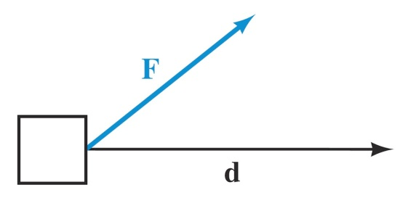 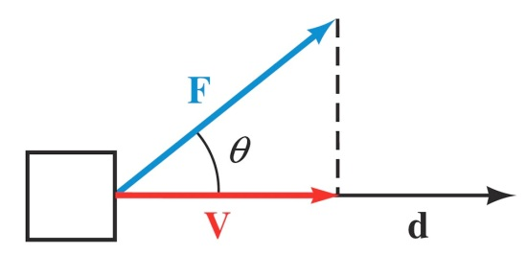

Work is performed when a force (constant) is used to move an object a certain distance.

***d***: displacement vector.

***V***: Represents the component of ***F*** that is the same direction of ***d,***

is sometimes called the ***projection*** of onto ***d***.











**Definition**

If a constant force ***F*** is applied, and the resulting movement of the object is represented by the displacement vector *d*, then the work performed by the force is



***Example***

A force ***F*** = 35*i* – 12*j* (in pounds) is used to push an object up a ramp. The resulting movement of the object is represented by the displacement vector ***d*** = 15*i* + 4*j* (in feet). Find the work done by the force.

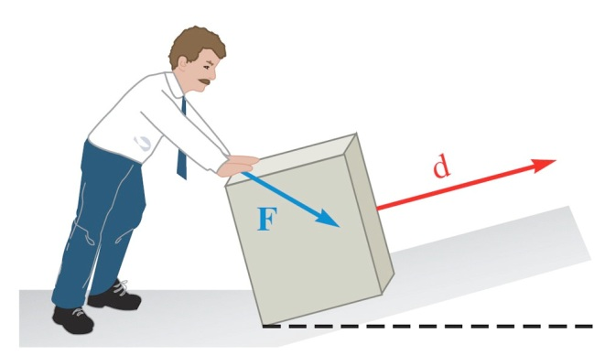

*Solution*







***Example***

A shipping clerk pushes a heavy package across the floor. He applies a force of 64 pounds in a downward direction, making an angle of 35° with the horizontal. If the package is moved 25 feet, how much work is done by the clerk?

*Solution*



F

25 ft.

**30°**









***Airspeed and Groundspeed***

The ***airspeed*** of a plane is its speed relative to the air

The ***groundspeed*** of a plane is its speed relative to the ground.

The ***groundspeed*** of a plane is represented by the vector sum of the airspeed and windspeed vectors.

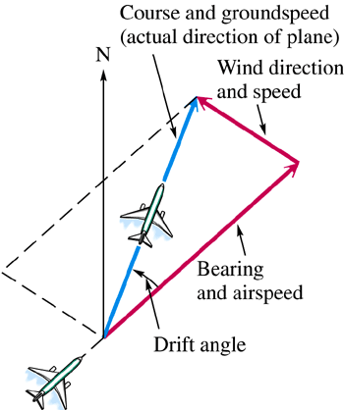

***Example***

A plane with an airspeed of 192 mph is headed on a bearing of 121°. A north wind is blowing (from north to south) at 15.9 mph. Find the groundspeed and the actual bearing of the plane.

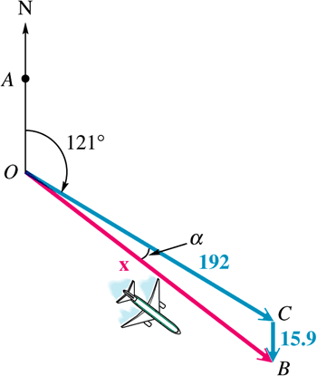*Solution*



The groundspeed is represented by |***x***|.







The plane’s groundspeed is about 201 mph.







The plane’s groundspeed is about 201 mph on a bearing of 121° + 4° = 125°.

***Exercises Section* 4.3 – Vectors and Dot Product**

1. Let **u** = –2, 1 and **v** = 4, 3. Find the following.
2. **u** + **v**
3. –2**u**
4. 4**u** – 3**v**
5. Given: , find the magnitudes of the horizontal and vertical vector components of V, , respectively
6. Find the angle *θ* between the two vectors **u** = 3, 4 and **v** = 2, 1.
7. A bullet is fired into the air with an initial velocity of 1,800 feet per second at an angle of 60° from the horizontal. Find the magnitude of the horizontal and vertical vector component as of the velocity vector.
8. A bullet is fired into the air with an initial velocity of 1,200 feet per second at an angle of 45° from the horizontal.
9. Find the magnitude of the horizontal and vertical vector component as of the velocity vector.
10. Find the horizontal distance traveled by the bullet in 3 seconds. (Neglect the resistance of air on the bullet).
11. A ship travels 130 km on a bearing of S 42° E. How far east and how far south has it traveled?
12. An arrow is shot into the air with so that its horizontal velocity is 15.0 ft./sec and its vertical velocity is 25.0 ft./sec. Find the velocity of the arrow?
13. An arrow is shot into the air so that its horizontal velocity is 25 feet per second and its vertical is 15 feet per second. Find the velocity of the arrow.
14. A plane travels 170 miles on a bearing of N 18 E and then changes its course to N 49 E and travels another 120 miles. Find the total distance traveled north and the total distance traveled east.
15. A boat travels 72 miles on a course of bearing N 27° E and then changes its course to travel 37 miles at N 55° E. How far north and how far east has the boat traveled on this 109-mile trip?
16. A boat is crossing a river that run due north. The boat is pointed due east and is moving through the water at 12 miles per hour. If the current of the river is a constant 5.1 miles per hour, find the actual course of the boat through the water to two significant digits.
17. Two forces of 15 and 22 Newtons act on a point in the plane. (A **newton** is a unit of force that equals .225 lb.) If the angle between the forces is 100°, find the magnitude of the resultant vector.
18. Find the magnitude of the equilibrant of forces of 48 Newtons and 60 Newtons acting on a point *A*, if the angle between the forces is 50°. Then find the angle between the equilibrant and the 48-newton force.
19. Find the force required to keep a 50-lb wagon from sliding down a ramp inclined at 20° to the horizontal. (Assume there is no friction.)

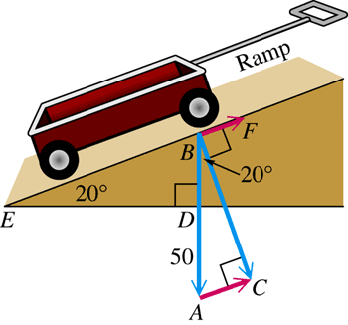

1. A force of 16.0 lb. is required to hold a 40.0 lb. lawn mower on an incline. What angle does the incline make with the horizontal?

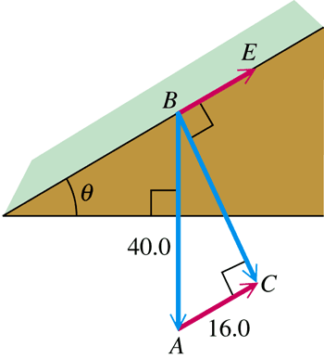

1. 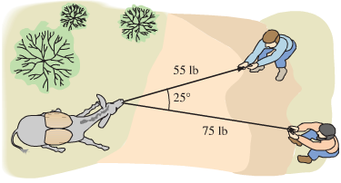Two prospectors are pulling on ropes attached around the neck of a donkey that does not want to move. One prospector pulls with a force of 55 lb, and the other pulls with a force of 75 lb. If the angle between the ropes is 25°, then how much force must the donkey use in order to stay put? (The donkey knows the proper direction in which to apply his force.)
2. A ship leaves port on a bearing of 28.0° and travels 8.20 mi. The ship then turns due east and travels 4.30 mi. How far is the ship from port? What is its bearing from port?
3. A solid steel ball is placed on a 10° incline. If a force of 3.2 lb in the direction of the incline is required to keep the ball in place, then what is the weight of the ball?
4. Find the amount of force required for a winch to pull a 3000-lb car up a ramp that is inclined at 20°.
5. If the amount of force required to push a block of ice up an ice-covered driveway that is inclined at 25° is 100lb, then what is the weight of the block?
6. If superman exerts 1000 lb of force to prevent a 5000-lb boulder from rolling down a hill and crushing a bus full of children, then what is the angle of inclination of the hill?
7. If Sisyphus exerts a 500-lb force in rolling his 4000-lb spherical boulder uphill, then what is the angle of inclination of the hill?
8. A plane is headed due east with an air speed of 240 mph. The wind is from the north at 30 mph. Find the bearing for the course and the ground speed of the plane.
9. A plane is headed due west with an air speed of 300 mph. The wind is from the north at 80 mph. Find the bearing for the course and the ground speed of the plane.
10. An ultralight is flying northeast at 50 mph. The wind is from the north at 20 mph. Find the bearing for the course and the ground speed of the ultralight.
11. A superlight is flying northwest at 75 mph. The wind is from the south at 40 mph. Find the bearing for the course and the ground speed of the superlight.
12. An airplane is heading on a bearing of 102° with an air speed of 480 mph. If the wind is out of the northeast (bearing 225°) at 58 mph, then what are the bearing of the course and the ground speed of the airplane?
13. 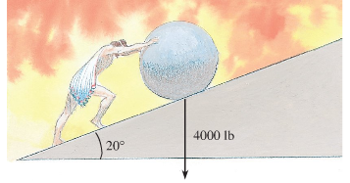In Roman mythology, Sisyphus revealed a secret of Zeus and thus incurred the god’s wrath. As punishment, Zeus banished him to Hades, where he was doomed for eternity to roll a rock uphill, only to have it roll back on him. If Sisyphus stands in front of a 4000-lb spherical rock on a 20° incline, then what force applied in the direction of the incline would keep the rock from rolling down the incline?
14. A trigonometry student wants to cross a river that is 0.2 mi wide and has a current of 1 mph. The boat goes 3 mph in still water.
15. Write the distance the boats travels as a function of the angle β.
16. Write the actual speed of the boat as a function of α and β.
17. Write the time for the trip as a function of α. Find the angle α for which the student will cross the river in the shortest amount of time.

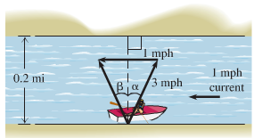

1. Amal uses three elephants to pull a very large log out of the jungle. The papa elephant pulls with 800 lb. of force, the mama elephant pulls with 500 lb. of force, and the baby elephant pulls with 200 lb. force. The angles between the forces are shown in the figure. What is the magnitude of the resultant of all three forces? If mama is pulling due east, then in what direction will the log move?

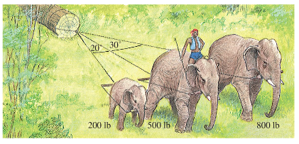

1. A plane is flying with an airspeed of 185 miles per hour with heading 120°. The wind currents are running at a constant 32 miles per hour at 165° clockwise from due north. Find the true course and ground speed of the plane.

***Section* 4.4 – Trigonometric Form of Complex Numbers**



The graph of the complex number *x* = *yi* is a vector (arrow) that extends from the origin out to the point (*x, y*)

* Horizontal axis: ***real******axis***
* Vertical axis: ***imaginary******axis***

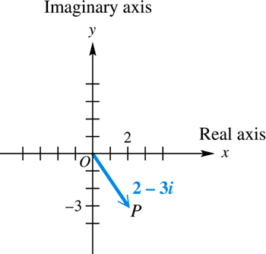

***Example***

Graph each complex number: , , and 

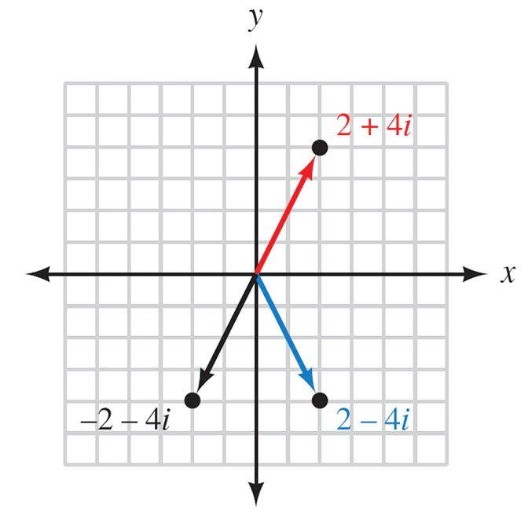

***Example***

Graph each complex number: 

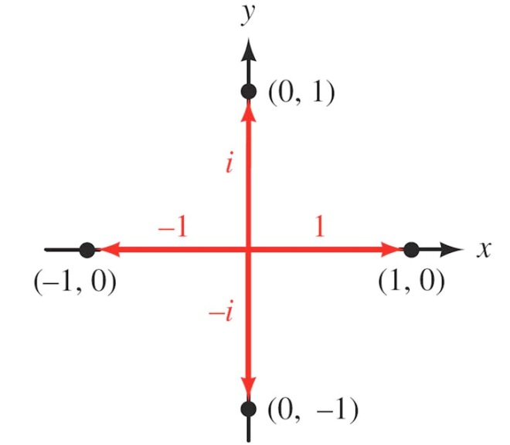

***Example***

Find the sum of 6 – 2*i* and –4 – 3*i*. Graph both complex numbers and their resultant.

*Solution*

(6 – 2*i*) + (–4 – 3*i*) = 6 – 4 – 2i – 3i

= 2 – 5*i*

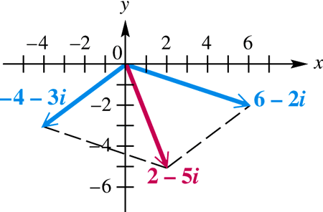

***Definition***

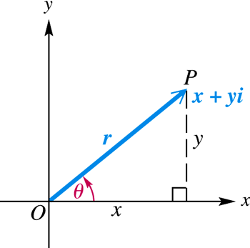

The *absolute value* or ***modulus*** of the complex number  is the distance from the origin to the point (*x, y*). If this distance is denoted by *r*, then



The ***argument***of the complex number  denoted is the smallest possible angle *θ* from the positive real axis to the graph of *z*.

 

 





 → is called the *trigonometric* from of *z*.

***Definition***

If  is a complex number in standard form then the ***trigonometric form*** for *z* is given by



Where ***r*** is the modulus or absolute value of *z* and

***θ***  is the argument of *z*.

We can convert back and forth between standard form and trigonometric form by using the relationships that follow

For 





***Example***

Write  in trigonometric form

*Solution*

The modulus *r*:















In radians: 

***Example***

Write  in rectangular form.

*Solution*









***Example***

Express  in rectangular form.

*Solution*





***Example***

Find the modulus of each of the complex numbers *5i*, 7, and 3 + 4*i*

*Solution*

For z = *5i* = 0 + 5*i* 

For *z* = *7* = 7 + 0*i* 

For 3 + 4*i* 

***Product Theorem***

If  and  are any two complex numbers, then





 

***Example***

Find the product of and . Write the result in rectangular form.

*Solution*











***Quotient Theorem***

If  and  are any two complex numbers, then





***Example***

Find the quotient . Write the result in rectangular form.

*Solution*











***Exercises Section* 4.4 – Trigonometric Form of Complex Numbers**

1. Write  in trigonometric form. (Use radian measure)
2. Write  in trigonometric form.
3. Write  in trigonometric form.
4. Write  in trigonometric form.
5. Write  in standard form.
6. Write  in standard form.
7. Find the quotient . Write the result in rectangular form.
8. Divide . Write the result in rectangular form.

***Section* 4.5 – Polar Coordinates**

To reach the point whose address is (2, 1), we start from origin and travel 2 units right and then 1 unit up. Another way to get to that point, we can travel  units on the terminal side of an angle in standard position and this type is called *Polar Coordinates*.

***Definition* of Polar Coordinates**

To define polar coordinates, let an ***origin*** *O* (called the ***pole***) and an ***initial ray*** from *O*. Then each point *P* can be located by assigning to it a ***polar coordinate pair***  in which r gives the directed from *O* to *P* and *θ* gives the directed angle from the initial ray to yay *OP*.

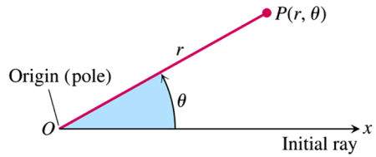

***Polar Coordinates***

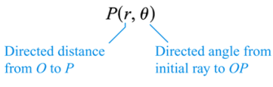

***Example***

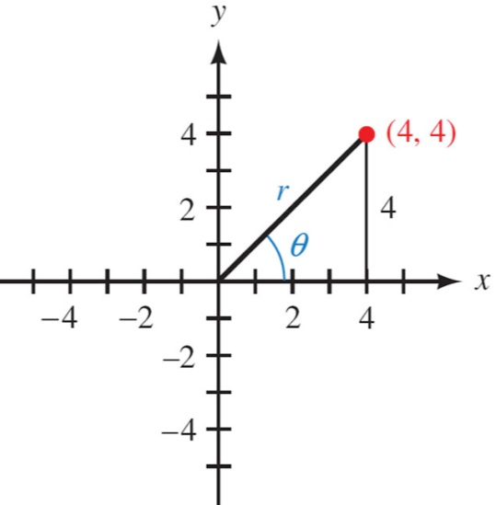A point lies at (4, 4) on a rectangular coordinate system. Give its address in polar coordinates 

*Solution*









The address is 

***Example***

Graph the points , , , and  on a polar coordinate system

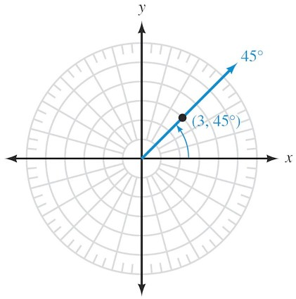 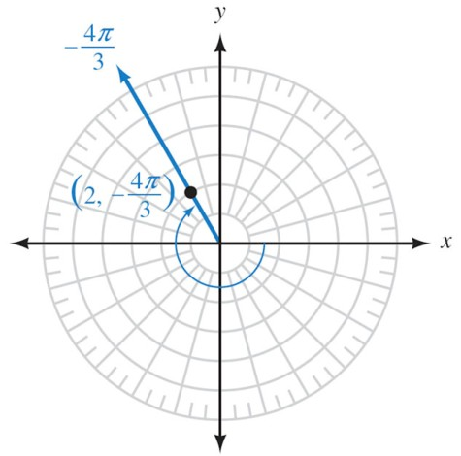

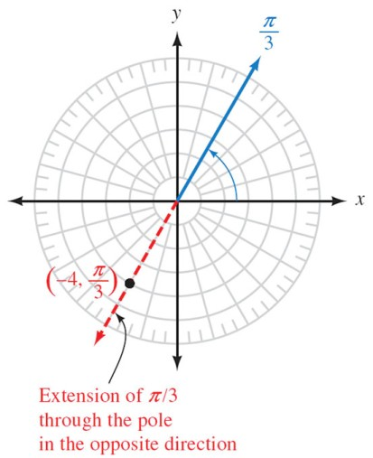 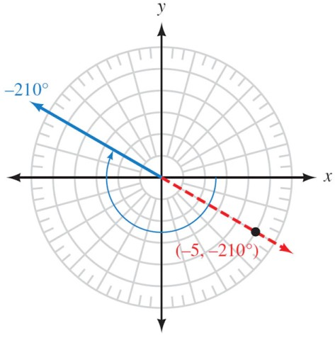

***Example***

Give three other order pairs that name the same point as

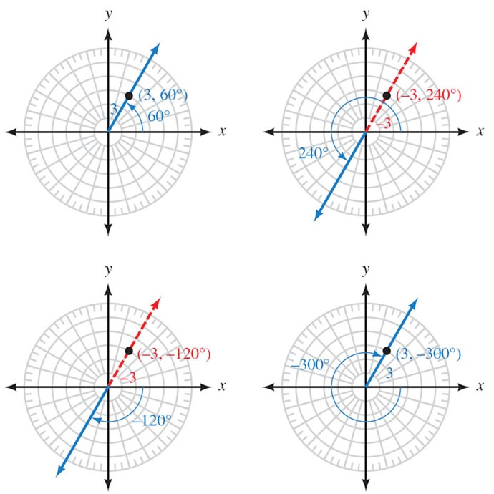



**Polar Coordinates and Rectangular Coordinates**

*To Convert Rectangular Coordinates to Polar Coordinates*

Let  and 

Where the sign of *r* and the choice of *θ* place the point (*r, θ*) in the same quadrant as (*x, y*)

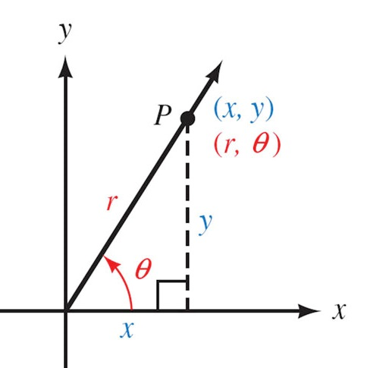

*To Convert Polar Coordinates to Rectangular Coordinates*

Let  

***Example***

Convert to rectangular coordinates. 

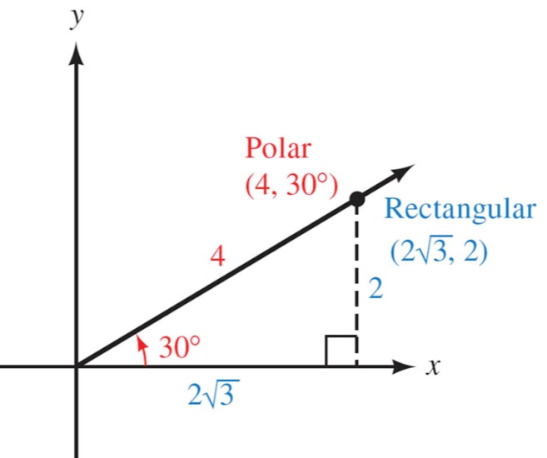*Solution*

















The pointin rectangular coordinates is equivalent to  in polar coordinates.

***Example***

Convert to rectangular coordinates .

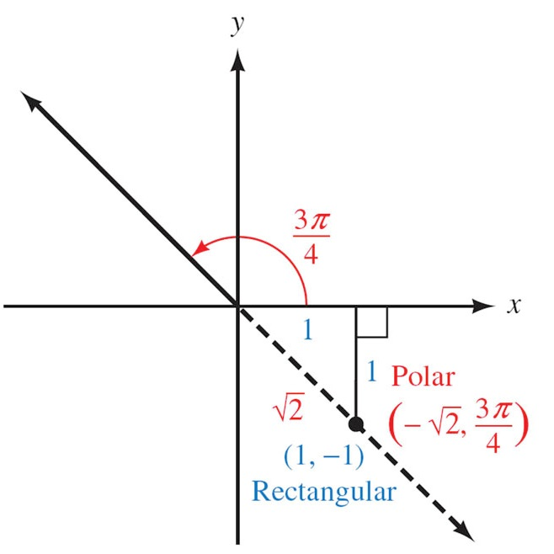*Solution*













The point in rectangular coordinates is equivalent to  in polar coordinates.

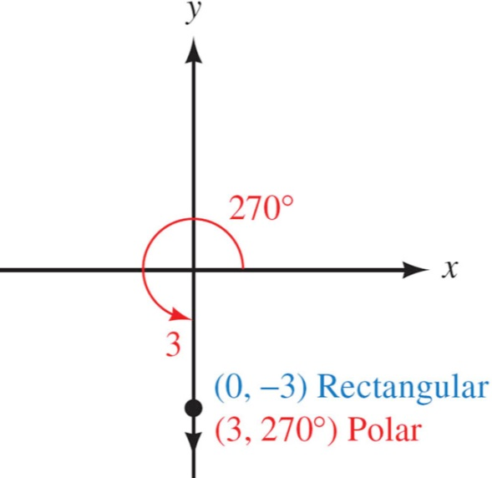***Example***

Convert to rectangular coordinates .

*Solution*













The point in rectangular coordinates is equivalent to  in polar coordinates.

***Example***

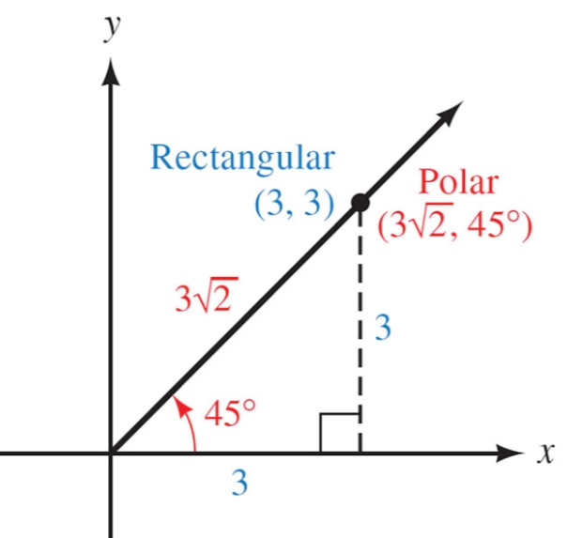Convert to polar coordinates .

*Solution*













The point  is just one.

***Example***

Convert to polar coordinates .

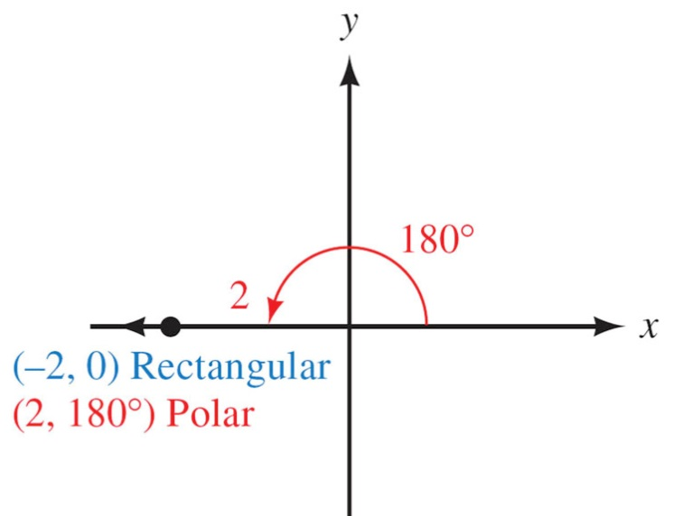*Solution*









The point 

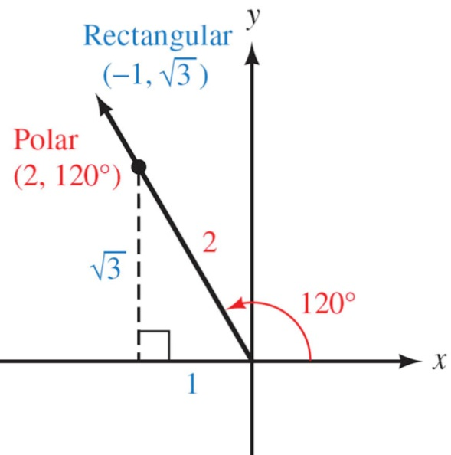***Example***

Convert to polar coordinates .

*Solution*









The point 

***Example***

Write the equation in rectangular coordinates 

*Solution*

 

 





 



***Example***

Write the equation in polar coordinates 

*Solution*

 





***Exercises*** ***Section* 4.5 – Polar Coordinates**

1. Convert to rectangular coordinates 
2. Convert to rectangular coordinates 
3. Convert to rectangular coordinates 
4. Convert to polar coordinates 
5. Convert to polar coordinates 
6. Convert to polar coordinates 
7. Convert to polar coordinates 
8. Write the equation in rectangular coordinates 
9. Write the equation in rectangular coordinates 
10. Write the equation in rectangular coordinates 
11. Write the equation in rectangular coordinates 
12. Write the equation in polar coordinates 
13. Write the equation in polar coordinates 
14. Write the equation in polar coordinates 
15. Write the equation in polar coordinates 

***Section* 4.6 - De Moivre’s Theorem**

**De Moivre’s *Theorem***

If  is a complex number, then





***Example***

Find  and express the result in rectangular form.

*Solution*







θ is in QI, that implies: 



Apply De Moivre’s theorem:





 







***n*th Root Theorem**

For a positive integer *n*, the complex number *a* + *bi* is an ***nth* root** of the complex number *x* + *iy* if



If *n* is any positive integer, *r* is a positive real number, and *θ* is in degrees, then the nonzero complex number has exactly *n* distinct *n*th roots, given by

 or 

Where  

 

***Example***

Find the two square root of **4*i***. Write the roots in rectangular form.

*Solution*

 





The absolute value: 

Argument: 

Since there are ***two*** square root, then *k* = 0 and 1.





The square roots are: 

 

 

***Example***

Find all fourth roots of . Write the roots in rectangular form.

*Solution*









The fourth roots have absolute value: 



Since there are ***four*** roots, then *k* = 0, 1, 2, and 3.









The fourth roots are: 









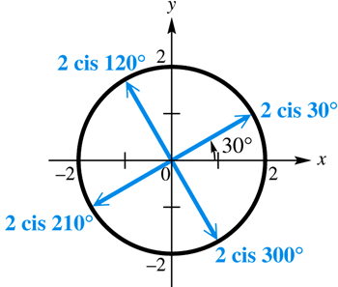

***Example***

Find all complex number solutions of . Graph them as vectors in the complex plane.

*Solution*



There is one real solution, 1, while there are five complex solutions.









The fifth roots have absolute value: 



Since there are ***fifth*** roots, then *k* = 0, 1, 2, 3, and 4.











Solution: 

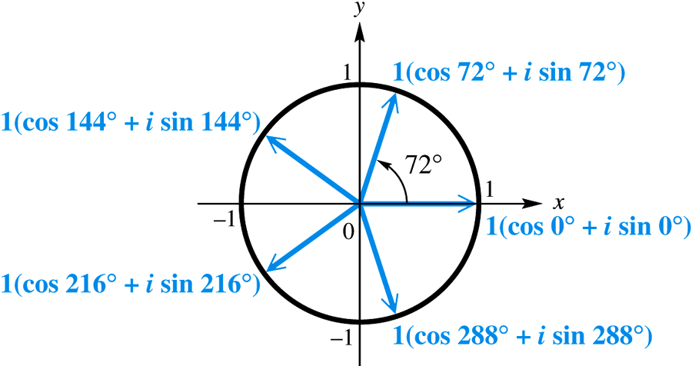

The graphs of the roots lie on a unit circle. The roots are equally spaced about the circle, 72° apart.

***Exercises*** ***Section* 4.6 - De Moivre’s Theorem**

1. Find  and express the result in rectangular form.
2. Find  and express the result in rectangular form.
3. Find fifth roots of  and express the result in rectangular form.
4. Find the fourth roots of 
5. Find the cube roots of 27.
6. Find all complex number solutions of .
7. Find 