***SOLUTION*** ***Section* 1.1 – Angles, Degrees, and Special Triangles**

***Exercise***

Indicate the angle if it is an acute or obtuse. Then give the complement and the supplement of each angle.

*a*) 10° *b*) 52° *c*) 90° *d*) 120° *e*) 150°

***Solution***

1. Acute; Complement is 90° − 10° = 80°; Supplement is 180° − 10° = 170°.
2. Acute; Complement is 90° − 52° = 38°; Supplement is 180° − 52° = 128°.
3. Neither (*right angle*); Complement is 90° − 90° = 0°; Supplement is 180° − 90° = 90°.
4. Obtuse; Complement is 90° − 120° = −30°; Supplement is 180° − 120° = 60°.
5. Obtuse; Complement is 90° − 150° = −60°; Supplement is 180° − 150° = 30°.

***Exercise***

Change 10° 45′ to decimal degrees

***Solution***

10° 45′ = 10° + 45′







***Exercise***

Convert to decimal degrees.

***Solution***









***Exercise***

Convert  to decimal degrees.

***Solution***









***Exercise***

Change  to decimal degrees to the nearest thousandth

***Solution***







***Exercise***

Convertto degrees, minutes, and seconds.

***Solution***













***Exercise***

Convert  to degrees, minutes, and seconds

***Solution***













***Exercise***

Convert to degrees, minutes, and seconds.

***Solution***













***Exercise***

Convert to degrees, minutes, and seconds.

***Solution***













***Exercise***

Convert to degrees, minutes, and seconds.

***Solution***













***Exercise***

Perform each calculation

1. 
2. 
3. 
4. 

***Solution***

1. 







1. 



1. 



1. 



***Exercise***

Find the angle of least possible positive measure coterminal with an angle of -75°.

***Solution***





***Exercise***

Find the angle of least possible positive measure coterminal with an angle of -800°.

***Solution***



***Exercise***

Find the angle of least possible positive measure coterminal with an angle of 270°.

***Solution***



***Exercise***

A vertical rise of the Forest Double chair lift 1,170 feet and the length of the chair lift as 5,570 feet. To the nearest foot, find the horizontal distance covered by a person riding this lift.

***Solution***

*A*

*B*

*C*

*1170*

*5570*

*x*









***Exercise***

A tire is rotating 600 times per minute. Through how many degrees does a point of the edge of the tire move in  second?

***Solution***



***Exercise***

A windmill makes 90 revolutions per minute. How many revolutions does it make per second?

***Solution***



***SOLUTION Section* 1.2 – Trigonometric Functions**

***Exercise***

Find the six trigonometry functions of *θ*  if *θ* is in the standard position and the point (−2, 3) is on the terminal side of *θ*.

***Solution***



|  |  |  |  |
| --- | --- | --- | --- |
|  |  |  |  |
|  |  |  |  |

***Exercise***

Find the six trigonometry functions of *θ*  if *θ* is in the standard position and the point (−3, −4) is on the terminal side of *θ*.

***Solution***



|  |  |  |  |
| --- | --- | --- | --- |
|  |  |  |  |
|  |  |  |  |

***Exercise***

Find the six trigonometry functions of *θ*  in standard position with terminal side through the point (−3, 0).

***Solution***



|  |  |  |  |
| --- | --- | --- | --- |
|  |  |  |  |
|  |  |  |  |

***Exercise***

Find the six trigonometry functions of *θ* if*θ* is in the standard position and the point (12, −5) is on the terminal side of *θ*.

***Solution***



|  |  |  |  |
| --- | --- | --- | --- |
|  |  |  |  |
|  |  |  |  |

***Exercise***

Find the values of the six trigonometric functions for an angle of 90°.

***Solution***

|  |  |  |  |
| --- | --- | --- | --- |
|  |  |  |  |
|  |  |  |  |

***Exercise***

Indicate the two quadrants *θ* could terminate in if 

***Solution***

 → QI & QIV

***Exercise***

Indicate the two quadrants *θ* could terminate in if 

***Solution***

 → QIII & QIV

***Exercise***

Find the remaining trigonometric function of *θ* if  and *θ* terminates in QI

***Solution***



  

  

***Exercise***

Find the remaining trigonometric function of *θ* if and *θ* terminates in QII.

***Solution***









***Exercise***

Find the remaining trigonometric function of *θ* if and *θ* terminates in QIII.

***Solution***









***Exercise***

Find the remaining trigonometric function of *θ* if and *θ* terminates in QIV.

***Solution***











***Exercise***

Find the remaining trigonometric functions of *θ* if  and *θ* is terminates in QIV.

***Solution***









Since *θ* is QIV 







 

 

***Exercise***

Find the remaining trigonometric functions of *θ* if  and .

***Solution***







 



 

***Exercise***

If , and *θ* is QIII, find cos*θ* and tan*θ* .

***Solution***









 Since *θ* is Q III 





***Exercise***

If , and *θ* is QIV, find sin*θ* and tan*θ* .

***Solution***

 



***Exercise***

Use the reciprocal identities if  find 

***Solution***







***Exercise***

Find , given that 

***Solution***







***Exercise***

Find , given that 

***Solution***









***Exercise***

Use a ratio identity to find  if  and 

***Solution***







***Exercise***

If  and *θ* terminates in QII, find 

***Solution***









***Exercise***

If  and *θ* terminated in QII, find cos*θ* and tan*θ*.

***Solution***

















***Exercise***

Find  if  and *θ* terminates in QI

***Solution***



















***Exercise***

Find the remaining trigonometric ratios of *θ*, if  and 

***Solution***

 









***Exercise***

Using the calculator and rounding your answer to the nearest hundredth, find the remaining trigonometric ratios of *θ* if and 

***Solution***











***Exercise***

Write  in terms of sin*θ* and cos*θ*, and then simplify if possible.

***Solution***







***Exercise***

Write  in terms of sin*θ* and cos*θ*, and then simplify if possible.

***Solution***





***Exercise***

Write  in terms of sin*θ* and/or cos*θ*, and then simplify if possible.

***Solution***



***Exercise***

Write  in terms of sin*θ* and cos*θ*, and then simplify if possible.

***Solution***







***Exercise***

Multiply 

***Solution***





***Exercise***

Multiply 

***Solution***



***Exercise***

Simplify the expression  as much as possible after substituting  for *x*.

***Solution***











***Exercise***

Simplify the expression  as much as possible after substituting  for *x*

***Solution***













***SOLUTION Section* 1.3– Evaluating Trigonometry Functions**

***Exercise***

Simplify by using the table. 

***Solution***



***Exercise***

Simplify by using the table. 

***Solution***







***Exercise***

Simplify by using the table. 

***Solution***







***Exercise***

Find the exact value of 

***Solution***

 



***Exercise***

Find *θ*  if  and *θ*  terminates in QIII with.

***Solution***





*θ* ∈ QIII





***Exercise***

Find *θ* to the nearest degree if  and *θ*  terminates in QIV with.

***Solution***





 



*θ* ∈ QIV





***Exercise***

Find the exact value of 

***Solution***









***Exercise***

Find the exact value of 

***Solution***

 



***Exercise***

Find the exact value of 

***Solution***

 



***Exercise***

Find the exact value of 

***Solution***



 







***Exercise***

Use the calculator to find the value of 

***Solution***





***Exercise***

Use the calculator to find the value of 

***Solution***





***Exercise***

Use the calculator to find the value of 

***Solution***







***Exercise***

Use the calculator to find *θ* to the nearest degree if  with *θ* ∈ QIV with 

***Solution***



Since *θ* ∈ QIV





***Exercise***

Use the calculator to find *θ* to the nearest degree if  with *θ* ∈ QIII with 

***Solution***

 Since *θ* ∈ QIII





***Exercise***

Use the calculator to find *θ* to the nearest degree if  with *θ* ∈ QII with 

***Solution***





 Since *θ* ∈ QII





***Exercise***

Find *θ* to the nearest tenth of a degree if  and *θ*  terminates in QIV with.

***Solution***



*θ* ∈ QIV





***SOLUTION Section* 1.4 – Solving Right Triangle Trigonometry**

***Exercise***

In the right triangle *ABC*, *a* = 2.73 and *b* = 3.41. Find the remaining side and angles.

***Solution***





*A*

*B*

*C*

***3.41***

***2.73***

***c***

 ***or*** 

 

 

 

*B* = 90° - *A*

= 90° - 38.7°

***Exercise***

The distance from *A* to *D* is 32 feet. Use the information in figure to solve *x*, the distance between *D* and *C*.

***Solution***

*A*

*B*

*C*

32

h

*x*

*D*

*38°*

*54°*

Triangle *DCB*





Triangle *ACB*















= 42 *ft*

***Exercise***

If C = 26° and *r* = 19, find *x*.

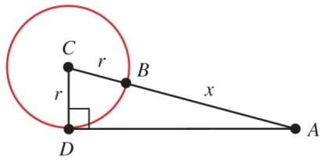

***Solution***











***Exercise***

If ∠ABD = 53°, C = 48°, and BC = 42, find *x* and then find *h*.

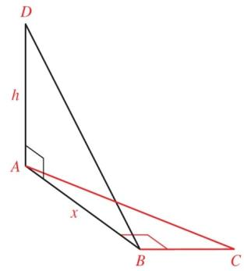

***Solution***









***Exercise***

If A = 41°, ∠BDC = 58°, and AB = 28, find *h*, then *x*.

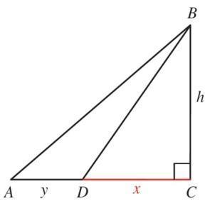

***Solution***









***Exercise***

A plane flies 1.7 hours at 120 mph on a bearing of 10°. It then turns and flies 9.6 hours at the same speed on a bearing of 100°. How far is the plane from its starting point?

***Solution***







The triangle is right triangle.







***Exercise***

The shadow of a vertical tower is 67.0 *ft* long when the angle of elevation of the sun is 36.0°. Find the height of the tower.

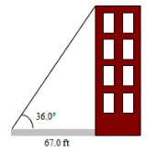

***Solution***





***Exercise***

The base of a pyramid is square with sides 700 *ft.* long, and the height of the pyramid is 600 *ft*. Find the angle of elevation of the edge indicated in the figure to two significant digits. (Hint: The base of the triangle in the figure is half the diagonal of the square base of the pyramid.)

***Solution***











***Exercise***

If a 73-foot flagpole casts a shadow 51 feet long, what is the angle of elevation of the sun (to the nearest tenth of a degree)?

***Solution***





***Exercise***

Suppose each edge of the cube is 3.00 inches long. Find the measure of the angle formed by diagonals DE and DG. *Round your answer to the nearest tenth of a degree*.

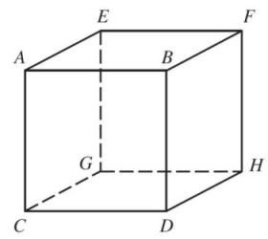

***Solution***









***Exercise***

A man wondering in the desert walks 2.3 miles in the direction S 31° W. He then turns 90° and walks 3.5 miles in the direction N 59° W. At that time, how far is he from his starting point, and what is his bearing from his starting point?

3.5 mi

2.3 mi

31°

**d**

N

S

E

W

*θ*

***Solution***







S (57°+31°) W

→ Bearing S 88° W

***Exercise***

A person standing at point A notices that the angle of elevation to the top of the antenna is 47° 30′. A second person standing 33.0 feet farther from the antenna than the person at A finds the angle of elevation to the top of the antenna to be 42° 10′. How far is the person at A from the base of the antenna?

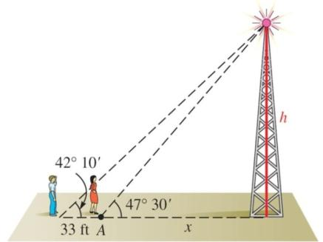

***Solution***

47° 30′ = 





42° 10′ = 







 

 

 



***Exercise***



Find ***h*** as indicated in the figure.

***Solution***

Outside triangle: 

Inside triangle: 

Both triangles have the same ***h***, therefore:











 

***Exercise***

Find ***h*** as indicated in the figure.

***Solution***

Outside triangle: 

Inside triangle: 

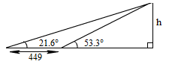Both triangles have the same ***h***, therefore:

















***Exercise***

The angle of elevation from a point on the ground to the top of a pyramid is 31° 40′. The angle of elevation from a point 143 *ft* farther back to the top of the pyramid is 14° 50′. Find the height of the pyramid.

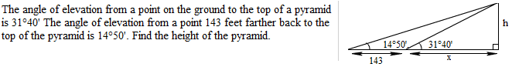

***Solution***







Both triangles have the same ***h***, therefore:

















***Exercise***

In one area, the lowest angle of elevation of the sun in winter is 21° 16′. Find the minimum distance, ***x***, that a plant needing full sun can be placed from a fence 4.41 *ft* high.

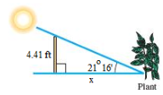

***Solution***





***Exercise***

A ship leaves its port and sails on a bearing of N 30° 10′ E, at speed 29.4 mph. Another ship leaves the same port at the same time and sails on a bearing of S 59° 50′ E, at speed 17.1 mph. Find the distance between the two ships after 2 hrs.

***Solution***





After 2 hours:











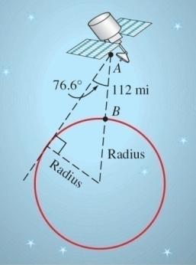***Exercise***

Suppose the figure below is exaggerated diagram of a plane flying above the earth. If the plane is 4.55 miles above the earth and the radius of the earth is 3,960 miles, how far is it from the plane to the horizon? What is the measure of angle A?

 ***Solution***









The plane is 190 miles from the horizon.





***Exercise***

The Ferry wheel has a 250 feet diameter and 14 feet above the ground. If *θ* is the central angle formed as a rider moves from position  to position , find the rider’s height above the ground h when *θ* is 45°.

***Solution***

Distance between 

**h**

*θ*

P0

P1

14 *ft*

*O*

*P*















***Exercise***

If a 75-foot flagpole casts a shadow 43 *ft* long, to the nearest 10 minutes what is the angle of elevation of the sum from the tip of the shadow?

***Solution***



75 ft

43 ft

*θ*









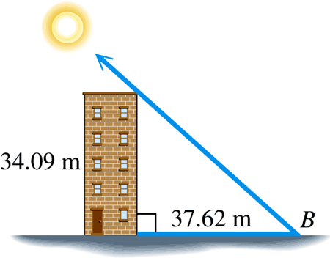***Exercise***

The length of the shadow of a building 34.09 *m* tall is 37.62 *m*. Find the angle of the elevation of the sun.

***Solution***





 ⇒ The angle of elevation is 

***Exercise***

San Luis Obispo, California is 12 miles due north of Grover Beach. If Arroyo Grande is 4.6 miles due east of Grover Beach, what is the bearing of San Luis Obispo from Arroyo Grande?

***Solution***

N

E

S

W

*θ*

*θ*

12

4.6





The bearing of San Luis Obispo from Arroyo Grande is

N 21° W

***Exercise***

The bearing from *A* to *C* is S 52° E. The bearing from *A* to *B* is N 84° E. The bearing from *B* to *C* is S 38° W. A plane flying at 250 mph takes 2.4 hours to go from *A* to *B*. Find the distance from *A* to *C*.

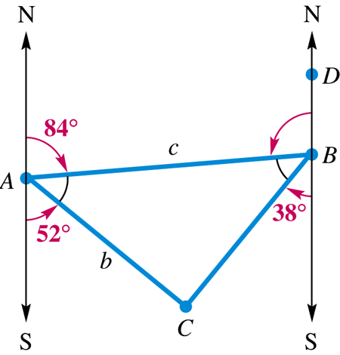***Solution***













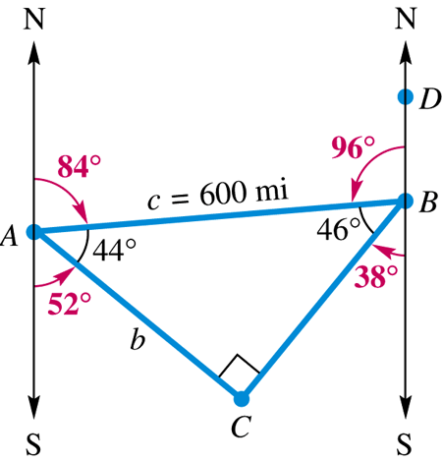











***Exercise***

From a window 31.0 *ft.* above the street, the angle of elevation to the top of the building across the street is 49.0° and the angle of depression to the base of this building is 15.0°. Find the height of the building across the street.

***Solution***













***Exercise***

A 10.5-*m* fire truck ladder is leaning against a wall. Find the distance ***d*** the ladder goes up the wall (above the fire truck) if the ladder makes an angle of 35° 29′ with the horizontal.

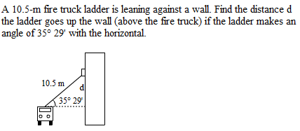

***Solution***







***Exercise***

A basic curve connecting two straight sections of road is often circular. In the figure, the points ***P*** and ***S*** mark the beginning and end of the curve. Let ***Q*** be the point of intersection where the two straight sections of highway leading into the curve would meet if extended. The radius of the curve is ***R***, and the central angle denotes how many degrees the curve turns.

1. If ***R*** = 965 ft. and **θ** = 37°, find the distance d between P and ***Q***.
2. Find an expression in terms of ***R*** and **θ** for the distance between points ***M*** and ***N***.

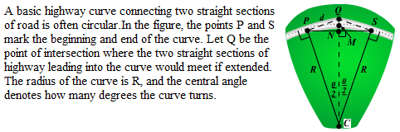***Solution***

1. 









1. 











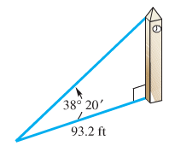***Exercise***

The angle of elevation from a point 93.2 ft from the base of a tower to the top of the tower is 38° 20′. Find the height of the tower.

***Solution***





***Exercise***

Jane was hiking directly toward a long straight road when she encountered a swamp. She turned 65° to the right and hiked 4 mi in that direction to reach the road. How far was she form the road when she encountered the swamp?

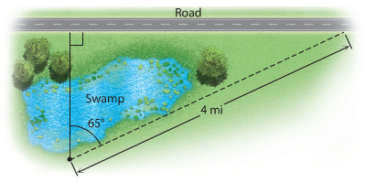

***Solution***







***Exercise***

From a highway overpass, 14.3 m above the road, the angle of depression of an oncoming car is measured at 18.3°. How far is the car from a point on the highway directly below the observer?

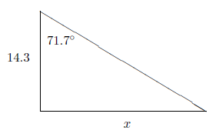***Solution***







***Exercise***

A tunnel under a river is 196.8 ft. below the surface at its lowest point. If the angle of depression of the tunnel is 4.962° , then how far apart on the surface are the entrances to the tunnel? How long is the tunnel?

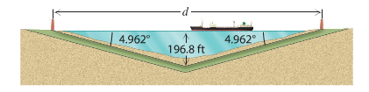

***Solution***

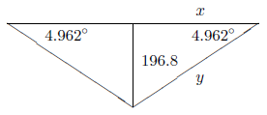









The tunnel length: 

***Exercise***

A boat sailing north sights a lighthouse to the east at an angle of 32° from the north. After the boat travels one more kilometer, the angle of the lighthouse from the north is 36°. If the boat continues to sail north, then how close will the boat come to the lighthouse?

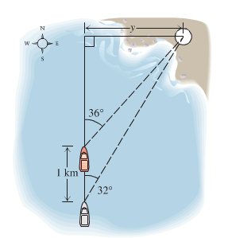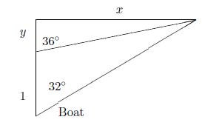***Solution***





















The closest will the boat come to the lighthouse is 4.5 km.

***Exercise***

The angle of elevation of a pedestrian crosswalk over a busy highway is 8.34°, as shown in the drawing. If the distance between the ends of the crosswalk measured on the ground is 342 ft., then what is the height h of the crosswalk at the center?

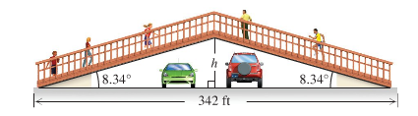

***Solution***





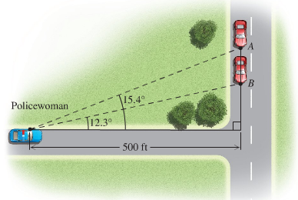***Exercise***

A policewoman has positioned herself 500 ft. from the intersection of two roads. She has carefully measured the angles of the lines of sight to points A and B. If a car passes from A to B is 1.75 sec and the speed limit is 55 mph, is the car speeding? (Hint: Find the distance from B to A and use R = D/T)

***Solution***













The speed is: 



⇒ The car is not speeding.

***Exercise***

From point A the angle of elevation to the top of the building is 30°. From point B, 20 meters closer to the building, the angle of elevation is 45°. Find the angle of elevation of the building from point C, which is another 20 meters closer to the building.

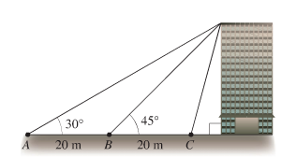

***Solution***

Let *x* be the distance between C and the building.





















***Exercise***

A hot air balloon is rising upward from the earth at a constant rate. An observer 250 m away spots the balloon at an angle of elevation of 24°. Two minutes later the angle of elevation of the balloon is 58°. At what rate is the balloon ascending?

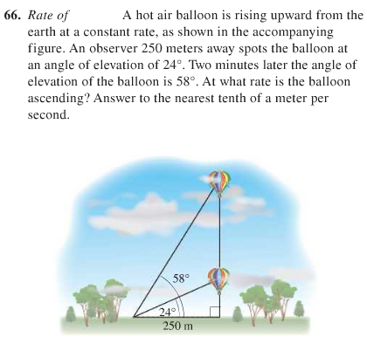***Solution***





It took 2 minutes to get from 







***Exercise***

A skateboarder wishes to build a jump ramp that is inclined at a 19° angle and that has a maximum height of 32.0 inches. Find the horizontal width *x* of the ramp.

***Solution***







***Exercise***

For best illumination of a piece of art, a lighting specialist for an art gallery recommends that a ceiling-mounted light be 6 ft from the piece of art and that the angle of depression of the light be 38°. How far from a wall should the light be placed so that the recommendations of the specialist are met? Notice that the art extends outward 4 inches from the wall.



***Solution***









***Exercise***

A surveyor determines that the angle of elevation from a transit to the top of a building is 27.8°. The transit is positioned 5.5 feet above ground level and 131 feet from the building. Find the height of the building to the nearest tenth of a foot.

***Solution***













***Exercise***

From a point A on a line from the base of the Washington Monument, the angle of elevation to the top of the monument is 42.0°. From a point 100 ft away from A and on the same line, the angle to the top is 37.8°. Find the height, to the nearest foot, of the Monument.

***Solution***

Triangle ACB: 

Triangle DCB: 

















