***Solution Section* 2.1 - Radians & Degrees, Circular Functions**

***Exercise***

Use a calculator to convert 256° 20′ to radians to the nearest hundredth of a radian.

***Solution***









***Exercise***

Convert -78.4° to radians

***Solution***





***Exercise***

Convert  to degrees

***Solution***





***Exercise***

Convert  to degrees

***Solution***





***Exercise***

Convert  to degrees

***Solution***





***Exercise***

Use the calculator to convert 2.4 to degree measure to the nearest tenth of a degree.

***Solution***







***Exercise***

In navigation, distance is not usually measured along a straight line, but along a great circle because the Earth is round. The formula to determine the great circle distance between two points  and  whose coordinates are given as latitudes and longitudes involves the expression



To use this formula, the latitudes and longitudes must be entered as angles in radians. However, most GPS units give these coordinates in degrees and minutes. To use this formula thus requires converting from degrees to radians.

Evaluate this expression for  and  corresponding to Bermuda and Barbados, respectively.

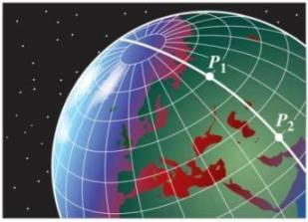

***Solution***

|  |  |
| --- | --- |
|  |  |
|  |  |







***Exercise***

If the angle *θ* is in standard position and the terminal side of *θ* intersects the unit circle at the point 

***Solution***









***Exercise***

Find the exact values of 

***Solution***









***Exercise***

Use reference angles and degree/radian conversion to find exact value of 

***Solution***















***Exercise***

Evaluate. Identify the function, the argument of the function, and the function value.

***Solution***



→ The function is sine, the argument is, and the value is 

***Exercise***

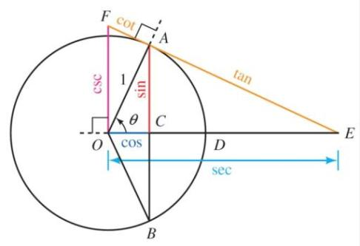

Show why 

***Solution***

is similar to

.







***Exercise***

Evaluate. Identify the function, the argument of the function, and the value of the function.

***Solution***









→ The function is sine, the argument is, and the value is 

***Exercise***

The function is the sine function, is the argument, and  is the value of the function

***Solution***



***Exercise***

Evaluate.

***Solution***





***Solution Section* 2.2 – Arc Length and Sector Area**

***Exercise***

The minute hand of a clock is 1.2 cm long. How far does the tip of the minute hand travel in 40 minutes?

***Solution***











***Exercise***

Find the radian measure if angle *θ*, if *θ* is a central angle in a circle of radius *r* = 4 inches, and *θ* cuts off an arc of length *s* = 12π inches.

***Solution***







***Exercise***

Give the length of the arc cut off by a central angle of 2 radians in a circle of radius 4.3 inches

***Solution***

***Given***: 







***Exercise***

A space shuttle 200 miles above the earth is orbiting the earth once every 6 hours. How long, in hours, does it take the space shuttle to travel 8,400 miles? (Assume the radius of the earth is 4,000 miles.) Give both the exact value and an approximate value for your answer.

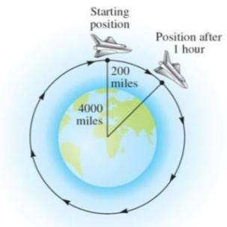

***Solution***













***Exercise***

The pendulum on a grandfather clock swings from side to side once every second. If the length of the pendulum is 4 feet and the angle through which it swings is 20°. Find the total distance traveled in 1 minute by the tip of the pendulum on the grandfather clock.

***Solution***

Since 

The length of the pendulum swings in 1 second:

.

In 60 seconds, the total distance traveled





.

***Exercise***

Reno, Nevada is due north of Los Angeles. The latitude of Reno is 40°, while that of Los Angeles is 34° N. The radius of Earth is about 4000 mi. Find the north-south distance between the two cities.

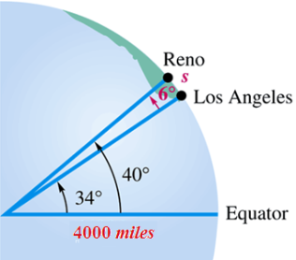***Solution***

The central angle between two cities: 









***Exercise***

The first cable railway to make use of the figure-eight drive system was a Sutter Street Railway. Each drive sheave was 12 feet in diameter. Find the length of cable riding on one of the drive sheaves.

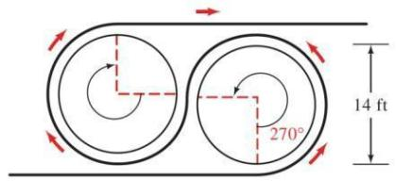

***Solution***

Since ,

The length of the cable riding on one of the drive sheaves is:









***Exercise***

The diameter of a model of George Ferris’s Ferris wheel is 250 feet, and θ is the central angle formed as a rider travels from his or her initial position Po to position P1. Find the distance traveled by the rider if θ = 45° and if θ =105°.

***Solution***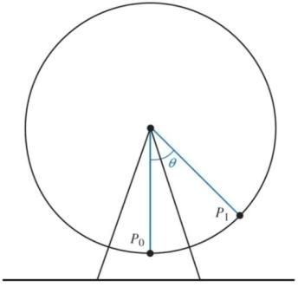



For *θ* = 45°







For *θ* = 105°







***Exercise***

Two gears are adjusted so that the smaller gear drives the larger one. If the smaller gear rotates through an angle of 225°, through how many degrees will the larger gear rotate?

***Solution***

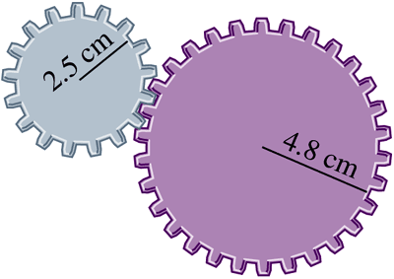The motion of the larger gear: 

The arc length on the smaller gear is:







The arc length on the larger gear is:









***Exercise***

If a central angle with its vertex at the center of the earth has a measure of 1′, then the arc on the surface of the earth that is cut off by this angle (knows as the great circle distance) has a measure of 1 nautical mile.

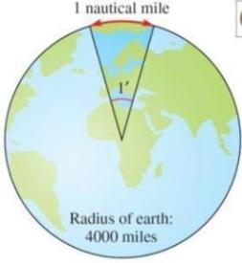

***Solution***











***Exercise***

If two ships are 20 nautical miles apart on the ocean, how many statute miles apart are they?

***Solution***











***Exercise***

Two gears are adjusted so that the smaller gear drives the larger one. If the smaller gear rotates through an angle of 300°, through how many degrees will the larger rotate?

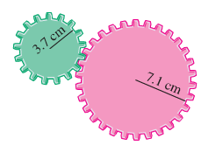***Solution***

Both gears travel the same arc distance (*s*), therefore:











***Exercise***

The rotation of the smaller wheel causes the larger wheel to rotate. Through how many degrees will the larger wheel rotate if the smaller one rotates through 60.0°?

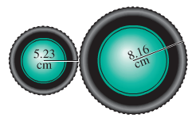***Solution***

Both gears travel the same arc distance (*s*), therefore:











***Exercise***

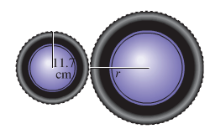Find the radius of the larger wheel if the smaller wheel rotates 80° when the larger wheel rotates 50°.

***Solution***







***Exercise***

How many inches will the weight rise if the pulley is rotated through an angle of 71° 50′?

Through what angle, to the nearest minute, must the pulley be rotated to raise the weight 6 in?

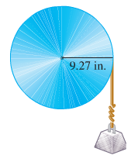

***Solution***

















***Exercise***

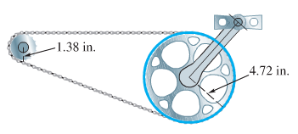The figure shows the chain drive of a bicycle. How far will the bicycle move if the pedals are rotated through 180°? Assume the radius of the bicycle wheel is 13.6 in.

***Solution***



The distance for the pedal gear:



For the smaller gear:



The wheel distance: 

***Exercise***

The circular of a Medicine Wheel is 2500 yrs old. There are 27 aboriginal spokes in the wheel, all equally spaced.

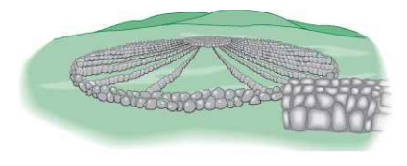

1. Find the measure of each central angle in degrees and in radians.
2. The radius measure of each of the wheel is 76.0 ft, find the circumference.
3. Find the length of each arc intercepted by consecutive pairs of spokes.
4. Find the area of each sector formed by consecutive spokes,

***Solution***

1. The central angle: 



1. 
2. Since 
3. Area 





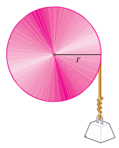***Exercise***

Find the radius of the pulley if a rotation of 51.6° raises the weight 11.4 cm.

***Solution***



***Exercise***

The total arm and blade of a single windshield wiper was 10 in. long and rotated back and forth through an angle of 95°. The shaded region in the figure is the portion of the windshield cleaned by the 7-in. wiper blade. What is the area of the region cleaned?

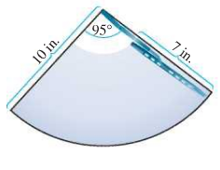

***Solution***

The total angle: 

: The area of arm only (not cleaned by the blade). 

: The area of arm and the blade. 

The total cleaned area:









***Exercise***

A frequent problem in surveying city lots and rural lands adjacent to curves of highways and railways is that of finding the area when one or more of the boundary lines is the arc of the circle. Find the area of the lot.

***Solution***



Using the Pythagorean theorem:



Total area = Area of the sector (ADC) +

Area of the triangle (ABC)

Total area 





***Exercise***

Nautical miles are used by ships and airplanes. They are different from statue miles, which equal 5280 ft. A nautical mile is defined to be the arc length along the equator intercepted by a central angle AOB of 1 min. If the equatorial radius is 3963 mi, use the arc length formula to approximate the number of statute miles in 1 nautical mile.

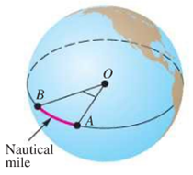

***Solution***



The arc length: 

There are 1.15 statute miles in 1 nautical mile.

***Exercise***

The distance to the moon is approximately 238,900 mi. Use the arc length formula to estimate the diameter *d* of the moon if angle *θ* is measured to be 0.5170°.

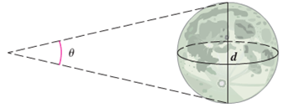

***Solution***







***Solution Section* 2.3 – Linear and Angular Velocities**

***Exercise***

Find the linear velocity of a point moving with uniform circular motion, if *s* = 12 cm and *t* = 2 sec.

***Solution***







***Exercise***

Find the distance ***s*** covered by a point moving with linear velocity *v* = 55 mi/hr and *t* = 0.5 hr.

***Solution***







***Exercise***

Point P sweeps out central angle θ = 12π as it rotates on a circle of radius *r* with *t* = 5π sec. Find the angular velocity of point P.

***Solution***







***Exercise***

Find an equation that expresses *l* in terms of time *t*. Find *l* when *t* is 0.5 sec, 1.0 sec, and 1.5 sec. (assume the light goes through one rotation every 4 seconds.)

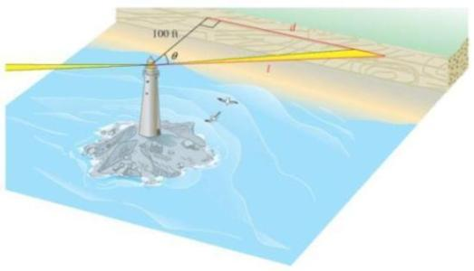

***Solution***













For *t* = 0.5 sec 

For *t* = 1.0 sec 

For *t* = 1.5 sec

***Exercise***

Find the angular velocity, in radians per minute, associated with given 7.2 rpm.

***Solution***



***Exercise***

When Lance Armstrong blazed up Mount Ventoux in the 2002 tour, he was equipped with a 150-millimeter-diameter chainring and a 95-millimeter-diameter sprocket. Lance is known for maintaining a very high cadence, or pedal rate. The sprocket and rear wheel rotate at the same rate, and the diameter of the rear wheel is 700 mm. If he was pedaling at a rate of 90 revolutions per minute, find his speed in kilometers per hour. (1 km = 1,000,000 mm or 106 mm)

***Solution***

Chainring:



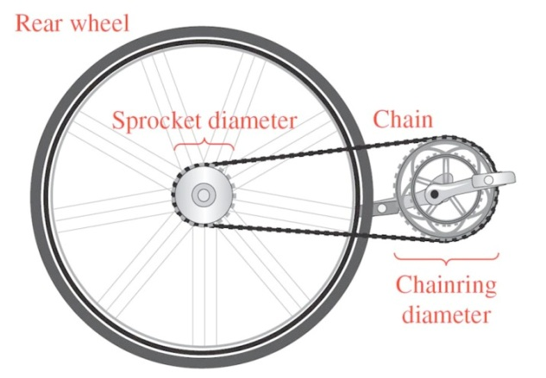 









Sprocket:













***Exercise***

A fire truck parked on the shoulder of a freeway next to a long block wall. The red light on the top of the truck is 10 feet from the wall and rotates through a complete revolution every 2 seconds. Find the equations that give the lengths *d* and l in terms of time.

***Solution***

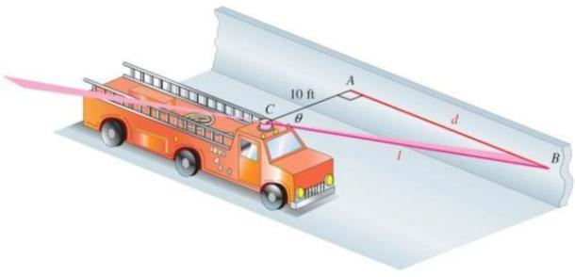 

















***Exercise***

Suppose that point *P* is on a circle with radius 60 cm, and ray *OP* is rotating with angular speed  radian per sec.

1. Find the angle generated by *P* in 8 sec.
2. Find the distance traveled by *P* along the circle in 8 sec.
3. Find the linear speed of *P* in 8 sec.

***Solution***

1. 



1. 



1. 



***Exercise***

A Ferris wheel has a radius 50.0 ft. A person takes a seat and then the wheel turns .

1. How far is the person above the ground?
2. If it takes 30 sec for the wheel to turn , what is the angular speed of the wheel?

***Solution***

1. 







Person is  above the ground

1. 





***Exercise***

Tires of a bicycle have radius 13 in. and are turning at the rate of 215 revolutions per min. How fast is the bicycle traveling in miles per hour? (*Hint*: 1 mi = 5280 ft.)

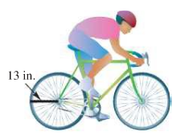

***Solution***









***Exercise***

Earth travels about the sun in an orbit that is almost circular. Assume that the orbit is a circle with radius 93,000,000 mi. Its angular and linear speeds are used in designing solar-power facilities.

1. Assume that a year is 365 days, and find the angle formed by Earth’s movement in one day.
2. Give the angular speed in radians per hour.
3. 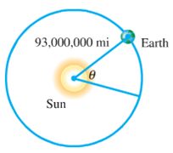Find the linear speed of Earth in miles per hour.

***Solution***

1. 
2. 
3. 

***Exercise***

Earth revolves on its axis once every 24 hr. Assuming that earth’s radius is 6400 km, find the following.

1. Angular speed of Earth in radians per day and radians per hour.
2. Linear speed at the North Pole or South Pole
3. Linear speed ar a city on the equator

***Solution***

1. 





1. At the poles, *r* = 0 so ***v*** = *rw* = 0
2. At the equator, *r* = 6400 km











***Exercise***

The pulley has a radius of 12.96 cm. Suppose it takes 18 sec for 56 cm of belt to go around the pulley.

1. Find the linear speed of the belt in cm per sec.
2. Find the angular speed of the pulley in rad per sec.

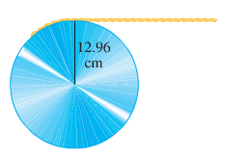***Solution***

***Given***: *s* = 56 cm in *t* = 18 sec

*r* = 12.96 cm

1. 
2. 

***Exercise***

The two pulleys have radii of 15 cm and 8 cm, respectively. The larger pulley rotates 25 times in 36 sec. Find the angular speed of each pulley in rad per sec.

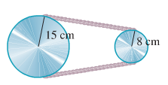

***Solution***

***Given***: 



The angular velocity of the larger pulley is:



The linear velocity of the larger pulley is:



The angular velocity of the smaller pulley is:







***Exercise***

A thread is being pulled off a spool at the rate of 59.4 cm per sec. Find the radius of the spool if it makes 152 revolutions per min.

***Solution***

***Given***: 











***Exercise***

A railroad track is laid along the arc of a circle of radius 1800 ft. The circular part of the track subtends a central angle of 40°. How long (in seconds) will it take a point on the front of a train traveling 30 mph to go around this portion of the track?

***Solution***

***Given***: *r* = 1800 ft.





The arc length: 









***Exercise***

A 90-horsepower outboard motor at full throttle will rotate it propeller at exactly 5000 revolutions per min. Find the angular speed of the propeller in radians per second.

***Solution***





***Exercise***

The shoulder joint can rotate at 25 rad/min. If a golfer’s arm is straight and the distance from the shoulder to the club head is 5.00 ft, find the linear speed of the club head from the shoulder rotation.

***Solution***

***Given***: 



***Solution Section* 2.4 –Translation of Trigonometric Functions**

***Exercise***

Find the amplitude, the period, any vertical translation, and any phase shift of 

***Solution***

***Amplitude***: *A* = 2

***Period***: 

***Phase Shift***: 

***VT:*** 

***Exercise***

Find the amplitude, the period, any vertical translation, and any phase shift of 

***Solution***

***Amplitude***: 

***Period***: 

***Phase Shift***: 

***VT:*** 

***Exercise***

Find the amplitude, the period, any vertical translation, and any phase shift of 

***Solution***

***Amplitude***: 

***Period***: 

***Phase Shift***: 

***VT:*** 

***Exercise***

Find the amplitude, the period, any vertical translation, and any phase shift of 

***Solution***

***Amplitude***: 

***Period***: 

***Phase Shift***: 

***VT:*** 

***Exercise***

Find the amplitude, the period, any vertical translation, and any phase shift of 

***Solution***

***Amplitude***: 

***Period***: 

***Phase Shift***: 

***VT:*** 

***Exercise***

Find the amplitude, the period, any vertical translation, and any phase shift of 

***Solution***

***Amplitude***: 

***Period***: 

***Phase Shift***: 

***VT:*** 

***Exercise***

Find the amplitude, the period, any vertical translation, and any phase shift of 

***Solution***

***Amplitude***: 

***Period***: 

***Phase Shift***: 

***VT:*** 

***Exercise***

Find the amplitude, the period, any vertical translation, and any phase shift of 

***Solution***

***Amplitude***: 

***Period***: 

***Phase Shift***: 

***VT:*** 

***Exercise***

Find the amplitude, the period, any vertical translation, and any phase shift of 

***Solution***

***Amplitude***: 

***Period***: 

***Phase Shift***: 

***VT:*** 

***Exercise***

Find the amplitude, the period, any vertical translation, and any phase shift of 

***Solution***

***Amplitude***: 

***Period***: 

***Phase Shift***: 

***VT:*** 

***Exercise***

Find the amplitude, the period, any vertical translation, and any phase shift of 

***Solution***

***Amplitude***: 

***Period***: 

***Phase Shift***: 

***VT:*** 

***Exercise***

Find the amplitude, the period, any vertical translation, and any phase shift of 

***Solution***

***Amplitude***: 

***Period***: 

***Phase Shift***: 

***VT:*** 

***Exercise***

Find the amplitude, the period, and the phase shift and sketch the graph of the equation



***Solution***

|  |  |
| --- | --- |
| Amplitude = 1  Period  Phase shift |  |

***Exercise***

Find the amplitude, the period, and the phase shift and sketch the graph of the equation



***Solution***

|  |  |
| --- | --- |
| Amplitude = 2  Period  Phase shift |  |

***Exercise***

Find the amplitude, the period, and the phase shift and sketch the graph of the equation



***Solution***

|  |  |
| --- | --- |
| Amplitude = 4  Period  Phase shift |  |

***Exercise***

Find the amplitude, the period, and the phase shift and sketch the graph of the equation



***Solution***

|  |  |
| --- | --- |
| Amplitude = 1  Period  Phase shift |  |

***Exercise***

Find the amplitude, the period, and the phase shift and sketch the graph of the equation



***Solution***

|  |  |
| --- | --- |
| Amplitude = 1  Period  Phase shift |  |

***Exercise***

Find the amplitude, the period, and the phase shift and sketch the graph of the equation



***Solution***

|  |  |
| --- | --- |
| Amplitude = 1  Period  Phase shift |  |

***Exercise***

Find the amplitude, the period, and the phase shift and sketch the graph of the equation



***Solution***

|  |  |
| --- | --- |
| Amplitude = 3  Period  Phase shift |  |

***Exercise***

Find the amplitude, the period, and the phase shift and sketch the graph of the equation



***Solution***

|  |  |
| --- | --- |
| Amplitude = 3  Period  Phase shift |  |

***Exercise***

Find the amplitude, the period, and the phase shift and sketch the graph of the equation



***Solution***

|  |  |
| --- | --- |
| Amplitude = 5  Period  Phase shift |  |

***Exercise***

Find the amplitude, the period, and the phase shift and sketch the graph of the equation



***Solution***

|  |  |
| --- | --- |
| Amplitude = 2  Period  Phase shift |  |

***Exercise***

Find the amplitude, the period, and the phase shift and sketch the graph of the equation



***Solution***

|  |  |
| --- | --- |
| Amplitude = 2  Period  Phase shift |  |

***Exercise***

Find the amplitude, the period, and the phase shift and sketch the graph of the equation



***Solution***

|  |  |
| --- | --- |
| Amplitude = 3  Period  Phase shift |  |

***Exercise***

Find the amplitude, the period, and the phase shift and sketch the graph of the equation



***Solution***

|  |  |
| --- | --- |
| Amplitude = 5  Period  Phase shift |  |

***Exercise***

Find the amplitude, the period, and the phase shift and sketch the graph of the equation



***Solution***

|  |  |
| --- | --- |
| Amplitude = 4  Period  Phase shift |  |

***Exercise***

Find the amplitude, the period, any vertical translation, and any phase shift. Then graph a one complete cycle of 

***Solution***

One cycle: 

 ***Multiply by 2***



|  |  |  |
| --- | --- | --- |
| *x* | *x* |  |
| 0 | 0 | 1 |
|  |  | 0 |
|  |  | -1 |
|  |  | 0 |
| *P* | *4π* | 1 |

Amplitude: *A* = 1

Period: 

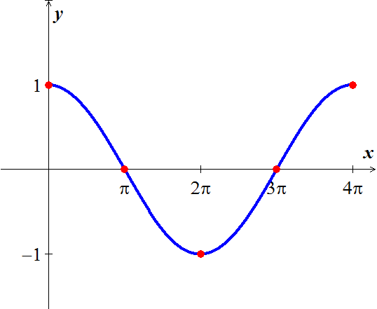

|  |  |
| --- | --- |
| *x* |  |
| 0 | 0 |
|  | -2 |
| 1 | 0 |
|  | 2 |
| *2* | 0 |

***Exercise***

Find the amplitude, the period, any vertical translation, and any phase shift. Then graph 

***Solution***







Amplitude: *A* = 2

Period: 

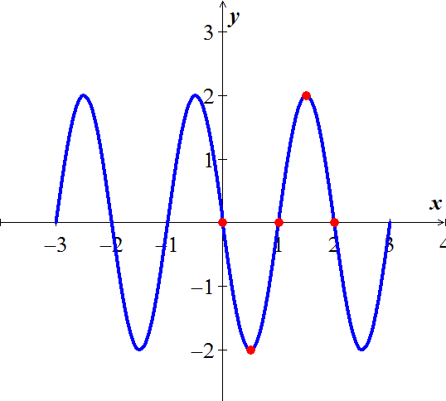

***Exercise***

|  |  |
| --- | --- |
| *x* |  |
| 0 | 4 |
|  | 0 |
|  | -4 |
|  | 0 |
| *3π* | 4 |

Find the amplitude, the period, any vertical translation, and any phase shift. Then graph 

***Solution***

Amplitude: *A* = 4

Period: 





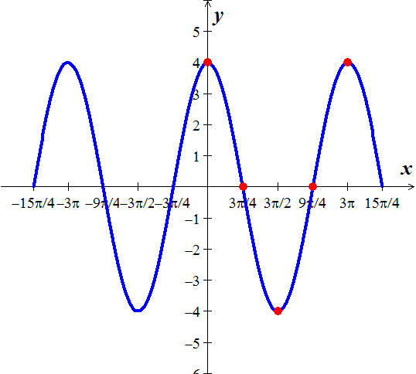

***Exercise***

|  |  |  |
| --- | --- | --- |
| *x* | *x* |  |
|  |  | 1 |
|  |  | 0 |
|  |  | -1 |
|  |  | 0 |
|  |  | 1 |

Graph one complete cycle 

***Solution***

*Amplitude*: *A* = 

*Period*: 

*Phase Shift* = 



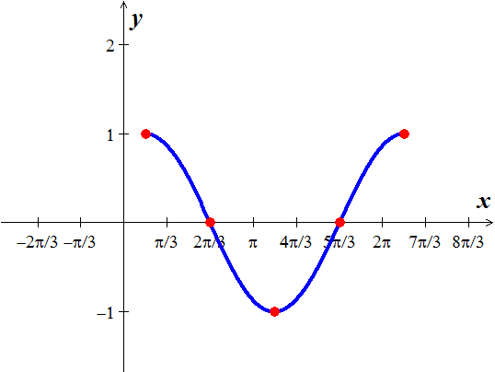

***Exercise***

Graph one complete cycle 

***Solution***

Amplitude: *A* = 

|  |  |
| --- | --- |
| *x* |  |
|  |  |
|  |  |
|  |  |
|  |  |
|  |  |

Period: 

Phase Shift: 

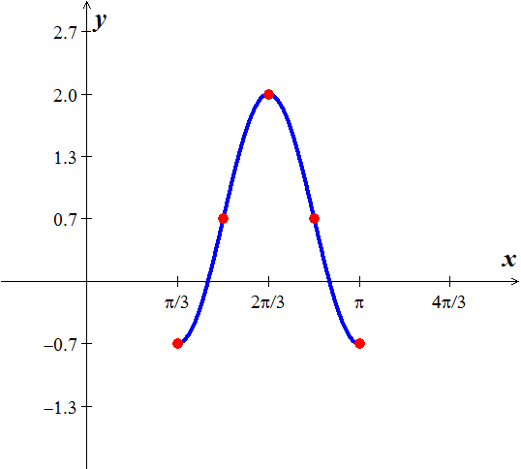

***Exercise***

Graph one complete cycle 

***Solution***

Amplitude: *A* = 

|  |  |
| --- | --- |
| ***x*** |  |
|  | -3 |
| 0 | -2 |
|  | -3 |
| 1 | -4 |
|  | -3 |

Period: 

Phase Shift: 



***Exercise***

Graph  over two periods.

***Solution***

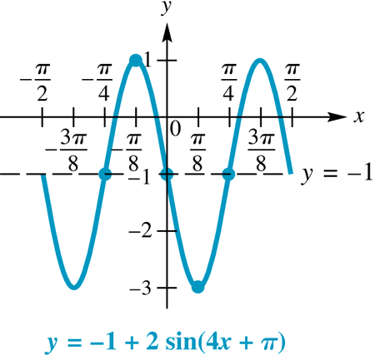

***Exercise***

Find an equation  or to match the graph

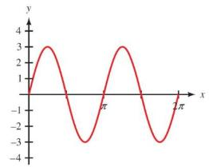

***Solution***



***Amplitude*** = 3

 

***Exercise***

Find an equation  or to match the graph

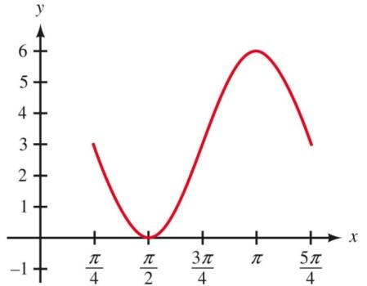

***Solution***



***Amplitude*** = 3

 

***Exercise***

Find an equation  or to match the graph

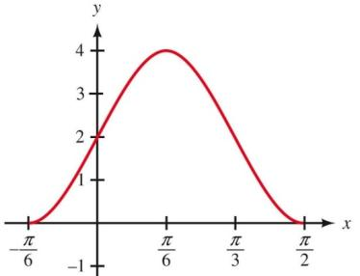

***Solution***

|  |  |
| --- | --- |
|  |  |
|  | ***Amplitude*** = 2 |

 

***Exercise***

Find an equation  or to match the graph

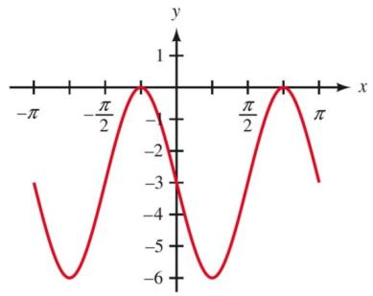

***Solution***

|  |  |
| --- | --- |
|  |  |
|  | ***Amplitude*** = 3 |

 

***Exercise***

Find an equation  or to match the graph

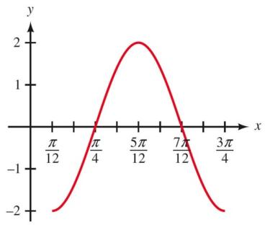

***Solution***

|  |  |
| --- | --- |
|  |  |
|  | ***Amplitude*** = 2 |

 

***Exercise***

Find an equation  or to match the graph

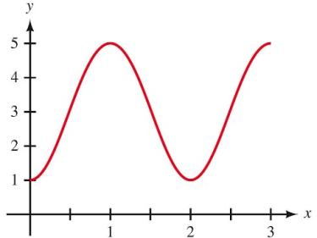

***Solution***

|  |  |
| --- | --- |
|  |  |
|  | ***Amplitude*** = 2 |

 

***Exercise***

The figure shows a function ***f*** that models the tides in feet at Clearwater Beach, *x* hours after midnight starting on Aug. 26,

1. Find the time between high tides.
2. What is the difference in water levels between high tide and low tide?
3. The tides can be modeled by . Estimate the tides when *x* = 10.

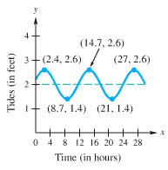

***Solution***

1. Time between high tides = 14.7 – 2.4 = 12.3 hrs.
2. Difference in water levels between high tide and low tide = 2.6 – 1.4 = 1.2 *ft*.
3. 

***Exercise***

The maximum afternoon temperature in a given city might be modeled by 

Where *t* represents the maximum afternoon temperature in month *x*, with *x* = 0 representing January, *x* = 1 representing February, and so on.. Find the maximum afternoon temperature to the nearest degree for each month.

1. Jan.
2. Apr.
3. May.
4. Jun.
5. Oct.

***Solution***

1. Jan. 
2. Apr. 
3. May. 
4. Jun. 
5. Oct. 

***Exercise***

A mass attached to a spring oscillates upward and downward. The length *L* of the spring after *t* seconds is given by the function , where *L* is measured in cm.

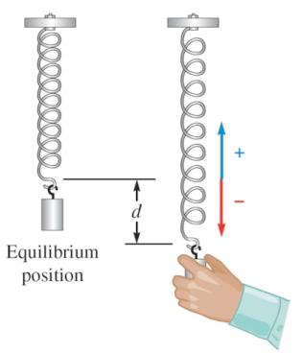

1. Sketch the graph of this function for 
2. What is the length the spring when it is at equilibrium?
3. What is the length the spring when it is shortest?
4. What is the length the spring when it is longest?

***Solution***

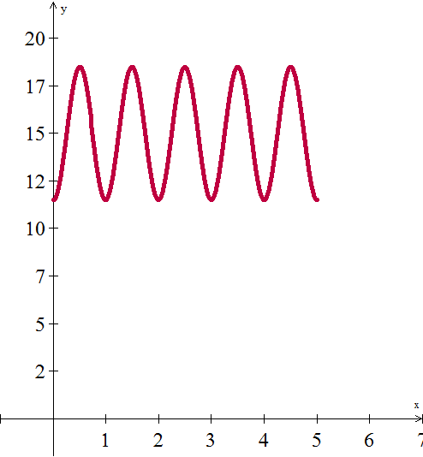

1. The length the spring when it is at equilibrium L = 15 cm
2. 
3. 

***Exercise***

The diameter of the Ferris wheel is 250 *ft*, the distance from the ground to the bottom of the wheel is 14 *ft.* We found the height of a rider on that Ferris wheel was given by the function:



Where *t* is the number of minutes from the beginning of a ride. Graph a complete cycle of this function.

|  |  |
| --- | --- |
| *t* |  |
| 0 | 139-125=14 |
| 5 | 139 |
| 10 | 139+125=264 |
| 15 | 139 |
| 20 | 14 |

***Solution***

***Amplitude***: *A* = 125

***Period***: 

***Phase Shift***: 

***VT:*** 

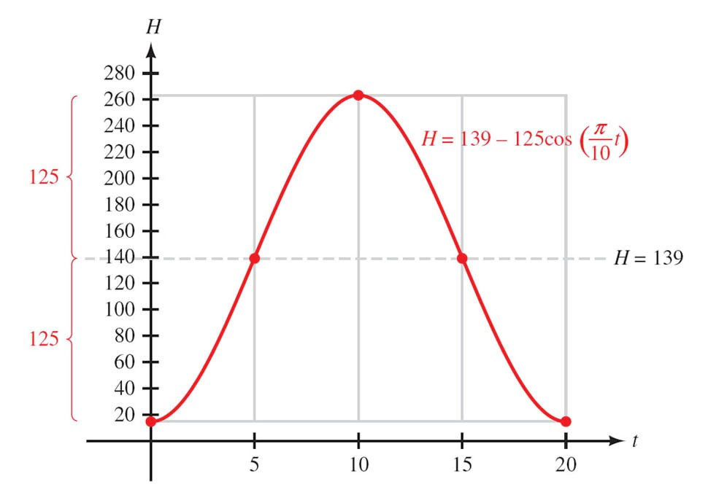

***Solution Section* 2.5 – Other Trigonometric Functions**

***Exercise***

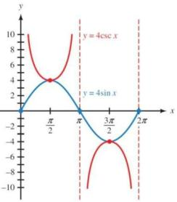Graph one complete cycle 

***Solution***

Period 

First, graph

|  |  |
| --- | --- |
| *x* |  |
| 0 | 0 |
|  | 3 |
|  | ∞ |
|  | -3 |
|  | 0 |

***Exercise***

Graph 

***Solution***

Period = 

One cycle: 

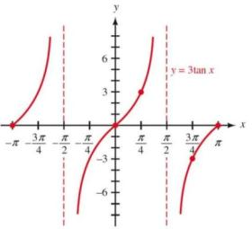

***Exercise***

Graph one complete cycle 

***Solution***

Period = 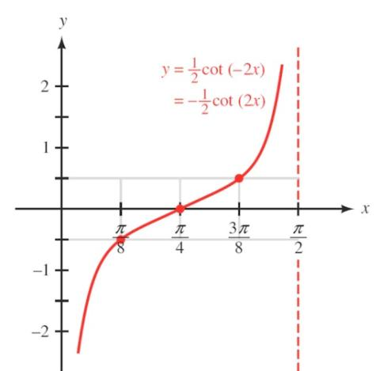

One cycle: 



|  |  |
| --- | --- |
| *x* |  |
| 0 | - ∞ |
|  | -0.5 |
|  | 0 |
|  | 0.5 |
|  | ∞ |

***Exercise***

Graph over a 2-period interval 

***Solution***

|  |  |
| --- | --- |
|  |  |
|  |
| ***Vertical translation*** = 1 |
| ***VA*** = |

***Exercise***

Graph over a 2-period interval 

***Solution***

|  |  |
| --- | --- |
|  |  |
|  |
| ***Vertical translation*** = -2 |
| ***VA*** = |

***Exercise***

Graph over a one-period interval 

***Solution***

|  |  |
| --- | --- |
|  |  |
|  |
| ***Vertical translation*** = 1 |
|  |

***Exercise***

Graph over a one-period interval 

***Solution***

|  |  |
| --- | --- |
|  |  |
|  |
| ***Vertical translation*** = 1 |
| ***VA*** = |

***Exercise***

Find an equation to match the graph

***Solution***

|  |  |
| --- | --- |
|  |  |
|  |
|  |
|  |

|  |  |
| --- | --- |
|  |  |
|  |
|  |
|  |

|  |  |
| --- | --- |
|  |  |
|  |
|  |
|  |

***Exercise***

A rotating beacon is located at point *A* next to a long wall. The beacon is 9 m from the wall. The distance ***a***is given by , where *t* is time measured in seconds since the beacon started rotating. (When *t* = 0, the beacon is aimed at point *R*.) Find ***a*** for *t* = 0.45

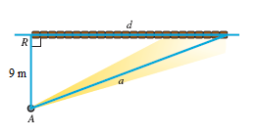

***Solution***







***Exercise***

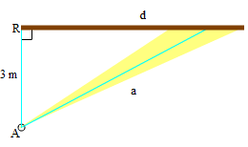A rotating beacon is located 3 m south of point *R* on an east-west wall. *d*, the length of the light display along the wall from *R*, is given by , where *t* is time measured in seconds since the beacon started rotating. (When *t* = 0, the beacon is aimed at point *R*. When the beacon is aimed to the right of *R*, the value of *d* is positive; *d* is negative if the beacon is aimed to the left of *R*.) Find a for *t* = 0.8

***Solution***





***Exercise***

The shortest path for the sun’s rays through Earth’s atmosphere occurs when the sun is directly overhead. Disregarding the curvature of Earth, as the sun moves lower on the horizon, the distance that sunlight passes through the atmosphere increases by a factor of , where *θ* is the angle of elevation of the sun. This increased distance reduces both the intensity of the sun and the amount of ultraviolet light that reached Earth’s surface.

1. Verify that 
2. Determine *θ* when 
3. The atmosphere filters out the ultraviolet light that causes skin to burn, Compare the difference between sunbathing when  and when . Which measure gives less ultraviolet light?

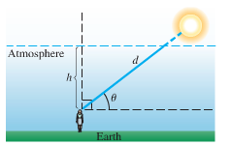***Solution***

1. 

 (***cross-multiplication***)

***h***

1. 



1. 

When the distance to the sun is lager , there is less ultraviolet light reaching the earth’s surface. In this case, sunlight passes through 15% more atmosphere.

***Exercise***

Let a person whose eyes are  feet from the ground stand ***d*** feet from an object  feet tall, where  feet. Let θ be the angle of elevation to the top of the object.

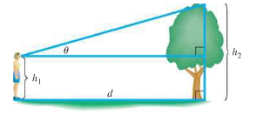

***h***

1. Show that 
2. Let  and . Graph ***d*** for the interval 

***Solution***

1. 





1. 



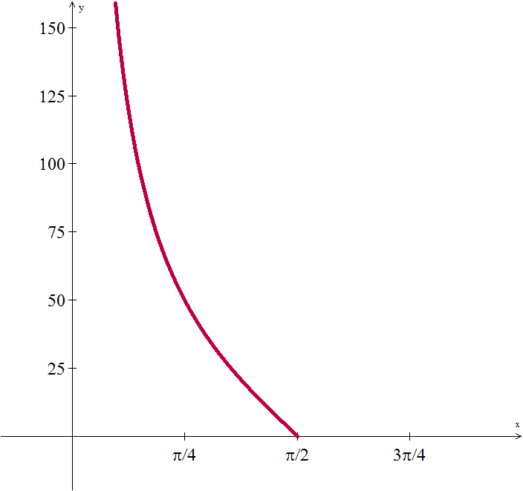

***Solution Section* 2.6 - Inverse Trigonometry Functions**

***Exercise***

Evaluate without using a calculator: 

***Solution***



***Exercise***

Evaluate without using a calculator: 

***Solution***



***Exercise***

Evaluate without using a calculator: 

***Solution***

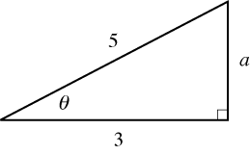







***Exercise***

Evaluate without using a calculator: 

***Solution***

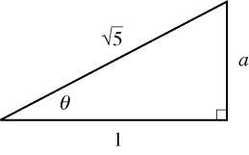











***Exercise***

Evaluate without using a calculator: 

***Solution***









***Exercise***

Evaluate without using a calculator: 

***Solution***



***Exercise***

Evaluate without using a calculator: 



***Solution***







***Exercise***

Evaluate without using a calculator: 

***Solution***





***Exercise***

Evaluate without using a calculator: 

***Solution***







***Exercise***

Evaluate without using a calculator: 

***Solution***





***Exercise***

Write an equivalent expression that involves *x* only for 

***Solution***





***Exercise***

Write an equivalent expression that involves *x* only for 



***Solution***









***Exercise***

Write an equivalent expression that involves *x* only for 

***Solution***



