***Solution Section* 3.1 – Proving Identities**

***Exercise***

Prove the identity 

***Solution***















***Exercise***

Prove the identity 

***Solution***









***Exercise***

Prove the identity 

***Solution***







***Exercise***

Prove the identity 

***Solution***





***Exercise***

Prove the identity 

***Solution***









***Exercise***

Prove the identity 

***Solution***





***Exercise***

Prove the identity 

***Solution***







***Exercise***

Prove the identity 

***Solution***











***Exercise***

Prove 

***Solution***







***Exercise***

Prove 

***Solution***







***Exercise***

Prove 

***Solution***







***Exercise***

Prove 

***Solution***













***Exercise***

Prove 

***Solution***

















***Exercise***

Prove: 

***Solution***











***Exercise***

Prove: 

***Solution***











***Exercise***

Prove: 

***Solution***













***Exercise***

Prove the identity: 

***Solution***







***Exercise***

Prove the identity: 

***Solution***







***Exercise***

Prove the identity: 

***Solution***













***Exercise***

Prove the identity: 

***Solution***









***Exercise***

Prove the identity: 

***Solution***







***Exercise***

Prove the following equation is an identity: 

***Solution***





***Exercise***

Prove the following equation is an identity: 

***Solution***









***Exercise***

Prove the following equation is an identity: 

***Solution***









***Exercise***

Prove the following equation is an identity: 

***Solution***









***Exercise***

Prove the following equation is an identity: 

***Solution***









***Exercise***

Prove the following equation is an identity: 

***Solution***











***Exercise***

Prove the following equation is an identity: 

***Solution***







***Exercise***

Prove the following equation is an identity: 

***Solution***







***Exercise***

Prove the following equation is an identity: 

***Solution***











***Exercise***

Prove the following equation is an identity: 

***Solution***





***Exercise***

Prove the following equation is an identity: 

***Solution***









***Exercise***

Prove the following equation is an identity: 

***Solution***





***Exercise***

Prove the following equation is an identity: 

***Solution***













***Exercise***

Prove the following equation is an identity: 

***Solution***













***Exercise***

Prove the following equation is an identity: 

***Solution***











***Exercise***

Prove the following equation is an identity: 

***Solution***







***Exercise***

Prove the following equation is an identity: 

***Solution***







***Exercise***

Prove the following equation is an identity: 

***Solution***



 







***Exercise***

Prove the following equation is an identity: 

***Solution***

 



***Exercise***

Prove the following equation is an identity: 

***Solution***









***Exercise***

Prove the following equation is an identity: 

***Solution***









***Exercise***

Prove the following equation is an identity: 

***Solution***











***Exercise***

Prove the following equation is an identity: 

***Solution***











***Exercise***

Prove the following equation is an identity: 

***Solution***







***Exercise***

Prove the following equation is an identity: 

***Solution***







***Exercise***

Prove the following equation is an identity: 

***Solution***













***Exercise***

Prove the following equation is an identity: 

***Solution***







***Exercise***

Prove the following equation is an identity: 

***Solution***

 









***Exercise***

Prove the following equation is an identity: 

***Solution***











***Exercise***

Prove the following equation is an identity: 

***Solution***









***Exercise***

Prove the following equation is an identity: 

***Solution***











***Exercise***

Prove the following equation is an identity: 

***Solution***









***Exercise***

Prove the following equation is an identity: 

***Solution***









***Exercise***

Prove the following equation is an identity: 

***Solution***















***Exercise***

Prove the following equation is an identity: 

***Solution***









***Exercise***

Prove the following equation is an identity: 

***Solution***













***Exercise***

Prove the following equation is an identity: 

***Solution***





***Exercise***

Prove the following equation is an identity: 

***Solution***











***Exercise***

Prove the following equation is an identity: 

***Solution***





***Exercise***

Prove the following equation is an identity: 

***Solution***









***Exercise***

Prove the following equation is an identity: 

***Solution***







***Exercise***

Prove the following equation is an identity: 

***Solution***









***Exercise***

Prove the following equation is an identity: 

***Solution***





















***Exercise***

Prove the following equation is an identity: 

***Solution***











***Exercise***

Prove the following equation is an identity: 

***Solution***





 







***Exercise***

Prove the following equation is an identity: 

***Solution***





***Exercise***

Prove the following equation is an identity: 

***Solution***











***Exercise***

Prove the following equation is an identity: 

***Solution***





***Exercise***

Prove the following equation is an identity: 

***Solution***







***Exercise***

Prove the following equation is an identity: 

***Solution***

 





***Exercise***

Prove the following equation is an identity: 

***Solution***













***Exercise***

Prove the following equation is an identity: 

***Solution***











***Exercise***

Prove the following equation is an identity: 

***Solution***







***Exercise***

Prove the following equation is an identity: 

***Solution***







***Exercise***

Prove the following equation is an identity: 

***Solution***







***Exercise***

Prove the following equation is an identity: 

***Solution***











***Exercise***

Prove the following equation is an identity: 

***Solution***







***Exercise***

Prove the following equation is an identity: 

***Solution***







***Exercise***

Prove the following equation is an identity: 

***Solution***











***Exercise***

Prove the following equation is an identity: 

***Solution***







***Exercise***

Prove the following equation is an identity: 

***Solution***







***Solution Section* 3.2 – Sum and Difference Formulas**

***Exercise***

Prove the identity 

***Solution***







***Exercise***

Prove the identity 

***Solution***

















***Exercise***

Prove the identity 

***Solution***







***Exercise***

Show that 

***Solution***







***Exercise***

Prove the identity 

***Solution***











***Exercise***

Prove the identity 

***Solution***









***Exercise***

Write the expression as a single trigonometric function 

***Solution***





***Exercise***

If with *A* in QII, and  with *B* in QIII, find , , and 

***Solution***

|  |  |
| --- | --- |
|  |  |
|  |  |
|  |  |

***Exercise***

If with *A* in QI, and  with *B* in QI, find , , and 

***Solution***

|  |  |
| --- | --- |
|  |  |
|  |  |
|  |  |

***Exercise***

If with *A* in QI, and  with *B* in QI, find 

***Solution***





















***Exercise***

Prove the following equation is an identity: 

***Solution***







***Exercise***

Prove the following equation is an identity: 

***Solution***





***Exercise***

Prove the following equation is an identity: 

***Solution***

 



***Exercise***

Prove the following equation is an identity: 

***Solution***







***Exercise***

Prove the following equation is an identity: 

***Solution***















***Exercise***

Prove the following equation is an identity: 

***Solution***













***Exercise***

Prove the following equation is an identity: 

***Solution***







***Exercise***

Prove the following equation is an identity: 

***Solution***







***Exercise***

Prove the following equation is an identity: 

***Solution***







***Exercise***

Prove the following equation is an identity: 

***Solution***









***Exercise***

Prove the following equation is an identity: 

***Solution***









***Exercise***

Prove the following equation is an identity: 

***Solution***















***Exercise***

Prove the following equation is an identity: 

***Solution***







***Exercise***

Prove the following equation is an identity: 

***Solution***







***Solution Section* 3.3 – Double-angle Formulas**

***Exercise***

Let  with A in QIII and find 

***Solution***











***Exercise***

Let  with *x* in QIV and find 

***Solution***

*x* in QIV 























***Exercise***

Verify: 

***Solution***

 



***Exercise***

Prove: 

***Solution***



 



***Exercise***

Prove: 

***Solution***











***Exercise***

Simplify 

***Solution***

 



***Exercise***

Write  in terms of 

***Solution***







 









***Exercise***

Find the values of the six trigonometric functions of *θ* if 

***Solution***

|  |  |
| --- | --- |
|  |  |
|  |  |
|  |  |

***Exercise***

Use a right triangle in QII to find the value of 

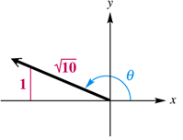

***Solution***

















***Exercise***

Prove the following equation is an identity: 

***Solution***













***Exercise***

Prove the following equation is an identity: 

***Solution***











***Exercise***

Prove the following equation is an identity: 

***Solution***

 





***Exercise***

Prove: 

***Solution***











***Exercise***

Prove the following equation is an identity: 

***Solution***

 

 



***Exercise***

Prove the following equation is an identity: 

***Solution***









***Exercise***

Prove the following equation is an identity: 

***Solution***







***Exercise***

Prove the following equation is an identity: 

***Solution***





































***Exercise***

Prove the following equation is an identity: 

***Solution***







***Exercise***

Prove the following equation is an identity: 

***Solution***









***Exercise***

Prove the following equation is an identity: 

***Solution***













***Exercise***

Prove the following equation is an identity: 

***Solution***

|  |  |
| --- | --- |
|  |  |

***Exercise***

Prove the following equation is an identity: 

***Solution***













***Exercise***

Prove the following equation is an identity: 

***Solution***





 





***Exercise***

Prove the following equation is an identity: 

***Solution***













***Exercise***

Prove the following equation is an identity: 

***Solution***







***Exercise***

Prove the following equation is an identity: 

***Solution***











***Exercise***

Prove the following equation is an identity: 

***Solution***











***Exercise***

Prove the following equation is an identity: 

***Solution***









***Solution Section* 3.4 – Half-Angle Formulas**

***Exercise***

Use half-angle formulas to find the exact value of 

***Solution***



 











***Exercise***

Find the exact of 

***Solution***

















***Exercise***

Given: , find 

***Solution***



|  |  |  |
| --- | --- | --- |
|  |  |  |

***Exercise***

Prove the identity 

***Solution***



 







***Exercise***

Prove the identity 

***Solution***

 









***Exercise***

Prove the following equation is an identity: 

***Solution***

 

 



***Exercise***

Prove the following equation is an identity: 

***Solution***













***Exercise***

Prove the following equation is an identity: 

***Solution***









***Exercise***

Prove the following equation is an identity: 

***Solution***

 

















 



***Exercise***

Prove the following equation is an identity: 

***Solution***

 













***Exercise***

Prove the following equation is an identity: 

***Solution***







***Exercise***

Prove the following equation is an identity: 

***Solution***









***Solution Section* 3.5 – Additional Identities**

***Exercise***

Write  as a sum or difference

***Solution***





***Exercise***

Evaluate without using the calculator 

***Solution***





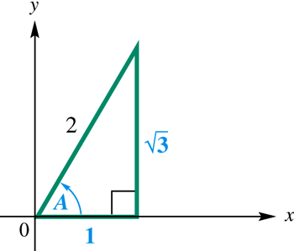 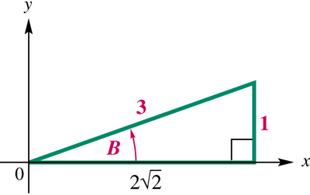

 









***Exercise***

Evaluate without using the calculator 

***Solution***







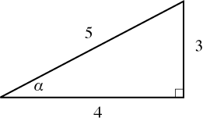 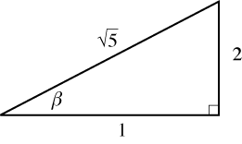











***Exercise***

Evaluate without using the calculator 

***Solution***













***Exercise***

Write as an equivalent expression involving only *x*.

***Solution***

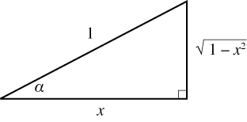 













***Exercise***

Write as an equivalent expression involving only *x*.

***Solution***



















***Exercise***

Evaluate without using the calculator 

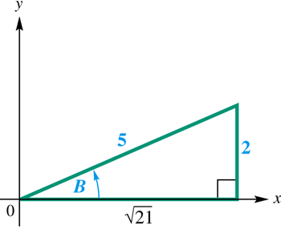***Solution***























***Exercise***

Evaluate without using the calculator 

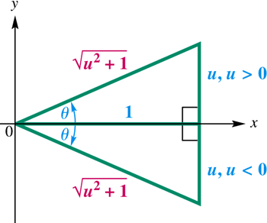***Solution***









***Exercise***

Write as an equivalent expression involving only *x*.

***Solution***









***Exercise***

Prove the identity: 

***Solution***









***Exercise***

Prove the following equation is an identity: 

***Solution***









***Exercise***

Prove the following equation is an identity: 

***Solution***







***Exercise***

Prove the following equation is an identity: 

***Solution***







***Exercise***

Prove the following equation is an identity: 

***Solution***







***Exercise***

Prove the following equation is an identity: 

***Solution***













***Exercise***

Prove the following equation is an identity: 

***Solution***







***Exercise***

Prove the following equation is an identity: 

***Solution***









***Exercise***

Prove the following equation is an identity: 

***Solution***







***Exercise***

Prove the following equation is an identity: 

***Solution***









***Exercise***

Prove the following equation is an identity: 

***Solution***













***Exercise***

Prove the following equation is an identity: 

***Solution***











***Exercise***

Prove the following equation is an identity: 

***Solution***







***Exercise***

Prove the following equation is an identity: 

***Solution***









***Exercise***

Prove the following equation is an identity: 

***Solution***









***Exercise***

Prove the following equation is an identity: 

***Solution***











***Exercise***

Prove the following equation is an identity: 

***Solution***









***Exercise***

Prove the following equation is an identity: 

***Solution***















***Exercise***

Prove the following equation is an identity: 

***Solution***







***Exercise***

Prove the following equation is an identity: 

***Solution***





***Solution Section* 3.6 – Solving Trigonometry Equations**

***Exercise***

Solve  

***Solution***







***Exercise***

Solve  

***Solution***

 











***Exercise***

Solve  

***Solution***



 

 







***Exercise***

Solve  

***Solution***











 





***Exercise***

Solve 

***Solution***

*is negative → cosine is in QII or QIII*.

 

 

 

 

 

***Exercise***

Solve:  

***Solution***

 











***The solutions are:*** 

***Exercise***

Solve:  

***Solution***







 

 

***The solutions are:*** 

***Exercise***

Solve:  

***Solution***





 









 

 

*Check*

|  |  |  |
| --- | --- | --- |
|  |  | **(*False statement*)** |

***The solutions are:*** 

***Exercise***

Solve:  

***Solution***

 













***The solutions are:*** 

***Exercise***

Solve:  

***Solution***





 

 

 

 



*Negative sign → cosine is in QII or QIII*

 

 

***The solutions are:*** 

***Exercise***

Solve  

***Solution***





 

 



***The solutions are:*** 

***Exercise***

Solve  

***Solution***



 

  



***The solutions are:*** 

***Exercise***

Solve  

***Solution***

















|  |  |
| --- | --- |
| ***False*** |  |

***The solutions are:*** 

***Exercise***

If a projectile (such as a bullet) is fired into the air with an initial velocity ***v*** at an angle of elevation θ, then the height *h* of the projectile at time *t* is given by:



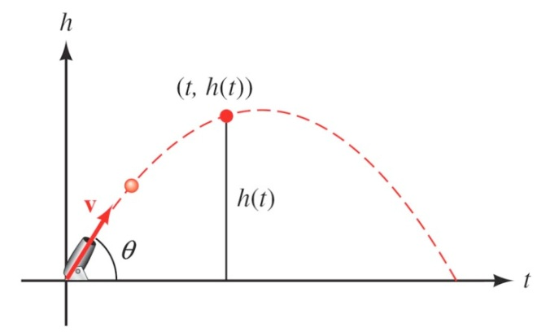

1. Give the equation for the height, if ***v*** is 600 *ft./sec* and θ = 45°.
2. Use the equation in part (*a*) to find the height of the object after  seconds.
3. Find the angle of elevation of θ of a rifle barrel, if a bullet fired at 1,500 ft./sec takes 3 seconds to reach a height of 750 feet. Give your answer in the nearest of a degree.

***Solution***

1. 





1. 



1. 









