2π (radians) ≡ 360° ≡ 1 revolution  (radians)  



 

**SOHCAHTOA**

A way of remembering how to compute the [**sine**](http://www.mathwords.com/s/sine.htm), [**cosine**](http://www.mathwords.com/c/cosine.htm), and [**tangent**](http://www.mathwords.com/t/tangent.htm) of an [angle](http://www.mathwords.com/a/angle.htm).

**SOH** stands for **S**ine equals **O**pposite over [**H**ypotenuse](http://www.mathwords.com/h/hypotenuse.htm).

**CAH** stands for **C**osine equals [**A**djacent](http://www.mathwords.com/a/adjacent.htm) over [**H**ypotenuse](http://www.mathwords.com/h/hypotenuse.htm).

**TOA** stands for **T**angent equals **O**ppositeover [**A**djacent](http://www.mathwords.com/a/adjacent.htm).

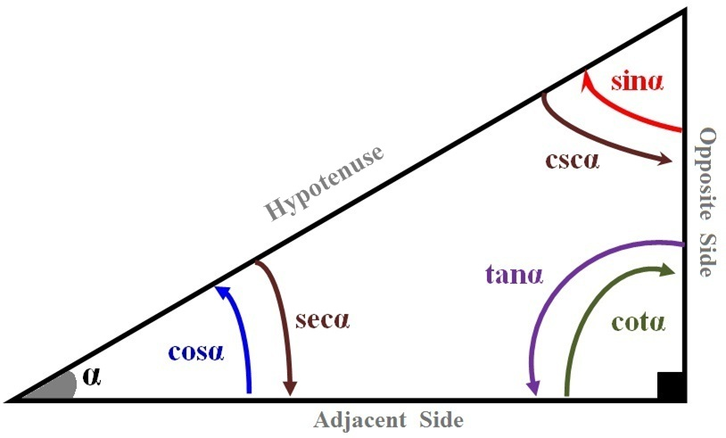 ***SOH*** 

***CAH*** 

***TOA*** 







|  |  |  |  |  |  |  |  |
| --- | --- | --- | --- | --- | --- | --- | --- |
| Angle α  in *degree* | Angle α  in *radian* | *sin* α | *cos* α | *tan* α | *cot* α | *sec* α | *csc* α |
| 0° | 0 | 0 | 1 | 0 | ∞ (*undefined*) | 1 | ∞ (*undefined*) |
| 30° | π/6 |  |  |  |  |  | 2 |
| 45° | π/4 |  |  | 1 | 1 |  |  |
| 60° | π/3 |  |  |  |  | 2 |  |
| 90° | π/2 | 1 | 0 | ± ∞ | 0 | ± ∞ | 1 |
| 120° | 2π/3 |  | - | - | - | -2 |  |
| 135° | 3π/4 |  | - | -1 | -1 | - |  |
| 150° | 5π/6 |  | - | - | - | - | 2 |
| 180° | π | 0 | -1 | 0 | ± ∞ | -1 | ± ∞ |

|  |  |  |  |  |  |  |
| --- | --- | --- | --- | --- | --- | --- |
| **Function** | **Domain (*n* ∈ Ζ)** | **Range** | **I** | **II** | **III** | **IV** |
| *y = sin t* | {*t* | - ∞ < *t* < ∞} | -1 ≤ *y* ≤ 1 | **+** | **+** | **-** | **-** |
| *y = cos t* | {*t* | - ∞ < *t* < ∞} | -1 ≤ *y* ≤ 1 | **+** | **-** | **-** | **+** |
| *y = tan t* | {*t* | - ∞ < *t* < ∞, *t* ≠ (2n+1) π/2} | -∞ < *y* < ∞ | **+** | **-** | **+** | **-** |
| *y = cot t* | {*t* | - ∞ < *t* < ∞, *t* ≠ nπ} | -∞ < *y* < ∞ | **+** | **-** | **+** | **-** |
| *y = csc t* | {*t* | - ∞ < *t* < ∞, *t* ≠ nπ} | *y* ≤ -1, *y* ≥ 1 | **+** | **+** | **-** | **-** |
| *y = sec t* | {*t* | - ∞ < *t* < ∞, *t* ≠ (2n+1) π/2} | *y* ≤ -1, *y* ≥ 1 | **+** | **-** | **-** | **+** |

  

cos(-α) = cosα sin(-α) = - sinα tan(-α) = - tanα

cos(90° - α) = sinα sin(90° - α) = cosα tan(90° - α) = cotα

cos(α - β) = cosα cosβ + sinα sinβ cos(α + β) = cosα cosβ - sinα sinβ

sin(α - β) = sinα cosβ - cosα sinβ sin(α + β) = sinα cosβ + cosα sinβ

 

***Double-Angle***

|  |  |  |
| --- | --- | --- |
|  |  |  |
|  |  |  |

***Half-Angle:***

|  |  |  |
| --- | --- | --- |
|  |  |  |

***Product-to-Sum:***

|  |  |
| --- | --- |
|  |  |
|  |  |

***Sum-to-Product:***

|  |  |
| --- | --- |
|  |  |
|  |  |

 where , , and 

 *iff*  where –1 ≤ *x* ≤ 1 and 0 ≤ *y* ≤ π

 *iff*  where –1 ≤ *x* ≤ 1 and -π/2 ≤ *y* ≤ π/2

***Law of Sines***:  

***Law of Cosines***:

|  |  |  |
| --- | --- | --- |
|  |  |  |
|  |  |  |
|  |  |  |

***Vectors***:

Magnitude: 

Dot Product: 

Angle: 

  

 

**De Moivre’s *Theorem*:** 



The graphs of  and, where B > 0, will have the following characteristics:

Amplitude = ** Period =  Phase Shift  One cycle:

Vertical Shift: 

***To graph*** *“****Sine* or *Cosine”***

1. Find the Amplitude
2. Find the Period
3. Construct a table

|  |  |  |
| --- | --- | --- |
| *x* |  |  |
|  |  |  |
|  |  |  |
|  |  |  |
|  |  |  |
|  |  |  |

1. Graph *One Cycle*
2. Extend the graph, if necessary

The graphs of  and, where B > 0, will have the following characteristics:

*No Amplitude* Period =  Phase Shift = One cycle:

|  |  |  |
| --- | --- | --- |
| *x* |  |  |
|  |  |  |
|  |  |  |
|  |  |  |
|  |  |  |
|  |  |  |

Vertical Shift: 

|  |  |  |
| --- | --- | --- |
|  | ***sin*** | ***cos*** |
| 0° | 0 | 4 |
| 30° | 1 | 3 |
| 45° | 2 | 2 |
| 60° | 3 | 1 |
| 90° | 4 | 0 |

|  |  |  |
| --- | --- | --- |
| 0° |  |  |
| 30° |  |  |
| 45° |  |  |
| 60° |  |  |
| 90° |  |  |

|  |  |  |
| --- | --- | --- |
| 0° |  |  |
| 30° |  |  |
| 45° |  |  |
| 60° |  |  |
| 90° |  |  |

|  |  |  |
| --- | --- | --- |
|  | *sin* | *cos* |
| 0° | 0 | 1 |
| 30° |  |  |
| 45° |  |  |
| 60° |  |  |
| 90° | 1 | 0 |

 



 

 







