Math 1316 – Trigonometry **Assignment 2** **Name**  _________________

*Instructor*: Fred Khoury

1. You will model a double Ferris wheel with a 50-foot arm that is spinning at a rate of 3 revolutions per minute in a counterclockwise direction. The center of the arm is 44 feet above the ground. The diameter of each wheel is 32 feet, and the wheels turn at a rate of 5 revolutions per minute in a clockwise direction. A diagram below is shown below. *M* is the midpoint of the arm; an *O* is the center of the lower wheel. Assume the rider is initially at point *P* on the wheel.

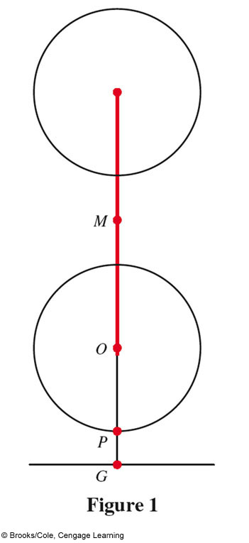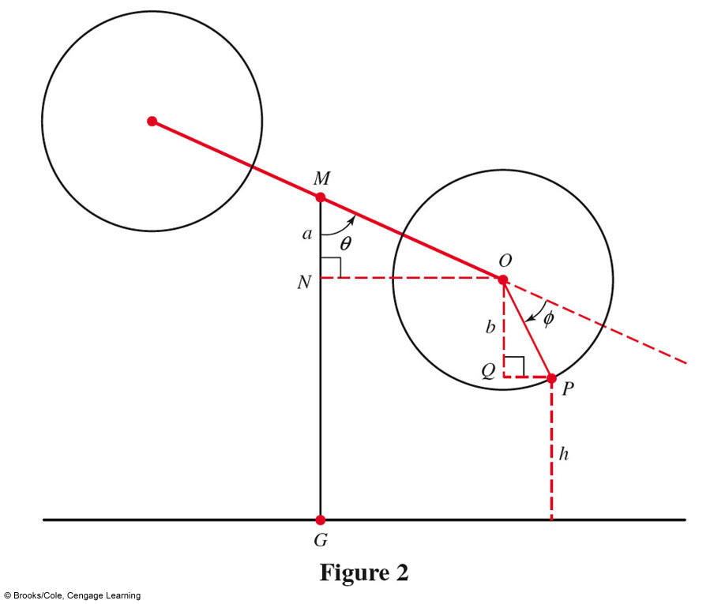

1. Determine the lengths of *MO, OP*, and *MG (left figure)*
2. Find angle *QOP* in terms of *θ* and *φ*.
3. Use right triangle trigonometry to find lengths *a* and *b*, and then the height of the rider *h*, in terms of *θ* and *φ*.
4. Let *t* be the number of minutes that have passed since the ride began. Use the angular velocity of the arm and wheel to find *θ* and *φ* in radians in terms of *t*.
5. Replace *θ* and *φ* in your part (***d***) to obtain the height *h* as a function of time *t* (in minutes)
6. An oil tanker strikes a sand bar that rips a hole in the hull of the ship. Oil begins leaking out of the tanks with the spilled oil performing a circle around the tanker. The radius of the circle increasing at rate of 2.2 *ft/hr*.
7. Write the area of the circle as a function of the time (***t***).
8. Write the radius of the circle as a function of time.
9. What is the radius of the circle after 3 hours.
10. Determine the area of the circle after 3 hours.
11. Compute the rate of change of the circle from 3 hours to 4 hours.
12. If the oil tanker is 200 yards from shore, when will the oil spill first reach the shore line

(1 *yd* = 3 *ft*)

1. Apply the appropriate angle in radian (*no decimal -* ***use*** *fraction*) and degree (*no decimal -* ***use*** *minute*)

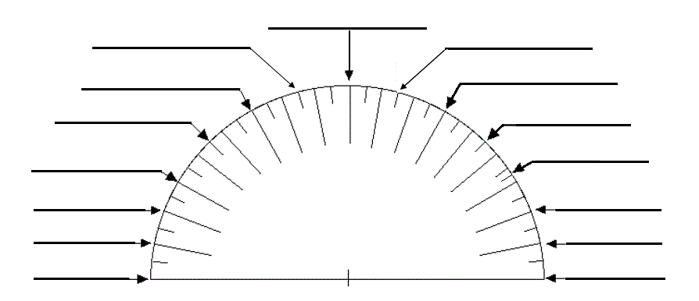

***Solution***

**1.**

1. *MO* = 

*OP*

*MG=* 44 *ft*

1. Find angle *QOP* in terms of *θ* and *φ*.

180° = MON + 90° + QOP + *φ*

180° = 90° - θ + 90° + QOP + *φ*

180° - 90° + θ - 90° - *φ* = QOP

QOP = *θ - φ*

1. Use right triangle trigonometry to find lengths *a* and *b*, and then the height of the rider *h*, in terms of *θ* and *φ*.















1. Let *t* be the number of minutes that have passed since the ride began. Use the angular velocity of the arm and wheel to find *θ* and *φ* in radians in terms of *t*.





1. Replace *θ* and *φ* in your part 4 to obtain the height *h* as a function of time *t* (in minutes)



  
 



1. Given: Rate of the radius: .
2. The area of the circle: 





1. 
2. 
3. 
4. 
5. 





1. Apply the appropriate angle in radian and degree (*no decimal -* ***use*** *minute*)

