Math 1316 – Trigonometry **Assignment 3** **Name** ________________

*Instructor*: Fred Khoury

 

1. If *d* is the distance that the circle has rolled then what is the length of the arc?
2. Find a relationship between *d* and *t* from part (***a***)
3. Find equations for *x* and *y* in terms of a, b, *r*, and *d*
4. Find *a*, *b*, *x*, and *y* in terms of *r* and *t*
5. How long it will take for the point *P* to get to the top of the wheel, if the wheel radius is 4 *ft* and turns with an angular velocity of 5 radians per minute.
6. Find the solution(s) for: 

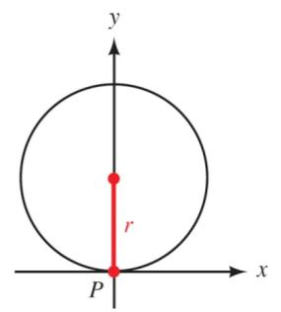 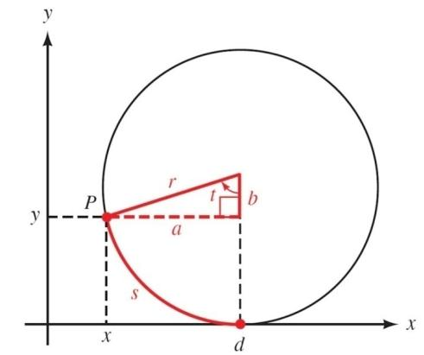

1. ***If d is the distance that the circle has rolled then what is the length of the arc?***



1. ***Find a relationship between d and t from part (a)***



1. ***Find equations for x and y in terms of a, b, r, and d***





1. ***Find a, b, x, and y in terms of r and t***









1. ***How long it will take for the point P to get to the top of the wheel, if the wheel radius is 4 ft and turns with an angular velocity of 5 radians per minute.***



1. Find one solution for: 









 



 

 





