Math 1316 – Trigonometry **Assignment 4**  **Name** ______________

*Instructor*: Fred Khoury

**1**. In any triangle ABC, prove that:







**2.** Find the area of the shaded star that is inscribed in a circle with a radius 1.

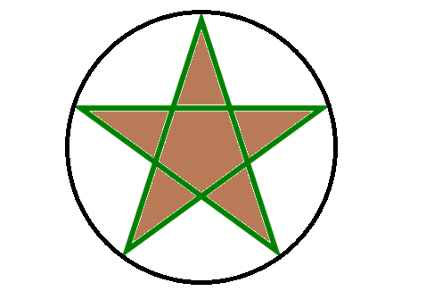

**3.** Evaluate:





***Solution***

1. 











































Given: 

The star divides the circle into 5 equal sections. .

The segment OB cut the angle  into half 

By definition: 









Consider the triangle AOB:

Using the Law of sine:





Use Heron's formula to find the area of the triangle:









The triangle AOB is equal to OBC and so on.

The total area of the star 



The star divides the circle into 6 equal sections. .

 







Consider the triangle AOB:

Using the Law of sine:



OR

Consider the right triangle AFB with 

The area of the triangle AOB = 2 times Area of AFB



There are 12 equal triangles that cover the star:



3. Evaluate:









The first quadrant:





There are four quadrant and 

