College Trigonometry – Some Final Exam Review Questions

Note: The final exam is cumulative. You should study your old tests to help prepare you for questions over Chapter 1 – 6.

[1] Find the lengths of the missing sides and angles for each triangle. If there is more than
one possible triangle for the given information, give the missing information for both
triangles.

- 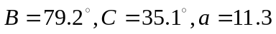
- 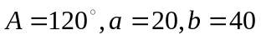
- 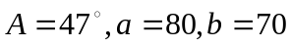
- 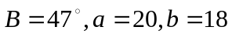
- 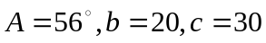
- 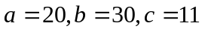

[2] Consider the vectors 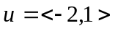 and 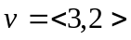.

(a) Calculate the magnitude of .
(b) Calculate 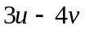
(c) Write in terms of the unit vectors and .

[3] Express each complex number in trigonometric form.

(a) 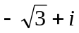
(b) – 3i

[4] Convert to polar coordinates with 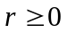 and 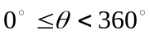.

- 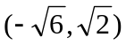
- 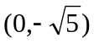

[5] Convert 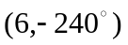to rectangular coordinates.

[6] For the point with polar coordinates 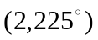, find a second set of polar coordinates such that 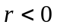 and .

[7] Convert each equation from rectangular to polar coordinates:

- 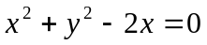
- 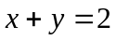

[8] Convert each equation from polar to rectangular coordinates.

- 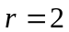
- 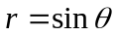
- 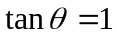

[9] Let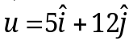, 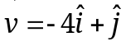and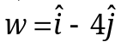, find:
(a)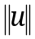
(b)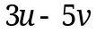
(c) 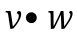
(d) The angle between and 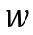to the nearest tenth of a degree.

[1] (a) 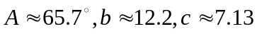
(b) no triangle possible
(c)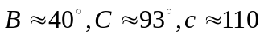
- triangle # 1: 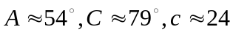; triangle #2: 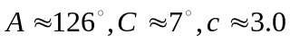
- 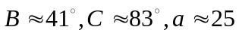
- 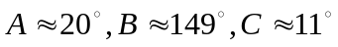

[2] (a) (b)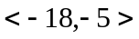 (c) 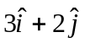

[3] (a) 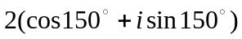 (b) 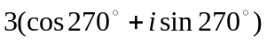

[4] (a) 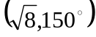 (b) 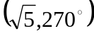

[5] 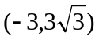

[6] 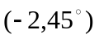

[7] (a) 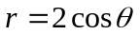 (b) 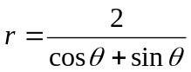

[8] (a) 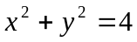 (b) 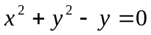 (c) 

[9] (a) 13 (b)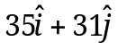 (c) – 8 (d) 143.3

