College Trigonometry

Study Questions for Exam 3

[1] Find all solutions in the interval 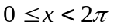.

- 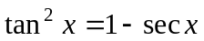
- 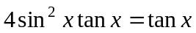
- 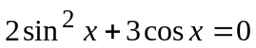
- 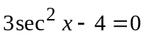
- 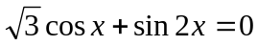
- 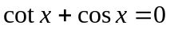
- 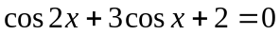

[2] Solve for 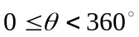: 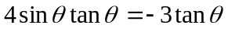. Approximate the solutions to the nearest
tenth of a degree.

[3] Find exact values for each of the following without using a calculator.

- 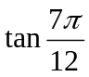
- 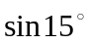
- 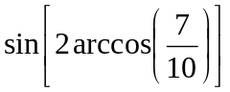
- 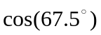
- 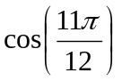
- cos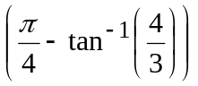
- 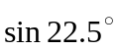

[4] If 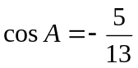 with A in QII and 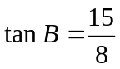 with B in QIII, find the exact value of each
of the following:

- 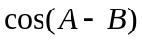
- 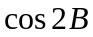
- 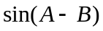
- 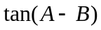

[5] Verify each identity.

- 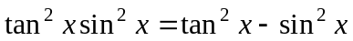
- 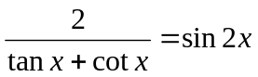
- 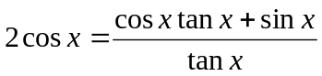
- 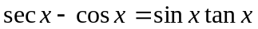
- 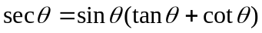
- 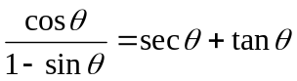
- 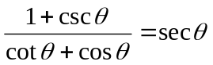
- 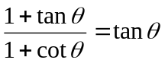
- 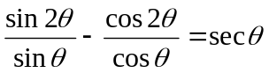
- 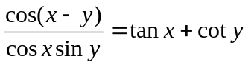

[6] Find all solutions of the equation 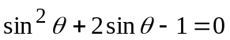 in the interval 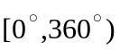. Approximate solutions should be rounded to the nearest tenth of a degree.

[7] Find all degree solutions of 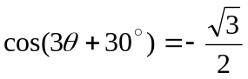.

[8] Find all solutions of the equation 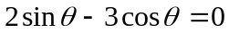 in the interval . Approximate solutions should be rounded to the nearest tenth of a degree.

Answers
[1]
- 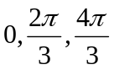
- 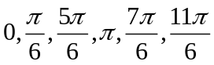
- 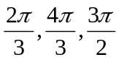
- 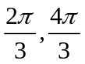
- 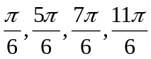
- 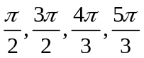
- 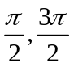
- 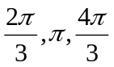

[2] 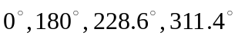

[3] (a) 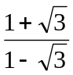
- 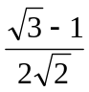
- 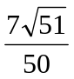
- 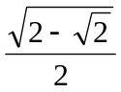
- 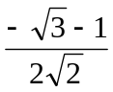
- 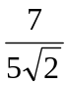
- 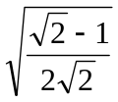

[4] (a) 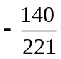
(b) 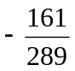
(c) 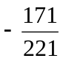
- 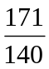

[6] 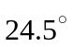, 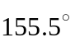

[7] 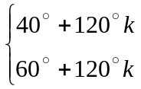 where k is any integer

[8] 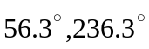

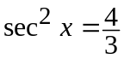
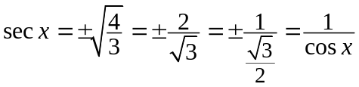
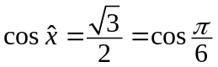
Since it is equal to ±, which means all the quadrant.
∴ 