College Trigonometry
Exam 4 Review

[1] Find the lengths of the missing sides and angles for each triangle. If there is more than
one possible triangle for the given information, give the missing information for both
triangles.

- 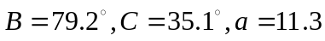
- 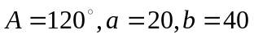
- 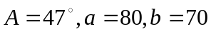
- 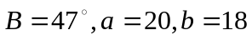
- 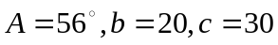
- 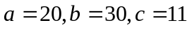

[2] The diagonals of a parallelogram are 26.8 meters and 39.4 meters. If they meet at an angle of 134.5 , find the length of the shorter side of the parallelogram.

[3] A man standing near a building notices that the angle of elevation to the top of the building is 64. He then walks 240 ft farther away from the building and finds the angle of elevation to the top to be 43. How tall is the building?

[4] Express each complex number in trigonometric form.

(a) 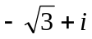
(b) – 3i

[5] Convert to polar coordinates with 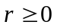 and 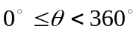.

- 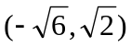
- 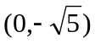

[6] Convert 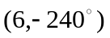to rectangular coordinates.

[7] For the point with polar coordinates 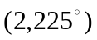, find a second set of polar coordinates such that 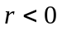 and .

[8] Convert each equation from rectangular to polar coordinates:
- 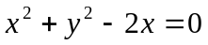
- 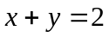

[9] Convert each equation from polar to rectangular coordinates.
- 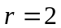
- 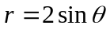
- 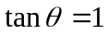
[10] Let U = 5i + 12j , V = - 4i + j and W = i – 4j , find:
(a) 
(b) 3U – 5V
(c) V W
(d) The angle between U and W to the nearest tenth of a degree.

Key

[1] (a) 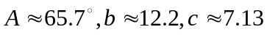
(b) no triangle possible
(c)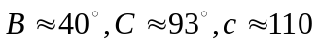
- triangle # 1: 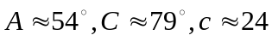; triangle #2: 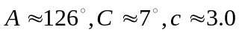
- 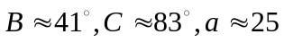
- 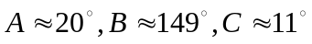

[2] 14.1 meters

[3] 410 ft

[4] (a) 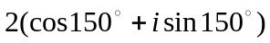 (b) 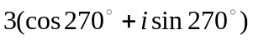

[5] (a) 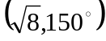 (b) 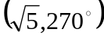

[6] 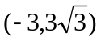

[7] 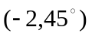

[8] (a) 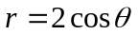 (b) 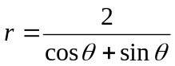
+
[9] (a) 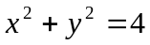 (b) 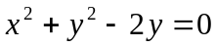 (c) 

[10] (a) 13 (b) 35i + 31j (c) – 8 (d)143.3

[3] A man standing near a building notices that the angle of elevation to the top of the building is 64. He then walks 240 ft farther away from the building and finds the angle of elevation to the top to be 43. How tall is the building?
A
B
C
D
240
64°
43°
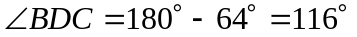
Using the law of sines for the triangle BDC:
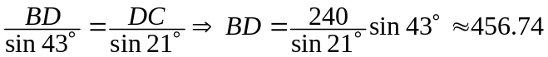
For the right triangle ABD:
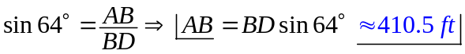

[7] For the point with polar coordinates , find a second set of polar coordinates such that and .

Has to be opposite from the point which give us 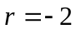 and the argument 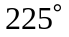 is in the third quadrant, therefore the angle has to be in the first quadrant. 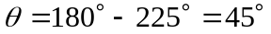.
The second set of polar coordinates is: 