***Formulas***

 

**By: *Fred E. Khoury***

***Derivative***

***Formula***



***Proof***









***Derivative***: Rational Function to Power ‘***n***’ in the form 

 

***Proof***



 







***Example***

Find 

***Solution***





***Derivative***: Rational Function in the form 





***Proof***



 





|  |  |
| --- | --- |
| ***Example***  Find  ***Solution*** | ***Example***  Find  ***Solution*** |

***Derivative***: Rational Function to Power ‘***n***’ in the form 



***Proof***



 







***Example***

Find 

***Solution***



***Derivative***: in the form 

The numerator power of *x* is 







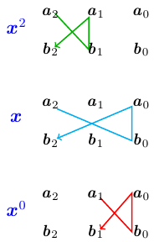 

***Example***







***Derivative***: in the form 













***Example***

 

***Solution***





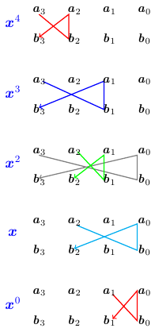

***Derivative***: in the form 







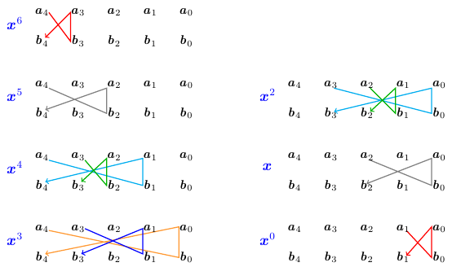

***Derivative***: in the form 











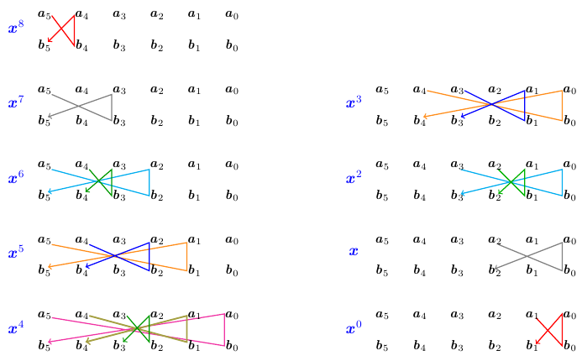

***Exponential Function***



***Numerator***: multiply *q* with  ***minus*** multiply *n* with 

***Denominator***: multiply *m* with  ***minus*** multiply *p* with 

***Proof***











 

***Example***

Solve: 

***Solution***



***Example***

Solve: 

***Solution***

ln

 

**−**ln

−ln

***Growth & Decay Formula***



***Proof***







 ***√***

I**ntegration by Part**

Evaluate 

|  |  |  |
| --- | --- | --- |
|  |  |  |
| **+** |  |  |
| **−** |  |  |
| **+** |  |  |
| **−** |  |  |
|  |  |  |





***Inverse Functions***



***Proof***













 ***√***

Interchange ***a*** and ***d*** and change there signs.

***Example***

Find the inverse function of: 

***Solution***

 

***Example***

Find the inverse function of: 

***Solution***

 

***Example***

Find the inverse function of: 

***Solution***

 

***Jose’s Method***

Evaluate 

|  |  |  |
| --- | --- | --- |
|  |  |  |
| **+** |  |  |
| **−** |  |  |
| **+** |  |  |







***Proof***

Find 

***Solution***

Let: 

 

Let: 











***Length***

***Length* of a curve ** is given by the formula:



If , then



***Iff***  satisfies these 2 conditions:

1. 
2. 

***Proof***







*We need to combined to a perfect square* 

* If 

 

* Let 

 







 ***√***

***Example***

Find the length of the graph of 

***Solution***

|  |  |
| --- | --- |
|  | 1. ***√*** 2. ***√*** |
| ***Examples*** |

If , then



***Iff***  satisfies these 2 conditions:

1. 
2. 

***Proof***







* If 

 

* Let 

 





***Example***





***Matrix: Upper triangular with* 1’ *to the Power n***

***m* *x* *m***

 = 

Note: ***j*** is the column number.

***Matrix: Upper triangular to the Power n***











***Quadratic equation***



If ***a + b + c* = 0** 

***Proof***

 











|  |  |
| --- | --- |
|  |  |

***Example***







***Quadratic equation***



If ***a - b + c* = 0** 

***Proof***

 











|  |  |
| --- | --- |
|  |  |

***Example***







***Square Root***

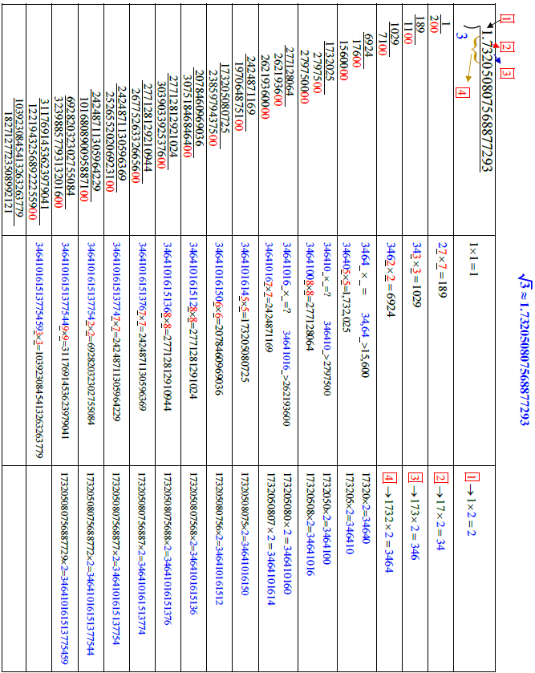

***Surface***

***Surface* of a curve ** is given by the formula:



If , then



: is the conjugate of 

***Iff***  satisfies these 2 conditions:

1. 
2. 

***Proof***







*We need to combined to a perfect square* 

* If 

 

* Let 

 



 ***√***



***Example***

Find the surface of the graph of 

***Solution***

|  |  |
| --- | --- |
|  | 1. ***√*** 2. ***√*** |

If , then



***Iff***  satisfies these 2 conditions:

1. 
2. 

***Proof***







* If 

 

* Let 

 





 ***√***

***Trigonometry***

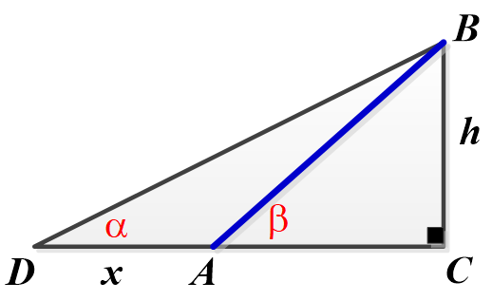

***Proof***

Triangle *DCB*:

Triangle *ACB*: 













***Height is equal to distance times* (*tan tan*) *divides by the* (*tan*(*larger angle*) *− tan*) (*difference between tangents*)**

***Example***

From a given point on the ground, the angle of elevation to the top of a tree is 36.7°. From a second point, 50 *feet* back, the angle of elevation to the top of the tree is 22.2°. Find the height of the tree to the nearest foot.

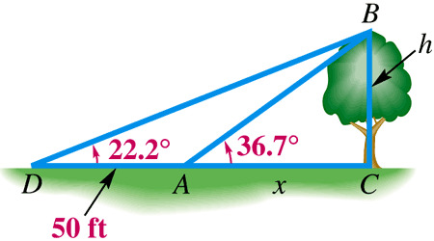***Solution***



