

***Proof***

Triangle *DCB*:

Triangle *ACB*: 













***Height is equal to distance times* (*tan tan*) *divides by the* (*tan*(*larger angle*) *− tan*) (*difference between tangents*)**

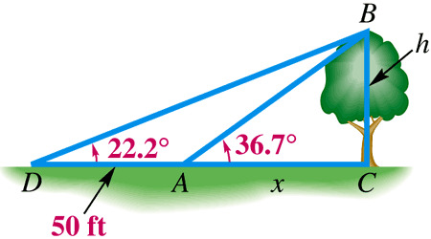***Example***

From a given point on the ground, the angle of elevation to the top of a tree is 36.7°. From a second point, 50 feet back, the angle of elevation to the top of the tree is 22.2°. Find the height of the tree to the nearest foot.

***Solution***

