***Lecture* 1 − Vectors (*Review*)**

The direction of the arrowhead specifies the ***direction*** of the vector and the ***length*** of the arrow specifies the *magnitude*.

The tail of the arrow is called the ***initial point*** of the vector and the tip the ***terminal point***.

**Parallelogram Rule for Vector Addition**

If ***v*** and ***w*** are vectors that are positioned so their initial points coincides, then the vectors form adjacent sides of a parallelogram, and then the sum ***v*** + ***w*** is the vector represented by the arrow from the common initial point of ***v*** and ***w*** to the opposite vertex of the parallelogram.



**Triangle Rule for Vector Addition**

If ***v*** and ***w*** are vectors that are positioned so the initial point of *w* is at the terminal point of ***v***, then the sum ***v*** + ***w*** is represented by the arrow from the initial point of ***v*** to the terminal point of ***w***.

 



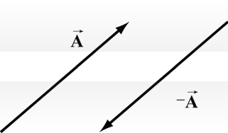**Inverse element for Vector Addition**

For every vector ***A*** , there is a unique inverse vector



This means that the vector −*A* has the same magnitude as *A*,



**Scalar Field**

A scalar function of one or more variables;

e.g. The distribution of locally averaged family incomes over the United States.

Or the electric charge distribution of the surface of a piece of metal.

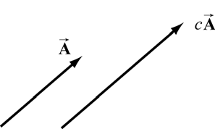 

**Distributive Law for Scalar Addition**

The multiplication operation also satisfies a distributive law for the addition of numbers.

Let *b* and *c* be real numbers. Then



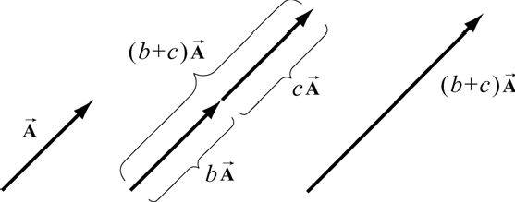

**Identity Element for Scalar Multiplication**

The number 1 acts as an identity element for multiplication



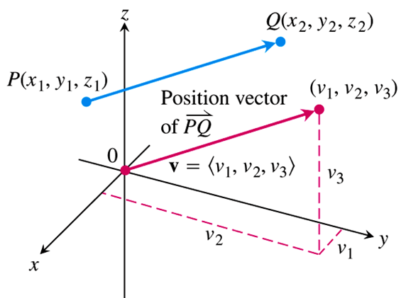

***Definition***

The vector represented by the direected line segment  has initial point *P* and terminal point *Q* and its length is denoted by 

**Magnitude**

The vector components 



The magnitude or length of the vector  is the nonegative number



**Unit vectors**

The idea of multiplication by real numbers allows us to define a set of unit vectors at each point in space. We associate to each point *P* in space, a set of three unit vectors . A unit vector means that the magnitude is one: 

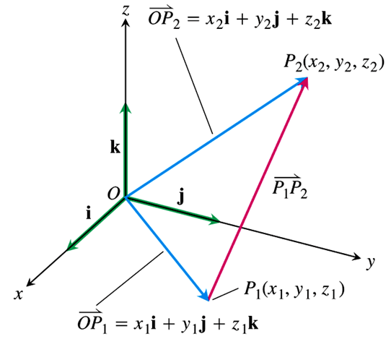

A vector ***v*** of length 1 is called a ***unit vector***. The ***standard unit vectors*** are



Any vector  can be written as a linear combination of the standard unit vectors as follows:









**Direction**

Let’s consider a vector . Since the *z-*component is zero, the vector  lies in the *x-y* plane. Let *θ* denote the angle that the vector  makes in the counterclockwise direction with the positive *x-*axis.

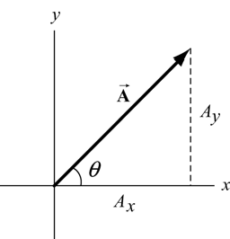



We can write a vector in the *x-y* plane as





**Proporties of Vector Operations**

Let ***u, v, w*** be vectors and *a, b* be scalars

|  |  |
| --- | --- |
|  |  |

***Vector Field***

A vector function of one or more variables; e.g. the velocity of a projectile fired from a cannon as a function of time.

Or the electric field as a function of time and space.

***Why vectors?***

Some quantities of physical interest cannot be characterized by a single number.

When we apply vectors to physical quantities it’s nice to keep in the back of our minds all these formal properties. However from the physicist’s point of view, we are interested in representing physical quantities such as displacement, velocity, acceleration, force, impulse, momentum, torque, and angular momentum as vectors. We can’t add force to velocity or subtract momentum from torque. We must always understand the physical context for the vector quantity. Thus, instead of approaching vectors as formal mathematical objects we shall instead consider the following essential properties that enable us to represent physical quantities as vectors.

In order to fully characterize a vector field, , which represents, say force, you must

1. Tell the point in space and time at which you are interested in determining *F*.
2. Tell the ***direction*** in which *F* acts.
3. Tell how ***much*** force is being applied .

***How is a vector represented?***

1. ***Graphically***: This type of representation is useful for illustrative purposes for vector fields and can be useful computationally for two-dimensional vector fields.
2. ***Resolution into components***: This is most commonly how we represent a vector.

*For example*, in rectangular components, we represent a vector by specifying its projections along the *x, y*, and *z* axes.

The ***Base*** vectors for rectangular components are vectors with ***unit*** magnitude and with a direction along the *x, y*, and *z* axes.

The most common notations are

|  |  |
| --- | --- |
|  | ***Base Vector Direction*** |
| N  O T A T I O N |  |

In general, a circumflex, “**^**.” Over a symbol will be used to indicate that symbol represents a unit vector.

Thus, in our notation, a vector , would be written as



In rectangular coordinates.

Rather than writing out “*x, y, z*” every time, it is preferable to define the position vector,





Thus, we write 

***Example***

A 75-N weight is suspended by two wires.

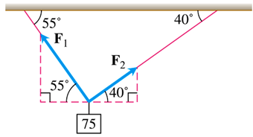

Find the forces  and  acting both wires

***Solution***

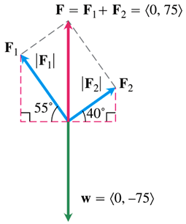

















The force vectors are then:













***The Dot Product***

If a force ***F*** is applied to a particle moving along a path, we often need to know the magnitude of the force and the direction of motion.

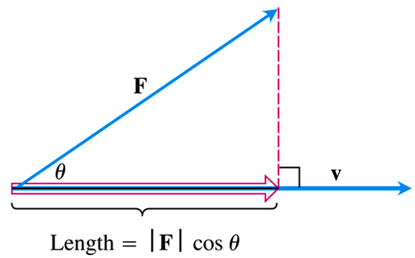

To calculate the angle between two vectors directly from their component, called the ***dot product***, also called *inner* or *scalar* products.

**Angle between Vectors**

***Theorem***

The angle *θ* between two nonzero vectors  is given by

|  |  |
| --- | --- |
|  |  |

***Definition***

The dot product of vector  is



***Example***

Find the dot product:

1. 
2. 

***Solution***

1. 



1. 



***Example***

Find the angle between 

***Solution***













***Definition* Perpendicular (*Orthogonal*) Vectors**

Vectors ***u*** and ***v*** are orthogonal (or perpendicular) iff 

**Dot Product Properties and Vector Projection**

If ***u, v*** and ***w*** are any vectors and *c* is a scalar, then

|  |  |
| --- | --- |
|  |  |

The vector projection of  onto a nonzero vector  is the vector  determined by dropping a perpendicular from *Q* to the line *PS*.

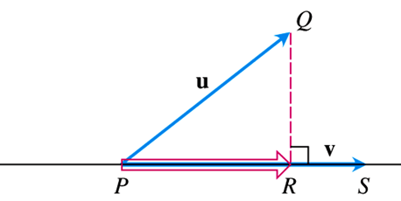 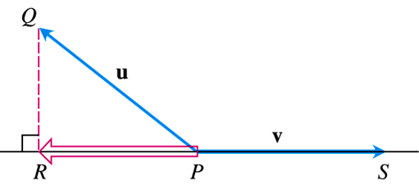

The notation for this vector is 

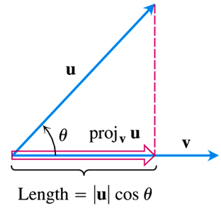 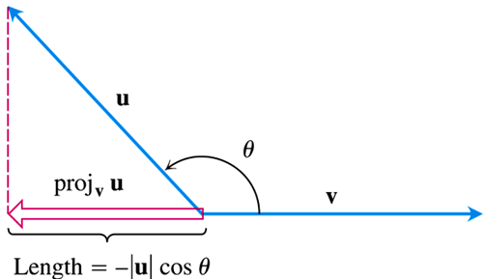



The scalar component of ***u*** in the direction of ***v*** is the scalar: 

***Example***

Find the vector projection of  and the scalar component of ***u*** in the direction of ***v***.

***Solution***













**The *Cross* *Product***

To find a vector in 3-space that is perpendicular to two vectors; the type of vector multiplication that facilities this construction is the cross product.

We start with two nonzero vectors ***u*** and ***v*** in space. If ***u*** and ***v*** are no parallel, they determine a plane. We select a unit vector ***n*** perpendicular to the plane by the ***right-hand rule***. Then the cross product  (“***u*** cross ***v***”) is the vector defined as follows

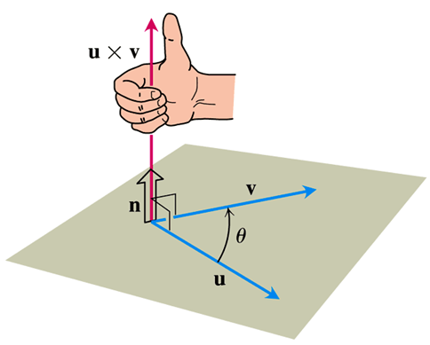

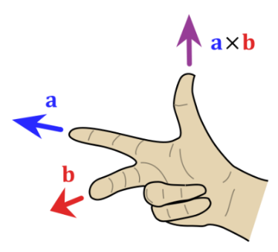 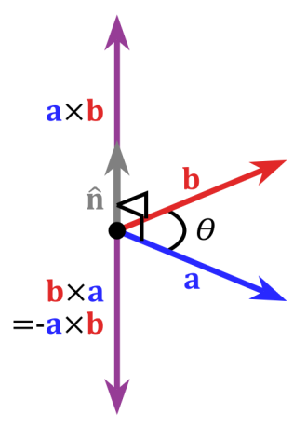 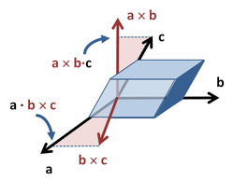

***Definition***



**Parallel Vectors**

Nonzero vectors ***u*** and ***v*** are parallel iff 

**Properties of the Cross Product**

If ***u, v*** and ***w*** are any vectors and *r, s* are scalars, then

|  |  |
| --- | --- |
|  |  |

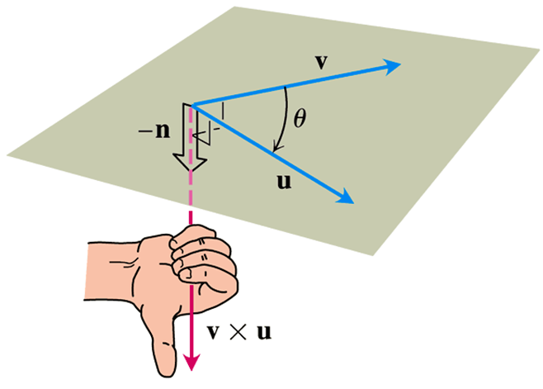

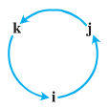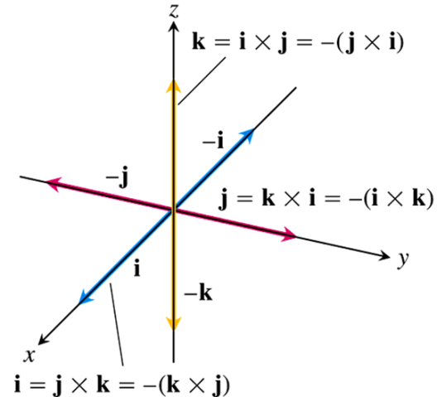***Note***:

* 
* 
* 
* 
* 
* 

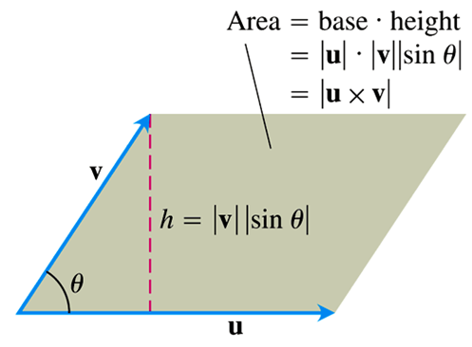

** Is the *Area* of the Parallelogram**

Because ***n*** is a unit vector, the magnitude of  is



**Determinant Formula for** 

***Definition***

The cross product of  and  is the vector









***Example***

Find  and  if  and 

***Solution***









**Triple Scalar or Box Product**

The product  is called the triple scalar product of ***u, v***, and ***w*** (in that order).



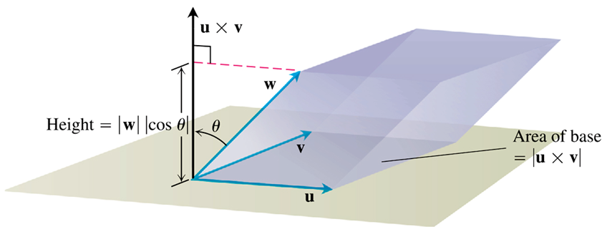

***Volume***

The Volume of the Parallelepiped is











***Example***

Find the volume of the box (parallelepiped) determined by   and 

***Solution***



The volume is 23 units cubed.