***Lecture* 2 − Vectors Calculus (*Review*)**

***Section* 2.1 − Vector Function of a Single Variable**

Suppose that we have a particle whose position vector is a function of time:



***Example***

Graph the vector function 

***Solution***



The curves traced by ***r*** winds around a circular cylinder, satisfies the equation.

The curve rises as the ***k***-components *z* = *t* increases. Each time *t* increases by 2π, the curve completes one turn around the cylinder. The curve is called a helix (from an old Greek word for “spiral”). The equations



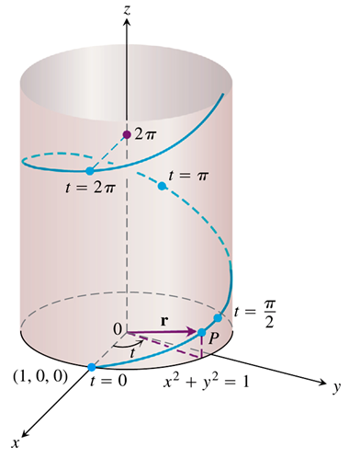

**Derivative**

***Definition***

The vector function  has a derivative (is differentiable) at *t* if *f, g*, and *h* have derivatives at *t*. The derivative is the vector function



 

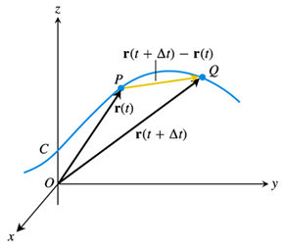 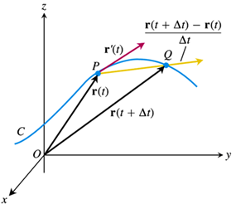

Notice that  is a ***secant*** of the arc in the trajectory. Clearly, as   has a direction which approaches the ***tangent*** to the arc. Thus,



is the unit tangent to the curve *C*

***Definitions***

If ***r*** is the position vector of a particle moving along a smooth curve in space, then



is the particle’s ***velocity vector***, tangent to the curve. At any time t, the direction of v is the ***direction of motion***, the magnitude of v is the particle’s ***speed***, and the derivative , when it exists, is the particle’s ***acceleration vector***. In summary,

1. Velocity is the derivative of position: 
2. Speed is the magnitude of velocity: 
3. Acceleration is the derivative of velocity: 
4. The unit vector  is the direction of motion at time *t*.

***Example***

Suppose a particle moves in the helix, with  with an angular speed of  with  and  at . Find the velocity and acceleration.

***Solution***



Differentiating





The speed is:







***Example***

Find the velocity, speed, and acceleration of a particle whose motion in space is given by the position vector . Sketch the velocity vector 

***Solution***

The velocity vector at time *t* is:





The acceleration vector at time *t* is:



The speed is:





 







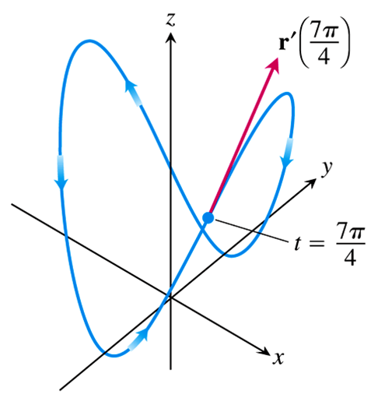





**Rules for Differentiation of Vectors**











Where 

= “ Triple scalar product.”

***Section* 2.2 − Functions of Three Variables**

***Definition***

The set of points  in space where a function of three independent variables has a constant value  is called a ***level surface*** of *f*.

***Theorem* − Chain Rule for Functions of Three Independent Variables**

If  is differentiable and if  are differentiable functions of *t*, then  is a differentiable function of *t* and

|  |  |
| --- | --- |
|  |  |

***Example***

Find  if 

In this example the values of  are changing along the path of a helix as *t* changes. What is the derivative’s value at *t* = 0?

***Solution***













**Functions Defined on Surfaces**

***Theorem* − Chain Rule for Two Independent Variables and Three Intermediate Variables**

Suppose that , , , and . If all four functions are differentiable, then *w* has partial derivatives with respect to *r* and *s*, given by the formulas

|  |  |
| --- | --- |
|  |  |

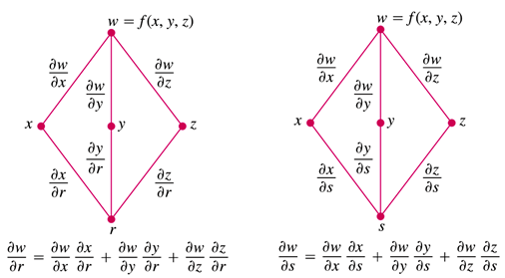

***Example***

Express  and  in terms of *r* and *s* if 

***Solution***















***Section* 2.3 − Arc Length along a Space Curve**

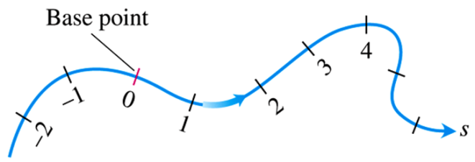

***Definition***

The ***length*** of a smooth curve , be a curve ***parametrically*** defined.

The parameter, ***s***, can be taken to be the ***arc length*** along the curve. Since ds is an infinitesimal section of arc length.









This derivative, which is the rate change of *φ* along the tangent of the curve,  is called the ***directional derivative*** of *φ* in the  direction,

**Directional Derivatives in the Plane**

The rate at which *f* changes with respect to *t* along a differentiable curve  is

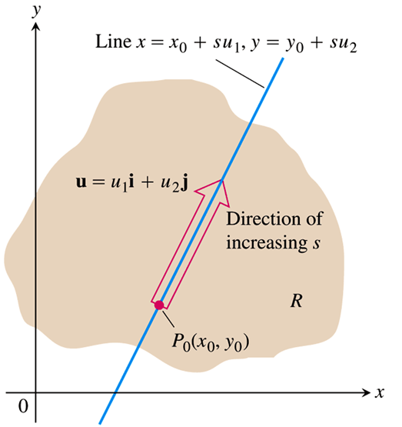

Suppose that the function  is defined throughout a region *R* in the *xy*-plane, that  is a point in *R*, and that  is a unit vector. Then the equations



***Example***

Find the derivative of  at  in the direction of the unit vector 

***Solution***















The rate of change of  at  in the direction  is 

***Section* 2.4 − *Gradient***

***Definition***

The gradient, denoted by , is defined as the vector which points in the direction of the greatest rate of change of the function on which it operates and has a magnitude equal to the maximum directional derivative of this function.

The ***gradient vector*** (*gradient*) of  at a point  is the vector



obtained by evaluating the partial derivatives of *𝜑* at . 

**Normal to level curves**

Setting the function , a constant, defines a surface. This surface is called a ***level surface*** with level *c*. Let’s see how this works. Suppose that  is a point which is constraint to lie on the level surface . Then, the directional derivative of  in any direction **tangent** to the level surface is







This vector lies in the tangent plane



Thus, the  is normal to the level surface of *φ*.

***Theorem* – The directional Derivative is a Dot Product**

If  is differentiable in an open region containing , then



The dot product of the gradient  at  and ***u***.

***Example***

Find the derivative of  at the point (2, 0) in the direction of 

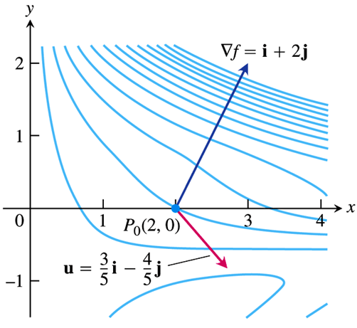***Solution***



The partial derivatives of *f* are continuous and at (2, 0)









Therefore, the derivative of *f* at (2, 0) in the direction of ***v*** is









***Example* (*Use of grad*)**

Suppose we have the following level curves for the temperature distribution some homogeneous material.



Which way will heat energy flow in this material?

Will it flow parallel to the isotherms?

How about perpendicular to the isotherms?

***Solution***

Of course, heat will flow in a direction NORMAL to the isotherms i.e. in the direction of the GREATEST DECREASE in temperature, .

The taster  varies in a certain direction, the faster heat will flow in that direction.

Thus, if *Q* is the amount of heat which passed through the surface, , then the rate of heat transfer is



And is found, not surprisingly, to be



We will find other important uses for grad in the section or the equations of mathematical physics

***Section* 2.5 − Line Integrals**

**1-Dimension**

The 1-dimensional line integral is just the ordinary integral you learned in Calculus:



If we let  letting each  go to zero at the same time such that



Then



**2-Dimensions**

Just as in the 1-dmensional case, the line is broken up into small segments.









The line integral from point *A* to point *B* is defined as the limit of



And is denoted by



**3-Dimensions**

Of course, a line integral can be defined along a space curve as









One important class of line integrals is the integral over a closed curve.



In most application it is necessary to specify the sense in which the closed loop is traversed.

The curve is said to be traversed in the positive sense with respect to normal vector, . If, when you “walk the curve” on the side of the surface out of which  points, the enclosed surface is to your left.

This is often denoted by



The types of line integrals we just discussed are independent of the direction along the path since the element of path length.

 Always positive

Another, similar, type of line integral is defined by





Of course



are similarly defined.

***Notice*** that these DO depend on the direction in which the integral is taken since  can be positive or negative.

**Physical Interpretation**

A very important line integral is



Which can be written succinctly as



If  is the force on a particle at position , then this line integral is the work done in moving a particle from point  to point .

Remember that  is tangent to the curve. If  is the unit tangent, then  and  is the component of force along the infinitesimal arc segment of length .



Then the amount of energy released by allowing the force to move the particle over this length is .

***Example***

Find the net amount of work required to move a 1 *kg* particle around the closed loop shown below.



***Solution***

The work required is  in the sense indicated.









(Vector fields which have the property that for any closed loop  are called “conservative”)

***Example***

Find the amount of work required to move a point charge, *q*, around the loop shown in the presence of the non-conservative electric field, . Force, 



***Solution***

The work required is 













***Section* 2.6 − Surface Integrals**

***Definition***



Divide the surface, *S*. into a set of sub-surfaces, .

Then form the sum 

Continue to divide the surface into finer and finer sub-surfaces computing this sum every time.

Then, if this sequence of sums converges, the surface integral of *F* exists and is denoted by



 as 



If the surface, *S*, is closed, then the surface integral over S is denoted by

|  |  |
| --- | --- |
|  |  |

**Physical Interpretation**

A very important type of surface integral in physics is



Where  is the unit normal to the surface at the point,  on *S*.



If  is a ***flux density***, then



Is called the ***flux*** through *S*.

For *example*, If  is a ***current density***, then the ***total current*** flowing through surface *S* is



Components of  perpendicular to  and not penetrate *S*.

Only components of  parallel to  will penetrate *S*.

What are the units of ?



***Example***

Suppose that we have a current density of



What is the current that flows through that section of a 1m sphere in the first octant, centered at the origin?



One way to define this surface is by specifying its *z* coordinate in terms of its *x* and *y* coordinates.





The normal to the sphere is



Then the surface integral that must be computed is



Now we have everything in the integral in terms of *x* and *y* but the element of surface area, d*S*.

Can we write d*S* in terms of d*x* and d*y*?

Yes. Since d*S* is (we can imagine) an exceedingly small piece of the surface, it is essentially planar.



If we were to project the element of surface area, d*x*d*y*, onto our surface, then we would create an element of surface area d*S* that we could use in the integration.

Let’s look at this figure edge-on such that the normal to the surface is lying in the plane of the paper.

|  |  |
| --- | --- |
| ***Edge view*** | ***View A−A*** |
| ***View B−B*** |

The dimension of dS in the direction perpendicular to the paper is the same as that of the element, d*x*d*y*.

But the remaining dimension of dS is stretched by this projection by a factor of



Therefore,



Substituting this expression for dS back into the integral.





Let 

Then 



































As we have seen in this example, if we hope to compute a surface integral analytically, we must

1. Find an expression which describes the surface in terms of a pair of variables. (in this example, *x* and *y*)
2. Find the unit normal and out function, , in terms of that same pair of variables.
3. And finally, write the element of surface area, d*S*, in terms of those variables.

However, when the surface, *S*, happens to be a part of a constant coordinate surface in some coordinate system, it is usually more convenient to carry out the integration in that coordinate system.

***Example***: The surface is part of a sphere

Let’s try to do the problem in spherical coordinates



























***Section* 2.7 − Volume Integrals**

***Definition***

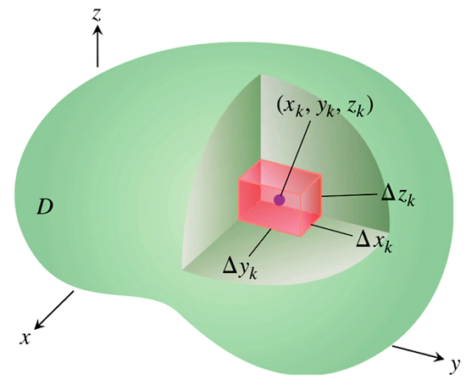

Of course, we divide the volume up into small sub-volumes with centers  and width volumes .

Then forming a sequence of sums of the form



By taking smaller and smaller sub-volumes, we end up with the volume integral

 (in the limit)

***Physical Interpretation***

Often physical quantities such as mass and charge are modeled as being continuously distributed in space with some density, *ρ*.

Suppose for example that we wish to find the bending moment felt by a pin holding the cone with uniform mass density, .

Then the bending moment is the volume integral



Given the geometry of the volume, this integral is most easily performed in spherical coordinates.















***Section* 2.8 − Measuring the variation of a Vector Field**

We have seen that the ***gradient*** of a ***scalar field*** is a measure of the variation of that field with position in space.

It is reasonable to ask if there is any systematic way of measuring the variation of a vector field with position.

Let’s plot a two-dimensional vector field and see what types of variation the field can have.

|  |  |
| --- | --- |
|  |  |
| **(*a*)** | **(*b*)** |

In these illustrations, there seems to be two distinctly ***different*** types of variation in the vector field.

For field (***a***), the vectors seem to be ***diverging*** as we move along the “flow” of the field.

For field (***b***), the vectors do not seem to be diverging, but they seem to be “***circulating***” in a loop.

The fields in (***a***) do not exhibit this circulating property.

It appears that in order to fully characterize the variation of vector field, ***two different types of measure*** will be ***required*** in contrast to the single type of measure needed for the gradient.

Indeed this is the case. The two types of measures are the ***divergence*** and the ***curl***.

***Section* 2.9 − Divergence**

Suppose the vector field represents current density.

Then one way to measure how much the field diverges is to ask if any **charge** is **accumulated** or **depleted** in some small volume, .

Since current density is the amount of charge per unit area flowing past a point in space in a particular direction, this question can be answered by finding the total flux leaving :

Rate that charge is leaving 

Note,  is used to denote the boundary of .

If this total flux is zero, then no net charge is being accumulated or depleted and the divergence of the field is zero.

|  |  |
| --- | --- |
|  | The current in = current out  ∴ No net accumulation of charge. |

If the total flux is positive, then charge is being depleted since more current is leaving  than entering and the divergence is positive.

|  |  |
| --- | --- |
|  | But more current leaves  ∴ There is a net depletion of charge. |

If the total flux is negative, then charge is being accumulated since more current is entering than leaving and the divergence is negative.

|  |  |
| --- | --- |
|  | But less current leaves  ∴ There is a net accumulation of charge. |

Since the divergence properties of the field may vary from place to place, we would like to make  as small as possible.

Indeed, we would like to allow  to approach zero.

In order to obtain a non-vanishing measure, we must normalize the total flux by the volume .

This leads us to the definition of the divergence of a vector field:



The divergence is defined as the net flux leaving per unit volume.

For example, suppose we have a current density of



Then what is the time rate of change of the charge density?

If *ρ* is the charge density, then the charge stored in volume d*V* is *ρ* d*V*.

Fortunately, we can do it once and for all in general for all ***continuously differentiable*** vector fields to obtain a simple formula for finding *div*.

Suppose that  is such a vector field. Then for the volume element, .



The net flux leaving, divided by  is







= flux leaving faces 1, 2, 3, 4, 5, & 6.

Since  is continuously differentiable, the mean value theorem states that



For some  in the interval 

Thus, the flux leaving faces 1 and 2 is



But this represents an average of a ***continuous function*** over a small area.

As the area becomes smaller and smaller, (that is, as  go to zero) this average must approach



Of course, we can do the same thing for the rest of the flux terms of  and we end up with the simple formula that



In small time interval, d*t*,  amount of charge leaves d*V*.

The charge and therefore also the charge density inside d*V* must decreases.

If  is the change in charge density, then the amount of charge that has left d*V* in d*t* time is also.



Therefore,



This relation is called the ***continuity equation***.

But what we need to do to come up with a number for this problem is to actually carry out the limiting process that defines *div*.

It would be a bit cumbersome to have to explicitly carry out this limiting process for every problem.

This is what we get in rectangular coordinates. When we get to other coordinate systems, we will do the same thing.

The only difference will be that the volume, , will be constructed in terms of *changes in our new coordinates* instead of changes, in *x, y*, and *z*.

Now we can complete the example we started.

Using the continuity equation, the rate at which charge density is changing is





If we take a closer look at the simple formula we derived for the divergence, it has the form of our previously defined “*del*” operator dotted with *J*.





Thus,



For *continuously differentiable* vector fields. This, however, is a ***conclusion***, not a definition.

As we saw earlier, the divergence of a vector only tells *part* of the story about its variation in space.

The next concept we must consider is the curl.

***Section* 2.10 − Curl**

The curl of a vector is intended to measure the *rotational tendency* of the vector field.

Suppose we have a fluid with a velocity field, .

To measure the rotational tendency of this velocity field, suppose we fashion a small disk mounted on a shaft:

|  |  |
| --- | --- |
|  |  |
| ***Top View*** | ***Perspective View*** |

The inner section will be made of a slick material while the outer-most ring is coated with a gritty surface.

The fluid will flow over the slick portion of the disk with little friction.

Over the rough outer ring, however, the moving fluid will cause frictional forces to exist on the disk.

Any imbalance in the symmetry of the velocity field should cause more frictional force on one side of the shaft than the other and therefore produce a torque on the shaft.

Thus, by measuring the torque, we should be able to learn something about the rotational tendency of the vector field.

Making the reasonable supposition that the force on a small section of the disk is proportional to the area of that section and the velocity of the fluid flowing across it, the torque produced because of that section is





Thus, the total torque on the shaft is

 C: is path around outer ring.

This integral is given by a special name. It is called the ***net circulation*** about the closed curve, C.

Since the torque on the shaft will depend in general on the orientation of the shaft. In order to fully characterize the rotational tendency of the field, we should do the measurement in ***three orthogonal directions***.

|  |  |  |
| --- | --- | --- |
|  |  |  |

Finally, since we would like to characterize the change in  at point rather than an average change over a large region, we should make the radius of our disk as small as possible.

Indeed, we should let it approach zero.

In order to obtain a non-zero result, we need to normalize the circulation by the area of the disk.

By so doing, we arrive at the definition of the curl of a vector field:

*The curl is a vector whose components are the net circulation per unit area in the positive sense in a plane perpendicular to the component.*

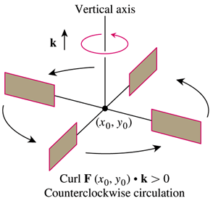 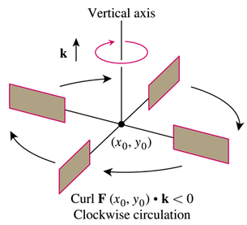

In rectangular components, for example, the curl of vector field  is





Similarly,





Again, it is cumbersome to have to actually perform this limiting process for every vector field.

If the vector field, , is continuously differentiable, then





As 

Similarly,





We notice that this simple expression for the curl has the form of the cross product of the “***del***” operator with the vector, .

Therefore, 

For continuously differentiable vector fields.

One way to remember how to expand this is to find the determinant.



***Section* 2.11 − Divergence Theorem**

Suppose that we have a volume, *V*, containing charge of density, *ρ*.

Suppose that what we really want to know is the rate at which the total charge within V is varying with time.

We have already seen that the continuity equation relates the change in charge density to the divergence of current density:



To find out about the change in total charge, we must perform a volume integral over *V*:







 

Now since the surface integral.



Is the total amount of current leaving *V*, we know that the rate of change of total charge in *V* is



But this means that the volume and surface integrals should be the same:



This equivalence is the ***divergence theorem***.

We know that from the definition that the volume integral.



Is formed by taking the limit of a sequence of sums:



|  |  |
| --- | --- |
|  | Volume element  Point at center is . |

Since it really doesn’t matter how we divide the volume up in our sequence as long as each sub-volume approaches zero, let’s assume that each sub-volume is a cube of width δ.

We will let the points at which we sample the integrand be at the centers of each of these cubes.

Then, by the definition of divergence,



And the concept of a limit, we have that



Where  is a function which approaches zero as δ, and hence,  go to zero.

Then the sum,



Is equivalent to



But 

Therefore, we have the result that



Now let’s take an exploded view of a portion of our segmented volume.



***Exploded view***

Clearly, the flux leaving one face of one of our cubes cancels the flux leaving an adjacent face of another cube.

It cancels, that is, except at the faces of sub-volumes which border on the boundary of our original volume, *V*.

That is,



And hence





***Section* 2.12 − Stoke’s Theorem**

We have just seen that the total flux leaving the surface of a volume, *V*, is equal to the integral of the divergence of the vector field over *V*.



That is, the sum of the fluxes leaving each “local” sub-volume comprising *V* is equal to the net amount of flux leaving the surface of *V*.

Now suppose that we have a surface, *S*, with bounding, space curve, .

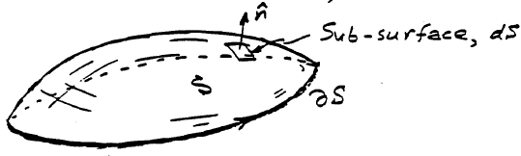

We know that the net circulation about any sub-area,  , comprising *S* is just



***Note***: 

A reasonable question to ask is: Can the sum of the circulations over each sub-surface,



Be simply related to the *net circulation* about the curve bounding *S*,



***Stoke’s Theorem*** states that



In the positive sense with respect to 

***Proof***

The surface integral we need is defined as