# MASSACHUSETTS INSTITUTE OF TECHNOLOGY

**Department of Physics**

**8.02**

**Review A: Vector Analysis**

A...................................................................................................................................... A-0

* 1. Vectors A-2

|  |  |  |
| --- | --- | --- |
| A.1.1 | Introduction | A-2 |
| A.1.2 | Properties of a Vector | A-2 |
| A.1.3 | Application of Vectors | A-6 |

* 1. Dot Product A-10

|  |  |  |
| --- | --- | --- |
| A.2.1 | Introduction | A-10 |
| A.2.2 | Definition | A-11 |
| A.2.3 | Properties of Dot Product | A-12 |
| A.2.4 | Vector Decomposition and the Dot Product | A-12 |

* 1. Cross Product A-14

|  |  |  |
| --- | --- | --- |
| A.3.1 | Definition: Cross Product | A-14 |
| A.3.2 | Right-hand Rule for the Direction of Cross Product | A-15 |
| A.3.3 | Properties of the Cross Product | A-16 |
| A.3.4 | Vector Decomposition and the Cross Product | A-17 |

**Vector Analysis**

# Vectors

* + 1. **Introduction**

Certain physical quantities such as mass or the absolute temperature at some point only have magnitude. These quantities can be represented by numbers alone, with the appropriate units, and they are called scalars. There are, however, other physical quantities which have both magnitude and direction; the magnitude can stretch or shrink, and the direction can reverse. These quantities can be added in such a way that takes into account both direction and magnitude. Force is an example of a quantity that acts in a certain direction with some magnitude that we measure in newtons. When two forces act on an object, the sum of the forces depends on both the direction and magnitude of the two forces. Position, displacement, velocity, acceleration, force, momentum and torque are all physical quantities that can be represented mathematically by vectors. We shall begin by defining precisely what we mean by a vector.

# Properties of a Vector

A vector is a quantity that has both direction and magnitude. Let a vector be denoted by

the symbol **A** . The magnitude of

**A** is | **A |** *A* . We can represent vectors as geometric

objects using arrows. The length of the arrow corresponds to the magnitude of the vector. The arrow points in the direction of the vector (Figure A.1.1).

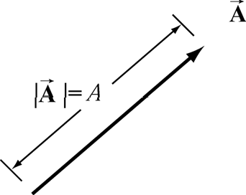

**Figure A.1.1** Vectors as arrows.

There are two defining operations for vectors:

1. **Vector Addition:** Vectors can be added.

Let **A**

and **B**

be two vectors. We define a new vector, **C**  **A**  **B** , the “vector addition”

of **A**

and **B** , by a geometric construction. Draw the arrow that represents **A** . Place the

tail of the arrow that represents **B**

at the tip of the arrow for **A** as shown in Figure

A.1.2(a). The arrow that starts at the tail of **A** and goes to the tip of **B**

is defined to be

the “vector addition” **C**  **A**  **B** . There is an equivalent construction for the law of vector

addition. The vectors **A**

and **B**

can be drawn with their tails at the same point. The two

vectors form the sides of a parallelogram. The diagonal of the parallelogram corresponds

to the vector **C**  **A**  **B** , as shown in Figure A.1.2(b).

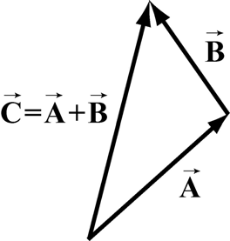 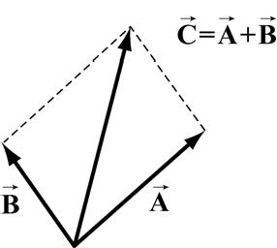

**Figure A.1.2** Geometric sum of vectors.

Vector addition satisfies the following four properties:

1. **Commutivity:** The order of adding vectors does not matter.

**A**  **B**  **B**  **A**

(A.1.1)

Our geometric definition for vector addition satisfies the commutivity property (i) since in the parallelogram representation for the addition of vectors, it doesn’t matter which side you start with as seen in Figure A.1.3.

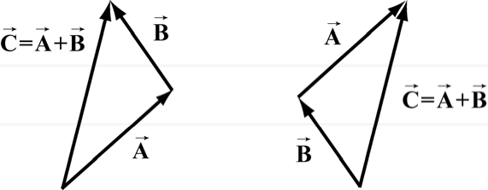

**Figure A.1.3** Commutative property of vector addition

1. **Associativity:** When adding three vectors, it doesn’t matter which two you start with

(**A**  **B**)  **C**  **A**  (**B**  **C**)

(A.1.2)

In Figure A.1.4(a), we add (**A**  **B**)  **C** , while in Figure A.1.4(b) we add We arrive at the same vector sum in either case.

**A**  (**B**  **C**) .

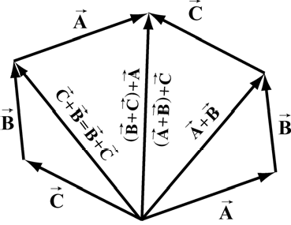

**Figure A.1.4** Associative law.

1. **Identity Element for Vector Addition:** There is a unique vector, **0** , that acts as an identity element for vector addition.

This means that for all vectors **A** ,

**A**  **0**  **0**  **A**  **A**

(A.1.3)

1. **Inverse element for Vector Addition:** For every vector **A** , there is a unique inverse vector

such that

1 **A**  **A**

 

**A**   **A**  **0**

(A.1.4)

This means that the vector **A**

has the same magnitude as **A** , *|* **A** *|**|* **A** *|* *A* , but they

point in opposite directions (Figure A.1.5).

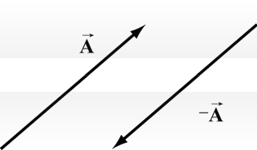

**Figure A.1.5** additive inverse.

1. **Scalar Multiplication of Vectors:** Vectors can be multiplied by real numbers.

Let **A**

be a vector. Let *c* be a real positive number. Then the multiplication of **A**

by *c* is

a new vector which we denote by the symbol

*c***A** . The magnitude of *c***A**

is *c* times the

magnitude of **A**

(Figure A.1.6a),

*cA*  *Ac*

(A.1.5)

Since *c*  0, the direction of *c***A**

is the same as the direction of **A** . However, the direction

of *c***A**

is opposite of **A**

(Figure A.1.6b).

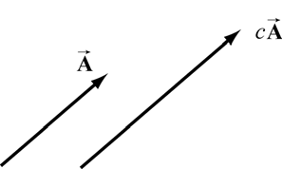 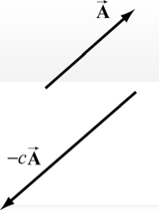

**Figure A.1.6** Multiplication of vector **A** by (a) *c*  0 , and (b) *c*  0 .

Scalar multiplication of vectors satisfies the following properties:

* 1. **Associative Law for Scalar Multiplication:** The order of multiplying numbers is doesn’t matter.

Let *b* and *c* be real numbers. Then

*b*(*c***A**)  (*bc*)**A**  (*cb***A**)  *c*(*b***A**)

(A.1.6)

* 1. **Distributive Law for Vector Addition:** Vector addition satisfies a distributive law for multiplication by a number.

Let *c* be a real number. Then

*c*(**A**  **B**)  *c***A**  *c***B**

(A.1.7)

Figure A.1.7 illustrates this property.

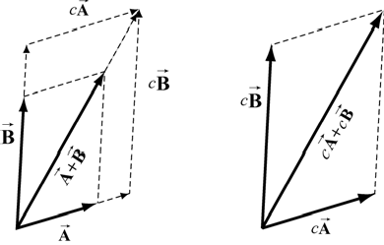

**Figure A.1.7** Distributive Law for vector addition.

* 1. **Distributive Law for Scalar Addition:** The multiplication operation also satisfies a distributive law for the addition of numbers.

Let *b* and *c* be real numbers. Then

(*b*  *c*)**A**  *b***A**  *c***A**

(A.1.8)

Our geometric definition of vector addition satisfies this condition as seen in Figure A.1.8.

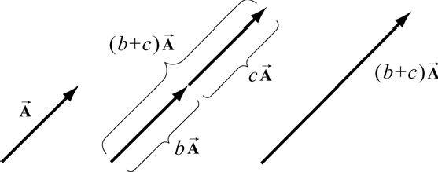

**Figure A.1.8** Distributive law for scalar multiplication

* 1. **Identity Element for Scalar Multiplication:** The number 1 acts as an identity element for multiplication,

1**A**  **A**

(A.1.9)

# Application of Vectors

When we apply vectors to physical quantities it’s nice to keep in the back of our minds all these formal properties. However from the physicist’s point of view, we are interested in representing physical quantities such as displacement, velocity, acceleration, force, impulse, momentum, torque, and angular momentum as vectors. We can’t add force to velocity or subtract momentum from torque. We must always understand the physical context for the vector quantity. Thus, instead of approaching vectors as formal

mathematical objects we shall instead consider the following essential properties that enable us to represent physical quantities as vectors.

1. Vectors can exist at any point *P* in space.
2. Vectors have direction and magnitude.
3. Vector Equality: Any two vectors that have the same direction and magnitude are equal no matter where in space they are located.
4. Vector Decomposition: Choose a coordinate system with an origin and axes. We can decompose a vector into component vectors along each coordinate axis. In Figure A.1.9

we choose Cartesian coordinates for the

*x*-*y* plane (we ignore the

*z* -direction for

simplicity but we can extend our results when we need to). A vector **A**

decomposed into the vector sum,

at *P* can be

where **A***x*

is the

**A**  **A***x*  **A** *y*

*x* -component vector pointing in the positive or negative

(A.1.10)

*x* -direction,

and **A** *y*

is the

*y* -component vector pointing in the positive or negative

*y* -direction

(Figure A.1.9).

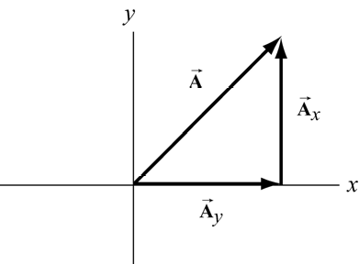

**Figure A.1.9** Vector decomposition

1. Unit vectors: The idea of multiplication by real numbers allows us to define a set of

unit vectors at each point in space. We associate to each point *P*

in space, a set of three

unit vectors (*ˆ***i***,ˆ***j***,***k***ˆ* ) . A unit vector means that the magnitude is one: *|ˆ***i** *|* 1, *|ˆ***j***|* 1 , and

*|* **k***ˆ |* 1 . We assign the direction of *ˆ***i**

to point in the direction of the increasing *x* -

coordinate at the point

*P* . We call *ˆ***i**

the unit vector at *P*

pointing in the + *x* -direction.

Unit vectors *ˆ***j** and **k***ˆ*

can be defined in a similar manner (Figure A.1.10).

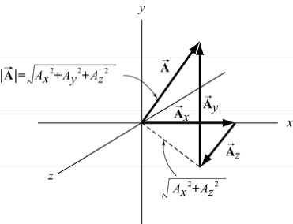

**Figure A.1.10** Choice of unit vectors in Cartesian coordinates.

1. Vector Components: Once we have defined unit vectors, we can then define the *x* -

component and

*y* -component of a vector. Recall our vector decomposition,

**A**  **A***x*  **A** *y* . We can write the *x*-component vector,

**A***x* , as

**A**  *A ˆ***i** (A.1.11)

*x x*

In this expression the term *A* , (without the arrow above) is called the *x*-component of

*x*

the vector **A** . The

*x* -component

*Ax* can be positive, zero, or negative. It is not the

2 1/ 2

magnitude of **A***x*

which is given by

( *Ax* )

. Note the difference between the *x* -

component, *Ax* , and the

*x* -component vector,

**A***x* .

In a similar fashion we define the *y* -component, *Ay* , and the

vector **A**

*z* -component,

*Az* , of the

**A**  *A ˆ***j***,*

**A**  *A* **k***ˆ*

(A.1.12)

A vector **A**

*y y z z*

can be represented by its three components

**A**  ( *Ax , Ay , Az* ) . We can also

write the vector as

**A**  *A ˆ***i**  *A ˆ***j**  *A* **k***ˆ*

*x y z*

(A.1.13)

1. Magnitude: In Figure A.1.10, we also show the vector components Using the Pythagorean theorem, the magnitude of the **A** is,

**A**  ( *Ax , Ay , Az* ) .

*2 2 2*

*A*  *Ax*  *Ay*  *Az* (A.1.14)

1. Direction: Let’s consider a vector

**A**  ( *Ax , Ay ,*0) . Since the

*z* -component is zero, the

vector **A**

lies in the

*x*-*y* plane. Let * *denote the angle that the vector **A**

makes in the

counterclockwise direction with the positive

*x* -axis (Figure A.1.12). Then the *x* -

component and

*y* -components are

*Ax*  *A* cos* , Ay*  *A* sin**

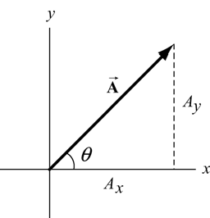

**Figure A.1.12** Components of a vector in the *x*-*y* plane.

(A.1.15)

We can now write a vector in the

*x*-*y* plane as

**A**  *A* cos* *ˆ**i**  *A* sin* *ˆ**j** (A.1.16)

Once the components of a vector are known, the tangent of the angle *  *can be determined by

*Ay*  *A*sin* Ax A*cos**

 tan**

(A.1.17)

which yields

* * tan1 ⎛ *Ay* ⎞

(A.1.18)

⎜ ⎟

⎝ *Ax* ⎠

Clearly, the direction of the vector depends on the sign of

*Ax* and

*Ay* . For example, if

both

*Ax*  0

and

*Ay*  0 , then

0  * * * */ 2 , and the vector lies in the first quadrant. If,

however, quadrant.

*Ax*  0

and

*Ay*  0 , then

* */2  * * 0 , and the vector lies in the fourth

1. Vector Addition: Let **A**

and **B**

be two vectors in the *x*-*y* plane. Let *A* and*B* denote

the angles that the vectors **A**

positive *x*-axis. Then

and **B**

make (in the counterclockwise direction) with the

**A**  *A* cos*A ˆ***i**  *A*sin*A ˆ***j** (A.1.19)

**B**  *B* cos*B ˆ***i**  *B* sin*B ˆ***j**

(A.1.20)

In Figure A.1.13, the vector addition

**C**  **A**  **B**

is shown. Let*C* denote the angle that

the vector **C** makes with the positive *x*-axis.

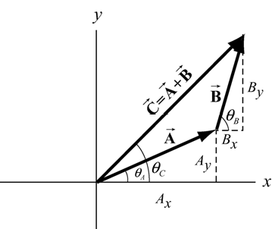

**Figure A.1.13** Vector addition with components

Then the components of **C** are

*Cx*  *Ax*  *Bx , Cy*  *Ay*  *By*

(A.1.21)

In terms of magnitudes and angles, we have

*Cx*  *C* cos*C*  *A*cos*A*  *B* cos*B*

*Cy*  *C* sin*C*  *A*sin*A*  *B* sin*B*

(A.1.22)

We can write the vector **C** as

**C**  ( *A*

 *B* )*ˆ***i**  ( *A*

* *B* )*ˆ***j**  *C*(cos* ˆ***i**  sin**

)*ˆ***j**

(A.1.23)

*x x y y C C*

# Dot Product

* + 1. **Introduction**

We shall now introduce a new vector operation, called the “dot product” or “scalar product” that takes any two vectors and generates a scalar quantity (a number). We shall see that the physical concept of work can be mathematically described by the dot product between the force and the displacement vectors.

Let **A**

and **B** be two vectors. Since any two non-collinear vectors form a plane, we

define the angle

* *to be the angle between the vectors **A** and **B**

as shown in Figure

A.2.1. Note that * *can vary from 0 to .

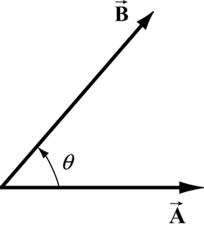

**Figure A.2.1** Dot product geometry.

# Definition

The dot product

**A**  **B**

of the vectors

**A** and **B**

is defined to be product of the magnitude

of the vectors **A**

and **B**

with the cosine of the angle * *between the two vectors:

**A**  **B**  *AB* cos**

(A.2.1)

Where

*A* | **A** | and

*B* | **B** | represent the magnitude of

**A** and **B**

respectively. The dot

product can be positive, zero, or negative, depending on the value of cos* *. The dot product is always a scalar quantity.

We can give a geometric interpretation to the dot product by writing the definition as

**A**  **B**  ( *A* cos* *)*B*

(A.2.2)

In this formulation, the term *A*cos*  *is the projection of the vector **A** in the direction of

the vector **B** . This projection is shown in Figure A.2.2a. So the dot product is the product

of the projection of the length of

**A** in the direction of **B**

with the length of **B** . Note that

we could also write the dot product as

**A**  **B**  *A*(*B* cos* *)

(A.2.3)

Now the term

*B* cos*  *is the projection of the vector **B**

in the direction of the vector **A** as

shown in Figure A.2.2b.From this perspective, the dot product is the product of the

projection of the length of **B**

in the direction of **A** with the length of **A** .

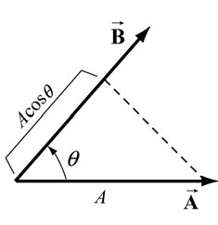 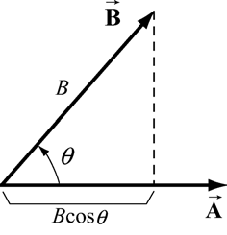

**Figure A.2.2a** and **A.2.2b** Projection of vectors and the dot product.

From our definition of the dot product we see that the dot product of two vectors that are

perpendicular to each other is zero since the angle between the vectors is

cos(* */ 2)  0 .

# Properties of Dot Product

* */2

and

The first property involves the dot product between a vector *c***A** where *c* is a scalar and a

vector **B** ,

(1a)

*c***A**  **B**  *c*(**A**  **B**)

(A.2.4)

The second involves the dot product between the sum of two vectors **A**

vector **C** ,

and **B** with a

(2a) (**A**  **B**)  **C**  **A**  **C**  **B**  **C**

(A.2.5)

Since the dot product is a commutative operation

**A**  **B**  **B**  **A**

(A.2.6)

the similar definitions hold

(1b)

**A**  *c***B**  *c*(**A**  **B**)

(A.2.7)

(2b)

**C**  (**A**  **B**)  **C**  **A**  **C**  **B**

(A.2.8)

# Vector Decomposition and the Dot Product

With these properties in mind we can now develop an algebraic expression for the dot product in terms of components. Let’s choose a Cartesian coordinate system with the

vector **B** pointing along the positive

*x* -axis with positive

*x* -component

*Bx* , i.e., **B**  *Bx*ˆ**i** .

The vector **A**

can be written as

ˆ ˆ ˆ

**A**  *Ax* **i**  *Ay* **j**  *Az***k**

(A.2.9)

We first calculate that the dot product of the unit vector *ˆ***i** with itself is unity:

ˆ**i**  ˆ**i** | ˆ**i** || ˆ**i** | cos(0)  1

(A.2.10)

since the unit vector has magnitude *|ˆ***i** *|* 1

and cos(0)  1. We note that the same rule

applies for the unit vectors in the *y* and *z* directions:

ˆ**j** ˆ**j**  **k**ˆ  **k**ˆ  1

(A.2.11)

The dot product of the unit vector *ˆ***i**

with the unit vector*ˆ***j** is zero because the two unit

vectors are perpendicular to each other:

*ˆ***i** *ˆ***j** *|ˆ***i** *||ˆ***j***|*cos(* */2)  0

(A.2.12)

Similarly, the dot product of the unit vector *ˆ***i**

with the unit vector **k***ˆ*

, and the unit vector

*ˆ***j** with the unit vector **k**ˆ

are also zero:

*ˆ***i**  **k***ˆ*

 *ˆ***j** **k***ˆ*  0

(A.2.13)

The dot product of the two vectors now becomes

**A**  **B**  ( *A* ˆ**i**  *A* ˆ**j**  *A* **k**ˆ )  *B* ˆ**i**

*x y z x*

 *A* ˆ**i**  *B* ˆ**i**  *A* ˆ**j** *B* ˆ**i**  *A* **k**ˆ  *B* ˆ**i**

*x x y x z x*

property (2a)

(A.2.14)

 *A B* (ˆ**i**  ˆ**i**)  *A B* (ˆ**j** ˆ**i**)  *A B* (**k**ˆ  ˆ**i**) property (1a) and (1b)

*x x y x z x*

 *Ax Bx*

This third step is the crucial one because it shows that it is only the unit vectors that undergo the dot product operation.

Since we assumed that the vector **B**

points along the positive

*x* -axis with positive *x* -

component

*B* , our answer can be zero, positive, or negative depending on the *x* -

*x*

component of the vector **A** . In Figure A.2.3, we show the three different cases.

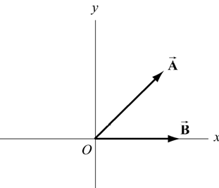 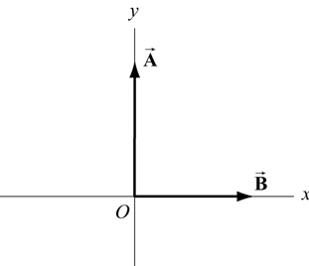 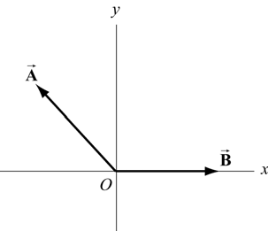

**Figure A.2.3** Dot product that is (a) positive, (b) zero or (c) negative.

The result for the dot product can be generalized easily for arbitrary vectors

**A**  *A ˆ***i**  *A ˆ***j**  *A* **k***ˆ*

*x y z*

(A.2.15)

and

to yield

**B**  *B ˆ***i**  *B ˆ***j**  *B* **k***ˆ*

*x y z*

(A.2.16)

**A**  **B**  *Ax Bx*  *Ay By*  *Az Bz*

(A.2.17)

# Cross Product

We shall now introduce our second vector operation, called the “cross product” that takes any two vectors and generates a new vector. The cross product is a type of “multiplication” law that turns our vector space (law for addition of vectors) into a vector algebra (laws for addition and multiplication of vectors). The first application of the cross

product will be the physical concept of torque about a point

*P* which can be described

mathematically by the cross product of a vector from *P* to where the force acts, and the force vector.

# Definition: Cross Product

Let **A**

and **B** be two vectors. Since any two vectors form a plane, we define the angle **

to be the angle between the vectors **A** and **B**

as shown in Figure A.3.2.1. The magnitude

of the cross product

**A**  **B**

of the vectors

1. and **B**

is defined to be product of the

magnitude of the vectors **A**

and **B**

with the sine of the angle * *between the two vectors,

**A**  **B**  *AB* sin**

(A.3.1)

where *A* and *B* denote the magnitudes of **A** and **B** , respectively. The angle* *between the

vectors is limited to the values 0  * * * *insuring that sin* * 0.

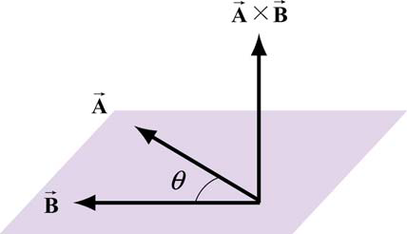

**Figure A.3.1** Cross product geometry.

The direction of the cross product is defined as follows. The vectors **A**

and **B**

form a

plane. Consider the direction perpendicular to this plane. There are two possibilities, as shown in Figure A.3.1. We shall choose one of these two for the direction of the cross

product **A**  **B** using a convention that is commonly called the *“right-hand rule*”.

# Right-hand Rule for the Direction of Cross Product

The first step is to redraw the vectors **A** and **B**

so that their tails are touching. Then

draw an arc starting from the vector **A** and finishing on the vector **B** . Curl your right

fingers the same way as the arc. Your right thumb points in the direction of the cross

product **A**  **B** (Figure A.3.2).

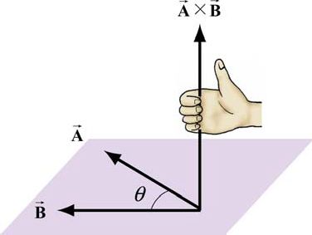

**Figure A.3.2** Right-Hand Rule.

You should remember that the direction of the cross product

**A**  **B**

is perpendicular to

the plane formed by **A**

and **B** .

We can give a geometric interpretation to the magnitude of the cross product by writing the definition as

**A**  **B**  *A* *B* sin* *

(A.3.2)

The vectors **A**

and **B**

form a parallelogram. The area of the parallelogram equals the

height times the base, which is the magnitude of the cross product. In Figure A.3.3, two different representations of the height and base of a parallelogram are illustrated. As

depicted in Figure A.3.3(a), the term *B* sin*  *is the projection of the vector **B**

in the

direction perpendicular to the vector product as

**A** . We could also write the magnitude of the cross

**A**  **B**  ( *A*sin* *)*B*

(A.3.3)

Now the term

*A*sin*  *is the projection of the vector **A** in the direction perpendicular to

the vector **B**

as shown in Figure A.3.3(b).

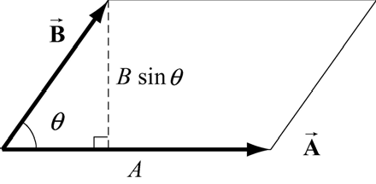 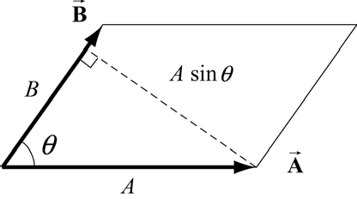

**Figure A.3.3** Projection of vectors and the cross product

The cross product of two vectors that are parallel (or anti-parallel) to each other is zero

since the angle between the vectors is 0 (or * *) and sin(0)  0

(or sin (* *)  0 ).

Geometrically, two parallel vectors do not have any component perpendicular to their common direction.

# Properties of the Cross Product

1. The cross product is anti-commutative since changing the order of the vectors cross product changes the direction of the cross product vector by the right hand rule:

**A**  **B**  **B**  **A**

(A.3.4)

1. The cross product between a vector *c***A** where c is a scalar and a vector **B** is

*c***A**  **B**  *c*(**A**  **B**)

(A.3.5)

Similarly,

**A**  *c***B**  *c*(**A**  **B**)

(A.3.6)

1. The cross product between the sum of two vectors **A** and **B**

with a vector **C** is

(**A**  **B**)  **C**  **A**  **C**  **B**  **C**

(A.3.7)

Similarly,

**A**  (**B**  **C**)  **A**  **B**  **A**  **C**

(A.3.8)

# Vector Decomposition and the Cross Product

We first calculate that the magnitude of cross product of the unit vector *ˆ***i** with *ˆ***j** :

| ˆ**i**  ˆ**j** || ˆ**i** || ˆ**j** | sin ⎛ * *⎞  1

2

⎜ ⎟

⎝ ⎠

(A.3.9)

since the unit vector has magnitude | ˆ**i** || ˆ**j** | 1 and sin (* */ 2)  1. By the right hand rule,

the direction of *ˆ***i** *ˆ***j** is in the **k***ˆ*

as shown in Figure A.3.4. Thus *ˆ***i** *ˆ***j**  **k***ˆ* .

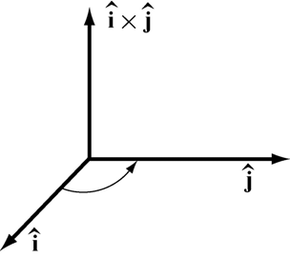

**Figure A.3.4** Cross product of *ˆ***i** *ˆ***j**

We note that the same rule applies for the unit vectors in the *y* and *z* directions,

*ˆ***j** **k***ˆ*

 *ˆ***i***,*

**k***ˆ* *ˆ***i**  *ˆ***j** (A.3.10)

Note that by the anti-commutatively property (1) of the cross product,

*ˆ***j***ˆ***i**  **k***ˆ ,*

*ˆ***i**  **k***ˆ*

 *ˆ***j** (A.3.11)

The cross product of the unit vector *ˆ***i**

parallel to each other, ( sin(0)  0 ),

with itself is zero because the two unit vectors are

| ˆ**i**  ˆ**i** || ˆ**i** || ˆ**i** | sin(0)  0

(A.3.12)

The cross product of the unit vector *ˆ***j** with itself and the unit vector **k***ˆ* also zero for the same reason.

with itself, are

*ˆ***j***ˆ***j**  0*,*

**k***ˆ*  **k***ˆ*  0

(A.3.13)

With these properties in mind we can now develop an algebraic expression for the cross product in terms of components. Let’s choose a Cartesian coordinate system with the

vector

1. pointing along the positive *x*-axis with positive *x*-component

*Bx* . Then the

vectors **A**

and

and **B**

can be written as

**A**  *A ˆ***i**  *A ˆ***j**  *A* **k***ˆ*

*x y z*

**B**  *B ˆ***i**

*x*

(A.3.14)

(A.3.15)

respectively. The cross product in vector components is

**A**  **B** 

*x y z*

( *A ˆ***i**  *A ˆ***j**  *A* **k***ˆ*

)  *B ˆ***i**

(A.3.16)

This becomes, using properties (3) and (2),

*x*

**A**  **B**  ( *A* ˆ**i**  *B* ˆ**i**)  ( *A* ˆ**j** *B* ˆ**i**)  ( *A* **k**ˆ  *B* ˆ**i**)

*x x y x z x*

 *A B* (ˆ**i**  ˆ**i**)  *A B* (ˆ**j** ˆ**i**)  *A B* (**k**ˆ  ˆ**i**)

*x x y x z x*

  *A B* **k**ˆ  *A B* ˆ**j**

*y x z x*

(A.3.17)

The vector component expression for the cross product easily generalizes for arbitrary vectors

**A**  *A ˆ***i**  *A ˆ***j**  *A* **k***ˆ*

*x y z*

(A.3.18)

and

**B**  *B ˆ***i**  *B ˆ***j**  *B* **k***ˆ*

*x y z*

(A.3.19)

to yield

**A**  **B**  ( *A B*  *A B* )ˆ**i**  ( *A B*

* *A B* )ˆ**j**  ( *A B*

 *A B* )**k**ˆ . (A.3.20)

*y z z y z x x z x y y x*