**VECTOR ANALYSIS**

Vector analysis is a mathematical subject which is much better taught by math- ematicians than by engineers. Most junior and senior engineering students, how- ever, have not had the time (or perhaps the inclination) to take a course in vector analysis, although it is likely that many elementary vector concepts and opera- tions were introduced in the calculus sequence. These fundamental concepts and operations are covered in this chapter, and the time devoted to them now should depend on past exposure.

The viewpoint here is also that of the engineer or physicist and not that of the mathematician in that proofs are indicated rather than rigorously expounded and the physical interpretation is stressed. It is easier for engineers to take a more rigorous and complete course in the mathematics department after they have been presented with a few physical pictures and applications.

It is possible to study electricity and magnetism without the use of vector analysis, and some engineering students may have done so in a previous electrical engineering or basic physics course. Carrying this elementary work a bit further, however, soon leads to line-filling equations often composed of terms which all look about the same. A quick glance at one of these long equations discloses little of the physical nature of the equation and may even lead to slighting an old friend.

Vector analysis is a mathematical shorthand. It has some new symbols, some new rules, and a pitfall here and there like most new fields, and it demands concentration, attention, and practice. The drill problems, first met at the end of Sec. 1.4, should be considered an integral part of the text and should all be worked. They should not prove to be difficult if the material in the accompanying section of the text has been thoroughly understood. It take a little longer to read the chapter this way, but the investment in time will produce a surprising interest.

**SCALARS AND VECTORS**

The term *scalar* refers to a quantity whose value may be represented by a single (positive or negative) real number. The *x*, *y*, and *z* we used in basic algebra are scalars, and the quantities they represent are scalars. If we speak of a body falling a distance *L* in a time *t*, or the temperature *T* at any point in a bowl of soup whose coordinates are *x*, *y*, and *z*, then *L*, *t*, *T* , *x*, *y*, and *z* are all scalars. Other scalar quantities are mass, density, pressure (but not force), volume, and volume resistivity. Voltage is also a scalar quantity, although the complex representation of a sinusoidal voltage, an artificial procedure, produces a *complex scalar*, or *phasor*, which requires two real numbers for its representation, such as amplitude and phase angle, or real part and imaginary part.

A *vector* quantity has both a magnitude1 and a direction in space. We shall be concerned with two- and three-dimensional spaces only, but vectors may be defined in *n*-dimensional space in more advanced applications. Force, velocity, acceleration, and a straight line from the positive to the negative terminal of a storage battery are examples of vectors. Each quantity is characterized by both a magnitude and a direction.

We shall be mostly concerned with scalar and vector *.fields*. A field (scalar or vector) may be defined mathematically as some function of that vector which connects an arbitrary origin to a general point in space. We usually find it possible to associate some physical effect with a field, such as the force on a compass needle in the earth s magnetic field, or the movement of smoke particles in the field defined by the vector velocity of air in some region of space. Note that the field concept invariably is related to a region. Some quantity is defined at every point in a region. Both *scalar .fields* and *vector .fields* exist. The temperature throughout the bowl of soup and the density at any point in the earth are examples of scalar fields. The gravitational and magnetic fields of the earth, the voltage gradient in a cable, and the temperature gradient in a soldering- iron tip are examples of vector fields. The value of a field varies in general with both position and time.

In this book, as in most others using vector notation, vectors will be indi- cated by boldface type, for example, A. Scalars are printed in italic type, for example, *A*. When writing longhand or using a typewriter, it is customary to draw a line or an arrow over a vector quantity to show its vector character. (CAUTION: This is the first pitfall. Sloppy notation, such as the omission of the line or arrow symbol for a vector, is the major cause of errors in vector analysis.)

1 We adopt the convention that magnitude infers absolute value ; the magnitude of any quantity is therefore always positive.

VECTOR ANALYSIS 3

VECTOR ALGEBRA

With the definitions of vectors and vector fields now accomplished, we may proceed to define the rules of vector arithmetic, vector algebra, and (later) of vector calculus. Some of the rules will be similar to those of scalar algebra, some will differ slightly, and some will be entirely new and strange. This is to be expected, for a vector represents more information than does a scalar, and the multiplication of two vectors, for example, will be more involved than the multi- plication of two scalars.

The rules are those of a branch of mathematics which is firmly established. Everyone plays by the same rules, and we, of course, are merely going to look at and interpret these rules. However, it is enlightening to consider ourselves pioneers in the field. We are making our own rules, and we can make any rules we wish. The only requirement is that the rules be self-consistent. Of course, it would be nice if the rules agreed with those of scalar algebra where possible, and it would be even nicer if the rules enabled us to solve a few practical problems. One should not fall into the trap of algebra worship and believe that the rules of college algebra were delivered unto man at the Creation. These rules are merely self-consistent and extremely useful. There are other less familiar alge- bras, however, with very different rules. In Boolean algebra the product *AB* can be only unity or zero. Vector algebra has its own set of rules, and we must be constantly on guard against the mental forces exerted by the more familiar rules

or scalar algebra.

Vectorial addition follows the parallelogram law, and this is easily, if inac- curately, accomplished graphically. Fig. 1.1 shows the sum of two vectors, A and

B. It is easily seen that A + B = B + A, or that vector addition obeys the com- mutative law. Vector addition also obeys the associative law,

A + (B + C)= (A + B)+ C

Note that when a vector is drawn as an arrow of finite length, its location is defined to be at the tail end of the arrow.

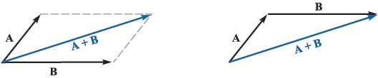

FIGURE 1.1

Two vectors may be added graphically either by drawing both vectors from a common origin and completing the parallelogram or by beginning the second vector from the head of the first and completing the triangle; either method is easily extended to three or more vectors.

*Coplanar* vectors, or vectors lying in a common plane, such as those shown in Fig. 1.1, which both lie in the plane of the paper, may also be added by expressing each vector in terms of horizontal and vertical components and adding the corresponding components.

Vectors in three dimensions may likewise be added by expressing the vec- tors in terms of three components and adding the corresponding components. Examples of this process of addition will be given after vector components are discussed in Sec. 1.4.

The rule for the subtraction of vectors follows easily from that for addition, for we may always express A - B as A + (-B); the sign, or direction, of the second vector is reversed, and this vector is then added to the first by the rule for vector addition.

Vectors may be multiplied by scalars. The magnitude of the vector changes, but its direction does not when the scalar is positive, although it reverses direction

when multiplied by a negative scalar. Multiplication of a vector by a scalar also obeys the associative and distributive laws of algebra, leading to

(*r* + *s*)(A + B) = *r*(A + B)+ *s*(A + B) = *r*A + *r*B + *s*A + *s*B

Division of a vector by a scalar is merely multiplication by the reciprocal of that scalar.

The multiplication of a vector by a vector is discussed in Secs. 1.6 and 1.7. Two vectors are said to be equal if their difference is zero, or A = B if

A - B = O.

In our use of vector fields we shall always add and subtract vectors which are defined at the same point. For example, the *total* magnetic field about a small horseshoe magnet will be shown to be the sum of the fields produced by the earth and the permanent magnet; the total field at any point is the sum of the indivi- dual fields at that point.

If we are not considering a vector *.field*, however, we may add or subtract vectors which are not defined at the same point. For example, the sum of the gravitational force acting on a 15O-lb*.f* (pound-force) man at the North Pole and that acting on a 175-lb*.f* man at the South Pole may be obtained by shifting each force vector to the South Pole before addition. The resultant is a force of 25 lb*.f* directed toward the center of the earth at the South Pole; if we wanted to be difficult, we could just as well describe the force as 25 lb*.f* directed *away* from the center of the earth (or upward ) at the North Pole.2

**THE CARTESIAN COORDINATE SYSTEM**

In order to describe a vector accurately, some specific lengths, directions, angles, projections, or components must be given. There are three simple methods of doing this, and about eight or ten other methods which are useful in very special cases. We are going to use only the three simple methods, and the simplest of these is the *cartesian*, or *rectangular*, *coordinate system.*

**VECTOR ANALYSIS 5**

▲

In the cartesian coordinate system we set up three coordinate axes mutually at right angles to each other, and call them the *x*, *y*, and *z* axes. It is customary to choose a *right-handed* coordinate system, in which a rotation (through the smal- ler angle) of the *x* axis into the *y* axis would cause a right-handed screw to progress in the direction of the *z* axis. If the right hand is used, then the thumb, forefinger, and middle finger may then be identified, respectively, as the *x*, *y*, and *z* axes. Fig. 1.2*a* shows a right-handed cartesian coordinate system. A point is located by giving its *x*, *y*, and *z* coordinates. These are, respec- tively, the distances from the origin to the intersection of a perpendicular dropped from the point to the *x*, *y*, and *z* axes. An alternative method of inter- preting coordinate values, and a method corresponding to that which *must* be used in all other coordinate systems, is to consider the point as being at the

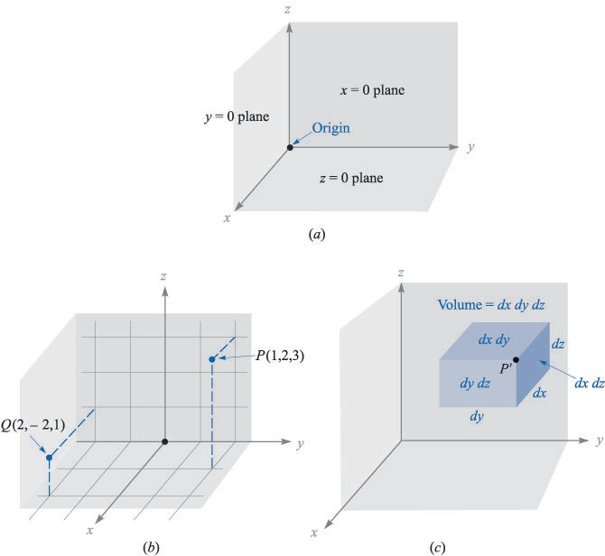

FIGURE 1.2

A right-handed cartesian coordinate system. If the curved fingers of the right hand indicate the direction through which the *x* axis is turned into coincidence with the *y* axis, the thumb shows the direction of the *z* axis. (*b*) The location of points *P*(1, 2, 3) and *Q*(2, -2, 1). (*c*) The differential volume element in cartesian coordinates; *dx*, *dy*, and *dz* are, in general, independent differentials.

common intersection of three surfaces, the planes *x* = constant, *y* = constant, and *z* = constant, the constants being the coordinate values of the point.

Fig. 1.2*b* shows the points *P* and *Q* whose coordinates are (1, 2, 3) and (2, -2, 1), respectively. Point *P* is therefore located at the common point of intersection of the planes *x* = 1, *y* = 2, and *z* = 3, while point *Q* is located at the intersection of the planes *x* = 2, *y* = -2, *z* = 1.

As we encounter other coordinate systems in Secs. 1.8 and 1.9, we should expect points to be located at the common intersection of three surfaces, not necessarily planes, but still mutually perpendicular at the point of intersection. If we visualize three planes intersecting at the general point *P*, whose coor- dinates are *x*, *y*, and *z*, we may increase each coordinate value by a differential amount and obtain three slightly displaced planes intersecting at point *P* t, whose coordinates are *x* + *dx*, *y* + *dy*, and *z* + *dz*. The six planes define a rectangular parallelepiped whose volume is *dv* = *dxdydz*; the surfaces have differential areas *dS* of *dxdy*, *dydz*, and *dzdx*. Finally, the distance *dL* from *P* to *P* t is the diagonal

of the parallelepiped and has a length of I

(*dx*)

+ (*dy*)2

+ (*dz*) . The volume

element is shown in Fig. 1.2*c*; point *P* t is indicated, but point *P* is located at the only invisible corner.

2

2

▲

All this is familiar from trigonometry or solid geometry and as yet involves only scalar quantities. We shall begin to describe vectors in terms of a coordinate system in the next section.

**VECTOR COMPONENTS AND UNIT VECTORS**

To describe a vector in the cartesian coordinate system, let us first consider a vector r extending outward from the origin. A logical way to identify this vector is by giving the three *component vectors*, lying along the three coordinate axes, whose vector sum must be the given vector. If the component vectors of the vector r are x, y, and z, then r = x + y + z. The component vectors are shown in Fig. 1.3*a*. Instead of one vector, we now have three, but this is a step forward, because the three vectors are of a very simple nature; each is always directed along one of the coordinate axes.

In other words, the component vectors have magnitudes which depend on the given vector (such as r above), but they each have a known and constant direction. This suggests the use of *unit vectors* having unit magnitude, by defini- tion, and directed along the coordinate axes in the direction of the increasing coordinate values. We shall reserve the symbol a for a unit vector and identify the direction of the unit vector by an appropriate subscript. Thus a*x*, a*y*, and a*z* are the unit vectors in the cartesian coordinate system.3 They are directed along the *x*, *y*, and *z* axes, respectively, as shown in Fig. 1.3*b*.

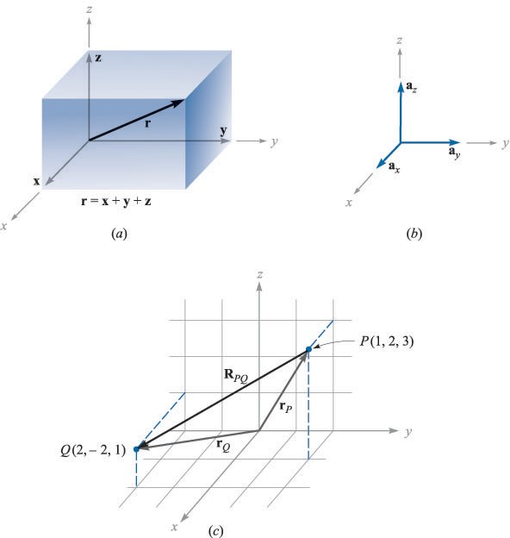

FIGURE 1.3

The component vectors x, y, and z of vector r. (*b*) The unit vectors of the cartesian coordinate system have unit magnitude and are directed toward increasing values of their respective variables. (*c*) The vector R*PQ* is equal to the vector difference r*Q* - r*P* .

If the component vector y happens to be two units in magnitude and directed toward increasing values of *y*, we should then write y = 2a*y*. A vector r*P* pointing from the origin to point *P*(1, 2, 3) is written r*P* = a*x* + 2a*y* + 3a*z*. The vector from *P* to *Q* may be obtained by applying the rule of vector addition. This rule shows that the vector from the origin to *P* plus the vector from *P* to *Q* is equal to the vector from the origin to *Q*. The desired vector from *P*(1, 2, 3) to *Q*(2, -2, 1) is therefore

R*PQ* = r*Q* - r*P* = (2 - 1)a*x* + (-2 - 2)a*y* + (1 - 3)a*z*

= a*x* - 4a*y* - 2a*z*

The vectors r*P*, r*Q*, and R*PQ* are shown in Fig. 1.3*c*.

**8 ENGINEERING ELECTROMAGNETICS**

This last vector does not extend outward from the origin, as did the vector r we initially considered. However, we have already learned that vectors having the same magnitude and pointing in the same direction are equal, so we see that to help our visualization processes we are at liberty to slide any vector over to the origin before determining its component vectors. Parallelism must, of course, be maintained during the sliding process.

If we are discussing a force vector F, or indeed any vector other than a displacement-type vector such as r, the problem arises of providing suitable letters for the three component vectors. It would not do to call them x, y, and z, for these are displacements, or directed distances, and are measured in meters (abbreviated m) or some other unit of length. The problem is most often avoided by using *component scalars*, simply called *components*, *Fx*, *Fy*, and *Fz*. The com- ponents are the signed magnitudes of the component vectors. We may then write F = *Fx*a*x* + *Fy*a*y* + *Fz*a*z*. The component vectors are *Fx*a*x*, *Fy*a*y*, and *Fz*a*z*.

Any vector B then may be described by B = *Bx*a*x* + *By*a*y* + *Bz*a*z*. The mag- nitude of B written IBI or simply *B*, is given by

IBI= *B*2 2 2

I *x* + *By* + *Bz*

(1)

Each of the three coordinate systems we discuss will have its three funda- mental and mutually perpendicular unit vectors which are used to resolve any vector into its component vectors. However, unit vectors are not limited to this application. It is often helpful to be able to write a unit vector having a specified direction. This is simply done, for a unit vector in a given direction is merely a vector in that direction divided by its magnitude. A unit vector in the r direction

is r/j*x*2 + *y*2 + *z*2, and a unit vector in the direction of the vector B is

B B

=

a*B* = I

(2)

*B*2 2

2 IBI

Exa 1.1

*x* + *By* + *Bz*

Specify the unit vector extending from the origin toward the point *G*(2, -2, -1).

*Solution.* We first construct the vector extending from the origin to point *G*,

G = 2a*x* - 2a*y* - a*z*

We continue by finding the magnitude of G,

IGI= I 2 2

(2)2 + (-2)

▲

+ (-1) = 3

VECTOR ANALYSIS 9

and finally expressing the desired unit vector as the quotient,

G

2 2 1

a*G* =

= a*x* - a*y* - a*z* = O.667a*x* - O.667a*y* - O.333a*z*

IGI 3 3 3

▲

A special identifying symbol is desirable for a unit vector so that its character is immediately apparent. Symbols which have been used are u*B* , a*B*, 1B, or even b. We shall consistently use the lowercase a with an appropriate subscript.

[NOTE: Throughout the text, drill problems appear following sections in which a new principle is introduced in order to allow students to test their understanding of the basic fact itself. The problems are useful in gaining familiarization with new terms and ideas and should all be worked. More general problems appear at the ends of the chapters. The answers to the drill problems are given in the same order as the parts of the problem.]

v D1.1. Given points *M*(-1, 2, 1), *N*(3, -3, O), and *P*(-2, -3, -4), find: (*a*) R*MN* ; (*b*)

R*MN* + R*MP*; (*c*) Ir*M* I; (*d*) a*MP*; (*e*) I2r*P* - 3r*N* I.

*Ans*. 4a*x* - 5a*y* - a*z*; 3a*x* - 1Oa*y* - 6a*z*; 2.45; -O.14OOa*x* - O.7OOa*y* - O.7OOa*z*; 15.56

THE VECTOR FIELD

We have already defined a vector field as a vector function of a position vector. In general, the magnitude and direction of the function will change as we move throughout the region, and the value of the vector function must be determined using the coordinate values of the point in question. Since we have considered only the cartesian coordinate system, we should expect the vector to be a func- tion of the variables *x*, *y*, and *z*.

If we again represent the position vector as r, then a vector field G can be expressed in functional notation as G(r); a scalar field *T* is written as *T* (r).

If we inspect the velocity of the water in the ocean in some region near the surface where tides and currents are important, we might decide to represent it by a velocity vector which is in any direction, even up or down. If the *z* axis is taken as upward, the *x* axis in a northerly direction, the *y* axis to the west, and the origin at the surface, we have a right-handed coordinate system and may write the velocity vector as v = *vx*a*x* + *vy*a*y* + *vz*a*z*, or v(r) = *vx*(r)a*x* + *vy*(r)a*y* + *vz*(r)a*z*; each of the components *vx*, *vy*, and *vz* may be a function of the three variables *x*, *y*, and *z*. If the problem is simplified by assuming that we are in some portion of the Gulf Stream where the water is moving only to the north, then *vy*, and *vz* are zero. Further simplifying assumptions might be made if the velocity falls off with depth and changes very slowly as we move north, south, east, or west. A suitable expression could be v = 2*ez*/1OOa*x*. We have a velocity of 2 m/s (meters per second) at the surface and a velocity of O.368 x 2, or O.736 m/s, at a depth of 1OO m (*z* = -1OO), and the velocity continues to decrease with depth; in this example the vector velocity has a constant direction.

While the example given above is fairly simple and only a rough approx- imation to a physical situation, a more exact expression would be correspond-

10 ENGINEERING ELECTROMAGNETICS

ingly more complex and difficult to interpret. We shall come across many fields in our study of electricity and magnetism which are simpler than the velocity example, an example in which only the component and one variable were involved (the *x* component and the variable *z*). We shall also study more com- plicated fields, and methods of interpreting these expressions physically will be discussed then.

v D1.2. A vector field S is expressed in cartesian coordinates as S =

2

2

{125/[(*x* - 1)

+ (*y* - 2)2

+ (*z* + 1) ]}{(*x* - 1)a*x* + (*y* - 2)a*y* + (*z* + 1)a*z*}. (*a*) Evaluate S

at *P*(2, 4, 3). (*b*) Determine a unit vector that gives the direction of S at *P*. (*c*) Specify

the surface *.f* (*x*, *y*, *z*) on which ISI = 1.

*Ans*. 5.95a*x* + 11.9Oa*y* + 23.8a*z*; O.218a*x* + O.436a*y* + O.873a*z*;

(*x* - 1)2 + (*y* - 2)2 + (*z* + 1)2 = 125

I

THE DOT PRODUCT

We now consider the first of two types of vector multiplication. The second type will be discussed in the following section.

Given two vectors A and B, the *dot product*, or *scalar product*, is defined as the product of the magnitude of A, the magnitude of B, and the cosine of the smaller angle between them,

(3)

A · B = IAI IBI cos e*AB*

The dot appears between the two vectors and should be made heavy for empha- sis. The dot, or scalar, product is a scalar, as one of the names implies, and it obeys the commutative law,

(4)

A · B = B · A

for the sign of the angle does not affect the cosine term. The expression A · B is read A dot B.

Perhaps the most common application of the dot product is in mechanics, where a constant force F applied over a straight displacement L does an amount of work *FL* cos e, which is more easily written F · L. We might anticipate one of the results of Chap. 4 by pointing out that if the force varies along the path, integration is necessary to find the total work, and the result becomes

r

Work =

F - *d*L

▲

Another example might be taken from magnetic fields, a subject about which we shall have a lot more to say later. The total flux <t crossing a surface

VECTOR ANALYSIS 11

▲

of area *S* is given by *BS* if the magnetic flux density *B* is perpendicular to the surface and uniform over it. We define a *vector sur.face* S as having the usual area for its magnitude and having a direction *normal* to the surface (avoiding for the moment the problem of which of the two possible normals to take). The flux crossing the surface is then B · S. This expression is valid for any direction of the uniform magnetic flux density. However, if the flux density is not constant over

the surface, the total flux is <t = r B · *d*S. Integrals of this general form appear in

Chap. 3 when we study electric flux density.

Finding the angle between two vectors in three-dimensional space is often a job we would prefer to avoid, and for that reason the definition of the dot product is usually not used in its basic form. A more helpful result is obtained by considering two vectors whose cartesian components are given, such as A = *Ax*a*x* + *Ay*a*y* + *Az*a*z* and B = *Bx*a*x* + *By*a*y* + *Bz*a*z*. The dot product also obeys the distributive law, and, therefore, A · B yields the sum of nine scalar terms, each involving the dot product of two unit vectors. Since the angle between two different unit vectors of the cartesian coordinate system is 9O°, we then have

a*x* · a*y* = a*y* · a*x* = a*x* · a*z* = a*z* · a*x* = a*y* · a*z* = a*z* · a*y* = O

The remaining three terms involve the dot product of a unit vector with itself, which is unity, giving finally

(5)

A · B = *AxBx* + *AyBy* + *AzBz*

which is an expression involving no angles.

A vector dotted with itself yields the magnitude squared, or

(6)

A · A = *A*2 = IAI2

and any unit vector dotted with itself is unity,

a*A* · a*A* = 1

One of the most important applications of the dot product is that of finding the component of a vector in a given direction. Referring to Fig. 1.4*a*, we can obtain the component (scalar) of B in the direction specified by the unit vector a as

B · a = IBI IaI cos e*Ba* = IBI cos e*Ba*

The sign of the component is positive if O ::: e*Ba* ::: 9O° and negative whenever 9O° ::: e*Ba* ::: 18O°.

In order to obtain the component *vector* of B in the direction of a, we simply multiply the component (scalar) by a, as illustrated by Fig. 1.4*b*. For example, the component of B in the direction of a*x* is B · a*x* = *Bx*, and the

12 ENGINEERING ELECTROMAGNETICS

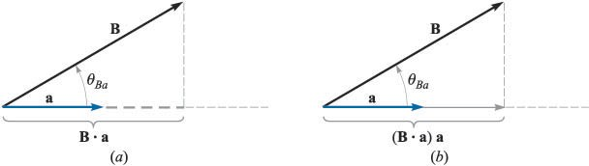

FIGURE 1.4

The scalar component of B in the direction of the unit vector a is B - a. (*b*) The vector component of B

in the direction of the unit vector a is (B - a)a.

component vector is *Bx*a*x*, or (B · a*x*)a*x*. Hence, the problem of finding the com- ponent of a vector in any desired direction becomes the problem of finding a unit vector in that direction, and that we can do.

The geometrical term *pro}ection* is also used with the dot product. Thus,

B · a is the projection of B in the a direction.

Exa 1.2

In order to illustrate these definitions and operations, let us consider the vector field G = *y*a*x* - 2.5*x*a*y* + 3a*z* and the point *Q*(4, 5, 2). We wish to find: G at *Q*; the scalar component of G at *Q* in the direction of a*N* = 1 (2a*x* + a*y* - 2a*z*); the vector component of G at *Q* in the direction of a*N* ; and finally, the angle e*Ga* between G(r*Q*) and a*N* .

3

*Solution.* Substituting the coordinates of point *Q* into the expression for G, we have

G(r*Q*) = 5a*x* - 1Oa*y* + 3a*z*

Next we find the scalar component. Using the dot product, we have

G · a*N* = (5a*x* - 1Oa*y* + 3a*z* ) · 1 (2a*x* + a*y* - 2a*z* 1 (1O - 1O - 6)= -2

) =

3 3

The vector component is obtained by multiplying the scalar component by the unit vector in the direction of a*N* ,

(G · a*N* )a*N* = -(2) 1 (2a*x* + a*y* - 2a*z* )= -1.333a*x* - O.667a*y* + 1.333a*z*

3

The angle between G(r*Q*) and a*N* is found from

G · a*N* = IGI cos e*Ga*

-2 = v'25 + 1OO + 9 cos e*Ga*

and

e*Ga* = cos-1 -

2

= 99.9°

v'134

▲

VECTOR ANALYSIS 13

▲

v D1.3. The three vertices of a triangle are located at *A*(6, -1, 2), *B*(-2, 3, -4), and *C*(-3, 1, 5). Find: (*a*) R*AB*; (*b*) R*AC* ; (*c*) the angle e*BAC* at vertex *A*; (*d*) the (vector) projection of R*AB* on R*AC* .

*Ans*. -8a*x* + 4a*y* - 6a*z*; -9a*x* - 2a*y* + 3a*z*; 53.6°; -5.94a*x* + 1.319a*y* + 1.979a*z*

THE CROSS PRODUCT

Given two vectors A and B, we shall now define the *cross product*, or *vector product*, of A and B, written with a cross between the two vectors as A x B and read A cross B. The cross product A x B is a vector; the magnitude of A x B is equal to the product of the magnitudes of A, B, and the sine of the smaller angle between A and B; the direction of A x B is perpendicular to the plane containing A and B and is along that one of the two possible perpendiculars which is in the direction of advance of a right-handed screwas A is turned into B. This direction is illustrated in Fig. 1.5. Remember that either vector may be moved about at will, maintaining its direction constant, until the two vectors have a common origin. This determines the plane containing both. However, in most of our applications we shall be concerned with vectors defined at the same point.

As an equation we can write

(7)

A x B = a*N* IAI IBI sin e*AB*

where an additional statement, such as that given above, is still required to explain the direction of the unit vector a*N* . The subscript stands for normal. Reversing the order of the vectors A and B results in a unit vector in the opposite direction, and we see that the cross product is not commutative, for B x A = -(A x B). If the definition of the cross product is applied to the unit

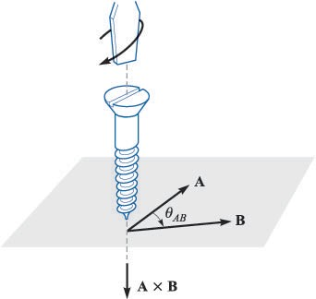

FIGURE 1.5

The direction of A x B is in the direction of advance of a right-handed screw as A is turned into B.

14 ENGINEERING ELECTROMAGNETICS

vectors a*x* and a*y*, we find a*x* x a*y* = a*z*, for each vector has unit magnitude, the two vectors are perpendicular, and the rotation of a*x* into a*y* indicates the posi- tive *z* direction by the definition of a right-handed coordinate system. In a similar way a*y* x a*z* = a*x*, and a*z* x a*x* = a*y*. Note the alphabetic symmetry. As long as the three vectors a*x*, a*y*, and a*z* are written in order (and assuming that a*x* follows a*z*, like three elephants in a circle holding tails, so that we could also write a*y*, a*z*, a*x* or a*z*, a*x*, a*y*), then the cross and equal sign may be placed in either of the two vacant spaces. As a matter of fact, it is now simpler to define a right-handed cartesian coordinate system by saying that a*x* x a*y* = a*z*.

A simple example of the use of the cross product may be taken from geometry or trigonometry. To find the area of a parallelogram, the product of the lengths of two adjacent sides is multiplied by the sine of the angle between them. Using vector notation for the two sides, we then may express the (scalar) area as the *magnitude* of A x B, or IA x BI.

The cross product may be used to replace the right-hand rule familiar to all electrical engineers. Consider the force on a straight conductor of length L, where the direction assigned to L corresponds to the direction of the steady current *I* , and a uniform magnetic field of flux density B is present. Using vector notation, we may write the result neatly as F = *I* L x B. This relationship will be obtained later in Chap. 9.

The evaluation of a cross product by means of its definition turns out to be more work than the evaluation of the dot product from its definition, for not only must we find the angle between the vectors, but we must find an expression for the unit vector a*N* . This work may be avoided by using cartesian components for the two vectors A and B and expanding the cross product as a sum of nine simpler cross products, each involving two unit vectors,

A x B = *AxBx*a*x* x a*x* + *AxBy*a*x* x a*y* + *AxBz*a*x* x a*z*

+ *AyBx*a*y* x a*x* + *AyBy*a*y* x a*y* + *AyBz*a*y* x a*z*

+ *AzBx*a*z* x a*x* + *AzBy*a*z* x a*y* + *AzBz*a*z* x a*z*

We have already found that a*x* x a*y* = a*z*, a*y* x a*z* = a*x*, and a*z* x a*x* = a*y*. The three remaining terms are zero, for the cross product of any vector with itself is zero, since the included angle is zero. These results may be combined to give

A x B = (*AyBz* - *AzBy*)a*x* + (*AzBx* - *AxBz*)a*y* + (*AxBy* - *AyBx*)a*z* (8)

or written as a determinant in a more easily remembered form,

a*x* a*y* a*z*

A x B = *Ax Ay Az*

(9)

*Bx By Bz*

▲

Thus, if A = 2a*x* - 3a*y* + a*z* and B = -4a*x* - 2a*y* + 5a*z*, we have

VECTOR ANALYSIS 15

▲

a*x* a*y* a*z*

A x B =

2 -3 1

-4 -2 5

= [(-3)(5)- (1(-2)]a*x* - [(2)(5)- (1)(-4)]a*y* + [(2)(-2)- (-3)(-4)]a*z*

= -13a*x* - 14a*y* - 16a*z*

v D1.4. The three vertices of a triangle are located at *A*(6, -1, 2), *B*(-2, 3, -4) and *C*(-3, 1, 5). Find: (*a*) R*AB* x R*AC* ; (*b*) the area of the triangle; (*c*) a unit vector perpen- dicular to the plane in which the triangle is located.

*Ans*. 24a*x* + 78a*y* + 2Oa*z* ; 42.O; O.286a*x* + O.928a*y* + O.238a*z*

OTHER COORDINATE SYSTEMS: CIRCULAR CYLINDRICAL COORDINATES

The cartesian coordinate system is generally the one in which students prefer to work every problem. This often means a lot more work for the student, because many problems possess a type of symmetry which pleads for a more logical treatment. It is easier to do now, once and for all, the work required to become familiar with cylindrical and spherical coordinates, instead of applying an equal or greater effort to every problem involving cylindrical or spherical symmetry later. With this future saving of labor in mind, we shall take a careful and unhurried look at cylindrical and spherical coordinates.

The circular cylindrical coordinate system is the three-dimensional version of the polar coordinates of analytic geometry. In the two-dimensional polar coordinates, a point was located in a plane by giving its distance p from the origin, and the angle ¢ between the line from the point to the origin and an arbitrary radial line, taken as ¢ = O.4 A three-dimensional coordinate system, circular cylindrical coordinates, is obtained by also specifying the distance *z* of the point from an arbitrary *z* = O reference plane which is perpendicular to the line p = O. For simplicity, we usually refer to circular cylindrical coordinates simply as cylindrical coordinates. This will not cause any confusion in reading this book, but it is only fair to point out that there are such systems as elliptic cylindrical coordinates, hyperbolic cylindrical coordinates, parabolic cylindrical coordinates, and others.

We no longer set up three axes as in cartesian coordinates, but must instead consider any point as the intersection of three mutually perpendicular surfaces. These surfaces are a circular cylinder (p = constant), a plane (¢ = constant), and

4 The two variables of polar coordinates are commonly called *r* and e. With three coordinates, however, it is more common to use p for the radius variable of cylindrical coordinates and *r* for the (different) radius variable of spherical coordinates. Also, the angle variable of cylindrical coordinates is customarily called ¢ because everyone uses e for a different angle in spherical coordinates. The angle ¢ is common to both cylindrical and spherical coordinates. See?

16 ENGINEERING ELECTROMAGNETICS

▲

another plane (*z* = constant). This corresponds to the location of a point in a cartesian coordinate system by the intersection of three planes (*x* = constant, *y* = constant, and *z* = constant). The three surfaces of circular cylindrical coordi- nates are shown in Fig. 1.6*a*. Note that three such surfaces may be passed through any point, unless it lies on the *z* axis, in which case one plane suffices. Three unit vectors must also be defined, but we may no longer direct them along the coordinate axes, for such axes exist only in cartesian coordinates. Instead, we take a broader view of the unit vectors in cartesian coordinates and realize that they are directed toward increasing coordinate values and are per- pendicular to the surface on which that coordinate value is constant (i.e., the unit vector a*x* is normal to the plane *x* = constant and points toward larger values of *x*). In a corresponding way we may now define three unit vectors in cylindrical

coordinates, ap, a¢, and a*z*.

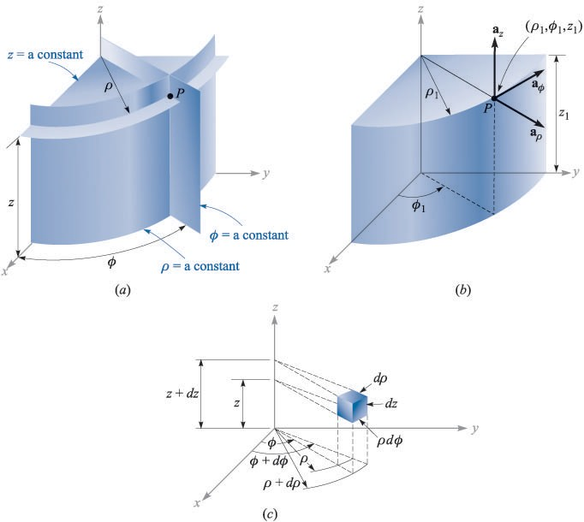

FIGURE 1.6

(a*a*) The three mutually perpendicular surfaces of the circular cylindrical coordinate system. (*b*) The three unit vectors of the circular cylindrical coordinate system. (*c*) The differential volume unit in the circular cylindrical coordinate system; *d*p, p*d*¢, and *dz* are all elements of length.

VECTOR ANALYSIS 17

The unit vector ap at a point *P*(p1, ¢1, *z*1) is directed radially outward, normal to the cylindrical surface p = p1. It lies in the planes ¢ = ¢1 and *z* = *z*1. The unit vector a¢ is normal to the plane ¢ = ¢1, points in the direction of increasing ¢, lies in the plane *z* = *z*1, and is tangent to the cylindrical surface p = p1. The unit vector a*z* is the same as the unit vector a*z* of the cartesian coordinate system. Fig. 1.6*b* shows the three vectors in cylindrical coordinates. In cartesian coordinates, the unit vectors are not functions of the coordi- nates. Two of the unit vectors in cylindrical coordinates, ap and a¢, however, *do* vary with the coordinate ¢, since their directions change. In integration or dif- ferentiation with respect to ¢, then, ap and a¢ must not be treated as constants.

The unit vectors are again mutually perpendicular, for each is normal to one of the three mutually perpendicular surfaces, and we may define a right- handed cylindrical coordinate system as one in which ap x a¢ = a*z*, or (for those who have flexible fingers) as one in which the thumb, forefinger, and middle finger point in the direction of increasing p, ¢, and *z*, respectively.

A differential volume element in cylindrical coordinates may be obtained by increasing p, ¢, and *z* by the differential increments *d*p, *d*¢, and *dz*. The two cylinders of radius p and p + *d*p, the two radial planes at angles ¢ and ¢ + *d*¢, and the two horizontal planes at elevations *z* and *z* + *dz* nowenclose a small volume, as shown in Fig. 1.6*c*, having the shape of a truncated wedge. As the volume element becomes very small, its shape approaches that of a rectangular parallelepiped having sides of length *d*p, p*d*¢ and *dz*. Note that *d*p and *dz* are dimensionally lengths, but *d*¢ is not; p*d*¢ is the length. The surfaces have areas of p *d*p *d*¢, *d*p *dz*, and p *d*¢ *dz*, and the volume becomes p *d*p *d*¢ *dz*.

The variables of the rectangular and cylindrical coordinate systems are easily related to each other. With reference to Fig. 1.7, we see that

*x* = p cos ¢

*y* = p sin ¢

*z* = *z*

(1O)

▲

FIGURE 1.7

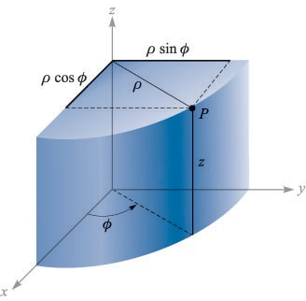

The relationship between the cartesian variables *x*, *y*, *z* and the cylindrical coordinate variables p, ¢, *z*. There is no change in the variable *z* between the two systems.

18 ENGINEERING ELECTROMAGNETICS

From the other viewpoint, we may express the cylindrical variables in terms of

*x*, *y*, and *z*:

p = j*x*2 + *y*

2

*y*

(p 2: O)

¢ tan-1

=

*x*

(11)

*z* = *z*

We shall consider the variable p to be positive or zero, thus using only the positive sign for the radical in (11). The proper value of the angle ¢ is determined by inspecting the signs of *x* and *y*. Thus, if *x* = -3 and *y* = 4, we find that the point lies in the second quadrant so that p = 5 and ¢ = 126.9°. For *x* = 3 and *y* = -4, we have ¢ = -53.1° or 3O6.9°, whichever is more convenient.

Using (1O) or (11), scalar functions given in one coordinate system are easily transformed into the other system.

A vector function in one coordinate system, however, requires two steps in order to transform it to another coordinate system, because a different set of component vectors is generally required. That is, we may be given a cartesian vector

A = *Ax*a*x* + *Ay*a*y* + *Az*a*z*

where each component is given as a function of *x*, *y*, and *z*, and we need a vector in cylindrical coordinates

A = *A*pap + *A*¢a¢ + *Az*a*z*

where each component is given as a function of p, ¢, and *z*.

To find any desired component of a vector, we recall from the discussion of the dot product that a component in a desired direction may be obtained by taking the dot product of the vector and a unit vector in the desired direction. Hence,

*A*p = A · ap and *A*¢ = A · a¢

Expanding these dot products, we have

*A*p = (*Ax*a*x* + *Ay*a*y* + *Az*a*z*) · ap = *Ax*a*x* · ap + *Ay*a*y* · ap (12)

*A*¢ = (*Ax*a*x* + *Ay*a*y* + *Az*a*z*) · a¢ = *Ax*a*x* · a¢ + *Ay*a*y* · a¢ (13)

and

*Az* = (*Ax*a*x* + *Ay*a*y* + *Az*a*z*) · a*z* = *Az*a*z* · a*z* = *Az* (14)

since a*z* · ap and a*z* · a¢ are zero.

▲

In order to complete the transformation of the components, it is necessary to know the dot products a*x* · ap, a*y* · ap, a*x* · a¢, and a*y* · a¢. Applying the defini- tion of the dot product, we see that since we are concerned with unit vectors, the result is merely the cosine of the angle between the two unit vectors in question. Referring to Fig. 1.7 and thinking mightily, we identify the angle between a*x* and

VECTOR ANALYSIS 19

TABLE 1.1

Dot roducts of unit v ctors in cy indrica and cart sian coordinat syst s

|  |  |  |  |
| --- | --- | --- | --- |
|  | ap | a¢ | a*z* |
| a*x* -  a*y* -  a*z*- | cos ¢ sin ¢ O | - sin ¢  cos ¢  O | O O 1 |

ap as ¢, and thus a*x* · ap = cos ¢, but the angle between a*y* and ap is 9O° - ¢, and a*y* · ap = cos (9O° - ¢) = sin ¢. The remaining dot products of the unit vectors are found in a similar manner, and the results are tabulated as functions of ¢ in Table 1.1

Transforming vectors from cartesian to cylindrical coordinates or vice versa is therefore accomplished by using (1O) or (11) to change variables, and by using the dot products of the unit vectors given in Table 1.1 to change components. The two steps may be taken in either order.

Exa 1.3

Transform the vector B = *y*a*x* - *x*a*y* + *z*a*z* into cylindrical coordinates.

*Solution.* The new components are

*B*p = B · ap = *y*(a*x* · ap)- *x*(a*y* · ap)

= *y* cos ¢ - *x* sin ¢ = p sin ¢ cos ¢ - p cos ¢ sin ¢ = O

*B*¢ = B · a¢ = *y*(a*x* · a¢)- *x*(a*y* · a¢)

= -*y* sin ¢ - *x* cos ¢ = -p sin2 ¢ - p cos2 ¢ = -p

Thus,

B = -pa¢ + *z*a*z*

▲

v D1.5. (*a*) Give the cartesian coordinates of the point *C*(p = 4.4,¢ = -115°, *z* = 2). (*b*) Give the cylindrical coordinates of the point *D*(*x* = -3.1, *y* = 2.6, *z* = -3). (*c*) Specify the distance from *C* to *D*.

*Ans*. *C*(*x* = -1.86O, *y* = -3.99, *z* = 2); *D*(p = 4.O5,¢ = 14O.O°, *z* = -3); 8.36

v D1.6. Transform to cylindrical coordinates: (*a*) F = 1Oa*x* - 8a*y* + 6a*z* at point *P*(1O, -8, 6); (*b*) G = (2*x* + *y*)a*x* - (*y* - 4*x*)a*y* at point *Q*(p, ¢, *z*). (*c*) Give the cartesian components of the vector H = 2Oap - 1Oa¢ + 3a*z* at *P*(*x* = 5, *y* = 2, *z* = -1).

*Ans*. 12.81ap + 6a*z*; (2p cos2 ¢ - p sin2 ¢ + 5p sin ¢ cos ¢)ap + (4p cos2 ¢ - p sin2 ¢-

3p sin ¢ cos ¢)a¢; *Hx* = 22.3, *Hy* = -1.857, *Hz* = 3

20 ENGINEERING ELECTROMAGNETICS

▲

THE SPHERICAL COORDINATE SYSTEM

We have no two-dimensional coordinate system to help us understand the three- dimensional spherical coordinate system, as we have for the circular cylindrical coordinate system. In certain respects we can draw on our knowledge of the latitude-and-longitude system of locating a place on the surface of the earth, but usually we consider only points on the surface and not those below or above ground.

Let us start by building a spherical coordinate system on the three cartesian axes (Fig. 1.8*a*). We first define the distance from the origin to any point as *r*. The surface *r* = constant is a sphere.

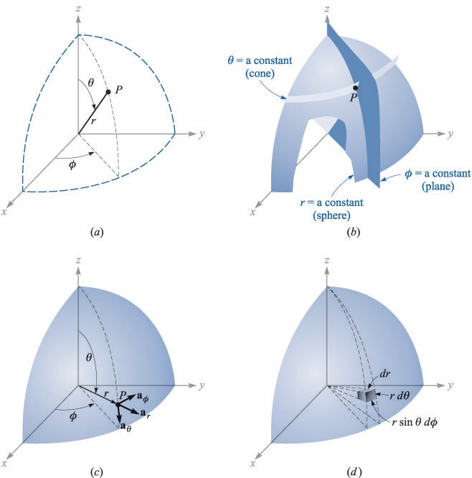

FIGURE 1.8

(*a*) The three spherical coordinates. (*b*) The three mutually perpendicular surfaces of the spherical coordi- nate system. (*c*) The three unit vectors of spherical coordinates: a*r* x ae = a¢. (*d*) The differential volume element in the spherical coordinate system.

VECTOR ANALYSIS 21

The second coordinate is an angle e between the *z* axis and the line drawn from the origin to the point in question. The surface e = constant is a cone, and the two surfaces, cone and sphere, are everywhere perpendicular along their intersection, which is a circle of radius *r* sin e. The coordinate e corresponds to latitude, except that latitude is measured from the equator and e is measured from the North Pole.

The third coordinate ¢ is also an angle and is exactly the same as the angle

¢ of cylindrical coordinates. It is the angle between the *x* axis and the projection in the *z* = O plane of the line drawn from the origin to the point. It corresponds to the angle of longitude, but the angle ¢ increases to the east. The surface ¢ = constant is a plane passing through the e = O line (or the *z* axis).

We should again consider any point as the intersection of three mutually perpendicular surfaces-a sphere, a cone, and a plane-each oriented in the manner described above. The three surfaces are shown in Fig. 1.8*b*.

Three unit vectors may again be defined at any point. Each unit vector is perpendicular to one of the three mutually perpendicular surfaces and oriented in that direction in which the coordinate increases. The unit vector a*r* is directed radially outward, normal to the sphere *r* = constant, and lies in the cone e = constant and the plane ¢ = constant. The unit vector ae is normal to the conical surface, lies in the plane, and is tangent to the sphere. It is directed along a line of

longitude and points south. The third unit vector a¢ is the same as in cylindrical coordinates, being normal to the plane and tangent to both the cone and sphere. It is directed to the east.

The three unit vectors are shown in Fig. 1.8*c*. They are, of course, mutually perpendicular, and a right-handed coordinate system is defined by causing a*r* x ae = a¢. Our system is right-handed, as an inspection of Fig. 1.8*c* will show, on application of the definition of the cross product. The right-hand rule serves to identify the thumb, forefinger, and middle finger with the direction of increasing *r*, e, and ¢, respectively. (Note that the identification in cylindrical coordinates was with p, ¢, and *z*, and in cartesian coordinates with *x*, *y*, and *z*). A differential volume element may be constructed in spherical coordinates by increasing *r*, e, and ¢ by *dr*, *d*e, and *d*¢, as shown in Fig. 1.8*d*. The distance between the two spherical surfaces of radius *r* and *r* + *dr* is *dr*; the distance between the two cones having generating angles of e and e + *d*e is *rd*e; and the distance between the two radial planes at angles ¢ and ¢ + *d*¢ is found to be *r* sin e*d*¢, after a few moments of trigonometric thought. The surfaces have areas of *r dr d*e, *r* sin e *dr d*¢, and *r*2 sin e *d*e *d*¢, and the volume is *r*2 sin e *dr d*e *d*¢.

The transformation of scalars from the cartesian to the spherical coordinate system is easily made by using Fig. 1.8*a* to relate the two sets of variables:

*x* = *r* sin e cos ¢

*y* = *r* sin e sin ¢

▲

*z* = *r* cos e

(15)

22 ENGINEERING ELECTROMAGNETICS

TABLE 1.2

Dot roducts of unit v ctors in s h rica and cart sian coordinat syst s

|  |  |  |  |
| --- | --- | --- | --- |
|  | a*r* | ae | a¢ |
| a*x* -  a*y* -  a*z* - | sin e cos ¢ sin e sin ¢ cos e | cos e cos ¢  cos e sin ¢  - sin e | - sin ¢  cos ¢  O |

The transformation in the reverse direction is achieved with the help of

2

*z*

*r* = j*x*2

+ *y* + *z*2

(*r* 2: O)

e = cos-1

j*x*2 + *y*2 + *z*2

*y*

= 1

¢ tan-

*x*

(O° ::: e ::: 18O°)

(16)

The radius variable *r* is nonnegative, and e is restricted to the range from O° to 18O°, inclusive. The angles are placed in the proper quadrants by inspecting the signs of *x*, *y*, and *z*.

▲

The transformation of vectors requires the determination of the products of the unit vectors in cartesian and spherical coordinates. We work out these prod- ucts from Fig. 1.8*c* and a pinch of trigonometry. Since the dot product of any spherical unit vector with any cartesian unit vector is the component of the spherical vector in the direction of the cartesian vector, the dot products with a*z* are found to be

a*z* · a*r* = cos e a*z* · ae = - sin e a*z* · a¢ = O

The dot products involving a*x* and a*y* require first the projection of the spherical unit vector on the *xy* plane and then the projection onto the desired axis. For example, a*r* · a*x* is obtained by projecting a*r* onto the *xy* plane, giving sin e, and then projecting sin e on the *x* axis, which yields sin e cos ¢. The other dot products are found in a like manner, and all are shown in Table 1.2.

Exa 1.4

We illustrate this transformation procedure by transforming the vector field

G = (*xz*/*y*)a*x* into spherical components and variables.

*Solution.* We find the three spherical components by dotting G with the appropriate unit vectors, and we change variables during the procedure:

VECTOR ANALYSIS 23

*xz xz*

*Gr* = G · a*r* = *y* a*x* · a*r* = *y* sin e cos ¢

cos2 ¢

= *r* sin e cos e sin ¢

*xz xz*

*G*e = G · ae = *y* a*x* · ae = *y* cos e cos ¢

cos2 ¢

= *r* cos2 e

sin ¢

*xz xz*

*G*¢ = G · a¢ = *y* a*x* · a¢ = *y* (- sin ¢)

▲

= -*r* cos e cos ¢

Collecting these results, we have

G = *r* cos e cos ¢ (sin e cot ¢ a*r* + cos e cot ¢ ae - a¢)

Appendix A describes the general curvilinear coordinate system of which the cartesian, circular cylindrical, and spherical coordinate systems are special cases. The first section of this appendix could well be scanned now.

v D1.7. Given the two points, *C*(-3, 2, 1) and *D*(*r* = 5,e = 2O°, ¢ = -7O°), find: (*a*) the spherical coordinates of *C*; (*b*) the cartesian coordinates of *D*; (*c*) the distance from *C* to *D*.

*Ans*. *C*(*r* = 3.74, e = 74.5°, ¢ = 146.3°); *D*(*x* = O.585, *y* = -1.6O7, *z* = 4.7O); 6.29

v D1.8. Transform the following vectors to spherical coordinates at the points given: (*a*) 1Oa*x* at *P*(*x* = -3, *y* = 2, *z* = 4); (*b*) 1Oa*y* at *Q*(p = 5,¢ = 3O°, *z* = 4); (*c*) 1Oa*z* at *M*(*r* = 4,e = 11O°, ¢ = 12O°).

*Ans*. -5.57a*r* - 6.18ae - 5.55a¢; 3.9Oa*r* + 3.12ae + 8.66a¢; -3.42a*r* - 9.4Oae

SUGGESTED REFERENCES

Grossman, S. I.: Calculus, 3d ed., Academic Press and Harcourt Brace Jovanovich, Publishers, Orlando, 1984. Vector algebra and cylindrical and spherical coordinates appear in chap. 17, and vector calculus is introduced in chap. 2O.

Spiegel, M. R.: Vector Analysis, Schaum Outline Series, McGraw-Hill Book Company, New York, 1959. A large number of examples and problems with answers are provided in this concise, inexpensive member of an outline series.

Swokowski, E. W.: Calculus with Analytic Geometry, 3d ed., Prindle, Weber, & Schmidt, Boston, 1984. Vector algebra and the cylindrical and spherical coordinate systems are discussed in chap. 14, and vector calculus appears in chap. 18.

24 ENGINEERING ELECTROMAGNETICS

Thomas, G. B., Jr., and R. L. Finney: Calculus and Analytic Geometry, 6th ed., Addison-Wesley Publishing Company, Reading, Mass., 1984. Vector algebra and the three coordinate systems we use are discussed in chap. 13. Other vector operations are discussed in chaps. 15 and 17.

PROBLEMS

Given the vectors M = -1Oa*x* + 4a*y* - 8a*z* and N = 8a*x* + 7a*y* - 2a*z*, find: (*a*) a unit vector in the direction of -M + 2N; (*b*) the magnitude of 5a*x* + N - 3M; (*c*) IMII2NI(M + N).

Given three points, *A*(4, 3, 2), *B*(-2, O, 5), and *C*(7, -2, 1): (*a*) specify the

vector A extending from the origin to point *A*; (*b*) give a unit vector extending from the origin toward the midpoint of line *AB*; (*c*) calculate the length of the perimeter of triangle *ABC*.

The vector from the origin to point *A* is given as 6a*x* - 2a*y* - 4a*z*, and the unit vector directed from the origin toward point *B* is 2 , - 2 , 1 . If points

3 3 3)

*A* and *B* are 1O units apart, find the coordinates of point *B*.

Given points *A*(8, -5, 4) and *B*(-2, 3, 2), find: (*a*) the distance from *A* to *B*; (*b*) a unit vector directed from *A* towards *B*; (*c*) a unit vector directed from the origin toward the midpoint of the line *AB*; (*d*) the coordinates of the point on the line connecting *A* to *B* at which the line intersects the plane *z* = 3.

A vector field is specified as G = 24*xy*a*x* + 12(*x*2 + 2)a*y* + 18*z*2a*z*. Given two points, *P*(1, 2, -1) and *Q*(-2, 1, 3), find: (*a*) G at *P*; (*b*) a unit vector in the direction of G at *Q*; (*c*) a unit vector directed from *Q* toward *P*; (*d*) the equation of the surface on which IGI= 6O.

For the G field given in Prob. 1.5 above, make sketches of *Gx Gy*, *Gz* and

IGI along the line *y* = 1, *z* = 1, for O ::: *x* ::: 2.

Given the vector field E = 4*zy*2 cos 2*x*a*x* + 2*zy* sin 2*x*a*y* + *y*2 sin 2*x*a*z*, find, for the region I*x*I, I*y*I, and I*z*I < 2: (*a*) the surfaces on which *Ey* = O; (*b*) the region in which *Ey* = *Ez*; (*c*) the region for which E = O.

Two vector fields are F = -1Oa*x* + 2O*x*(*y* - 1)a*y* and G = 2*x*2*y*a*x*- 4a*y* + *z*a*z*. For the point *P*(2, 3, -4), find: (*a*) IFI; (*b*) IGI; (*c*) a unit vector in the direction of F - G; (*d*) a unit vector in the direction of F + G.

25

A field is given as G = *x*2

2 (*x*a*x* + *y*a*y*). Find: (*a*) a unit vector in the

+ *y*

direction of G at *P*(3, 4, -2); (*b*) the angle between G and a*x* at *P*; (*c*) the

value of the double integral r 4

G · *dx dz* a*y* on the plane *y* = 7.

*x*=O r*z*=O

▲

2

Use the definition of the dot product to find the interior angles at *A* and *B* of the triangle defined by the three points: *A*(1, 3, -2), *B*(-2, 4, 5), and *C*(O, -2, 1).

1.11 Given the points *M*(O.1, -O.2, -O.1), *N*(-O.2, O.1, O.3), and *P*(O.4, O, O.1),

find: (*a*) the vector R*MN* ; (*b*) the dot product R*MN* · R*MP*; (*c*) the scalar projection of R*MN* on R*MP*; (*d*) the angle between R*MN* and R*MP*.

VECTOR ANALYSIS 25

1.12 Given points *A*(1O, 12, -6), *B*(16, 8, -2), *C*(8, 1, 4), and *D*(-2, -5, 8),

determine: (*a*) the vector projection of R*AB* + R*BC* on R*AD*; (*b*) the vector projection of R*AB* + R*BC* on R*DC* ; (*c*) the angle between R*DA* and R*DC* .

(*a*) Find the vector component of F = 1Oa*x* - 6a*y* + 5a*z* that is parallel to G = O.1a*x* + O.2a*y* + O.3a*z*. (*b*) Find the vector component of F that is perpendicular to G. (*c*) Find the vector component of G that is perpen- dicular to F.

The three vertices of a regular tetrahedron are located at *0*(O, O, O),

*A*(O, 1, O), *B*(O. v'

5

3, O.5, O), and *C* v'

3/6, O.5,

v'2/3). (*a*) Find a unit vec-

tor perpendicular (outward) to face *ABC*; (*b*) Find the area of face *ABC*.

(

Three vectors extending from the origin are given as r1 = 7a*x* + 3a*y* - 2a*z*, r2 = -2a*x* + 7a*y* - 3a*z*, and r3 = 2a*x* - 2a*y* + 3a*z*. Find: (*a*) a unit vector perpendicular to both r1 and r2; (*b*) a unit vector perpendicular to the vectors r1 - r2 and r2 - r3; (*c*) the area of the tri- angle defined by r1 and r2; (*d*) the area of the triangle defined by the heads of r1, r2, and r3.

Describe the surface defined by the equation: (*a*) r · a*x* = 2, where

r = *x*a*x* + *y*a*y* + *z*a*z*; (*b*) Ir x a*x*I= 2.

Point *A*(-4, 2, 5) and the two vectors, R*AM* = 2Oa*x* + 18a*y* - 1Oa*z* and R*AN* = -1Oa*x* + 8a*y* + 15a*z*, define a triangle. (*a*) Find a unit vector per- pendicular to the triangle. (*b*) Find a unit vector in the plane of the triangle and perpendicular to R*AN* . (*c*) Find a unit vector in the plane of the triangle that bisects the interior angle at *A*.

1.18 Given points *A*(p = 5, ¢ = 7O°, *z* = -3) and *B*(p = 2, ¢ = -3O°, *z* = 1),

find: (*a*) a unit vector in cartesian coordinates at *A* directed toward *B*; (*b*) a unit vector in cylindrical coordinates at *A* directed toward *B*; (*c*) a unit vector in cylindrical coordinates at *B* directed toward *A*.

(*a*) Express the vector field D = (*x*2 + *y*2)-1(*x*a*x* + *y*a*y*) in cylindrical components and cylindrical variables. (*b*) Evaluate D at the point where p = 2, <p = O.2n (rad), and *z* = 5. Express the result in both cylind- rical and cartesian components.

Express in cartesian components: (*a*) the vector at *A*(p = 4, ¢ = 4O°,

*z* = -2) that extends to *B*(p = 5, ¢ = -11O°, *z* = 2); (*b*) a unit vector at *B* directed toward *A*; (*c*) a unit vector at *B* directed toward the origin.

Express in cylindrical components: (*a*) the vector from *C*(3, 2, -7) to

*D*(-1, -4, 2); (*b*) a unit vector at *D* directed toward *C*; (*c*) a unit vector

at *D* directed toward the origin.

A field is given in cylindrical coordinates as F =

4O

p2 + 1

+ 3(cos ¢ +

sin ¢)

ap + 3(cos ¢ - sin ¢)a¢ - 2a*z*. Prepare simple sketches of IFI: (*a*)

vs ¢ with p = 3; (*b*) vs p with ¢ = O; (*c*) vs p with ¢ = 45°.

▲

The surfaces p = 3 and 5, ¢ = 1OO° and 13O°, and *z* = 3 and 4.5 identify a closed surface. (*a*) Find the volume enclosed. (*b*) Find the total area of the enclosing surface. (*c*) Find the total length of the twelve edges of the

26 ENGINEERING ELECTROMAGNETICS

surface. (*d*) Find the length of the longest straight line that lies entirely within the volume.

At point *P*(-3, -4, 5), express that vector that extends from *P* to

*Q*(2, O, -1) in: (*a*) rectangular coordinates; (*b*) cylindrical coordinates;

(*c*) spherical coordinates. (*d*) Show that each of these vectors has the same magnitude.

1 ( sin ¢ \

Let E = *r*2 cos ¢a*r* + sin e a¢

. Given point *P*(*r* = O.8, e = 3O°,

¢ = 45°), determine: (*a*) E at *P*; (*b*) IEI at *P*; (*c*) a unit vector in the

▲

direction of E at *P*.

(*a*) Determine an expression for a*y* in spherical coordinates at *P*(*r* = 4,

e = O.2n, ¢ = O.8n). (*b*) Express a*r* in cartesian components at *P*.

The surfaces *r* = 2 and 4, e = 3O° and 5O°, and ¢ = 2O° and 6O° identify a closed surface. (*a*) Find the enclosed volume. (*b*) Find the total area of the enclosing surface. (*c*) Find the total length of the twelve edges of the surface. (*d*) Find the length of the longest straight line that lies entirely within the volume.

(*a*) Determine the cartesian components of the vector from *A*(*r* = 5, e = 11O°, ¢ = 2OO°) to *B*(*r* = 7, e = 3O°, ¢ = 7O°). (*b*) Find the spherical components of the vector at *P*(2, -3, 4) extending to *Q*(-3, 2, 5). (*c*) If D = 5a*r* - 3ae + 4a¢, find D · ap at *M*(1, 2, 3).

Express the unit vector a*x* in spherical components at the point: (*a*) *r* = 2, e = 1 rad, ¢ = O.8 rad; (*b*) *x* = 3, *y* = 2, *z* = -1; (*c*) p = 2.5, ¢ = O.7 rad, *z* = 1.5.

1.30 Given *A*(*r* = 2O, e = 3O°, ¢ = 45°) and *B*(*r* = 3O, e = 115°, ¢ = 16O°),

find: (*a*) IR*AB*I; (*b*) IR*AC* I, given *C*(*r* = 2O, e = 9O°, ¢ = 45°); (*c*) the dis- tance from *A* to *C* on a great circle path.