URBANFIX: AN AI-POWERED END-TO-END GOVERNANCE SYSTEM FOR CIVIC INFRASTRUCTURE COMPLAINTS
A PROJECT REPORT
Submitted by
Parth Pancholi (25BCE10443)
Aditya Dev (25BCE10863)
Prince Mahar (25BCE10429)
Arun Kumar (25BCE11009)
Aditi Sahu (25BCE10844)
in partial fulfillment for the award of the degree
of
BACHELOR OF TECHNOLOGY
in
COMPUTER SCIENCE AND ENGINEERING

SCHOOL OF COMPUTING SCIENCE AND ENGINEERING
VIT BHOPAL UNIVERSITY
KOTHRIKALAN, SEHORE
MADHYA PRADESH - 466114
October 2026
VIT BHOPAL UNIVERSITY, KOTHRIKALAN, SEHORE
MADHYA PRADESH - 466114
BONAFIDE CERTIFICATE
Certified that this project report titled "UrbanFix: An AI-Powered End-to-End Governance System for Civic Infrastructure Complaints" is the bonafide work of Parth Pancholi (Register No: 25BCE10443), Aditya Dev (Register No: 25BCE10863), Prince Mahar (Register No: 25BCE10429), Arun Kumar (Register No: 25BCE11009), Aditi Sahu (Register No: 25BCE10844) who carried out the project work under my supervision. Certified further that to the best of my knowledge the work reported at this time does not form part of any other project or research work based on which a degree or award was conferred on an earlier occasion on this or any other candidate.

PROGRAM CHAIR | PROJECT GUIDE
(PC Signed not Required) | Dr. Gaurav Soni, Supervisor
Name, Designation
School of Computing Science and Engineering | School of Computing Science and Engineering
VIT BHOPAL UNIVERSITY | VIT BHOPAL UNIVERSITY

The Project Exhibition I Examination is held on ____________________

ACKNOWLEDGEMENT
We thank our project guide, Dr. Gaurav Soni, for his guidance and feedback at every review of this project.
We also thank the Program Chair and the faculty of the School of Computing Science and Engineering, VIT Bhopal University, for running the Project Exhibition I course and for the lab facilities we used.
This project depends on open data. The organisers of CRDDC 2022 (RDD2022), the authors of TACO, the STORM team at the University of West Attica and the contributors of the Road Hazards dataset made their images public, and the Department of Administrative Reforms and Public Grievances and the Ministry of Road Transport and Highways publish the statistics we use in Chapter 1.
Finally, we thank our families and friends for their patience and support.
Parth Pancholi, Aditya Dev, Prince Mahar, Arun Kumar, Aditi Sahu
LIST OF ABBREVIATIONS

Term | Expansion | Term | Expansion
AI | Artificial Intelligence | MPS | Metal Performance Shaders (Apple GPU backend)
API | Application Programming Interface | NLP | Natural Language Processing
CPGRAMS | Centralised Public Grievance Redress and Monitoring System | NSFW | Not Safe For Work
CPU | Central Processing Unit | OCR | Optical Character Recognition
CRDDC | Crowdsensing-based Road Damage Detection Challenge | OTP | One-Time Password
CSV | Comma-Separated Values | PDF | Portable Document Format
DARPG | Department of Administrative Reforms and Public Grievances | RDD | Road Damage Dataset
ER | Entity-Relationship | REST | Representational State Transfer
FY | Financial Year | SMTP | Simple Mail Transfer Protocol
GPU | Graphics Processing Unit | TACO | Trash Annotations in Context
HMAC | Hash-based Message Authentication Code | TF-IDF | Term Frequency, Inverse Document Frequency
HTTPS | Hypertext Transfer Protocol Secure | TTL | Time To Live
JSON | JavaScript Object Notation | UI | User Interface
JWT | JSON Web Token | UT | Union Territory
mAP | mean Average Precision | YOLO | You Only Look Once (object detector family)
MoRTH | Ministry of Road Transport and Highways
LIST OF FIGURES AND GRAPHS
FIGURE NO. TITLE PAGE NO.
Fig. 1.1 Pothole-related road accidents (2020 to 2024) and deaths (2018 to 2022) in India 1
Fig. 1.2 Grievances received and disposed on CPGRAMS, with the backlog at the start of each year (2019 to 2024) 2
Fig. 1.3 Average grievance disposal time on CPGRAMS: central ministries against State and UT governments 2
Fig. 2.1 Feature coverage of the reviewed systems [1] to [7] compared with UrbanFix 6
Fig. 2.2 Number of reviewed systems lacking each capability 6
Fig. 2.3 Reported complaint-text classification accuracy in the literature, with baselines and the manual officer reference 7
Fig. 3.1 Largest public dataset found for each candidate complaint category and the selection criteria it meets 9
Fig. 4.1 The UrbanFix governance loop: Report, Validate, Prioritise, Act, Prove and Learn 11
Fig. 4.2 Use-case diagram of UrbanFix by role 12
Fig. 4.3 Complaint lifecycle: internal stages, public statuses and allowed transitions 12
Fig. 4.4 Urgency scoring: question weights per category and all reachable scores 13
Fig. 4.5 System architecture of UrbanFix 14
Fig. 4.6 Sequence of complaint submission, OTP verification and AI validation 15
Fig. 4.7 Entity-relationship diagram of the UrbanFix database 16
Fig. 5.1 Citizen screens: home, public registry and category selection 18
Fig. 5.2 Citizen screens: swipe questionnaire, complaint tracker and account entry 18
Fig. 5.3 Supervisor screens: triage queue, complaint detail and field staff roster 19
Fig. 5.4 Field worker screens: task list, task detail, attendance and leave 19
Fig. 5.5 Admin screens: console, category and urgency analytics, people management 20
Fig. 5.6 Supervisor city counters and researcher screens: insights, access and usage 20
Fig. 5.7 Training and validation loss with validation mAP50 for the four category models 22
Fig. 5.8 Precision-recall curves on the validation sets 23
Fig. 5.9 Normalised confusion matrices on the validation sets 23
Fig. 5.10 Precision, recall and mAP50 of the four models side by side 24
Fig. 5.11 Sample validation images with model output for each category 24
Fig. 5.12 Inference time per image on CPU and on the Apple MPS GPU backend 24
Fig. 6.1 Complaints reaching each workflow stage (demonstration dataset) 25
Fig. 6.2 Days from filing to closure by category (demonstration dataset) 26
LIST OF TABLES
TABLE NO. TITLE PAGE NO.
Table 2.1 Summary of the reviewed systems 5
Table 3.1 Hardware and software requirements 8
Table 3.2 Training datasets for the four UrbanFix categories 9
Table 3.3 Functional requirements by role 10
Table 4.1 Workflow transitions enforced by the server 13
Table 5.1 API validation tests and results 21
Table 5.2 Model training configuration 22
Table 5.3 Validation results of the best checkpoint of each model 23
Table A.1 REST API route groups 30
ABSTRACT
Purpose. Civic complaints in India are slow to resolve and hard to follow. In FY 2023-24, State and UT governments took 119 days on average to dispose of a grievance on CPGRAMS, and in 2024 potholes were linked to 5,432 road accidents. UrbanFix is a mobile governance system that follows a complaint from the citizen's photo to a checked and publicly recorded repair.
Methodology. Citizens report without an account and confirm each report with an email OTP. A YOLOv8 model trained for the chosen category checks the photo, and a weighted questionnaire sets an urgency level that anyone can trace back to the answers. The complaint then moves through seven stages enforced by the server, from supervisor triage and assignment within the ward to field repair, photo proof and closure with a PDF receipt. Every status change is public, and approved researchers can query anonymised data for a limited time. The app offers only the four categories with a public annotated dataset: potholes, litter, open manholes and graffiti.
Findings. On held-out data the pothole model reaches a mask mAP50 of 0.724, the litter model a mask mAP50 of 0.502, the open manhole model a box mAP50 of 0.908 and the graffiti model a box mAP50 of 0.729. All 16 API validation tests pass.
TABLE OF CONTENTS
CHAPTER NO. TITLE PAGE NO.
List of Abbreviations iv
List of Figures and Graphs v
List of Tables vi
Abstract vii
CHAPTER 1: PROJECT DESCRIPTION AND OUTLINE 1
1.1 Introduction 1
1.2 Motivation for the Work 1
1.3 About the Project and Techniques Used 2
1.4 Problem Statement 3
1.5 Objectives of the Work 3
1.6 Organization of the Report 3
1.7 Summary 3
CHAPTER 2: RELATED WORK INVESTIGATION 4
2.1 Introduction 4
2.2 Core Area of the Project 4
2.3 Existing Approaches and Methods 4
2.3.1 Web portals with location and image evidence 4
2.3.2 NLP-based routing and urgency 4
2.3.3 Image handling and defect datasets 4
2.4 Pros and Cons of the Stated Approaches 5
2.5 Issues and Observations from the Investigation 5
2.6 Summary 7
CHAPTER 3: REQUIREMENT ARTIFACTS 8
3.1 Introduction 8
3.2 Hardware and Software Requirements 8
3.3 Specific Project Requirements 8
3.3.1 Data requirement 8
3.3.2 Functional requirements 10
3.3.3 Performance and security requirements 10
3.3.4 Look and feel requirements 10
3.4 Summary 10
CHAPTER 4: DESIGN METHODOLOGY AND ITS NOVELTY 11
4.1 Methodology and Goal 11
4.2 Functional Modules Design and Analysis 11
4.3 Software Architectural Designs 13
4.4 Subsystem Services 15
4.5 User Interface Designs 16
4.6 Novelty of the Approach 16
4.7 Summary 16
CHAPTER 5: TECHNICAL IMPLEMENTATION AND ANALYSIS 17
5.1 Outline 17
5.2 Technical Coding and Code Solutions 17
5.3 Working Layout of Forms 17
5.4 Prototype Submission 21
5.5 Test and Validation 21
5.6 Performance Analysis 21
5.7 Summary 24
CHAPTER 6: PROJECT OUTCOME AND APPLICABILITY 25
6.1 Outline 25
6.2 Key Implementation Outlines of the System 25
6.3 Significant Project Outcomes 25
6.4 Project Applicability on Real-World Applications 26
6.5 Inference 26
CHAPTER 7: CONCLUSIONS AND RECOMMENDATION 27
7.1 Outline 27
7.2 Limitations and Constraints of the System 27
7.3 Future Enhancements 27
7.4 Inference 27
REFERENCES 28
APPENDIX A: API ENDPOINTS 30

CHAPTER 1
PROJECT DESCRIPTION AND OUTLINE

1.1 Introduction
Potholes, uncollected garbage, open manholes and graffiti are easy to fix one at a time. Getting them fixed is harder: someone has to hear about the fault, confirm it, judge its urgency, send a worker, check the repair and tell the person who reported it. Today these steps are split across phone lines, office visits, social media and state portals, and the person who complained rarely hears back.
UrbanFix puts these steps in one AI-powered system: an Expo (React Native) app, an Express and MongoDB API, and a Python service running YOLOv8 models. Each complaint is tracked from the first photo to the final receipt in a public registry.

1.2 Motivation for the Work
Potholes caused 5,432 road accidents in 2024, up from 3,713 in 2020, according to data the Ministry of Road Transport and Highways gave the Lok Sabha in February 2026. Its annual reports count 8,963 deaths in pothole-related accidents from 2018 to 2022 (Fig. 1.1).
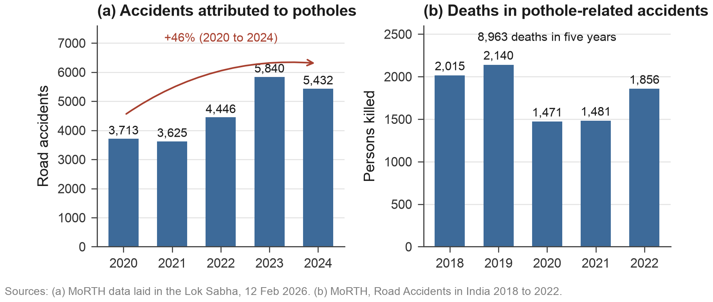
Fig. 1.1 Pothole-related road accidents (2020 to 2024) and deaths (2018 to 2022) in India
CPGRAMS, the national grievance portal, received 18.7 to 26.2 lakh new grievances a year from 2019 to 2024, and its backlog fell from 10.7 lakh to 3.1 lakh (Fig. 1.2). Speed depends on who handles the case: in FY 2023-24 central ministries took 16 days on average and State and UT governments 119 days (Fig. 1.3). Municipal complaints go to the state side.
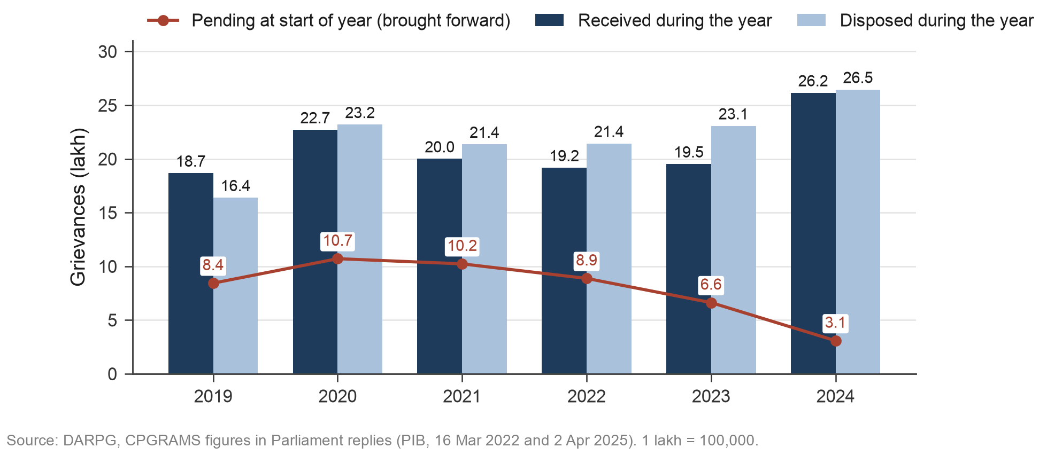
Fig. 1.2 Grievances received and disposed on CPGRAMS, with the backlog at the start of each year (2019 to 2024)
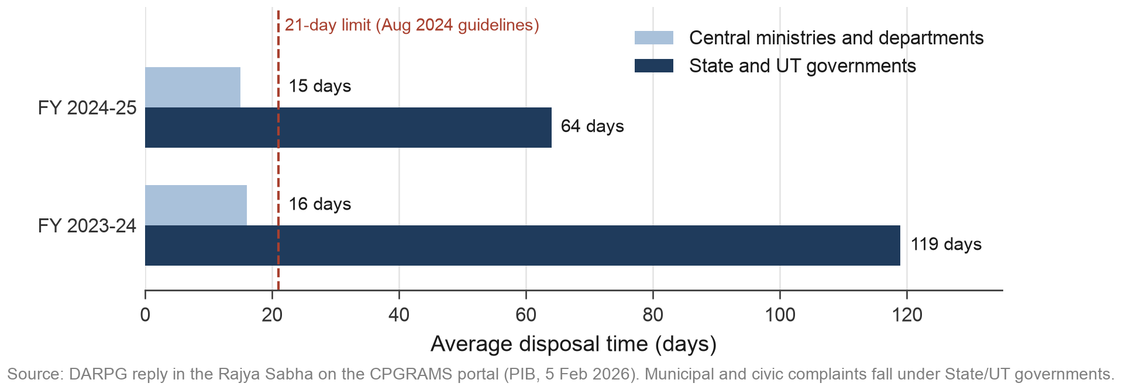
Fig. 1.3 Average grievance disposal time on CPGRAMS: central ministries against State and UT governments

1.3 About the Project and Techniques Used
UrbanFix works as a loop of six steps: Report, Validate, Prioritise, Act, Prove and Learn (Fig. 4.1).
- Citizens report through a six-step wizard and confirm with a six-digit email code instead of an account.
- A YOLOv8 model per category boxes or masks the defect and returns a confidence; unsure results go to a person.
- Weighted yes/no answers set the urgency, with the model's damage estimate as a second signal.
- The server enforces seven stages, assignment within the ward, and photo proof before closure.
- Every complaint and its history is public without the citizen's identity, and researchers get logged access to anonymised data.

1.4 Problem Statement
Civic complaints arrive through scattered channels, are checked by hand, prioritised by no visible rule and resolved out of public view. The task is to build one system that checks each report against photo evidence, ranks it by an urgency rule anyone can follow, moves it through an accountable workflow and publishes the result, without asking citizens to create an account.

1.5 Objectives of the Work
- Let citizens report from a phone with an email OTP instead of an account.
- Check every photo with a model trained on a public dataset for its category.
- Compute an urgency level that can be traced back to the answers.
- Enforce a ward workflow with role checks, remarks, photo proof and an audit trail.
- Publish every complaint and give researchers anonymised data.

1.6 Organization of the Report
Chapter 2 reviews related systems and datasets, Chapter 3 the requirements and Chapter 4 the design. Chapter 5 covers implementation, screens, training and tests, Chapter 6 outcomes, and Chapter 7 limitations and next steps.

1.7 Summary
Grievances are many, local redress is slow and potholes cause thousands of road deaths. UrbanFix answers with account-free reporting, AI photo checks, a traceable urgency rule, an enforced ward workflow and a public record.

CHAPTER 2
RELATED WORK INVESTIGATION

2.1 Introduction
We reviewed seven IEEE conference papers from 2025 and 2026 on AI-assisted grievance systems ([1] to [7]) and the public image datasets for the defects UrbanFix handles.

2.2 Core Area of the Project
A grievance system takes in a complaint, routes it, decides its urgency and reports the outcome. Computer vision adds one more job: confirming that the photo shows the reported defect.

2.3 Existing Approaches and Methods

2.3.1 Web portals with location and image evidence
Infra-Alert [1] tags complaints with the Geolocation API, stores before and after photos in Cloudinary and generates PDF reports. AI verification and prioritisation are left for future work, and citizens see only their own complaints, as on CPGRAMS.

2.3.2 NLP-based routing and urgency
CitiWatch [2] routes complaints with TF-IDF and a supervised classifier (96.8%). VidyutSaathi [3] uses Sentence-BERT, a multi-task network and DBSCAN duplicate grouping, and reports 81% faster response. CivicX [6] reaches 91.4% against 94.1% for officers, and Smart City Concern [7] uses zero-shot BART (92.8%) with sentiment as a stand-in for urgency. Text routing now sits between 90% and 97% (Fig. 2.3).

2.3.3 Image handling and defect datasets
ReGenX [4] sorts waste photos into four types (85.2%) and CivicMate [5] screens photos for NSFW content (F1 0.97); neither checks that the photo shows the reported defect. Datasets that would allow such a check exist for potholes (RDD2022 [9]), litter (TACO [10]), open manholes (Road Hazards [11]) and graffiti (STORM [12]).

2.4 Pros and Cons of the Stated Approaches
Table 2.1 Summary of the reviewed systems
System | Main method | Strength | Limitation
[1] Infra-Alert | Geolocation API, Cloudinary, PDF reports | Before and after proof, location accuracy | No AI verification or urgency; own-complaints view only
[2] CitiWatch | TF-IDF + supervised classifier, phone OTP | 96.8% routing accuracy | No images; no public registry
[3] VidyutSaathi | Sentence-BERT, multi-task NN, DBSCAN | Urgency, duplicates and workload in one pipeline | Opaque urgency; internal tool only
[4] ReGenX | Geofencing, on-device TFLite | Low cost, no IoT hardware | Waste domain only; no public view
[5] CivicMate | NudeNet NSFW filter, CNN, chatbot | Accurate content moderation | Checks safety, not defect authenticity
[6] CivicX | RF/SVM/transformer, geo-heatmaps | Benchmarked against officers | Official-only transparency
[7] Smart City Concern | Zero-shot BART, DistilBERT, OCR | Web and social intake, duplicates | Sentiment stands in for urgency

Fig. 2.1 rates each system on twelve capabilities, and Fig. 2.2 counts how many of the seven lack each one.

2.5 Issues and Observations from the Investigation
- None checks that a photo shows the reported defect (Fig. 2.2).
- None publishes every complaint with its history; CivicMate's community view is partial.
- Urgency comes from opaque models ([3], [6]) or sentiment ([7]).
- Text routing is close to solved.
- Usable datasets exist for only some complaint types (Section 3.3.1).
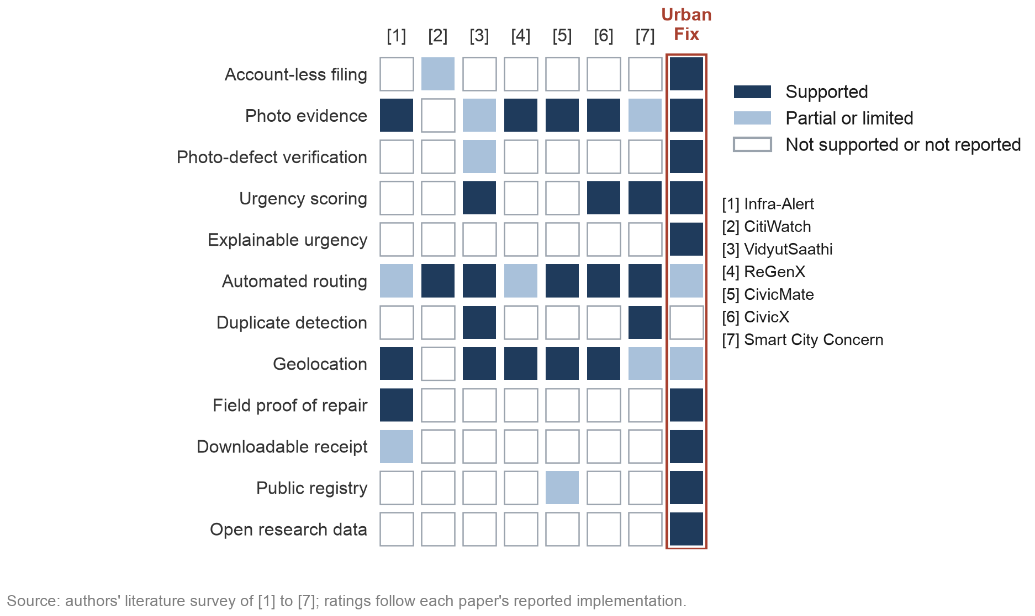
Fig. 2.1 Feature coverage of the reviewed systems [1] to [7] compared with UrbanFix
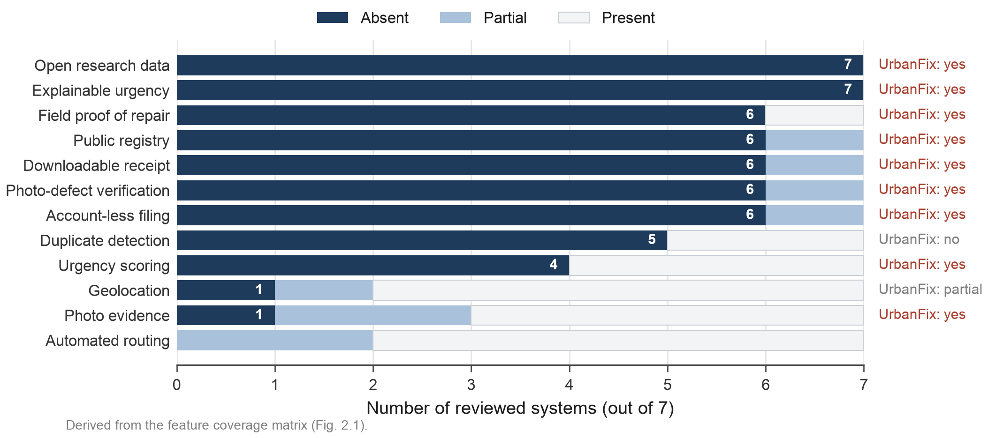
Fig. 2.2 Number of reviewed systems lacking each capability
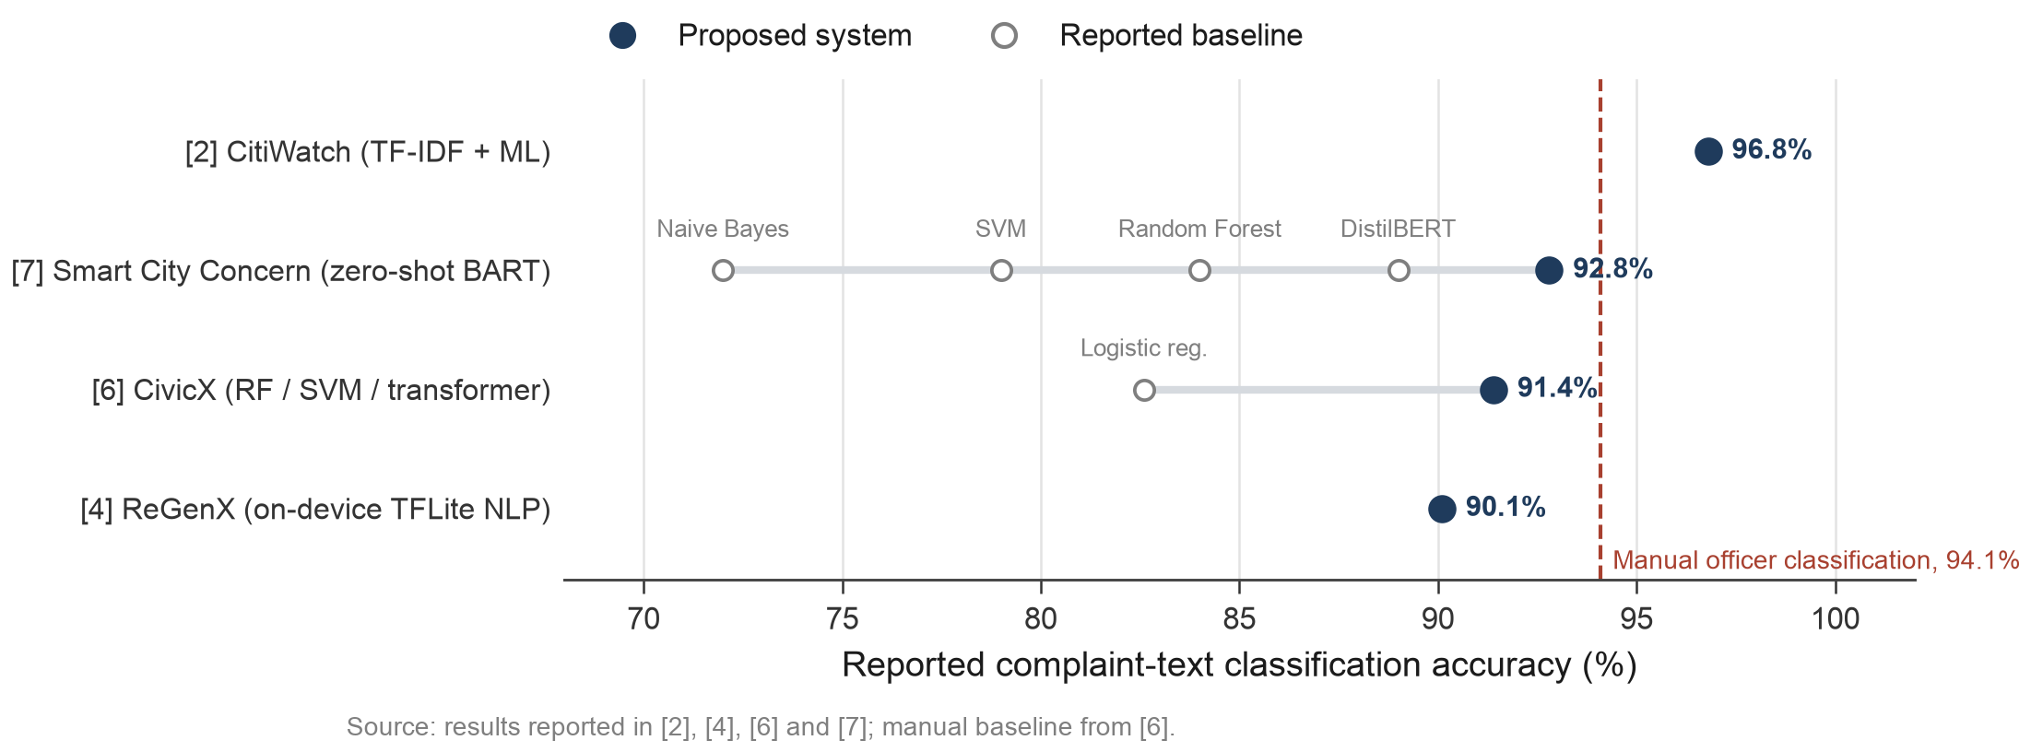
Fig. 2.3 Reported complaint-text classification accuracy in the literature, with baselines and the manual officer reference

2.6 Summary
The reviewed systems route text well but do not check photos, explain urgency or publish their records. UrbanFix covers these points for the categories that public data supports.

CHAPTER 3
REQUIREMENT ARTIFACTS

3.1 Introduction
This chapter lists what UrbanFix needs to run and what each role must be able to do.

3.2 Hardware and Software Requirements
Table 3.1 Hardware and software requirements
Component | Requirement used in this project
Development machine | Apple M5 laptop, 16 GB unified memory, macOS; Apple MPS backend for model training
Phone (client) | Android or iOS phone with Expo Go supporting SDK 57; same Wi-Fi network as the server during development
Mobile app | Expo SDK 57, React Native 0.86, React 19, React Navigation 7, Reanimated 4, FlashList, react-native-svg, Axios
Backend | Node.js 20 or newer, Express 4, Mongoose 8, JSON Web Tokens, bcrypt, Zod, Multer, Nodemailer, PDFKit
Database | MongoDB 8.3 (any version 7 or newer works), local instance
AI service | Python 3, FastAPI, PyTorch 2.14, Ultralytics 8.4 (YOLOv8), Jupyter for training notebooks
Email | Any SMTP server; Ethereal test inbox used automatically in development

3.3 Specific Project Requirements

3.3.1 Data requirement
A category is offered only if a public, documented dataset of street-level images with boxes or masks exists for it. Of the ten categories in the original design, six failed (Fig. 3.1): water leakage, illegal parking and fallen trees have only small hobby sets, the streetlight set is labelled per image, the road sign set was never released and the electrical pole set has no licence.
Table 3.2 Training datasets for the four UrbanFix categories
Category | Dataset | Images | Labels | Split used
Pothole / Road Damage | Roboflow Pothole Segmentation YOLOv8 [8] | 780 | Polygon masks | 720 train / 60 val
Garbage / Litter | TACO [10] | 1500 | COCO masks, merged to one class | 1214 train / 214 val
Open Manhole | Road Hazards Dataset [11] | 2,716 | YOLO boxes (manhole class) | 1123 train / 480 val
Graffiti | STORM graffiti/tagging dataset [12] | 1,022 | Bounding boxes | 813 train / 209 test

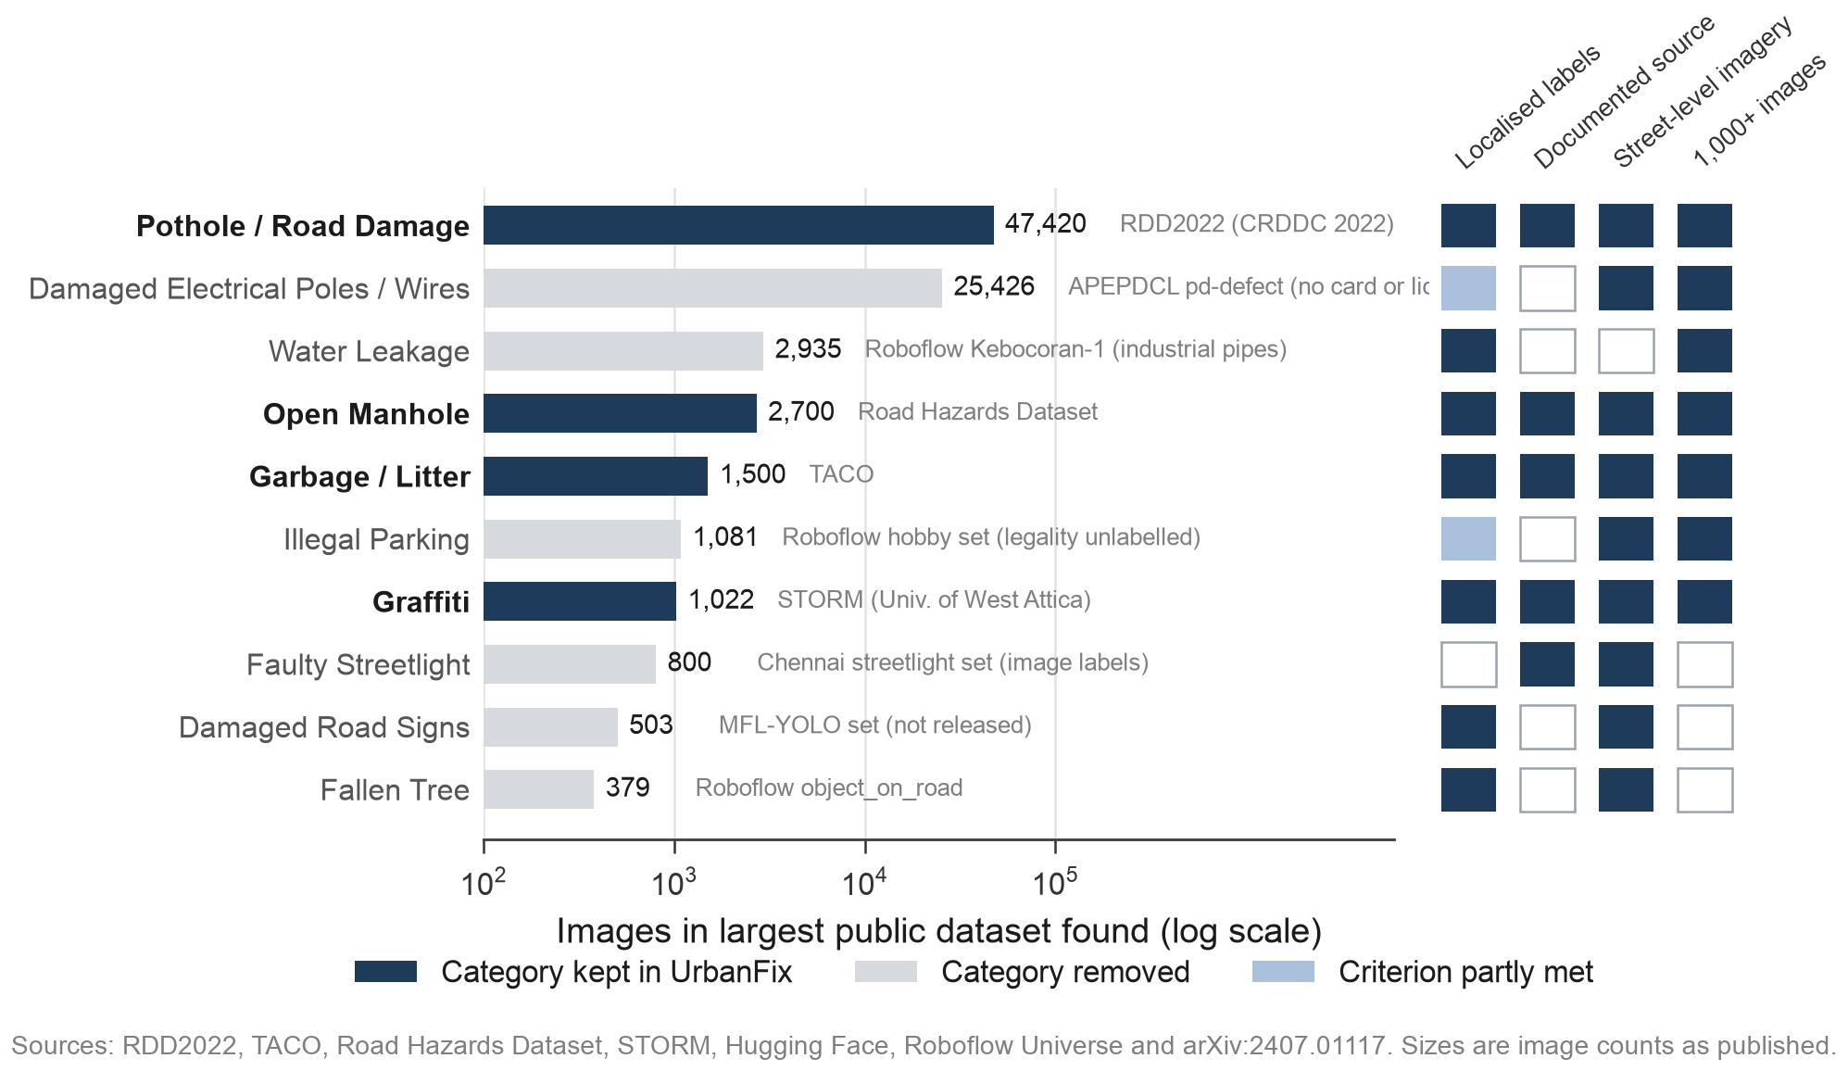
Fig. 3.1 Largest public dataset found for each candidate complaint category and the selection criteria it meets

3.3.2 Functional requirements
Table 3.3 Functional requirements by role
Role | Functions
Citizen (no account) | File complaint with category, questions, ward, photos; verify by email OTP; receive tracking ID; track any complaint; download PDF receipt; browse registry
Supervisor | Triage (accept or reject with remarks); assign field worker in ward; review proof; close or send for rework; approve field leave; own attendance and leave
Field worker | View assigned tasks; start work; upload up to three proof photos with a completion note; check in and out; request leave
Admin | Analytics dashboard; status override; create, edit, deactivate staff through invite links; approve supervisor leave; approve research access; view research audit log
Researcher | Apply publicly; after approval, view insights, run grouped queries and export CSV or JSON within scope and limits
AI service | Run the category model on complaint photos; return detections, confidence, annotated images and damage share

3.3.3 Performance and security requirements
- The tracking ID returns at once; AI analysis runs afterwards and cannot block a submission.
- OTPs expire in five minutes, tokens in seven days; passwords use bcrypt (cost 12).
- Staff set passwords through 72-hour invite links stored only as SHA-256 hashes.
- Every role route checks the JWT and role; workflow changes follow one transition table.
- Public responses never include citizen IDs.
- Research data passes through one anonymising projection; exports are capped at 5 a day and 5,000 rows.

3.3.4 Look and feel requirements
The app uses a light theme with one pink accent (#FF5FA2), Space Grotesk and Plus Jakarta Sans, rounded cards and a glass tab bar. Status colours are fixed: amber Pending, violet In Progress, green Resolved, red Rejected.

3.4 Summary
UrbanFix runs on ordinary hardware with open-source software, and its categories follow from the data requirement.

CHAPTER 4
DESIGN METHODOLOGY AND ITS NOVELTY

4.1 Methodology and Goal
Each complaint passes through six steps (Fig. 4.1), and each leaves a record the next one uses, so nothing closes without evidence.
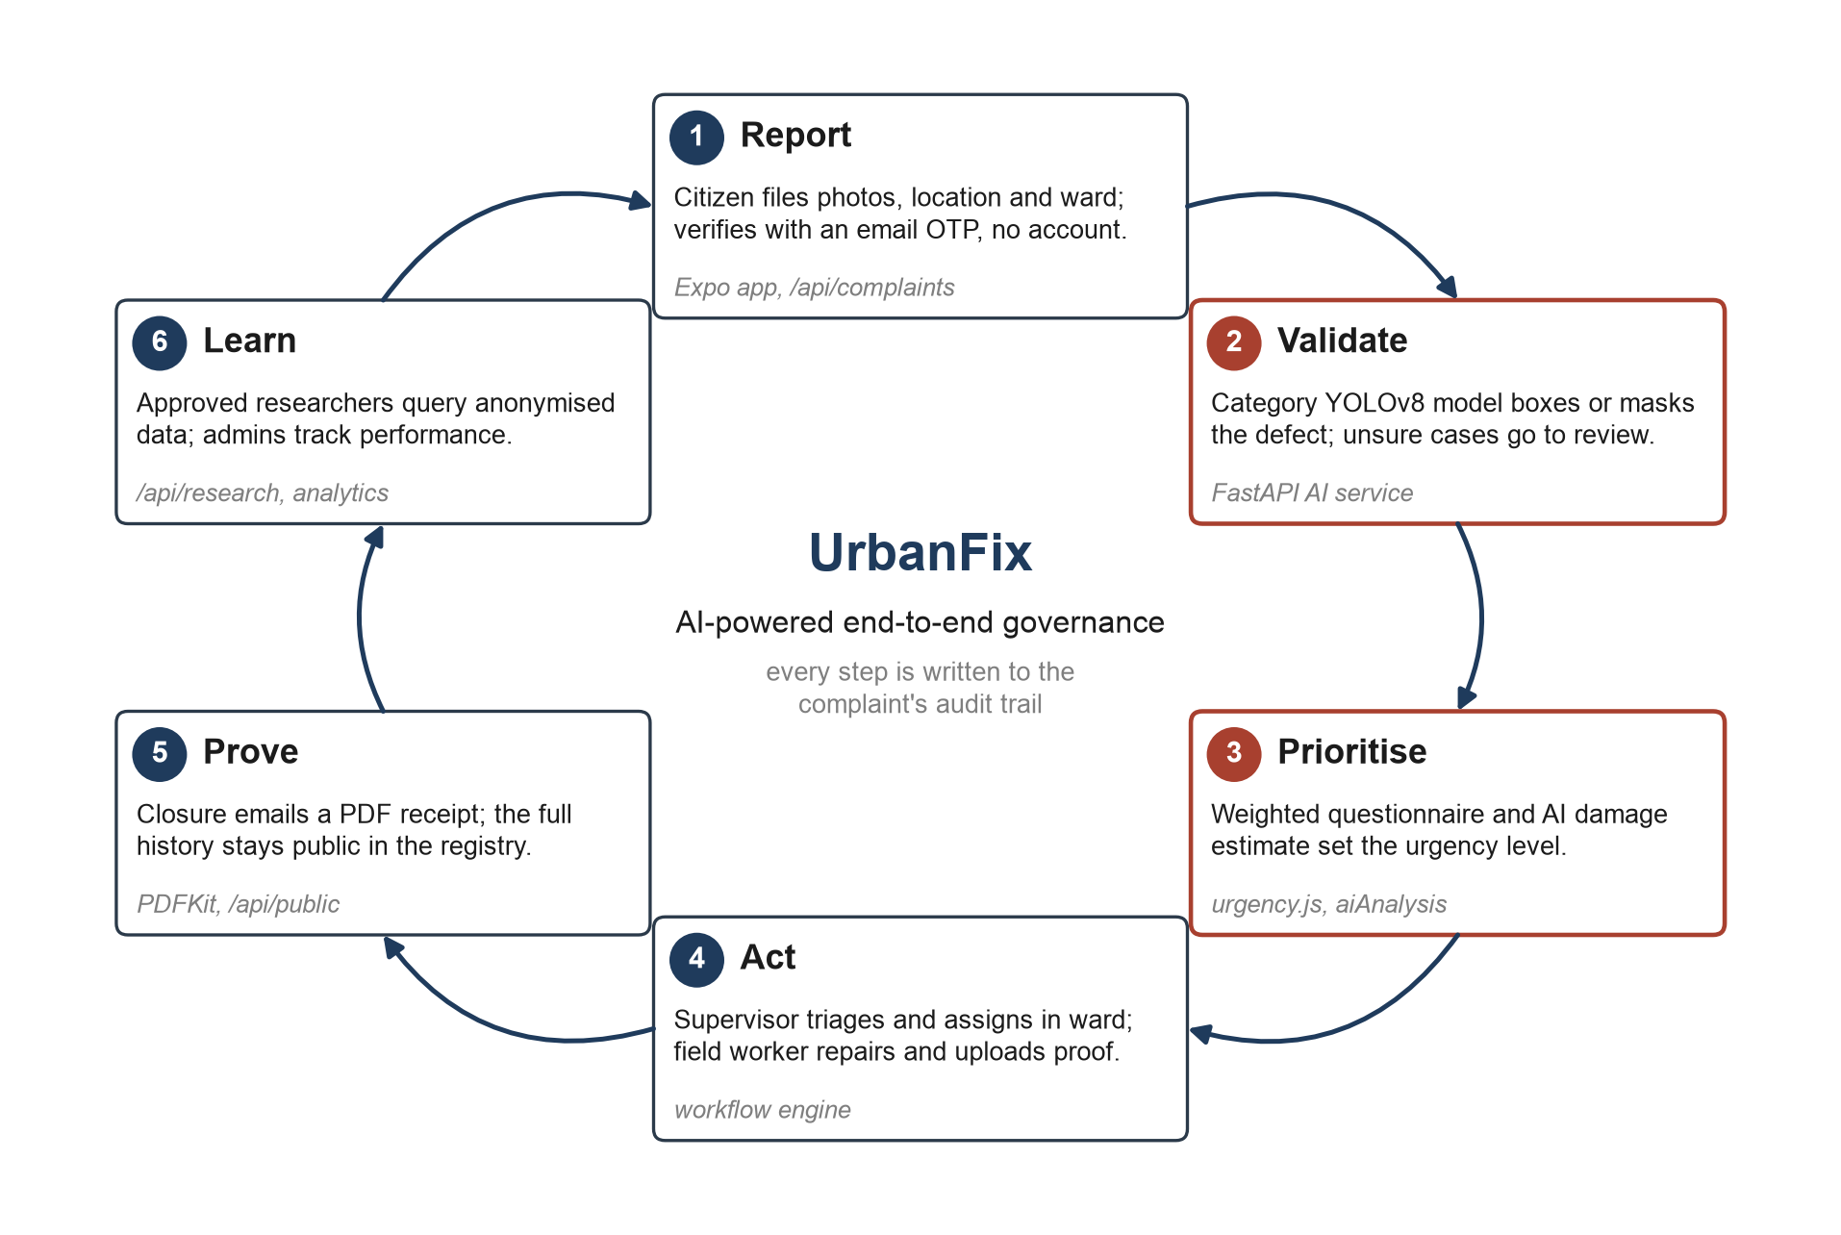
Fig. 4.1 The UrbanFix governance loop: Report, Validate, Prioritise, Act, Prove and Learn
We built the citizen flow first, then the staff workflow, the research layer and the AI service, testing on Android phones through Expo Go.

4.2 Functional Modules Design and Analysis
Fig. 4.2 maps each actor to their functions.
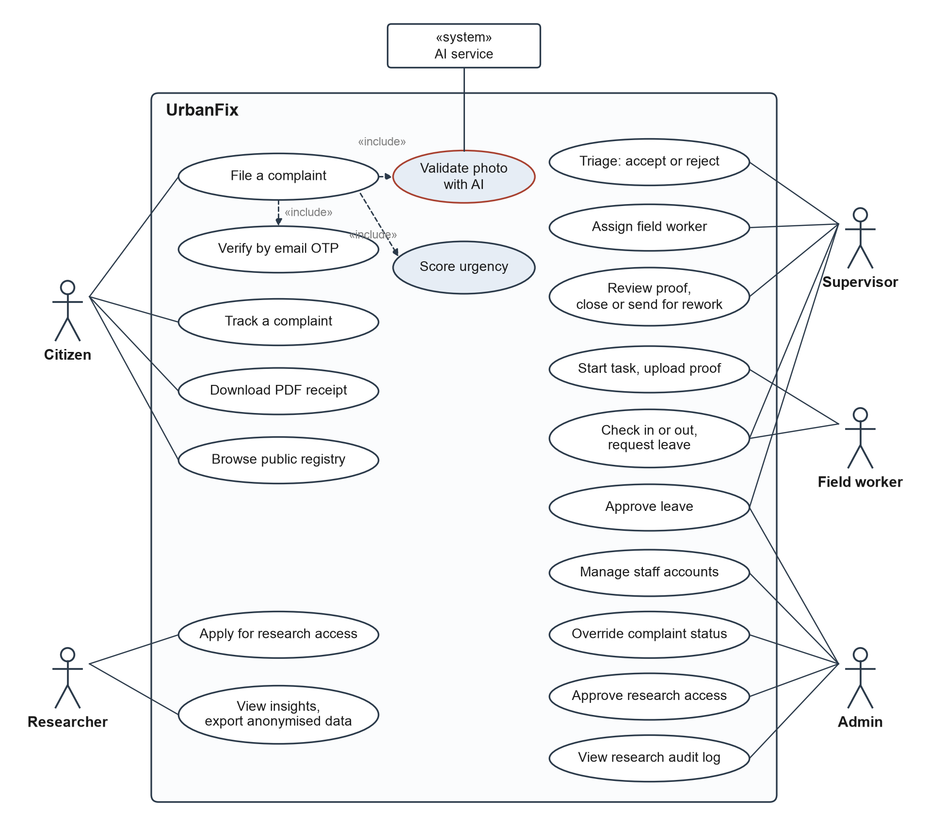
Fig. 4.2 Use-case diagram of UrbanFix by role
Staff see a detailed stage and citizens a simpler status (Fig. 4.3). Permitted moves are defined in backend/utils/complaintStage.js (Table 4.1).
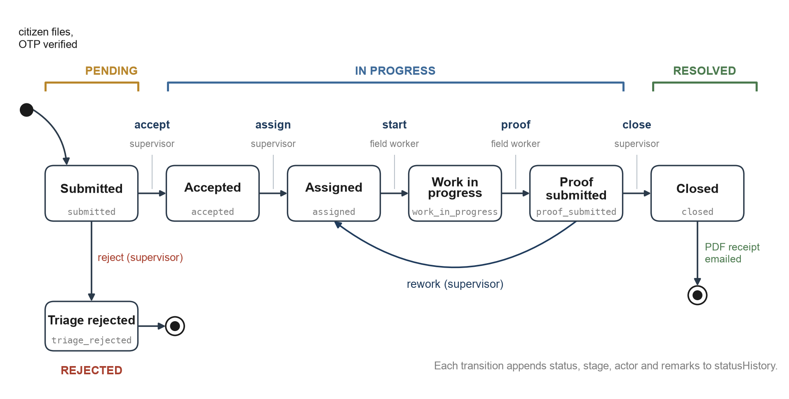
Fig. 4.3 Complaint lifecycle: internal stages, public statuses and allowed transitions
Table 4.1 Workflow transitions enforced by the server
Action | From | To | Who | Extra rule
accept | submitted | accepted | supervisor, admin | remarks of 10+ characters
reject | submitted | triage_rejected | supervisor, admin | remarks of 10+ characters
assign | accepted, assigned | assigned | supervisor, admin | same ward; worker active and not on leave
start | assigned | work_in_progress | assigned field worker | only the assignee
proof | work_in_progress | proof_submitted | assigned field worker | note and up to 3 photos
close | proof_submitted | closed | supervisor, admin | remarks; PDF receipt emailed
rework | proof_submitted | assigned | supervisor, admin | remarks of 10+ characters

Each category has five questions, weighted 2 for safety and 1 otherwise. The weighted share of "Yes" answers gives High at 0.6, Medium at 0.3, and Standard below (Fig. 4.4). For a pothole, one safety "Yes" scores 0.29 and two score 0.57.
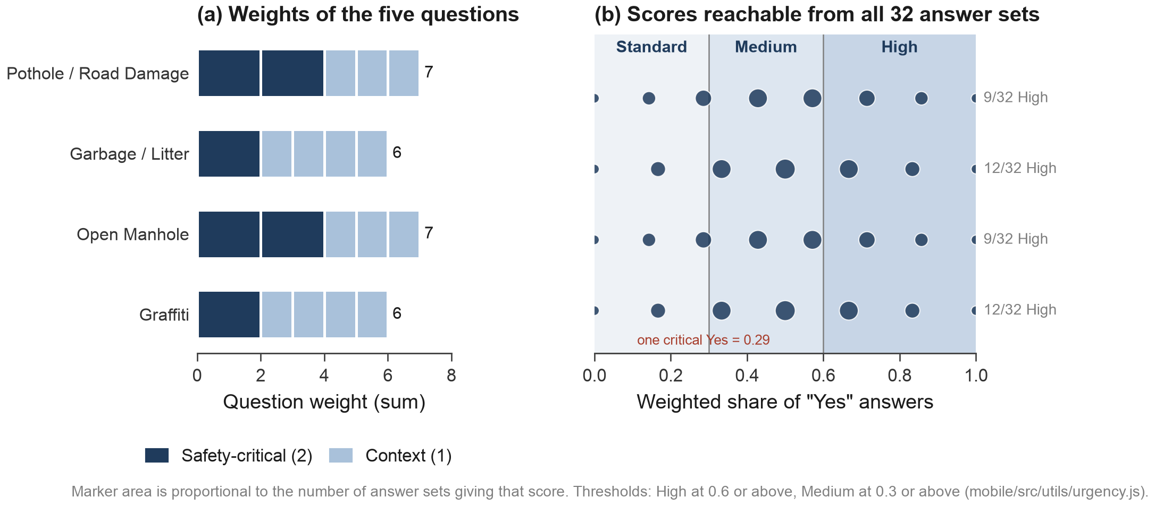
Fig. 4.4 Urgency scoring: question weights per category and all reachable scores

4.3 Software Architectural Designs
UrbanFix has three tiers and a separate AI service (Fig. 4.5). The Express API holds the rules, MongoDB stores seven collections, and only the backend calls the FastAPI model service.
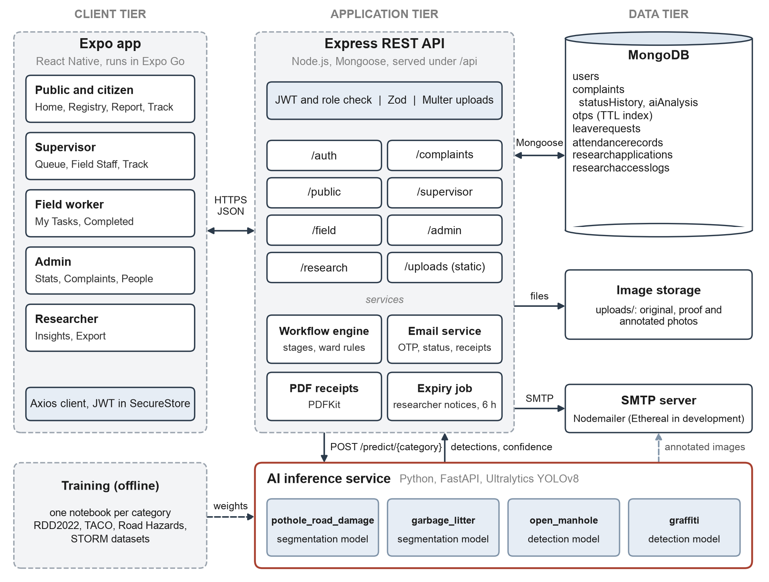
Fig. 4.5 System architecture of UrbanFix
Fig. 4.6 follows one complaint to the supervisor's queue; the AI call runs after the tracking ID is returned.
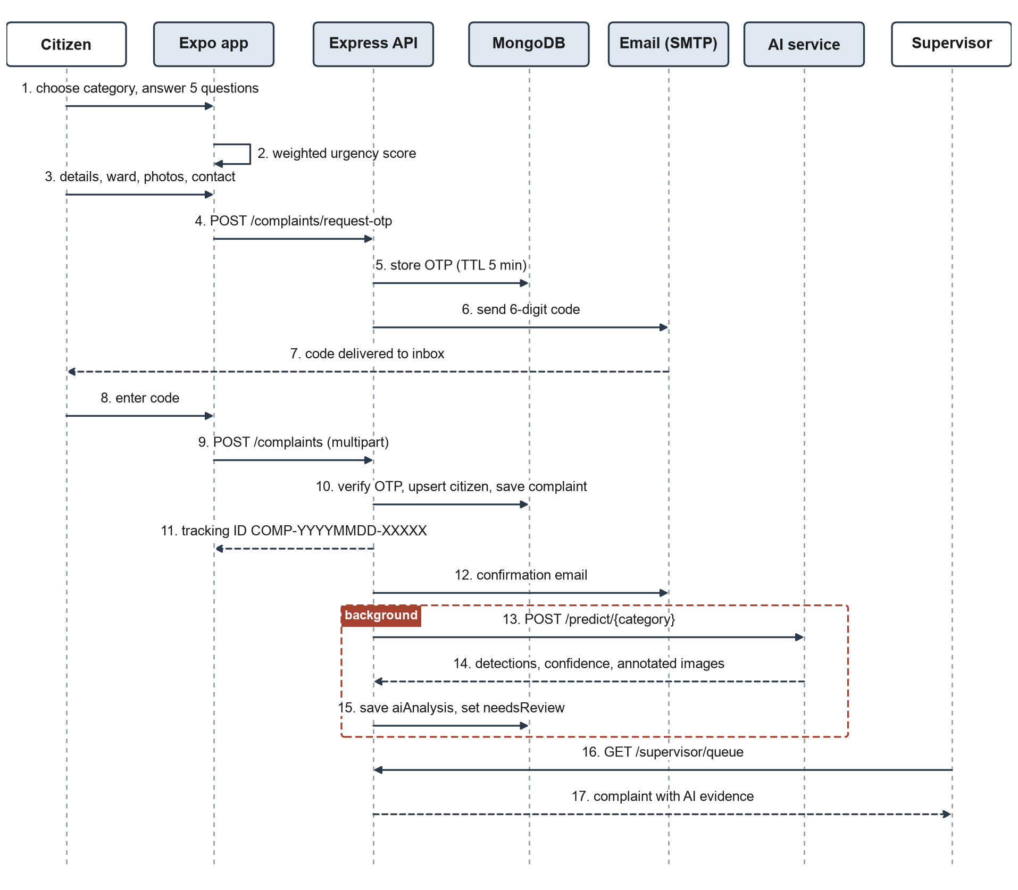
Fig. 4.6 Sequence of complaint submission, OTP verification and AI validation

4.4 Subsystem Services
In the data model (Fig. 4.7) User holds every role, and each Complaint embeds its statusHistory and aiAnalysis.
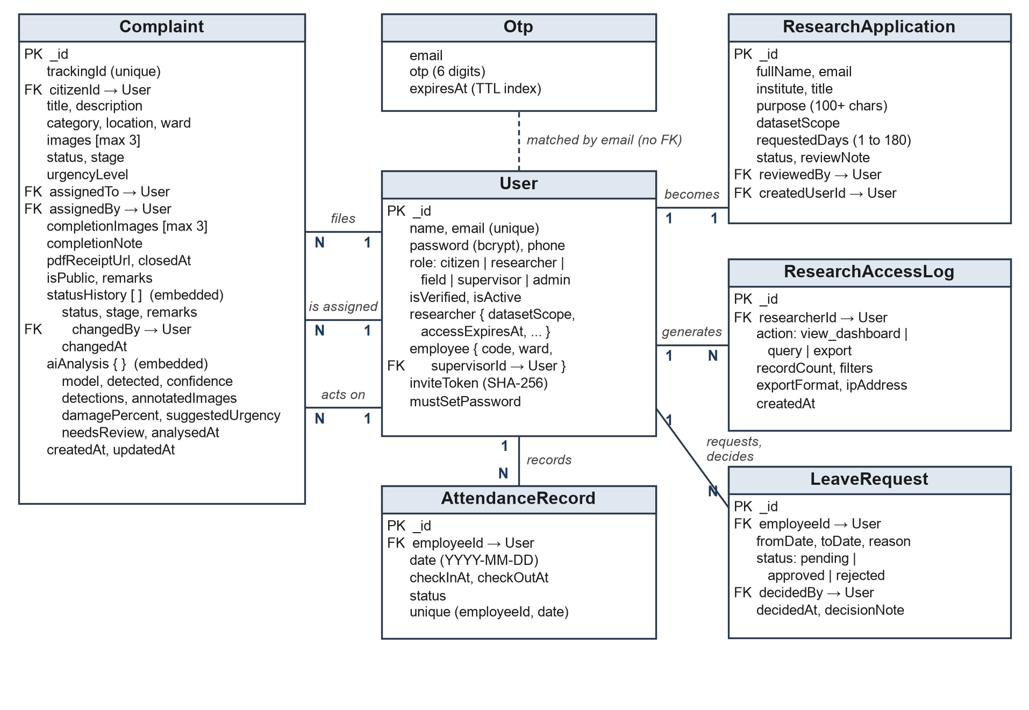
Fig. 4.7 Entity-relationship diagram of the UrbanFix database
The backend also sends emails, builds PDF receipts and warns researchers before their access ends.

4.5 User Interface Designs
Each role has three to five bottom tabs, and questions appear one at a time on swipe cards. Section 5.3 shows the screens.

4.6 Novelty of the Approach
- Categories follow dataset availability, so every report can be checked.
- The model checks the defect itself, which no reviewed system does.
- Urgency is traceable, and a person makes the final call.
- One system covers every step from intake to the closing receipt, plus research access.
- Citizens need no account.

4.7 Summary
The server enforces each step, and every change goes into a public audit trail.

CHAPTER 5
TECHNICAL IMPLEMENTATION AND ANALYSIS

5.1 Outline
This chapter shows the main code, the screens, the tests and the model results.

5.2 Technical Coding and Code Solutions
The urgency score (mobile/src/utils/urgency.js) is a weighted share of "Yes" answers, which keeps categories with different question mixes comparable:
const HIGH_THRESHOLD = 0.6;
const MEDIUM_THRESHOLD = 0.3;
export const calculateUrgency = (answers, questions = []) => {
const totalWeight = questions.reduce((sum, q) => sum + (q.weight || 1), 0);
const scoredWeight = questions.reduce(
(sum, q) => sum + (answers[q.id] === 'Yes' ? q.weight || 1 : 0), 0);
return urgencyFromRatio(totalWeight > 0 ? scoredWeight / totalWeight : 0);
};

A single object in backend/utils/complaintStage.js defines every legal move, and the workflow service rejects anything else. In this listing SUP stands for the supervisor and admin roles:
export const TRANSITIONS = {
accept: { from: ['submitted'], to: 'accepted', roles: SUP, remarks: true },
reject: { from: ['submitted'], to: 'triage_rejected', roles: SUP, remarks: true },
assign: { from: ['accepted', 'assigned'], to: 'assigned', roles: SUP },
start: { from: ['assigned'], to: 'work_in_progress', roles: ['field'], assignedOnly: true },
proof: { from: ['work_in_progress'], to: 'proof_submitted', roles: ['field'], assignedOnly: true },
close: { from: ['proof_submitted'], to: 'closed', roles: SUP, remarks: true },
rework: { from: ['proof_submitted'], to: 'assigned', roles: SUP, remarks: true },
};

The API accepts only the four categories that have datasets (backend/validators/complaintValidator.js):
import { CATEGORIES } from '../constants/categories.js';
category: z.enum(CATEGORIES, { errorMap: () => ({ message: 'Please choose a valid category' }) }),

Every model was trained with the same Ultralytics call on the Apple MPS backend, and the inference service runs the saved weights on each photo:
model = YOLO('yolov8n-seg.pt' if task == 'segment' else 'yolov8n.pt')
model.train(data=data_yaml, epochs=60, imgsz=640, batch=16, patience=15, device='mps', seed=0)

result = YOLO('weights/pothole_road_damage_model.pt').predict(photo, imgsz=640, conf=0.25)[0]
boxes = result.boxes.xyxy.tolist(); conf = result.boxes.conf.tolist()

5.3 Working Layout of Forms
The screens below come from the running app on a demonstration database.
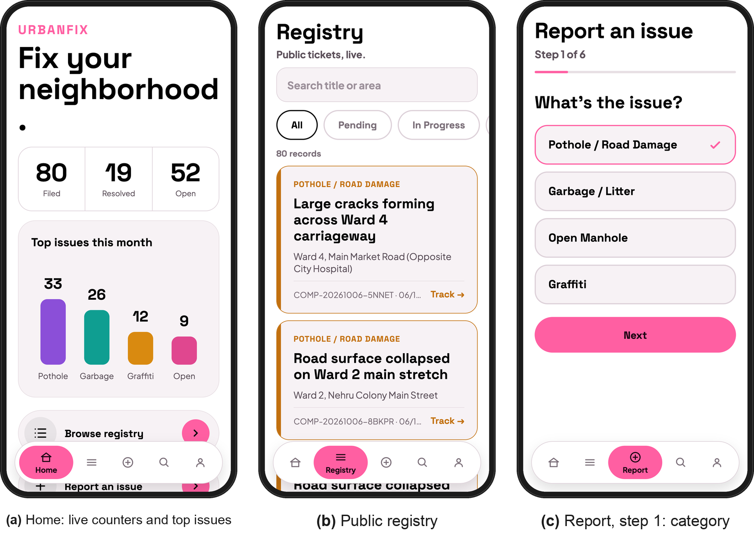
Fig. 5.1 Citizen screens: home, public registry and category selection
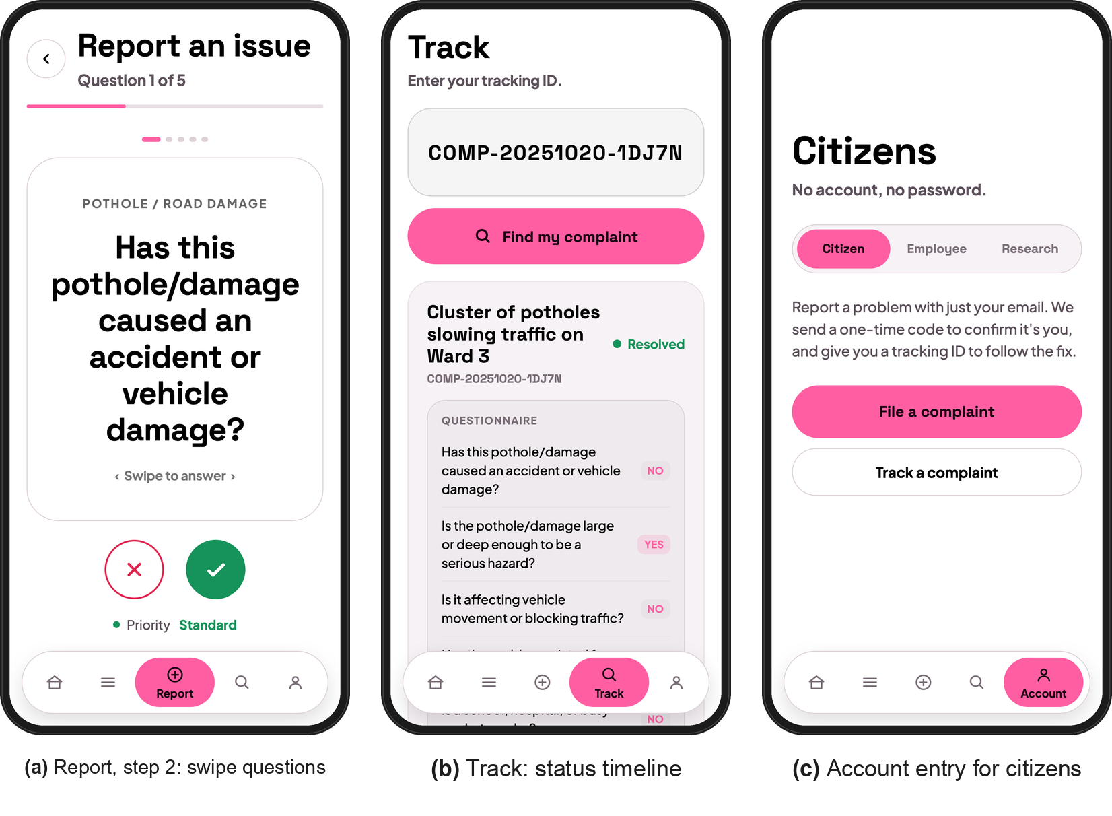
Fig. 5.2 Citizen screens: swipe questionnaire, complaint tracker and account entry
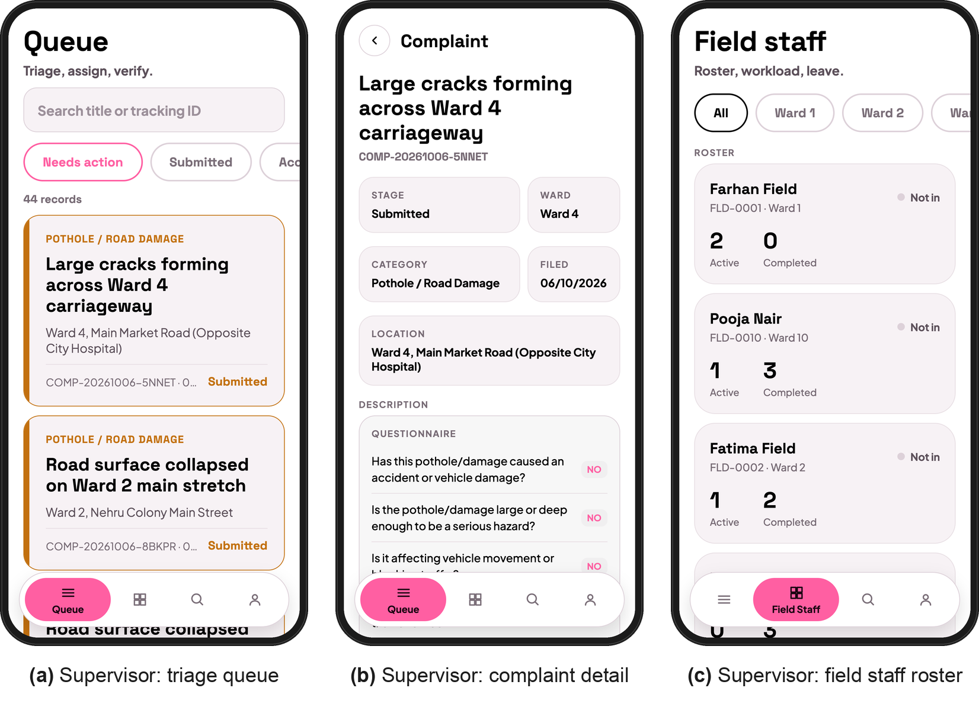
Fig. 5.3 Supervisor screens: triage queue, complaint detail and field staff roster
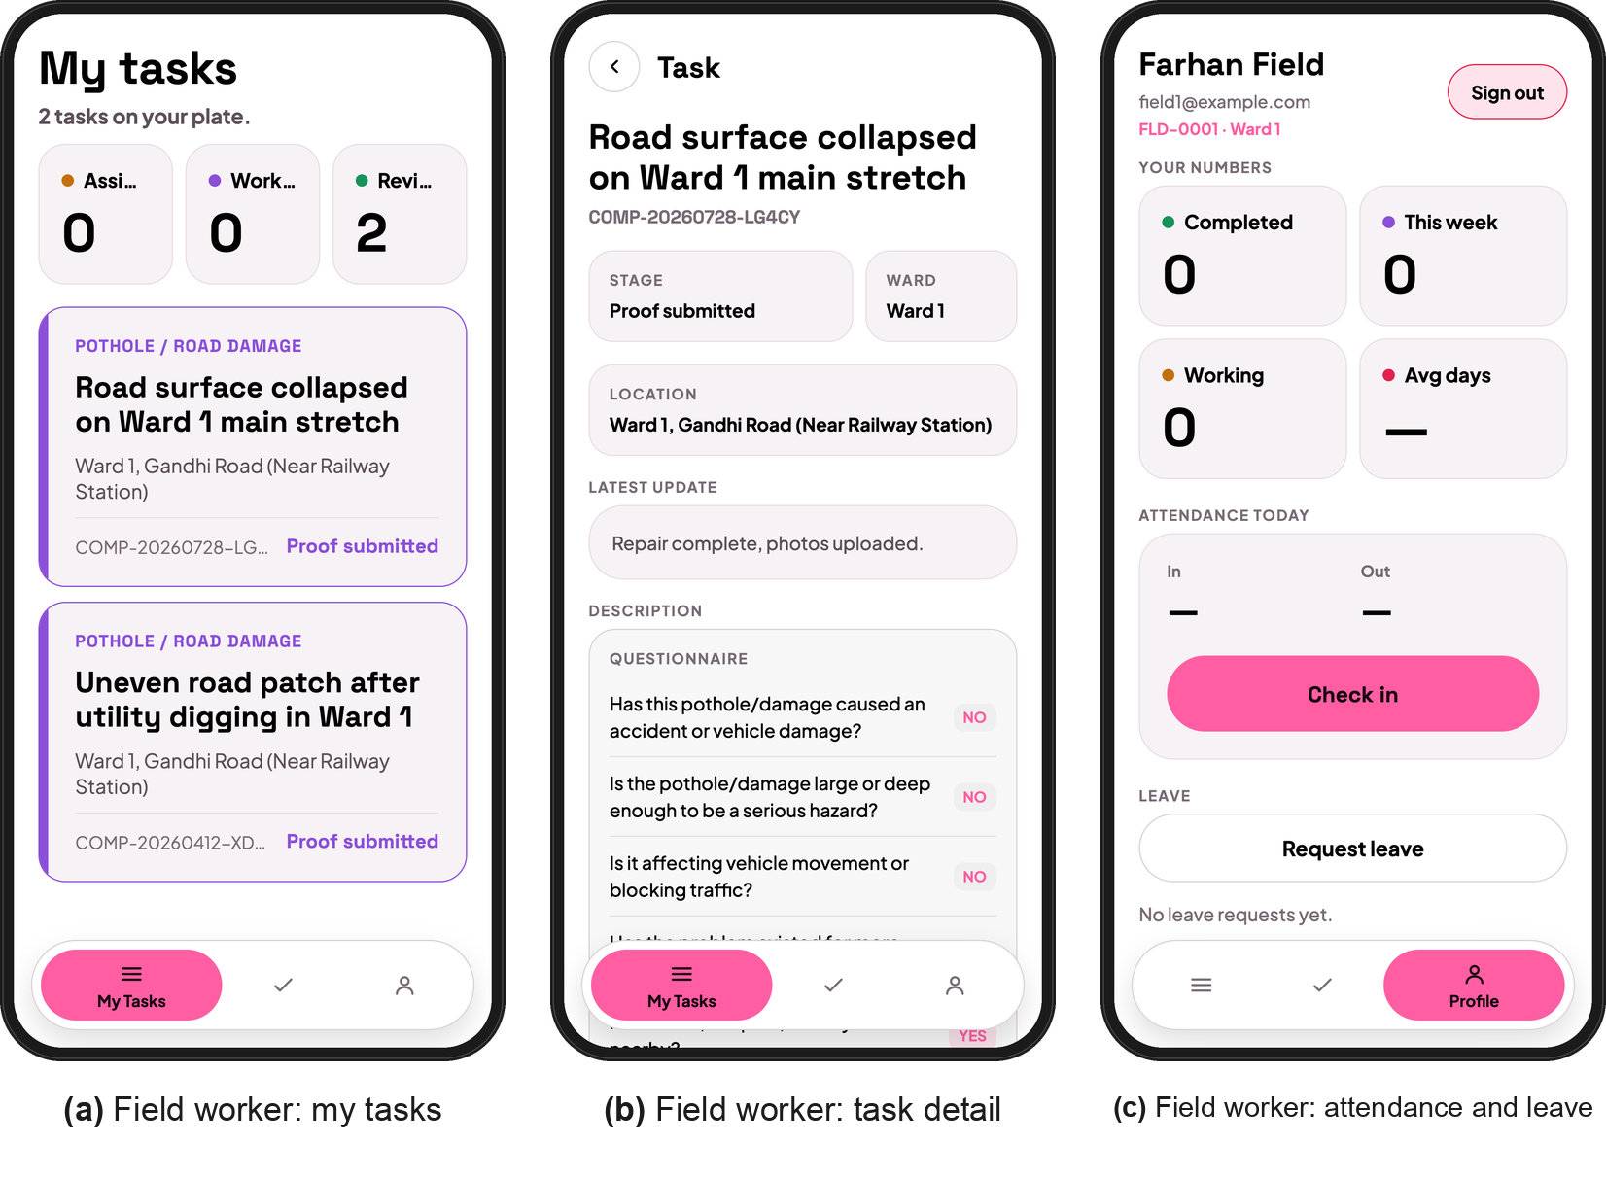
Fig. 5.4 Field worker screens: task list, task detail, attendance and leave
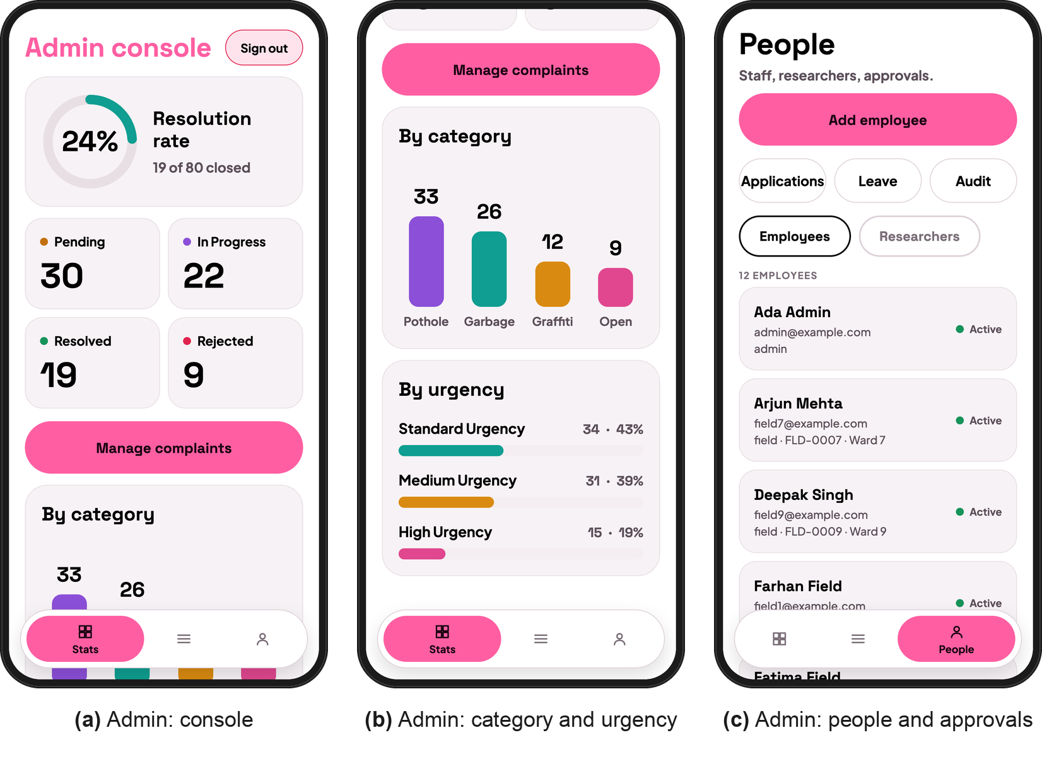
Fig. 5.5 Admin screens: console, category and urgency analytics, people management
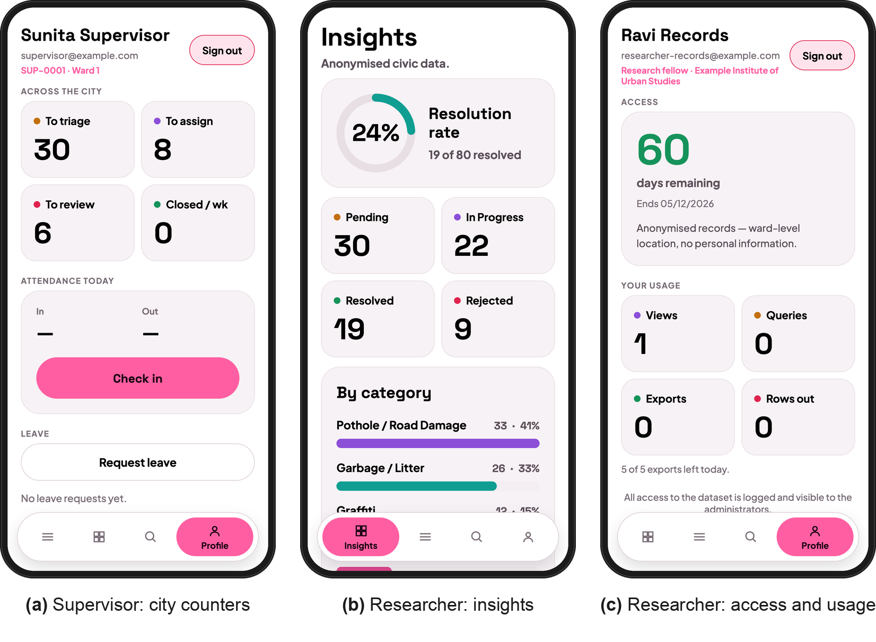
Fig. 5.6 Supervisor city counters and researcher screens: insights, access and usage

5.4 Prototype Submission
The repository has mobile/, backend/ and ai_model/. Run npm run seed:roles and npm run dev in backend/, then npx expo start --go -c in mobile/ and scan the QR code with Expo Go.

5.5 Test and Validation
A test script called the running API on a separate database (Table 5.1).
Table 5.1 API validation tests and results
ID | Test | Expected | Observed | Result
T1 | Health check | 200 | 200 | Pass
T2 | OTP request without email | 400 | 400 | Pass
T3 | Category outside the four datasets | 400 | 400 Please choose a valid category | Pass
T4 | Wrong OTP | 400 | 400 Invalid or expired OTP | Pass
T5 | Expired OTP | 400 | 400 OTP has expired. Please request a new one. | Pass
T6 | Valid submission returns tracking ID | 201, COMP-YYYYMMDD-XXXXX | 201 COMP-20261006-NKKGR | Pass
T7 | Public tracker hides citizen identity | actor shown as "Citizen" | 200 Citizen; citizenId absent | Pass
T8 | Registry entries carry no citizenId | no citizenId field | 200, 0 with citizenId | Pass
T9 | Field worker cannot accept | 403 | 403 | Pass
T10 | Remarks under 10 characters | 400 | 400 Remarks must be at least 10 characters long | Pass
T11 | Supervisor accepts with remarks | 200, stage accepted | 200 accepted | Pass
T12 | Reject after accept (illegal transition) | 400 | 400 Cannot reject a complaint that is "Accepted". | Pass
T13 | Assign Ward 1 complaint to Ward 2 worker | 400 | 400 This complaint is in Ward 1; Fatima Field covers Ward 2. | Pass
T14 | Receipt before closure | 400 | 400 Receipts can only be compiled for resolved complaints. | Pass
T15 | Aggregate-only researcher asks for records | 403 | 403 Your access is limited to aggregate statistics. | Pass
T16 | Login with wrong password | 401 | 401 | Pass

All 16 tests passed.

5.6 Performance Analysis
All four models start from COCO-pretrained YOLOv8 nano weights (Table 5.2).
Table 5.2 Model training configuration
Setting | Value
Base models | yolov8n-seg (pothole, litter), yolov8n (open manhole, graffiti)
Image size, batch | 640 x 640 pixels, batch 16
Epochs, early stopping | 60 maximum, patience 15
Optimiser | Ultralytics auto (AdamW or SGD chosen from iteration count)
Augmentation | Ultralytics defaults: mosaic, HSV jitter, flips, scale, translate
Hardware | Apple M5, PyTorch 2.14 with MPS backend, seed 0

Training took from 29 to 52 minutes per model. Only 1428 of the 1,500 TACO images could still be downloaded.
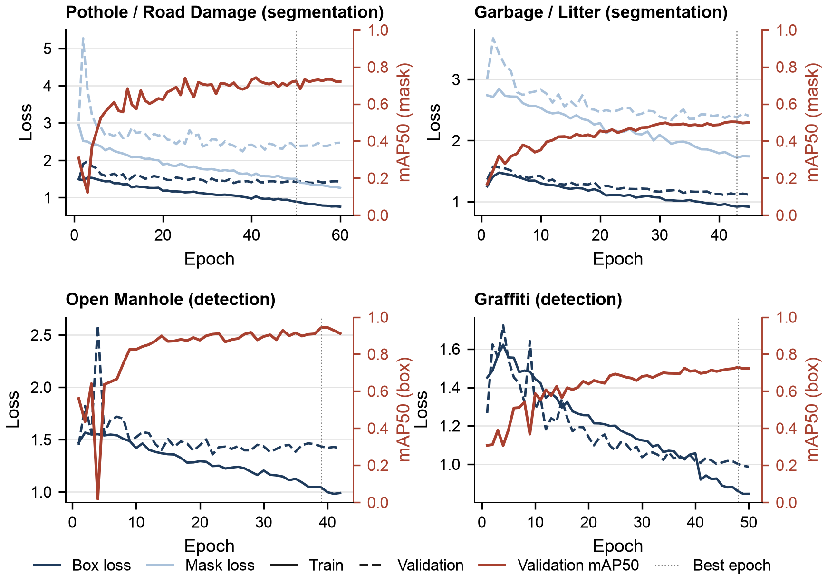
Fig. 5.7 Training and validation loss with validation mAP50 for the four category models
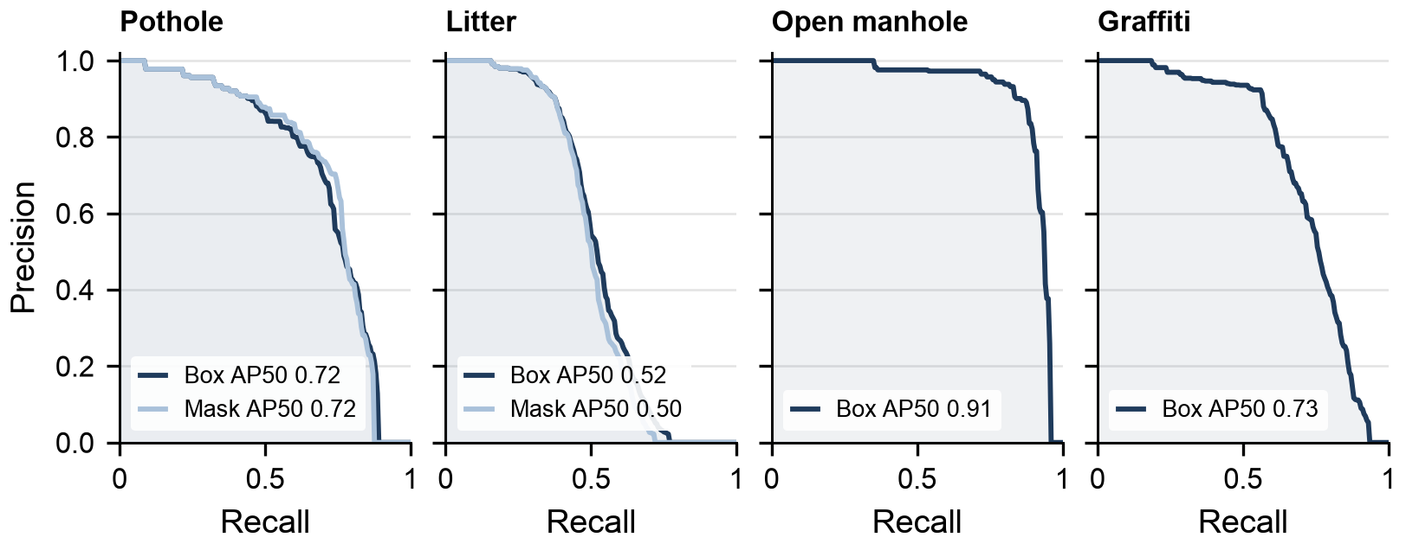
Fig. 5.8 Precision-recall curves on the validation sets
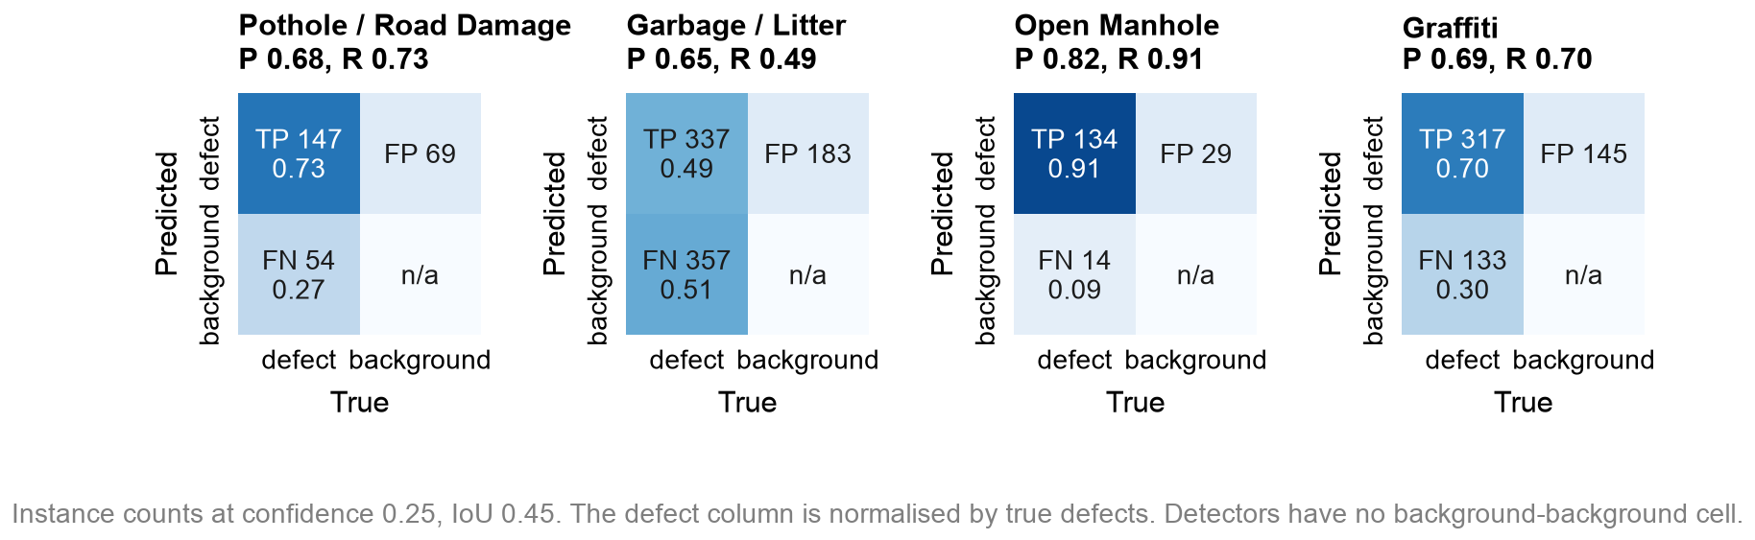
Fig. 5.9 Normalised confusion matrices on the validation sets
Table 5.3 Validation results of the best checkpoint of each model
Model | Task | Precision | Recall | mAP50 | mAP50-95
Pothole / Road Damage (box) | segment | 0.733 | 0.682 | 0.719 | 0.447
Pothole / Road Damage (mask) | segment | 0.725 | 0.711 | 0.724 | 0.426
Garbage / Litter (box) | segment | 0.748 | 0.446 | 0.521 | 0.375
Garbage / Litter (mask) | segment | 0.757 | 0.434 | 0.502 | 0.317
Open Manhole (box) | detect | 0.890 | 0.874 | 0.908 | 0.469
Graffiti (box) | detect | 0.836 | 0.604 | 0.729 | 0.526

Open manholes score highest (mAP50 0.91) thanks to their regular shape, though augmented copies in the dataset may inflate this. The pothole model reaches 0.72, matching the earlier notebook run. Graffiti is precise (0.84) but misses faint tags (recall 0.60), and litter is hardest (0.50) because TACO merges 60 object types into one class. When the model misses a defect, the complaint goes to a supervisor for review.
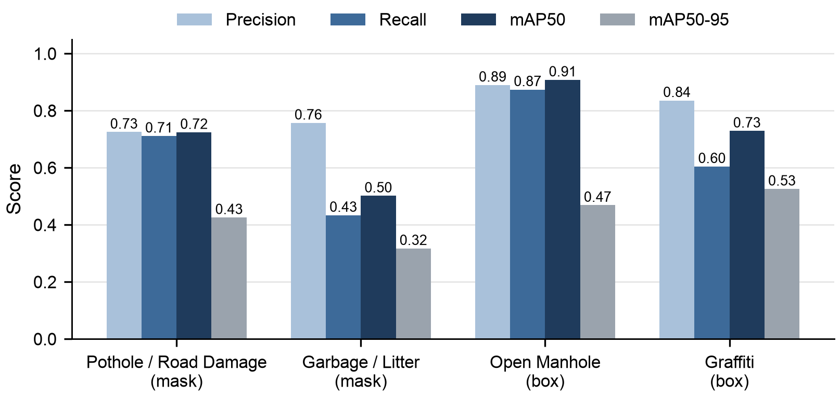
Fig. 5.10 Precision, recall and mAP50 of the four models side by side
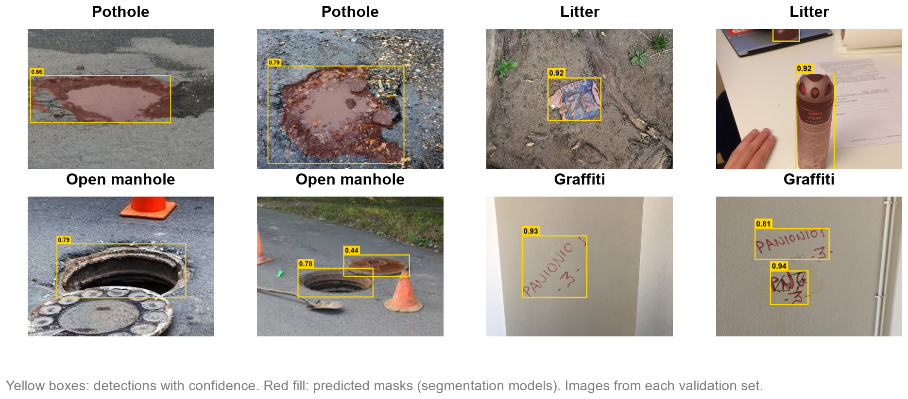
Fig. 5.11 Sample validation images with model output for each category
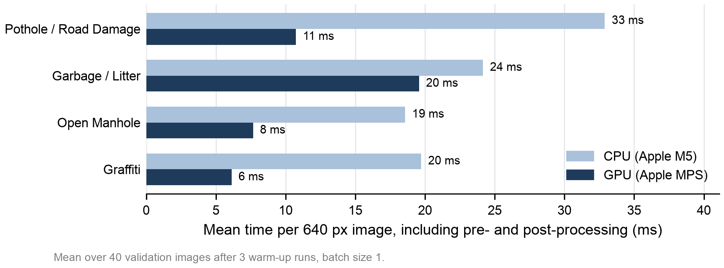
Fig. 5.12 Inference time per image on CPU and on the Apple MPS GPU backend
A photo takes 19 to 33 ms on the laptop CPU (Fig. 5.12), so the AI service needs no GPU server.

5.7 Summary
All tests pass, and the models are accurate and fast enough for ward-level use on a laptop CPU.

CHAPTER 6
PROJECT OUTCOME AND APPLICABILITY

6.1 Outline
What UrbanFix delivers and where it could be used.

6.2 Key Implementation Outlines of the System
- An Expo app with five tab sets, one per role, that runs on Android and iOS through Expo Go.
- An Express API with seven route groups, workflow rules enforced on the server, invite-based onboarding and an audit trail on every complaint.
- Four YOLOv8 models, one per category, trained on public datasets and served through a FastAPI inference service.
- A public registry and tracker, PDF receipts, and a research layer that protects privacy, logs access and enforces limits.

6.3 Significant Project Outcomes
We seeded 80 demonstration complaints over twelve months and moved them through the stages (Figs. 6.1 and 6.2). Because the data is generated, the charts illustrate the dashboards and do not measure a real ward.
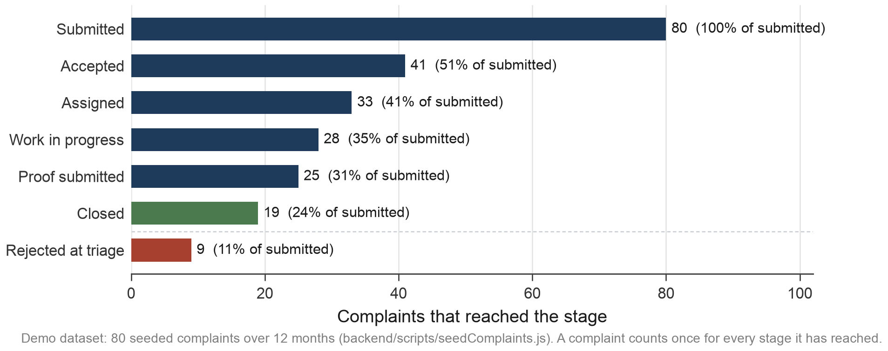
Fig. 6.1 Complaints reaching each workflow stage (demonstration dataset)
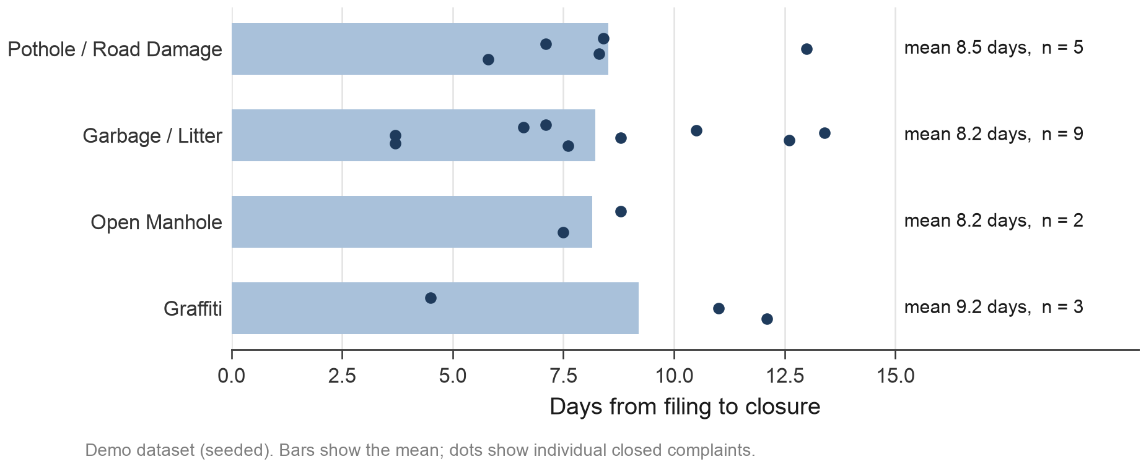
Fig. 6.2 Days from filing to closure by category (demonstration dataset)

6.4 Project Applicability on Real-World Applications
- A municipal corporation could run UrbanFix ward by ward, mapping supervisors to wards and field staff to teams.
- A Smart City SPV could publish the registry and resolution data as an open performance dashboard.
- Researchers and planners could study complaint patterns by category, ward and month using anonymised exports.
- Campuses, townships and housing societies could use the same workflow for their own maintenance.

6.5 Inference
A student team built a full governance loop with open tools and public data.

CHAPTER 7
CONCLUSIONS AND RECOMMENDATION

7.1 Outline
UrbanFix checks, prioritises, routes and publishes civic complaints in one system.

7.2 Limitations and Constraints of the System
- Only four categories have suitable public datasets, so common complaints such as water leakage and faulty streetlights are left out.
- The models learned from public data collected in other cities and countries, and nobody has measured their accuracy on Indian street photos in different light and weather.
- We chose the question weights ourselves; they have not been fitted to real outcomes.
- Location is recorded as a ward and free text rather than GPS, and there is no duplicate detection, so a pothole reported twice appears twice.
- The workflow results in Chapter 6 come from demonstration data, there has been no pilot with a municipal body, and citizens need a smartphone, internet access and email.

7.3 Future Enhancements
- Collect and label local photos to fine-tune each model, and add categories as new public datasets appear.
- Record GPS with each report, add map views and duplicate detection, and learn the question weights from closed complaints.
- Support Hindi and regional languages, and add an SMS or IVR channel for citizens without smartphones.
- Pilot the system in one ward of a municipal corporation and compare its accuracy with manual review, as CivicX [6] did.

7.4 Inference
No reviewed system combines defect-level photo checks, traceable urgency and a public record. The next step is a field pilot.

REFERENCES
[1] P. M. Javali, S. Athanikar, K. Naregal, S. Shinde, and A. Gudnavar, "A web-based public grievance redressal system with image and geolocation support," in Proc. Int. Conf. Smart & Sustainable Technology (INCSST), Karnataka, India, Jul. 2025, doi: 10.1109/INCSST64791.2025.11210297.
[2] S. K. Kanagapriya and V. Kesika, "AI-driven anonymous civic intelligence for transparent and efficient municipal governance," in Proc. 7th Int. Conf. Intelligent Communication Technologies and Virtual Mobile Networks (ICICV), 2026, doi: 10.1109/ICICV68925.2026.11554648.
[3] P. Cholke, A. S. Mishra, V. N. Mehar, M. R. Chikhale, H. S. Marathe, and D. Y. Nhalade, "AI-driven complaint management system: An automated framework for prioritizing, tracking, and resolving public service complaints efficiently," in Proc. Int. Conf. Emerging Smart Computing and Informatics (ESCI), Pune, India, Mar. 2026, doi: 10.1109/ESCI68015.2026.11493166.
[4] M. Vishwanath, V. A. M., P. U. Kulkarni, P. M. K., and V. V. Murthy, "AI-driven smart waste management with geofencing and civic accountability," in Proc. 3rd Int. Conf. Emerging Applications of Material Science and Technology (ICEAMST), Bengaluru, India, 2025, doi: 10.1109/ICEAMST67459.2025.11336075.
[5] S. Salunkhe, A. Salvi, T. Salunke, A. Patil, A. Saware, and R. Jolhe, "CivicMate: An AI-driven city grievances," in Proc. Int. Conf. Nascent Technologies in Engineering (ICNTE), Navi Mumbai, India, 2026, doi: 10.1109/ICNTE66387.2026.11437408.
[6] S. N. Katkar, V. Parab, V. Makadiya, M. Pingale, and A. Mane, "CivicX: An AI-driven data-centric platform for urban grievance management and intelligent plan approval," in Proc. Int. Conf. Communication, Computing and Emerging Technologies (IC3ET), 2026, pp. 631-641, doi: 10.1109/IC3ET64989.2026.11467223.
[7] R. Praveen Kumar, P. Sam Benny, Ch. Manideep, G. Sushmitha, and Md. Athfaan, "Smart City Concern: An AI-driven multimodal civic grievance management system," in Proc. 6th Int. Conf. Trends in Material Science and Inventive Materials (ICTMIM), 2026, pp. 1894-1901, doi: 10.1109/ICTMIM68190.2026.11507401.
[8] Roboflow Universe, "Pothole Segmentation YOLOv8 dataset, version 1," CC BY 4.0. [Online]. Available: https://universe.roboflow.com/farzad/pothole_segmentation_yolov8
[9] D. Arya, H. Maeda, S. K. Ghosh, D. Toshniwal, and Y. Sekimoto, "RDD2022: A multi-national image dataset for automatic road damage detection," arXiv:2209.08538, 2022. [Online]. Available: https://figshare.com/articles/dataset/21431547
[10] P. F. Proença and P. Simões, "TACO: Trash annotations in context for litter detection," arXiv:2003.06975, 2020. [Online]. Available: http://tacodataset.org
[11] sabidrahman, "Pothole, cracks and open manhole (Road Hazards) dataset," Kaggle, 2025. [Online]. Available: https://www.kaggle.com/datasets/sabidrahman/pothole-cracks-and-openmanhole
[12] C. Patrikakis, P. Kasnesis, L. Toumanidis, and A. Tzitamidis, "STORM graffiti/tagging detection dataset," University of West Attica, Zenodo, 2019, doi: 10.5281/zenodo.3238357.
[13] G. Jocher, A. Chaurasia, and J. Qiu, "Ultralytics YOLOv8," version 8.0.0, 2023. [Online]. Available: https://github.com/ultralytics/ultralytics
[14] Ministry of Road Transport and Highways, Government of India, "Road Accidents in India" annual reports, 2018 to 2022, New Delhi.
[15] Ministry of Road Transport and Highways, reply on pothole-related road accidents 2020 to 2024, Lok Sabha, 12 Feb. 2026.
[16] Press Information Bureau, "Grievance Cell," Ministry of Personnel, Public Grievances and Pensions, 16 Mar. 2022. [Online]. Available: https://pib.gov.in/PressReleasePage.aspx?PRID=1806610
[17] Press Information Bureau, "Disposal rate of grievance redressal mechanism," Parliament question, 2 Apr. 2025. [Online]. Available: https://pib.gov.in/PressReleasePage.aspx?PRID=2117810
[18] Press Information Bureau, "CPGRAMS portal," Parliament question, 5 Feb. 2026. [Online]. Available: https://pib.gov.in/PressReleasePage.aspx?PRID=2223804
[19] E. F. Sherley S, Sanjay T, Shri Kaanth P, and J. Samuel S, "Comprehensive dataset for urban streetlight analysis," arXiv:2407.01117, 2024.
[20] Expo, "Expo SDK 57 documentation," 2026. [Online]. Available: https://docs.expo.dev

APPENDIX A: API ENDPOINTS
Table A.1 REST API route groups
Prefix | Who | Endpoints
/api/auth | everyone | POST /register, /verify-otp, /resend-otp, /login, /set-password; GET /me
/api/complaints | citizens | POST /request-otp, / (multipart); GET /track/:id, /download-receipt/:id, /my-complaints
/api/public | anyone | GET /complaints (category, status, ward, location, page), /stats
/api/supervisor | supervisor, admin | GET /queue, /complaints/:id, /field-staff, /stats, /leave; PATCH /complaints/:id/accept, reject, assign, close, rework; PATCH /leave/:id
/api/field | field worker | GET /tasks, /tasks/:id, /stats, /leave, /attendance; PATCH /tasks/:id/start; POST /tasks/:id/proof, /leave, /attendance/check-in, /attendance/check-out
/api/admin | admin | GET /stats, /activity-heatmap, /complaints, /users, /research-applications, /audit/research, /leave; POST /users; PATCH /complaints/:id/status, /users/:id, deactivate, reactivate, /research-applications/:id, /leave/:id
/api/research | researcher, admin | POST /apply (public); GET /me, /dashboard, /query, /export?format=csv|json
AI service | backend only | POST /predict/{category}; GET /models, /health

