CampusNetSim: A Cloud-Native Wi-Fi Congestion Simulation and Automated Load-Balancing System on AWS Serverless Services
Sumedha Phadnis and Priyanka J
Cloud Architecture Design (AWS) - Course Project Report

Keywords—Serverless computing, AWS Lambda, Amazon API Gateway, Amazon DynamoDB, DynamoDB Streams, event-driven architecture, WLAN load balancing, access point utilization, campus network simulation.
Abstract—Campus Wi-Fi load is uneven. Client devices associate with the access point (AP) that has the strongest signal, which saturates APs near lecture halls and leaves neighbouring APs lightly used. CampusNetSim, the cloud-native system presented here, simulates how devices associate with campus APs, detects overloaded APs and automatically moves simulated clients to APs that still have free slots. Ten AWS Lambda functions sit behind an Amazon API Gateway HTTP API, and four on-demand Amazon DynamoDB tables hold all state. A DynamoDB Stream on the AP state table drives load balancing and history logging, so the fully serverless backend never has to poll. Real phones join by scanning an AP's QR code. The code opens a check-in page hosted on Amazon S3, while a React dashboard on AWS Amplify displays live utilization, migrations, connected devices and traffic trends. A validated PUT endpoint in the final build lets AP capacities be changed at run time. Conditional writes make event processing concurrency-safe, and DynamoDB becomes the single source of truth for the campus layout. We ran the system twice with real phones. Each time an AP reached 100% utilization, the load balancer moved a device to the AP with the most free capacity, bringing the source below the 85% trigger and leaving the target at 33.33%. All 14 functional API tests returned the expected status codes. Warm reads had a median latency of 60-69 ms.
I. Introduction
Watch a lecture hall as one class leaves and the next arrives, and a familiar weakness of campus Wi-Fi appears. Client radios associate with the access point that offers the strongest signal, regardless of how many clients that AP already serves. One AP saturates while an AP in the library, two buildings away, sits half empty. Research on WLAN association control has shown that signal-strength-only association produces markedly worse throughput and fairness than load-aware association [1]-[3].
Getting a client onto a less loaded AP is not as simple as it sounds. The IEEE 802.11 standard [4] lets an AP suggest a transition through BSS Transition Management [5] and speeds up the roam once the client decides to move [6], but the decision always remains with the client's chipset and driver. Consumer routers rarely expose steering controls to third-party software. Mobile operating systems also stop applications from switching networks silently. For a student project, reliable client steering across a mix of devices and operating systems is therefore out of reach.
CampusNetSim sidesteps this by enforcing moves inside a controlled simulation. We model four APs (AP01-AP04) in three buildings, with two in the academic block and one each in the hostel and the library. Each AP has its own configurable capacity. Every association change arrives as an explicit CONNECT or DISCONNECT event. Because the system owns the association state, it can detect an overloaded AP, choose a target, perform the move and record verifiable before-and-after utilization. Real phones still take part. Scanning an AP-specific QR code opens a browser check-in page that registers the phone with that AP in application state, although the phone's actual network connection never changes.
Every component runs on managed AWS serverless services [7]-[9], with no servers to provision. The main contributions are: (i) an event-driven, polling-free load-balancing pipeline built on DynamoDB Streams; (ii) run-time capacity reconfiguration with server-side validation and concurrency-safe event processing; (iii) a phone check-in path that lets real devices trigger the pipeline without any installation; and (iv) a live evaluation with real phones, functional API tests and latency measurements.
The rest of the paper is organised as follows. Section II surveys prior work on WLAN load balancing and serverless design. The methodology follows in Section III; Sections IV and V cover the architecture and workflows, and Section VI formalises the utilization model and the balancing algorithm. Configuration tables appear in Section VII. Implementation and results are reported in Section VIII, and Sections IX and X give the conclusion and future work.
II. Related Works
Most prior work on wireless LAN load balancing operates at the level of AP association. Bejerano, Han and Li [1] cast association control as a max-min fair bandwidth allocation problem. Their load-aware association clearly outperforms the default strongest-signal policy. Bejerano and Han [2] later proposed cell breathing. Each AP adjusts its transmit power to shrink or grow its coverage, and clients drift toward less loaded cells with no client-side change. Balachandran, Bahl and Voelker [3] studied hot-spot congestion in public-area wireless networks and proposed network-directed roaming, in which an overloaded AP explicitly redirects users to neighbouring APs. CampusNetSim follows the same idea of network-side redirection, but performs it on a simulated association model where every move can be enforced and audited.
The 802.11 standard [4] defines how roaming can be influenced in real deployments. In 802.11v [5], BSS Transition Management lets an AP ask a client to move, while 802.11r [6] adds Fast BSS Transition to cut roaming latency. Neither mechanism can force a move, since a client is free to ignore a transition request. For this reason above all, CampusNetSim enforces moves inside its own event model and makes no attempt at real client steering.
Jonas et al. [7] and Castro et al. [8] describe serverless computing from the cloud side. Developers deploy stateless functions and the provider handles provisioning and scaling, with cold starts and platform-specific integration as the price. Li et al. [9] survey serverless architectures and classify their design trade-offs in detail. Amazon's Dynamo paper [10] argues for key-value stores such as DynamoDB when most operations are simple reads and writes by primary key. Per-AP state, append-only history and migration logs fit that pattern. Ahmed et al. [11] built a four-layer IoT platform to monitor and control smart campus buildings remotely. CampusNetSim also targets live campus monitoring through a web dashboard, but its data come from simulated association events and phone check-ins, not physical sensors. Table I sets these five mechanisms side by side with CampusNetSim.
TABLE I
Comparison of Related Approaches
Approach | Where control lives | Needs client support | Relation to CampusNetSim
Association control [1] | Network (central) | Yes | Same objective; simulated enforcement
Cell breathing [2] | AP transmit power | No | Alternative real-network mechanism
Network-directed roaming [3] | Overloaded AP | Partly | Closest idea: redirect from hot spot
802.11v / 802.11r [5], [6] | AP request, client decides | Yes | Advisory only; motivates simulation
Smart-campus IoT [11] | Cloud platform | Sensors | Similar cloud monitoring stack

III. Proposed Methodology
A. System Model
The campus is modelled as a set of APs, each with an identifier, a building, a display name, a capacity C_{i} (the number of devices at which the AP is considered full) and a live connected-device count n_{i}. Association changes arrive as CONNECT and DISCONNECT events from three sources: phones using the check-in page, the load balancer when it moves devices, and an optional synthetic traffic generator. Each AP's state sits in one DynamoDB item. Any change to an AP is therefore a single item update, which DynamoDB Streams can publish [14].
B. Design Principles
The design rests on four principles. One function per responsibility: each API route has its own Lambda function with permissions limited to the tables it needs, following the AWS serverless guidance [12]. Event-driven reaction: the APState stream, not a schedule, triggers load balancing and history logging, and the system sits idle when nothing changes [13], [14]. Single source of truth: AP capacities, buildings and names live only in the APState table; every function reads them from there at run time. Verifiable actions: every automated move writes a Migrations record with the utilization of both APs before and after the move.
C. Functional Components
Event ingestion. Every CONNECT or DISCONNECT event enters through POST /events, which EventProcessor handles. EventProcessor first validates the event and reads the AP's configuration and current count with a strongly consistent read. It rejects a CONNECT when the AP is already full; otherwise it computes the new utilization and status and writes only the live-state attributes back with a conditional update. If the AP turns CONGESTED (100% utilization), EventProcessor attaches an advisory recommendation that favours another AP in the same building.
Reactive load balancing. LoadBalancer is the first of two consumers on the APState stream. When an AP reaches the 85% trigger, it selects the AP with the most free capacity, computes how many devices to move (at most five) and moves them by posting DISCONNECT and CONNECT events through the public API, so every move passes the same validation as any other event. Real phones are moved first, and their roster entries are updated so that the phone's page can show the redirect. HistoryWriter consumes the same stream and stores each AP state in APHistory with a 24-hour expiry using DynamoDB time to live (TTL) [15].
Read services and administration. StatusReader, HistoryReader and MigrationReader serve the dashboard and the check-in page. DeviceRegistry keeps the roster of checked-in phones and the AP each one is on. AdminReset zeroes all four APs, clears the Migrations and APHistory tables and marks every connected phone as disconnected, which lets us rerun a demonstration from a clean state.
D. Run-Time Capacity Reconfiguration and Consistency
UpdateAPConfig, added in the final build, lets an operator change an AP's capacity while the system is running. Sitting behind PUT /aps/{ap_id}/config, the function accepts only capacity, building and ap_name, and the capacity must be an integer from 1 to 1000. A capacity below the number of currently connected devices is refused with HTTP 409. Only the supplied attributes change, and the AP's utilization is recalculated in the same write. Because EventProcessor now reads capacity from APState on every event, the new value applies to the very next event, including the utilization status and the balancing trigger.
Two concurrent events on the same AP could otherwise read the same count and overwrite each other. EventProcessor therefore uses optimistic concurrency [16]: its update succeeds only if the stored count and capacity still equal the values it read; otherwise DynamoDB rejects the write and the API returns HTTP 409 so that the caller can retry. The same condition protects against a capacity change that lands between the read and the write of an event.
IV. Architecture Diagram
Fig. 1 shows the deployed architecture in five layers. The client layer contains the phone check-in page, a static page on Amazon S3, and the monitoring dashboard, a React and Vite application on AWS Amplify Hosting. Both call a single API Gateway HTTP API [17] with CORS enabled. Seven request handlers, one per API route, make up most of the compute layer. Two event-driven functions are attached to the APState stream, and TrafficGenerator, deployed without a trigger, is invoked manually to create synthetic load. Four on-demand DynamoDB tables form the storage layer, and every function writes its logs to Amazon CloudWatch Logs.
Two kinds of connection carry all of the system's logic. Request handlers read and write the four tables in response to API calls, and the APState stream fans each change out to LoadBalancer and HistoryWriter. LoadBalancer never writes APState directly. Its moves go back through the API, so every capacity and concurrency check stays in EventProcessor.

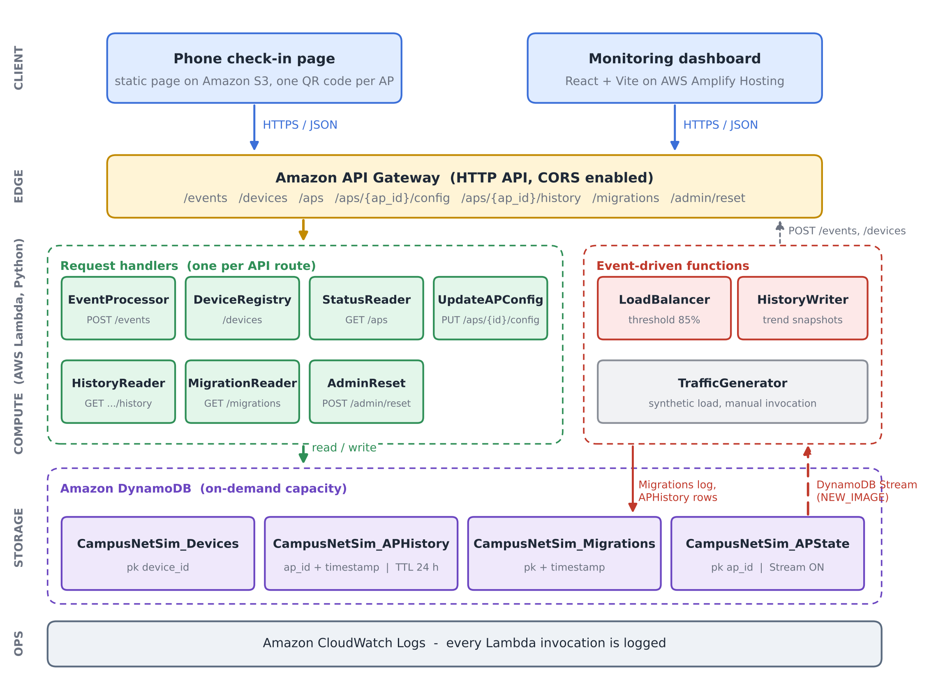
Fig. 1. CampusNetSim system architecture. Seven request handlers serve the API routes. The APState stream drives two event-driven functions, and all state lives in four on-demand DynamoDB tables.

V. Workflow
Fig. 2 follows a single phone from the QR-code scan to the next dashboard refresh. Scanning the QR code opens the check-in page with the AP identifier in the link (step 1). Tapping Join posts a CONNECT event to /events and then a JOIN to /devices (step 2). EventProcessor validates the event and updates APState (step 3), which emits one stream record (step 4). The record reaches LoadBalancer and HistoryWriter independently (steps 5 and 6). LoadBalancer acts only when the AP has reached 85%, moving devices and logging the migration (step 7), while HistoryWriter always stores a snapshot for the trend chart. Both front ends poll the read endpoints every five seconds (step 8). A migrated phone sees its new AP in the roster and shows a banner explaining the move.
Fig. 3 covers what happens when an operator changes an AP's capacity. On the dashboard, the operator picks an AP and types a new maximum; the dashboard checks it locally before sending PUT /aps/{ap_id}/config. UpdateAPConfig validates the request again on the server and updates APState in place. That update also passes through the APState stream. As a result, the trend chart records the recalculated utilization immediately.

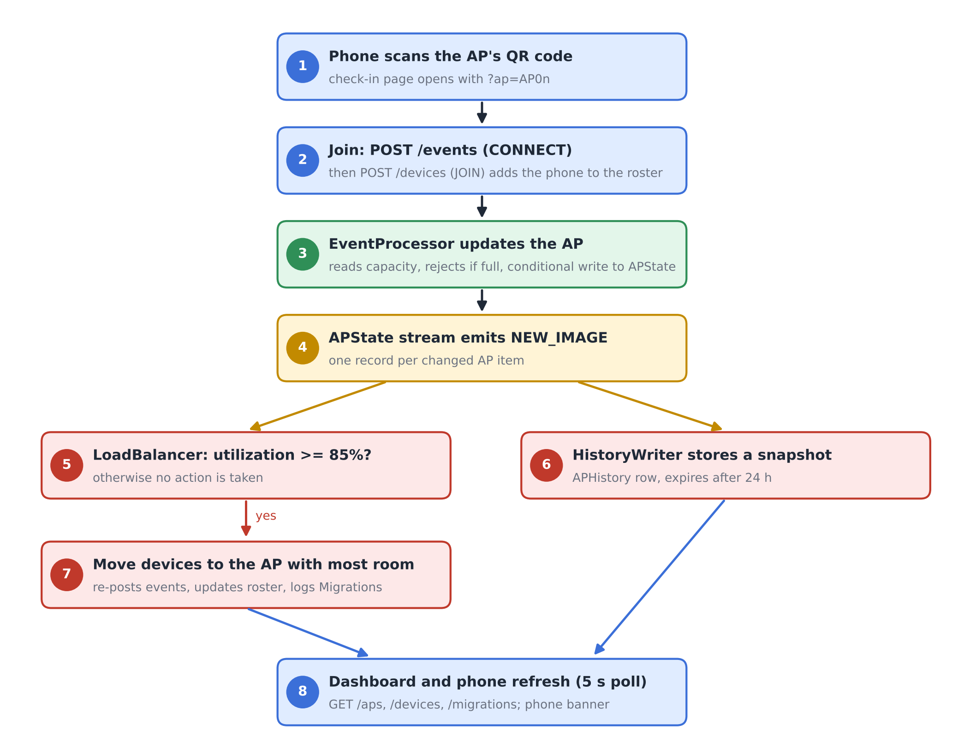
Fig. 2. End-to-end workflow from phone check-in to automated rebalancing and dashboard refresh.
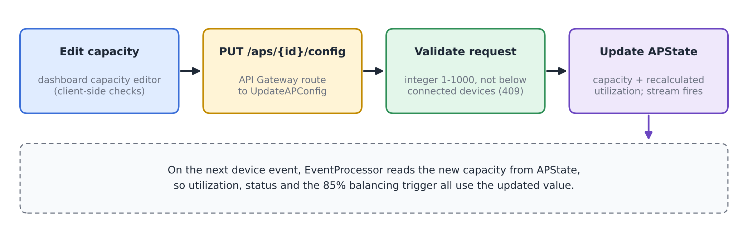
Fig. 3. Run-time capacity reconfiguration flow.

VI. Algorithm / Formulas
A. Utilization and Status
For an AP i with n_{i} connected devices and capacity C_{i}, utilization is
U_{i} = (n_{i} / C_{i}) × 100 (1)
rounded to two decimals. The status shown on the dashboard and the check-in page is
S_{i} = NORMAL (U_{i} < 70), BUSY (70 ≤ U_{i} < 90) (2)
with HIGH_LOAD for 90 ≤ U_{i} < 100 and CONGESTED for U_{i} ≥ 100. EventProcessor rejects any CONNECT once n_{i} = C_{i}. Utilization therefore never exceeds 100%, and CONGESTED means exactly full.
B. Balancing Trigger, Target and Move Size
LoadBalancer reacts to a stream record for AP i only when
U_{i} ≥ θ, θ = 85 (3)
and the condition still holds in a fresh read of GET /aps. The target is the AP with the most free slots,
j* = argmax_{j ≠ i} (C_{j} − n_{j}) (4)
and the source should drop to about five points below the trigger, giving a target count
n_{i}^{tgt} = ⌊C_{i} (θ − 5) / 100⌋ (5)
The number of devices moved is limited by the need, the free space at j* and a per-migration cap K = 5:
k = min( max(1, n_{i} − n_{i}^{tgt}), C_{j*} − n_{j*}, K ) (6)
C. Capacity Update and Consistency Rules
A capacity change for AP i to a new value C_{i}' is accepted only if
n_{i} ≤ C_{i}' ≤ 1000, C_{i}' ∈ ℤ (7)
and the stored utilization is recomputed with (1). An event write computed from a read of (n_{i}, C_{i}) is committed only if the stored item still matches that read:
commit ⇔ n_{i}^{stored} = n_{i}^{read} ∧ C_{i}^{stored} = C_{i}^{read} (8)
As a worked example, consider an AP with C_{i} = 2 and n_{i} = 2 (U_{i} = 100%). Equation (5) gives n_{i}^{tgt} = ⌊2 × 80 / 100⌋ = 1, so (6) moves k = 1 device, provided the target has at least one free slot. After the move, the source AP sits at 50%, one device out of two. Run A in Section VIII produced exactly this result.
D. Algorithm
Algorithm 1 gives the per-record procedure of LoadBalancer. Fig. 4 draws the same logic as a flowchart.
Algorithm 1: Reactive AP load balancing (per stream record)
1: input: stream record r for AP i
2: if r is not INSERT/MODIFY or device id starts with "migrated-" then return
3: if U_{i} < θ in r then return
4: read all APs via GET /aps; if U_{i} < θ then return
5: j* ← argmax_{j≠i} (C_{j} − n_{j}) (4); if C_{j*} − n_{j*} ≤ 0 then return
6: k ← min(max(1, n_{i} − n_{i}^{tgt}), C_{j*} − n_{j*}, 5) (5)-(6)
7: D ← connected real phones on AP i (roster)
8: for m = 1 to k do
9: d ← D[m] if available, else synthetic id "migrated-i-xxxx"
10: POST /events (d, i, DISCONNECT); POST /events (d, j*, CONNECT)
11: if d is a real phone then POST /devices (d, JOIN, j*)
12: if at least one move succeeded then write Migrations record {i, j*, moved, U before/after}

Line 2 guards against feedback loops. A migration produces events that change APState again, but LoadBalancer ignores records written for synthetic migrated devices, and a target AP that has just received devices normally sits below the trigger. Moves pass through POST /events. EventProcessor's capacity check and conditional write therefore protect the balancer's own writes as well.
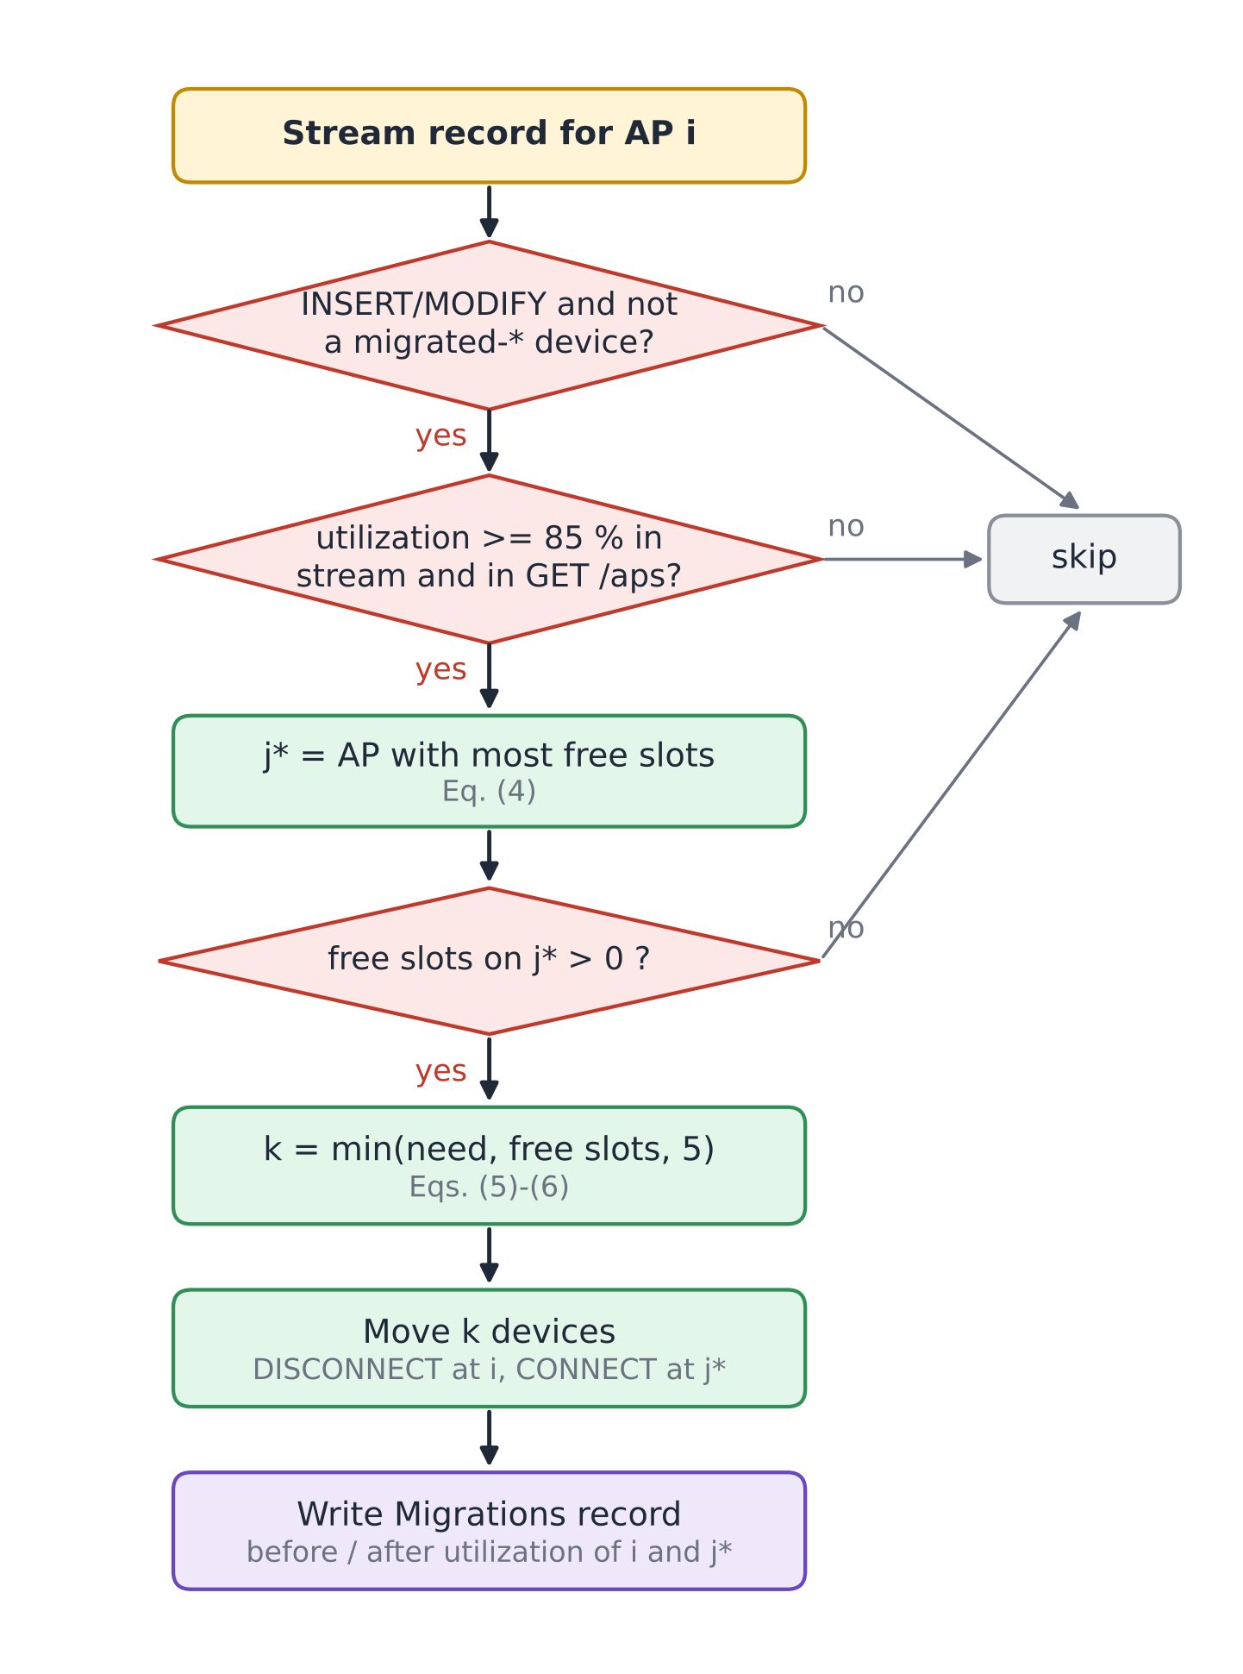
Fig. 4. Decision flowchart of the LoadBalancer function (Algorithm 1).
VII. Tables and Figures
Four tables document the deployed configuration. Table II lists the Lambda functions with their triggers and settings, Table III the DynamoDB tables, Table IV the API routes and Table V the parameters used in Section VI. Figures 1-4 above describe the architecture, workflows and algorithm; Figs. 5-10 in Section VIII document the running system and the measured results.

TABLE II
AWS Lambda Functions (ap-south-1, x86_64, 128 MB)
Function | Trigger | Runtime / timeout | Responsibility
CampusNetSim-EventProcessor | HTTP API: /events | Python 3.13 / 3 s | Validate CONNECT/DISCONNECT, conditional APState update, advisory recommendation
CampusNetSim-DeviceRegistry | HTTP API: /devices | Python 3.13 / 3 s | Phone roster: JOIN, LEAVE, list
CampusNetSim-StatusReader | HTTP API: /aps | Python 3.13 / 3 s | Live state of all APs
UpdateAPConfig | HTTP API: /aps/{ap_id}/config | Python 3.14 / 3 s | Validated capacity, building and name update
CampusNetSim-HistoryReader | HTTP API: /aps/{ap_id}/history | Python 3.13 / 3 s | Up to 200 history points for one AP
CampusNetSim-MigrationReader | HTTP API: /migrations | Python 3.13 / 3 s | 50 most recent migrations
CampusNetSim-AdminReset | HTTP API: /admin/reset | Python 3.13 / 40 s | Reset APs, clear logs, disconnect phones
CampusNetSim-LoadBalancer | DynamoDB Stream (APState) | Python 3.13 / 30 s | Detect >= 85% and move devices
CampusNetSim-HistoryWriter | DynamoDB Stream (APState) | Python 3.13 / 3 s | Append snapshot to APHistory
CampusNetSim-TrafficGenerator | None (manual) | Python 3.13 / 30 s | Synthetic CONNECT/DISCONNECT traffic

TABLE III
Amazon DynamoDB Tables (On-Demand Capacity)
Table | Key schema | Purpose / features
APState | ap_id | Live AP config and counts; stream (NEW_IMAGE)
APHistory | ap_id + timestamp | Utilization snapshots; TTL 24 h
Devices | device_id | Phone roster and current AP
Migrations | pk + timestamp | Audit log of automated moves

TABLE IV
API Gateway Routes
Route | Method | Function
/events | POST | EventProcessor
/devices | GET, POST | DeviceRegistry
/aps | GET | StatusReader
/aps/{ap_id}/config | PUT | UpdateAPConfig
/aps/{ap_id}/history | GET | HistoryReader
/migrations | GET | MigrationReader
/admin/reset | POST (else 405) | AdminReset

TABLE V
Model Parameters
Symbol | Value | Meaning
BUSY / HIGH_LOAD / CONGESTED | 70 / 90 / 100 % | Status thresholds, Eq. (2)
θ | 85 % | Balancing trigger, Eq. (3)
θ − 5 | 80 % | Source target after a move, Eq. (5)
K | 5 | Max devices per migration, Eq. (6)
C_{i} range | 1-1000 | Allowed capacity, Eq. (7)
History TTL | 24 h | APHistory retention
Poll interval | 5 s | Dashboard and check-in refresh

VIII. Implementation, Results, and Discussion
A. Backend Deployment
The backend runs in the AWS Mumbai region (ap-south-1). The four tables were created with on-demand capacity, so no throughput had to be provisioned. The APState stream uses the NEW_IMAGE view type and has two enabled consumers, LoadBalancer and HistoryWriter, each with a batch size of 100 starting from the latest record [13], [14]. APHistory has TTL enabled on its expires_at attribute, so old readings disappear without a clean-up job [15]. All functions are written in Python and use the boto3 SDK; read functions convert DynamoDB Decimal values back to JSON numbers. The complete source of every deployed function, the check-in page, the dashboard and an AWS SAM template that recreates the stack are published in the project repository [19].
B. Front Ends and Hosting
The phone check-in page is a single HTML file on Amazon S3. On first use it generates a device identifier with the browser's random UUID generator and keeps it in local storage, so later check-ins from the same phone map to the same roster entry. After joining, the page polls GET /devices and GET /aps every five seconds. It treats a new AP in its roster entry as a migration and a DISCONNECTED entry as a reset, and in either case shows a banner explaining what happened.
The dashboard is built with React, Vite, Tailwind CSS and Recharts. It shows the AP cards, a utilization bar chart with the 70% and 90% reference lines, the automated load-balancing log, the connected-device roster and the traffic trend of the selected AP. The final build adds the capacity editor and an AP details panel that lists the devices on the selected AP (Fig. 5). The production build is deployed to AWS Amplify Hosting by manual upload [18]. Two deployment issues had to be fixed: a ZIP archive created on Windows stored backslash paths, which made the hosted page request its JavaScript and CSS files at wrong URLs, and the Vite configuration initially lacked the Tailwind CSS plugin, which left the page unstyled. A small script now rebuilds the archive with forward-slash paths.

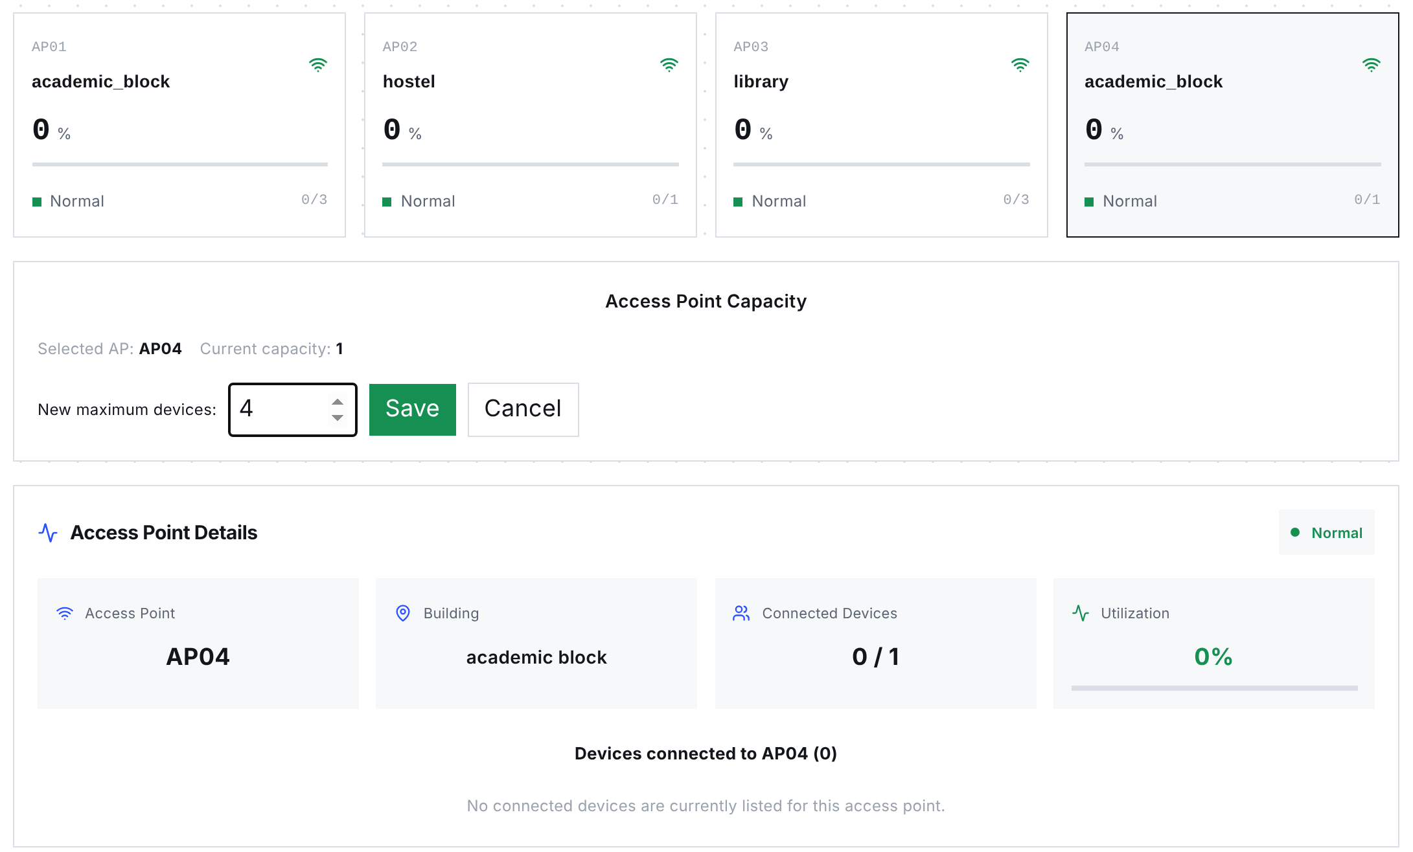
Fig. 5. Dashboard of the final build, showing AP cards with capacities 3, 1, 3 and 1, the capacity editor open for AP04, and the details panel for the selected AP. The screenshot comes from the production build, using the API state recorded on 23 October 2026.

C. Capacity Reconfiguration and Consistency Enhancements
Table VI lists the six changes made in the final build. Taken together, these changes take hard-coded capacities out of EventProcessor, make concurrent writes safe and let the operator control the campus layout directly.

TABLE VI
Enhancements in the Final Build
Component | Change | Effect
UpdateAPConfig (new Lambda) and PUT /aps/{ap_id}/config | Validated partial update of capacity, building and AP name; utilization recalculated with the capacity | Operators change capacity at run time without touching DynamoDB
EventProcessor | Reads capacity, building and name from APState on every event (strongly consistent read) | DynamoDB is the single source of truth for the layout
EventProcessor | Rejects CONNECT at capacity (409); conditional update on count and capacity (409 on conflict) | No lost updates and no utilization above 100%
EventProcessor | Updates only live-state attributes instead of replacing the item | Configuration fields survive device events
Dashboard | Capacity editor with local checks (positive integer, not below connected devices) and AP details panel | Capacity changes and per-AP devices visible in one place
Dashboard deployment | Forward-slash ZIP packaging script; Tailwind plugin in the Vite configuration | Reliable Amplify deployments

D. Functional Verification
On 23 October 2026, we exercised every route against the deployed API. Ten of the 14 tests deliberately target validation paths, which change no data, and the other four call the read endpoints. Table VII lists the requests and responses; all 14 returned the expected status code and error message. The reset endpoint was checked only with a GET, which is correctly refused, because a POST permanently deletes the logs.

TABLE VII
Functional API Tests Against the Deployed System
# | Request | Expected | Observed response
1 | GET /aps | 200, four APs | 200, AP01-AP04 with capacities 3, 1, 3, 1
2 | GET /devices | 200, roster | 200, roster list
3 | GET /migrations | 200, log | 200, one migration (AP04 to AP03)
4 | GET /aps/AP03/history | 200 | 200, empty list (readings older than 24 h expired)
5 | GET /admin/reset | 405 | 405 "Use POST to trigger a reset"
6 | PUT /aps/AP01/config {capacity: 0} | 400 | 400 "Capacity must be an integer from 1 to 1000"
7 | PUT /aps/AP01/config {capacity: "four"} | 400 | 400, same message
8 | PUT /aps/AP01/config {capacity: 5000} | 400 | 400, same message
9 | PUT /aps/AP01/config {color: "red"} | 400 | 400 "Unsupported configuration field"
10 | PUT /aps/AP99/config {capacity: 4} | 404 | 404 "AP not found"
11 | POST /events, event_type PING | 400 | 400 "event_type must be CONNECT or DISCONNECT"
12 | POST /events, no device_id | 400 | 400 "device_id, ap_id and event_type are required"
13 | POST /events, ap_id AP99 | 400 | 400 "Unknown ap_id: AP99"
14 | POST /devices JOIN without ap_id | 400 | 400 "ap_id required for JOIN"

Response times of the three most frequently polled routes were measured from a browser client in India with 20 sequential requests per route after the functions were warm (Table VIII). Median latencies of 60-69 ms are far below the five-second polling interval. The first requests after a period of inactivity took up to about 1.3 s, which reflects Lambda cold starts [8].
TABLE VIII
Warm Request Latency (20 Requests per Route)
Route | Min (ms) | Median (ms) | P90 (ms) | Max (ms)
GET /aps | 57 | 68 | 79 | 84
GET /devices | 56 | 69 | 78 | 81
GET /migrations | 58 | 60 | 80 | 282

E. Live Load-Balancing Runs
The pipeline was tested end to end with real phones instead of staged data. In Run A (September 2026), AP02 in the hostel had a capacity of 2 and AP04 in the academic block a capacity of 3. Two team members joined AP02 from their phones within a few minutes, driving it to 2 of 2 devices and 100% utilization (Fig. 8a). The resulting APState write reached LoadBalancer through the stream; it chose AP04, which had the most free slots, and moved one phone there. AP02 dropped to 50% and AP04 rose to 33.33%. The moved phone displayed the redirect banner with its new AP (Fig. 8b), and the dashboard logged the migration and showed both phones in the roster (Figs. 6 and 7).
Run B took place on 20 October 2026 during the final demonstration, after the capacities had been changed through the new capacity editor to 3, 1, 3 and 1 for AP01-AP04. Several participants checked in from their own phones. When a phone joined AP04 (capacity 1), the AP reached 100%, and LoadBalancer moved the phone to AP03 in the library, leaving AP04 at 0% and AP03 at 33.33% (Fig. 9). This run also confirms that a capacity set at run time is used by EventProcessor and by the balancing trigger without redeploying anything. Table IX lists both migrations and Fig. 10 compares utilization before and after each move.

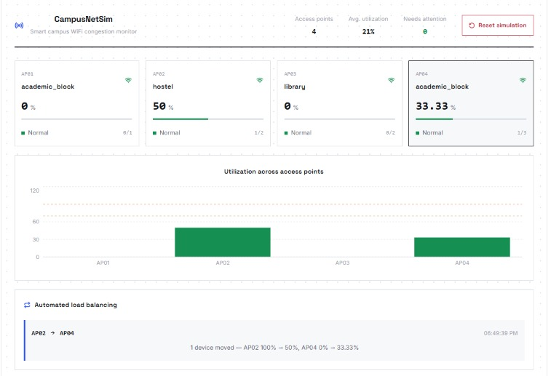
Fig. 6. Dashboard during Run A: AP02 at 50% (1 of 2) and AP04 at 33.33% (1 of 3) after the automated move, with the migration in the load-balancing panel.
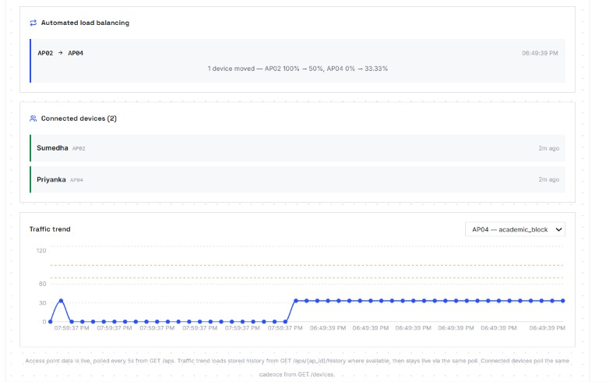
Fig. 7. Dashboard during Run A: migration log, connected-device roster with both phones and the AP04 traffic trend rising after the move.
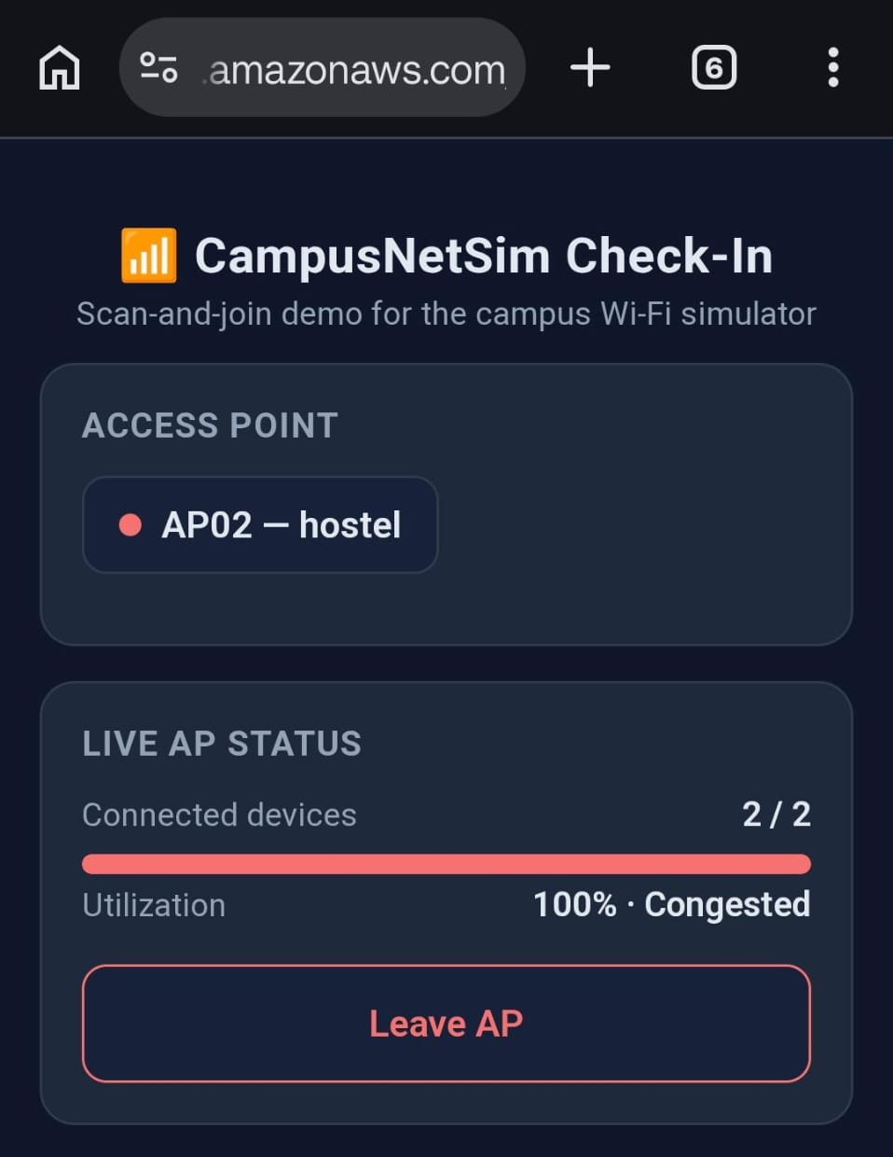  (a) AP02 full before the move | 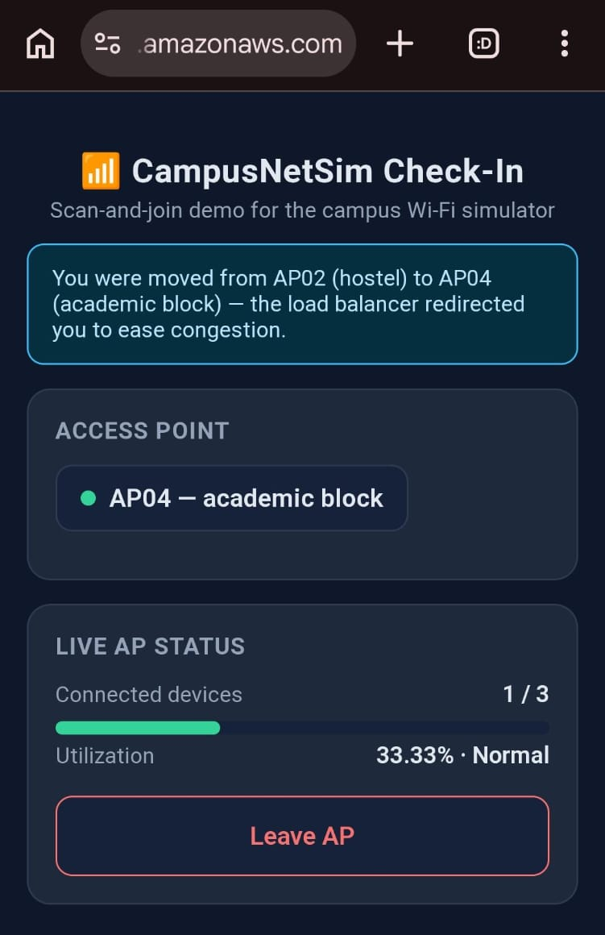  (b) after the move to AP04
Fig. 8. Phone check-in page in Run A: (a) AP02 at 2 of 2 devices and 100% (Congested); (b) moments later, the redirect banner and AP04 at 1 of 3 devices (33.33%, Normal).
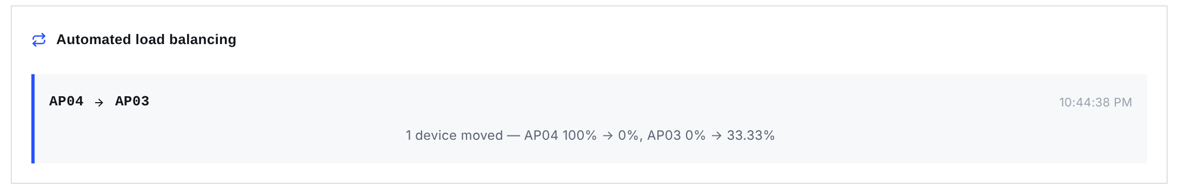
Fig. 9. Migration recorded in Run B: one device moved from AP04 (100% to 0%) to AP03 (0% to 33.33%).
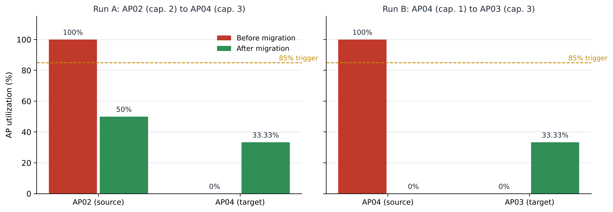
Fig. 10. Utilization of the source and target APs before and after each live migration. The source dropped below the 85% trigger in both runs, while the target never came close to it.

TABLE IX
Recorded Migrations
Run | Source (C) | Target (C) | k | Source U | Target U
A | AP02 (2) | AP04 (3) | 1 | 100 → 50 % | 0 → 33.33 %
B | AP04 (1) | AP03 (3) | 1 | 100 → 0 % | 0 → 33.33 %

F. Discussion
Both runs behaved as intended. The stream delivered the state change, the balancer picked the AP with the most free capacity, and the source finished below the 85% trigger without pushing the target over it. LoadBalancer writes its moves through POST /events, so they obey the same capacity limit and conditional write as phone events. Each move also left an auditable Migrations record.
Several limitations remain. The demonstrations used very small capacities, so one device shifts utilization in large steps (for an AP of capacity 1, from 0% straight to 100%) and the system mostly exercises the full-AP case. The two components can also disagree on the target. EventProcessor's advisory recommendation prefers an AP in the same building, whereas LoadBalancer picks the AP with the most free slots campus-wide, and the actual move follows the balancer. LoadBalancer reaches the other functions only through the public API over HTTPS, a path that adds latency and depends on a hard-coded base URL. EventProcessor also scans the APState table on every event. For four APs the cost is negligible, but it grows linearly with the campus. No route is authenticated. Anyone who knows the API Gateway endpoint URL can call PUT /aps/{ap_id}/config and POST /admin/reset, and the check-in page still keeps a static list of valid AP identifiers. All results so far come from four simulated APs and a handful of phones, and we have not yet measured behaviour under many simultaneous check-ins.
IX. Conclusion
Congestion detection and automated rebalancing for campus APs can be built entirely from managed serverless services, as CampusNetSim shows with ten Lambda functions and four DynamoDB tables. One DynamoDB Stream on APState drives both load balancing and history logging. The system reacts to every change without polling and does nothing otherwise. Real phones join through a QR-code check-in page with nothing to install. Within one five-second polling interval, the dashboard reflects each change. Capacities can now be changed at run time with server-side validation, and conditional writes make event processing concurrency-safe, leaving DynamoDB as the single source of truth for the campus layout. Two live runs, each started by real phone check-ins, confirmed the behaviour. In both, the balancer moved a device from a full AP to the AP with the most free capacity, and all 14 functional tests and the latency measurements matched what we expected.
X. Future Work
We plan seven extensions. (1) Authenticate and authorize callers, for example with JWT authorizers on the HTTP API, beginning with the configuration and reset routes. (2) Attach an Amazon EventBridge schedule to TrafficGenerator and run repeatable experiments under normal, peak-hour and congestion loads. Each experiment would report utilization before and after balancing and how many migrations occurred. (3) Make EventProcessor and LoadBalancer agree on targets, for example by having LoadBalancer also prefer an AP in the same building. (4) Replace the per-event table scan with direct GetItem lookups on ap_id. The balancer's HTTP calls could then move to direct function invocations or shared code. (5) Forecast from APHistory when an AP will reach the 85% trigger, and rebalance before it does. (6) Detect when an AP fails and reassign its devices to the remaining APs. (7) Load-test the system with many simultaneous check-ins, and add CloudWatch alarms plus an AWS budget alert.
References
[1] Y. Bejerano, S.-J. Han, and L. Li, "Fairness and load balancing in wireless LANs using association control," IEEE/ACM Trans. Netw., vol. 15, no. 3, pp. 560-573, Jun. 2007.
[2] Y. Bejerano and S.-J. Han, "Cell breathing techniques for load balancing in wireless LANs," IEEE Trans. Mobile Comput., vol. 8, no. 6, pp. 735-749, Jun. 2009.
[3] A. Balachandran, P. Bahl, and G. M. Voelker, "Hot-spot congestion relief in public-area wireless networks," in Proc. 4th IEEE Workshop Mobile Comput. Syst. Appl. (WMCSA), Callicoon, NY, USA, 2002, pp. 70-80.
[4] IEEE Standard for Information Technology - Telecommunications and Information Exchange Between Systems - Local and Metropolitan Area Networks - Specific Requirements - Part 11: Wireless LAN Medium Access Control (MAC) and Physical Layer (PHY) Specifications, IEEE Std 802.11-2020, 2021.
[5] IEEE Standard for Information Technology - Part 11, Amendment 8: IEEE 802.11 Wireless Network Management, IEEE Std 802.11v-2011, 2011.
[6] IEEE Standard for Information Technology - Part 11, Amendment 2: Fast Basic Service Set (BSS) Transition, IEEE Std 802.11r-2008, 2008.
[7] E. Jonas et al., "Cloud programming simplified: A Berkeley view on serverless computing," EECS Dept., Univ. California, Berkeley, CA, USA, Tech. Rep. UCB/EECS-2019-3, Feb. 2019.
[8] P. Castro, V. Ishakian, V. Muthusamy, and A. Slominski, "The rise of serverless computing," Commun. ACM, vol. 62, no. 12, pp. 44-54, Dec. 2019.
[9] Z. Li, L. Guo, J. Cheng, Q. Chen, B. He, and M. Guo, "The serverless computing survey: A technical primer for design architecture," ACM Comput. Surv., vol. 54, no. 10s, Art. no. 220, 2022.
[10] G. DeCandia et al., "Dynamo: Amazon's highly available key-value store," in Proc. 21st ACM Symp. Operating Syst. Principles (SOSP), Stevenson, WA, USA, 2007, pp. 205-220.
[11] M. A. Ahmed, S. A. Chavez, A. M. Eltamaly, H. O. Garces, A. J. Rojas, and Y.-C. Kim, "Toward an intelligent campus: IoT platform for remote monitoring and control of smart buildings," Sensors, vol. 22, no. 23, Art. no. 9045, 2022.
[12] Amazon Web Services, "Serverless architectures with AWS Lambda: Overview and best practices," AWS Whitepaper, 2017. [Online]. Available: https://d1.awsstatic.com/whitepapers/serverless-architectures-with-aws-lambda.pdf
[13] Amazon Web Services, "Using AWS Lambda with Amazon DynamoDB," AWS Lambda Developer Guide. [Online]. Available: https://docs.aws.amazon.com/lambda/latest/dg/with-ddb.html (accessed Oct. 23, 2026).
[14] Amazon Web Services, "Change data capture for DynamoDB Streams," Amazon DynamoDB Developer Guide. [Online]. Available: https://docs.aws.amazon.com/amazondynamodb/latest/developerguide/Streams.html (accessed Oct. 23, 2026).
[15] Amazon Web Services, "Using time to live (TTL) in DynamoDB," Amazon DynamoDB Developer Guide. [Online]. Available: https://docs.aws.amazon.com/amazondynamodb/latest/developerguide/TTL.html (accessed Oct. 23, 2026).
[16] Amazon Web Services, "Optimistic locking with version number," Amazon DynamoDB Developer Guide. [Online]. Available: https://docs.aws.amazon.com/amazondynamodb/latest/developerguide/BestPractices_OptimisticLocking.html (accessed Oct. 23, 2026).
[17] Amazon Web Services, "Working with HTTP APIs," Amazon API Gateway Developer Guide. [Online]. Available: https://docs.aws.amazon.com/apigateway/latest/developerguide/http-api.html (accessed Oct. 23, 2026).
[18] Amazon Web Services, "Deploying an application to Amplify without a Git repository," AWS Amplify Hosting User Guide. [Online]. Available: https://docs.aws.amazon.com/amplify/latest/userguide/manual-deploys.html (accessed Oct. 23, 2026).
[19] S. Phadnis and P. J, "CampusNetSim: Cloud-native campus Wi-Fi congestion simulation and load balancing," GitHub repository, 2026. [Online]. Available: https://github.com/pj-06/campusnetsim

