CampusNetSim: A Cloud-Native Wi-Fi Congestion Simulation and Automated Load-Balancing System on AWS Serverless Services
Sumedha Phadnis and Priyanka J
Cloud Architecture Design (AWS) - Course Project Report

Keywords—Serverless computing, AWS Lambda, Amazon API Gateway, Amazon DynamoDB, DynamoDB Streams, event-driven architecture, WLAN load balancing, access point utilization, campus network simulation.
Abstract—Campus Wi-Fi rarely spreads its load evenly. Each client device joins whichever access point (AP) gives it the strongest signal. APs beside lecture halls fill up as a result, while their neighbours stay lightly used. CampusNetSim is a cloud-native system that simulates device-to-AP association across a campus; it detects overloaded APs and automatically shifts simulated clients onto APs with free slots. Ten AWS Lambda functions run behind one Amazon API Gateway HTTP API. All state lives in four on-demand Amazon DynamoDB tables. Load balancing and history logging both hang off a DynamoDB Stream on the AP state table, so nothing in the fully serverless backend polls. A phone joins the simulation when its owner scans the QR code assigned to an AP. That scan opens a check-in page on Amazon S3. Meanwhile, a React dashboard hosted on AWS Amplify tracks live utilization, migrations, connected devices and traffic trends. Operators can now resize an AP at run time through a validated PUT endpoint. Conditional writes stop concurrent events from overwriting each other, which leaves DynamoDB as the single source of truth for the campus layout. We tested the system in two live runs, using real phones and no staged data. Each run began with an AP at 100% utilization. The load balancer then moved one device to the AP with the most free capacity, which brought the source under the 85% trigger and left the target at 33.33%. Every one of the 14 functional API tests returned the status code we expected. Once the functions were warm, median read latency stayed between 60 and 69 ms.
I. Introduction
Campus Wi-Fi shows a familiar weakness at every class change. Client radios associate with the access point that offers the strongest signal, regardless of how many clients that AP already serves. One AP saturates; the library AP two buildings away sits half empty. Research on WLAN association control has shown that signal-strength-only association produces markedly worse throughput and fairness than load-aware association [1]-[3].
Getting a client onto a less loaded AP is not as simple as it sounds. The IEEE 802.11 standard [4] lets an AP suggest a transition through BSS Transition Management [5] and speeds up the roam once the client decides to move [6], but the decision always remains with the client's chipset and driver. Consumer routers seldom give third-party software any access to their steering controls. Mobile operating systems also stop applications from switching networks silently. A student project therefore cannot steer clients reliably across mixed devices and operating systems.
CampusNetSim avoids the problem by enforcing moves in a controlled simulation. Our model places four APs in three buildings: AP01 and AP04 in the academic block, AP02 in the hostel and AP03 in the library. An operator can set each AP's capacity separately. Association changes reach the system only as explicit CONNECT or DISCONNECT events. Owning the association state lets the system detect an overloaded AP, pick a target, carry out the move and log verifiable utilization before and after it. Real phones still have a role. When a user scans an AP-specific QR code, a browser check-in page opens and registers that phone with the AP in application state; the phone's real network connection stays exactly as it was.
Nothing in the stack needs a provisioned server, since every component is a managed AWS serverless service [7]-[9]. Four contributions come out of this work. The first two are (i) an event-driven, polling-free load-balancing pipeline built on DynamoDB Streams and (ii) run-time capacity reconfiguration with server-side validation and concurrency-safe event processing; we also contribute (iii) a phone check-in path that lets real devices trigger the pipeline without any installation and (iv) a live evaluation with real phones, functional API tests and latency measurements.
Nine sections follow this introduction. Section II reviews WLAN association control, 802.11 roaming support and serverless computing. Methodology comes in Section III; Sections IV and V present the architecture and the two workflows, and Section VI formalises the utilization model and Algorithm 1. Section VII gathers the deployed configuration into Tables II-V. Implementation and results are reported in Section VIII, and Sections IX and X give the conclusion and future work.
II. Related Works
Most prior work on wireless LAN load balancing operates at the level of AP association. Bejerano, Han and Li [1] cast association control as a max-min fair bandwidth allocation problem. In their results, load-aware association clearly beat the default strongest-signal policy. Bejerano and Han [2] later proposed cell breathing. Each AP adjusts its transmit power to shrink or grow its coverage, and clients drift toward less loaded cells with no client-side change. Balachandran, Bahl and Voelker [3] studied hot-spot congestion in public-area wireless networks and proposed network-directed roaming, in which an overloaded AP explicitly redirects users to neighbouring APs. CampusNetSim follows the same idea of network-side redirection, but performs it on a simulated association model where every move can be enforced and audited.
The 802.11 standard [4] defines how roaming can be influenced in real deployments. In 802.11v [5], BSS Transition Management lets an AP ask a client to move, while 802.11r [6] adds Fast BSS Transition to cut roaming latency. Neither mechanism can force a move, since a client is free to ignore a transition request. For this reason above all, CampusNetSim enforces moves inside its own event model and makes no attempt at real client steering.
Jonas et al. [7] and Castro et al. [8] describe serverless computing from the cloud side. Developers deploy stateless functions and the provider handles provisioning and scaling, with cold starts and platform-specific integration as the price. Li et al. [9] survey serverless architectures and sort them by their design trade-offs. Amazon's Dynamo paper [10] explains why stores like DynamoDB suit workloads built from single-item reads and writes. Per-AP state, append-only history and migration logs fit that pattern. Ahmed et al. [11] built a four-layer IoT platform to monitor and control smart campus buildings remotely. CampusNetSim also targets live campus monitoring through a web dashboard, but its data come from simulated association events and phone check-ins, not physical sensors. Table I sets these five mechanisms side by side with CampusNetSim.
TABLE I
Comparison of Related Approaches
Approach | Where control lives | Needs client support | Relation to CampusNetSim
Association control [1] | Network (central) | Yes | Same objective; simulated enforcement
Cell breathing [2] | AP transmit power | No | Alternative real-network mechanism
Network-directed roaming [3] | Overloaded AP | Partly | Closest idea: redirect from hot spot
802.11v / 802.11r [5], [6] | AP request, client decides | Yes | Advisory only; motivates simulation
Smart-campus IoT [11] | Cloud platform | Sensors | Similar cloud monitoring stack

III. Proposed Methodology
A. System Model
Our simulated campus is a set of APs. Each AP has an identifier, a building, a display name, a capacity C_{i} (the number of devices at which the AP is considered full) and a live connected-device count n_{i}. Association changes arrive as CONNECT and DISCONNECT events from three sources: phones using the check-in page, the load balancer when it moves devices, and an optional synthetic traffic generator. Each AP's state sits in one DynamoDB item. Changing an AP therefore means updating exactly one item, and DynamoDB Streams can publish each such update as a record [14].
B. Design Principles
Four design principles follow. One function per responsibility: every API route gets its own Lambda function, whose permissions cover only the tables it needs, as the AWS serverless guidance recommends [12]. Event-driven reaction: stream records from APState start load balancing and history logging, so nothing runs while the campus is quiet [13], [14]. Single source of truth: AP capacities, buildings and names live only in the APState table; every function reads them from there at run time. Verifiable actions: every automated move writes a Migrations record with the utilization of both APs before and after the move.
C. Functional Components
Event ingestion. EventProcessor sits behind POST /events, the single entry point for CONNECT and DISCONNECT events. Validation comes first, followed by a strongly consistent read of the AP's configuration and current device count. A CONNECT to an AP that is already full gets HTTP 409; for any other event, EventProcessor computes the new utilization and status and writes back only the live-state attributes with a conditional update. A CONGESTED AP (100%) also gets an advisory recommendation pointing to another AP in its building.
Reactive load balancing. Two functions read the APState stream, and LoadBalancer is the one that moves devices. When an AP reaches the 85% trigger, it selects the AP with the most free capacity, computes how many devices to move (at most five) and moves them by posting DISCONNECT and CONNECT events through the public API, so every move passes the same validation as any other event. Real phones are moved first, and their roster entries are updated so that the phone's page can show the redirect. HistoryWriter consumes the same stream and stores each AP state in APHistory with a 24-hour expiry using DynamoDB time to live (TTL) [15].
Read services and administration. StatusReader, HistoryReader and MigrationReader serve the dashboard and the check-in page. DeviceRegistry, behind GET and POST /devices, keeps the roster of checked-in phones and the AP each phone is on. AdminReset (POST /admin/reset) sets all four APs to zero devices, empties the Migrations and APHistory tables and marks every connected phone as disconnected, so each demonstration starts from a clean state.
D. Run-Time Capacity Reconfiguration and Consistency
UpdateAPConfig, new in the final build, changes an AP's capacity on a running system. It sits behind PUT /aps/{ap_id}/config and accepts only three fields (capacity, building and ap_name); capacity must be an integer from 1 to 1000. If the new capacity is lower than the number of devices currently connected, UpdateAPConfig returns HTTP 409. Nothing beyond the supplied attributes changes, and the function recomputes the AP's utilization within that same write. Because EventProcessor now reads capacity from APState on every event, the new value applies to the very next event, including the utilization status and the balancing trigger.
Two concurrent events on the same AP could otherwise read the same count and overwrite each other. EventProcessor therefore uses optimistic concurrency [16]: its update succeeds only if the stored count and capacity still equal the values it read; otherwise DynamoDB rejects the write and the API returns HTTP 409 so that the caller can retry. The same condition protects against a capacity change that lands between the read and the write of an event.
IV. Architecture Diagram
Fig. 1 shows the deployed architecture in five layers. The client layer contains the phone check-in page, a static page on Amazon S3, and the monitoring dashboard, a React and Vite application on AWS Amplify Hosting. Both call a single API Gateway HTTP API [17] with CORS enabled. Seven request handlers, one per API route, make up most of the compute layer. Two event-driven functions are attached to the APState stream, and TrafficGenerator, deployed without a trigger, is invoked manually to create synthetic load. Storage is four on-demand DynamoDB tables; every function logs to Amazon CloudWatch Logs.
Just two kinds of connection carry the logic of all ten functions. The seven request handlers read and write DynamoDB tables when API calls arrive, while the APState stream fans every change out to LoadBalancer and HistoryWriter. LoadBalancer has no direct write path to APState. Its moves travel back through POST /events, so EventProcessor applies the same capacity and concurrency checks to them as to any phone event.

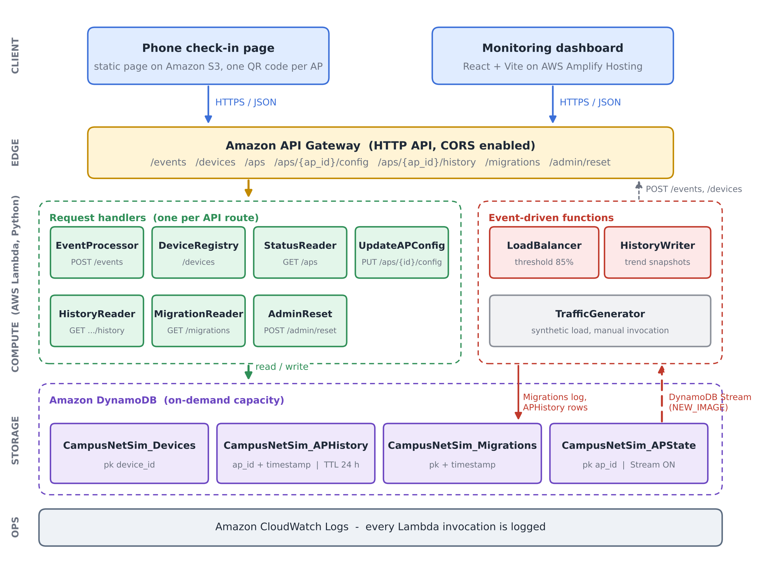
Fig. 1. CampusNetSim system architecture. Each of the seven API routes has its own request handler. LoadBalancer and HistoryWriter run off the APState stream, and four on-demand DynamoDB tables hold all state.

V. Workflow
Fig. 2 follows one phone from QR scan to dashboard refresh. Step 1 is the scan itself: the QR code opens the check-in page with the AP identifier already in the link. Tapping Join posts a CONNECT event to /events and then a JOIN to /devices (step 2). EventProcessor validates the event and updates APState (step 3), which emits one stream record (step 4). The record reaches LoadBalancer and HistoryWriter independently (steps 5 and 6). LoadBalancer acts only when the AP has reached 85%, moving devices and logging the migration (step 7), while HistoryWriter always stores a snapshot for the trend chart. Both front ends poll the read endpoints every five seconds (step 8). When a phone has been migrated, it spots its new AP in the roster and displays a banner explaining why it was moved.
Fig. 3 traces a capacity change from the dashboard editor to APState. The operator picks an AP and types a new maximum. Before sending PUT /aps/{ap_id}/config, the dashboard checks the value locally. On the server, UpdateAPConfig repeats the validation and updates APState in place. Like any other APState write, the capacity update produces a stream record, which HistoryWriter picks up. As a result, the trend chart records the recalculated utilization immediately.

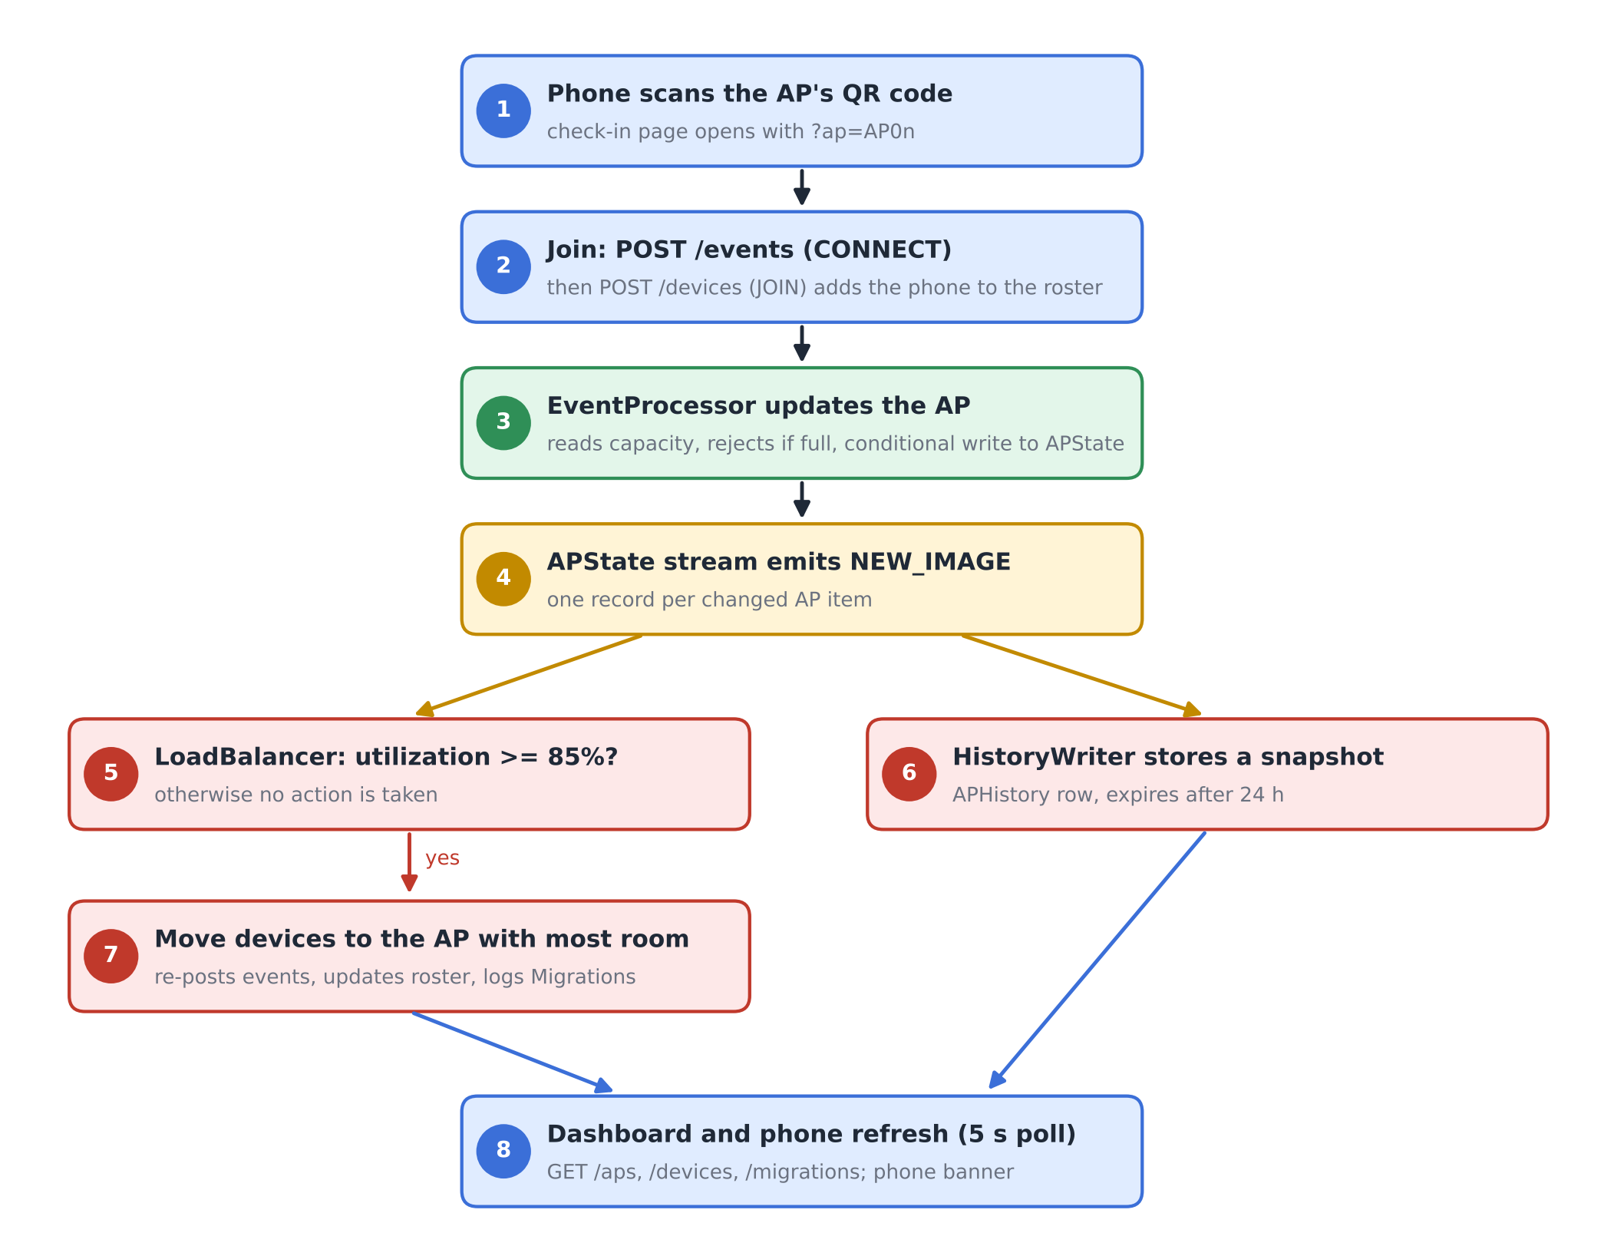
Fig. 2. End-to-end workflow from phone check-in to automated rebalancing and dashboard refresh.
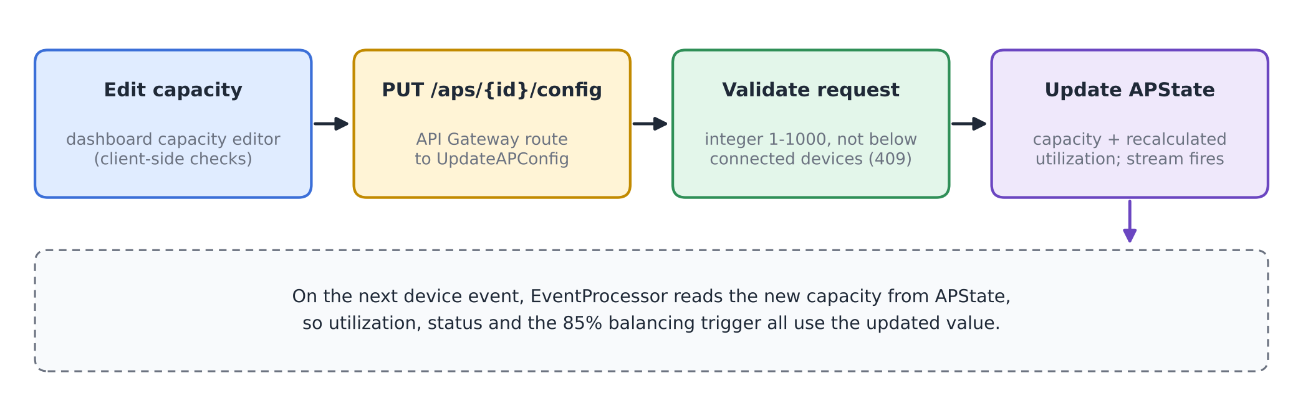
Fig. 3. Run-time capacity reconfiguration flow.

VI. Algorithm / Formulas
A. Utilization and Status
For an AP i with n_{i} connected devices and capacity C_{i}, utilization is
U_{i} = (n_{i} / C_{i}) × 100 (1)
rounded to two decimals. The status shown on the dashboard and the check-in page is
S_{i} = NORMAL (U_{i} < 70), BUSY (70 ≤ U_{i} < 90) (2)
with HIGH_LOAD for 90 ≤ U_{i} < 100 and CONGESTED for U_{i} ≥ 100. EventProcessor rejects any CONNECT once n_{i} = C_{i}. Utilization therefore never exceeds 100%, and CONGESTED means exactly full.
B. Balancing Trigger, Target and Move Size
LoadBalancer reacts to a stream record for AP i only when
U_{i} ≥ θ, θ = 85 (3)
and the condition still holds in a fresh read of GET /aps. The target is the AP with the most free slots,
j* = argmax_{j ≠ i} (C_{j} − n_{j}) (4)
and the source should drop to about five points below the trigger, giving a target count
n_{i}^{tgt} = ⌊C_{i} (θ − 5) / 100⌋ (5)
The number of devices moved is limited by the need, the free space at j* and a per-migration cap K = 5:
k = min( max(1, n_{i} − n_{i}^{tgt}), C_{j*} − n_{j*}, K ) (6)
C. Capacity Update and Consistency Rules
A capacity change for AP i to a new value C_{i}' is accepted only if
n_{i} ≤ C_{i}' ≤ 1000, C_{i}' ∈ ℤ (7)
and the stored utilization is recomputed with (1). An event write computed from a read of (n_{i}, C_{i}) is committed only if the stored item still matches that read:
commit ⇔ n_{i}^{stored} = n_{i}^{read} ∧ C_{i}^{stored} = C_{i}^{read} (8)
As a worked example, consider an AP with C_{i} = 2 and n_{i} = 2 (U_{i} = 100%). Equation (5) gives n_{i}^{tgt} = ⌊2 × 80 / 100⌋ = 1, so (6) moves k = 1 device, provided the target has at least one free slot. One device remains on the source AP out of two slots, so its utilization falls to 50%. Run A in Section VIII followed exactly this pattern, with AP02 falling from 100% to 50%.
D. Algorithm
Algorithm 1 gives the per-record procedure of LoadBalancer. Fig. 4 draws the same logic as a flowchart.
Algorithm 1: Reactive AP load balancing (per stream record)
1: input: stream record r for AP i
2: if r is not INSERT/MODIFY or device id starts with "migrated-" then return
3: if U_{i} < θ in r then return
4: read all APs via GET /aps; if U_{i} < θ then return
5: j* ← argmax_{j≠i} (C_{j} − n_{j}) (4); if C_{j*} − n_{j*} ≤ 0 then return
6: k ← min(max(1, n_{i} − n_{i}^{tgt}), C_{j*} − n_{j*}, 5) (5)-(6)
7: D ← connected real phones on AP i (roster)
8: for m = 1 to k do
9: d ← D[m] if available, else synthetic id "migrated-i-xxxx"
10: POST /events (d, i, DISCONNECT); POST /events (d, j*, CONNECT)
11: if d is a real phone then POST /devices (d, JOIN, j*)
12: if at least one move succeeded then write Migrations record {i, j*, moved, U before/after}

The check in line 2 stops the balancer from reacting to its own moves. A migration produces events that change APState again, but LoadBalancer ignores records written for synthetic migrated devices, and a target AP that has just received devices normally sits below the trigger. Every move is simply a pair of POST /events calls. EventProcessor's capacity check and conditional write therefore protect the balancer's own writes as well.
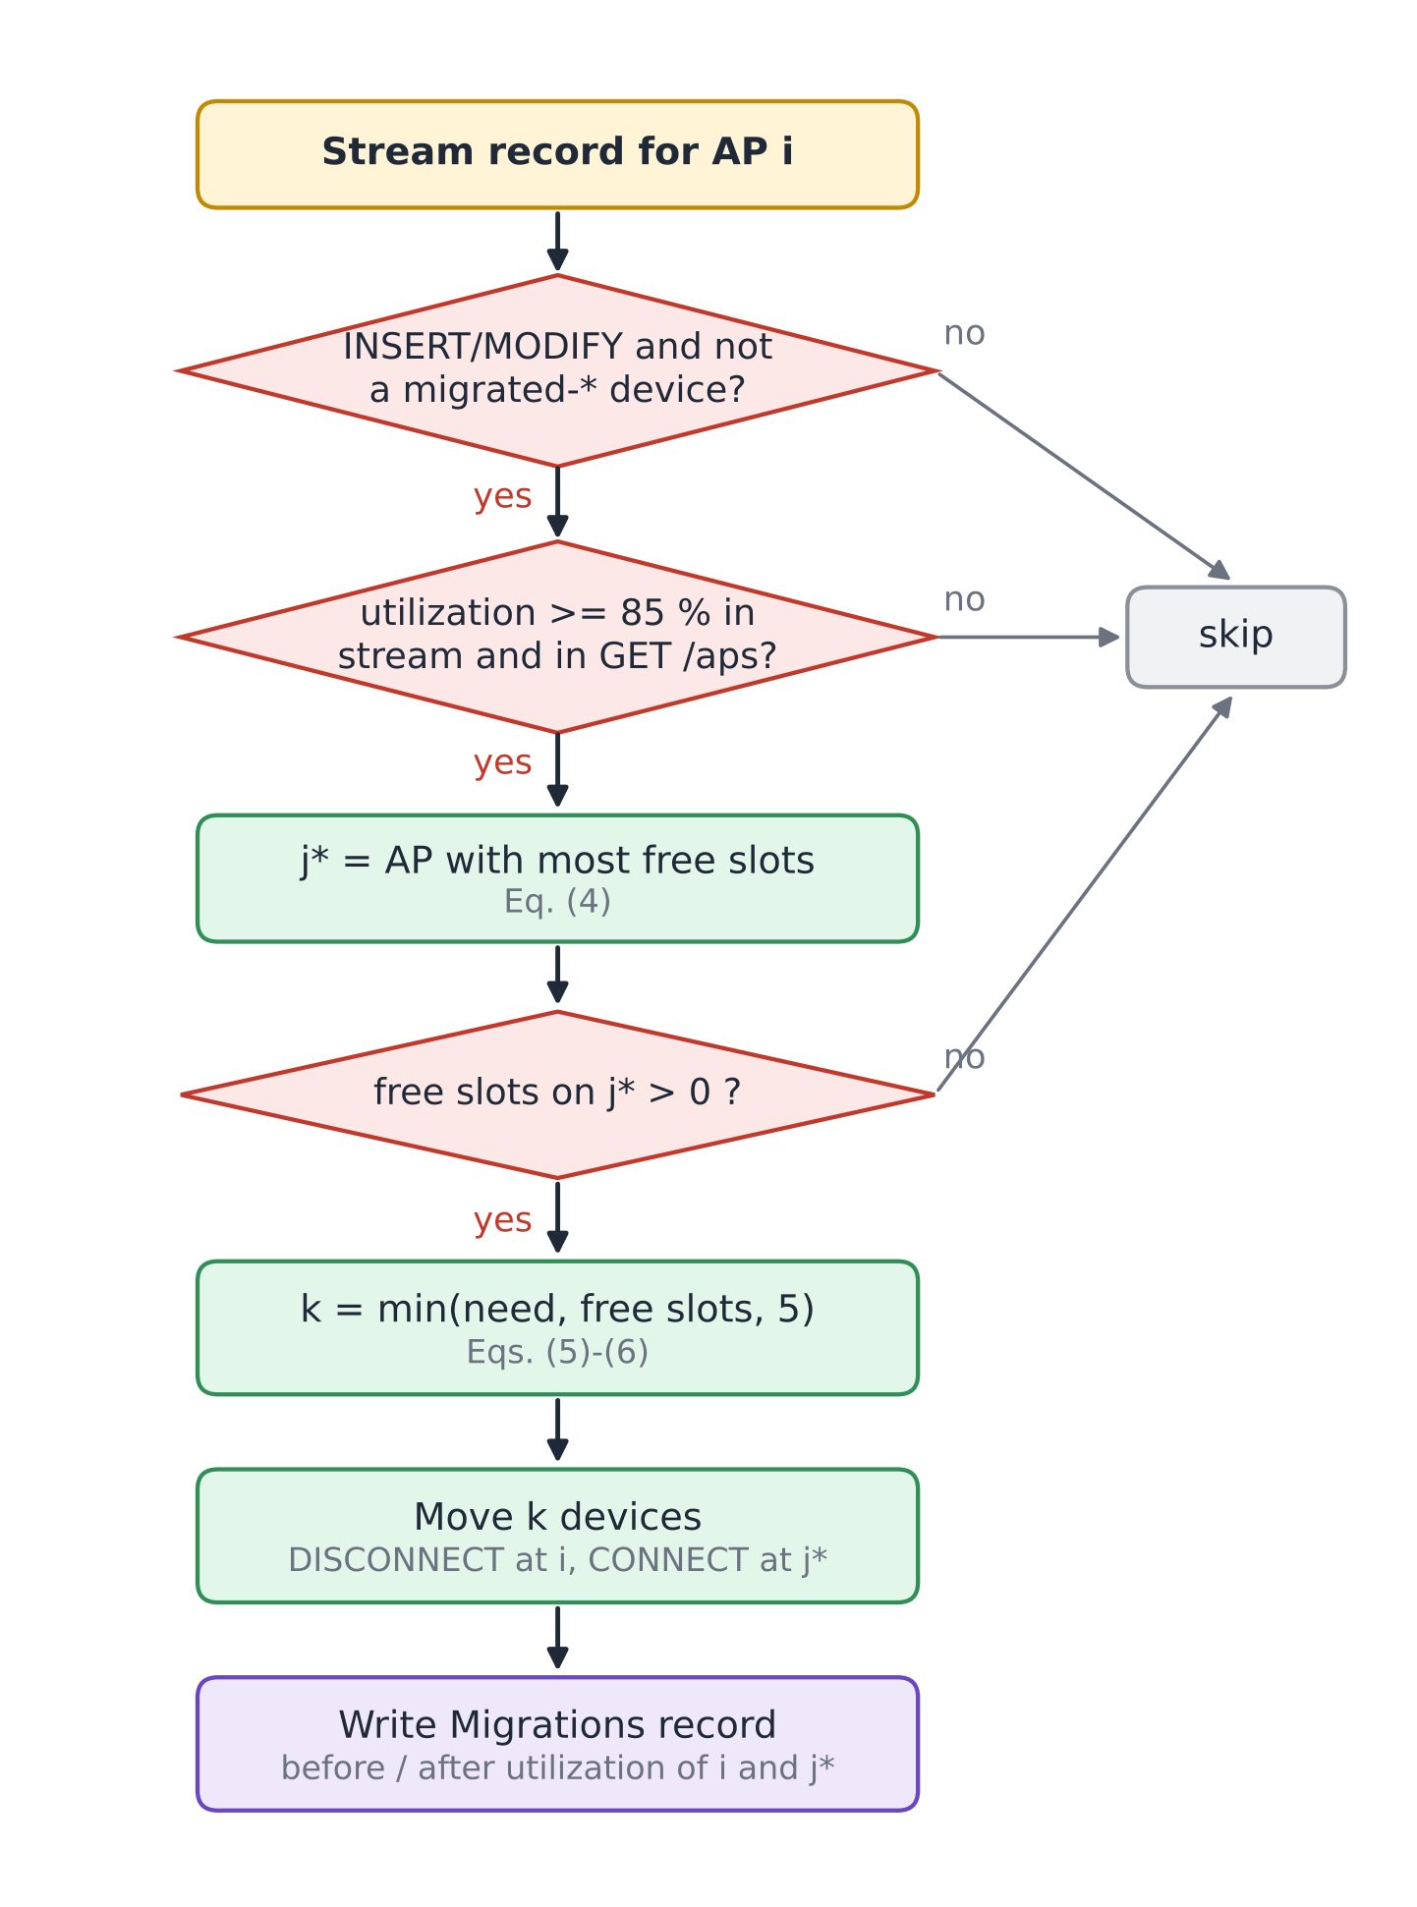
Fig. 4. Decision flowchart of the LoadBalancer function (Algorithm 1).
VII. Tables and Figures
Four tables document the deployed configuration. Table II lists the Lambda functions with their triggers and settings, Table III the DynamoDB tables, Table IV the API routes and Table V the parameters used in Section VI. Figures 1-4 above describe the architecture, workflows and algorithm; Figs. 5-10 in Section VIII document the running system and the measured results.

TABLE II
AWS Lambda Functions (ap-south-1, x86_64, 128 MB)
Function | Trigger | Runtime / timeout | Responsibility
CampusNetSim-EventProcessor | HTTP API: /events | Python 3.13 / 3 s | Validate CONNECT/DISCONNECT, conditional APState update, advisory recommendation
CampusNetSim-DeviceRegistry | HTTP API: /devices | Python 3.13 / 3 s | Phone roster: JOIN, LEAVE, list
CampusNetSim-StatusReader | HTTP API: /aps | Python 3.13 / 3 s | Live state of all APs
UpdateAPConfig | HTTP API: /aps/{ap_id}/config | Python 3.14 / 3 s | Validated capacity, building and name update
CampusNetSim-HistoryReader | HTTP API: /aps/{ap_id}/history | Python 3.13 / 3 s | Up to 200 history points for one AP
CampusNetSim-MigrationReader | HTTP API: /migrations | Python 3.13 / 3 s | 50 most recent migrations
CampusNetSim-AdminReset | HTTP API: /admin/reset | Python 3.13 / 40 s | Reset APs, clear logs, disconnect phones
CampusNetSim-LoadBalancer | DynamoDB Stream (APState) | Python 3.13 / 30 s | Detect >= 85% and move devices
CampusNetSim-HistoryWriter | DynamoDB Stream (APState) | Python 3.13 / 3 s | Append snapshot to APHistory
CampusNetSim-TrafficGenerator | None (manual) | Python 3.13 / 30 s | Synthetic CONNECT/DISCONNECT traffic

TABLE III
Amazon DynamoDB Tables (On-Demand Capacity)
Table | Key schema | Purpose / features
APState | ap_id | Live AP config and counts; stream (NEW_IMAGE)
APHistory | ap_id + timestamp | Utilization snapshots; TTL 24 h
Devices | device_id | Phone roster and current AP
Migrations | pk + timestamp | Audit log of automated moves

TABLE IV
API Gateway Routes
Route | Method | Function
/events | POST | EventProcessor
/devices | GET, POST | DeviceRegistry
/aps | GET | StatusReader
/aps/{ap_id}/config | PUT | UpdateAPConfig
/aps/{ap_id}/history | GET | HistoryReader
/migrations | GET | MigrationReader
/admin/reset | POST (else 405) | AdminReset

TABLE V
Model Parameters
Symbol | Value | Meaning
BUSY / HIGH_LOAD / CONGESTED | 70 / 90 / 100 % | Status thresholds, Eq. (2)
θ | 85 % | Balancing trigger, Eq. (3)
θ − 5 | 80 % | Source target after a move, Eq. (5)
K | 5 | Max devices per migration, Eq. (6)
C_{i} range | 1-1000 | Allowed capacity, Eq. (7)
History TTL | 24 h | APHistory retention
Poll interval | 5 s | Dashboard and check-in refresh

VIII. Implementation, Results, and Discussion
A. Backend Deployment
The backend runs in the AWS Mumbai region (ap-south-1). The four tables were created with on-demand capacity, so no throughput had to be provisioned. The APState stream uses the NEW_IMAGE view type and has two enabled consumers, LoadBalancer and HistoryWriter, each with a batch size of 100 starting from the latest record [13], [14]. APHistory has TTL enabled on its expires_at attribute, so old readings disappear without a clean-up job [15]. All functions are written in Python and use the boto3 SDK; read functions convert DynamoDB Decimal values back to JSON numbers. The complete source of every deployed function, the check-in page, the dashboard and an AWS SAM template that recreates the stack are published in the project repository [19].
B. Front Ends and Hosting
The phone check-in page is a single HTML file on Amazon S3. On first use it generates a device identifier with the browser's random UUID generator and keeps it in local storage, so later check-ins from the same phone map to the same roster entry. Once a phone has joined, its page polls GET /devices and GET /aps every five seconds. A new AP in the phone's roster entry signals a migration, and a DISCONNECTED entry signals a reset; either way, the page shows a banner explaining what happened.
The dashboard is built with React, Vite, Tailwind CSS and Recharts. It shows the AP cards, a utilization bar chart with the 70% and 90% reference lines, the automated load-balancing log, the connected-device roster and the traffic trend of the selected AP. The final build adds the capacity editor and an AP details panel that lists the devices on the selected AP (Fig. 5). The production build is deployed to AWS Amplify Hosting by manual upload [18]. Two deployment issues had to be fixed: a ZIP archive created on Windows stored backslash paths, which made the hosted page request its JavaScript and CSS files at wrong URLs, and the Vite configuration initially lacked the Tailwind CSS plugin, which left the page unstyled. A small script now rebuilds the archive with forward-slash paths.

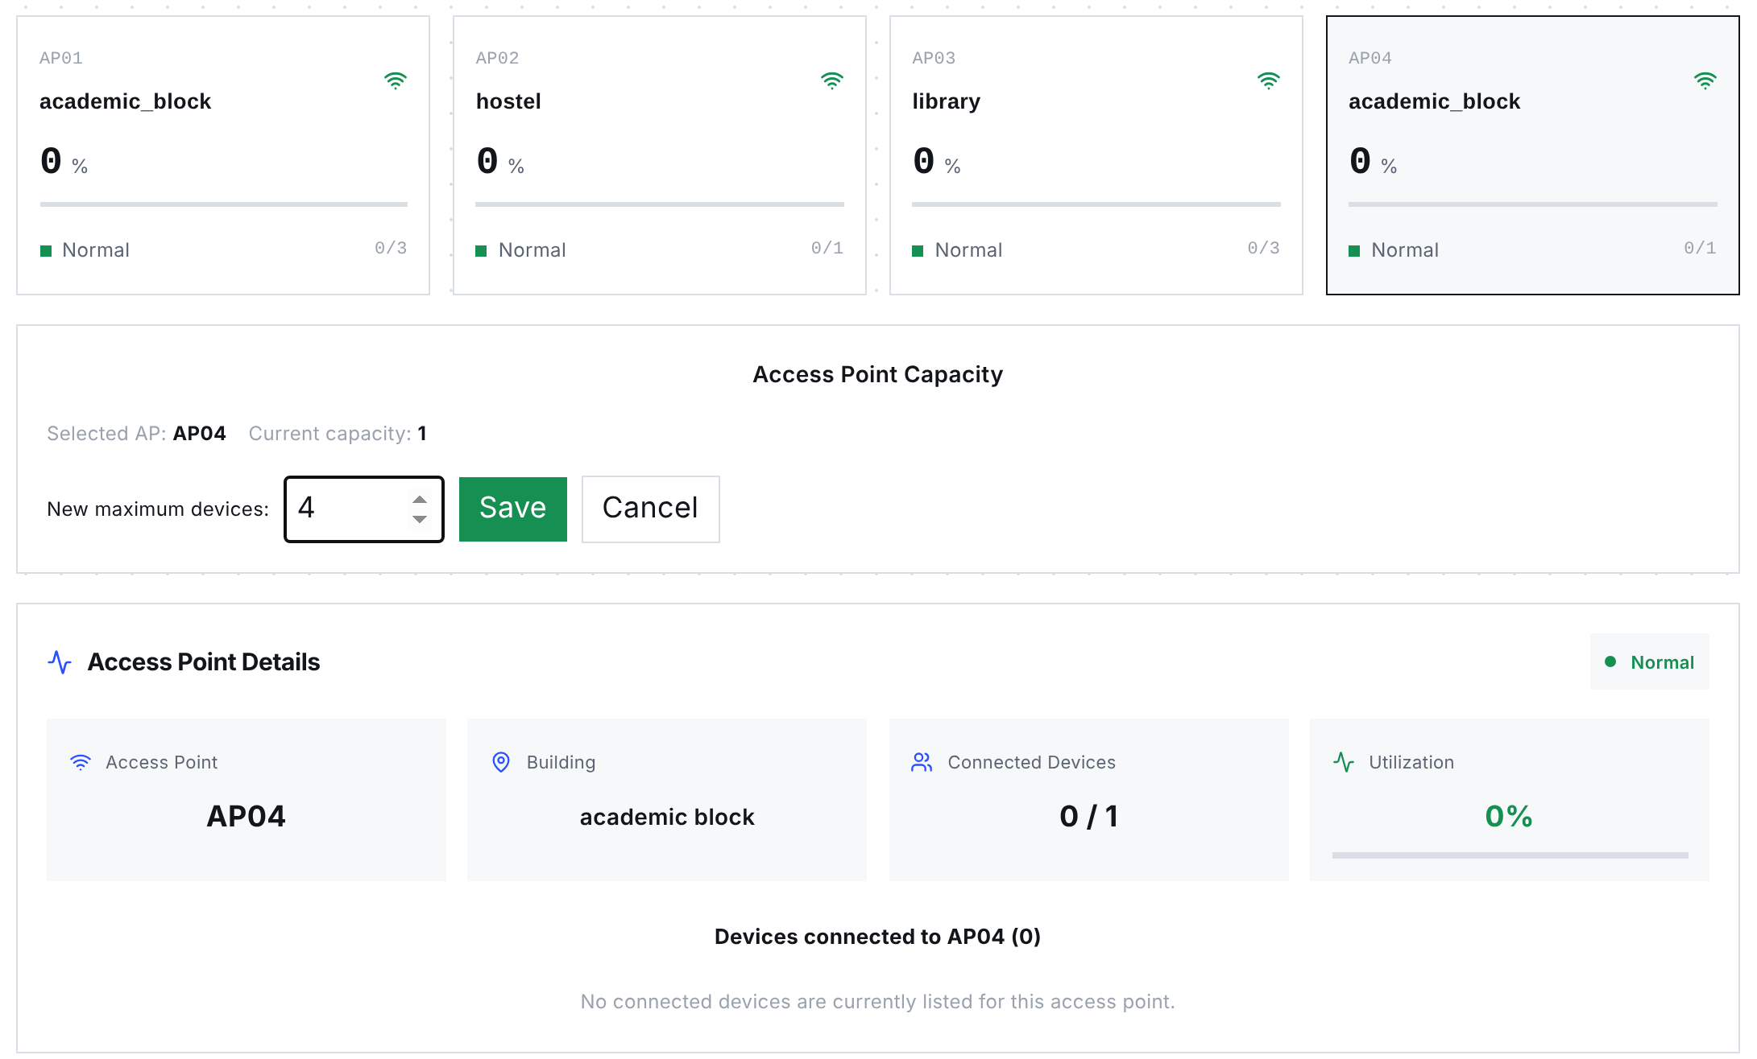
Fig. 5. Final-build dashboard with the capacity editor open for AP04. The AP cards show capacities of 3, 1, 3 and 1, and the details panel lists the devices on the selected AP. Rendered from the production build using API state captured on 23 October 2026.

C. Capacity Reconfiguration and Consistency Enhancements
Six changes went into the final build; Table VI lists each with its effect. Together they move AP capacities out of EventProcessor's code and into APState, block lost updates with an HTTP 409 on conflict, and give the operator direct control over the campus layout.

TABLE VI
Enhancements in the Final Build
Component | Change | Effect
UpdateAPConfig (new Lambda) and PUT /aps/{ap_id}/config | Validated partial update of capacity, building and AP name; utilization recalculated with the capacity | Operators change capacity at run time without touching DynamoDB
EventProcessor | Reads capacity, building and name from APState on every event (strongly consistent read) | DynamoDB is the single source of truth for the layout
EventProcessor | Rejects CONNECT at capacity (409); conditional update on count and capacity (409 on conflict) | No lost updates and no utilization above 100%
EventProcessor | Updates only live-state attributes instead of replacing the item | Configuration fields survive device events
Dashboard | Capacity editor with local checks (positive integer, not below connected devices) and AP details panel | Capacity changes and per-AP devices visible in one place
Dashboard deployment | Forward-slash ZIP packaging script; Tailwind plugin in the Vite configuration | Reliable Amplify deployments

D. Functional Verification
We called all seven routes of the deployed API on 23 October 2026. Ten of the 14 tests hit validation paths that change no data. The other four call read endpoints. Table VII lists the requests and responses; all 14 returned the expected status code and error message. The reset endpoint was checked only with a GET, which is correctly refused, because a POST permanently deletes the logs.

TABLE VII
Functional API Tests Against the Deployed System
# | Request | Expected | Observed response
1 | GET /aps | 200, four APs | 200, AP01-AP04 with capacities 3, 1, 3, 1
2 | GET /devices | 200, roster | 200, roster list
3 | GET /migrations | 200, log | 200, one migration (AP04 to AP03)
4 | GET /aps/AP03/history | 200 | 200, empty list (readings older than 24 h expired)
5 | GET /admin/reset | 405 | 405 "Use POST to trigger a reset"
6 | PUT /aps/AP01/config {capacity: 0} | 400 | 400 "Capacity must be an integer from 1 to 1000"
7 | PUT /aps/AP01/config {capacity: "four"} | 400 | 400, same message
8 | PUT /aps/AP01/config {capacity: 5000} | 400 | 400, same message
9 | PUT /aps/AP01/config {color: "red"} | 400 | 400 "Unsupported configuration field"
10 | PUT /aps/AP99/config {capacity: 4} | 404 | 404 "AP not found"
11 | POST /events, event_type PING | 400 | 400 "event_type must be CONNECT or DISCONNECT"
12 | POST /events, no device_id | 400 | 400 "device_id, ap_id and event_type are required"
13 | POST /events, ap_id AP99 | 400 | 400 "Unknown ap_id: AP99"
14 | POST /devices JOIN without ap_id | 400 | 400 "ap_id required for JOIN"

Response times of the three most frequently polled routes were measured from a browser client in India with 20 sequential requests per route after the functions were warm (Table VIII). Median latencies of 60-69 ms are far below the five-second polling interval. The first requests after a period of inactivity took up to about 1.3 s, which reflects Lambda cold starts [8].
TABLE VIII
Warm Request Latency (20 Requests per Route)
Route | Min (ms) | Median (ms) | P90 (ms) | Max (ms)
GET /aps | 57 | 68 | 79 | 84
GET /devices | 56 | 69 | 78 | 81
GET /migrations | 58 | 60 | 80 | 282

E. Live Load-Balancing Runs
The pipeline was tested end to end with real phones instead of staged data. In Run A (September 2026), AP02 in the hostel had a capacity of 2 and AP04 in the academic block a capacity of 3. Two team members joined AP02 from their phones within a few minutes, driving it to 2 of 2 devices and 100% utilization (Fig. 8a). The resulting APState write reached LoadBalancer through the stream; it chose AP04, which had the most free slots, and moved one phone there. AP02 dropped to 50% and AP04 rose to 33.33%. The moved phone displayed the redirect banner with its new AP (Fig. 8b), and the dashboard logged the migration and showed both phones in the roster (Figs. 6 and 7).
Run B took place on 20 October 2026 during the final demonstration, after the capacities had been changed through the new capacity editor to 3, 1, 3 and 1 for AP01-AP04. Several participants checked in from their own phones. When a phone joined AP04 (capacity 1), the AP reached 100%, and LoadBalancer moved the phone to AP03 in the library, leaving AP04 at 0% and AP03 at 33.33% (Fig. 9). This run also confirms that a capacity set at run time is used by EventProcessor and by the balancing trigger without redeploying anything. Table IX lists both migrations and Fig. 10 compares utilization before and after each move.

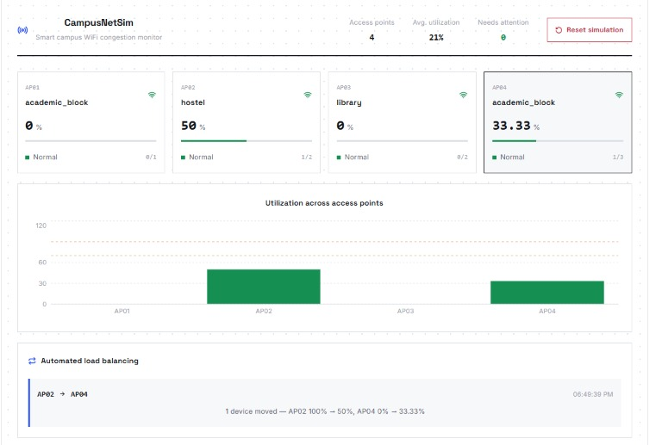
Fig. 6. Dashboard during Run A: AP02 at 50% (1 of 2) and AP04 at 33.33% (1 of 3) after the automated move, with the migration in the load-balancing panel.
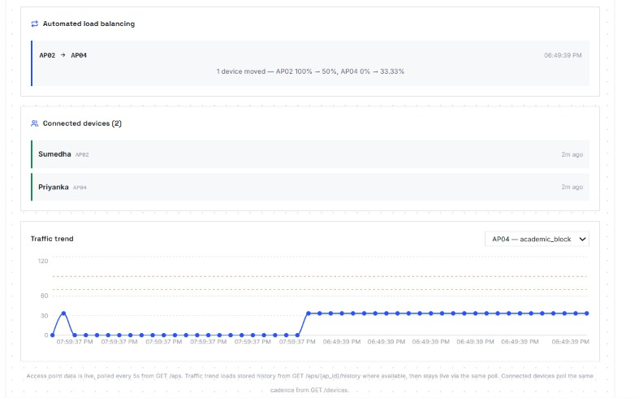
Fig. 7. Dashboard during Run A: migration log, connected-device roster with both phones and the AP04 traffic trend rising after the move.
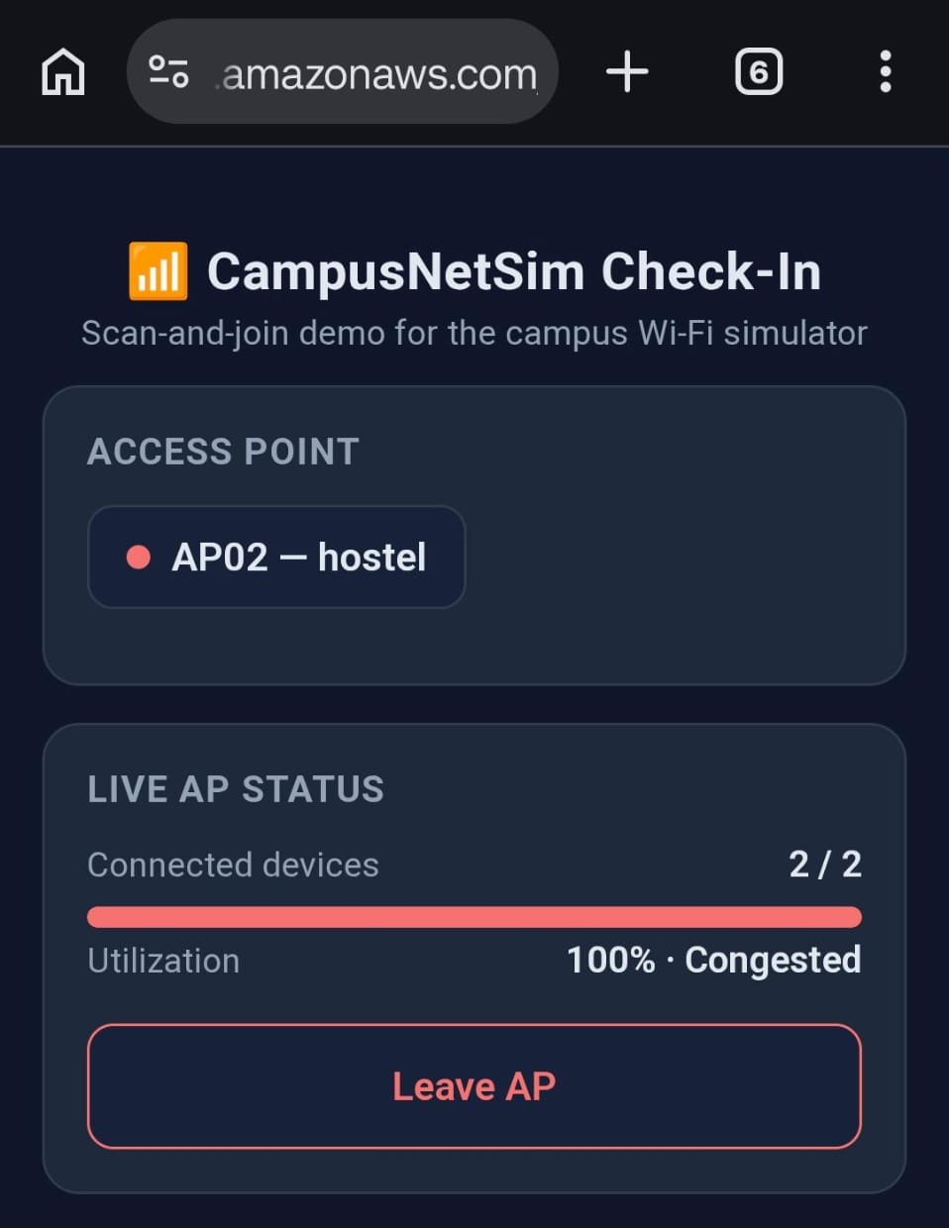  (a) AP02 full before the move | 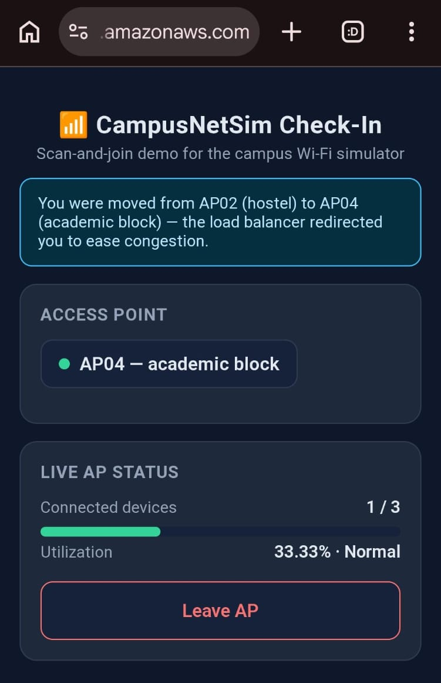  (b) after the move to AP04
Fig. 8. Phone check-in page in Run A: (a) AP02 at 2 of 2 devices and 100% (Congested); (b) moments later, the redirect banner and AP04 at 1 of 3 devices (33.33%, Normal).
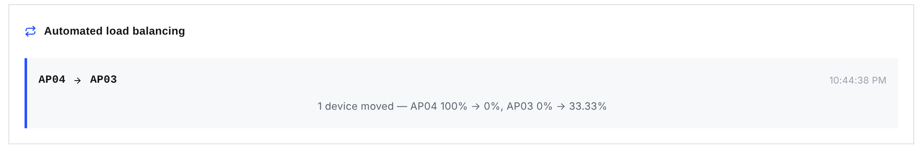
Fig. 9. Migration recorded in Run B: one device moved from AP04 (100% to 0%) to AP03 (0% to 33.33%).
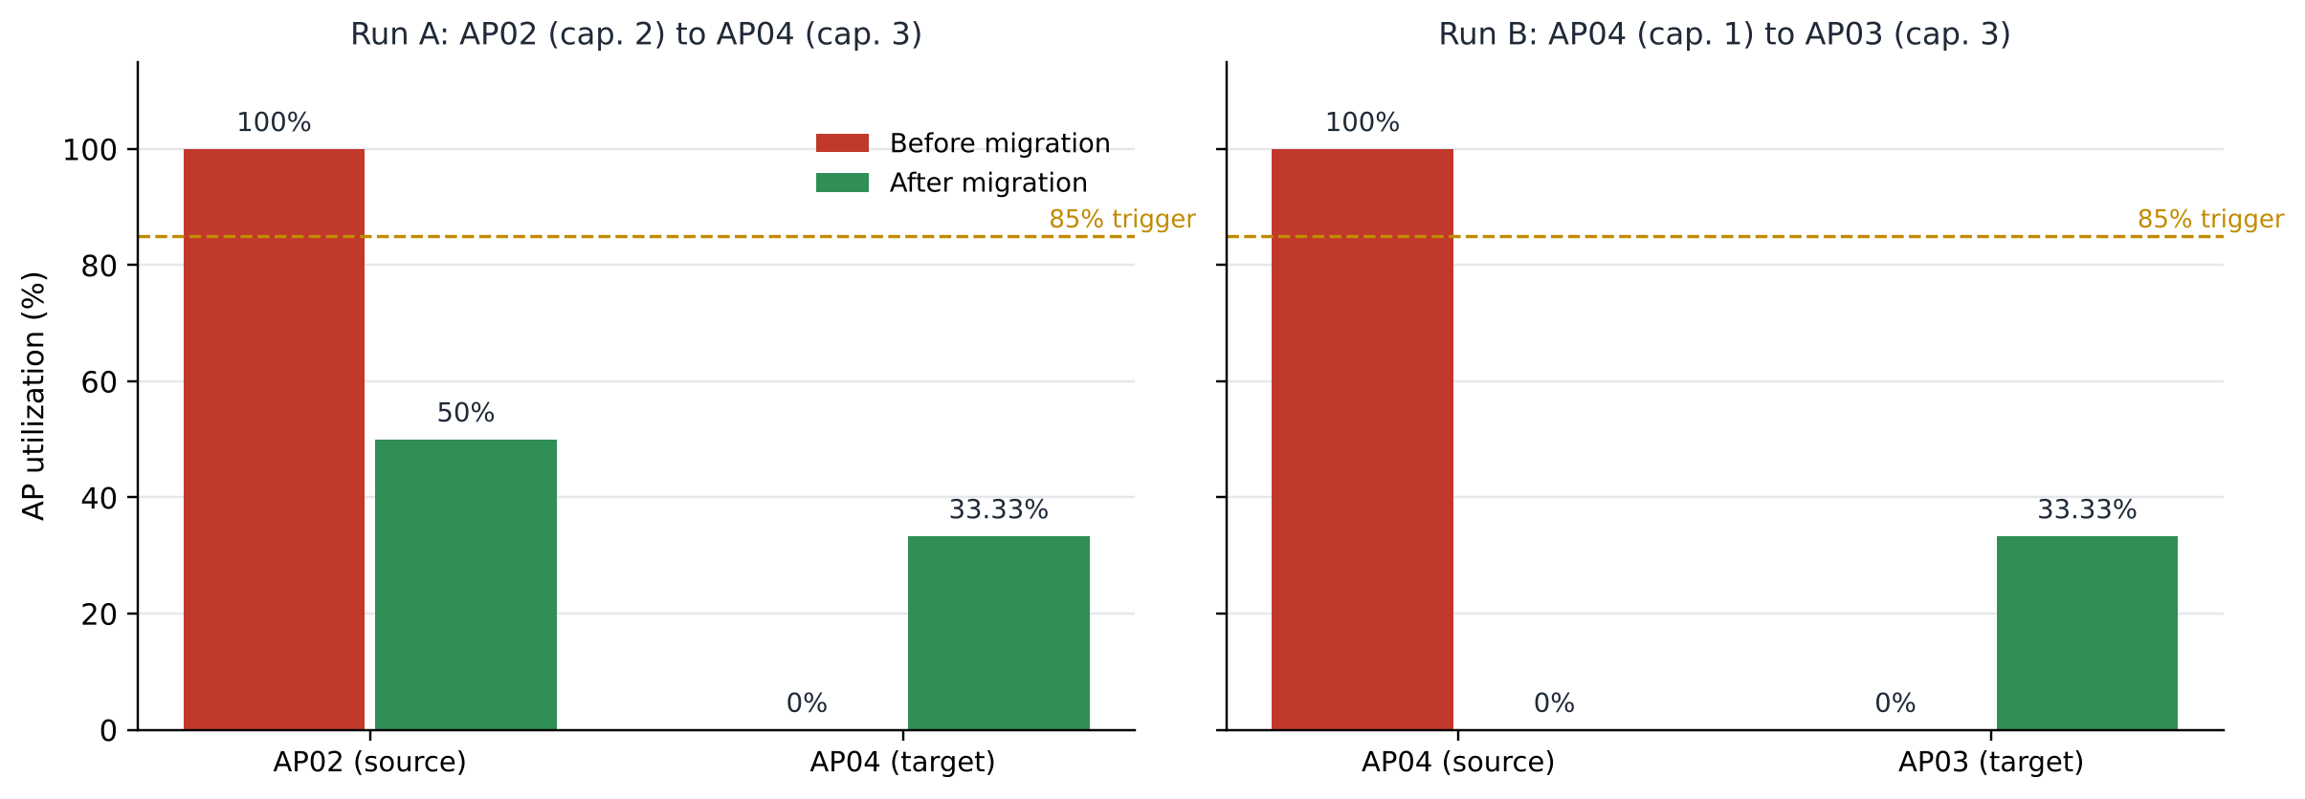
Fig. 10. Utilization of the source and target APs before and after each live migration. In both runs the source fell under the 85% trigger; neither target rose above 33.33%.

TABLE IX
Recorded Migrations
Run | Source (C) | Target (C) | k | Source U | Target U
A | AP02 (2) | AP04 (3) | 1 | 100 → 50 % | 0 → 33.33 %
B | AP04 (1) | AP03 (3) | 1 | 100 → 0 % | 0 → 33.33 %

F. Discussion
Both runs did what the design predicts. The APState stream passed the state change to LoadBalancer, which chose the AP with the most free capacity; the source then settled below the 85% trigger, and the target stayed under it. Because LoadBalancer sends its moves through POST /events, the capacity limit and conditional write that govern phone events apply to them too. Every move is also on file in the Migrations table, with utilization before and after.
Several limitations remain. Our demonstrations used capacities of only 1 to 3. With so few slots, one device moves utilization in large steps (for an AP of capacity 1, from 0% straight to 100%), and the system mostly exercises the full-AP case. EventProcessor and LoadBalancer can also name different targets. The advisory recommendation favours an AP in the same building, while the balancer picks the AP with the most free slots anywhere on campus; only the balancer's choice is carried out. To reach other functions, LoadBalancer goes through the public API over HTTPS. Each call therefore pays an API Gateway round trip and relies on a hard-coded base URL. On every event, EventProcessor also scans the whole APState table. With four APs that scan costs almost nothing, but its cost grows linearly as more APs are added. We have not added authentication to any route. Anyone with the API Gateway endpoint URL can therefore call PUT /aps/{ap_id}/config or POST /admin/reset. The check-in page also still relies on a static list of valid AP identifiers. Every result here comes from four simulated APs and a handful of phones. We have yet to measure behaviour under many simultaneous check-ins.
IX. Conclusion
CampusNetSim shows that ten Lambda functions and four DynamoDB tables, all managed serverless services, are enough to detect AP congestion and rebalance devices automatically. A single stream on the APState table feeds both LoadBalancer and HistoryWriter. Nothing polls; Lambda functions run only when an AP's state actually changes, and the system sits idle the rest of the time. Phones join by QR code, with no app to install. The dashboard picks up each change within one five-second polling interval. Operators can now change capacities at run time, with validation on the server, while conditional writes keep event processing concurrency-safe and DynamoDB remains the single source of truth for the campus layout. We confirmed this behaviour in two live runs, Run A in September and Run B on 20 October 2026, both started by real phone check-ins. In both, the balancer moved a device off a full AP onto the AP with the most free capacity. All 14 functional tests passed, and warm reads met the latency we expected, with medians of 60-69 ms.
X. Future Work
Our next steps fall into seven items, starting with security. (1) Protect the configuration and reset routes first, using JWT authorizers on the HTTP API, and then extend authentication and authorization to the remaining routes. (2) Schedule TrafficGenerator with Amazon EventBridge and repeat experiments under normal, peak-hour and congestion loads. For each experiment we would compare utilization before and after balancing and count the migrations. (3) Have LoadBalancer prefer same-building targets too, so its choice matches EventProcessor's recommendation. (4) Swap the per-event scan of APState for direct GetItem lookups on ap_id. The balancer's HTTP calls could then move to direct function invocations or shared code. (5) Use the 24-hour APHistory record to predict when an AP will hit the 85% trigger, and move devices before it does. (6) Detect a failed AP and reassign its devices. (7) Load-test with many simultaneous check-ins, then add CloudWatch alarms and an AWS budget alert so failures and costs are visible.
References
[1] Y. Bejerano, S.-J. Han, and L. Li, "Fairness and load balancing in wireless LANs using association control," IEEE/ACM Trans. Netw., vol. 15, no. 3, pp. 560-573, Jun. 2007.
[2] Y. Bejerano and S.-J. Han, "Cell breathing techniques for load balancing in wireless LANs," IEEE Trans. Mobile Comput., vol. 8, no. 6, pp. 735-749, Jun. 2009.
[3] A. Balachandran, P. Bahl, and G. M. Voelker, "Hot-spot congestion relief in public-area wireless networks," in Proc. 4th IEEE Workshop Mobile Comput. Syst. Appl. (WMCSA), Callicoon, NY, USA, 2002, pp. 70-80.
[4] IEEE Standard for Information Technology - Telecommunications and Information Exchange Between Systems - Local and Metropolitan Area Networks - Specific Requirements - Part 11: Wireless LAN Medium Access Control (MAC) and Physical Layer (PHY) Specifications, IEEE Std 802.11-2020, 2021.
[5] IEEE Standard for Information Technology - Part 11, Amendment 8: IEEE 802.11 Wireless Network Management, IEEE Std 802.11v-2011, 2011.
[6] IEEE Standard for Information Technology - Part 11, Amendment 2: Fast Basic Service Set (BSS) Transition, IEEE Std 802.11r-2008, 2008.
[7] E. Jonas et al., "Cloud programming simplified: A Berkeley view on serverless computing," EECS Dept., Univ. California, Berkeley, CA, USA, Tech. Rep. UCB/EECS-2019-3, Feb. 2019.
[8] P. Castro, V. Ishakian, V. Muthusamy, and A. Slominski, "The rise of serverless computing," Commun. ACM, vol. 62, no. 12, pp. 44-54, Dec. 2019.
[9] Z. Li, L. Guo, J. Cheng, Q. Chen, B. He, and M. Guo, "The serverless computing survey: A technical primer for design architecture," ACM Comput. Surv., vol. 54, no. 10s, Art. no. 220, 2022.
[10] G. DeCandia et al., "Dynamo: Amazon's highly available key-value store," in Proc. 21st ACM Symp. Operating Syst. Principles (SOSP), Stevenson, WA, USA, 2007, pp. 205-220.
[11] M. A. Ahmed, S. A. Chavez, A. M. Eltamaly, H. O. Garces, A. J. Rojas, and Y.-C. Kim, "Toward an intelligent campus: IoT platform for remote monitoring and control of smart buildings," Sensors, vol. 22, no. 23, Art. no. 9045, 2022.
[12] Amazon Web Services, "Serverless architectures with AWS Lambda: Overview and best practices," AWS Whitepaper, 2017. [Online]. Available: https://d1.awsstatic.com/whitepapers/serverless-architectures-with-aws-lambda.pdf
[13] Amazon Web Services, "Using AWS Lambda with Amazon DynamoDB," AWS Lambda Developer Guide. [Online]. Available: https://docs.aws.amazon.com/lambda/latest/dg/with-ddb.html (accessed Oct. 23, 2026).
[14] Amazon Web Services, "Change data capture for DynamoDB Streams," Amazon DynamoDB Developer Guide. [Online]. Available: https://docs.aws.amazon.com/amazondynamodb/latest/developerguide/Streams.html (accessed Oct. 23, 2026).
[15] Amazon Web Services, "Using time to live (TTL) in DynamoDB," Amazon DynamoDB Developer Guide. [Online]. Available: https://docs.aws.amazon.com/amazondynamodb/latest/developerguide/TTL.html (accessed Oct. 23, 2026).
[16] Amazon Web Services, "Optimistic locking with version number," Amazon DynamoDB Developer Guide. [Online]. Available: https://docs.aws.amazon.com/amazondynamodb/latest/developerguide/BestPractices_OptimisticLocking.html (accessed Oct. 23, 2026).
[17] Amazon Web Services, "Working with HTTP APIs," Amazon API Gateway Developer Guide. [Online]. Available: https://docs.aws.amazon.com/apigateway/latest/developerguide/http-api.html (accessed Oct. 23, 2026).
[18] Amazon Web Services, "Deploying an application to Amplify without a Git repository," AWS Amplify Hosting User Guide. [Online]. Available: https://docs.aws.amazon.com/amplify/latest/userguide/manual-deploys.html (accessed Oct. 23, 2026).
[19] S. Phadnis and P. J, "CampusNetSim: Cloud-native campus Wi-Fi congestion simulation and load balancing," GitHub repository, 2026. [Online]. Available: https://github.com/pj-06/campusnetsim

