CampusNetSim: A Cloud-Native Wi-Fi Congestion Simulation and Automated Load-Balancing System on AWS Serverless Services
Sumedha Phadnis and Priyanka J
Cloud Architecture Design (AWS) - Course Project Report

Keywords—Serverless computing, AWS Lambda, Amazon API Gateway, Amazon DynamoDB, DynamoDB Streams, event-driven architecture, WLAN load balancing, access point utilization, campus network simulation.
Abstract—Campus Wi-Fi load is lopsided. Phones and laptops pick the access point (AP) with the strongest signal and ignore its load. APs beside lecture halls therefore fill up while those next door stay nearly idle. CampusNetSim, our cloud-native system, simulates which AP each device on a campus is attached to, spots overloaded APs and moves simulated clients onto APs that have free slots. Ten AWS Lambda functions do the work, all reached through a single Amazon API Gateway HTTP API. AP state, history, the phone roster and the migration log each get their own on-demand Amazon DynamoDB table. A DynamoDB Stream on the AP state table triggers both load balancing and history logging. No backend function polls. To join, a user points a phone camera at the QR code for an AP. That opens a static check-in page served from Amazon S3. Whoever monitors the campus watches a React dashboard on AWS Amplify, which plots live utilization, logs migrations, lists connected devices and draws the traffic trend of the selected AP. Capacity is no longer fixed: in the final build an operator resizes an AP mid-run through a PUT endpoint that validates each request. If two events hit the same AP at once, a conditional write makes sure neither count is lost. DynamoDB is therefore the single source of truth for the campus layout, and no function keeps its own copy of AP capacities. We then tested the whole pipeline twice with real phones, once in September and once at the final demonstration on 20 October 2026. In each test, phones checking in pushed one AP to 100% utilization. LoadBalancer moved one device to the AP with the most free capacity. After the move the source was back under the 85% trigger, and the target, which had been empty, sat at 33.33% with one device out of three. Each of the 14 functional API tests, from GET /aps to an invalid JOIN on /devices, came back with the expected status code. Warm read requests took a median of 60-69 ms.
I. Introduction
Class changes make it obvious: a whole lecture hall reconnects at once. Each client radio in the room picks the access point with the strongest signal, and nothing in that choice looks at how many clients that AP already serves. One AP saturates while the library AP, two buildings over, stays half empty. Research on WLAN association control has shown that signal-strength-only association produces markedly worse throughput and fairness than load-aware association [1]-[3].
Getting a client onto a less loaded AP is not as simple as it sounds. The IEEE 802.11 standard [4] lets an AP suggest a transition through BSS Transition Management [5] and speeds up the roam once the client decides to move [6], but the decision always remains with the client's chipset and driver. Consumer routers seldom give third-party software any access to their steering controls. Mobile operating systems also stop applications from switching networks silently. No student project can steer real clients reliably across that many device and OS combinations.
CampusNetSim therefore simulates association itself; because the simulation owns every link between a device and an AP, its load balancer can enforce each move it decides on. Four APs make up the model. AP01 and AP04 cover the academic block, while AP02 serves the hostel and AP03 sits in the library, two buildings away from the lecture halls. Each AP gets its own capacity (AP02 had two slots in Run A, AP04 three). A device moves between APs only when a CONNECT or DISCONNECT event says so. The system holds the association state itself. That lets it find an overloaded AP, decide where its devices should go, make the move and record utilization on both APs before and after. Real phones still have a role. When a user scans an AP-specific QR code, a browser check-in page opens and registers that phone with the AP in application state; the phone's real network connection stays exactly as it was.
Nothing in the stack needs a provisioned server, since every component is a managed AWS serverless service [7]-[9]. Four contributions come out of this work. The first two are (i) an event-driven, polling-free load-balancing pipeline built on DynamoDB Streams and (ii) run-time capacity reconfiguration with server-side validation and concurrency-safe event processing; we also contribute (iii) a phone check-in path that lets real devices trigger the pipeline without any installation and (iv) a live evaluation with real phones, functional API tests and latency measurements.
Nine sections follow. In Section II we review WLAN association control [1]-[3], the 802.11v and 802.11r roaming amendments [5], [6] and serverless computing [7]-[9]. Section III gives the methodology. Sections IV and V then present the architecture and the check-in and capacity workflows, while Section VI formalises the utilization model and Algorithm 1. Tables II-V, in Section VII, record the deployed configuration. Implementation and results are reported in Section VIII, and Sections IX and X give the conclusion and future work.
II. Related Works
Most prior work on wireless LAN load balancing operates at the level of AP association. Bejerano, Han and Li [1] cast association control as a max-min fair bandwidth allocation problem. Against the default strongest-signal policy, their load-aware scheme came out clearly ahead. Bejerano and Han [2] later proposed cell breathing. Each AP adjusts its transmit power to shrink or grow its coverage, and clients drift toward less loaded cells with no client-side change. Balachandran, Bahl and Voelker [3] studied hot-spot congestion in public-area wireless networks and proposed network-directed roaming, in which an overloaded AP explicitly redirects users to neighbouring APs. CampusNetSim follows the same idea of network-side redirection, but performs it on a simulated association model where every move can be enforced and audited.
The 802.11 standard [4] defines how roaming can be influenced in real deployments. In 802.11v [5], BSS Transition Management lets an AP ask a client to move, while 802.11r [6] adds Fast BSS Transition to cut roaming latency. Neither mechanism can force a move, since a client is free to ignore a transition request. For this reason above all, CampusNetSim enforces moves inside its own event model and makes no attempt at real client steering.
Jonas et al. [7] and Castro et al. [8] describe serverless computing from the cloud side. Developers deploy stateless functions and the provider handles provisioning and scaling, with cold starts and platform-specific integration as the price. Li et al. [9] go further and survey serverless architectures, sorting them by the design trade-offs each one makes. Amazon's Dynamo paper [10] describes a key-value store, the forerunner of DynamoDB, built for single-item reads and writes. CampusNetSim's data match that design closely, since each AP state, history snapshot and migration log entry is a single item. Ahmed et al. [11] built a four-layer IoT platform to monitor and control smart campus buildings remotely. CampusNetSim also targets live campus monitoring through a web dashboard, but its data come from simulated association events and phone check-ins, not physical sensors. Table I sets these five mechanisms side by side with CampusNetSim.
TABLE I
Comparison of Related Approaches
Approach | Where control lives | Needs client support | Relation to CampusNetSim
Association control [1] | Network (central) | Yes | Same objective; simulated enforcement
Cell breathing [2] | AP transmit power | No | Alternative real-network mechanism
Network-directed roaming [3] | Overloaded AP | Partly | Closest idea: redirect from hot spot
802.11v / 802.11r [5], [6] | AP request, client decides | Yes | Advisory only; motivates simulation
Smart-campus IoT [11] | Cloud platform | Sensors | Similar cloud monitoring stack

III. Proposed Methodology
A. System Model
A campus, for our purposes, is a set of APs. Each AP has an identifier, a building and a display name. It also stores a capacity C_{i} (the number of devices at which we treat the AP as full) and a live connected-device count n_{i}. Association changes arrive as CONNECT and DISCONNECT events from three sources: phones using the check-in page, the load balancer when it moves devices, and an optional synthetic traffic generator. Each AP's state sits in one DynamoDB item. Changing an AP therefore means updating exactly one item, and DynamoDB Streams can publish each such update as a record [14].
B. Design Principles
Four design principles follow. One function per responsibility: every API route gets its own Lambda function, whose permissions cover only the tables it needs, as the AWS serverless guidance recommends [12]. Event-driven reaction: stream records from APState start load balancing and history logging, so nothing runs while the campus is quiet [13], [14]. Single source of truth: AP capacities, buildings and names live only in the APState table; every function reads them from there at run time. Verifiable actions: every automated move writes a Migrations record with the utilization of both APs before and after the move.
C. Functional Components
Event ingestion. POST /events is EventProcessor's job. EventProcessor validates the event, then performs a strongly consistent read of the AP's configuration and current device count, so a capacity changed a moment earlier is already visible. A CONNECT aimed at a full AP gets HTTP 409 back. Otherwise EventProcessor computes the new utilization and status. A conditional update then writes back the live-state attributes and leaves capacity, building and name untouched. When an AP hits 100% (CONGESTED), EventProcessor adds an advisory recommendation for another AP in its building.
Reactive load balancing. LoadBalancer reads the APState stream and moves devices. When an AP reaches the 85% trigger, it selects the AP with the most free capacity, computes how many devices to move (at most five) and moves them by posting DISCONNECT and CONNECT events through the public API, so every move passes the same validation as any other event. Real phones are moved first, and their roster entries are updated so that the phone's page can show the redirect. HistoryWriter consumes the same stream and stores each AP state in APHistory with a 24-hour expiry using DynamoDB time to live (TTL) [15].
Read services and administration. StatusReader, HistoryReader and MigrationReader serve the dashboard and the check-in page. DeviceRegistry records each phone and its current AP in the Devices table. Before each demonstration we call AdminReset (POST /admin/reset), which has a 40 s timeout, to start from a clean campus. AdminReset zeroes all four APs, empties Migrations and APHistory and disconnects every phone in the roster.
D. Run-Time Capacity Reconfiguration and Consistency
UpdateAPConfig, new in the final build, resizes APs on a live system. A request to PUT /aps/{ap_id}/config with a field like color gets HTTP 400; capacity, building and ap_name are the only accepted fields, and capacity must be an integer from 1 to 1000. Setting capacity below the current device count returns HTTP 409. UpdateAPConfig touches only the supplied attributes and recomputes utilization in the same write. EventProcessor reads capacity from APState on every event, so the next CONNECT or DISCONNECT already uses the new value for the status and for the 85% trigger.
Two concurrent events on the same AP could otherwise read the same count and overwrite each other. EventProcessor therefore uses optimistic concurrency [16]: its update succeeds only if the stored count and capacity still equal the values it read; otherwise DynamoDB rejects the write and the API returns HTTP 409 so that the caller can retry. The same condition protects against a capacity change that lands between the read and the write of an event.
IV. Architecture Diagram
Fig. 1 shows the deployed architecture in five layers. The client layer contains the phone check-in page, a static page on Amazon S3, and the monitoring dashboard, a React and Vite application on AWS Amplify Hosting. Both call a single API Gateway HTTP API [17] with CORS enabled. Seven request handlers, one per API route, make up most of the compute layer. Two event-driven functions are attached to the APState stream, and TrafficGenerator, deployed without a trigger, is invoked manually to create synthetic load. State sits in four on-demand DynamoDB tables. Logs from all ten functions go to Amazon CloudWatch Logs.
Components talk in exactly two ways. API calls reach seven request handlers, such as StatusReader for GET /aps, and each reads or writes DynamoDB tables directly. Stream records carry every APState change to LoadBalancer and HistoryWriter in batches of up to 100. LoadBalancer could write APState directly, but we chose not to let it. Each of its moves becomes a DISCONNECT and a CONNECT sent to POST /events. EventProcessor then applies the same capacity check and HTTP 409 conditional write it uses for phones.

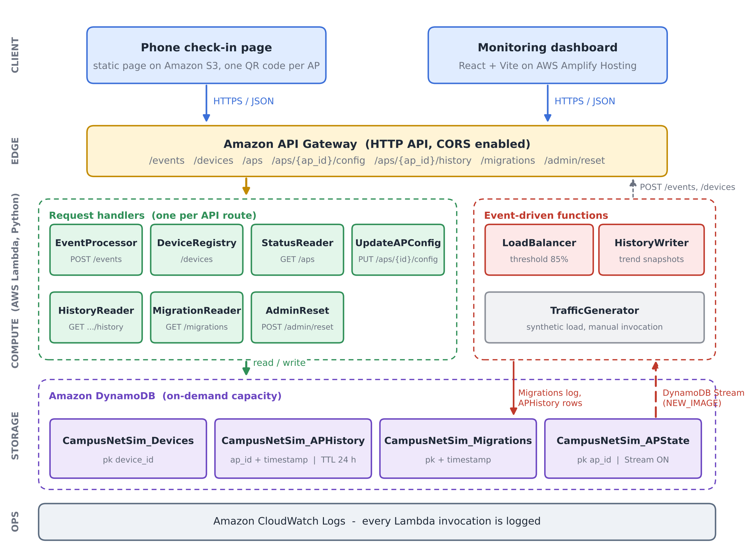
Fig. 1. CampusNetSim system architecture. Seven handlers, one per route, sit behind the HTTP API. Two functions, LoadBalancer and HistoryWriter, run on the APState stream (NEW_IMAGE view), and four on-demand tables, from APState to Migrations, hold all state.

V. Workflow
Fig. 2 traces eight steps from QR scan to dashboard refresh. Scanning the code (step 1) opens the check-in page with, for example, AP02 already in the link. In step 2 the user taps Join, which posts a CONNECT to /events and then a JOIN to /devices, so both the AP count and the phone roster change. Step 3 is validation and the APState update in EventProcessor, and that write emits exactly one stream record (step 4). The record reaches LoadBalancer and HistoryWriter independently (steps 5 and 6). LoadBalancer acts only when the AP has reached 85%, moving devices and logging the migration (step 7), while HistoryWriter always stores a snapshot for the trend chart. In step 8, the dashboard and the check-in page each poll the read endpoints every five seconds. A phone that LoadBalancer has moved finds its new AP in the roster on the next poll and shows a banner saying where it went.
Fig. 3 covers resizing an AP. Say an operator wants AP04 to hold two devices. They select it on the dashboard and type 2. The dashboard first checks that the value is a positive integer no smaller than the number of connected devices, and only then sends PUT /aps/{ap_id}/config. On the server, UpdateAPConfig repeats those checks, adds the 1-1000 range test and only then updates APState in place, so a request that skips the dashboard is still validated. That write, too, lands on the APState stream. As a result, the trend chart records the recalculated utilization immediately.

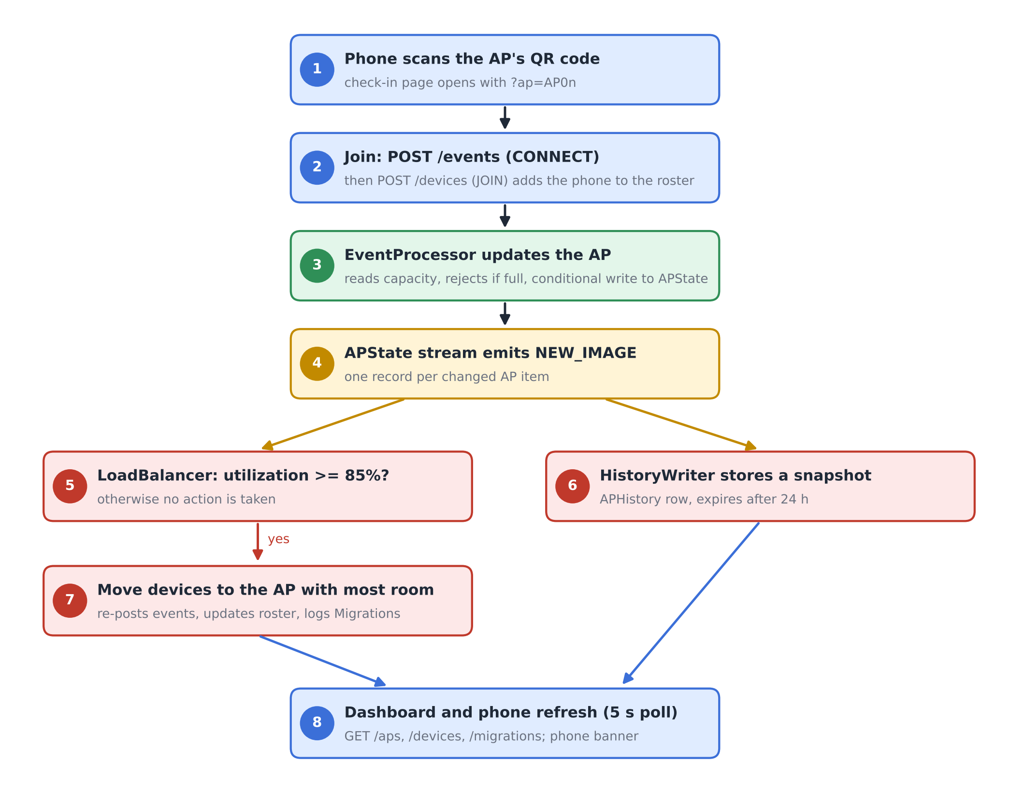
Fig. 2. End-to-end workflow from phone check-in to automated rebalancing and dashboard refresh.
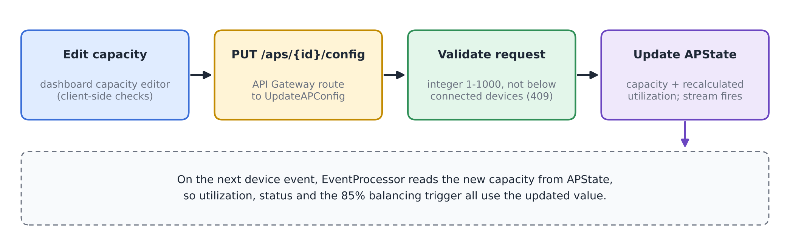
Fig. 3. Run-time capacity reconfiguration flow.

VI. Algorithm / Formulas
A. Utilization and Status
For an AP i with n_{i} connected devices and capacity C_{i}, utilization is
U_{i} = (n_{i} / C_{i}) × 100 (1)
rounded to two decimals. The status shown on the dashboard and the check-in page is
S_{i} = NORMAL (U_{i} < 70), BUSY (70 ≤ U_{i} < 90) (2)
with HIGH_LOAD for 90 ≤ U_{i} < 100 and CONGESTED for U_{i} ≥ 100. EventProcessor rejects any CONNECT once n_{i} = C_{i}. Utilization therefore never exceeds 100%, and CONGESTED means exactly full.
B. Balancing Trigger, Target and Move Size
LoadBalancer reacts to a stream record for AP i only when
U_{i} ≥ θ, θ = 85 (3)
and the condition still holds in a fresh read of GET /aps. The target is the AP with the most free slots,
j* = argmax_{j ≠ i} (C_{j} − n_{j}) (4)
and the source should drop to about five points below the trigger, giving a target count
n_{i}^{tgt} = ⌊C_{i} (θ − 5) / 100⌋ (5)
The number of devices moved is limited by the need, the free space at j* and a per-migration cap K = 5:
k = min( max(1, n_{i} − n_{i}^{tgt}), C_{j*} − n_{j*}, K ) (6)
C. Capacity Update and Consistency Rules
A capacity change for AP i to a new value C_{i}' is accepted only if
n_{i} ≤ C_{i}' ≤ 1000, C_{i}' ∈ ℤ (7)
and the stored utilization is recomputed with (1). An event write computed from a read of (n_{i}, C_{i}) is committed only if the stored item still matches that read:
commit ⇔ n_{i}^{stored} = n_{i}^{read} ∧ C_{i}^{stored} = C_{i}^{read} (8)
As a worked example, consider an AP with C_{i} = 2 and n_{i} = 2 (U_{i} = 100%). Equation (5) gives n_{i}^{tgt} = ⌊2 × 80 / 100⌋ = 1, so (6) moves k = 1 device, provided the target has at least one free slot. The source keeps one device of two, or 50%. Run A in Section VIII matched this calculation exactly: AP02 went from 100% to 50% while AP04, the target, rose from 0% to 33.33%.
D. Algorithm
Algorithm 1 gives the per-record procedure of LoadBalancer. Fig. 4 draws the same logic as a flowchart.
Algorithm 1: Reactive AP load balancing (per stream record)
1: input: stream record r for AP i
2: if r is not INSERT/MODIFY or device id starts with "migrated-" then return
3: if U_{i} < θ in r then return
4: read all APs via GET /aps; if U_{i} < θ then return
5: j* ← argmax_{j≠i} (C_{j} − n_{j}) (4); if C_{j*} − n_{j*} ≤ 0 then return
6: k ← min(max(1, n_{i} − n_{i}^{tgt}), C_{j*} − n_{j*}, 5) (5)-(6)
7: D ← connected real phones on AP i (roster)
8: for m = 1 to k do
9: d ← D[m] if available, else synthetic id "migrated-i-xxxx"
10: POST /events (d, i, DISCONNECT); POST /events (d, j*, CONNECT)
11: if d is a real phone then POST /devices (d, JOIN, j*)
12: if at least one move succeeded then write Migrations record {i, j*, moved, U before/after}

Line 2 keeps LoadBalancer from reacting to its own moves. Without it, LoadBalancer would see its own moves as fresh load and might start a new migration. Its events change APState again, but LoadBalancer ignores records for synthetic devices whose ids start with "migrated-", and a target AP that has just received devices normally sits below the trigger. Each move is a DISCONNECT/CONNECT pair posted to /events. EventProcessor's capacity check and conditional write therefore protect the balancer's own writes as well.
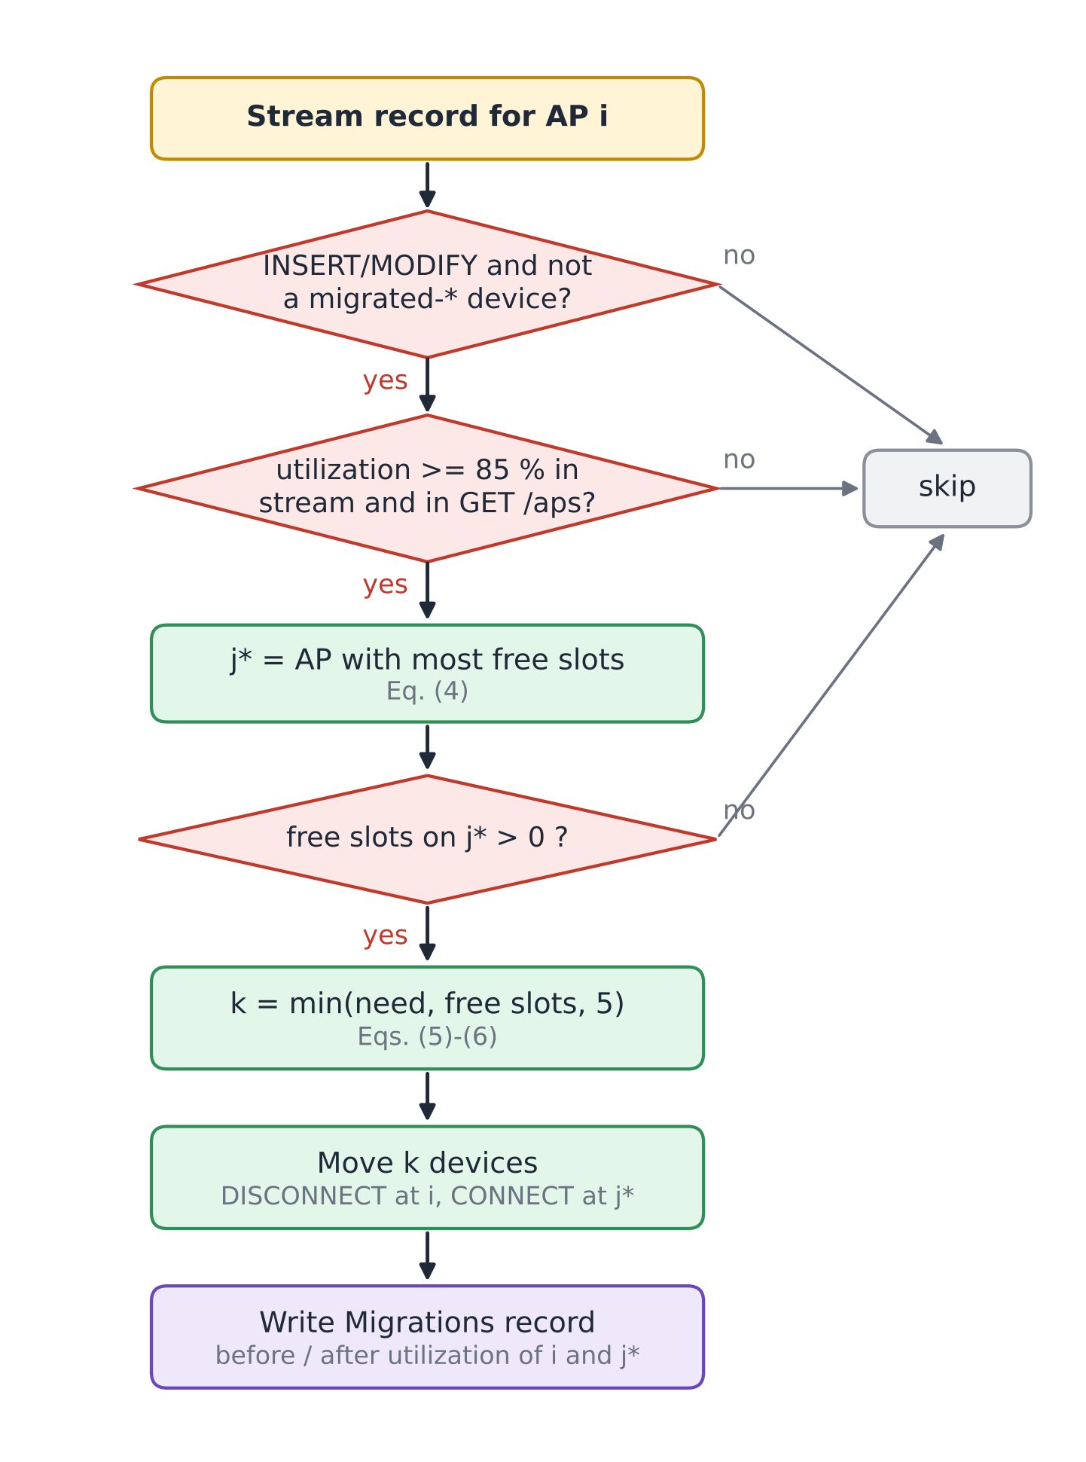
Fig. 4. Decision flowchart of the LoadBalancer function (Algorithm 1).
VII. Tables and Figures
Four tables document the deployed configuration. Table II lists the Lambda functions with their triggers and settings, Table III the DynamoDB tables, Table IV the API routes and Table V the parameters used in Section VI. Figures 1-4 above describe the architecture, workflows and algorithm; Figs. 5-10 in Section VIII document the running system and the measured results.

TABLE II
AWS Lambda Functions (ap-south-1, x86_64, 128 MB)
Function | Trigger | Runtime / timeout | Responsibility
CampusNetSim-EventProcessor | HTTP API: /events | Python 3.13 / 3 s | Validate CONNECT/DISCONNECT, conditional APState update, advisory recommendation
CampusNetSim-DeviceRegistry | HTTP API: /devices | Python 3.13 / 3 s | Phone roster: JOIN, LEAVE, list
CampusNetSim-StatusReader | HTTP API: /aps | Python 3.13 / 3 s | Live state of all APs
UpdateAPConfig | HTTP API: /aps/{ap_id}/config | Python 3.14 / 3 s | Validated capacity, building and name update
CampusNetSim-HistoryReader | HTTP API: /aps/{ap_id}/history | Python 3.13 / 3 s | Up to 200 history points for one AP
CampusNetSim-MigrationReader | HTTP API: /migrations | Python 3.13 / 3 s | 50 most recent migrations
CampusNetSim-AdminReset | HTTP API: /admin/reset | Python 3.13 / 40 s | Reset APs, clear logs, disconnect phones
CampusNetSim-LoadBalancer | DynamoDB Stream (APState) | Python 3.13 / 30 s | Detect >= 85% and move devices
CampusNetSim-HistoryWriter | DynamoDB Stream (APState) | Python 3.13 / 3 s | Append snapshot to APHistory
CampusNetSim-TrafficGenerator | None (manual) | Python 3.13 / 30 s | Synthetic CONNECT/DISCONNECT traffic

TABLE III
Amazon DynamoDB Tables (On-Demand Capacity)
Table | Key schema | Purpose / features
APState | ap_id | Live AP config and counts; stream (NEW_IMAGE)
APHistory | ap_id + timestamp | Utilization snapshots; TTL 24 h
Devices | device_id | Phone roster and current AP
Migrations | pk + timestamp | Audit log of automated moves

TABLE IV
API Gateway Routes
Route | Method | Function
/events | POST | EventProcessor
/devices | GET, POST | DeviceRegistry
/aps | GET | StatusReader
/aps/{ap_id}/config | PUT | UpdateAPConfig
/aps/{ap_id}/history | GET | HistoryReader
/migrations | GET | MigrationReader
/admin/reset | POST (else 405) | AdminReset

TABLE V
Model Parameters
Symbol | Value | Meaning
BUSY / HIGH_LOAD / CONGESTED | 70 / 90 / 100 % | Status thresholds, Eq. (2)
θ | 85 % | Balancing trigger, Eq. (3)
θ − 5 | 80 % | Source target after a move, Eq. (5)
K | 5 | Max devices per migration, Eq. (6)
C_{i} range | 1-1000 | Allowed capacity, Eq. (7)
History TTL | 24 h | APHistory retention
Poll interval | 5 s | Dashboard and check-in refresh

VIII. Implementation, Results, and Discussion
A. Backend Deployment
The backend runs in the AWS Mumbai region (ap-south-1). The four tables were created with on-demand capacity, so no throughput had to be provisioned. The APState stream uses the NEW_IMAGE view type and has two enabled consumers, LoadBalancer and HistoryWriter, each with a batch size of 100 starting from the latest record [13], [14]. APHistory has TTL enabled on its expires_at attribute, so old readings disappear without a clean-up job [15]. All functions are written in Python and use the boto3 SDK; read functions convert DynamoDB Decimal values back to JSON numbers. The complete source of every deployed function, the check-in page, the dashboard and an AWS SAM template that recreates the stack are published in the project repository [19].
B. Front Ends and Hosting
The phone check-in page is a single HTML file on Amazon S3. On first use it generates a device identifier with the browser's random UUID generator and keeps it in local storage, so later check-ins from the same phone map to the same roster entry. A joined phone polls GET /devices and GET /aps every five seconds. The page watches its roster entry for two changes. A different AP means LoadBalancer has migrated the phone; a DISCONNECTED status means AdminReset has run. Either change brings up a banner.
The dashboard is built with React, Vite, Tailwind CSS and Recharts. It shows the AP cards, a utilization bar chart with the 70% and 90% reference lines, the automated load-balancing log, the connected-device roster and the traffic trend of the selected AP. The final build adds the capacity editor and an AP details panel that lists the devices on the selected AP (Fig. 5). The production build is deployed to AWS Amplify Hosting by manual upload [18]. Two deployment issues had to be fixed: a ZIP archive created on Windows stored backslash paths, which made the hosted page request its JavaScript and CSS files at wrong URLs, and the Vite configuration initially lacked the Tailwind CSS plugin, which left the page unstyled. A small script now rebuilds the archive with forward-slash paths.

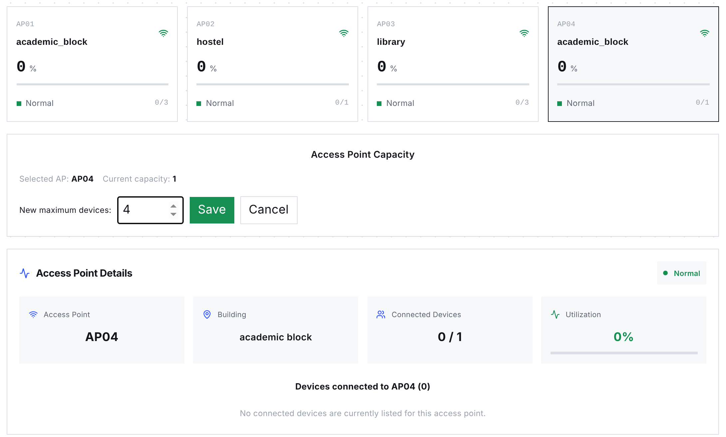
Fig. 5. Final-build dashboard while an operator edits AP04's capacity. AP cards show capacities of 3, 1, 3 and 1 for AP01-AP04; a details panel lists the devices on the selected AP. Screenshot of the production build, taken with the API state of 23 October 2026.

C. Capacity Reconfiguration and Consistency Enhancements
Table VI lists the six final-build changes. Capacities moved out of EventProcessor's source code and into the APState table. Conflicting writes now get HTTP 409, which prevents lost updates, and the operator controls the campus layout directly from the dashboard.

TABLE VI
Enhancements in the Final Build
Component | Change | Effect
UpdateAPConfig (new Lambda) and PUT /aps/{ap_id}/config | Validated partial update of capacity, building and AP name; utilization recalculated with the capacity | Operators change capacity at run time without touching DynamoDB
EventProcessor | Reads capacity, building and name from APState on every event (strongly consistent read) | DynamoDB is the single source of truth for the layout
EventProcessor | Rejects CONNECT at capacity (409); conditional update on count and capacity (409 on conflict) | No lost updates and no utilization above 100%
EventProcessor | Updates only live-state attributes instead of replacing the item | Configuration fields survive device events
Dashboard | Capacity editor with local checks (positive integer, not below connected devices) and AP details panel | Capacity changes and per-AP devices visible in one place
Dashboard deployment | Forward-slash ZIP packaging script; Tailwind plugin in the Vite configuration | Reliable Amplify deployments

D. Functional Verification
On 23 October 2026 we sent 14 requests that together cover all seven routes of the deployed API. Ten of the 14 tests hit validation paths that change no data. Four more call read endpoints: GET /aps, /devices, /migrations and /aps/AP03/history. Table VII lists the requests and responses; all 14 returned the expected status code and error message. The reset endpoint was checked only with a GET, which is correctly refused, because a POST permanently deletes the logs.

TABLE VII
Functional API Tests Against the Deployed System
# | Request | Expected | Observed response
1 | GET /aps | 200, four APs | 200, AP01-AP04 with capacities 3, 1, 3, 1
2 | GET /devices | 200, roster | 200, roster list
3 | GET /migrations | 200, log | 200, one migration (AP04 to AP03)
4 | GET /aps/AP03/history | 200 | 200, empty list (readings older than 24 h expired)
5 | GET /admin/reset | 405 | 405 "Use POST to trigger a reset"
6 | PUT /aps/AP01/config {capacity: 0} | 400 | 400 "Capacity must be an integer from 1 to 1000"
7 | PUT /aps/AP01/config {capacity: "four"} | 400 | 400, same message
8 | PUT /aps/AP01/config {capacity: 5000} | 400 | 400, same message
9 | PUT /aps/AP01/config {color: "red"} | 400 | 400 "Unsupported configuration field"
10 | PUT /aps/AP99/config {capacity: 4} | 404 | 404 "AP not found"
11 | POST /events, event_type PING | 400 | 400 "event_type must be CONNECT or DISCONNECT"
12 | POST /events, no device_id | 400 | 400 "device_id, ap_id and event_type are required"
13 | POST /events, ap_id AP99 | 400 | 400 "Unknown ap_id: AP99"
14 | POST /devices JOIN without ap_id | 400 | 400 "ap_id required for JOIN"

Response times of the three most frequently polled routes were measured from a browser client in India with 20 sequential requests per route after the functions were warm (Table VIII). Median latencies of 60-69 ms are far below the five-second polling interval. The first requests after a period of inactivity took up to about 1.3 s, which reflects Lambda cold starts [8].
TABLE VIII
Warm Request Latency (20 Requests per Route)
Route | Min (ms) | Median (ms) | P90 (ms) | Max (ms)
GET /aps | 57 | 68 | 79 | 84
GET /devices | 56 | 69 | 78 | 81
GET /migrations | 58 | 60 | 80 | 282

E. Live Load-Balancing Runs
The pipeline was tested end to end with real phones instead of staged data. In Run A (September 2026), AP02 in the hostel had a capacity of 2 and AP04 in the academic block a capacity of 3. Two team members joined AP02 from their phones within a few minutes, driving it to 2 of 2 devices and 100% utilization (Fig. 8a). The resulting APState write reached LoadBalancer through the stream; it chose AP04, which had the most free slots, and moved one phone there. AP02 dropped to 50% and AP04 rose to 33.33%. The moved phone displayed the redirect banner with its new AP (Fig. 8b), and the dashboard logged the migration and showed both phones in the roster (Figs. 6 and 7).
Run B took place on 20 October 2026 during the final demonstration, after the capacities had been changed through the new capacity editor to 3, 1, 3 and 1 for AP01-AP04. Several participants checked in from their own phones. When a phone joined AP04 (capacity 1), the AP reached 100%, and LoadBalancer moved the phone to AP03 in the library, leaving AP04 at 0% and AP03 at 33.33% (Fig. 9). This run also confirms that a capacity set at run time is used by EventProcessor and by the balancing trigger without redeploying anything. Table IX lists both migrations and Fig. 10 compares utilization before and after each move.

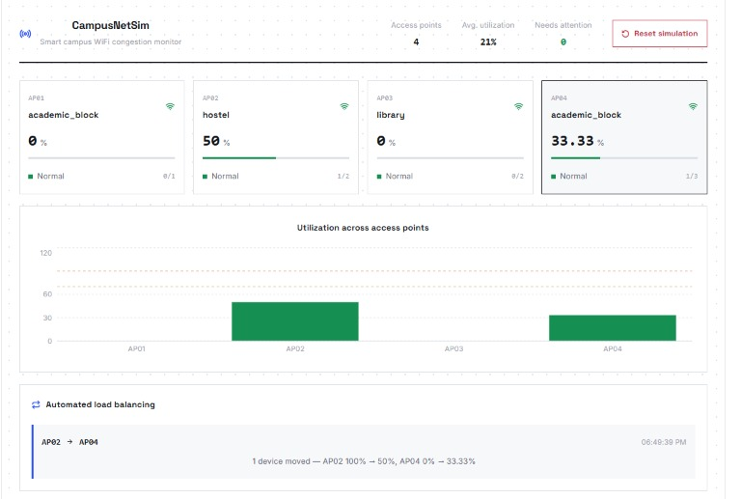
Fig. 6. Dashboard during Run A: AP02 at 50% (1 of 2) and AP04 at 33.33% (1 of 3) after the automated move, with the migration in the load-balancing panel.
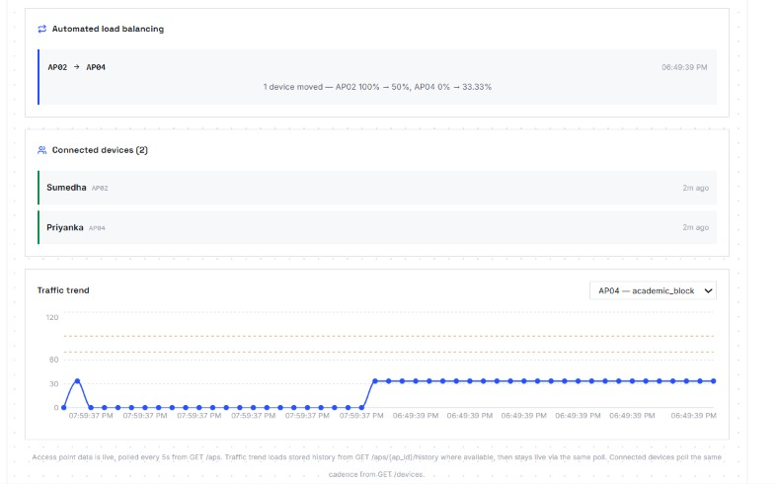
Fig. 7. Dashboard during Run A: migration log, connected-device roster with both phones and the AP04 traffic trend rising after the move.
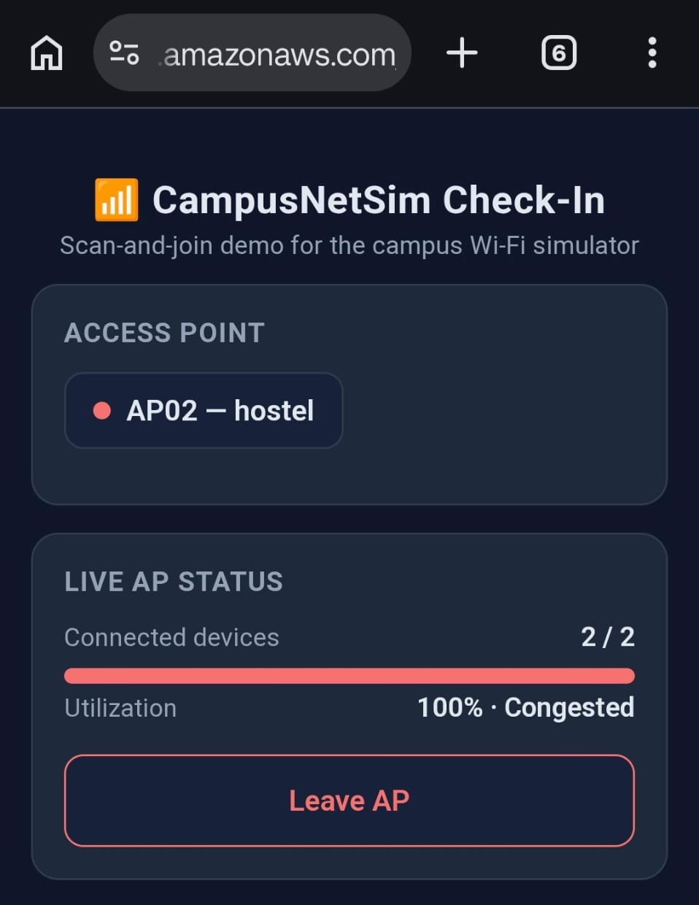  (a) AP02 full before the move | 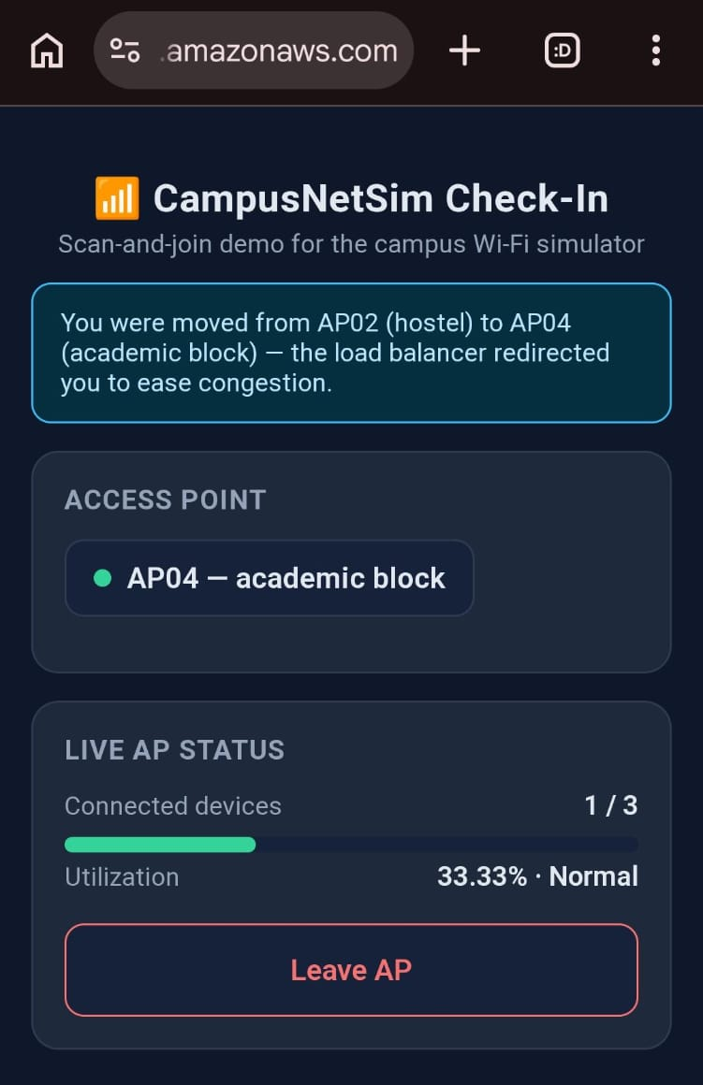  (b) after the move to AP04
Fig. 8. Phone check-in page in Run A: (a) AP02 at 2 of 2 devices and 100% (Congested); (b) moments later, the redirect banner and AP04 at 1 of 3 devices (33.33%, Normal).
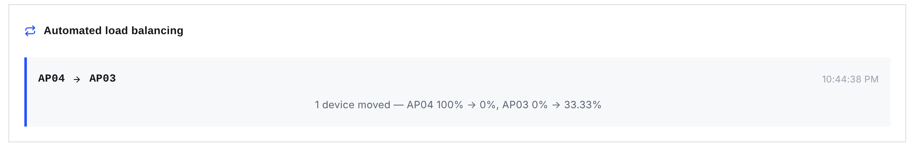
Fig. 9. Migration recorded in Run B: one device moved from AP04 (100% to 0%) to AP03 (0% to 33.33%).
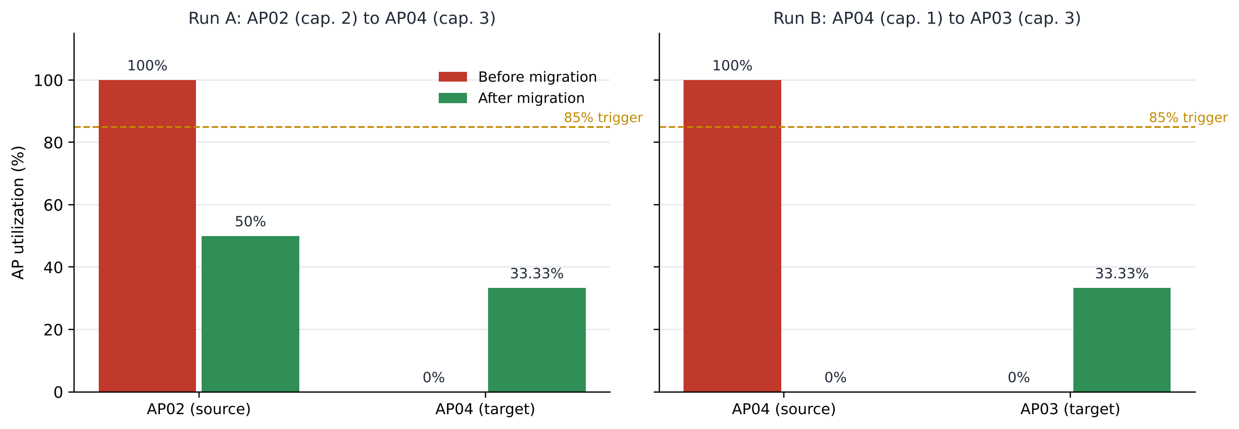
Fig. 10. Utilization of the source and target APs before and after each live migration. Both sources fell below the 85% trigger.

TABLE IX
Recorded Migrations
Run | Source (C) | Target (C) | k | Source U | Target U
A | AP02 (2) | AP04 (3) | 1 | 100 → 50 % | 0 → 33.33 %
B | AP04 (1) | AP03 (3) | 1 | 100 → 0 % | 0 → 33.33 %

F. Discussion
In each run, LoadBalancer followed Algorithm 1 from line 1 to line 12, ending with a Migrations record. LoadBalancer received the state change through the APState stream. It chose the AP with the most free capacity (AP04 in Run A, AP03 in Run B). Afterwards the source sat below the 85% trigger and the target stayed under it. Its moves went through POST /events. They therefore faced the same capacity limit and conditional write as any phone check-in. Every move left a row in Migrations with both APs' utilization before and after.
Several limitations remain. No AP in our demonstrations had more than three slots. A single device therefore swings utilization sharply; on an AP of capacity 1 it goes from 0% straight to 100%. Most of what the system exercised was the full-AP case. Two functions also pick targets independently, and they do not always agree on which AP should receive the moved devices. EventProcessor recommends a same-building AP, such as AP04 for a full AP01 in the academic block. LoadBalancer looks campus-wide for the most free slots, and its choice is the one the system executes. LoadBalancer reaches StatusReader, EventProcessor and DeviceRegistry over HTTPS through the public API. Each call adds an API Gateway round trip. It also breaks if the base URL hard-coded into LoadBalancer ever changes. EventProcessor also runs a full Scan of APState for every event it handles. Four items make that cheap. A campus with hundreds of APs would pay a cost that grows linearly with the AP count. None of the seven routes checks who is calling. Anyone who learns the endpoint URL could resize an AP through PUT /aps/{ap_id}/config, or wipe every log with POST /admin/reset, without any credentials. The check-in page also carries a fixed list of the four AP IDs, AP01 to AP04. Four simulated APs and a handful of phones produced every number in Tables VII-IX, a small test bed for a campus network. We have not yet seen what happens when dozens of phones check in at once.
IX. Conclusion
CampusNetSim needed nothing beyond managed serverless services, ten Lambda functions and four DynamoDB tables, to detect AP congestion and rebalance devices on its own. Every APState write produces one stream record, and that record wakes both LoadBalancer and HistoryWriter. No backend function polls, so a quiet campus triggers no load balancing or history writes; the only invocations come from the two front ends reading state every five seconds. Joining takes a camera and a browser. The dashboard polls every five seconds, so a migration shows up there no more than one polling interval after it happens. Operators can now resize APs at run time. Server-side validation checks every resize, conditional writes keep concurrent events from clobbering each other, and DynamoDB remains the single source of truth for the campus layout. Real phones started both live runs, Run A in September and Run B at the final demonstration on 20 October 2026. Each time, one device left a full AP for the AP with the most free slots: AP02 to AP04 in Run A, AP04 to AP03 in Run B. Every functional test passed (14 of 14), and warm reads took 60-69 ms at the median.
X. Future Work
Seven items remain for future work. (1) Put JWT authorizers on the HTTP API, protecting the configuration and reset routes first and the other five routes after them. (2) Drive TrafficGenerator from an Amazon EventBridge schedule. A peak-hour or congestion scenario could then be rerun whenever needed. For every rerun we would log utilization before and after balancing, plus the number of migrations, and compare the results across scenarios. (3) Teach LoadBalancer to prefer same-building targets. (4) Fetch the one AP each event needs with GetItem on ap_id, dropping the full-table scan. Calling EventProcessor directly as a Lambda function, or sharing its code, would also remove the HTTPS hop and the hard-coded base URL. (5) Forecast the moment an AP will cross 85% from its APHistory snapshots, which cover the last 24 hours, and move devices before it gets there. (6) Handle AP failure: when an AP such as AP03 fails, its devices should move to the other three. (7) Stress-test the system with many simultaneous check-ins. Alarms in CloudWatch and an AWS budget alert would complete the monitoring setup, flagging both errors and unexpected spending.
References
[1] Y. Bejerano, S.-J. Han, and L. Li, "Fairness and load balancing in wireless LANs using association control," IEEE/ACM Trans. Netw., vol. 15, no. 3, pp. 560-573, Jun. 2007.
[2] Y. Bejerano and S.-J. Han, "Cell breathing techniques for load balancing in wireless LANs," IEEE Trans. Mobile Comput., vol. 8, no. 6, pp. 735-749, Jun. 2009.
[3] A. Balachandran, P. Bahl, and G. M. Voelker, "Hot-spot congestion relief in public-area wireless networks," in Proc. 4th IEEE Workshop Mobile Comput. Syst. Appl. (WMCSA), Callicoon, NY, USA, 2002, pp. 70-80.
[4] IEEE Standard for Information Technology - Telecommunications and Information Exchange Between Systems - Local and Metropolitan Area Networks - Specific Requirements - Part 11: Wireless LAN Medium Access Control (MAC) and Physical Layer (PHY) Specifications, IEEE Std 802.11-2020, 2021.
[5] IEEE Standard for Information Technology - Part 11, Amendment 8: IEEE 802.11 Wireless Network Management, IEEE Std 802.11v-2011, 2011.
[6] IEEE Standard for Information Technology - Part 11, Amendment 2: Fast Basic Service Set (BSS) Transition, IEEE Std 802.11r-2008, 2008.
[7] E. Jonas et al., "Cloud programming simplified: A Berkeley view on serverless computing," EECS Dept., Univ. California, Berkeley, CA, USA, Tech. Rep. UCB/EECS-2019-3, Feb. 2019.
[8] P. Castro, V. Ishakian, V. Muthusamy, and A. Slominski, "The rise of serverless computing," Commun. ACM, vol. 62, no. 12, pp. 44-54, Dec. 2019.
[9] Z. Li, L. Guo, J. Cheng, Q. Chen, B. He, and M. Guo, "The serverless computing survey: A technical primer for design architecture," ACM Comput. Surv., vol. 54, no. 10s, Art. no. 220, 2022.
[10] G. DeCandia et al., "Dynamo: Amazon's highly available key-value store," in Proc. 21st ACM Symp. Operating Syst. Principles (SOSP), Stevenson, WA, USA, 2007, pp. 205-220.
[11] M. A. Ahmed, S. A. Chavez, A. M. Eltamaly, H. O. Garces, A. J. Rojas, and Y.-C. Kim, "Toward an intelligent campus: IoT platform for remote monitoring and control of smart buildings," Sensors, vol. 22, no. 23, Art. no. 9045, 2022.
[12] Amazon Web Services, "Serverless architectures with AWS Lambda: Overview and best practices," AWS Whitepaper, 2017. [Online]. Available: https://d1.awsstatic.com/whitepapers/serverless-architectures-with-aws-lambda.pdf
[13] Amazon Web Services, "Using AWS Lambda with Amazon DynamoDB," AWS Lambda Developer Guide. [Online]. Available: https://docs.aws.amazon.com/lambda/latest/dg/with-ddb.html (accessed Oct. 23, 2026).
[14] Amazon Web Services, "Change data capture for DynamoDB Streams," Amazon DynamoDB Developer Guide. [Online]. Available: https://docs.aws.amazon.com/amazondynamodb/latest/developerguide/Streams.html (accessed Oct. 23, 2026).
[15] Amazon Web Services, "Using time to live (TTL) in DynamoDB," Amazon DynamoDB Developer Guide. [Online]. Available: https://docs.aws.amazon.com/amazondynamodb/latest/developerguide/TTL.html (accessed Oct. 23, 2026).
[16] Amazon Web Services, "Optimistic locking with version number," Amazon DynamoDB Developer Guide. [Online]. Available: https://docs.aws.amazon.com/amazondynamodb/latest/developerguide/BestPractices_OptimisticLocking.html (accessed Oct. 23, 2026).
[17] Amazon Web Services, "Working with HTTP APIs," Amazon API Gateway Developer Guide. [Online]. Available: https://docs.aws.amazon.com/apigateway/latest/developerguide/http-api.html (accessed Oct. 23, 2026).
[18] Amazon Web Services, "Deploying an application to Amplify without a Git repository," AWS Amplify Hosting User Guide. [Online]. Available: https://docs.aws.amazon.com/amplify/latest/userguide/manual-deploys.html (accessed Oct. 23, 2026).
[19] S. Phadnis and P. J, "CampusNetSim: Cloud-native campus Wi-Fi congestion simulation and load balancing," GitHub repository, 2026. [Online]. Available: https://github.com/pj-06/campusnetsim

